DESIGN: VDAB Alert Widget

The Alert Widget is an installable Wordpress program that can display a list of VDAB alerts.

It should be packaged so it can be added as an independent plugin.

## Requirement

* The Widget should be packaged as a plugin that can be installed on a number of Wordpress themes.
* The code that displays the actual alert information should be in a separate PHP function which takes an Alert as an argument.
* The Widget should only display unique Alerts. Alerts with the same information should be dropped.
* The Widget should support the configuration of the **number of alerts**. This represents the number of unique alerts to display.
* When the alert is clicked on it should go to the URL defined by **ContainerURL**
* The number of lines of code should be minimized and optimal.
* The code should be commented to ensure that someone with PHP coding skills can alter and enhance the implementation.
* A separate CSS (vdablaert.css) should be provided with the plugin.

## Configurable Parameters

|  |  |  |
| --- | --- | --- |
| Title | String | The title of the widget which will be displayed on top of the widget |
| AlertURL | String | The URL of the flow that provides the Alert data. |
| NoRows | Integer | The number of rows that should be displayed in the widget. |
|  |  |  |
|  |  |  |

## Alert Expansion

The Alert will expand under its row to include the following

|  |  |
| --- | --- |
| Heading | Sample Data |
| Alert Time | 7-July-2019 8:42 AM |
| Category | Application |
| Severity | Critical |
| Source | DissolvedO2Check |
|  |  |
|  |  |

Buoy4327: The dissolved O2 at this buoy is too low.

|  |  |
| --- | --- |
|  |  |
| Alert Time | 7-July-2019 8:42 AM |
| Category | Application |
| Severity | Critical |
| Source | DissolvedO2Check |

Add division

<div class=”vdabalert_table”>

TABLE HTML HERE.

</div>

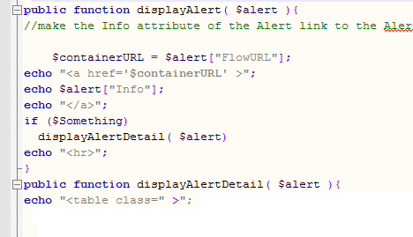

## Code Review (6/27/19) Refactoring

|  |  |  |
| --- | --- | --- |
| Change filename | Filename should be **vdabalert_plugin.ph** | **done** |
| **displayAlert** | **Modify to do one alert in this function** |  |
| **Create fixupJSON routine** | **Create a separate subfunction to clean up the JSON** |  |
| **Create removeDuplicateAlerts** |  |  |