DESIGN: Data Plot

This document covers wordpress support for VDAB alerts which consists of the following componenents:

|  |  |
| --- | --- |
| Plot Page | The data plot page includes an entry form, plotting area and dynamic controls.  Use Rickshaw if at all possible |
| VDAB flow for data | A VDAB flow that returns the data needed for the plot using JSON format. |
|  |  |

## Data Plot Requirements

The Alert Widget is an installable Wordpress widget that can display a list of VDAB alerts.It should be packaged so it can be added as an independent plugin.

1. Select a data item from VDAB using a form. (Not the form VDAB itself, this is just an example fo the data items)

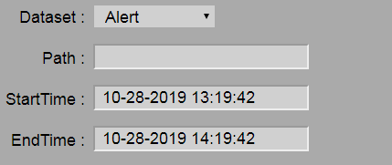

1. Allow the user to select a bar graph, plot, filled plot.
2. Plot Requirements
   1. Support multiple Y Axis (See MyWatershed)
   2. Have the X Axis is always time.
3. Hover over give values for the data point. (Built into Rickshaw)
4. Include the following graph options.
   1. Plot, Scatter or Bar option.
5. Areas of page.
   1. Select the dataset, path, start and endtime (Using calendar). With plot button. (See 1- like that but in regular form.)
   2. Main plot
   3. Legend area where you can select datasets
   4. Graph options.

## Completion Points

|  |  |
| --- | --- |
| Points | Criteria for earning points. |
| 1 | Get some of the rickshaw sample working |
| 1 | Get a line graph working with a single request form. Enter the dataset, path, startdate and enddate (timedates) |
|  |  |
|  |  |
|  |  |
|  |  |
|  |  |

## Sampe Queries

<http://mirror1.gldw.org/vdab/getGLDWData?Dataset=USGSData&Path=MI04001000&StartTime=9-28-2019%2013:19&EndTime=10-28-2019%2014:19>

<http://localhost/vdab/getGLDWData?Dataset=USGSData&Path=MI04001000&StartTime=9-28-2019 13:19:21&EndTime=10-28-2019 14:19>:22

[http://localhost/vdab/getGLDWData?Dataset=USGSData&Path=MI04001000&StartTime=9-28-2019 13:19:21&EndTime=10-28-2019 14:19](http://localhost/vdab/getGLDWData?Dataset=USGSData&Path=MI04001000&StartTime=9-28-2019%2013:19:21&EndTime=10-28-2019%2014:19):22

<http://mirror1.gldw.org/vdab/getGLDWData?Dataset=NDBCData&Path=NDBC_45142&StartTime=9-28-2019%2013:19&EndTime=10-28-2019%2014:19>

## NOTES – Similar Plots

## MonitorMyWatershed

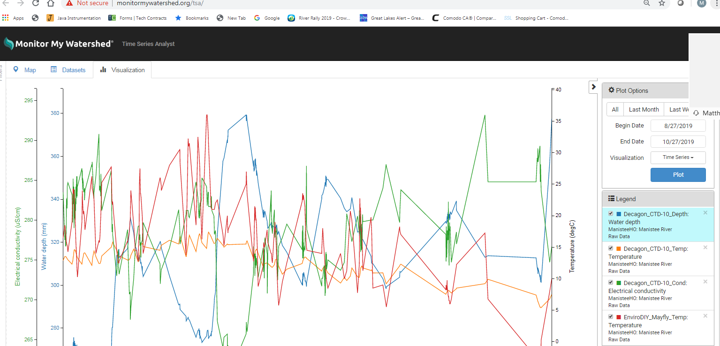



<https://tech.shutterstock.com/rickshaw/examples/extensions.html>

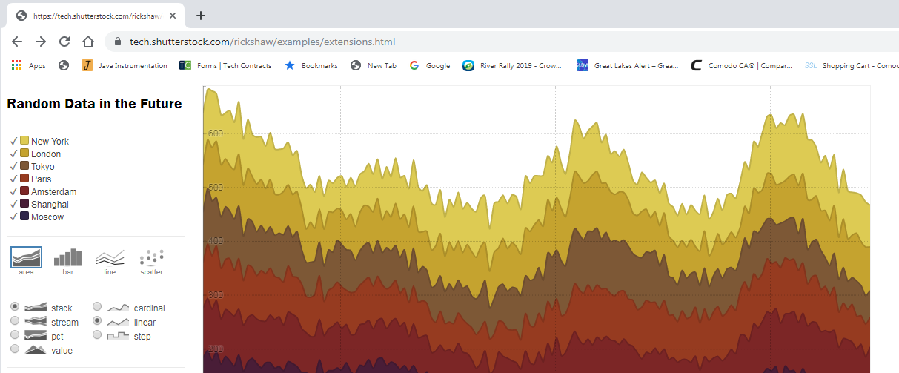

## GLOS

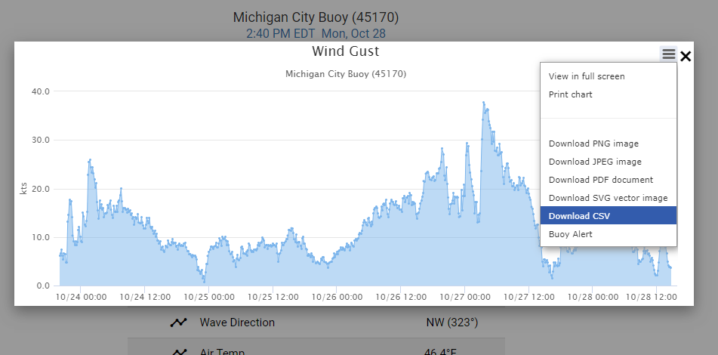

## WQDataLive

