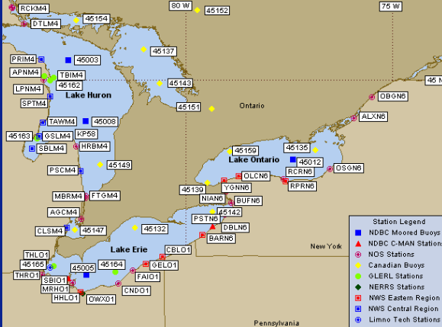

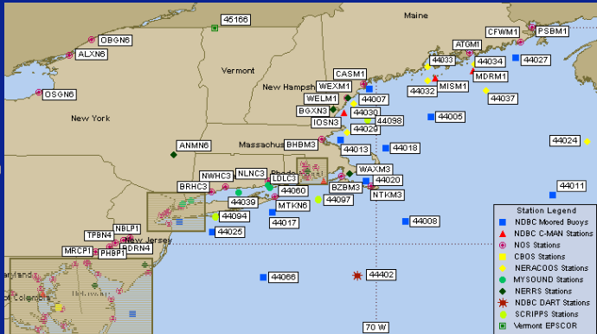

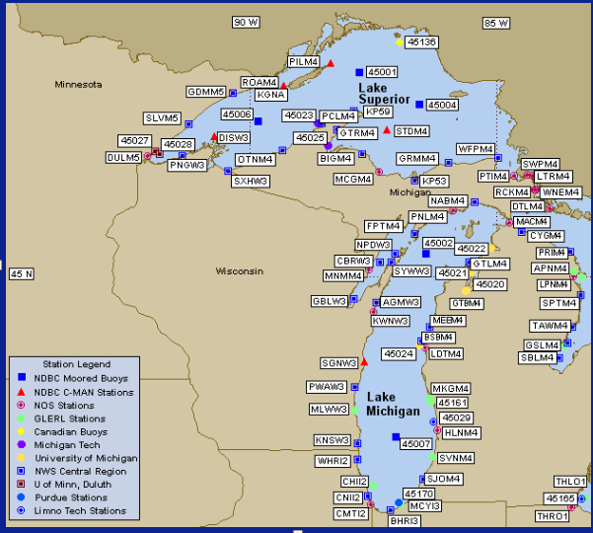

**rd Meteorological Data**

#YY MM DD hh mm WDIR WSPD GST WVHT DPD APD MWD PRES ATMP WTMP DEWP VIS PTDY TIDE

#yr mo dy hr mn degT m/s m/s m sec sec degT hPa degC degC degC nmi hPa ft

2014 09 11 16 50 120 5.0 6.0 0.6 6 4.2 134 1016.5 29.3 30.5 24.4 MM +0.3 MM

|  |  |
| --- | --- |
| WDIR | Wind direction (the direction the wind is coming from in degrees clockwise from true N) during the same period used for WSPD. See [Wind Averaging Methods](https://www.ndbc.noaa.gov/wndav.shtml) |
| WSPD | Wind speed (m/s) averaged over an eight-minute period for buoys and a two-minute period for land stations. Reported Hourly. See [Wind Averaging Methods](https://www.ndbc.noaa.gov/wndav.shtml). |
| GST | Peak 5 or 8 second gust speed (m/s) measured during the eight-minute or two-minute period. The 5 or 8 second period can be determined by payload, See the [Sensor Reporting, Sampling, and Accuracy](https://www.ndbc.noaa.gov/rsa.shtml) section. |
| WVHT | Significant wave height (meters) is calculated as the average of the highest one-third of all of the wave heights during the 20-minute sampling period. See the [Wave Measurements](https://www.ndbc.noaa.gov/wave.shtml) section. |
| DPD | Dominant wave period (seconds) is the period with the maximum wave energy. See the [Wave Measurements](https://www.ndbc.noaa.gov/wave.shtml) section. |
| APD | Average wave period (seconds) of all waves during the 20-minute period. See the [Wave Measurements](https://www.ndbc.noaa.gov/wave.shtml) section. |
| MWD | The direction from which the waves at the dominant period (DPD) are coming. The units are degrees from true North, increasing clockwise, with North as 0 (zero) degrees and East as 90 degrees. See the [Wave Measurements](https://www.ndbc.noaa.gov/wave.shtml) section. |
| PRES | Sea level pressure (hPa). For C-MAN sites and Great Lakes buoys, the recorded pressure is reduced to sea level using the method described in *NWS Technical Procedures Bulletin 291* (11/14/80). ( labeled BAR in Historical files) |
| ATMP | Air temperature (Celsius). For sensor heights on buoys, see [Hull Descriptions](https://www.ndbc.noaa.gov/hull.shtml). For sensor heights at C-MAN stations, see [C-MAN Sensor Locations](https://www.ndbc.noaa.gov/cmanht.shtml) |
| WTMP | Sea surface temperature (Celsius). For buoys the depth is referenced to the hull's waterline. For fixed platforms it varies with tide, but is referenced to, or near [Mean Lower Low Water (MLLW)](https://tidesandcurrents.noaa.gov/datum_options.html#MLLW). |
| DEWP | Dewpoint temperature taken at the same height as the air temperature measurement. |
| VIS | Station visibility (nautical miles). Note that buoy stations are limited to reports from 0 to 1.6 nmi. |
| PTDY | Pressure Tendency is the direction (plus or minus) and the amount of pressure change (hPa)for a three hour period ending at the time of observation. (not in Historical files) |
| TIDE | The water level in feet above or below [Mean Lower Low Water (MLLW)](https://tidesandcurrents.noaa.gov/datum_options.html#MLLW). |

