Northeast Ohio TDS Monitoring Project

## Project Overview

The Northeast Ohio TDS Monitoring Project is the first project under the GLDS Enhanced Citizen Data Collection Program.

The project will illustrate how VDAB processing hosted by the GLDW can enhance the quality of citizen collected TDS Data.

Many of the following techniques will be leveraged to enhance this data.

* OCR will be used to eliminate reading errors.
* Color coded standards.
* Barcoded labels confirm identity and meter.
* GPS data attached and verifies location
* Externalized calibration.
* Citizen precision score. (Keep track – get rating)
* Validation against same site historical readings.
* Sanity check with changes in correlation with neighboring reading
* Registration of sampling locations and citizen.

The enhanced monitor for TDS will include the following:

* The project kit will include a TDS meter, sample cup and registration labels.
* The back end server software will be assembled using custom and standard VDAB components and will be hosted on the GLDW cloud.
* A smartphone app will be included to send a picture, GPS data and manually entered data.

# Major Software Components

|  |  |  |
| --- | --- | --- |
| Component | Description | Notes |
| Manual data input flow | This provides the ability to enter complete TDS data using a web form. | This is primarily for testing purposes |
| Automated email input flow | This receives emails sent from a smartphone reading the JSON data in the body and receiving supporting images | Initially get working with JSON data in the body.  If possible it can later do some OCR to validate the data. |
| TDS initial processing flow | Takes initially validated TDS data and does additional processing including some of the following:   * Push data into a DB * Perform additional checks |  |
| Image/OCR Flow to read data | Receives the picture received from the smartphone and applies OCR to get or confirm the data. | MAYBE – This may be too complicated.  This can be done in May after the quarter finals. |
| TDS data check flow | Checks the TDS data and creates alerts when the validated data represents an environmental concern. |  |
| Alert handling flows | This flow when handle alerting conditions by notifying individuals that subscribe to this alert. |  |
|  |  |  |
| Smartphone app | An Android or Iphone app that takes a picture and sends an email with the JSON TDS data | This can be done in May after the quarter finals. |

# Manual Data Input Flow

Initially all testing will be done by manually inputting TDS data on a form.

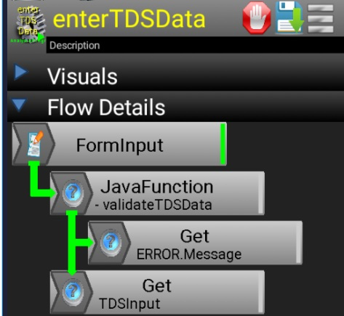

## TDS Input Form

Form Fields for form. Form name is TDSInput and should include the following feeds

|  |  |
| --- | --- |
| Field | Field Description |
| LocationID | A six digit number identifying the sample location |
| Reporter | The user name of the person reporting the data. |
| TDS | The Total Dissolved Solids in the water sample in parts per million |
| pH | The pH of the water sample in pH units. |
| Temperature | The water temperature reported in degrees F |
| Latitude | The latitude reported from the sampling location |
| Longitude | The longitude of the sample location |
| Depth | The number of feet under the surface for the sample |

## TDS Validation Funcset

|  |  |
| --- | --- |
| Package | gldw.citizen |
| Class | TDSInputSupport.java |
| Function | func_validateTDSData(..) |
| Conditions | Declare an error for any of the following:  TDS > 1000  TDS < 20  pH < 3  pH > 12  LocationID does not have six digits.  Reporter is null  Temperature > 100F  Temperature < -40F |
|  |  |

# Automated Email Input Flow

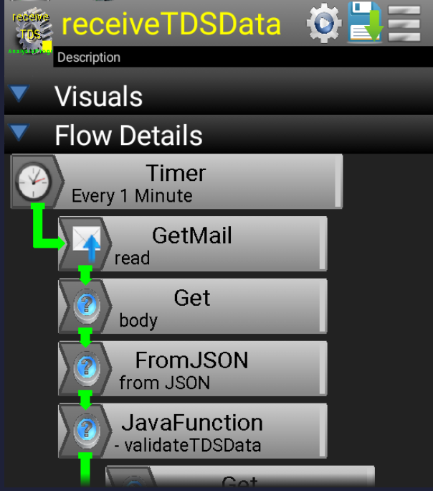The automated Email input flow receives the JSON event data in the body of the email.

# Data Collection Kit

The data collection kit will include the following.

* TDS/Temperature Meter ($13)
* Collection container with markings that help when analyzing the photograph ($1)
* Color coded conductance standards ($4)
* Registration Labels attached to container containing the citizen’s ID.