Find CSS to change the following in the Site Identity, Menu and Page Title

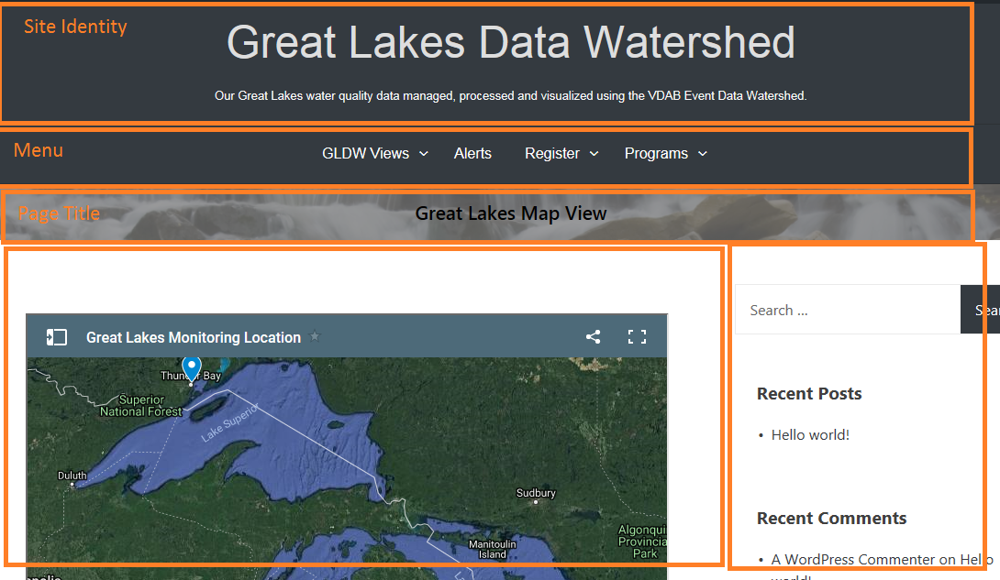

|  |  |  |  |
| --- | --- | --- | --- |
|  | Site Identify | Menu | Page Title |
| Area size | .site-branding {  padding-bottom:30px;  } | .menu{  padding:0 0 0 0;  } | .page-header {  padding-bottom: 10px;  padding-top:15px;  } |
| Centering | .site-branding {  text-align: center;  } | .menu{  text-align:center;  } | .page-header {  text-align: center;  } |
| Background Color | .site-branding {  Background-color:white;    } | .main-navigation {  background-color:none;  } | .page-header {  background-color: #ECECEC  } |
| Text Color | .site-title a {  color: #DEDEDE;  } | .nav-menu a {  color:white;  } | .page-title {  color: black;  } |
| Text Size | .site-title a {    font-size: 3.0rem;  } | .nav-menu{  font-size:15px;  } | .page-title {  font-size: 1.3rem;  } |
| Image Background | #masthead {  background-image: url("https://amp.thisisinsider.com/images/5ad8eadbbd967148008b4640-960-720.jpg");  background-size:100%;  background-position:center;  } | .menu{  background-image: url("https://amp.thisisinsider.com/images/5ad8eadbbd967148008b4640-960-720.jpg");    } | .page-header {  background-image: url("https://amp.thisisinsider.com/images/5ad8eadbbd967148008b4640-960-720.jpg");  } |
|  |  |  |  |

The following are new css attributes.

.nav-menu{

font-family:sans-serif;

font-size:15px;

}

.page-header {

background-color: #ECECEC;

padding-bottom: 15px;

padding-top:15px;

-webkit-background-size: 100%;

background-size: 100%;

}

.site-title a {

color: #DEDEDE;

font-family: sans-serif;

font-size: 3.0rem;

font-weight:550;

}

.page-title {

font-weight:600;

color: black;

font-size: 1.3rem;

}

.site-title {

padding-bottom: 12px;

}