## Performance Test 2 Aug 19

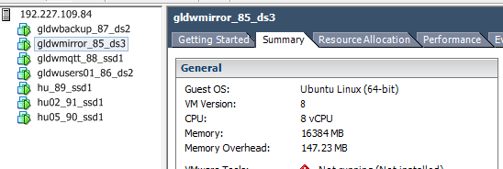

* 740K events.
* Run AllReports – This include Great Lakes Reports and Buoy Data from NDBC
  + About 500 greate lakes events.
  + About 20 buoy events.

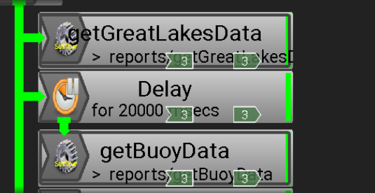

* Minimal response peeking at 300 CPU Msecs.

