Creating New Users

1. Review the user information.
2. Create a GLDW User Server Info sheet and send back to the user for approval.
3. Get a 12 digit random password. (Existing list).
4. Create the user server on the user01.gldw.org server. Use the next user id which should be an odd number
5. Perform the initial configuration of the User as MJATech.
6. Clean the Android client data on a Bluestacks instance and start that client.
7. Register the client using the new users username and assigned password.
8. Create the database and database login.
9. Setup the database psersistence.
10. Add the user to the list of Enterprise Bluestacks licenses
11. **ISSUE – database passwords are not save after the Container is renamed.**
12. **Enable taps to Mirror1 for the user.**

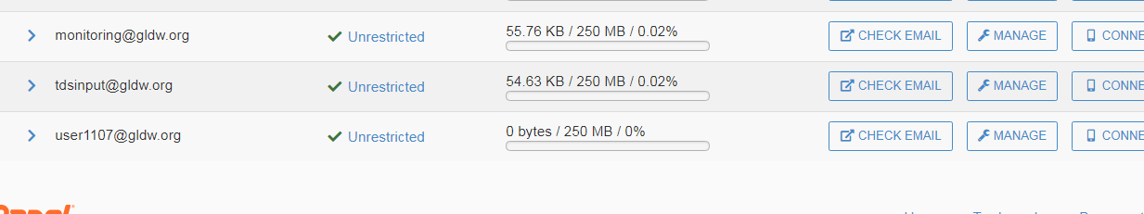

## Database Setup

5. Create Database name prefixed with gldw and including the user number.



mysql> CREATE DATABASE vdab;

Query OK, 1 row affected (0.08 sec)

6. Create user showgldw_XXXX with the assigned password XXXXX:

mysql> CREATE USER 'gldw_1107'@'localhost' IDENTIFIED BY 'XXXXXXX';



7. Grant all privileges to “vdab” to user “vdab” from localhost access :

mysql> GRANT ALL PRIVILEGES ON vdab.* to vdab@localhost;

Query OK, 0 rows affected (0.00 sec)



8. Verify the granted access for user “vdab fo” :

mysql> SHOW GRANTS FOR 'vdab'@'localhost';

2 rows in set (0.00 sec)

mysql>

9. Display the created database :

mysql> show databases;

+--------------------+

| Database |

+--------------------+

| vdab

mysk |

