Getting Started as a GLDW VDAB User

1. Register as a user on the GLDW web site. Request your own VDAB server.

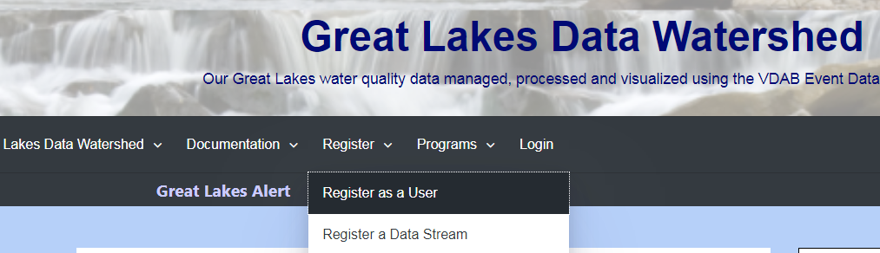

1. 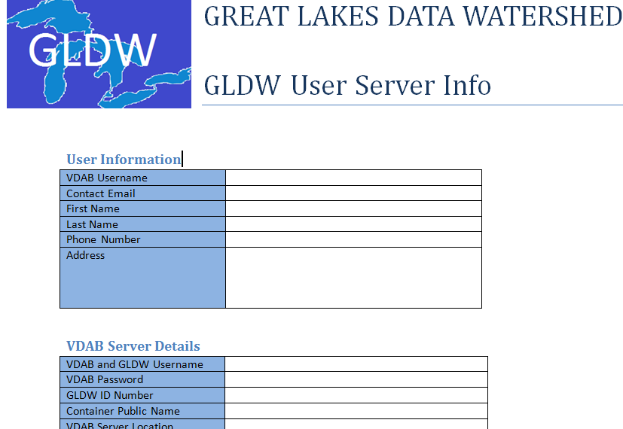You will receive an email confirming your user registration your login information. Reply to this Email with any corrections.
2. While we are working on a full featured web client for Q1 2020, currently you can only program VDAB flows using an Android client. Follow the detailed procedure found below for installing and running the Android Client. Make sure to use the username and password that have been assigned. [https://vdabtec.com/vdab/docs/VDABInstallation_AndroidClient.pdf](https://vdabtec.com/vdab/docs/VDABInstallation_AndroidClient.pdf%20)
3. It is highly recommended that you attend a GLDW User orientation presentation. They are generally scheduled every 2-3 weeks.