## Background Information

1. The maps are created on *mirror1.gldw.org* using the following flows
   1. **skedReports** – schedules the data reports at 7:00AM and 1:00PM
   2. 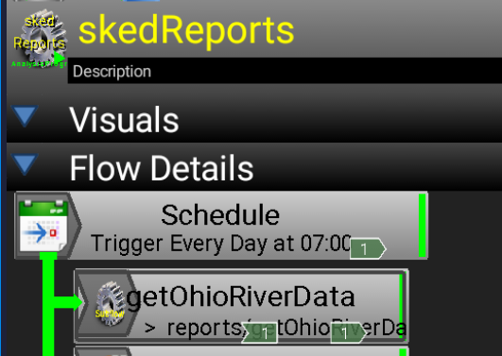
   3. **getGreatLakesData** actually grabs the reports for the GreatLakes and creates a file with the data.
   4. 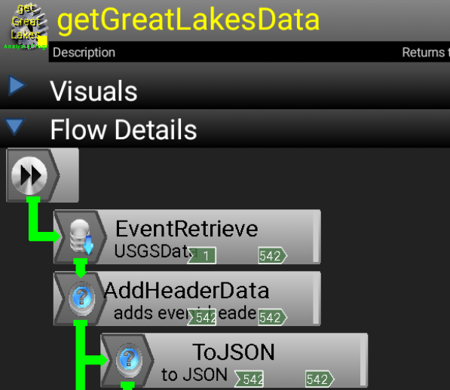

## Grab the Maps

1. Goto mirror1.gldw.org and identify the latest csv file for each major hydrologic unit.

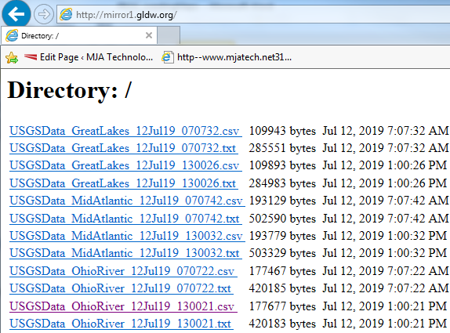

1. Pick one of the Hydrologic Units, (**GreatLakes**, MidAtlantic, OhioRiver) and click on the latest csv file.
2. The file should open up in Excel. Make sure of the following:
   1. The columns are aligned.
   2. They have column headers.
   3. There are an appropriate number of rows. (543 for **GreatLakes**)
3. ~~Delete the following columns (~~DONE AUTOMATICALLY NOW~~)~~
   1. ~~Label~~
   2. ~~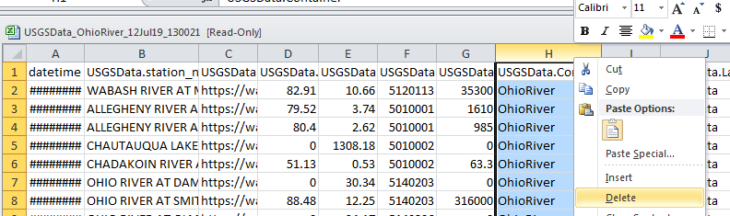Container~~
   3. ~~EventTime~~
4. ~~Rename the column headers (~~DONE AUTOMATICALLY NOW)
   1. ~~datetime > Sample Time~~
   2. ~~station_nm > Station Name~~
   3. ~~url > Link~~
   4. ~~percentile > Percentile~~
   5. ~~stage > Stage~~
   6. ~~huc_cd > HU Code~~
   7. ~~flow > Flow (cfs)~~
5. After all edits save it as a CSV file on your local driver under the WebSupport Github project.

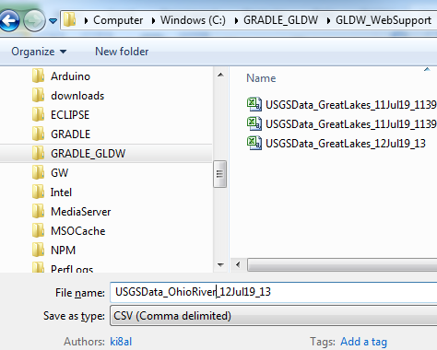

## Loading Maps

1. Log into the [GLDataWatershed@gmail.com](mailto:GLDataWatershed@gmail.com) google account.
2. Make sure you are logged in Chrome as well as on the current page.
3. 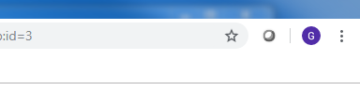
4. Go the Google Drive for this account.
5. Go to the appropriate fusion document and open it.

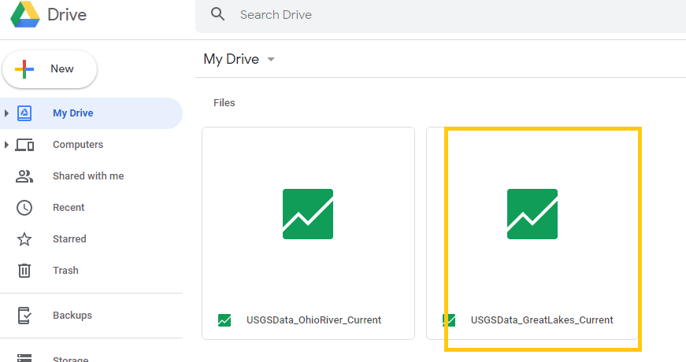

1. Delete all the existing rows.

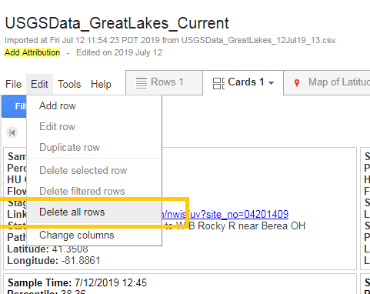

1. Import more rows
2. Chose file csv file you created.

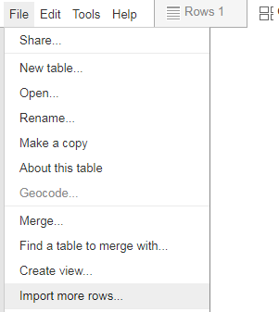

1. Check that the map published properly

