Affine Registration of Images
We have two N-dimensional data sets that need to be registered. Assuming the transformation is affine, following linear equations can be written:
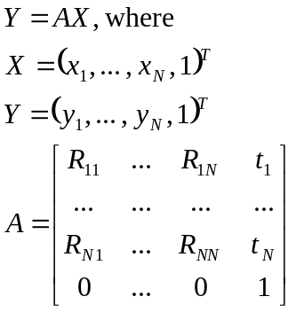 (1).
Parameters 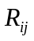 determine the rotation, scale and shear, - translation. But for simplicity we will just use 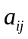, assuming that i and j vary in the range (1, … , N+1) .
In order to determine the transformation parameters , we need to register certain “point source”-like objects in both channels 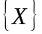 and 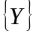.
We assume we have p sets of corresponding point pairs (p>N), we can then write them in the matrix form:
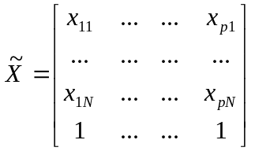 and 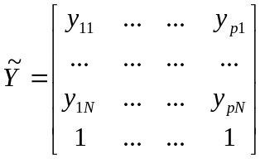 (2).
In order to determine A in least squares sense, we can write the following condition:
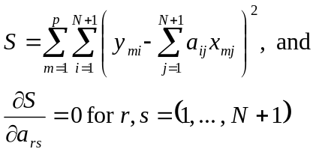 (3).
We can write
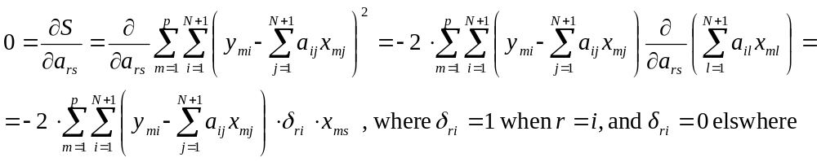 (4).
We can further simplify that to:
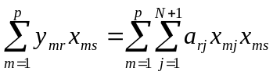 (5),
we can see that in the form of matrices 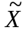, 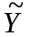, and A, defined above this equation is equivalent to:
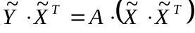 (6),
And, therefore the matrix A can be determined from:
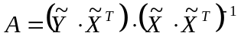 (7).

H. Spath. Fitting affine and orthogonal transformations between two sets of points. Mathematical Communications, 9:27–34, 2004.

