PeakSelector: PALM Data Processing and Analysis for Z-extraction using Astigmatism only.

Contents
PeakSelector: iPALM (3D) Data Processing and Analysis 1
1 Calibration File Processing Steps 1
2 Data File Processing Steps (should be done on Linux-based computer with access to the Janelia cluster) 5
2.1 Old procedure (still works but takes longer time and need more oversight). 5
2.1.1 Extract individual Cam1, Cam2, Cam3 data files 5
2.1.2 Select and apply fiducial anchor points. 5
2.1.3 Transform Raw, Save individual and Sum Raw files, Extract Peaks for the Sum file, Re-exctract Peaks Multilabel, and perform Grouping. 5
2.1.4 Use calibration file (_WND.sav) to extract Z-coordinate 5

.

Calibration File Processing Steps

- Process calibration file set as usual 2D data set using “Extract Peaks .sif/ .tif/ .txt/ .dat to .pks file” selection from “File” menu.
- Save the processed data set as “***_ISD.sav” file.
- Once the data set is processed:
  - Apply filters: typically Sigma X Pos Full<0.2 pix, Sigma X Pos Full<0.2 pix.
  - Press “Unzoomed Centers”.
- Select the area with one (or few!) fiducial persisting through most of the frames.
- Select “Z-coordinate Operations – Astig Only” from “Special Functions” menu, “Z-coordinate Operations (Astigmatism Only – no Interference” pop-up menu will appear (see Figure 1).
- If it is not 50 nm, change the value of Cal. Z Step (nm) in the field indicated by a red arrow in Figure 1.
- If desired, change the file name for _WND.sav (for example Cal1_c123_sum_MultiZ_F1_WND.sav) file to be created (the program will propose a reasonable file name automatically and add “_WND.sav” to the end of file name if it is missing).
- Press “Test Ellipticity vs Frame” to create the calibration. Proper calibration should produce results similar to those shown in Figure 2.
- You can manually modify the Ellipticity Fit Coefficients (do not forget to press “Enter” each time you change the value!) and press “Plot Ellipticity vs. Z: Data + Fit” to see the results, as shown in Figure 3.
- Press “Save Ellipticity + Wind” to save the calibration into slected _WND.sav filename.
- Press “Extract Z Coordinate” to extract Z for all points in the calibration file.
- Save the file ( e.g. into “Cal1_c123_sum_MultiZ”) for the record.
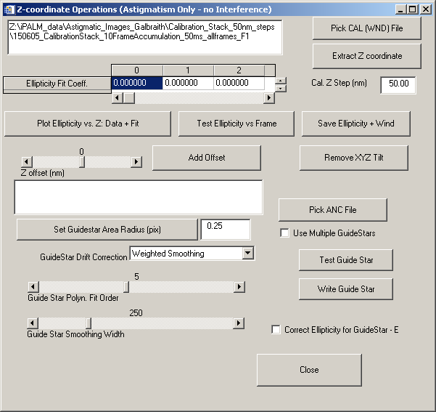
Figure 1. “Z-coordinate Operations (Astigmatism Only – no Interference” pop-up menu, most fields empty when first loaded.
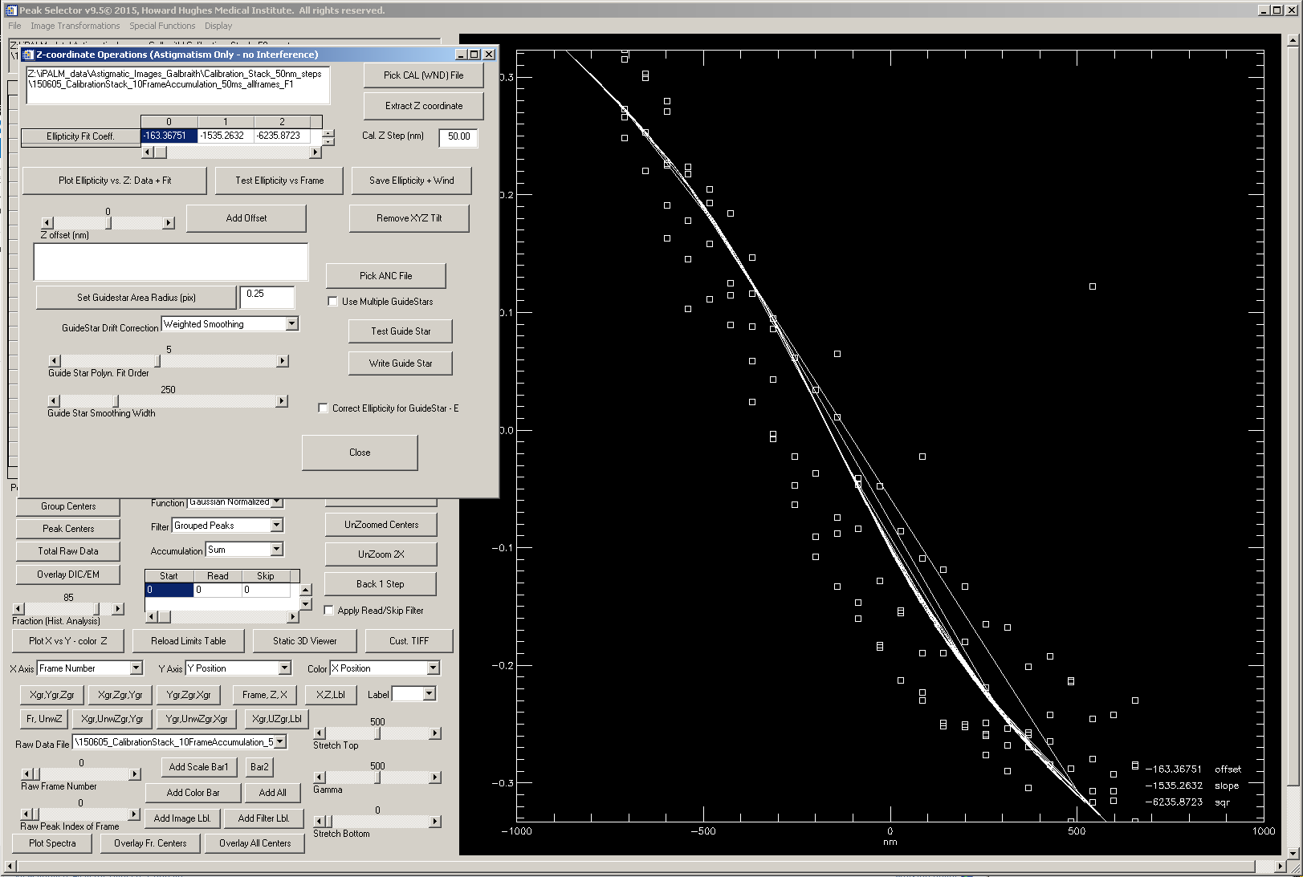
Figure 2. Results of proper Z-calibration (after pressing “Test Ellipticity vs. Frame” to create the calibration (4 fiducials were selected).
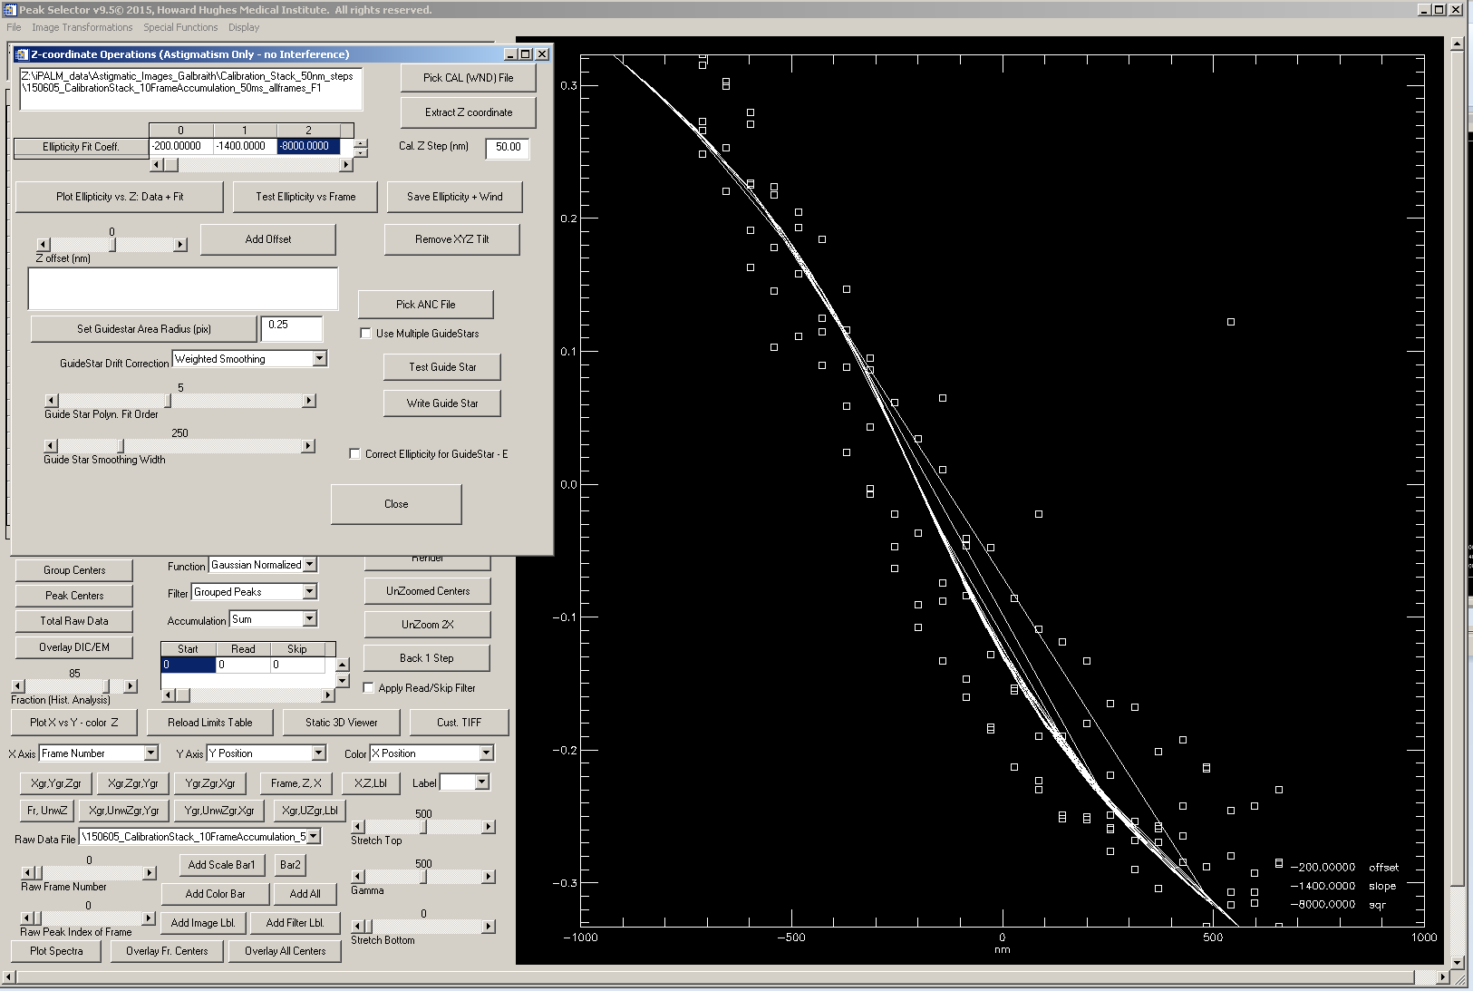
Figure 3. Results of proper Z-calibration after manually modifying “Ellipticity Fit Coeffs.” pressing “Plot Ellipticity vs. Z: Data + Fit”.

Data File Processing Steps

Extract data file(s)
- Process calibration file set as usual 2D data set using “Extract Peaks .sif/ .tif/ .txt/ .dat to .pks file” selection from “File” menu. You can also extract multiple consecutive files (up to 3) using “Extract Peaks Multiple Labels” selection from “File” menu, followed by (after they have been processed) pressing “Merge Labels Consecutively” selection from “File” menu.
- Once these steps are completed, save the data into _IDL.SAV file by selecting “Save Processed as IDL(.sav)” option from “File” menu.

Use calibration file (_WND.sav) to extract Z-coordinate
Once previous step had been completed, Z-coordinate can be extracted using X-Y Ellipticity data.
- Select “Z-coordinate Operations – Astig Only” from “Special Functions” menu. “Z-coordinate Operations (Astigmatism Only – no Interference” pop-up menu will appear (see Figure 1). Press Pick WND File and select the appropriate calibration file. The “Ellipticity Fit Coeff.” will update with non-zero values only if the calibration data.
- Press “Extract Z Coordinate” to extract Z for all points in the calibration file.
- Once these steps are completed, save the data into _IDL.SAV file by selecting “Save Processed as IDL(.sav)” option from “File” menu.
- The Z-coordinate data is located in the field “Inwrapped Z” (Row 44 in the main parameter table) for Frame Peaks and in the field “Inwrapped Group Z” (Row 47 in the main parameter table) for Group Peaks.
- In order to render the data with Z-coordinate as a false color, you will need to press “”Swap Z with Unwrap Z” first.
X
Y

