## образования и молодежной политики Свердловской области



ГАПОУ СО «Екатеринбургский колледж транспортного строительства»

Отчёт по программе «Неявные интенты»

Выполнил: Лобанов Глеб

Группа: ПР-32

Преподаватель: Мирошниченко Г.В

2025 г.

**Задание:**

Используя UI-фрагменты и FragmentManager, неявные интенты. начать строить приложение CriminalIntent. Оно предназначено для хранения информации об «офисных преступлениях»: грязной посуде, оставленной в раковине, или пустом лотке общего принтера после печати документов.

**Входные данные:**

Crime – описание преступления

Title_for_the_crime – заголовок для преступления

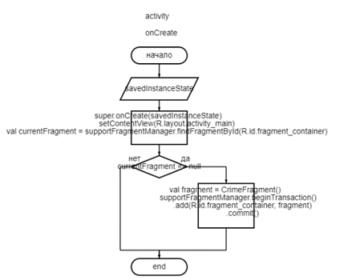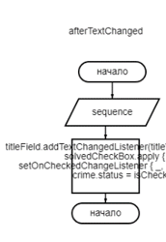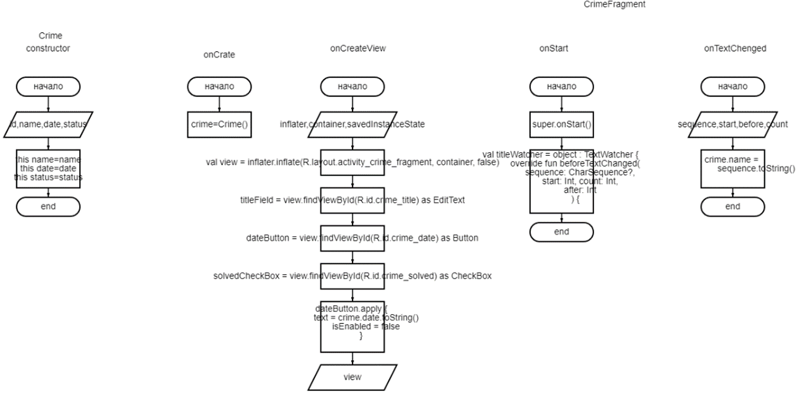**Блок-схема**

**Листинг программы:**

Классы

***MainActivity***

class MainActivity : AppCompatActivity() {  
  
 override fun onCreate(savedInstanceState: Bundle?) {  
 super.onCreate(savedInstanceState)  
 setContentView(R.layout.activity_main)  
  
 val currentFragment = supportFragmentManager.findFragmentById(R.id.fragment_container)  
  
 if (currentFragment == null) {  
 val fragment = CrimeFragment()  
 supportFragmentManager.beginTransaction()  
 .add(R.id.fragment_container, fragment)  
 .commit()  
 }  
 }  
}

***Crime***

@Entity(tableName = "crime")  
data class Crime(  
 @PrimaryKey var id: UUID = UUID.randomUUID(),  
 @ColumnInfo(name = "title") var title: String = "",  
 @ColumnInfo(name = "date") var date: Date = Date(),  
 @ColumnInfo(name = "is_solved") var isSolved: Boolean = false,  
 @ColumnInfo(name = "suspect") var suspect: String = ""  
) {  
 @Ignore  
 constructor(title: String, date: Date, isSolved: Boolean, suspect: String) : this(  
 UUID.randomUUID(),  
 title,  
 date,  
 isSolved,  
 suspect  
 )  
}

***CrimeDao***

@Dao  
interface CrimeDao {  
 @Query("SELECT * FROM crime")  
 fun getCrimes(): LiveData<List<Crime>>  
  
 @Query("SELECT * FROM crime WHERE id=(:id)")  
 fun getCrime(id: UUID): LiveData<Crime?>  
  
 @Insert  
 fun addCrime(crime: Crime)  
  
 @Update  
 fun updateCrime(crime: Crime)  
}

***CrimeDatabase***

@Database(entities = [Crime::class], version = 2)  
@TypeConverters(CrimeTypeConverters::class)  
abstract class CrimeDatabase : RoomDatabase() {  
 abstract fun crimeDao(): CrimeDao  
  
 companion object {  
 const val DATABASE_NAME = "crime-database"  
  
 val migration_1_2 = object : Migration(1, 2) {  
 override fun migrate(database: SupportSQLiteDatabase) {  
 database.execSQL("ALTER TABLE Crime ADD COLUMN suspect TEXT NOT NULL DEFAULT ''")  
 }  
 }  
 }  
}

***CrimeRepository***

class CrimeRepository private constructor(context: Context) {  
  
 private val database: CrimeDatabase = Room.databaseBuilder(  
 context.*applicationContext*,  
 CrimeDatabase::class.*java*,  
 CrimeDatabase.DATABASE_NAME  
 )  
 .addMigrations(CrimeDatabase.migration_1_2)  
 .build()  
  
 private val crimeDao = database.crimeDao()  
  
 fun getCrimes(): LiveData<List<Crime>> {  
 return crimeDao.getCrimes()  
 }  
  
 fun getCrime(id: UUID): LiveData<Crime?> {  
 return crimeDao.getCrime(id)  
 }  
  
 fun addCrime(crime: Crime) {  
 crimeDao.addCrime(crime)  
 }  
  
 fun updateCrime(crime: Crime) {  
 crimeDao.updateCrime(crime)  
 }  
  
 companion object {  
 private var INSTANCE: CrimeRepository? = null  
  
 fun initialize(context: Context) {  
 if (INSTANCE == null) {  
 INSTANCE = CrimeRepository(context)  
 }  
 }  
  
 fun get(): CrimeRepository {  
 return INSTANCE ?: throw IllegalStateException("CrimeRepository must be initialized")  
 }  
 }  
}

***CrimeTypeConverters***

class CrimeTypeConverters {  
 @TypeConverter  
 fun fromDate(date: Date?): Long? {  
 return date?.*time* }  
  
 @TypeConverter  
 fun toDate(millisSinceEpoch: Long?): Date? {  
 return millisSinceEpoch?.*let* **{** Date(**it**) **}** }  
  
 @TypeConverter  
 fun fromUUID(uuid: UUID?): String? {  
 return uuid?.toString()  
 }  
  
 @TypeConverter  
 fun toUUID(uuid: String?): UUID? {  
 return UUID.fromString(uuid)  
 }  
}

***CrimeFragment***

class CrimeFragment : Fragment() {  
  
 private lateinit var crime: Crime  
 private lateinit var titleField: EditText  
 private lateinit var dateButton: Button  
 private lateinit var solvedCheckBox: CheckBox  
 private lateinit var suspectButton: Button  
 private lateinit var reportButton: Button  
  
 override fun onCreate(savedInstanceState: Bundle?) {  
 super.onCreate(savedInstanceState)  
 crime = Crime()  
 }  
  
 override fun onCreateView(  
 inflater: LayoutInflater,  
 container: ViewGroup?,  
 savedInstanceState: Bundle?  
 ): View? {  
 val view = inflater.inflate(R.layout.*fragment_crime*, container, false)  
  
 titleField = view.findViewById<EditText>(R.id.*crime_title*)!!  
 dateButton = view.findViewById<Button>(R.id.*crime_date*)!!  
 solvedCheckBox = view.findViewById<CheckBox>(R.id.*crime_solved*)!!  
 suspectButton = view.findViewById<Button>(R.id.*crime_suspect*)!!  
 reportButton = view.findViewById<Button>(R.id.*crime_report*)!!  
  
 dateButton.*apply* **{** *text* = crime.date.toString()  
 *isEnabled* = false  
 **}** return view  
 }  
  
 override fun onStart() {  
 super.onStart()  
  
 val titleWatcher = object : TextWatcher {  
 override fun beforeTextChanged(sequence: CharSequence?, start: Int, count: Int, after: Int) {}  
  
 override fun onTextChanged(sequence: CharSequence?, start: Int, before: Int, count: Int) {  
 crime.title = sequence.*toString*()  
 }  
  
 override fun afterTextChanged(sequence: Editable?) {}  
 }  
  
 titleField.addTextChangedListener(titleWatcher)  
  
 solvedCheckBox.setOnCheckedChangeListener **{** _, isChecked **->** crime.isSolved = isChecked  
 **}** suspectButton.*apply* **{** val pickContactIntent = Intent(Intent.*ACTION_PICK*, ContactsContract.Contacts.*CONTENT_URI*)  
 setOnClickListener **{** startActivityForResult(pickContactIntent, REQUEST_CONTACT)  
 **}** val packageManager: PackageManager = requireActivity().*packageManager* val resolvedActivity: ResolveInfo? = packageManager.resolveActivity(pickContactIntent, PackageManager.*MATCH_DEFAULT_ONLY*)  
 *isEnabled* = true  
 **}** reportButton.setOnClickListener **{** Intent(Intent.*ACTION_SEND*).*apply* **{** *type* = "text/plain"  
 putExtra(Intent.*EXTRA_TEXT*, getCrimeReport())  
 putExtra(Intent.*EXTRA_SUBJECT*, getString(R.string.*crime_report_subject*))  
 **}**.*also* **{** intent **->** val chooserIntent = Intent.createChooser(intent, getString(R.string.*send_report*))  
 startActivity(chooserIntent)  
 **}  
 }** }  
  
 override fun onActivityResult(requestCode: Int, resultCode: Int, data: Intent?) {  
 when {  
 resultCode != Activity.*RESULT_OK* -> return  
 requestCode == REQUEST_CONTACT && data != null -> {  
 val contactUri: Uri? = data.*data* val queryFields = *arrayOf*(ContactsContract.Contacts.*DISPLAY_NAME*)  
 if (contactUri != null) {  
 val cursor = requireActivity().*contentResolver*.query(contactUri, queryFields, null, null, null)  
 cursor?.*use* **{** if (**it**.*count* > 0) {  
 **it**.moveToFirst()  
 val suspect = **it**.getString(0)  
 crime.suspect = suspect  
 suspectButton.*text* = suspect  
 }  
 **}** } else {  
 // Обработка случая, когда contactUri равен null  
 }  
 }  
 }  
 }  
  
 private fun getCrimeReport(): String {  
 val solvedString = if (crime.isSolved) {  
 getString(R.string.*crime_report_solved*)  
 } else {  
 getString(R.string.*crime_report_unsolved*)  
 }  
  
 val dateString = DateFormat.format(DATE_FORMAT, crime.date).toString()  
  
 val suspect = if (crime.suspect.*isBlank*()) {  
 getString(R.string.*crime_report_no_suspect*)  
 } else {  
 getString(R.string.*crime_report_suspect*, crime.suspect)  
 }  
  
 return getString(R.string.*crime_report*, crime.title, dateString, solvedString, suspect)  
 }  
  
 companion object {  
 private const val REQUEST_CONTACT = 1  
 private const val DATE_FORMAT = "EEE, MMM, dd"  
 }  
}

**Тестовые ситуации:**

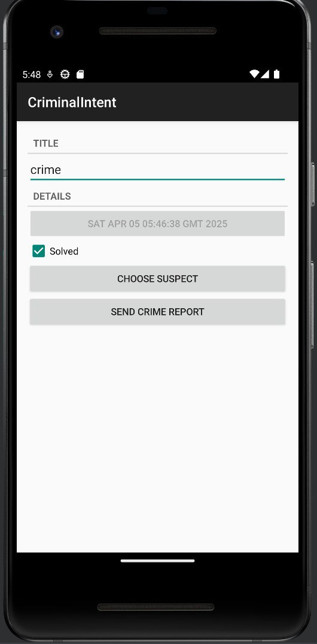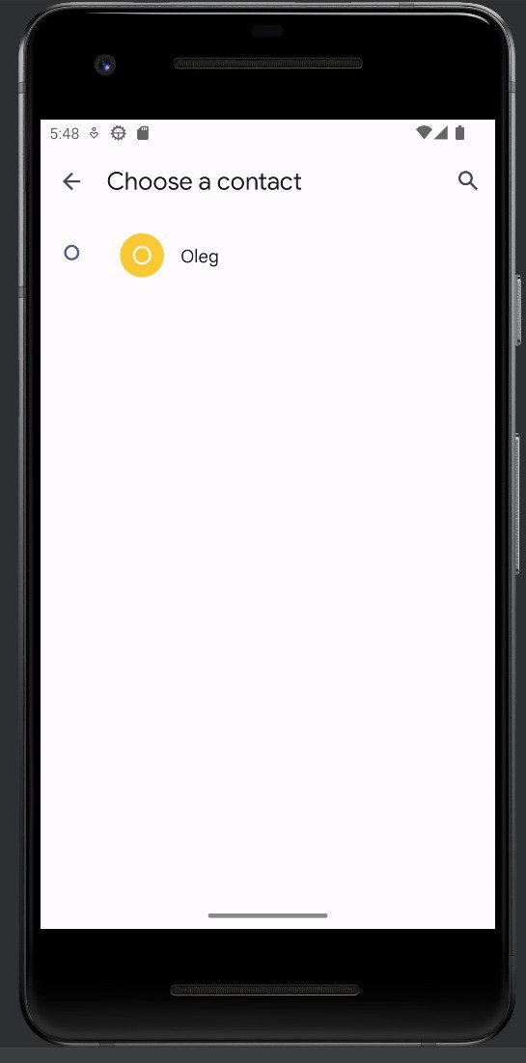

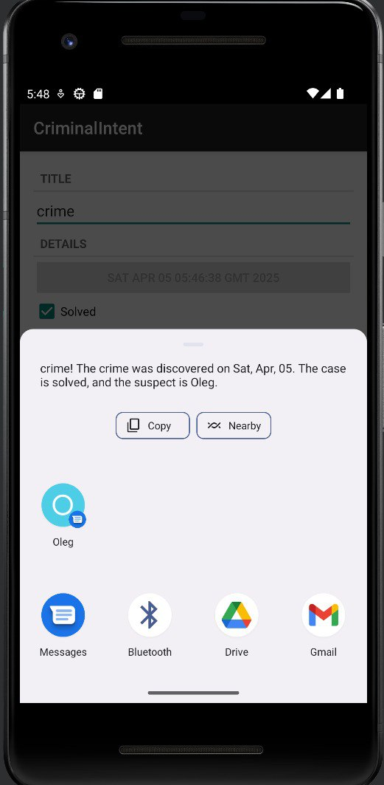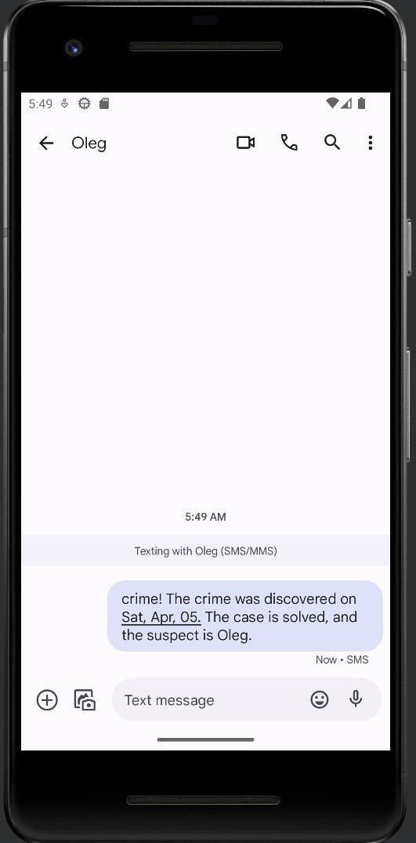

**Вывод:** Привыполнении задания было изучено использование неявные интенты и применены полученные знания для создания приложения.