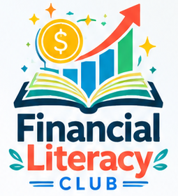 | FINANCIAL LITERACY CLUB  Curriculum Alignment with Massachusetts Personal Financial Literacy Standards  2026–2027 | Keefe Regional Technical School

Purpose. The Financial Literacy Club uses the four areas of the Massachusetts Personal Financial Literacy Standards as an organizing framework for student-led learning, guest speaker sessions, and practical financial decision-making activities.

01 EARNING & SPENDING INCOME  FLC COVERAGE  • Careers, income, and compensation  • Budgeting, spending choices, and financial planning  • Paychecks, gross vs. net income, and taxes  APPLIED LEARNING  Budgeting exercises • paycheck examples • career and income discussions | 02 SAVING MONEY  FLC COVERAGE  • Banking and savings accounts  • Emergency funds and financial goals  • Short- and long-term saving strategies  APPLIED LEARNING  Savings scenarios • goal-setting activities • comparison of banking options
03 USING CREDIT & MAKING INVESTMENTS  FLC COVERAGE  • Credit scores, borrowing, loans, interest, and debt  • Investing fundamentals and diversification  • Long-term investing and retirement planning  APPLIED LEARNING  Credit case studies • investment simulations • market and risk discussions | 04 PROTECTING & INSURING ASSETS  FLC COVERAGE  • Insurance fundamentals and risk protection  • Fraud, scams, identity theft, and cybersecurity awareness  • Consumer rights and financial safety  APPLIED LEARNING  Fraud/scam scenarios • consumer-protection discussions • guest expert sessions

HOW FLC  BRINGS THE  STANDARDS  TO LIFE | LEARN + DISCUSS  Student-friendly instruction, examples, and guided discussion | APPLY  Mini cases, simulations, budgeting exercises, and decision-making practice | CONNECT  Guest speakers from finance, business, higher education, and public service | EXTEND  College, career, and long-term financial planning connections
Program note: FLC is a student-led extracurricular program. The Massachusetts standards are used as an educational organizing framework; this document does not imply DESE endorsement or formal curriculum approval.
Reference: Massachusetts Department of Elementary and Secondary Education — Personal Financial Literacy in the Massachusetts Curriculum Frameworks.

