**Overview**

**Intro**

Standard download functionality of APEX Interactive Reports is very simple and supports only basic features, but end user need eye-candy looking reach reports. Therefore report developers are forced to use third-party tools (BI Publisher, Apache FOP). There are problems to build such reports that correct reflect all customizations, because there are no standard way to get prepared dataset from Interactive Report.

APEX_IR.GET_REPORT function from APEX-API has only restricted support of IR-feature: compute, aggregate, calculations, highlights are not supported.

The "**GPV Interactive Report to XML**" APEX plugin provided simple access the data getting in IR by end user and save that in XML-format, ready to future processing. This solution is simple to use and don’t required a lot of knowledge of Interactive Report internal.

**Features at a Glance**

These features of Interactive Reports are supported:

* Many features of Interactive Reports are supported:
* Filtering and Sorting
* Control Break
* Highlights
* Computations
* Aggregations
* Simple data types of column (String/Date/Number)
* Column and header alignment

Possibly is to include in XML values of page or application items.

**Feature Requests and Bugs**

If you would like to see additional functionality added to the plug-in, or if you have found a bug, please let us know by .

**License**

The "GPV Interactive Report to XML" APEX plugin and IR_TO_XML package is currently available for use in all personal or commercial projects under both MIT and GPL licenses. This means that you can choose the license that best suits your project and use it accordingly. Both licenses have been included with this software.

**Legal Disclaimer**

The program(s) and/or file(s) are supplied as is. The author disclaims all warranties, expressed or implied, including, without limitation, the warranties of merchantability and of fitness for any purpose. The author assumes no liability for damages, direct or consequential, which may result from the use of these program(s) and/or file(s).

**Installation and Configuration**

**Installation**

**Install required package**

This plugin requires IR_TO_XML package. To install this package navigate to the “SQL-Workschop > SQL-Scripts”. Upload file **IR_TO_XML.sql**.

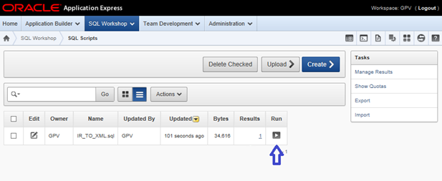

This script will be created IR_TO_XML package. Run this script by pressing Run-icon.

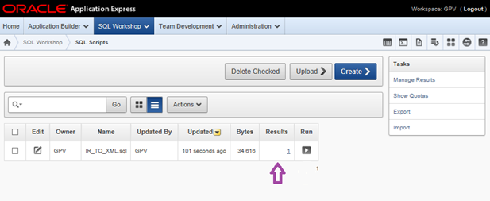

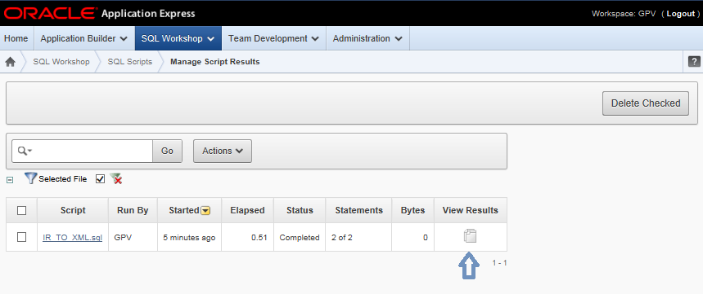

After execution take a look at executions results. At first open “*Manage Script Results*” tab by pressing on link on **Results** column.

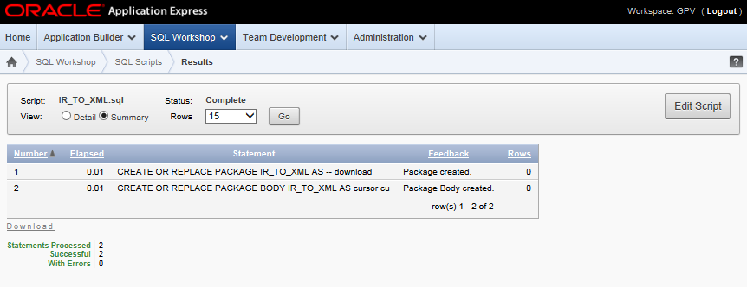

There must be no errors.

**Install plugin**

Navigate to “*Shared Components > Plug-ins*” and click **Import >**. From there you can follow the menu to upload plugin-file “**process_type_plugin_gpv_ir_xml.sql**” and install the plug-in using the file above.

**Using in your application**

1. First you must create button that will be started plugin.

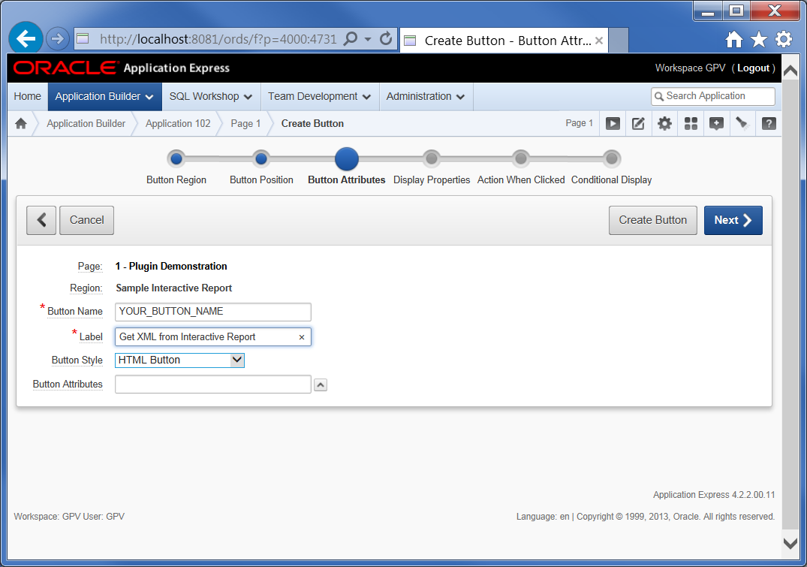

Enter “*Button name*” and “*Label*”.

**Please note the name you given; this will be used in the future.**

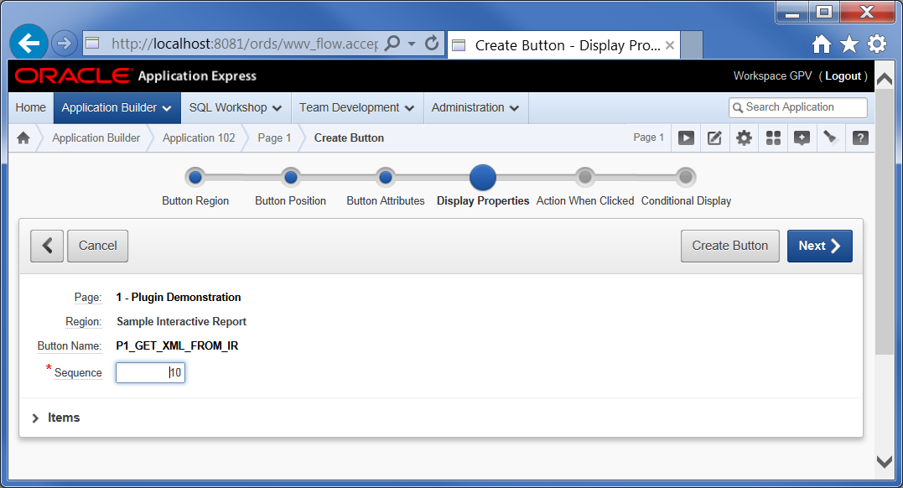

Press “**Next**”.

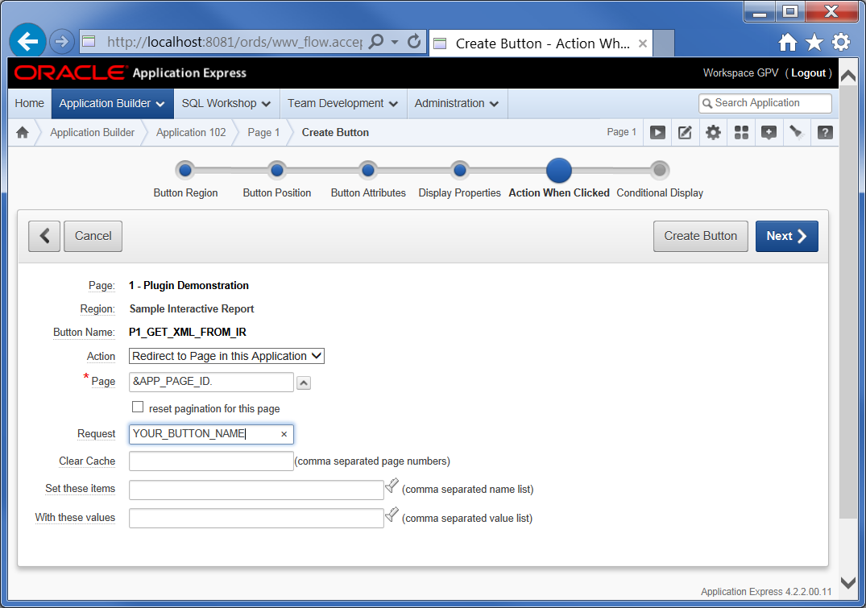

Enter **&APP_PAGE_ID.** In field “*Page*”.

Set “*Request*” : **name of the button** given on step 1.

1. Second create “*On Load - Before Header*” process with type “**Plug-Ins**”.

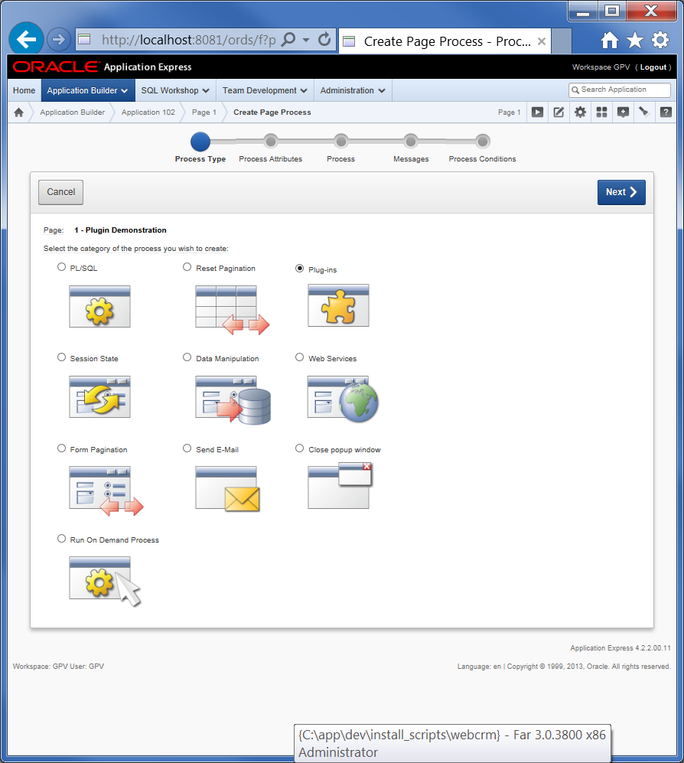

Select Process Type “**Plug-ins”**.

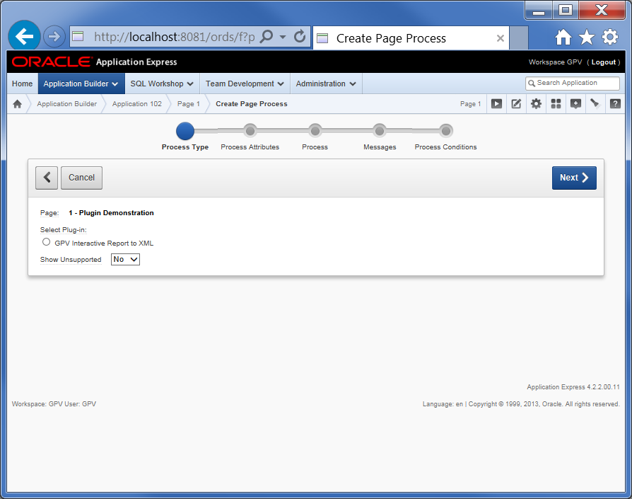

Select “**GPV Interactive Report to XML”**.

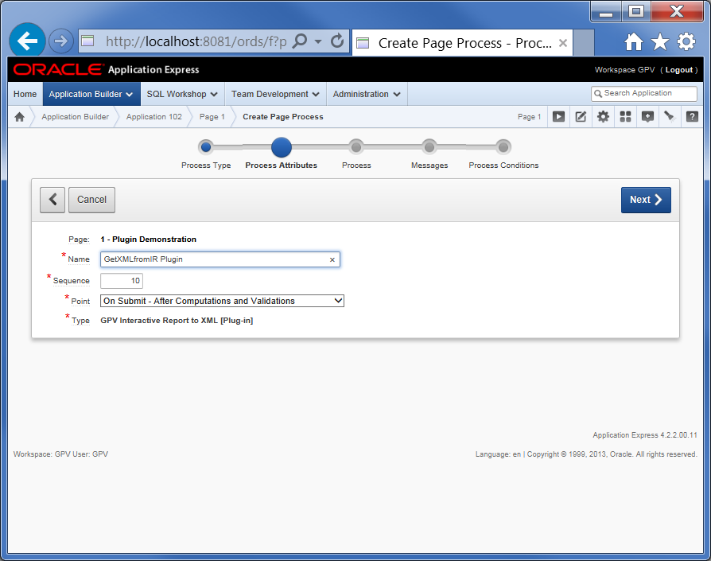

Give plugin a name (for example “*GetXMLfromIR Plugin*”).

Select execution “*Point*” : “**On Submit – After Computations and Validations**”

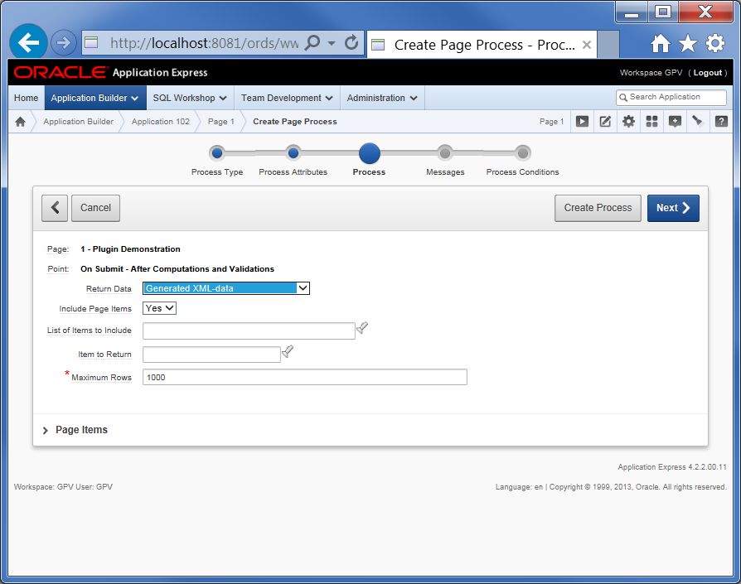

Press “**Next**”.

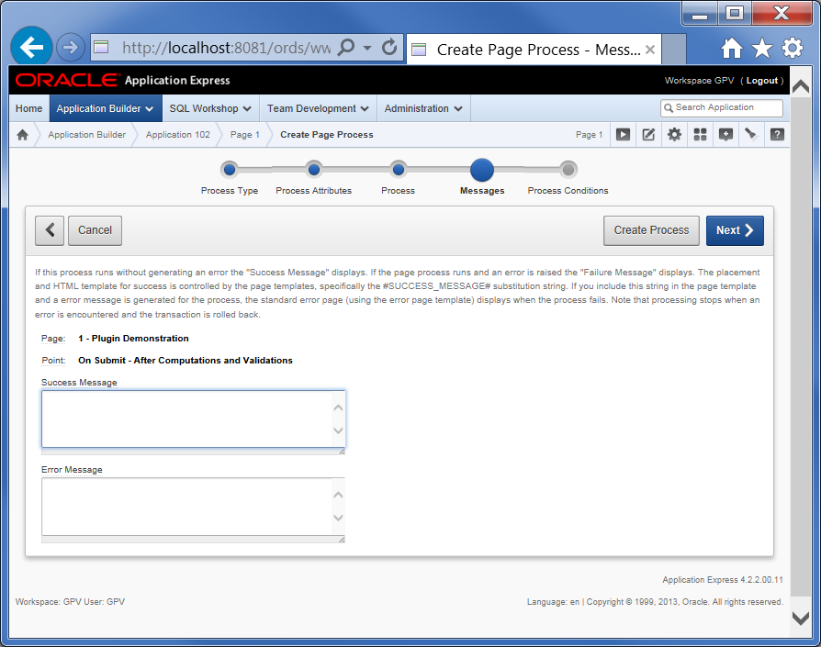

Press “**Next**”.

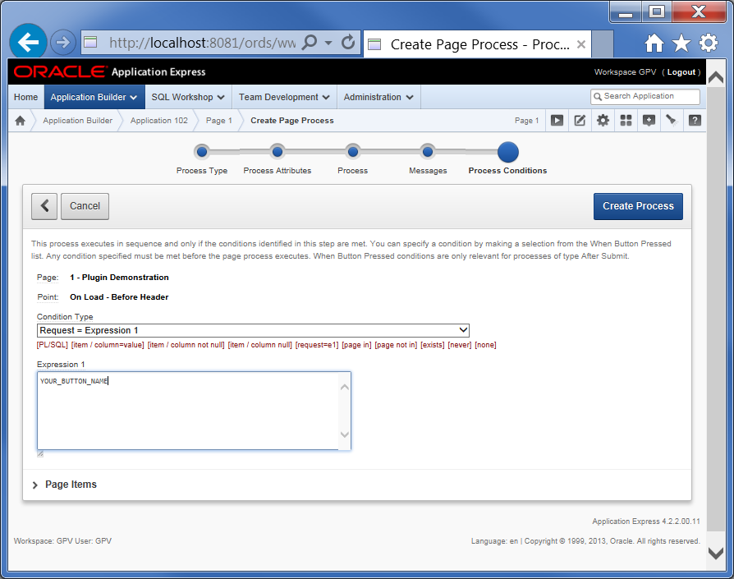

Set “**Condition Type**” : “**Request = Expression 1**”

Set “*Expression 1*” : **name of the button** given on step 1.

Press “**Create Process**”.

**Configuration Settings**

**Return Data**

Choose "Generated XML-data" to return result of Interactive Report in XML format.

Choose "Generated SQL-Query (debug only)" to return generated by Interactive Report SQL-Query.

**Include Page Items**

Include all items that belongs current page with their values in XML. Can be used to display parameters of Interactive Report.

"Item to Return" will be excluded from export.

**List of Items to Include**

Comma decimeters list of page or application item to be included in XML.

"Item to Return" is automatically excluded from export.

**Item to Return**

Item where XML-data or SQl-query will be saved. Data greater 32k will be truncated.

When null - result will be downloaded as file. Filesize do not have 32k restriction.

**Maximum Rows**

Rows grater this value will be not exported.

To export all rows set value of 1000000000.