PROJECT OTM
Performance Overview — KPIs, CAPEX & OPEX
Assa Abloy operation · DHL Supply Chain, Bemmel (NL_0032)
Field | Detail
Deliverable | 3 — Performance overview including financial analysis
Due date | 21-10-2026
Concept | Option B — single-deep racks, fast-pick area, small-parts shelving, zone + batch picking, wave release
Envelope | ≤ 7,000 m² · ≤ 12.2 m (design uses 6,731 m²)
Team | Group 3 — Vidhi (Receiving), Gleb (Storage), Arnau (Picking), Rachel Selvarathnam (Shipping)
Version | Final portfolio version — includes all feedback (space checks, lengths, small parts, own KPIs, €20/h, hazmat)
Supporting files | Deliverable_3_Calculations.xlsx (all cost formulas) · Deliverables 1 and 2 (updated) · analysis/*.py

Expected performance and cost of the Option B design. Volumes are measured in the Assa Abloy Q2-2025 data; prices are public benchmarks or labelled assumptions (Section 9), never quotes. Every number can be rebuilt with analysis/performance_cost.py and checked in the calculation workbook.
Who is responsible for what
Every team member hands in this whole document (the complete warehouse design). Each process has one owner; the sections of a process carry the owner's name in their heading. Sections without a name were made by the whole group.
Process | Owner | Scope | Sections in this document
Receiving | Vidhi | unloading trailers and containers, checking, container unpacking, returns intake — up to the pick-up point | §3.1, §6.3
Storage | Gleb | putaway, racks and storage places, slotting, replenishment of the fast-pick area, inventory control | §2.3, §4, §4.1, §4.2, §4.3, §5.2, §6.2, §6.5
Picking | Arnau | order release (waves), picking, sorting batch picks into orders at the put-to-light wall | §2.2, §4.3, §5.1
Shipping | Rachel | packing, outbound staging, dock doors, trailer departure plan and loading | §2.1, §5.1, §6.4

Contents
(In Word: right-click → Update Field to build the table of contents.)

Summary
What the design delivers, what it costs, and what to watch:
 | Result
Picking effort | 31 → 12 picker-hours a day (batching, fast-pick area, wave release)
Order lead time | orders out within 24 h: 37% → 65%; slowest 10% wait 102 h → 70 h
Trailers at the doors | 15 parked at once → max 4 of 5 doors
Storage | 8,960 pallet positions + 188 small-parts shelving bays; racks 84% full at the peak; a pick face for each of the 1,409 fast movers
People and trucks | 4.7 FTE on an average day, 8.7 on the peak day; 2 ETV 216i, 3 EJE 120i, 2 ERE 225, 6 trolleys
One-off investment (CAPEX) | €1,630k all new; €521k if today's racking is re-used; of which €157k for the process changes
Running cost (OPEX) | €342k a year at €20/h; €483k incl. depreciation
Cost per unit | €3.09 per order line · €13.75 per order
Saving and payback | ~€101k a year in picking labour → the process changes pay back in 1.6 years

- The labour gain comes from how we work, not from steel. Batching, a fast-pick area and wave release need €157k and save ~€101k a year. Racks are needed to hold the stock, so they are a capacity cost, not a saving.
- Small parts are stored efficiently: 2,657 slow SKUs with a few litres of stock each move from pallet locations to bins next to the put-wall. That frees 1,005 pallet locations. A Kardex lift was compared: denser, but ~€19k a year more and busy only a few % of the day at our volume.
- Space checks passed: 91% of containers fit the container zone, 97% when door R2 is lent; outbound staging uses at most 46% of its area; packing needs 423 of 450 m².
- Watch the stock growth. Occupied locations grew 16% a quarter between April and June; at that rate the racks are full in ~4 months. Clearing dead stock (21% of loads > 1 year) is the main lever.

1. What changed since Deliverable 2
Two feedback rounds and a final check of the design led to these changes. Deliverables 1 and 2 were regenerated so all three documents use the same numbers.
Topic | Before | Now | Why
Racking | Double-deep, telescopic forks | Single-deep, back-to-back (8,960 positions) | Team decision: no two-deep racks; every pallet directly reachable
Long goods | Cantilever for items up to 11 m | Long-goods module: 320 positions for pallets up to 2.05 m, 3.2 m aisle | Feedback: nothing longer than a door (~2 m); the 11 m item is a data error
Small parts | One pallet location per SKU | Bin shelving for 2,657 slow small SKUs next to the put-wall | Feedback: store small items efficiently (Kardex compared)
Loose containers | Unpacked at door R1 | Own 190 m² zone; big containers borrow door R2 | Feedback: is there enough space to unpack?
Reach / pallet trucks | 3 ETV 216i / 4 EJE 120i | 2 ETV 216i / 3 EJE 120i | Peak need covered; lease includes repair
Labour cost | €28 per hour | €20 per hour (€28 as high case) | Feedback: €20/h for an operator
KPIs | W3 list | Our own design KPIs + the W3 ones | Feedback: come up with our own KPIs
Hazardous goods | Class unknown, PGS 15 | Recounted, classified by customs code → mostly PGS 37-2 | Feedback: recheck counts and classes
Fast-pick area | 500 m² band, inside not drawn | 930 carton-flow lanes + a wall row of shelves and floor pallets: a pick face for all 1,409 fast movers | Own check: 1,409 fast movers but only 930 lanes (§4.3)
Receiving doors | R2 and R3 side by side | R2 in the north half, R3 in the south half of receiving | R2's half can be lent to container unpacking while R3 keeps working (§3.1)

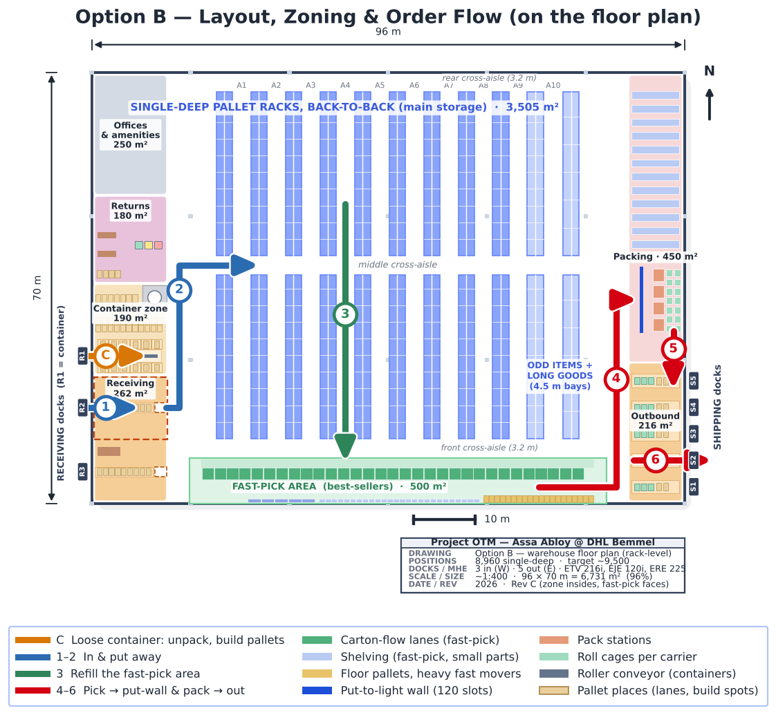
Fig 1. Updated floor plan: container zone (C) with R1, long-goods module, the packing area with the put-to-light wall, and the main order flow (1–6).

2. Our KPIs — expected performance of the design
We made our own KPIs: each one measures something our design promises to do (fill the racks well, keep pickers in the fast-pick area, walk little, unpack containers inside their zone, ship within a day, …). The four W3 lecture KPIs (dock-to-stock, put-away time, pick rate, on-time shipment; HAN University of Applied Sciences, 2026a) are included too. For every KPI we give how to calculate it, today's value where the data shows it, the value we expect from the design, and a target.
Each KPI is linked to one of the five performance objectives that Deliverable 1 (§11) ranked for this operation (Slack et al., 2022), and to the process owner who watches it:
Objective (D1 rank) | KPIs that measure it | Owners
Dependability (1) | On-time shipment; Trailers at the doors at once | Rachel (Shipping)
Speed (2) | Dock-to-stock time; Container door time; Put-away cycle time; Order lead time (per order); Orders out within 24 h | Gleb (Storage), Rachel (Shipping), Vidhi (Receiving)
Quality (3) | Pick accuracy; Trucks and pickers separated | Arnau (Picking), whole team
Cost (4) | Rack fill at peak; Small-item density; Floor area used; Pick rate; Fast-pick hit rate; Walking per picked line; Trolley fill; Small-parts picking time; Picking hours per day; Direct labour; Labour productivity; Truck utilisation (average day); Cost per order line; Cost per order | Arnau (Picking), Gleb (Storage), whole team
Flexibility (5) | Storage headroom; Containers unpacked inside their zone; Outbound staging fill | Gleb (Storage), Rachel (Shipping), Vidhi (Receiving)

Space
KPI | How we calculate it | Today (data) | Expected (design) | Target
Rack fill at peak ★  Cost · Gleb (Storage) | pallet locations used at the peak ÷ rack positions | 8,512 locations used | 84% (7,507 of 8,960; small parts moved to bin shelving) | ≤ 90%
Storage headroom ★  Flexibility · Gleb (Storage) | months until the racks are full at the Apr–Jun growth rate | +10% locations in 2 months | ~4 months (~5 with a 12th module) | ≥ 12 months
Small-item density ★  Cost · Gleb (Storage) | SKUs stored per m² of floor | ~2.6 SKUs/m² (one pallet location each) | ~13 SKUs/m² in bin shelving | ≥ 5× better
Floor area used ★  Cost · whole team | zones + aisles ÷ 7,000 m² | — | 6,731 m² (96%) | ≤ 7,000 m²

Inbound
KPI | How we calculate it | Today (data) | Expected (design) | Target
Dock-to-stock time  Speed · Vidhi (Receiving) | truck at the door → pallet in its location | big China receipts take 1–3 days to book in | ~1.5 h per palletised trailer; ~3.8 h per loose container | < 3.5 h (Extensiv, n.d.)
Containers unpacked inside their zone ★  Flexibility · Vidhi (Receiving) | % of containers whose unpacking fits the 190 m² zone | — | 91% (another 6% by lending door R2) | ≥ 90%
Container door time ★  Speed · Vidhi (Receiving) | dock-on + unpack + palletise per 40 ft container | — | ~3.3 h | ≤ 4 h
Put-away cycle time  Speed · Gleb (Storage) | minutes per pallet, reach truck | — | 2.4 min per pallet (~25 per truck-hour) | ≤ 3 min

Picking
KPI | How we calculate it | Today (data) | Expected (design) | Target
Pick rate  Cost · Arnau (Picking) | order lines per picker-hour | — | ~54 lines/h (fast-pick 99, reserve 49, large orders 44, small-parts shelving 50) | ≥ 50 lines/h
Fast-pick hit rate ★  Cost · Arnau (Picking) | lines picked in the fast-pick area ÷ all picked lines | — | 71% | ≥ 60%
Walking per picked line ★  Cost · Arnau (Picking) | metres walked in all tours ÷ picked lines | — | ~14 m | ≤ 15 m
Trolley fill ★  Cost · Arnau (Picking) | volume or weight filled per trolley tour | — | 80% (batch closed at 80%) | 75–85%
Small-parts picking time ★  Cost · Arnau (Picking) | small-parts lines ÷ 50 lines/h | — | 1.9 h/day for 93 lines | ≤ 2 h/day
Picking hours per day ★  Cost · Arnau (Picking) | picker-hours, average day | ~31 h (modelled: single-order picking, staffed for the 08:00 peak) | 11.7 h | —
Pick accuracy  Quality · Arnau (Picking) | % of orders without a picking error | not in the data | ≥ 99.7% (scan every pick + put-to-light check) | median 99.3%, best 99.68% (Extensiv, n.d.)

Service
KPI | How we calculate it | Today (data) | Expected (design) | Target
Order lead time (per order) ★  Speed · Rachel (Shipping) | order received → trailer leaves | median 25 h, p90 102 h | median 22 h, p90 70 h | p90 ≤ 72 h
Orders out within 24 h ★  Speed · Rachel (Shipping) | % of orders | 37% | 65% | ≥ 60%
On-time shipment  Dependability · Rachel (Shipping) | % of lines staged before the planned departure | 49.9% (50.1% 'LATE', A005) | ≥ 98% (every wave ends ≥ 45 min before its trailers leave) | ≥ 98%

Docks
KPI | How we calculate it | Today (data) | Expected (design) | Target
Trailers at the doors at once ★  Dependability · Rachel (Shipping) | busy day, p90 | 15 (parked all day) | max 4 of 5 doors (time slots) | ≤ 5
Outbound staging fill ★  Flexibility · Rachel (Shipping) | staging m² needed on the busiest afternoon ÷ 216 m² | — | 46% (p90 day 28%) | ≤ 80%

People
KPI | How we calculate it | Today (data) | Expected (design) | Target
Direct labour ★  Cost · whole team | FTE, average / peak day | not in the data | 4.7 / 8.7 FTE + 1.5 indirect | —
Labour productivity ★  Cost · whole team | order lines per direct labour hour | — | 18.2 lines/h | —

Machinery
KPI | How we calculate it | Today (data) | Expected (design) | Target
Truck utilisation (average day) ★  Cost · whole team | operating h ÷ (units × 7.5 h) | — | ETV 33% · EJE 31% · ERE 14% | peak day ≤ 80%

Cost
KPI | How we calculate it | Today (data) | Expected (design) | Target
Cost per order line ★  Cost · whole team | (OPEX + depreciation) ÷ lines | — | €3.09 | —
Cost per order ★  Cost · whole team | (OPEX + depreciation) ÷ orders | — | €13.75 | —

Safety
KPI | How we calculate it | Today (data) | Expected (design) | Target
Trucks and pickers separated ★  Quality · whole team | pick faces without reach-truck traffic | — | 100% (trucks refill from the rear and use the perimeter + cross-aisles) | 0 lost-time incidents

★ = our own design KPI; the others are the W3 lecture KPIs. Under each KPI: its performance objective and owner. How the KPIs are used to control the operation: Deliverable 2 §7.

2.1 Order lead time Rachel (Shipping)
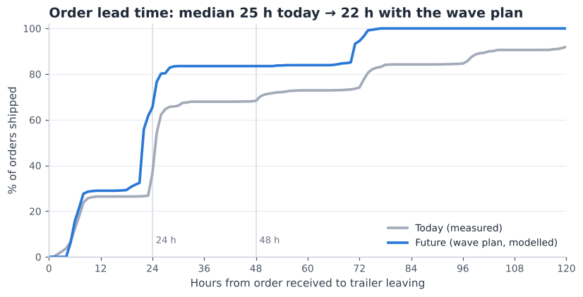
Fig 2. Share of orders shipped within X hours — today (measured) vs future (wave plan, modelled).
- Today (measured, 8,774 orders): median 25 h, average 45 h, slowest 10% 102 h or more. Only 37% of orders leave within 24 hours.
- Future (modelled on the same orders): an order received before 12:00 is picked in wave 3 and leaves on the same afternoon's trailer of its carrier; a later order is picked in the first wave next morning and leaves on that day's first slot of its carrier. Weekends are skipped.
- Result: 65% within 24 hours and the slowest 10% at 70 h. The median moves less (25 → 22 h) because 55% of orders arrive between 15:00 and 17:00 and still leave the next day — the gain is that no order waits for a second or third day.

2.2 Picking effort — where the saving comes from Arnau (Picking)
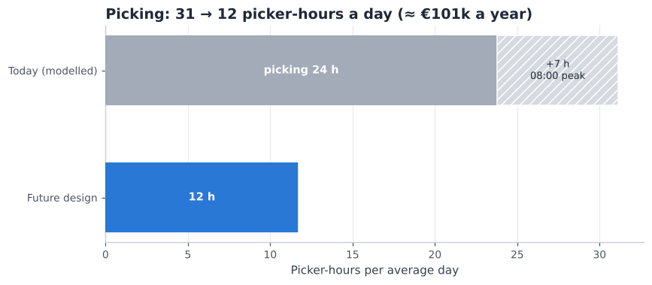
Fig 3. Picker-hours per average day: today's way of working (modelled) vs the design.
Lever | Today h/day | Future h/day | Saved h/day | Saved per year
Batch picking + demand-based slotting (fast-pick area) | 23.8 | 11.7 | 12.1 | €62,846
Wave release instead of one evening release (no 08:00 peak staffing) | 7.4 | 0.0 | 7.4 | €38,362

Today is modelled with the same pick-time model and rates as the design (D2 §6.2), but the way the data says the site works now: one order per tour, stock not placed by demand (the WMS class agrees with demand for only 48.6% of SKUs), and all orders released in the evening so the morning starts at 1.31× the average workload. It is a model, not a measurement — DHL's real pick hours would confirm it (A006).

2.3 Storage space Gleb (Storage)
- Positions: 8,960 (incl. 320 long-goods). Moving small parts to shelving frees 1,005 locations, so the peak need is ~7,507 (84% full).
- Growth: occupied locations rose from 7,715 (April) to 8,512 (June), +16% per quarter. At that speed the racks are full in ~4 months (~6 with a 12th rack module, +864 positions, which fits in the core). Three months of data cannot tell whether this is a season or a trend, so DHL should track the KPI monthly.
- What we do about it: (1) clear dead stock — 21% of loads are older than one year (D1 Fig 2b); (2) keep the 12th module as the first expansion; (3) the remaining ~270 m² of the 7,000 m² envelope stays free.

2.4 Stress test — 150%, 200% and 250% volume
Promised in D2 §3.1: what happens when volume grows? Workload scales with volume; trucks and doors are checked against the same rules as in D2.
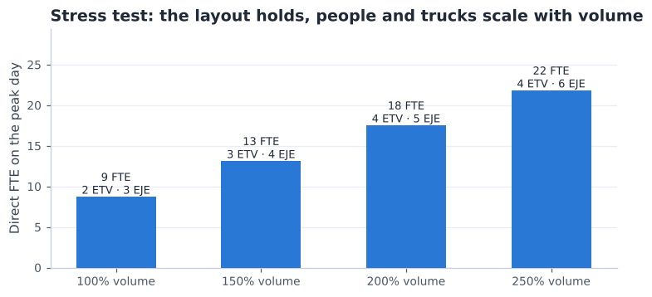
Fig 4. Direct FTE and trucks needed on the peak day at higher volumes.
Volume | Direct FTE (peak day) | ETV 216i | EJE 120i | ERE 225 | Outbound doors | Pickers in busiest wave
100% | 8.7 | 2 | 3 | 1 | 4 | 3
150% | 13.1 | 3 | 4 | 2 | 5 | 4
200% | 17.5 | 4 | 5 | 2 | 7 | 5
250% | 21.8 | 4 | 6 | 2 | 8 | 6

- Up to 150% the design runs as planned: 3 reach trucks, 4 pallet trucks and 5 shipping doors in the busiest hour.
- At 200% and more the 5 shipping doors are not enough in the busiest hour; the departure plan would need more spread (more slots before 12:00) or a 6th door — and storage would need the 12th module and a dead-stock clean-up first.
- Pickers per wave stay low (≤ 6 in the busiest wave at 250%), so aisle congestion is not the limit.

3. The zones — what happens where
The building has nine zones. Goods come in on the west side, are stored in the middle and leave on the east side (flow-through, D2 §5.1). Fig 5 numbers the zones in the order the goods pass through them; the table says what happens in each zone, who works there and when it is busy.
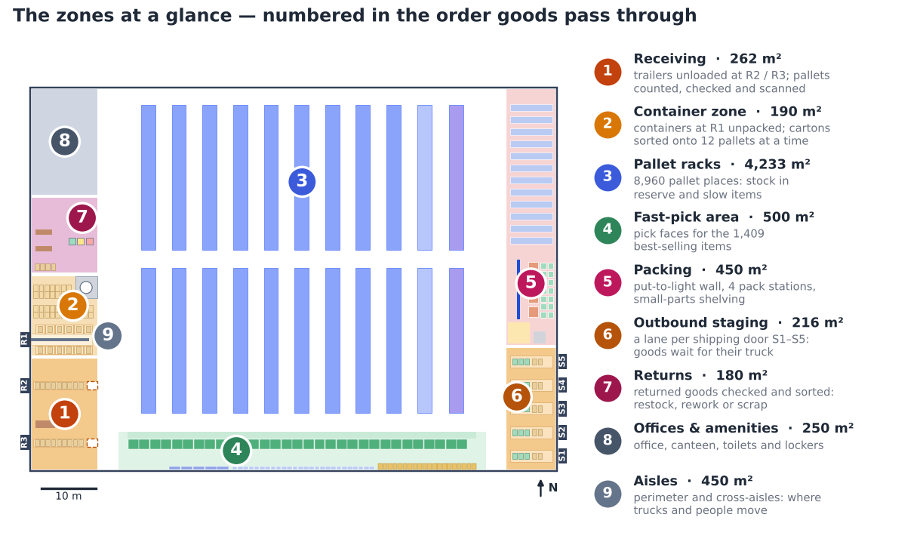
Fig 5. The nine zones, numbered in the order the goods pass through them (north up; receiving doors R1–R3 on the west wall, shipping doors S1–S5 on the east wall).
Zone | m² | What happens | Who / with what | When busy
1 Receiving | 262 | Trailers from the European plants are unloaded at R2 / R3. Every pallet is counted, checked and scanned against the delivery note, then left at a pick-up point for the reach truck. | receiving operator, ERE 225, scanner | the 2 daily deliveries (8-hour window)
2 Container zone | 190 | A loose container at R1 is unpacked: cartons roll out on a conveyor, are scanned and stacked on the build spot of their item (12 at once), then wrapped and labelled. | 2-person crew (DHL or contractor), conveyor, stretch wrapper | when a container arrives (~1 a day, ~3 h each)
3 Pallet racks | 4,233 | Full pallets of every item in reserve; the two lowest levels are the pick places of slow items (Section 4). | reach-truck drivers (ETV 216i); pickers on the lowest levels | putaway after each delivery, refills all day
4 Fast-pick area | 500 | A pick face for each of the 1,409 best-selling items: carton-flow lanes and, across the aisle, a wall row of shelves and floor pallets (Section 4). | zone-1 pickers with trolleys; EJE 120i for large orders | the 3 waves, 06:00–15:15
5 Packing | 450 | Small orders are sorted into customer orders at the put-to-light wall and packed; small parts are picked from the bin shelving next to it (Section 5). | putter, 2–4 packers, 4 pack stations | during and after each wave
6 Outbound staging | 216 | One lane per shipping door: parcels in roll cages per carrier and wrapped pallets wait for their trailer, which is loaded at its booked time. | loader with an ERE 225 | 10:30–16:45, 14 trailer slots
7 Returns | 180 | Returns are received, inspected and put in one of three places: restock, rework or scrap. Restocked goods go back through the normal putaway. | receiving operator, scanner | when a return arrives
8 Offices & amenities | 250 | Team leader, inventory control and admin; canteen, toilets and lockers for everyone. | team leader, admin | all day
9 Aisles | 450 | Two perimeter aisles and three cross-aisles, all 3.2 m wide (the storage aisles between the racks are counted in zone 3). Reach trucks use the main aisles; pickers stay in their pick zones. | everyone | all day

3.1 Receiving, container zone and returns — enlarged Vidhi (Receiving)
The west side handles everything that comes in. Fig 6 shows it enlarged, with the trailer flow (blue) and the container flow (orange):
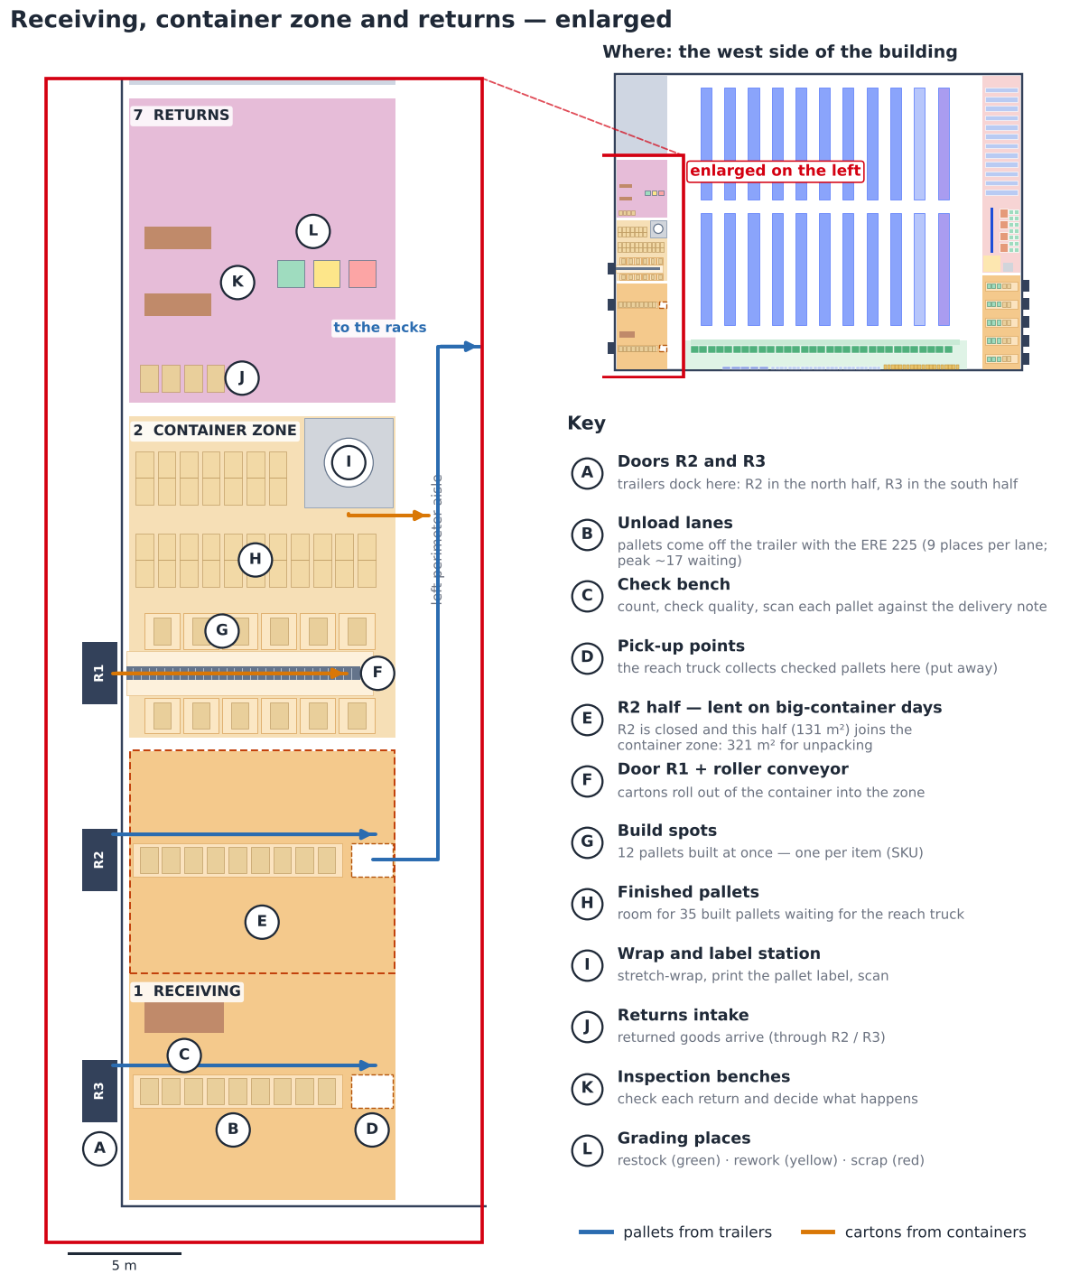
Fig 6. Receiving, the container zone and returns enlarged (west side), with the key.
- Trailers (blue): pallets come off the trailer with the ERE 225 into the unload lane of their door (B), are checked at the bench (C) and left at the pick-up point (D). Two reach trucks take them away while the trailer is still being unloaded, so at the peak only ~17 pallets wait at once — two lanes of 9 places are enough.
- Containers (orange): the conveyor (F) brings the cartons out of the container. The crew scans each carton and puts it on the build spot of its item (G). A container holds 7 items (median; 11 for a large one), so 12 build spots cover most containers in one pass. A full pallet is wrapped and labelled (I) and waits in H for the reach truck.
- Big-container days (E): door R2 is closed and its half of receiving (131 m²) joins the container zone: 321 m², enough for 97% of containers. That is why R2 and R3 sit in different halves: trailers keep using R3 while R2's half is lent (§6.3).
- Returns: intake (J) → inspection at the bench (K) → restock, rework or scrap (L).
- Outbound staging (zone 6, east side): each shipping door S1–S5 has its own lane. Packed parcels wait in roll cages per carrier with the wrapped pallets next to them, so a trailer is loaded straight from its lane at its booked time. On the busiest day of Q2 the goods needed 100 of the 216 m² (§6.4).

4. Storage — where and how goods are stored Gleb (Storage)
Every item gets a place that suits how often it is picked and how big it is: fast movers close to the pickers, full pallets high up in the racks, small slow parts in bins. The table says what is stored where; Fig 7 shows each place (A–F) on the layout and enlarged. In total there are 8,960 pallet places; at the peak the racks are 84% full (§2.3).
Place (Fig 7) | What is stored | How it is stored | Size
A Carton-flow lanes | the 888 most-picked fast movers (90% of fast-pick lines); the busiest 42 have two lanes | cases on sloping lanes, 5 levels × 6 lanes per 2 m bay; filled from the back, picked from the front | 31 bays, 930 lanes
B Wall row | the other fast movers: 462 small items on shelves, 42 long items (up to ~2 m) lying on long shelves, 17 heavy or bulky items on floor pallets | across the pick aisle from the lanes; shelves 0.6 m deep; heavy items nearest packing | 31 shelving bays, 20 pallet places
C Pallet racks | full pallets of every item (reserve) and the pick places of slow items | single-deep, back-to-back: one pallet each side, 3 EUR pallets per 2.7 m bay, 8 levels | 9 modules, 7,776 places
D Odd-items module | loads that are not a standard pallet | the same racks, in their own module next to the long goods | 864 places
E Long-goods module | pallets 1.3–2.05 m long (255 loads) | 2 per 4.5 m bay, forks under the long side; 3.2 m aisle (§6.2) | 320 places
F Small-parts shelving | 2,657 slow small items (≤ 50 L of stock each) | one item per half-bin, 7 levels, in the packing area (§5.2) | 188 bays

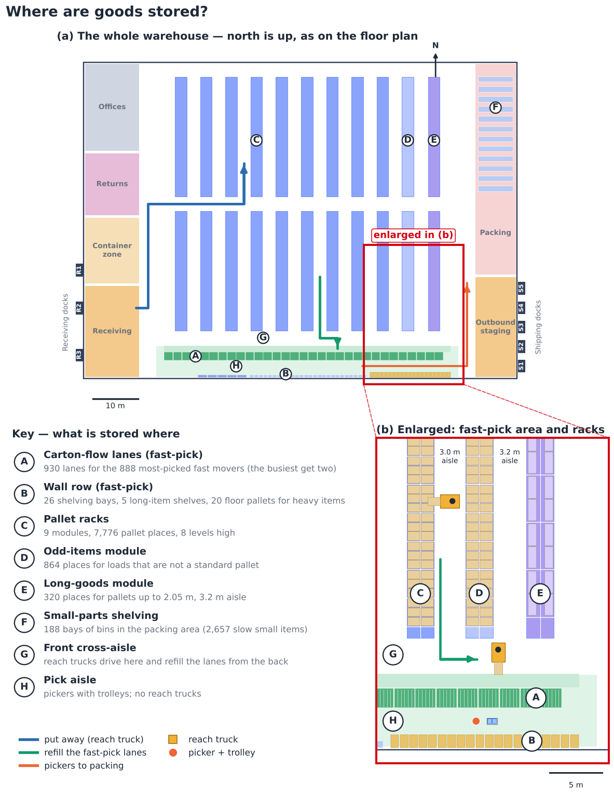
Fig 7. Where goods are stored: (a) the whole warehouse, (b) the fast-pick area and the racks enlarged, with the key.
How the goods move between these places — put away, store, refill, pick — is shown from the side in Fig 8:
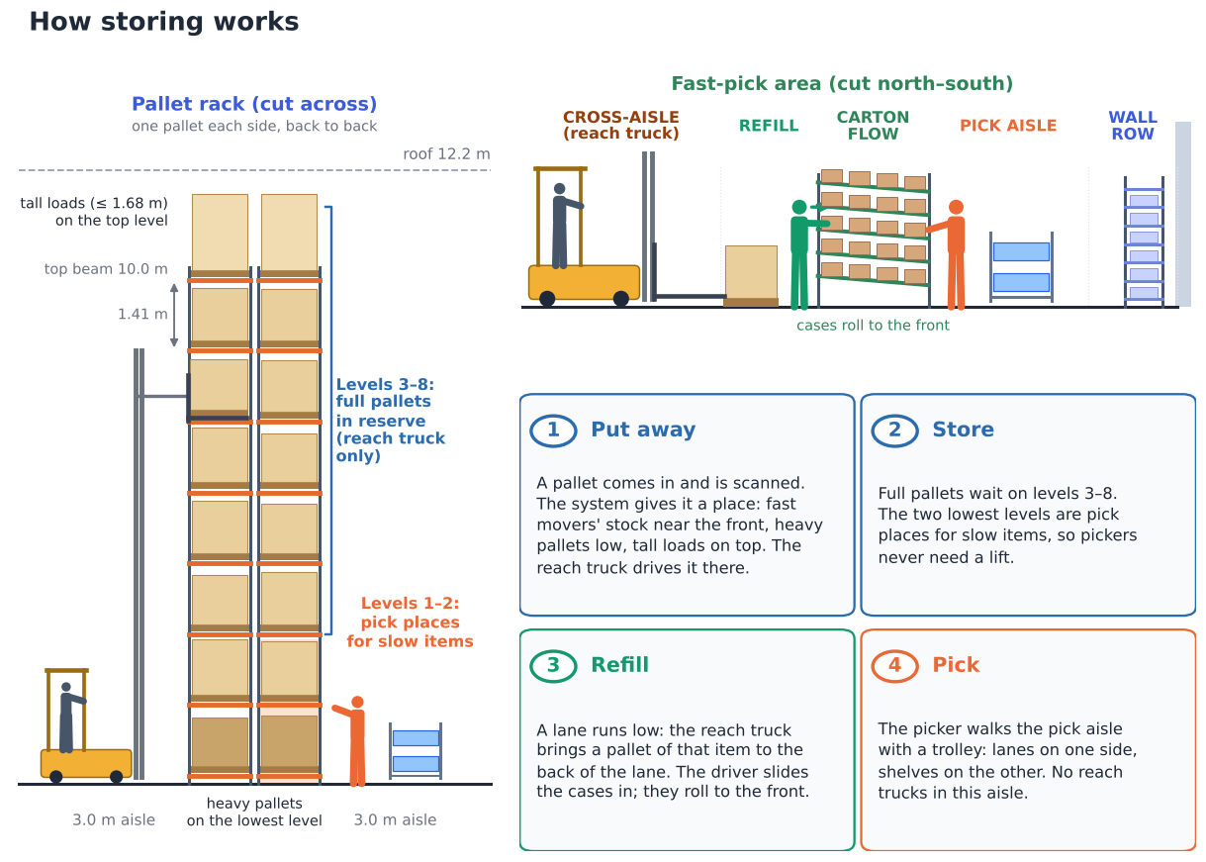
Fig 8. How storing works: a rack cut across (left), the fast-pick area cut north–south (right) and the four steps.

4.1 Putting away — where does a pallet go? Gleb (Storage)
- The scanner decides, not the driver. When a pallet is scanned at receiving, the WMS gives it a place by fixed rules: long pallets → long-goods module; odd loads → odd-items module; reserve pallets of fast movers → racks near the front cross-aisle (short refill trips); slow movers → further back. Small slow parts do not go to the racks at all: their cartons are put into bins.
- Height rules: pallets over 1 t (10 loads) on the lowest level; tall loads of 1.16–1.68 m (940 loads) on the top level, which has ~1.7 m of free height (1,120 places). The few loads that fit no level are handled as in §6.2.
- Route: the reach truck takes the pallet from the pick-up point in receiving, drives north on the left perimeter aisle, along a cross-aisle and into the storage aisle (blue in Fig 7). Every storage aisle is open at both ends, so the truck never backs out. ~99 pallets come in on an average day; one truck puts away ~25 an hour.
- Single-deep, back-to-back: each rack holds one pallet on each side, so every pallet can be taken out directly — no pallet ever has to be moved to reach another.

4.2 Refilling the fast-pick area Gleb (Storage)
- Trigger: every lane has a minimum. When a pick takes it below, the WMS creates a refill task for the reach truck (min/max, D2 §3).
- Refill from the back: the truck takes a reserve pallet of that item from the racks, drives down the storage aisle to the front cross-aisle and puts the pallet down in the refill strip behind the lanes. The driver slides the cases into the lane from the back; they roll forward to the pick face, so the oldest cases are always picked first.
- How often: ~24 pallets a day (~1.3 truck-hours), spread over the day and mostly between the waves.
- Wall row: shelves are refilled by hand from the pick aisle and floor pallets are swapped with the EJE 120i — both between the waves.
- Safety: reach trucks work only behind the lanes and in the racks; pickers only in the pick aisle and at the lowest rack levels. People and reach trucks never share a pick face.

4.3 Does every fast mover have a pick face? Gleb (Storage) · Arnau (Picking)
A check of our own design (A046): 1,409 fast movers (A and B items) were picked in Q2, but 31 carton-flow bays give 930 lanes. Lanes go to the items that are picked most and fit a lane (each item ≤ 28 × 33 × 60 cm and ≤ 15 kg). The rest stand on the wall row across the same aisle, so the picker's walk does not change:
Pick face | Items | Share of fast-pick lines | Size
Carton-flow lanes | 888 (+42 second lanes) | 89.5% | 930 lanes in 31 bays
Shelves (wall row) | 462 | 5.6% | 26 bays of 21 slots (+15% spare)
Long-item shelves | 42 | 2.0% | 5 bays of 2.2 m
Floor pallets (heavy or bulky) | 17 | 2.9% | 20 places, nearest packing
Total | 1,409 | 100% | wall row: 55 of 64 m used

The shelving costs ~€7,200 (Section 7). The 9 m left on the wall row is room for new items.

5. Sorting and small parts — what, how and when
Sorting means putting goods into the right group for the next step. In our design it happens in four places. Each one is simple, uses a scan to check the item, and happens at a fixed moment in the day.
Where | What is sorted | How | When | Equipment
1. Container zone (door R1) | Cartons from a container → one pallet per SKU | Cartons roll out on the conveyor; the worker scans each carton and puts it on the build spot of its SKU (a container has 7 SKUs on average, so 12 build spots are enough). Full pallet → wrap, label, putaway. | Morning, when the container arrives (~3 h) | Roller conveyor, RF scanner, stretch wrapper
2. Put-to-light wall (packing) | Picked items → customer orders | Pickers collect the items of many small orders in one trolley tour (~31 lines); small parts come straight from the shelving next to the wall. The packer scans an item, a light shows the order's slot, the item goes in and the button is pressed. A full slot lights up → pack. | During each wave (3 a day, ~40 small orders per wave) | Wall with 120 slots
3. Carrier lanes (outbound) | Packed parcels and pallets → trailer | The label says the carrier and departure slot. Parcels go into roll cages per carrier, pallets into the staging lane of their trailer (14 trailer slots a day). | All afternoon, until each trailer's departure | 41 roll cages, floor lanes
4. Returns | Returned goods → restock / rework / scrap | Inspect and grade, then each group goes to its own cage. | When a return arrives | Returns area, RF scanner

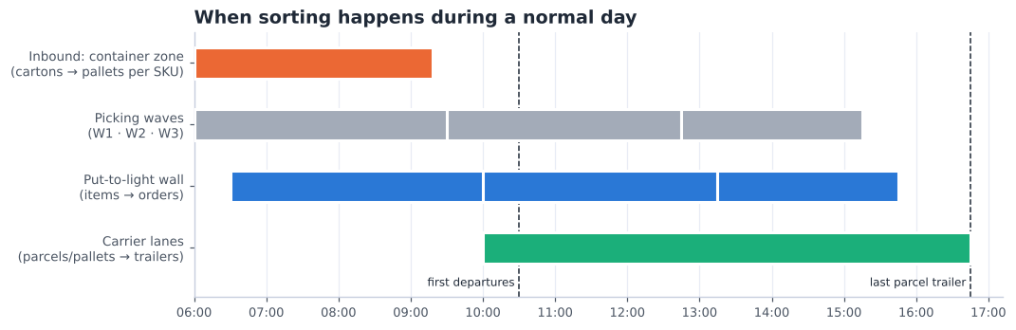
Fig 9. When the sorting points are busy during a normal day.
- Why a put-to-light wall and not sorting by hand: 84% of orders are small (median 7 litres). Picking them one by one would mean ~120 walks a day; picking them together and sorting at the wall is about twice as fast (D2 §6.2).
- Why not an automatic sorter: ~120 small orders a day is far too little for a sorter machine to pay off; the wall costs about €30k (Section 7).
- Large orders are not sorted: each one is picked straight onto its own pallet, so it goes directly to packing.

5.1 The put-to-light wall — where it is and how it works Arnau (Picking) · Rachel (Shipping)
The put-to-light wall is where the small orders are sorted. Pickers do not pick order by order: they pick many small orders at once into a few totes (a batch), and the wall splits that batch into customer orders. It does not store anything — an item stays in the wall for at most one wave (~3 hours).
Where it is. In the packing area on the east side of the building, at its south end: right next to the right perimeter aisle (where the pickers arrive from the fast-pick area and the racks) and just north of the outbound staging and the shipping doors. Fig 10 shows it on the whole layout and enlarged; it is also drawn on the floor plan (Fig 1).
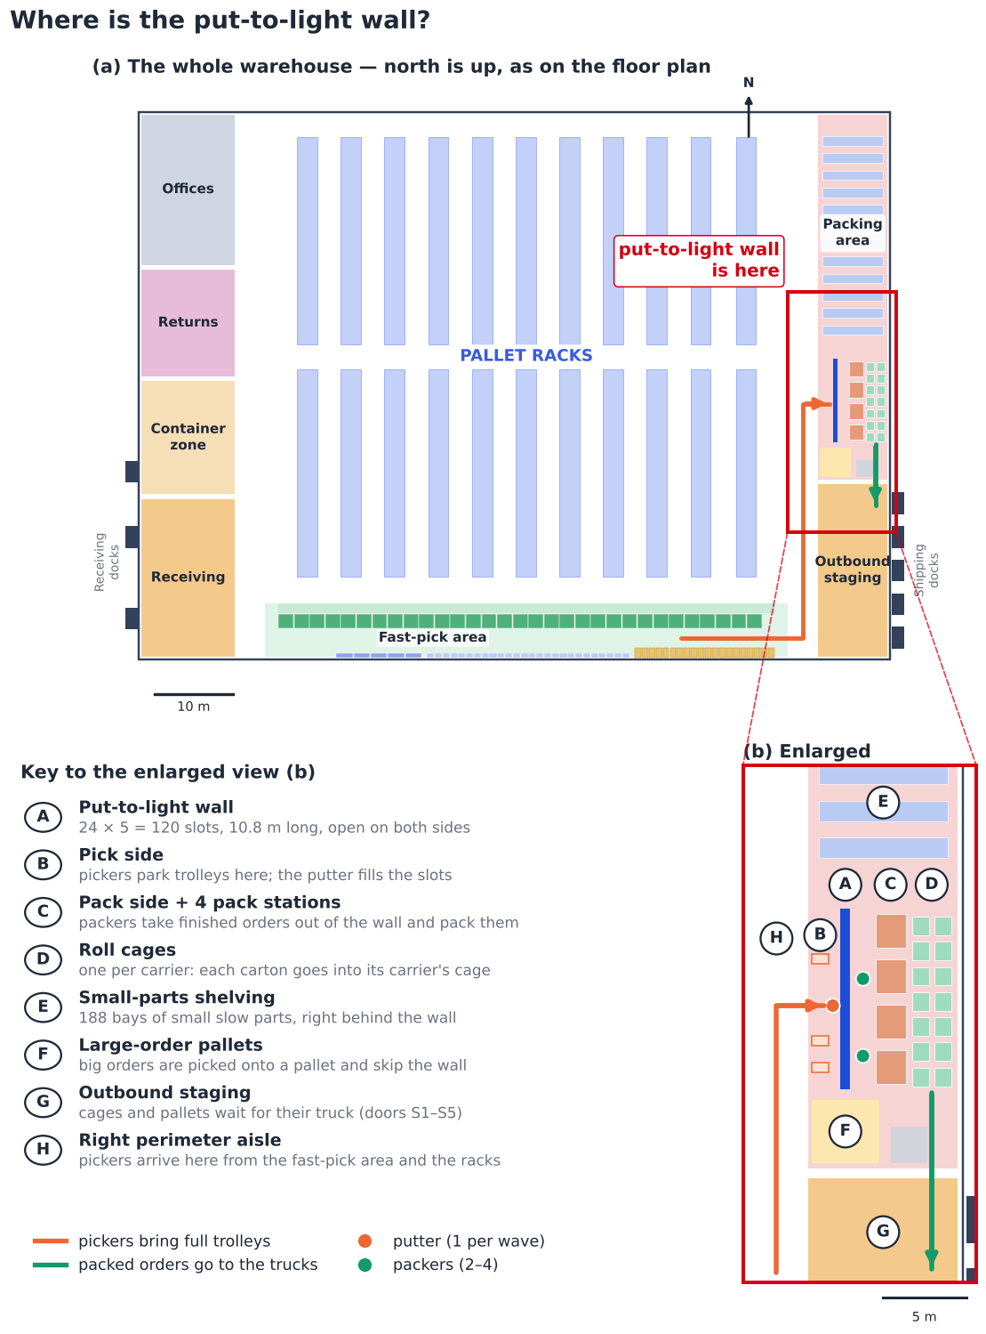
Fig 10. Where the put-to-light wall is: (a) the whole warehouse, (b) the packing area enlarged, with the key.
How it works. The wall is a shelf you can reach from both sides. The pick side faces the aisle, the pack side faces the pack stations. Fig 11 shows it from the side:
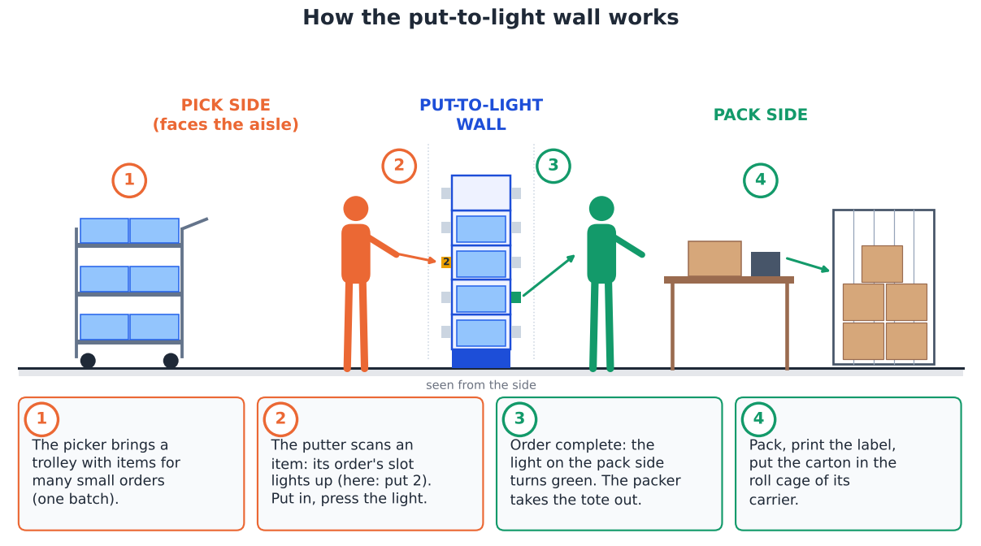
Fig 11. How the wall works, seen from the side: pick side (left), the wall, pack side (right).
- Size: 24 columns × 5 levels = 120 slots, 10.8 m long, 0.6 m deep, slots between 0.2 and 2.0 m high. Each slot holds one open tote (600 × 400 mm, ~40 L) for one order and has a light with a button on both sides.
- Why 120 slots: the peak wave has ~73 small orders; 78% need one tote, 13% two and 9% three or four (average 1.35). 73 × 1.35 × 1.2 spare → 120 slots. A bigger order gets 2–4 slots next to each other.
- Orders from two zones wait in their slot until the last item arrives — only then does the pack-side light go on, so nobody packs half an order. A wrong item gives no light, so picking mistakes are caught here.
Where each item is stored before it reaches the wall:
Item type | Stored in | How it is stored | Who picks it
Fast movers (A/B) | Fast-pick area (south band, §4) | cases in carton-flow lanes, refilled from the back by the reach truck and picked from the front; less-picked, long or heavy ones on the wall row across the pick aisle | zone 1 picker with a trolley
Slow movers (C) | Low levels of the reserve racks | on the pallet, levels 1–2 within reach | zone 2–3 picker with a trolley
Small slow parts | Bin shelving behind the wall (E) | one SKU per half-bin (300 × 400 mm), 7 levels, 188 bays | the putter, between puts
Big orders (pallet-sized) | — | do not use the wall: picked straight onto a pallet (F) | EJE 120i picker

Who works at the wall, and how they move:
Role | Where (Fig 10) | How they move | People
Picker | zones → aisle H → pick side B | pushes a trolley along the zone route, leaves the full trolley at B and takes an empty one back (2 trolleys per picker) | 1–2 per zone per wave
Putter | pick side B + shelving E | walks along the 10.8 m wall putting items in; picks small parts in E (~8 s per item) | 1 per wave
Packer | pack side C → cages D | takes a finished order out of the wall, turns to the bench 1–2 m away, puts the carton in the carrier's cage | ~1.9 FTE (average), ~3.4 (peak, 4 stations)

5.2 How are small items stored efficiently? Gleb (Storage)
Today every SKU sits on a pallet location, even when its whole stock is a few litres. 2,657 slow SKUs (C class or no demand in Q2) have ≤ 50 litres of stock, units ≤ 20 L, ≤ 15 kg and ≤ 60 cm — together only 32 m³, yet they fill 1,005 pallet locations of about 1 m³ on their own (and share others). They need 3,424 half-bins (300 × 400 mm, ~20 L). We compared three ways to store them (A042):
Option | Floor m² | Pallet locations used | One-off cost | Pick rate | Cost per year*
Keep in pallet racks (today) | 393 | 1,005 | €130,650 | 49 lines/h | €28,576
Bin shelving next to the put-wall (chosen) | 207 | 0 | €69,184 | 50 lines/h | €19,597
Kardex Shuttle XP 500 lifts | 66 | 0 | €224,560 | 75 lines/h | €38,555

* depreciation over 7 years + picking labour for the ~93 small-part lines a day.
- Chosen: bin shelving next to the put-wall. 188 bays, 2.5 m high, in the packing area's spare floor. It is the cheapest option, frees 1,005 pallet locations, and the picked item goes straight into the wall — no walk to the reserve aisles.
- Kardex Shuttle XP 500 (Relevator Group, n.d.): 3 lifts ~10 m high would need only 66 m² and picks faster with a light pointer, but costs ~€19k a year more. With ~93 lines a day the lifts would stand still most of the day. They become the better choice when floor space runs out or small-part volume grows strongly — the shelving bins fit the lift trays, so the step is easy.
- A/B small items stay in the fast-pick area (390 SKUs): they are picked too often for a lift or a far-away shelf.

6. Design checks — machinery, long goods, space and hazardous goods

6.1 Machinery — is everything fit and justified?
Each machine was checked on three questions: does it have a job every day, does it fit the loads and the aisles, and is the number right?
Machine | Job | Units | Use (avg day) | Fits? | Verdict
ETV 216i reach truck | Putaway, refill fast-pick area, full pallets | 3 → 2 | 33% | Yes: 10.7 m lift for the 10.0 m top beam; single-deep → standard forks | Keep. 2 cover the peak day; a breakdown still leaves enough for an average day.
EJE 120i pallet truck | Large orders picked onto a pallet | 4 → 3 | 31% | Yes: 0.72 m wide, no U-turns needed | Keep 3 (peak need).
ERE 225 rider pallet truck | Unload / load trailers, container-zone pallets | 2 → 2 | 14% | Yes: 2.5 t, carries the few heavy loads | Keep 1 per dock side: docks are 96 m apart and both are busy 10:30–14:00. Low use — could drop to 1 if DHL accepts the walk.
Pick trolley + totes | Small orders, batch picking | 6 | — | Yes: 250 kg, 6 totes | Keep (cheap, flexible).
Put-to-light wall | Sort batch picks into orders | 120 slots | — | Peak wave ~73 small orders × 1.35 totes + 20% | Keep.
Small-parts bin shelving | Store and pick small slow parts | 188 bays | — | 2.5 m high, 7 levels; within reach without a ladder | Add (feedback 2).
Roller conveyor + 2 stretch wrappers | Unpack containers; wrap new and outgoing pallets | new | — | Yes: no heavy carrying out of the container | Add.
RF terminals | Scan every move | 14 | — | One per person at the peak + 20% | Keep.
Telescopic forks | (double-deep) | dropped | — | Not needed with single-deep racks | Removed.
Cantilever racking | (items > 2.4 m) | dropped | — | No real item is longer than ~2 m | Removed.
Kardex lifts | (small parts) | compared | — | Fit, but little work at our volume | Upgrade path (§5.2).
ECE 225 order picker / EZS 130 tugger | (rejected in D2) | — | — | Too long for 3.0 m aisles / driver idle | Not used.

6.2 Long goods — lengths, turning, capacity and access Gleb (Storage)
- Real lengths: nothing longer than a door (~2 m) can come in. The WMS shows 115 loads longer than 2.05 m — up to an '11 m' item that weighs 0.5 kg and is 1 cm high — so these are data errors and are capped at 2.05 m, the length of an XLONG pallet. That gives 255 long loads (1.3–2.05 m).
- Where they go: the long-goods module has 4.5 m bays with two long pallets each: 320 positions for 255 loads today (80% full).
- Turning clearance: a reach truck stacking a 2.05 m pallet crosswise needs an aisle of 2,976 mm (VDI right-angle stacking formula with the ETV 216i data: Wa 1,665 mm, 200 mm safety; Jungheinrich, 2019). A 3.0 m aisle leaves only 24 mm, so the long-goods aisle is 3.2 m (224 mm spare). The 3.2 m cross-aisles let the truck turn into it with the load.
- Truck capacity: the forks go under the long side, so the load centre is ~400 mm — inside the 600 mm rating, full 1.6 t. Forked on the short side the load centre would be ~1 m and the truck could carry only ~937 kg; the heaviest long load is 2,035 kg (95% below 346 kg), so loads over 1.6 t go to a floor position.
- Access: the module is open from both ends (front, middle and rear cross-aisles) and its outer row faces the 3.2 m perimeter aisle, so long goods never pass through the standard 3.0 m aisles.
Loads checked against the racks and trucks (all 11,015 loads in stock, 01-06-2025):
Check | Data | Result
Weight | 10 loads > 1 t, 3 > 1.6 t (actual qty × unit weight) | ETV 216i lifts 1.6 t → the few heavier loads go to floor positions, moved with the ERE 225 (2.5 t)
Height | 940 loads 1.16–1.68 m tall, 42 taller; 493 have no height in the WMS | tall loads use the top level (1,120 positions with ~1.7 m free); the tallest stand on the floor
Aisles | 3.0 m storage, 3.2 m long-goods / cross / perimeter | ETV needs 2.63–2.79 m (2.98 m with a long load), EJE 1.79–1.94 m → OK

6.3 Space for unpacking loose containers Vidhi (Receiving)
- What a container needs: cartons are sorted on the floor into one build spot per SKU. Measured on 568 Asian receipts: the median container needs ~134 m², the p90 ~186 m², the largest (82 SKUs) ~458 m².
- The zone (190 m²) fits 91% of containers.
- Borrowing door R2 (feedback idea, A044): receiving needs at most ~80 m² of its 262 m², because two reach trucks put pallets away while a trailer is unloaded (peak ~17 pallets waiting). On a big-container day R2 is blocked and 131 m² of receiving joins the zone → 321 m², enough for 97% of containers. R1 + R3 still give the 2 doors the base and peak days need; R2 is only blocked when no second trailer is booked.
- The last few % (more SKUs than build spots) are sorted in two passes.

6.4 Outbound staging (216 m²) and packing (450 m²) Rachel (Shipping)
- Outbound staging: all afternoon trailers' goods wait at the same time after wave 3. Measured per day: median 34 m², p90 60 m², busiest day 100 m² → every Q2 day fits, with room for twice the volume.
- Packing: pack stations, put-wall, small-parts shelving, waiting pallets, wrapper and packaging stock need 423 m² → fits in 450 m² with 27 m² spare (D2 §5.4).

6.5 Hazardous goods — recount and classes Gleb (Storage)
Counted per load (LODNUM) with the hazmat flag: 138 SKUs and 2,197 loads (20% of loads), ~385 t gross on 01-06-2025 (same method in April and May: 1727, 1895 loads — the count grows with the stock). The customs code tells what the products are:
Customs code | What it is | Likely hazard | Dutch rule | Loads | Tonnes
8303 | Safes and strong-boxes (electronic locks) | lithium cells in equipment (UN3481 / UN3091, class 9) | PGS 37-2 | 1,603 | 315
8471 | Readers / data units | lithium cells in equipment (UN3481, class 9) | PGS 37-2 | 171 | 10
8301 | Locks and padlocks (electronic) | lithium cells in equipment (UN3481 / UN3091, class 9) | PGS 37-2 | 148 | 27
8531 | Alarm and signalling devices | lithium cells in equipment (UN3481 / UN3091, class 9) | PGS 37-2 | 141 | 17
8525 | Cameras | lithium cells in equipment (UN3481, class 9) | PGS 37-2 | 88 | 8
4819 | Cardboard boxes | unclear - packaging should not be hazardous; check the flag | check flag | 33 | 6
8302 | other | unknown | check | 10 | 0
none | other | unknown | check | 7 | 1
3403 | Lubricants | possibly aerosols or flammable liquids (class 2 / 3) | PGS 15 | 6 | 0
8507 | Batteries (loose) | lithium batteries (UN3480 / UN3090, class 9) | PGS 37-2 | 5 | 0
8479 | other | unknown | check | 2 | 0

- 97% of hazardous loads are electronic security products (safes, locks, alarms, cameras, readers) — most likely with lithium cells inside (UN3481/UN3091, class 9). Storage then follows PGS 37-2 (from 333 kg; 1,000 kg for small cells; Evofenedex, n.d.; Special Cargo, n.d.; BOVAG, n.d.), not PGS 15.
- Only a few loads are chemicals (lubricants → PGS 15 if aerosols or flammable), and 33 loads of cardboard boxes look like a wrong flag.
- To confirm with Assa Abloy: the UN numbers on the safety data sheets. The hazmat section and its fire separation are sized after that and are not in this budget.

7. Costs — CAPEX and OPEX
The capacity plan (D2 §6) is turned into money in three steps: (1) count what the design needs (positions, bays, trucks, people), (2) multiply by a price from a public source or a labelled assumption (Section 9), (3) add it up per year. Labour is costed at €20 per hour for an operator (feedback; €28 tested as the high case). Trucks are leased with full service (repairs included), so they are OPEX. The building, dock levellers, sprinklers and the hazmat compartment are outside the project scope and not included.

7.1 One-off investment (CAPEX)
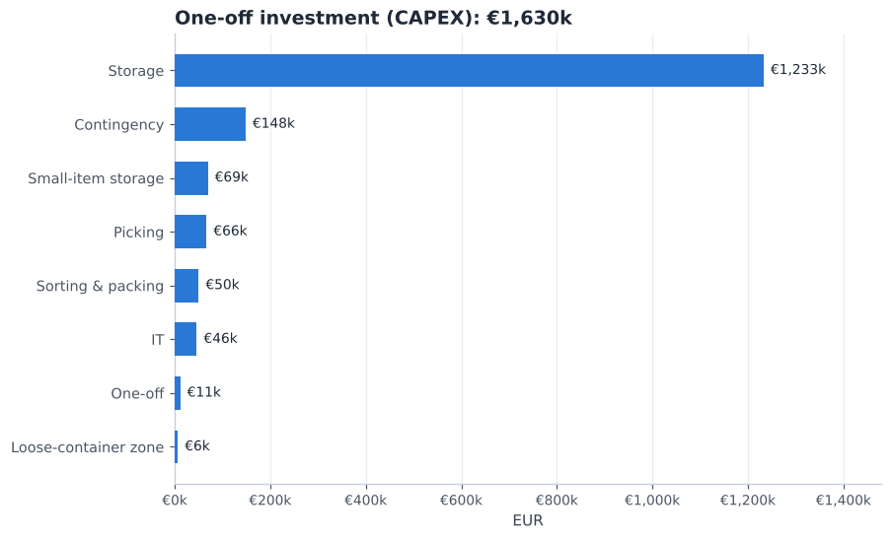
Fig 12. CAPEX by group — total €1,630k.
Item | Quantity | Unit price | Total | Source
Single-deep pallet racking (incl. installation) | 8,640 positions | €130 | €1,123,200 | A033 / IndexBox, n.d.; T-Racking, n.d.
Long-goods racking, 4.5 m bays (2.05 m pallets) | 320 positions | €160 | €51,200 | A033
Rack protection, end guards, load signs | 1 lot | €58,240 | €58,240 | A033 / SSI Schäfer, n.d.; STOW, n.d.
Bin shelving for small parts (next to the put-wall) | 188 bays | €200 | €37,600 | A042 / Manutan, n.d.
Half-bins and dividers | 3,948 slots | €8.00 | €31,584 | A042 / Logistiekdirect, n.d.
Carton-flow bays, fast-pick area | 31 bays | €1,800 | €55,800 | A034 / Shelving.com, n.d.
Fast-pick shelving + long-item shelves (wall row) | 36 bays | €200 | €7,200 | A046 / Manutan, n.d.
Pick trolleys (3-tier, 6 totes) | 6 trolleys | €433 | €2,598 | TBSG, n.d. / boxic24, n.d.
Totes 600 x 400 | 54 totes | €16 | €864 | Logistiekdirect, n.d.
Put-to-light wall (slots) | 120 slots | €150 | €18,000 | A035 / LatestCost, n.d.
Put-to-light installation + WMS link | 1 lot | €12,000 | €12,000 | A035 / LatestCost, n.d.
Pack stations (bench, scale, label printer) | 4 stations | €2,500 | €10,000 | A036
Stretch wrapper (packing) | 1 units | €3,849 | €3,849 | Machineseeker, n.d.
Roll cages for parcels | 41 cages | €150 | €6,150 | A036
Extendable roller conveyor (into the container) | 2 units | €1,250 | €2,500 | Cromwell, n.d.
Stretch wrapper (newly built pallets) | 1 units | €3,849 | €3,849 | Machineseeker, n.d.
RF terminals with cradles | 14 units | €1,500 | €21,000 | A036 / Bechtle, n.d.
WMS set-up: waves, put-wall, slotting, putaway rules | 1 lot | €25,000 | €25,000 | A037
Move-in / re-slotting (each load moved once) | 11,015 loads | €1.03 | €11,317 | ETV cycle model + A030
Contingency 10% | 1 lot | €148,195 | €148,195 | A037
Total CAPEX |  |  | €1,630,146

- Racking is 76% of the investment. If the racking already standing in Bemmel can be rebuilt in the new layout (about €25 per position), the investment drops to €521k. DHL must confirm the type and condition of today's racks.
- Depreciation: €141,591 a year (racking 15 years, equipment 7, IT 5).

7.2 Running cost (OPEX)
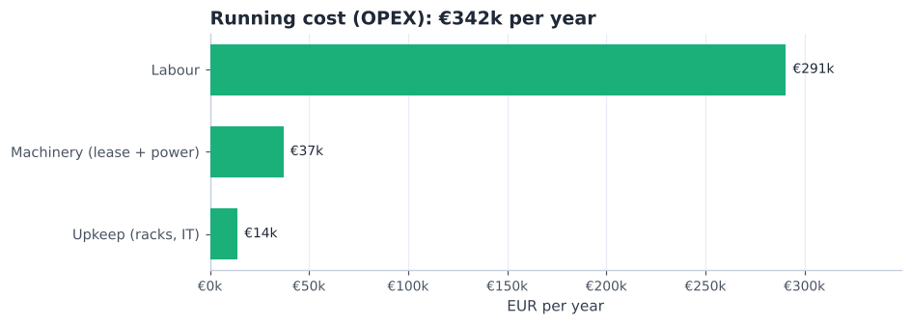
Fig 13. OPEX by group — total €342k per year.
Item | Quantity / year | Unit cost | Per year | Source
Direct DHL labour (receiving, putaway, replenishment, picking, packing, loading) | 9,161 paid h | €20 | €183,228 | capacity plan (D2 §6) x A030
Loose-container zone crew (2 people x 3 h per container) | 1,562 paid h | €20 | €31,232 | A019 x A030 (or contractor fee, see break-even)
Team leader + inventory control / admin | 2,928 paid h | €26 | €76,128 | A032 x A030
ETV 216i reach truck lease (2) | 24 truck-months | €900 | €21,600 | A038 / Liftlease, n.d.; Beekmans Heftrucks, n.d.; Itolang, n.d.; Solid Lift, n.d.
EJE 120i pallet truck lease (3) | 36 truck-months | €150 | €5,400 | A038
ERE 225 rider pallet truck lease (2) | 24 truck-months | €350 | €8,400 | A038
Electricity for trucks | 8,113 kWh | €0.20 | €1,660 | A039 / Statista, n.d.
Rack inspection (EN 15635) and repairs | 1 per year | €2,500 | €2,500 | A040 / SSI Schäfer, n.d.; STOW, n.d.
IT support, licences, device spares | 1 per year | €11,400 | €11,400 | A040
Total OPEX per year |  |  | €341,548
+ depreciation of CAPEX |  |  | €141,591 | A041
Total yearly cost |  |  | €483,139

Labour hours come from the capacity plan: 4.7 FTE on an average day × 8 paid hours × 244 working days. Peak days are covered by flexible staff at the same hourly cost.

7.3 Cost per unit
Per … | Volume per year | Cost
Order line | 156,160 | €3.09
Order | 35,136 | €13.75
Inbound pallet | 24,132 | €20.02
Pallet position per month | 8,960 | €4.49

These are full costs (OPEX + depreciation) split over the volume — useful for DHL to compare with the price agreed with Assa Abloy.

7.4 Today vs future — saving and payback
 | Process changes only | Whole design, re-used racking | Whole design, all new
One-off investment | €156,708 | €520,642 | €1,630,146
Labour saved per year (Section 2.2) | €101,208 | €101,208 | €101,208
Simple payback | 1.6 years | 5.1 years | 16.1 years

- Process changes = carton-flow lanes and shelving of the fast-pick area, trolleys and totes, put-to-light wall, RF terminals and the WMS set-up of waves and slotting. They create the whole labour saving and pay for themselves quickly — they can start before the racks are rebuilt.
- Racks, shelving and the container zone are capacity: they are needed to store and receive the goods at all, so they are judged on cost per position and space, not on labour saved.
- Only labour savings are counted. Shorter lead times, fewer parked trailers, fewer picking errors and a safer layout have value too, but no reliable price.

7.5 What if our cost assumptions are wrong?
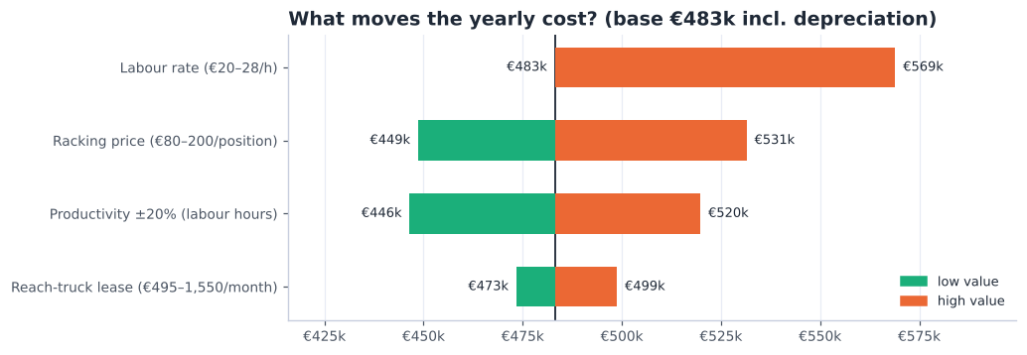
Fig 14. Yearly cost (OPEX + depreciation) when each assumption moves to the low or high end of its range.
- Labour rate and productivity matter most — labour is ~60% of the yearly cost. DHL's real hourly cost and time studies (A006, A025) are the most valuable inputs to get.
- Racking price is the biggest one-off uncertainty, but spread over 15 years its effect on the yearly cost is smaller.
- The truck lease price hardly matters: only 7 trucks are leased.
- Loose containers: a DHL crew costs ~€128 per container (244 containers a year). If a contractor quotes less, use the contractor in the same zone.

8. Supporting documents
Document | What it contains
Deliverable 1 — Analysis (updated) | Data analysis, concept choice and decision matrix; now single-deep racks and per-order lead time
Deliverable 2 — Future state (v3) | Processes, flowcharts, layout and 3D, docks, picking, machinery, capacity plan; now with the container zone and R2 overflow, long-goods module, small-parts shelving, area checks and the hazmat classes
Deliverable_3_Calculations.xlsx | Every price, quantity and formula of this report; change an input and all totals update
data/assumptions.json | All assumptions A001–A047, each with reason, source and impact
documentation/sources.md | All sources with links and what they support (cited in APA; reference list at the end)
analysis/*.py | Scripts that turn the raw data into every table and figure (run order in README.md)

9. Cost assumptions and open points
Assumptions added for Deliverable 3 (full register in data/assumptions.json):
ID | Assumption | Value | Source
A030 | Labour cost per paid hour | operative EUR 20 (high case EUR 28); team leader EUR 27; admin EUR 24 | Rogier, course teacher, personal communication, October 2026; Centraal Bureau voor de Statistiek, 2025b, 2025a; Cao Beroepsgoederenvervoer, n.d.; Connecting People, n.d.
A031 | Working days per year | 244 | Measured (Assa Abloy & DHL Supply Chain, 2025)
A032 | Indirect staff | 1.5 FTE (1 team leader + 0.5 inventory control / WMS admin) | Planning assumption
A033 | Racking prices | EUR 130 per installed single-deep position (80-200); long-goods position EUR 160; protection 5% of racking; re-use of existing racking EUR 25/position | IndexBox, n.d.; T-Racking, n.d. + assumption
A034 | Carton-flow bay price | EUR 1,800 per 2 m bay (1,100-2,300) | Shelving.com, n.d.; Machineseeker, n.d.
A035 | Put-to-light wall | EUR 150 per slot + EUR 12,000 installation and WMS link | LatestCost, n.d.
A036 | Small equipment prices | RF terminal EUR 1,500; trolley EUR 433; tote EUR 16; wrapper EUR 3,849; roller conveyor EUR 1,250; pack station EUR 2,500; roll cage EUR 150 | boxic24, n.d.; Logistiekdirect, n.d.; Machineseeker, n.d.; Cromwell, n.d.; Bechtle, n.d. + assumption
A037 | WMS set-up and contingency | WMS set-up EUR 25,000; contingency 10% of CAPEX | Assumption
A038 | Truck full-service lease per month | ETV 216i EUR 900 (495-1,550); EJE 120i EUR 150; ERE 225 EUR 350 | Liftlease, n.d.; Beekmans Heftrucks, n.d.; Itolang, n.d.; Solid Lift, n.d. + assumption
A039 | Truck energy | ETV 4 kWh per operating hour, pallet trucks 1.5 kWh/h; EUR 0.2046 per kWh | Statista, n.d. + assumption
A040 | Upkeep | rack inspection + repairs EUR 2,500/yr; IT support 15% of IT CAPEX/yr | SSI Schäfer, n.d.; STOW, n.d. + assumption
A041 | Depreciation | racking 15 yrs, equipment 7 yrs, IT 5 yrs, straight-line | Assumption
A042 | Small parts move from pallet racks to bin shelving | 2,657 slow SKUs (C or no demand) with stock <= 50 L, unit <= 20 L, <= 15 kg, <= 60 cm -> 3,424 half-bins on 188 shelving bays (207 m2) next to the put-wall; frees 1,005 rack locations; 50 lines/h | Relevator Group, n.d.; Cisco-Eagle, n.d.; Commander, n.d.; Modern Materials Handling, n.d.; Manutan, n.d. + measured
A043 | Maximum real item / pallet length | 2.05 m (XLONG pallet); 115 loads recorded longer are data errors (e.g. a 10.95 m item of 0.5 kg) | Rogier, course teacher, personal communication, October 2026 + Jungheinrich, 2019
A044 | Big containers borrow door R2 | on container days with > ~12 SKUs the north half of receiving (131 m2) beside R2 is used for unpacking; 91% of containers fit the zone alone, 97% with R2 | Rogier, course teacher, personal communication, October 2026 + dock model
A045 | Area check outbound staging and packing | outbound staging need: p90 60 m2, max 100 m2 of 216; packing need 423 m2 of 450 incl. shelving and the put-wall | Measured + planning assumption
A046 | Every fast mover (A/B item) gets a pick face in the fast-pick area | 31 carton-flow bays (2 m, 5 levels x 6 lanes = 930 lanes) hold the 888 most-picked A/B items that fit a lane (each <= 28 x 33 x 60 cm, <= 15 kg) + 42 second lanes for the top 1%; across the 2.6 m pick aisle a wall row holds the rest: 26 shelving bays (462 items), 5 long-item bays of 2.2 m (42 items up to ~2 m, lying lengthwise) and 20 floor pallet faces (17 heavy/bulky items) = 55 of 63.6 m | Measured (Q2 order lines, SKU dimensions) + planning assumption + Manutan, n.d.
A047 | Fixed places inside the working zones | Receiving: R2 in the north half (lent to container unpacking on big-container days), R3 in the south half; container zone: 10.5 m roller conveyor from R1, 12 build spots (6 each side), 35-pallet buffer, 4 x 4 m wrap/label station; fast-pick band: wall row 1.2 m, pick aisle 2.6 m, carton flow 1.8 m deep, refill strip ~1.6 m | Layout design (geometry.py)

- To get from DHL: real hourly labour cost and pick/pack times (A006, A025, A030); type and condition of today's racking (re-use); container numbers per week (A019).
- To get from suppliers: Jungheinrich lease quote for the trucks (A038); racking quote incl. the long-goods module (A033); contractor price per loose container (A026).
- To get from Assa Abloy: UN numbers / safety data sheets of the hazardous SKUs (A028), and a clean-up of the item lengths in the master data (A043).

References
APA 7th edition. Conversations with the course teacher and DHL are personal communications and are cited in the text only.
Assa Abloy, & DHL Supply Chain. (2025). Assa Abloy storage details (1 April, 1 May and 1 June 2025) and outbound details (April–June 2025) [Unpublished raw data]. DHL Supply Chain, Bemmel.
Bechtle. (n.d.). Zebra MC3300 charging cradle base [Product listing]. Retrieved October 18, 2026, from https://www.bechtle.com/de-en/shop/zebra-mc3300-charging-cradle-base--4258458--p
Beekmans Heftrucks. (n.d.). Reachtrucks. Retrieved October 18, 2026, from https://www.beekmansheftrucks.nl/product-categorie/reachtrucks/
BOVAG. (n.d.). Veelgestelde vragen over PGS 37-2. Retrieved October 18, 2026, from https://mijn.bovag.nl/dossiers/veelgestelde-vragen-over-pgs-37-2
boxic24. (n.d.). Fetra 28301 [Product listing]. Retrieved October 18, 2026, from https://boxic24.com/english/fetra-28301.html
Cao Beroepsgoederenvervoer. (n.d.). TLN functieloonschalen per 1 januari 2025. Retrieved October 18, 2026, from https://www.caoberoepsgoederenvervoer.nl/tln-functieloonschalen-per-1-januari-2025/
Centraal Bureau voor de Statistiek. (2025a). De arbeidsmarkt in cijfers 2025: Lonen en loonkosten. Retrieved October 18, 2026, from https://longreads.cbs.nl/dearbeidsmarktincijfers-2025/lonen-en-loonkosten/
Centraal Bureau voor de Statistiek. (2025b). Loonkosten per gewerkt uur 6 procent hoger in 2024. Retrieved October 18, 2026, from https://www.cbs.nl/nl-nl/nieuws/2025/42/loonkosten-per-gewerkt-uur-6-procent-hoger-in-2024
Cisco-Eagle. (n.d.). Vertical lift modules vs. horizontal carousels. Retrieved October 18, 2026, from https://www.cisco-eagle.com/blog/?p=2003
Commander. (n.d.). LogiMat vertical lift module [Product page]. Retrieved October 18, 2026, from https://www.commander.ca/product-logimat-vertical-lift-module/
Connecting People. (n.d.). Salaris orderpicker. Retrieved October 18, 2026, from https://www.connectingpeople.nl/salaris/orderpicker/
Cromwell. (n.d.). [Extendable roller conveyor, product listing]. Retrieved October 18, 2026, from https://cromwell.co.uk/
Evofenedex. (n.d.). PGS 37: Opslag lithiumbatterijen. Retrieved October 18, 2026, from https://www.evofenedex.nl/kennis/gevaarlijke-stoffen/pgs-37-opslag-lithiumbatterijen
Extensiv. (n.d.). 3PL fulfillment KPIs: Formulas & benchmarks. Retrieved October 18, 2026, from https://www.extensiv.com/blog/3pl-fulfillment-kpis-formulas-benchmarks
HAN University of Applied Sciences. (2026a). [Lecture slides on warehouse design, layouts, storage and order-picking systems, week 3]. OPERMB04 Operations Management. Unpublished course material.
IndexBox. (n.d.). European Union: Metal racks market analysis, forecast, size, trends and insights. Retrieved October 18, 2026, from https://www.indexbox.io/store/european-union-metal-racks-market-analysis-forecast-size-trends-and-insights/
Itolang. (n.d.). Lease. Retrieved October 18, 2026, from https://itolang.nl/lease
Jungheinrich. (2019). ETV 216i: Technical data [Data sheet]. Retrieved October 7, 2026, from https://www.fallsway.com/hubfs/Fallsway_January2022/Pdf/jungheinrich-ii-etv-216i-spec-sheet-english.pdf
LatestCost. (n.d.). Put-to-light system cost. Retrieved October 18, 2026, from https://latestcost.com/put-light-system-cost/
Liftlease. (n.d.). Reachtruck leasen. Retrieved October 18, 2026, from https://liftlease.nl/lease/reachtruck-leasen
Logistiekdirect. (n.d.). Magazijnbak Eco Euronorm 64 liter, 600x400x320 mm [Product listing]. Retrieved October 18, 2026, from https://www.logistiekdirect.be/magazijnbak-eco-euronorm-64-liter-donkergrijs-600x400x320mm
Machineseeker. (n.d.). Vogel Verpackungen Starter [Product listing]. Retrieved October 18, 2026, from https://www.machineseeker.com/vogel+verpackungen-starter/i-22833460
Manutan. (n.d.). Open stelling van plaatstaal Quick-Fix Plus, hoogte 2000 mm, breedte 1000 mm [Product listing]. Retrieved October 18, 2026, from https://www.manutan.be/nl/mab/open-stelling-van-plaatstaal-quick-fix-plus-hoogte-2000-mm-breedte-1000-mm
Modern Materials Handling. (n.d.). Van Meter optimizes with vertical lift modules. Retrieved October 18, 2026, from https://www.mmh.com/article/van_meter_optimizes_with_vertical_lift_modules_vlms
Relevator Group. (n.d.). Vertical lift modules [Product category]. Retrieved October 18, 2026, from https://www.relevatorgroup.com/product-category/vertical-storage-systems/vertical-lift-modules/
Shelving.com. (n.d.). Gravity flow rack prices [Price list]. Retrieved October 18, 2026, from https://www.shelving.com/v/gravityflowrackprices.pdf
Slack, N., Brandon-Jones, A., & Burgess, N. (2022). Operations management (10th ed.). Pearson.
Solid Lift. (n.d.). Reachtrucks. Retrieved October 18, 2026, from https://www.solidlift.nl/reachtrucks
Special Cargo. (n.d.). PGS 37-2 onder de loep. Retrieved October 18, 2026, from https://services.specialcargo.com/nl-nl/blog/kennisbank/pgs-372/
SSI Schäfer. (n.d.). What does the rack inspection check? Retrieved October 14, 2026, from https://ssi-schaefer.com/en-de/what-does-the-rack-inspection-check--1580504
Statista. (n.d.). [Electricity prices for non-household consumers in the Netherlands, Eurostat nrg_pc_205]. Retrieved October 18, 2026, from https://www.statista.com/statistics/596254/electricity-non-household-price-netherlands
STOW. (n.d.). DIN EN 15635 and other safety standards for racking. Retrieved October 14, 2026, from https://www.stow-group.com/en/racking/blog/warehouse-safety-standards/
T-Racking. (n.d.). How much does pallet racking cost? Retrieved October 18, 2026, from https://t-racking.com/how-much-does-pallet-racking-cost
TBSG. (n.d.). Order picking and display trolley with adjustable shelves [Product listing]. Retrieved October 14, 2026, from https://www.tbsg.co.uk/order-picking-and-display-trolley-with-adjustable-shelves--2

