PROJECT OTM — DHL ON THE MOVE
Final Portfolio — Warehouse Redesign
Assa Abloy operation · DHL Supply Chain, Bemmel (NL_0032)
OPERMB04 Operations Management · HAN University of Applied Sciences
Field | Detail
Student | Rachel Selvarathnam
Student number | ____________________
Class | ____________________
My process | Shipping — packing, outbound staging, dock doors, trailer departure plan and loading
Group | Group 3 — Vidhi (Receiving), Gleb (Storage), Arnau (Picking), Rachel Selvarathnam (Shipping)
Contents | Part 1 Analysis · Part 2 Future state · Part 3 Performance overview — the whole warehouse design
Supporting files | Deliverable_3_Calculations.xlsx (all cost formulas); analysis/*.py, data/assumptions.json, documentation/sources.md in the group repository

Every student of Group 3 hands in this same complete design. The process each student is responsible for is marked in the heading of every section that belongs to it, for example “4.2 Refilling the fast-pick area Gleb (Storage)”. Sections without a name were made by the whole group.

Who is responsible for what
The project covers four processes end-to-end (project brief). Each team member owns one process and wrote, calculated and checked its sections; the choices across the four processes were aligned together.
Process | Owner | Scope | Part 1 § | Part 2 § | Part 3 §
Receiving | Vidhi | unloading trailers and containers, checking, container unpacking, returns intake — up to the pick-up point | 5 | 2.1, 2.5, 4.1, 4.3, 4.6, 7.1 | 3.1, 6.3
Storage | Gleb | putaway, racks and storage places, slotting, replenishment of the fast-pick area, inventory control | 3, 4, 8, 13 | 2.1, 2.2, 3.1, 3.2, 5.2, 5.3, 7.2 | 2.3, 4, 4.1, 4.2, 4.3, 5.2, 6.2, 6.5
Picking | Arnau | order release (waves), picking, sorting batch picks into orders at the put-to-light wall | 6, 8, 9 | 2.3, 2.4, 4.2, 6.2, 7.3 | 2.2, 4.3, 5.1
Shipping | Rachel Selvarathnam | packing, outbound staging, dock doors, trailer departure plan and loading | 7, 9 | 2.4, 4.4, 4.5, 5.4, 7.4 | 2.1, 5.1, 6.4

Joint work of the whole group: data preparation and quality checks, the operations-strategy analysis, design options and the decision matrix (Part 1); concept, layout and zoning, labour plan, machinery and monitoring & control (Part 2); KPI framework, zone guide, costs, payback and sensitivity (Part 3).

My part — Rachel Selvarathnam (Shipping)
Part | Section | Shared?
Part 1 (Analysis) | 7. Outbound profile (shipping) | own section
Part 1 (Analysis) | 9. Peak activity analysis | with Arnau
Part 2 (Future state) | 2.4 Consolidation, packing & shipping | with Arnau
Part 2 (Future state) | 4.4 Outbound dock doors | own section
Part 2 (Future state) | 4.5 When trailers leave — departure plan | own section
Part 2 (Future state) | 5.4 Are the outbound staging and packing areas big enough? | own section
Part 2 (Future state) | 7.4 Shipping — departure plan, packing and loading | own section
Part 3 (Performance overview) | 2.1 Order lead time | own section
Part 3 (Performance overview) | 5.1 The put-to-light wall — where it is and how it works | with Arnau
Part 3 (Performance overview) | 6.4 Outbound staging (216 m²) and packing (450 m²) | own section

How this portfolio meets the assessment form
Knock-out criteria: APA referencing — every part cites its sources as (author, year) in the text and ends with an APA 7 reference list; conversations with the teacher and DHL are cited as personal communications. Hand-in deadline — handed in via Brightspace before the deadline.
Deliverable (weight) | Standard for ‘Excellent’ | Where to find it
Analysis (1/3) | Requirements based on an excellent analysis of the data; design aspects, policies and equipment all suitable, substantiated with appropriate sources | Part 1 §3–10 data analysis per process (SKUs, inventory, inbound, orders, outbound, ABC, peaks, data quality); §11 operations strategy; §12 requirements per process; §13 capacity; §14–15 options and decision matrix · Part 2 §3 policies, §6.3 equipment · Part 3 §6.1 machinery check
Future state (1/3) | Process fully in line with customer requirements and design choices; detailed elaboration; excellent input for the new operation | Part 2 §2 process maps (swimlane + flowcharts), §3 policies, §4 docks and departure plan, §5 layout and zoning (2D, 3D), §6 capacity plan (labour, equipment), §7 planning and control · Part 3 §3–5 zones, storage and sorting explained
Performance overview (1/3) | Relevant KPIs; detailed capacity plan with expected operating costs; aligned with the analysis and future state | Part 3 §2 own + lecture KPIs with expected values, each linked to a performance objective and an owner; §2.4 stress test; §7 CAPEX, OPEX, cost per unit, payback, sensitivity; calculation workbook

Test grid (module learning outcomes TWM20/TWM21):
Learning outcome (weight) | Assessment criteria | Where to find it
Alignment of operations performance and business strategy (20%) | categorisation of operations processes; classification of process performance; relationship operations–strategy; evaluation of current alignment | Part 1 §11.1 the four processes and their type; §11.2 the four V's; §11.3 performance objectives, order winners and qualifiers; §11.4 current alignment and gaps · Part 3 §2 KPIs per objective
Designs a process given product/service and performance characteristics (40%) | classification of expected process performance; appropriateness of choices; quality of process mapping | Part 3 §2 expected performance per KPI; Part 1 §12–15 and Part 2 §2–6 choices per process from the data; Part 2 §2 swimlane and flowcharts; Part 3 §3–5 zone, storage and put-wall figures
Proposes methods for planning and control (40%) | relevance of the factors considered; quality of planning and control decisions | Part 2 §7 loading, sequencing, scheduling and control per process with the factors from the data; §4.5 departure plan and waves; §6 capacity plan · Part 3 §2 KPIs as control measures, §2.4 stress test

Contents
(In Word: right-click → Update Field to build the table of contents.)

Part 1 — Analysis
Assessment form: Analysis (process requirements, suitable design choices, policies & equipment)

PROJECT OTM
Warehouse Design — Analysis & Policy Pre-selection
Assa Abloy operation · DHL Supply Chain, Bemmel (NL_0032)
Field | Detail
Deliverable | 1 — Analysis of data, pre-selection & justification of policies
Due date | 16-09-2026
Data period analysed | Q2 2025 (01 Apr – 30 Jun)
Site constraints | ≤ 7,000 m² footprint · ≤ 12.2 m height
Scope | Receiving · Storage · Picking · Shipping (end-to-end)
Team | Group 3 — Vidhi (Receiving), Gleb (Storage), Arnau (Picking), Rachel Selvarathnam (Shipping)
Version | Final portfolio version — analysis, operations strategy, design options, policies & recommendation

This draft covers Deliverable 1 end-to-end: data analysis, storage-capacity feasibility, three design options, policy pre-selection, equipment, and a recommended concept with a decision matrix. All figures are measured from the provided Assa Abloy data or computed by the analysis scripts; nothing is fabricated, and open assumptions are listed in Section 16. Sources are cited in APA 7 (reference list at the end).
Who is responsible for what
Every team member hands in this whole document (the complete warehouse design). Each process has one owner; the sections of a process carry the owner's name in their heading. Sections without a name were made by the whole group.
Process | Owner | Scope | Sections in this document
Receiving | Vidhi | unloading trailers and containers, checking, container unpacking, returns intake — up to the pick-up point | §5
Storage | Gleb | putaway, racks and storage places, slotting, replenishment of the fast-pick area, inventory control | §3, §4, §8, §13
Picking | Arnau | order release (waves), picking, sorting batch picks into orders at the put-to-light wall | §6, §8, §9
Shipping | Rachel | packing, outbound staging, dock doors, trailer departure plan and loading | §7, §9

1. Introduction & scope
DHL Supply Chain previously ran warehouse operations for four clients in Tiel and recently relocated to a new site in Bemmel under significant time pressure. The Operations Manager considers the current (post-move) design sub-optimal. The objective of this project is to develop an alternative, more efficient and effective warehouse design for the Assa Abloy operation, based on a thorough analysis of the operational data (HAN University of Applied Sciences, 2026b).
The design covers four processes end-to-end — receiving, storage, picking and shipping — with all choices aligned across them. Facility architecture is out of scope; legal aspects (fire safety, compliance) are considered. The site envelope is a maximum footprint of 7,000 m² and a maximum height of 12.2 m (HAN University of Applied Sciences, 2026b). Each process has one owner in the team (table on the cover page); the choices across the four processes were made together.

2. Data sources & method
Two datasets from the Assa Abloy operation (warehouse NL_0032) form the primary source of truth (Assa Abloy & DHL Supply Chain, 2025):
Dataset | Files | Grain | Volume
Storage / inventory | 3 snapshots (01-04/05/06-2025) | Inventory detail (DTLNUM) | 16,575–17,290 records
Outbound shipping & picking | 3 months (Apr–Jun 2025) | Order line | 39,069 lines · 8,781 orders

Analysis is performed in Python (pandas). Every headline number is reproducible from the scripts in /analysis and cached in outputs/reports/phase1_metrics.json. Data-quality issues are flagged (Section 10), not silently corrected. The design approach follows the structured warehouse-design steps of the Week 3 lecture (HAN University of Applied Sciences, 2026a; Baker & Canessa, 2009).

3. SKU profile Gleb (Storage)
- 5,291 SKUs in stock across 11 product families.
- 3,115 SKUs have a case pack; 2,176 are each-only (≈41%) — confirming real each-pick demand.
- Each size is small: median cube 0.0005 m³ (~500 cm³) — typical for locks, cylinders and fittings.
- Units per pallet: median 1000 (mean skewed by high-count small parts).
- Pallet weight: median 431 kg — realistic for a EURO pallet (see data-quality flag on sentinel maxima).
- Pallet-type mix (SKU level): EURO 2,864, K3 2,040, XLONGPALLET 168 (long goods), plus K1/K2/K5/CONS.
- Hazardous SKUs: 138 — require segregation/compliance consideration.
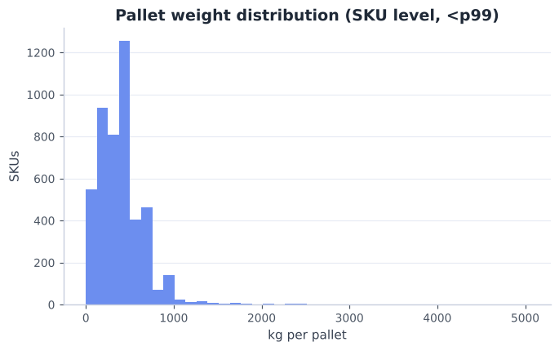
Fig 1. Pallet-weight distribution at SKU level (<p99).

4. Inventory & storage-position requirement Gleb (Storage)
Snapshot | Detail recs | Loads | Occupied locations | Active SKUs | Cube (m³)
2025-04-01 | 16,575 | 10,176 | 7,715 | 5,164 | 3,209
2025-05-01 | 16,793 | 10,534 | 8,149 | 5,273 | 3,434
2025-06-01 | 17,290 | 11,015 | 8,512 | 5,291 | 3,679

- Occupied locations (pallet positions) grew 7,715 → 8,512 over the quarter; loads grew +8.2% (10,176 → 11,015); cube +15%.
- Peak pallet positions ≈ 8,512 occupied locations → the storage baseline. The 11,015 loads sit in those locations (some locations hold more than one load), so loads overstate the positions needed (A004).
- Loads per SKU: mean 2.07, median 1, max 337; 72.7% of SKUs occupy a single load — a long slow-moving tail one pallet deep.
- Eaches held roughly flat (~2.9M) while loads rose → stock is fragmenting into more, less-full locations: a current-design inefficiency to target.
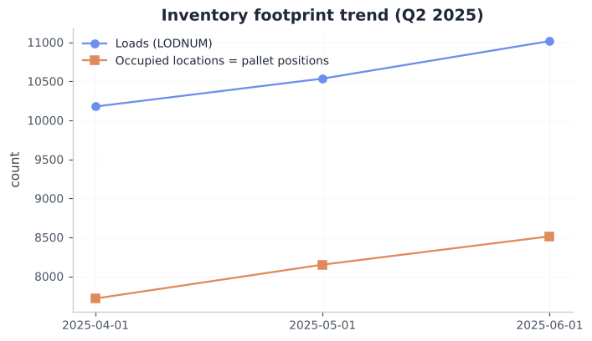
Fig 2. Inventory footprint trend, Q2 2025 (loads and occupied locations).
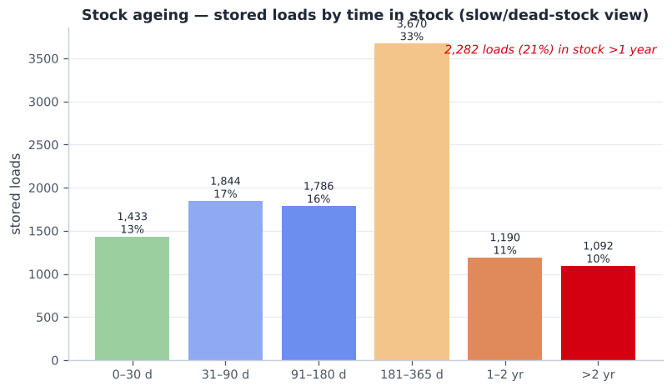
Fig 2b. Stock ageing — 21% of loads have been in stock >1 year (dead-stock signal).

5. Inbound profile (receiving) Vidhi (Receiving)
No receiving file was provided, so receipts are measured from the storage snapshots: loads with an ADD DATE in the 14 days before each snapshot (A007). Loads that already left before the snapshot are not visible, so these are lower bounds.
Snapshot | Receiving days | Loads booked in | Loads / day | Busiest day | From Asia
2025-04-01 | 10 | 709 | 71 | 111 | 22%
2025-05-01 | 9 | 974 | 108 | 167 | 54%
2025-06-01 | 9 | 1,058 | 118 | 160 | 48%

- ~99 loads are received per working day; the busiest day reached 167 (×1.69). Two shipments a day come straight from Assa Abloy factories (Rogier, course teacher, personal communication, October 7, 2026).
- ~41% of loads come from Asia and arrive loose in sea containers — cartons stacked on the container floor. A container brings a median of 20 pallets of 7 SKUs (p75: 34 pallets, 11 SKUs) that must be unpacked, sorted per SKU and palletised.
- Pallet mix: EURO, K3 and XLONG pallets; 255 loads are 1.3–2.05 m long, 10 loads weigh over 1 t and 42 are taller than 1.68 m.
- Hazardous goods: 2,197 loads carry the hazmat flag — they must be identified at receiving and stored by the rules (Section 10, D2 §5.3).
- Requirement for receiving: two trailer doors plus one container door; a separate zone to unpack containers; a check bench and pallet labels; capacity for a 1.7× busy day.

6. Order & picking profile and lead time Arnau (Picking)
Metric | Mean | Median | p95 | Max
Lines per order | 4.45 | 1 | 19 | 191
Units per line | 34.77 | 5 | 150 | 12020
Units per order | 154.7 | 8 | 575 | 20480

- 8,781 orders / 39,069 lines; 50.5% single-line orders and 23.6% single-unit lines — a small-order-heavy profile.
- Pick type is derived from what the client ordered (A022) — each line's quantity is compared with the SKU's case and pallet quantity: 75% each-pick lines, 24% case lines, 1% full-pallet lines (by units: 61% case, 26% each, 13% pallet).
- Picking is each-dominant by line count (the labour driver) and case-dominant by volume. DHL's historical pick flags (case/list 60.8%, each 16.0%, 20.6% unflagged) reflect past practice and are not used for design.
- Delivery lead time (order received → trailer leaves), per order: median 25 h, average 45 h, p90 102 h; 26% of orders leave the same day. Counted per order line instead the median is 52 h, because big multi-line orders wait longest. Measured as last TRAILER DISPATCED DATE − ORDER ARRIVE DATE of each order.
- Channel mix (order type): NLD 20,944, EDC 4,703, BEL 4,596, DIRECT 4,003, AMADE 2,216.
- Geography: NLD 22,510, BEL 6,386, DEU 3,534, FRA 1,041, POL 911 — an NL hub serving Western Europe.
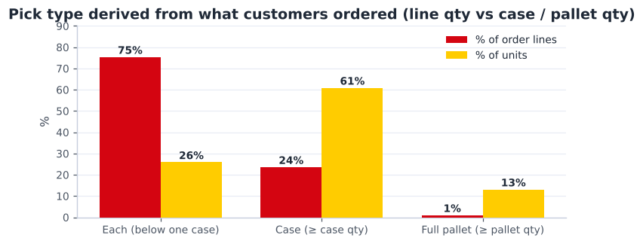
Fig 3. Pick type derived from the orders (line quantity vs case / pallet quantity).
Delivery lead time per region (order received → trailer dispatched), countries with ≥ 20 orders:
Country | Orders | Median h | Mean h | p90 h | ≤ 48 h
NLD | 5,115 | 25 | 39 | 98 | 71%
BEL | 1,707 | 25 | 38 | 84 | 74%
DEU | 793 | 23 | 56 | 171 | 70%
FRA | 381 | 8 | 32 | 117 | 81%
CHE | 172 | 140 | 104 | 166 | 24%
LUX | 112 | 24 | 31 | 74 | 81%
POL | 57 | 120 | 129 | 204 | 19%
AUT | 46 | 26 | 56 | 122 | 59%
GBR | 37 | 120 | 99 | 154 | 27%
CZE | 36 | 108 | 108 | 168 | 6%
ITA | 34 | 108 | 96 | 144 | 18%
EST | 33 | 74 | 113 | 230 | 18%
SWE | 31 | 71 | 86 | 146 | 23%
HRV | 31 | 144 | 128 | 149 | 13%
ISR | 25 | 148 | 124 | 184 | 4%
FIN | 24 | 71 | 119 | 264 | 0%
ESP | 22 | 75 | 78 | 140 | 27%
SVN | 20 | 142 | 131 | 170 | 15%

- NL, BE, DE, LU and FR ship in about a day (median 8–25 h); Switzerland (~140 h) and Poland (~120 h) take 5–6 days, pointing at customs or weekly consolidation for export — a service question to raise with DHL.

7. Outbound profile (shipping) Rachel (Shipping)
Measured from the 912 outbound trailers in Q2 2025 (trailer number and dispatch time per order line; Assa Abloy & DHL Supply Chain, 2025):
Measure | Value
Trailers per day (mean / p90 / max) | 15 / 19 / 22
Load per trailer (mean) | 1.2 pallets + 15 cartons
Trailers without any pallet (parcel only) | 73%
Dock time per trailer (mean / p90) | 18 / 22 min
Trailers in the busiest hour (p90 / max) | 9 / 12
Trailers parked at the doors at the same time today (median / p90) | 12 / 15

- Shipping is parcel-heavy: most trailers carry a few cartons for a parcel network (DHL Parcel, DSV, DHL4YOU …) and only about one pallet — so packing and sorting cartons per carrier matter more than pallet loading.
- Today trailers wait at the doors all day (p90 15 at once): goods are loaded whenever they are ready, so doors are blocked and the departure time is not planned.
- Requirement for shipping: a fixed departure plan per carrier, staging lanes so goods wait on the floor and not in trailers, enough doors for the busiest hour, and carton sorting per carrier.

8. Demand-based ABC classification Gleb (Storage) · Arnau (Picking)
ABC is recomputed from actual outbound demand (picked quantity), not assumed. The distribution is steeper than the classic 80/20 rule:
Top X% of SKUs | % of picked volume
5% of SKUs | 58.9%
10% of SKUs | 74.5%
20% of SKUs | 88.1%
30% of SKUs | 94.0%
50% of SKUs | 98.5%

A/B/C by demand volume (A ≤ 80% cumulative, B ≤ 95%, C remainder):
Class | SKUs | % SKUs | % volume | % pick-lines
A | 565 | 13.0% | 80.0% | 41.8%
B | 858 | 19.7% | 15.0% | 29.9%
C | 2,931 | 67.3% | 5.0% | 28.3%

- ~13% of SKUs drive 80% of volume, yet C-class is 67% of SKUs and still 28% of picks → forward-pick / fast-lane slotting is high-value.
- Demand-ABC agrees with the WMS classification on only 48.6% of SKUs → strong evidence the current slotting is misaligned with real demand (re-slot).
- 4,354 SKUs shipped in Q2; 855 shipped were not in the latest stock snapshot (transient/cross-dock — to confirm).
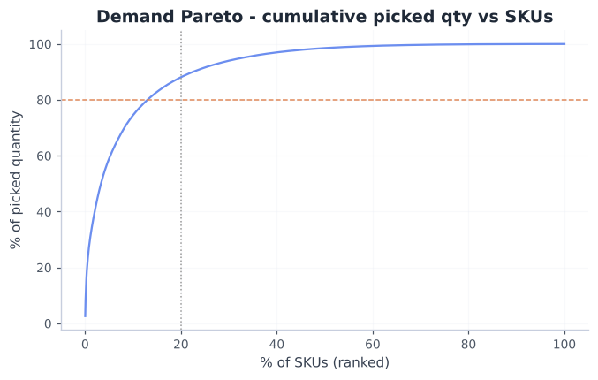
Fig 4. Demand Pareto — cumulative picked quantity vs ranked SKUs.
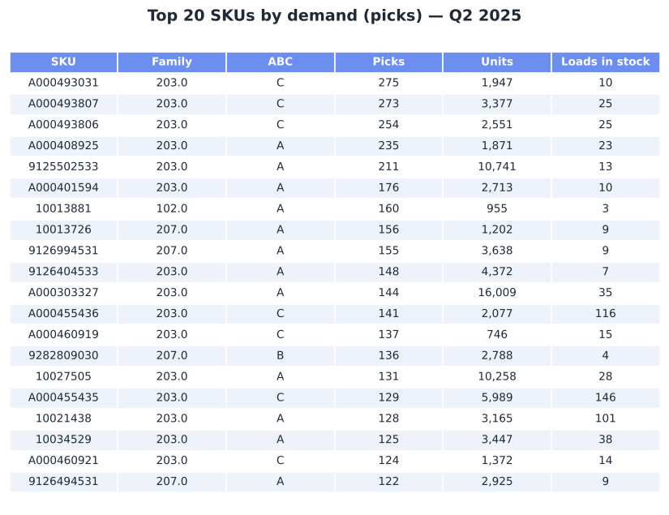
Fig 4b. Top-20 SKUs by demand — note several high-demand items still WMS-classed C.

9. Peak activity analysis Arnau (Picking) · Rachel (Shipping)
Metric | Average / day | PEAK / day | Peak ÷ Avg | Peak date
Order lines | 640 | 1171 | 1.83× | 2025-05-27
Units | 22269 | 63469 | 2.85× | 2025-05-27
Orders | 144 | 250 | 1.74× | 2025-04-29
Shipments | 134 | 229 | 1.71× | 2025-04-29

- Design to peak, not average. Units peak (2.85×) is far spikier than lines (1.83×), so sizing on lines alone understates pick/pack surges.
- Weekly peak 3563 lines (week of 2025-06-01) vs ~2791 average.
- The 08:00 intraday peak is caused by the order-release routine, not by customers (A023): 55% of orders arrive 15:00–17:00, are released 16:00–18:00 and are picked the next morning, so the backlog hits the floor at shift start (1.31× the average hour). Monday–Friday only, weekdays fairly even.
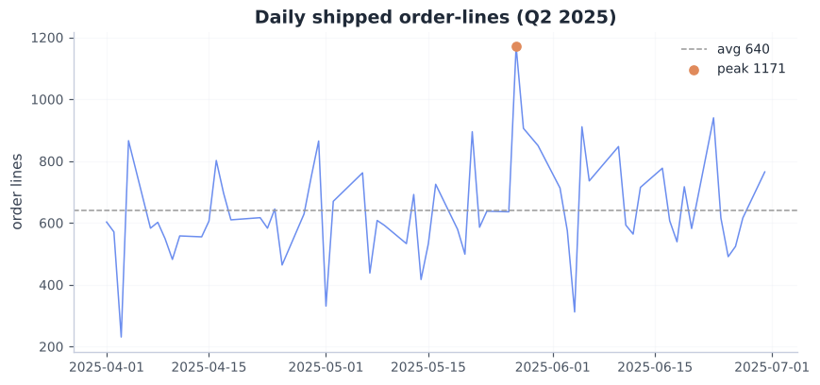
Fig 5. Daily shipped order-lines with average and peak.
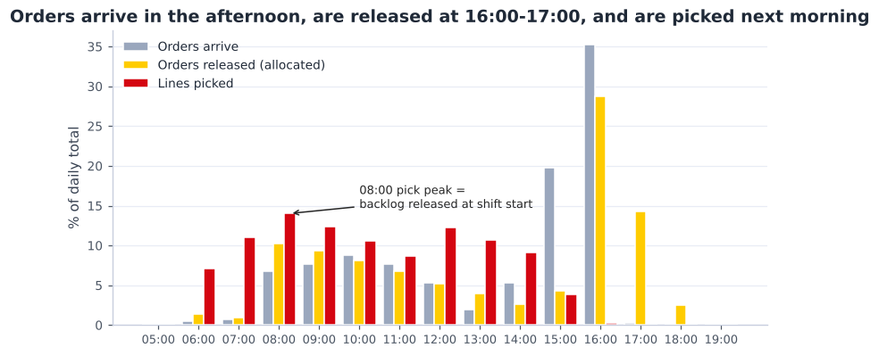
Fig 6. Order arrival vs release vs picking by hour — the 08:00 peak is the release backlog.

10. Data-quality flags
Raised, not silently corrected:
- PA WGT sentinel/impossible values — median 431 kg is fine, but p95 = 9999 kg and max = 60423 kg are impossible for one pallet (9,999 looks like a placeholder). To be cleaned before rack load-rating.
- units_per_pallet extreme mean (15171 vs median 1000) — use robust statistics.
- "Other" pick class = 20.6% of lines — no PALL/LIST/TROLLEY flag set. Resolved for the design: the pick type is derived from order quantities instead of these flags (A022).
- Stock vs demand mismatch — 855 shipped-not-stocked; a further set of stocked-not-shipped SKUs are dead-stock candidates. To confirm handling (cross-dock vs obsolete).
Data checks requested in class (Week 3):
Question | Answer | Note
Most ordered product | A000493031 — in 268 orders | 1,947 units picked in Q2
Heaviest SKU (single item) | A000316052 — 90.0 kg per piece | heaviest pallet (cleaned) 5,039 kg; p99 pallet 1,344 kg
Longest SKU | A000132438 — 205 cm (realistic maximum ~2 m, door size) | 76 SKUs recorded longer than 2.05 m (up to 1095 cm for a 0.5 kg item) are data errors (A043)
Most lines in one order | 191 lines | median order = 1 line
Max pallets in stock | 11,015 loads in 8,512 locations | June 2025 snapshot (peak of the quarter)

11. Operations strategy — process types, performance objectives and current alignment
Before choosing a design, this section asks what the operation is, what it must be good at for its customer, and whether it is good at that today. It uses the operations-strategy concepts of Slack et al.: the four V's, process types, the five performance objectives and order winners versus qualifiers (Slack et al., 2022).

11.1 The four processes and their type
The warehouse transforms inputs (pallets and containers from the factories, orders from customers) into outputs (complete orders on the right trailer). It is a chain of four processes, each with an owner:
Process (owner) | Input → output | Process type | What drives its performance
Receiving (Vidhi) | trailers and containers → checked pallets ready for putaway | batch: work arrives in loads, twice a day | ~99 loads/day, 41% loose in containers
Storage (Gleb) | pallets → stock in the right place, fast-pick faces filled | stock (buffer) process | 8,512 occupied locations at the peak, 4,354 SKUs shipped
Picking (Arnau) | orders → picked items | high-volume repetitive work with very high variety | ~640 lines/day, 75% each-picks
Shipping (Rachel) | picked items → packed orders on the booked trailer | scheduled batch: by trailer departure | ~15 trailers/day, 73% parcel-only

11.2 The four V's of the Assa Abloy operation
Dimension | Measured (Q2 2025) | Level | What it means for the design
Volume | ~640 order lines and ~144 orders a day; ~99 inbound loads; ~15 trailers | medium | repeatable tasks → standard methods, scanning and batching pay off
Variety | 4,354 SKUs shipped, 5,291 in stock; small parts to 2 m long pallets; each, case and pallet picks; pallets and loose containers; 138 hazardous SKUs | high | several storage types and picking by order size; no single automated system fits all items
Variation | peak day 1.83× lines and 2.85× units; 08:00 peak 1.31× the average hour; stock +16% per quarter | high (partly self-made) | level the self-made peak with waves; flexible staff; storage headroom
Visibility | business customers and web shops (5% of lines are web orders) see only the result: complete, correct and on time | low | efficiency can be designed in the back office, but the dispatch promise must be kept

Process type: high variety with medium volume of small, repetitive tasks puts the operation between a batch and a mass process on the product–process matrix (Slack et al., 2022). That matches a people-based process supported by scanners, carton flow and a put-to-light wall (Option B), not full automation (Option C), which suits high volume with low variety.

11.3 What the operation must be good at — performance objectives
For DHL, the Assa Abloy contract is won and kept on its service and its cost. We rank the five performance objectives (Slack et al., 2022) as follows — this ranking is our judgement, based on the data in the table:
Rank | Objective | What it means here | Order winner or qualifier | Evidence (data)
1 | Dependability | every order leaves on the agreed trailer, every day | order winner | orders arrive 15:00–17:00 (55%) and are expected out the next day
2 | Speed | short time from order to trailer | order winner | today only 37% of orders leave within 24 h
3 | Quality | right item, right quantity, safe and legal storage | qualifier | benchmark pick accuracy ≥ 99.3% (Extensiv, n.d.); 2,197 hazardous loads
4 | Cost | low cost per order line for the contract | order winner at contract renewal | labour is the largest cost; the 08:00 peak forces over-staffing
5 | Flexibility | absorb peaks, growth and new items | qualifier | peak day 1.83× lines; stock +16% per quarter

11.4 Is the current operation aligned with these objectives?
Objective | Today (measured or modelled) | Gap | Design response
Dependability | all orders released in the evening → 08:00 peak of 1.31× the average hour; trailers parked at the doors (p90 15 at once) | large | 3 waves planned backwards from a fixed trailer departure plan (D2 §4.5)
Speed | median 25 h, slowest 10% 102 h; 37% within 24 h | large | same-day wave for orders before 12:00 → 65% within 24 h (D3)
Quality | slotting agrees with demand for only 48.6% of SKUs; master-data errors (Section 10) | medium | slotting by demand, a scan at every move, the put-to-light wall checks every item
Cost | ~31 picker-hours a day (modelled: one order per tour, peak staffing) | large | batch picking from a fast-pick area → ~12 h a day (D3 §2.2)
Flexibility | 21% of loads older than one year; racks would be full in ~4 months at the April–June growth | medium | dead-stock clean-up, a reserved 12th rack module, flexible staff

- Conclusion: the current operation is organised around storing (positions filled after a rushed move) instead of around the flow the customer pays for: dispatch on time, fast, at low cost. The biggest gaps are dependability, speed and cost — all three are caused by how work is released and picked, not by a lack of space.
- So the design aims first at flow (waves, fast-pick area, batch picking, departure plan) and then at storage density. Section 12 turns these objectives into requirements per process; Deliverable 3 measures them with KPIs.

12. Design requirements per process (input to design options)
The data (Sections 3–10) and the performance objectives (Section 11) give these requirements. Each process owner checked that the design meets them:
Process (owner) | Requirement | From
Receiving (Vidhi) | ~99 loads/day, 167 on the busiest day; 2 trailer doors + 1 container door; a zone to unpack and palletise containers | Section 5
Storage (Gleb) | ~8,512 pallet positions at the peak → target ~9,500 (÷ 0.90); room for long pallets up to 2.05 m; 72.7% single-load SKUs; re-slot to demand (only 48.6% agreement today); within 7,000 m² and 12.2 m | Sections 3, 4, 8
Picking (Arnau) | 75% each-pick lines and half of the orders single-line → batch picking from a fast-pick area; capacity for 1171 lines on the peak day; level the 08:00 peak | Sections 6, 8, 9
Shipping (Rachel) | ~15 trailers/day, mostly parcels; a departure plan per carrier; staging lanes instead of parked trailers; doors for the busiest hour | Section 7
All (group) | dependability and speed first, then quality and cost (Section 11); choices aligned across the four processes | Section 11

13. Storage capacity feasibility Gleb (Storage)
Design target: peak 8,512 occupied locations ÷ 0.90 working utilisation ≈ 9,500 pallet positions (A010). This replaces the earlier 14,074 (loads × 1.15 buffer), which overstated the need by counting loads instead of positions. Measured pallet+load height is low (p90 116 cm), giving a 1.41 m level pitch and up to 8 levels under 12.2 m.
Bottom-up floor area needed to hold that target, by storage concept:
Concept | MHE | Levels | Total area m² * | % of 7,000 m² | Fits?
Selective - wide aisle | Counterbalance FLT | 6 | 6,810 | 97% | TIGHT
Selective - narrow aisle | Reach truck | 7 | 5,040 | 72% | YES
Double-deep | Reach truck (deep) | 7 | 4,280 | 61% | YES
VNA | VNA turret truck | 8 | 3,390 | 48% | YES
Drive-in | Counterbalance FLT | 5 | 6,330 | 90% | TIGHT

* includes a 35% allowance for receiving, staging, pick, pack, ship, offices and circulation.
- At the corrected target several concepts fit: double-deep 61%, narrow-aisle selective 72%, VNA 48%. Wide-aisle (97%) and drive-in (90%) are tight.
- → Space alone no longer decides the concept. The choice is driven by travel and labour, slotting flexibility, growth headroom and cost — compared in the options and decision matrix below.
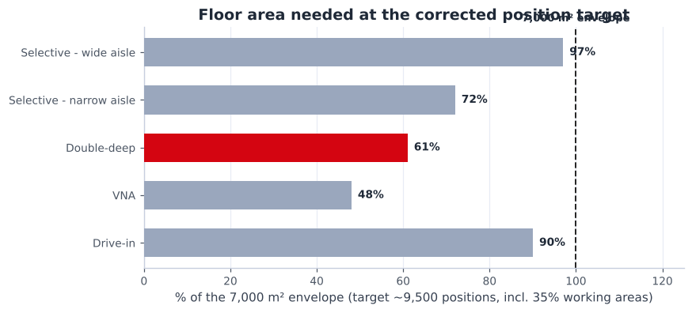
Fig 7. Floor area to hold the corrected position target, by concept, vs the 7,000 m² envelope.

14. Design options
Three end-to-end options (storage × picking × MHE × policies), each aligned across the four processes. Storage systems and picking methods are taken from the Week 3 lecture and the order-picking literature (HAN University of Applied Sciences, 2026a; de Koster et al., 2007).

Option A — Conventional+ (improve the current concept)
- Storage: selective single-deep, narrow-aisle (reach), 7 levels; two-zone ABC. ≈72% of the envelope.
- Picking: RF-directed discrete + simple batch; case pick from pick-face; pallet from reserve.
- MHE: reach trucks, low-level order pickers, pallet trucks, RF scanners.
- Verdict: cheapest and simplest, but the most aisles, travel and labour.

Option B — Hybrid density + velocity slotting + zone/batch picking (recommended)
- Storage: single-deep pallet racking placed back-to-back (one pallet each side of the rack, every pallet directly reachable from an aisle), 3.0 m reach-truck aisles, 8 levels; selective racks for irregular SKUs + a forward-pick module (carton-flow / shelving) for fast case/each; a long-goods module for XLONG pallets; bin shelving for small slow parts. ≈72% of the envelope for storage + working areas.
- Update (Deliverable 3): first drafted as double-deep; changed to single-deep back-to-back (team decision: no two-deep racks). The drawn layout holds 8,960 positions; moving 2,657 small slow parts to bins frees 1,005 locations, so the peak need fits — and no telescopic forks are needed.
- Picking: zone + batch/wave picking (batches the 50% single-line orders); A-movers in a golden-zone forward pick; voice/RF; put-to-light consolidation at pack.
- MHE: reach trucks with standard forks (Jungheinrich ETV 216i), pick trolleys for small orders and walkie pallet trucks (EJE 120i) for large orders, rider pallet trucks (ERE 225) at the docks, voice/RF, print-and-apply — sized in Deliverable 2.
- Policies: velocity (demand-ABC) slotting, hybrid random-within-zone storage, min/max replenishment, FIFO via FIF DATE where relevant.
- Verdict: fits the envelope, materially lower travel/labour than A thanks to slotting and batching, moderate CAPEX — strongest business case.

Option C — High-density / semi-automated
- Storage: VNA (man-up turret) for reserve + automated small-parts store (shuttle/AutoStore-style) for the large C each-pick tail. ≈48% of the envelope (densest).
- Picking: goods-to-person / pick-to-light for smalls; VNA combined storage+pick; automated sortation.
- MHE: VNA turret trucks + guidance, automation modules, minimal manual MHE.
- Verdict: densest and lowest labour, but highest CAPEX and complexity; ROI depends on labour cost.

15. Decision matrix & recommendation
Option | Weighted score (max 5) | Result
B - Hybrid density | 3.75 | RECOMMENDED
C - Semi-automated | 3.70 | Strong alternative
A - Conventional+ | 3.05 | Baseline

Weight-sensitivity (robustness):
Option | Base | Cost-driven | Space-driven
B - Hybrid density | 3.75 | 3.65 | 4.75
C - Semi-automated | 3.70 | 3.35 | 4.85
A - Conventional+ | 3.05 | 3.35 | 3.55

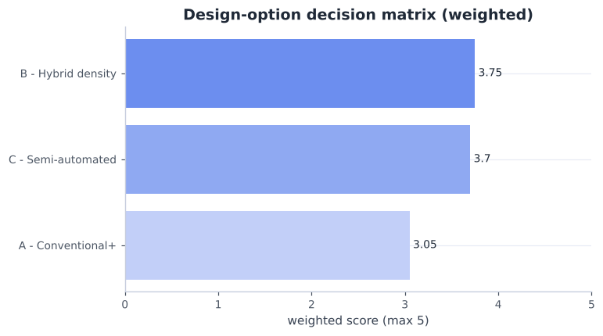
Fig 8. Weighted decision-matrix scores.
- Recommended: B - Hybrid density. It wins on base and cost-driven weightings; C overtakes only when space is the dominant criterion — likely if A008 resolves to a small Assa-only envelope.
- Why (data): single-deep reach racking holds the corrected target in ≈72% of the envelope with every pallet directly accessible (no honeycombing); 75% of order lines are each-picks and 50% of orders single-line → batch/zone picking from a fast-pick area is the biggest labour lever; 48.6% ABC mismatch → velocity slotting is a cheap, high-value win; 73% single-load tail → dense reserve.
- Conditions before locking: confirm the 7,000 m² scope (A008); obtain labour/equipment costs (A006) to confirm B vs C in the financial model (done in Deliverable 3); the EURO/K3/XLONG pallet mix was checked against the single-deep racks in Deliverable 3 (long pallets up to 2.05 m in 4.5 m bays behind a 3.2 m aisle).
Recommended concept preview (detailed layout and 3D in Deliverable 2):
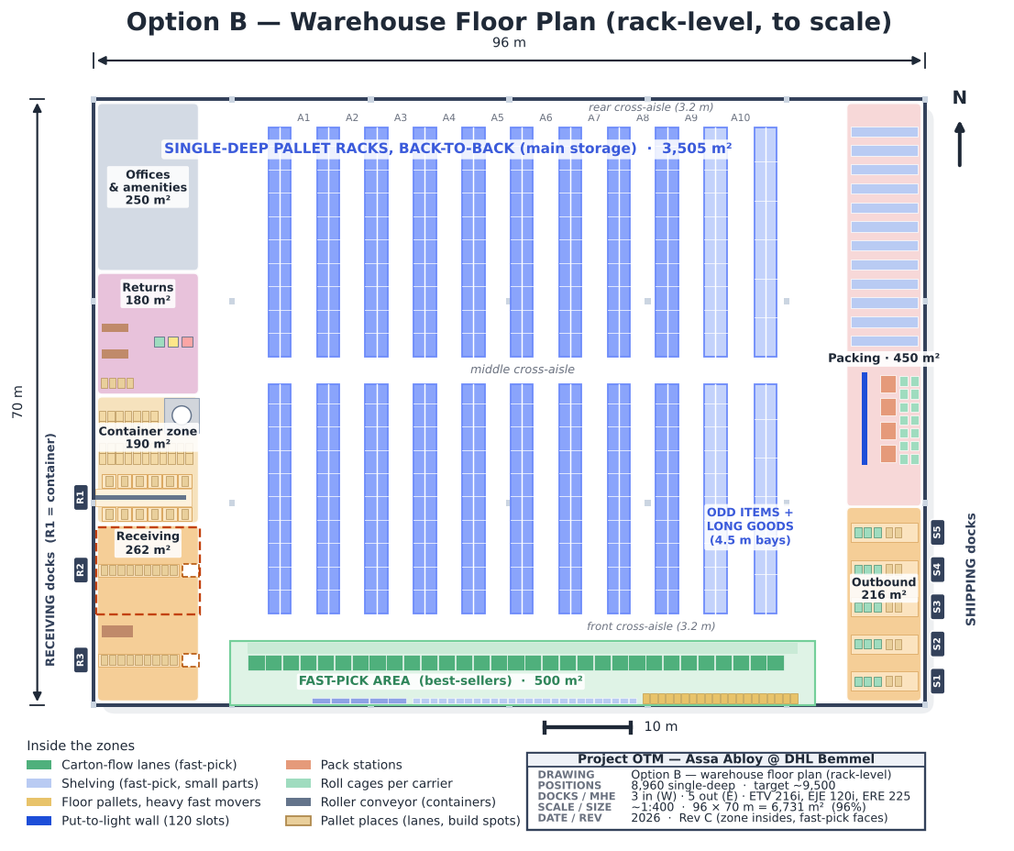
Fig 9. Recommended Option B — warehouse floor plan (rack-level, to scale).

16. Assumptions & open questions
Logged in data/assumptions.json. Items that materially affect the design:
ID | Assumption / open question | Impact
A001 | Max facility footprint | HIGH
A002 | Max clear/building height | HIGH
A003 | Analysis period is representative of normal operation | HIGH
A004 | Storage requirement is based on OCCUPIED LOCATIONS (pallet positions), not loads | HIGH
A005 | STAGED STATUS 'LATE' reflects staging vs the LATE SHIP window, i.e. a genuine on-time-staging miss | HIGH
A006 | No labour-productivity, MHE-fleet or cost data was provided | HIGH
A008 | The 7,000 m2 / 12.2 m envelope is the space available to DESIGN THE ASSA ABLOY operation within | HIGH
A010 | Design pallet-position target | HIGH
A013 | Functional (non-storage) areas sized from actual order volume | HIGH
A014 | Labour productivity benchmarks (units/person-hour) | HIGH
A017 | Peak-aware slotting: spread fast movers, duplicate extreme SKUs, balance picks/aisle on peak forecast | HIGH
A018 | Inbound arrives as 2 shipments per day, direct from Assa Abloy factories | HIGH
A019 | Part of inbound arrives LOOSE (floor-loaded sea containers) and is de-stuffed and palletised by hand | HIGH
A020 | Dock-door planning parameters | HIGH
A022 | Pick type is derived from what the client ordered, not from DHL's historical pick flags | HIGH
A024 | Picking is split by ORDER SIZE computed from SKU each-dimensions and weights | HIGH
A025 | Pick-time model parameters | HIGH
A028 | Hazardous SKUs: hazard class unknown - PGS 15 (packaged hazardous substances) or PGS 37 (lithium batteries) to be confirmed | HIGH
A030 | Labour cost per paid hour | HIGH
A033 | Racking prices | HIGH
A042 | Small parts move from pallet racks to bin shelving | HIGH

References
APA 7th edition. Conversations with the course teacher and DHL are personal communications and are cited in the text only.
Assa Abloy, & DHL Supply Chain. (2025). Assa Abloy storage details (1 April, 1 May and 1 June 2025) and outbound details (April–June 2025) [Unpublished raw data]. DHL Supply Chain, Bemmel.
Baker, P., & Canessa, M. (2009). Warehouse design: A structured approach. European Journal of Operational Research, 193(2), 425–436. https://doi.org/10.1016/j.ejor.2007.11.045
de Koster, R., Le-Duc, T., & Roodbergen, K. J. (2007). Design and control of warehouse order picking: A literature review. European Journal of Operational Research, 182(2), 481–501. https://doi.org/10.1016/j.ejor.2006.07.009
Extensiv. (n.d.). 3PL fulfillment KPIs: Formulas & benchmarks. Retrieved October 18, 2026, from https://www.extensiv.com/blog/3pl-fulfillment-kpis-formulas-benchmarks
HAN University of Applied Sciences. (2026a). [Lecture slides on warehouse design, layouts, storage and order-picking systems, week 3]. OPERMB04 Operations Management. Unpublished course material.
HAN University of Applied Sciences. (2026b). Project DHL on the move: Project OTM [Unpublished project brief]. OPERMB04 Operations Management.
Slack, N., Brandon-Jones, A., & Burgess, N. (2022). Operations management (10th ed.). Pearson.

Part 2 — Future state
Assessment form: Future state (process mapping, layout, zoning & capacity plan)

PROJECT OTM
Future-State Operational Design
Assa Abloy operation · DHL Supply Chain, Bemmel (NL_0032)
Field | Detail
Deliverable | 2 — Proposed future state for the in-scope processes
Due date | 07-10-2026
Concept | Option B — Hybrid density + velocity slotting + zone/batch picking
Envelope | ≤ 7,000 m² · ≤ 12.2 m
Team | Group 3 — Vidhi (Receiving), Gleb (Storage), Arnau (Picking), Rachel Selvarathnam (Shipping)
Version | Final portfolio version — processes, layout, capacity plan, planning and control (Section 7)

Future-state design for the recommended Option B (Deliverable 1). Workload drivers are measured from the Assa Abloy Q2-2025 data; equipment data come from Jungheinrich; productivities and handling allowances are documented assumptions (Section 7) to be validated with DHL. Reproducible from analysis/*.py.
Who is responsible for what
Every team member hands in this whole document (the complete warehouse design). Each process has one owner; the sections of a process carry the owner's name in their heading. Sections without a name were made by the whole group.
Process | Owner | Scope | Sections in this document
Receiving | Vidhi | unloading trailers and containers, checking, container unpacking, returns intake — up to the pick-up point | §2.1, §2.5, §4.1, §4.3, §4.6, §7.1
Storage | Gleb | putaway, racks and storage places, slotting, replenishment of the fast-pick area, inventory control | §2.1, §2.2, §3.1, §3.2, §5.2, §5.3, §7.2
Picking | Arnau | order release (waves), picking, sorting batch picks into orders at the put-to-light wall | §2.3, §2.4, §4.2, §6.2, §7.3
Shipping | Rachel | packing, outbound staging, dock doors, trailer departure plan and loading | §2.4, §4.4, §4.5, §5.4, §7.4

1. Recommended concept and what changed
Option B was selected in Deliverable 1. It combines single-deep pallet racking placed back-to-back (one pallet each side, every pallet reachable from an aisle), a module for odd items, a long-goods module with 4.5 m bays, bin shelving for small slow parts, and a fast-pick area (carton-flow / shelving) for the best-sellers, run with demand-based slotting and zone + batch picking. This version builds in the points agreed with the teacher and DHL:
Topic | Before | Now (this version)
Storage basis | 14,074 positions (11,015 loads + buffer) | ~9,500 positions: peak 8,512 occupied locations ÷ 0.90
Pick method | DHL's historical pick flags (61% case) | Derived from the orders: 75% each / 24% case / 1% full-pallet lines
Inbound | Estimated from flow balance | Measured ~99 loads/day; 2 shipments/day from Assa Abloy factories, pallets + loose containers
Dock doors | 3 + 3 assumed | Calculated: 3 receiving (west, 1 container dock) + 5 shipping (east)
Equipment | Generic truck types (then ECE 225 for picking) | Jungheinrich ETV 216i ×2, EJE 120i ×3, ERE 225 ×2 + 6 pick trolleys; ECE 225 dropped (too long for the aisles, 2 pallets far too big for the orders)
Picking | One method for all orders | Split by order size: 84% small orders on trolleys (batch), 16% large orders picked onto a pallet
Aisles | Racks run to 1.5 m from the wall (dead ends) | Front + rear cross-aisles: every aisle open at both ends — no U-turns
Trailers | Leave whenever loaded | Departure plan by carrier (14 slots); 3 pick waves planned backwards
Loose containers | Unpacked at the dock door | Own 190 m² loose-container zone at door R1: unpack, sort per SKU, build pallets
Racking | Double-deep (telescopic forks) | Single-deep back-to-back: 8,960 positions incl. 320 long-goods, standard forks
Small parts | A pallet location each | 2,657 slow small SKUs in half-bins on 188 shelving bays next to the put-wall
Fast-pick area | 500 m² band, inside not drawn | 930 carton-flow lanes (refilled from the rear) + a wall row of shelves and floor pallets across the pick aisle: a pick face for all 1,409 A/B SKUs (A046)
Receiving doors | R2 and R3 side by side | R2 in the north half, R3 in the south half: R2's half can be lent to container unpacking while R3 keeps working (A044, A047)
08:00 peak | Treated as customer demand | Caused by the order-release routine → release in waves

The design follows the steps of the Week 3 design approach (HAN University of Applied Sciences, 2026a; Baker & Canessa, 2009) and was iterated after each feedback round:
Design step (W3) | Where it is done
Define requirements and objective | D1 §9 requirements; brief limits 7,000 m² / 12.2 m
Collect and analyse data | D1 §3–8 (SKUs, stock, orders, ABC, peaks); D2 §4.1 inbound
Process flows, handling, storage and throughput | D2 §2 processes; §4 docks, departures, order release
Equipment, storage and handling systems, policies | D2 §3 policies and COI slotting; §6.2–6.3 picking and machinery
Layout, zones and flows | D2 §5, incl. the U-shaped vs flow-through evaluation
Evaluate (cost, performance) | D2 §6 capacity and W3 KPIs; Deliverable 3 CAPEX/OPEX
Iterate | 14,074 → 9,500 positions; ECE 225 → trolleys + EJE 120i; front/rear cross-aisles; docks to side walls

2. Future-state processes
Each process below states the steps, the system transaction, the physical movement, the equipment, and where the Deliverable-1 design choices are applied. The swimlane (Fig 1) gives the end-to-end overview; per-process flowcharts follow.
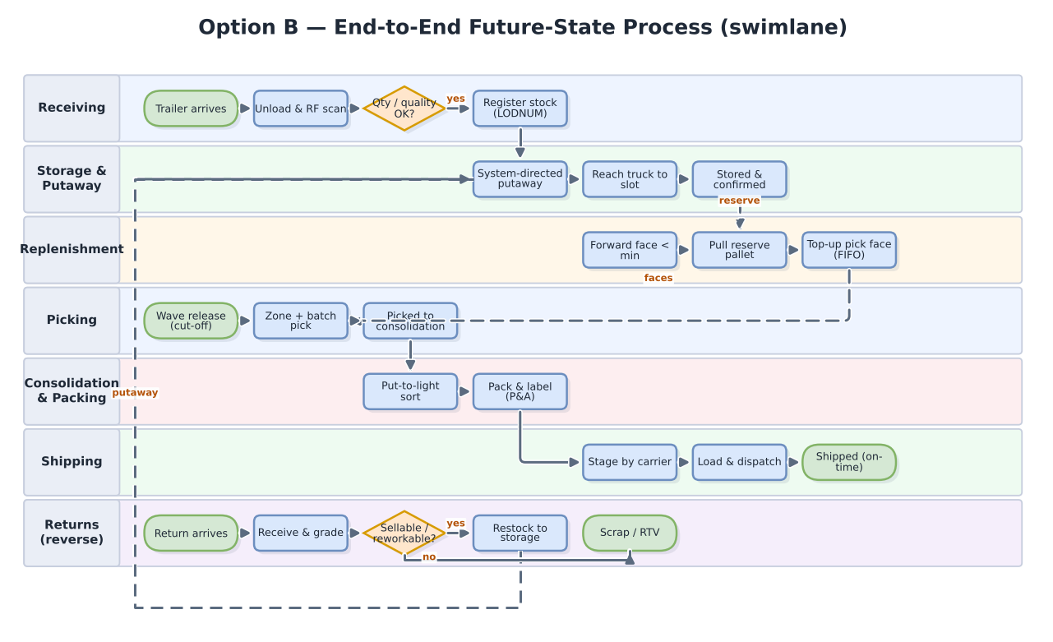
Fig 1. End-to-end future-state process — cross-functional swimlane.

2.1 Receiving & putaway Vidhi (Receiving) · Gleb (Storage)
- What arrives: 2 shipments a day straight from Assa Abloy factories (Rogier, course teacher, personal communication, October 7, 2026). Trailers from the European plants arrive palletised; sea containers from Asia (~41% of loads) arrive loose — cartons stacked on the container floor.
- Palletised trailer (doors R2–R3): dock → unload with ERE 225 pallet truck → RF-scan against the ASN → quantity/quality check → register the load (LPN) → system-directed putaway with an ETV 216i reach truck → confirm.
- Loose container (door R1, next to the loose-container zone): dock → a 2-person crew rolls the cartons out on an extendable roller conveyor, sorts them by SKU and builds pallets on the build spots → stretch-wrap, print LPN labels, scan against the ASN → the pallet goes to normal putaway. About 3 h per 40 ft container (A019, A026, Section 4.6).
- Where (Fig 2b): each trailer door has an unload lane with 9 pallet places, a check bench and a pick-up point where the reach truck collects the pallet; R2 is in the north half of receiving and R3 in the south half. The container zone at R1 has the roller conveyor, 12 build spots (one per SKU), room for 35 finished pallets and a wrap/label station.
- Policy applied: demand-based directed putaway (A/B reserve close to the fast-pick area, C further away); pallets over 1 t on low levels, tall loads on the top level; long goods (up to 2.05 m) in the long-goods module via its 3.2 m aisle (where each kind of load is stored: Fig 2c).
- Truck route: reach trucks use the left perimeter aisle and the cross-aisle, never the fast-pick area — Jungheinrich's 'clear traffic guidance' principle (Jungheinrich, n.d.-d).
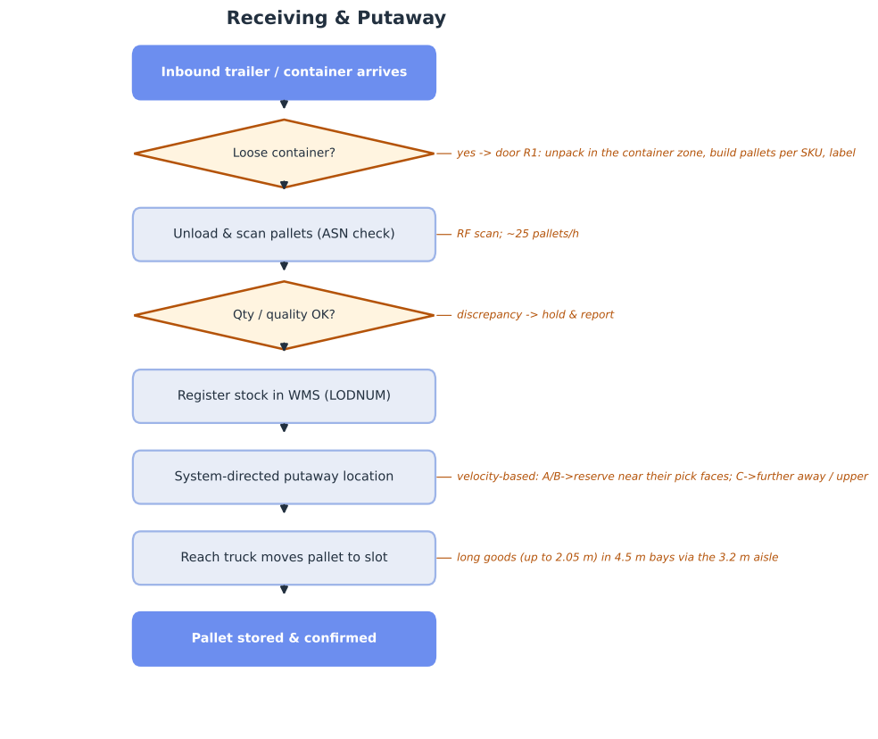
Fig 2. Receiving & putaway flow.
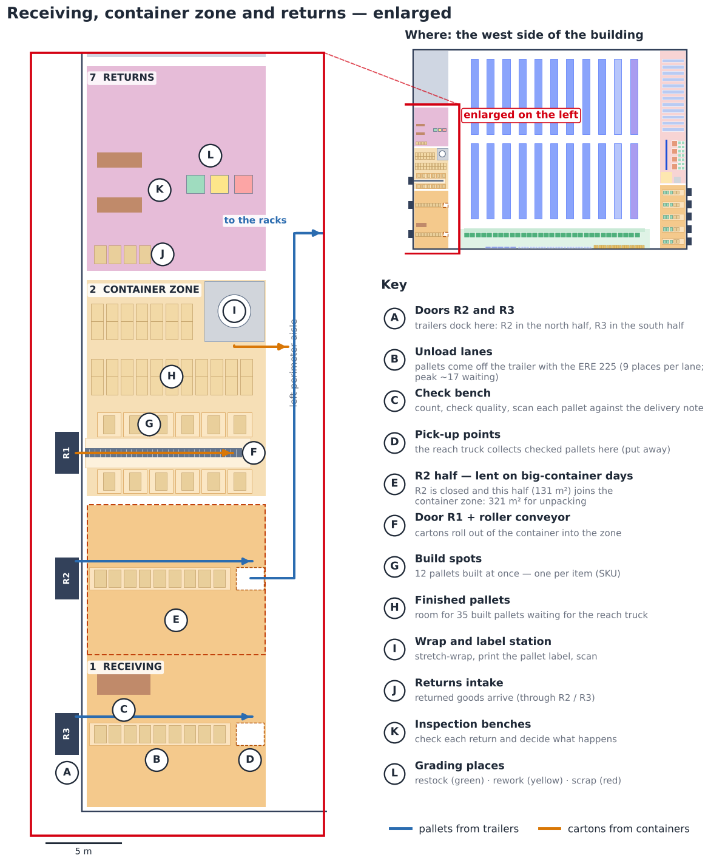
Fig 2b. Receiving, the container zone and returns enlarged (west side), with the key.
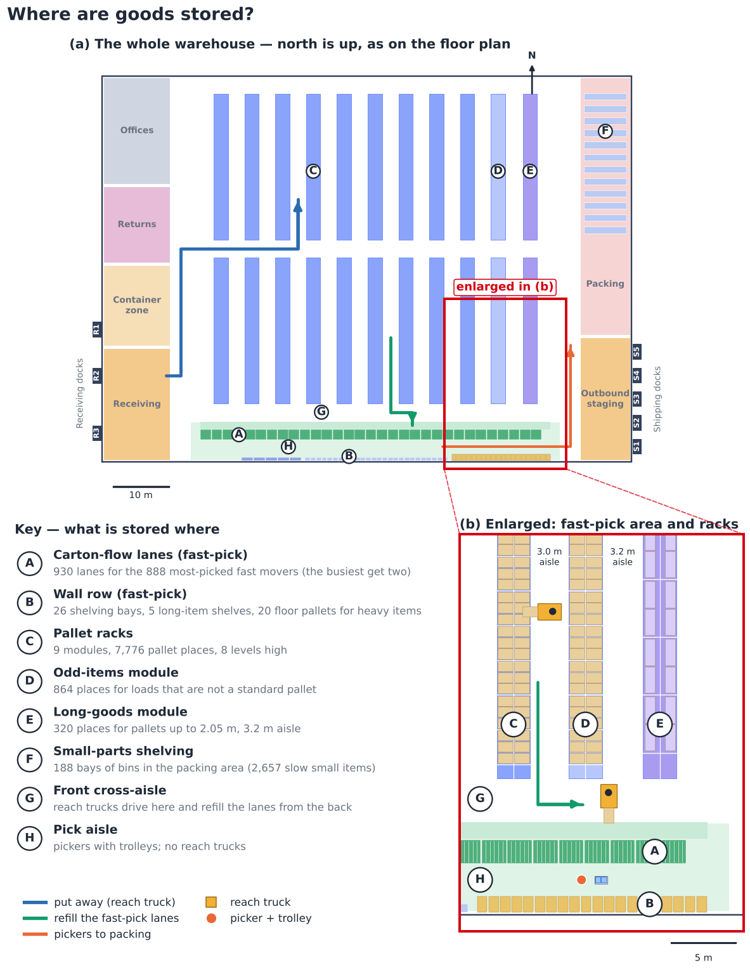
Fig 2c. Where goods are stored: the whole warehouse, the fast-pick area and the racks enlarged, with the key.

2.2 Replenishment Gleb (Storage)
- Steps: fast-pick face below minimum → WMS replenishment task → ETV 216i takes the reserve pallet down the storage aisle → puts it down in the refill strip behind the carton-flow lanes → the driver slides the cases into the lane from the rear → confirm (~24 pallets/day on average).
- The fast-pick area (Fig 3b, A046): 31 carton-flow bays give 930 lanes for the 888 most-picked A/B SKUs (90% of their lines; the busiest 42 get a second lane). The other 521 A/B SKUs — less picked, long or heavy — stand on the wall row across the same pick aisle (shelves, long-item shelves, floor pallets) and are refilled by hand or with the EJE 120i between the waves.
- Policy applied: min/max replenishment; FIFO via FIF DATE where relevant. Pickers work the front of the lanes and trucks the rear, so people and reach trucks never share a face.
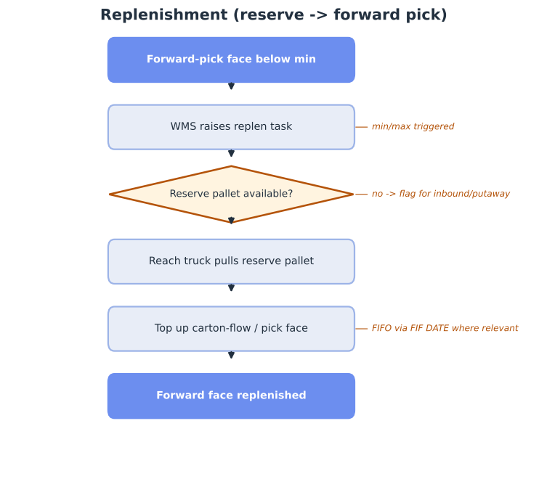
Fig 3. Replenishment flow.
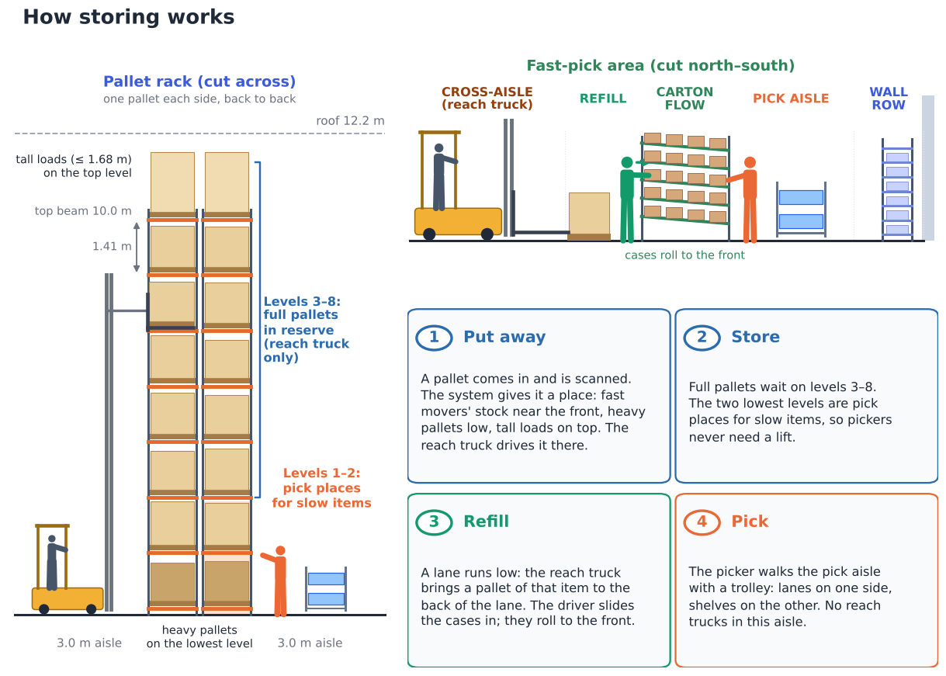
Fig 3b. How storing works: a rack cut across, the fast-pick area cut north–south, and the four steps put away → store → refill → pick.

2.3 Picking (zone + batch / wave) Arnau (Picking)
- The order decides the method (A022, A024). The typical order is only 7 litres (75% fit in one tote), while the biggest orders carry most of the volume. At release the WMS computes each order's volume and weight from the SKU data and sends it down one of three routes:
- Small orders → pick trolley (84% of orders, 46% of lines): zone batch picking — a picker per zone fills a 6-tote trolley with the wave's lines up to its volume/weight limit (~31 lines per tour); the put-to-light wall sorts them per order.
- Large orders → pick-to-pallet with an EJE 120i (16% of orders, 88% of volume): one order per pallet (median 234 L, 140 kg), dropped at packing.
- Full-pallet lines (1% of lines) → ETV 216i straight from reserve to outbound.
- Small slow parts (2,657 SKUs, ~93 lines/day) → bin shelving next to the put-wall: the item is picked into the order's tote and goes straight into the put-wall — no walk into the reserve aisles.
- Where: A/B items in the fast-pick area (zone 1); other C items at the low levels of the reserve aisles (zones 2–3). Aisles are open at both ends, so pickers and pallet trucks walk straight through — no U-turns.
- Why not the ECE 225: 3.7 m long with 2.4 m forks, it cannot turn in 3.0 m aisles, and its 2 pallets (~2,300 L) would need ~333 typical orders to fill one trip (Section 6.3).
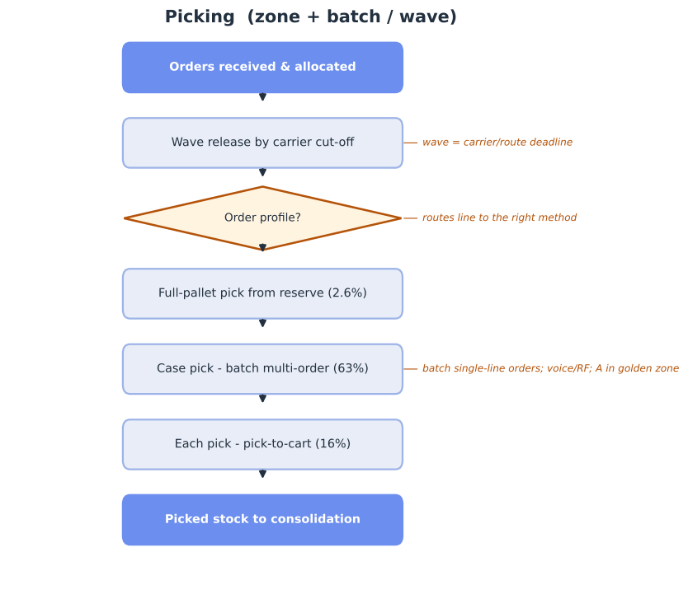
Fig 4. Picking flow (zone + batch/wave).

2.4 Consolidation, packing & shipping Rachel (Shipping) · Arnau (Picking)
- Steps: full trolleys of batch-picked totes → put-to-light wall sorts the items into orders → pack, print-and-apply → parcel cartons onto roll cages by carrier / large-order pallets wrapped → stage by carrier → live-load at the booked time → dispatch.
- Where: the put-to-light wall stands at the south end of the packing area (east side), with its pick side on the right perimeter aisle where the pickers arrive and the pack stations behind it (Fig 5b).
- The put-to-light wall (Fig 5c): 24 × 5 = 120 slots, 10.8 m long, open on both sides; each slot holds one order tote. The putter scans an item, the slot of its order lights up with the quantity, the item goes in and the light is pressed. When an order is complete the light on the pack side goes on and the packer takes the tote out. Small slow parts are picked from the bin shelving directly behind the wall (Deliverable 3, §5.1–5.2).
- Measured outbound: 15 trailers/day (p90 19), carrying on average only 1.2 pallets + 15 cartons; 73% of trailers carry no pallets at all (DHL Parcel routes).
- Policy applied: carriers book collection time slots from a fixed departure plan (Section 4.5); goods wait in the outbound staging lanes, not in parked trailers; 5 shipping doors on the east wall (Section 4.4).
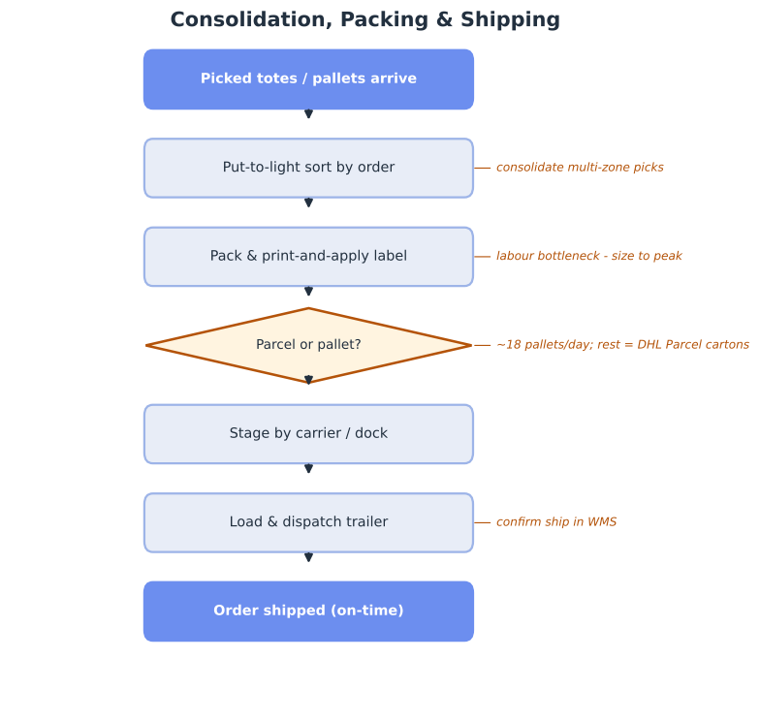
Fig 5. Consolidation, packing & shipping flow.
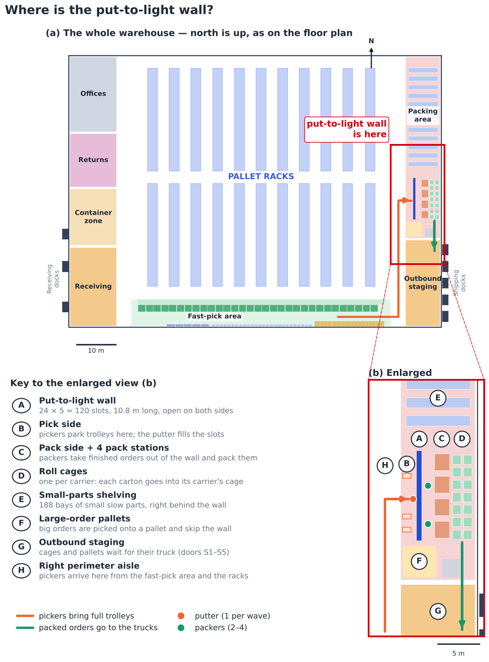
Fig 5b. Where the put-to-light wall is: the whole warehouse and the packing area enlarged.
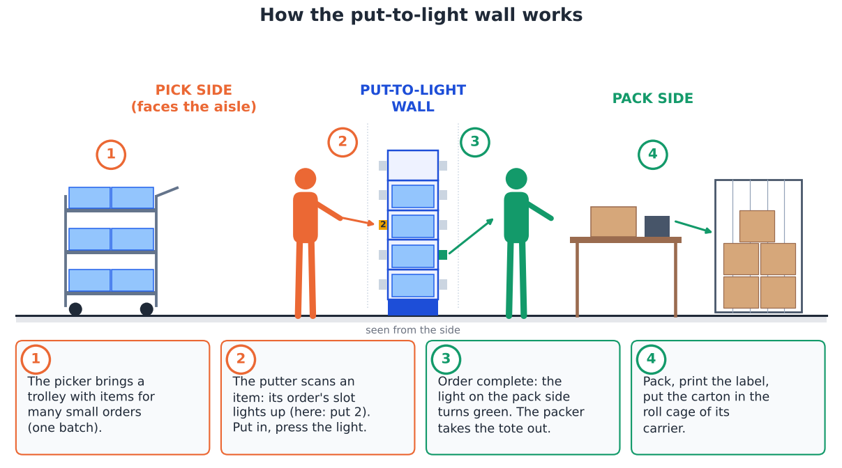
Fig 5c. How the put-to-light wall works, seen from the side.

2.5 Returns (reverse logistics) Vidhi (Receiving)
- Steps: customer return arrives through the receiving doors → receive & scan (RMA) → inspect and grade in the Returns area → sellable: restock · reworkable: rework, then restock · otherwise scrap / return to vendor → update inventory and credit.
- Policy applied: returns re-enter through the same demand-based putaway, so graded stock rejoins the reserve.
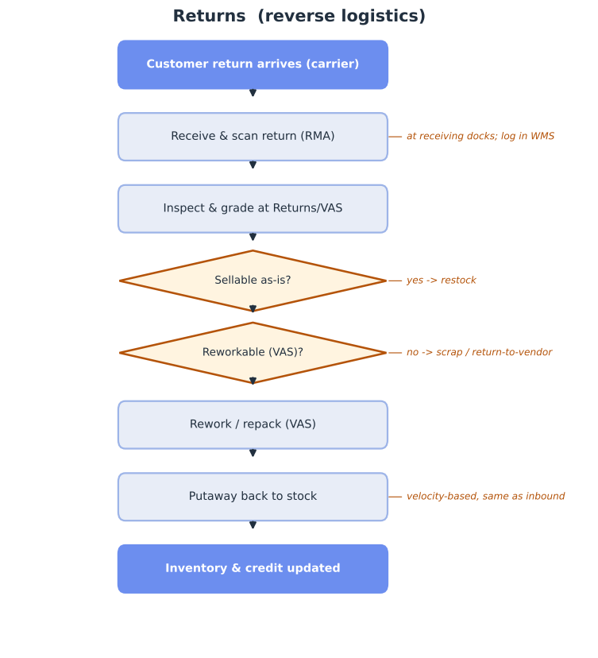
Fig 6. Returns / reverse-logistics flow.

3. Warehouse policies
Policy | Decision | Why (data)
Storage | Random within velocity zones; fixed fast-pick faces + random reserve; small slow parts in bins, not on pallets | 73% single-load tail; 48.6% ABC mismatch; 2,657 SKUs have ≤ 50 L of stock
Slotting | Demand-ABC; fast movers spread across zones, extreme SKUs duplicated; heavy low | 13% SKUs = 80% volume; A = 60% of picks (Gadeyne, n.d.)
Zoning | Fast-pick (A/B) vs reserve; truck routes kept out of the pick zone | 75% of order lines are each-picks; safety (Jungheinrich, n.d.-d)
Batching | Small orders: zone batch picking, trolley filled to volume/weight; large: one order per pallet | median order 7 L; 88% of volume in large orders
Order release | 3 waves (06:00, 09:30, 12:45) planned backwards from trailer departures | 08:00 = 1.31× the mean hour (A023)
Routing | Largest gap in the reserve aisles; return route in the fast-pick area | shortest walk of 4 W3 policies tested (Section 6.2)
Putaway | System-directed, velocity-based to zone | align stock to demand
Replenishment | Min/max top-up from the rear of the lanes | keep faces filled at peak
Dock scheduling | Carrier time slots; stage, then live-load; 1 container dock | 15 trailers/day, 73% parcel-only; ~41% loose inbound
FIFO / FEFO | FIFO via FIF DATE where relevant | parts mostly not date-critical

3.1 Peak-season slotting (congestion control) Gleb (Storage)
At peak, congestion — not walk distance — becomes the dominant cost (Gadeyne, n.d.). Because the peak is spiky (1.83× lines / 2.85× units) and picks are concentrated, clustering all fast movers in one golden zone would jam a single area. We therefore adopt peak-aware slotting:
- Picks are concentrated: the top 1% of SKUs (~43) do ~15.0% of all picks, and A-class SKUs ~60.0% of picks.
- Spread fast movers across all pick zones (balanced on peak-day pick frequency): one zone would carry ~60.0% of picks; spread over 3 zones each carries ~20.0%.
- Duplicate the extreme SKUs (~43 items) in different zones to allow parallel picking.
- Levers in priority order (Gadeyne, n.d.): slotting → order batching → wave-release timing → pick-path sequencing.
- Validate by simulation at 150% / 200% / 250% of normal volume (Deliverable 3).

3.2 Slotting by Cube-per-Order Index (COI) and affinity Gleb (Storage)
W3 key principle: the racking configuration should match each product's turnover, using the COI = storage space a SKU needs ÷ how often it is picked (HAN University of Applied Sciences, 2026a). Low COI = little space, many picks → closest to packing.
COI quintile | A SKUs | B SKUs | C SKUs
Q1 (best) | 161 | 172 | 121
Q2 | 111 | 152 | 191
Q3 | 83 | 124 | 247
Q4 | 73 | 105 | 276
Q5 (worst) | 56 | 70 | 328

- COI confirms the ABC slotting: the best COI fifth of SKUs carries 55% of all picks, the best two fifths 72% — these fill the fast-pick area first.
- COI corrects ABC in two places: 129 A items are bulky (poor COI) → kept on pallet faces at ground level near packing, not in carton-flow; 121 C items are tiny but picked often (best COI) → moved into the fast-pick shelving.
- Affinity: in multi-line orders, 62% of item pairs share a product family vs 40% by chance → families are slotted together within each zone. Half of all orders are single-line, so affinity refines COI rather than replacing it.

4. Inbound, order release & dock doors

4.1 What comes in Vidhi (Receiving)
No separate receiving file was provided, so receipts are measured from the storage snapshots: loads with an ADD DATE in the 14 days before each snapshot (A007). Loads already shipped before the snapshot are not visible, so these are lower bounds.
Snapshot | Receiving days | Loads booked in | Loads / day | Busiest day | From Asia %
2025-04-01 | 10 | 709 | 71 | 111 | 22%
2025-05-01 | 9 | 974 | 108 | 167 | 54%
2025-06-01 | 9 | 1,058 | 118 | 160 | 48%

- ~99 loads are received per working day; the busiest day reached 167 (×1.7).
- 2 shipments a day, direct from Assa Abloy factories (Rogier, course teacher, personal communication, October 7, 2026) — in China, Germany, Romania, the Netherlands, Spain, Finland and others.
- ~41% of loads come from Asia and arrive loose in sea containers. The largest receipts (70–100 loads, all from China) take 1–3 days to book in — consistent with de-stuffing and palletising by hand.

4.2 Why picking peaks at 08:00 Arnau (Picking)
Fig 7. Orders arrive in the afternoon, are released at 16:00–17:00 and are picked the next morning — the 08:00 peak is the release backlog.
- 55% of orders arrive between 15:00 and 17:00, and ~43% are released (allocated) between 16:00 and 18:00.
- Picking starts at 06:00 and peaks at 08:00 at 1.31× the average working hour: the whole afternoon backlog lands on the floor at the start of the shift (A023).
- Future state: release work in 3 waves — W1 at 06:00, W2 at 09:30, W3 at 12:45 (W3 is the same-day wave for orders received before 12:00, Section 4.5). Levelling the load frees ~24% of peak-hour picker capacity without any change in customer service.

4.3 Inbound dock doors Vidhi (Receiving)
Doors needed = the larger of (a) door-hours ÷ (receiving window 8 h × 85% utilisation) and (b) the number of arrivals that can be at the dock at the same time. A palletised trailer occupies a door ~1.3 h (unload with ERE 225 at ~1 min per pallet + 20 min dock-on and paperwork); a loose container ~3.3 h.
Scenario | Door-hours / day | Doors by capacity | Arrivals at once | Doors needed
Average day: 1 palletised trailer + 1 loose container | 4.6 | 1 | 2 | 2
Peak day: palletised volume x1.7 + 1 loose container | 5.3 | 1 | 2 | 2
Worst case: 2 loose containers (4 h de-stuff each) | 8.7 | 2 | 2 | 2
Sensitivity: ~8 smaller trucks/day (WMS truck IDs) | 4.3 | 1 | 3 | 3

Result: 3 receiving doors on the west wall — R1 a container dock (leveller with the range for container chassis), R2–R3 for trailers. The two daily shipments need 2 doors so a 3-hour container never blocks a trailer; the third door covers the 'many smaller trucks' case, customer returns and breakdowns.

4.4 Outbound dock doors Rachel (Shipping)
Sized trailer by trailer from the 912 outbound trailers in Q2. Dock time per trailer = 15 min dock-on and paperwork + loading of its actual pallets and roll cages with an ERE 225 (mean 18 min, p90 22 min). Doors are sized on the busiest hour: p90 9 trailers × 18 min ÷ (60 min × 85%) = 3.1 → 4 doors, plus 1 spare.
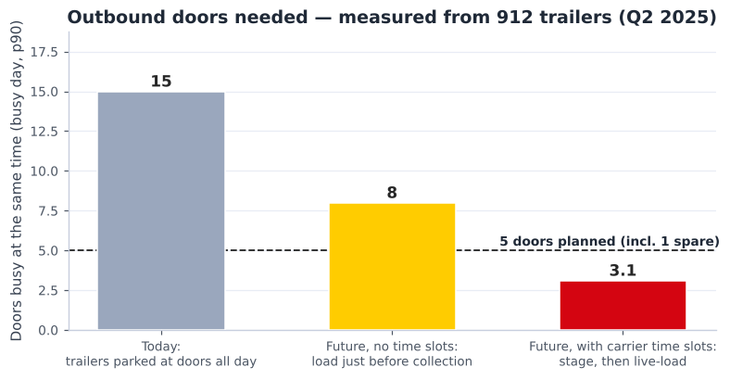
Fig 8. Outbound doors needed today vs in the future state (busy day, p90).
Measure | Value
Trailers per day (mean / p90 / max) | 15 / 19 / 22
Load per trailer (mean) | 1.2 pallets + 15 cartons
Trailers with no pallets (parcel only) | 73%
Trailers dispatched in the busiest hour (p90 / max) | 9 / 12
Today: trailers parked at the doors at once (p90) | 15
Future without time slots (p90) | 8
Future with carrier time slots | 3.1 → 5 doors incl. 1 spare

- Result: 5 shipping doors on the east wall, next to outbound staging and packing.
- Carrier time slots are a condition of this design. WMS dispatch times are closed in batches (60% of afternoon dispatches are under 2 minutes apart); without booked slots up to 8 doors would be needed, and today's all-day parked trailers would need ~15.
- Main carriers (trailers/day): Ex-works (customer pickup) 3.0, DHL DSV 2.4, DHL Parcel Netherlands 2.1, DHL Parcel NL DACH 1.4, DHL Parcel BE & LU 1.1, DHL4YOU 1.0.

4.5 When trailers leave — departure plan Rachel (Shipping)
Trailers get fixed departure slots, set close to each carrier's current median departure time (measured), and the picking waves are planned backwards from them: every wave finishes at least 45 minutes before the departure time of the trailers it feeds, leaving time to pack and stage.
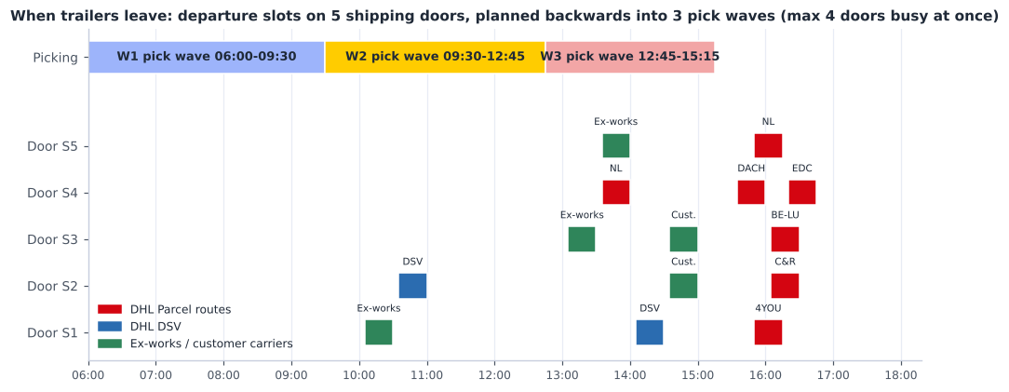
Fig 9. Departure slots on the 5 shipping doors and the 3 pick waves that feed them (max 4 doors busy at once).
Departure | Carrier | Trailers | Fed by wave
10:30 | Ex-works pickup (AM) | 1 | W1
11:00 | DHL DSV run 1 | 1 | W1
13:30 | Ex-works pickup (PM) | 1 | W2
14:00 | DHL Parcel NL run 1 | 1 | W2
14:00 | Ex-works pickup (PM) | 1 | W2
14:30 | DHL DSV run 2 | 1 | W2
15:00 | Customer carriers | 2 | W2
16:00 | DHL Parcel NL DACH | 1 | W3
16:15 | DHL Parcel NL run 2 | 1 | W3
16:15 | DHL4YOU | 1 | W3
16:30 | DHL Connect & Return | 1 | W3
16:30 | DHL Parcel BE & LU | 1 | W3
16:45 | DHL Parcel EDC | 1 | W3

- Waves: W1 06:00–09:30 (afternoon orders from the day before); W2 09:30–12:45 (rest of the backlog + morning orders); W3 12:45–15:15 (orders received before 12:00 (same-day parcel)).
- Same-day service becomes possible: 32% of orders arrive before 12:00 and can go out on the afternoon parcel trailers via wave 3; later orders leave the next day.
- Doors: at most 4 of the 5 doors are in use at once (25-minute slots), leaving one free for ex-works pickups that arrive late or early.

4.6 Loose containers — their own zone Vidhi (Receiving)
After the last feedback meeting, loose containers get their own 190 m² zone directly behind door R1, between receiving and returns, so unpacking cartons does not share space with pallet receiving. The zone is sized from 568 Asian receipts in the stock data: a container brings a median of 20 pallets of 7 SKUs (p75: 34 pallets, 11 SKUs).
Part of the zone | m²
Unload lane with extendable roller conveyor (12 x 2 m) | 24
Pallet build spots (12 x 3 m2) | 36
Finished-pallet buffer (35 x 1.9 m2) | 66
Label / scan / stretch-wrap station | 16
+30% walkways → needed | 185
Planned in the layout | 190

Who does the work | How | DHL labour | Pros | Cons
In-house DHL crew | 2 DHL staff unpack each container in the loose-container zone at door R1 | 6 person-h per container | Full control, flexible timing | Heavy manual handling, training, peak days need 2 crews
On-site specialist contractor | Contractor crew unpacks and palletises in the same zone, paid per container | none | No own labour or peak staffing; specialist speed and safety; cost scales with containers | Per-container fee (no public price - quote needed); booking coordination
Port / CFS devanning | Container unpacked and palletised near the port; arrives as a palletised trailer | none | Simplest receiving - everything palletised | Extra transport and handling cost; ~1 day longer lead time; less control

Is that enough for a big container? Unpacking spreads cartons over the floor while they are sorted. A median container needs ~134 m², the p90 container ~186 m² and the largest (89 pallets, 82 SKUs) ~458 m². 91% of containers fit the zone.
- Big containers borrow door R2 (A044): receiving needs at most ~80 m² of its 262 m², because the two reach trucks put pallets away while the trailer is unloaded (peak ~17 pallets waiting). On a big-container day R2 is blocked and the north half of receiving (131 m²) becomes extra unpacking space: 321 m² in total, enough for 97% of containers.
- Doors still fit: with R2 blocked, R1 (container) and R3 (trailers) remain — the base and peak scenarios need 2 doors. R2 is only blocked when the booked arrivals show no second trailer that day.
- The few largest containers (more SKUs than build spots) are sorted in two passes: first the SKUs with the most cartons, then the rest from mixed pallets.
Decision rule: the zone is the same in both cases. A DHL crew costs about €128 per container (Deliverable 3); an on-site contractor is chosen only if its fixed price per container is lower (Prestatie Personeelsdiensten, n.d.-a, n.d.-b). Port devanning stays the fall-back if containers ever need to arrive palletised.

5. Layout & zoning (3-dimensional)
Zones are sized from the measured volumes and laid out as a straight-through flow: goods come in on the west side and leave on the east side. Building ≈ 96 m × 70 m.
Zone | Area m² | % of building
Receiving & inbound staging | 262 | 4%
Loose-container zone (unpack & palletise) | 190 | 3%
Offices & amenities | 250 | 4%
Returns / VAS | 180 | 3%
Single-deep pallet racks (A/B/C reserve) | 3,505 | 52%
Odd-item + long-goods modules | 728 | 11%
Fast-pick area (carton-flow / shelving) | 500 | 7%
Packing & consolidation | 450 | 7%
Outbound staging & shipping | 216 | 3%
Circulation / aisles | 450 | 7%

Total floor area 6,731 m² = 96% of the 7,000 m² envelope.
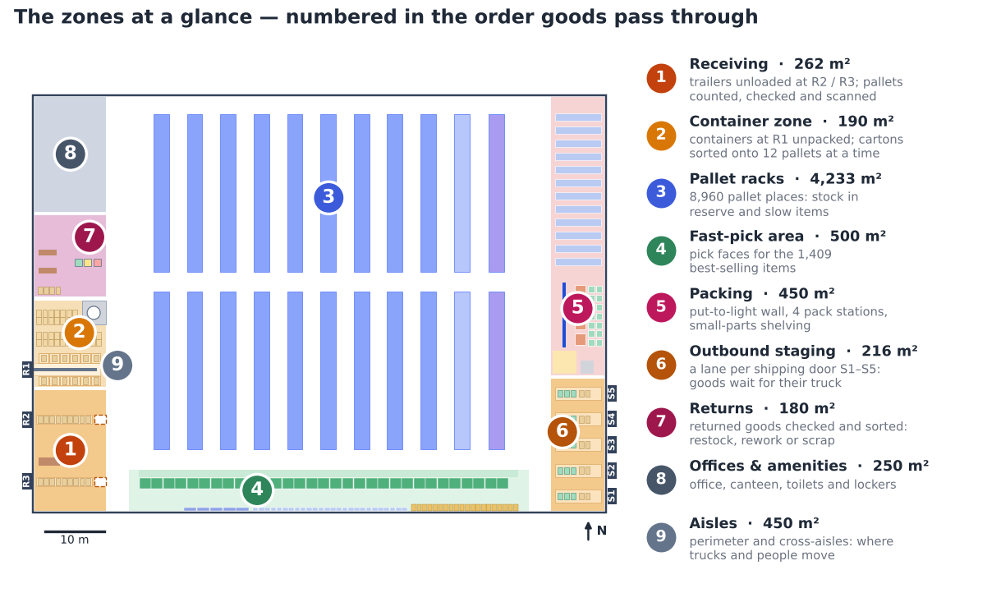
Fig 9b. The nine zones, numbered in the order the goods pass through them, with what happens in each (Deliverable 3 §3 adds who works there and when).
- Storage: 8,960 single-deep positions, counted on the drawing (11 back-to-back rack modules × 2 rows × 18 bays × 3 pallets × 8 levels) against a target of ~9,500 (peak 8,512 occupied locations ÷ 0.90). Top beam 10.0 m, within the ETV 216i's 10.7 m lift; one module (864 positions) holds odd items and one long-goods module holds 320 pallets of up to 2.05 m (4.5 m bays, two pallets each). Small slow parts leave the racks for bin shelving, which frees 1,005 locations: the peak need drops to ~7,507 locations (84% of the racks).
- Working areas sized from measured volumes: inbound ~99 loads/day (peak 167); outbound 18 pallets + 225 cartons/day.
- Docks: 3 receiving (west: R1 = container dock beside the loose-container zone, R2 and R3 for trailers in the north and south half of receiving) and 5 shipping (east, one staging lane per door). A trailer door needs ~4.3 m of wall — the 9.9 m receiving and 9.5 m outbound columns are too narrow on the south wall, so the doors sit on the side walls. This also separates inbound and outbound truck traffic.
- Aisles open at both ends: three 3.2 m cross-aisles (front, middle, rear) break up the racking, so no truck or picker ever needs a U-turn. Storage aisles are 3.0 m — wider than the ETV 216i needs (2.63–2.79 m; Jungheinrich, 2019) and far wider than the EJE 120i (1.79–1.94 m; Jungheinrich, n.d.-a); the aisle in front of the long goods is 3.2 m (Section 5.2).
Fig 10. Detailed warehouse floor plan (rack-level, to scale) — racks, aisles, docks, dimensions, and the inside of every zone: unload lanes, container zone, fast-pick lanes and wall row, packing, outbound lanes.
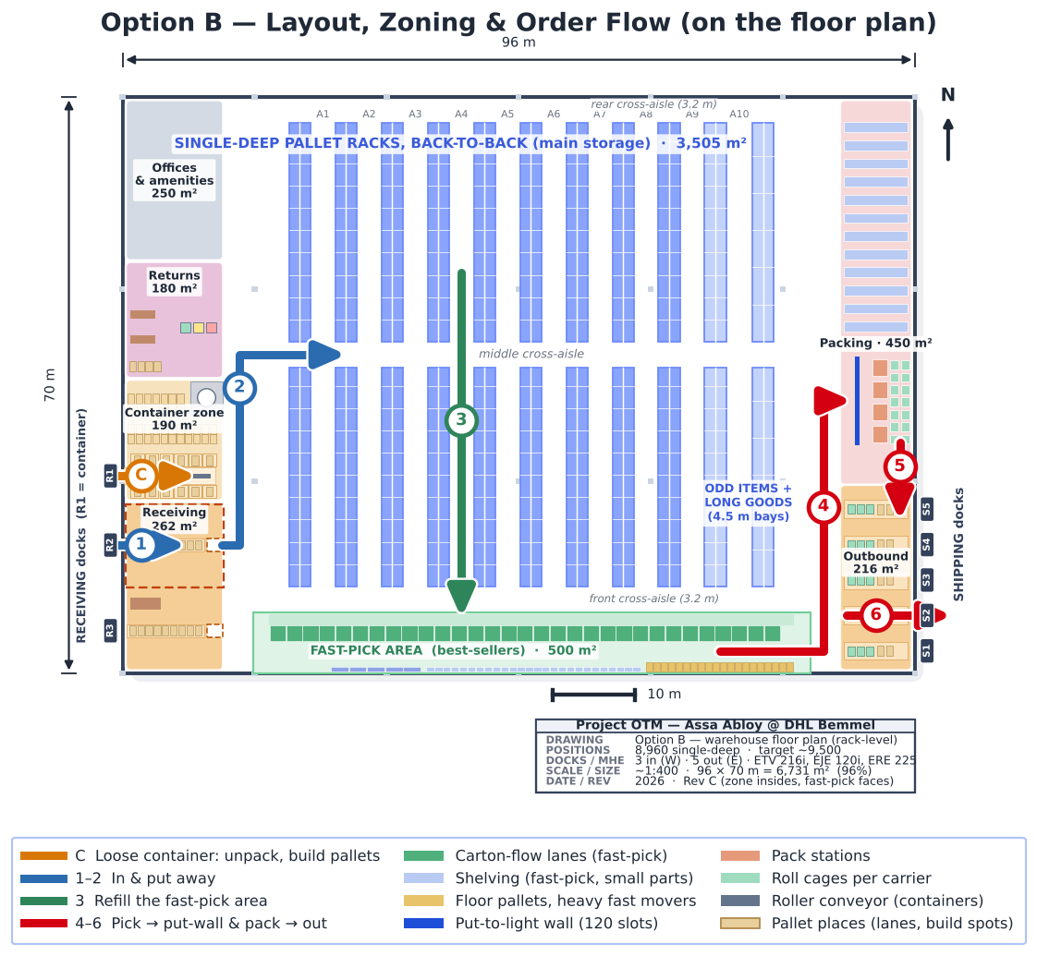
Fig 11. Main flow on the floor plan: in (R2) → put away → refill → pick → put-to-light wall and pack → out (S2). Arrows follow the real truck and picker routes; container flow C via R1.
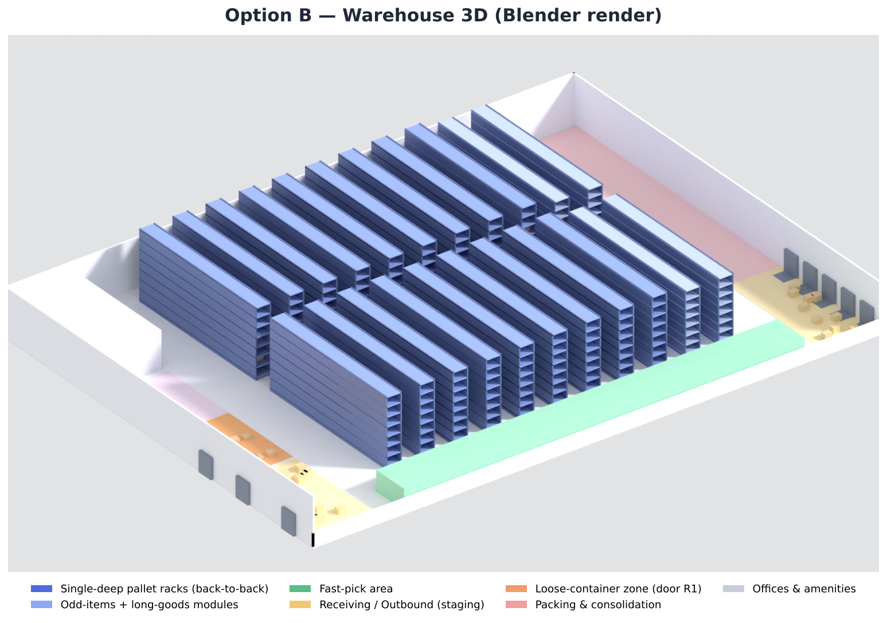
Fig 12. Option B in 3D (Blender): rack rows, fast-pick area, zones, 3 receiving doors (west) and 5 shipping doors (east).
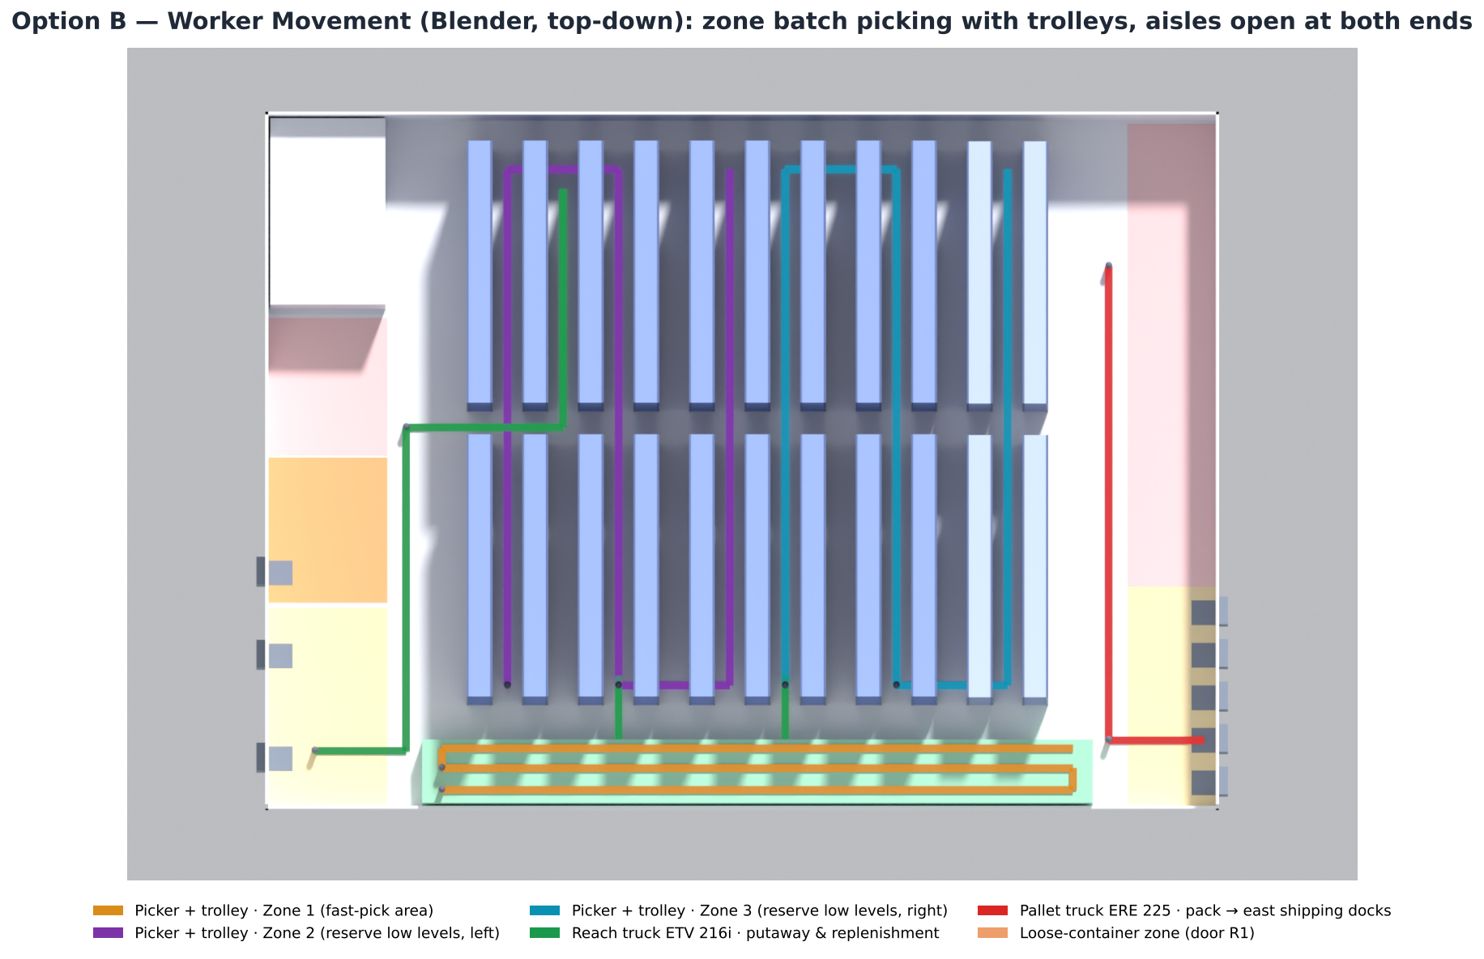
Fig 13. Worker and truck movement (Blender, top-down): pickers with trolleys in zones 1–3, reach trucks ETV 216i via perimeter and cross-aisle, ERE 225 to the shipping doors.

5.1 Layout concept: U-shaped or flow-through?
W3 asks to produce a few basic concepts, evaluate them on travel distance and select the best. The two dock configurations from the literature — flow-through and U-shaped (Huertas et al., 2007) — were compared on the Option B layout, with class-based storage and the measured inbound mix:
Criterion | Flow-through (chosen) | U-shaped
Put-away travel (reach truck, per load, one way) | 65 m | 59 m (-9%)
Reach-truck time saved per day | - | ~11 min
Picking travel (all picks start/end at packing, east) | same | same
Dock doors | 8 (separate in/out) | ~6 if inbound always arrives before noon (shared)
Traffic and errors (Huertas et al.) | Inbound and outbound separated - less congestion, fewer mix-ups | Inbound, returns and outbound share one dock face
Fit to our profile (Huertas et al.) | Suits high volume, long/narrow buildings | Suits strong ABC (ours: 13% of SKUs = 80%)

Verdict: Keep flow-through. U-shaped saves only ~9% put-away travel (~11 reach-truck minutes/day) because slow C items still bring 46% of inbound loads and picking travel is identical; its door saving depends on all inbound arriving before noon, which sea containers cannot guarantee. Flow-through keeps inbound, returns and outbound apart and fits the side-wall dock lengths.

5.2 Rack and aisle configuration — the W3 design questions Gleb (Storage)
Question (W3) | Our answer | Why
How many aisles? | 10 storage aisles between 11 rack modules | 9 standard modules + 1 odd-items + 1 long-goods module
How long is each aisle? | ~56 m, split into two runs of ~26.5 m | middle cross-aisle halves the walk to any face
Cross-aisles — where, how many? | 3: front, middle, rear (3.2 m) | aisles open at both ends → largest-gap routing, no U-turns; costs ~6% rack length
How do pallets go into the racking? | EUR 800×1200 with the 800 mm side to the aisle, 3 per 2.7 m bay; one pallet deep per side, racks back-to-back; long pallets (≤ 2.05 m) 2 per 4.5 m bay | standard forks on the ETV 216i; long pallets forked on the long side (load centre 400 mm → full 1.6 t)
How wide is the aisle? | 3.0 m storage, 3.2 m for long goods and cross/perimeter | ETV 216i needs 2.63–2.79 m; with a 2.05 m load crosswise 2976 mm (VDI formula on Jungheinrich, 2019 data)
1-way or 2-way traffic? | storage aisles: one truck at a time; main aisles: trucks one-way (west up with put-aways, east down to packing) | pickers stay in their zones; fewer crossings
How high is each level? All the same? | 1.41 m pitch → 8 levels; taller loads on the top level | p90 load height 1.16 m + 0.25 m beam/clearance; top load ~1 m under the roof
Product characteristics? | heaviest item 90.0 kg per piece; pallets > 1 t low; longest real item ~2 m | mechanical handling only for heavy items; 115 loads recorded longer than 2.05 m (up to an '11 m' item of 0.5 kg) are data errors

5.3 Legal aspects of pallet storage Gleb (Storage)
- Racking (EN 15512 / EN 15635; SSI Schäfer, n.d.; STOW, n.d.): racks designed to EN 15512; in use, a trained employee inspects visually every week and a competent expert at least every 12 months; damage is classed green/amber/red and every bay shows a load sign.
- Fire safety: the top of the highest load stays ~1 m below the 12.2 m roof (sprinkler clearance assumed ≥ 0.5 m, A011 — to confirm against the sprinkler design).
- Hazardous goods (rechecked, A028): 138 SKUs, 2,197 loads (20% of loads), ~385 t gross — counted per load, the same way in all three snapshots (1,727, 1,895, 2,197 loads). The customs codes show what they are (table below): 97% are electronic safes, locks, alarms, cameras and readers — most likely lithium cells built into the product (UN3481/UN3091, class 9). Those fall under PGS 37-2 (lithium energy carriers, from 333 kg; 1,000 kg for small cells; Evofenedex, n.d.; Special Cargo, n.d.; BOVAG, n.d.), not PGS 15. Only the lubricants (possibly aerosols) fall under PGS 15 (Informatiepunt Leefomgeving, n.d.). A separate hazmat section is reserved; its fire separation follows PGS 37-2 once Assa Abloy confirms the UN numbers.
- Manual handling: totes are limited to 15 kg (A024); items up to 90 kg each are only moved with pallet trucks or lift aids.
Customs code | What it is | Likely hazard | Dutch rule | SKUs | Loads | Tonnes
8303 | Safes and strong-boxes (electronic locks) | lithium cells in equipment (UN3481 / UN3091, class 9) | PGS 37-2 | 41 | 1,603 | 315
8471 | Readers / data units | lithium cells in equipment (UN3481, class 9) | PGS 37-2 | 2 | 171 | 10
8301 | Locks and padlocks (electronic) | lithium cells in equipment (UN3481 / UN3091, class 9) | PGS 37-2 | 35 | 148 | 27
8531 | Alarm and signalling devices | lithium cells in equipment (UN3481 / UN3091, class 9) | PGS 37-2 | 25 | 141 | 17
8525 | Cameras | lithium cells in equipment (UN3481, class 9) | PGS 37-2 | 16 | 88 | 8
4819 | Cardboard boxes | unclear - packaging should not be hazardous; check the flag | check flag | 1 | 33 | 6
8302 | other | unknown | check | 8 | 10 | 0
none | other | unknown | check | 2 | 7 | 1
3403 | Lubricants | possibly aerosols or flammable liquids (class 2 / 3) | PGS 15 | 5 | 6 | 0
8507 | Batteries (loose) | lithium batteries (UN3480 / UN3090, class 9) | PGS 37-2 | 1 | 5 | 0
8479 | other | unknown | check | 2 | 2 | 0

5.4 Are the outbound staging and packing areas big enough? Rachel (Shipping)
Outbound staging (216 m²): the goods of all afternoon trailers wait at the same time after wave 3. Measured per day (pallets × 1.9 m² + roll cages × 1.0 m², +30% lanes): median 34 m², p90 60 m², busiest day 100 m². 216 m² holds every day of Q2 with room for 2× the volume (stress test, D3).
Packing (450 m²) — what has to fit:
Part | m²
Pack stations (4 x 10 m2: bench, scale, printer, working space) | 40
Put-to-light wall (120 tote slots, 10.8 m, work strip both sides) | 39
Large orders waiting to be packed (peak wave 13 pallets x 1.9 m2) | 25
Stretch wrapper incl. safety zone | 12
Trolleys and empty totes | 10
Packaging material (one day of cartons, film, labels) | 40
Small-parts bin shelving (188 bays, incl. aisles) | 207
Total incl. 30% walkways (shelving already incl. aisles) | 423
Planned | 450

6. Capacity plan — labour & equipment

6.1 Labour
Workload drivers are measured: inbound ~99 loads/day, outbound 18 pallets + 225 cartons/day, 483 each lines and 151 case lines/day, replenishment ~24 pallets/day. Picking hours come from the pick-time model in Section 6.2; other rates are benchmarks (A014). Unpacking loose containers is shown on its own line and not counted in the DHL FTE below, because it can be done by a DHL crew or a contractor (A026, costed in Deliverable 3).
Process | Rate / h | Peak × | FTE avg | FTE peak
Receiving - palletised (unload+check) | 25 | 1.69 | 0.31 | 0.52
Loose-container unpacking (own zone, A026) | - | 2.0 | 0.80 | 1.60
Putaway (reach truck) | 20 | 1.69 | 0.66 | 1.11
Replenishment (reach truck) | 18 | 2.85 | 0.18 | 0.51
Picking - small orders (trolley, batch) | - | 1.83 | 0.39 | 0.71
Picking - large orders (EJE, to pallet) | - | 1.83 | 0.92 | 1.69
Picking - small parts (bin shelving) | - | 1.83 | 0.25 | 0.46
Full-pallet picking (reach truck) | 22 | 1.83 | 0.04 | 0.07
Packing / consolidation | 45 | 1.83 | 1.88 | 3.44
Shipping / loading | 30 | 2.85 | 0.08 | 0.22

Direct DHL labour ≈ 4.7 FTE on an average day and 8.7 FTE on the peak day (single shift, 7.5 productive hours; loose-container unpacking excluded). Cross-training covers the peak; supervision and admin come on top.
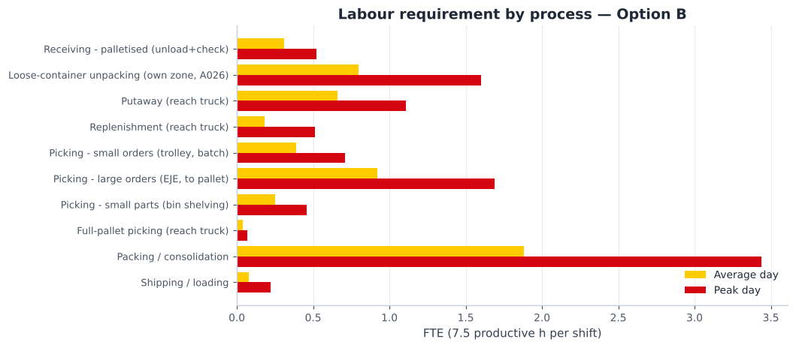
Fig 14. Labour requirement by process (average vs peak day).

6.2 Picking — how many people, how efficient Arnau (Picking)
The picking method is matched to the demand profile — small, light orders with a few lines, plus a minority of pallet-sized orders — using the standard order-picking choices: picker-to-parts, low-level picking, batching and zoning (de Koster et al., 2007). Pick times are modelled on the Option B layout: walking (return route in the fast-pick area; in the reserve aisles the best of the four W3 routing policies, which is largest gap) + picking + setup, with a 10% delay allowance (A025).
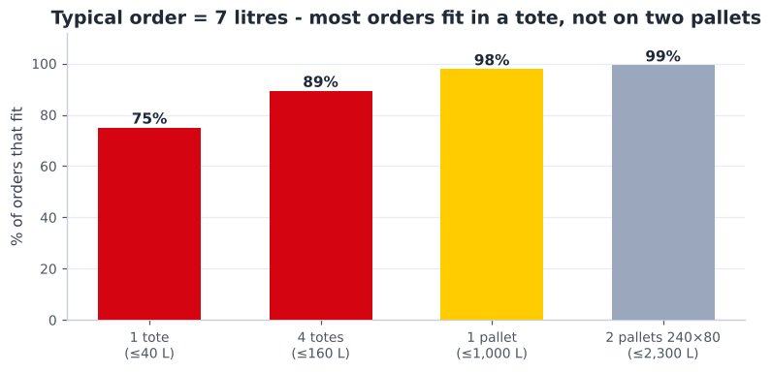
Fig 15. Share of orders that fit each carrier: one tote, four totes, one pallet, two pallets (240×80).
Segment | Orders / day | Lines / day | % orders | % lines | % volume
Large | 23 | 343 | 16% | 54% | 88%
Small | 120 | 291 | 84% | 46% | 12%

Small orders — zone | Lines / day | Lines / tour | Walk / tour (m) | Lines / h | Picker-h peak
Fast-pick area (A/B) | 188 | 31 | 123 | 99 | 3.5
Reserve low levels (C) | 50 | 16 | 471 | 49 | 1.9

- Large orders (EJE 120i): 23 orders/day, ~15 lines each (12 in the fast-pick area, 2 in the reserve), ~279 m and ~18 min per order → 44 lines/h.
- Picking needs 1.6 FTE on an average day and 2.9 on the peak day. Trolley batching makes small-order picking about twice as fast as one-order-per-tote picking in the reserve zone.
- How the volume per trip is ensured: each trolley batch is closed at 80% of its volume (240 L) or weight (250 kg), computed from SKU dimensions — so no trip is overloaded and none runs nearly empty.
Item | Use | Needed | Planned | Why this number
Pick trolley (3-tier, 6 totes) | Small orders - cluster picking in zones | 1 | 6 | 2 per picker (picking + at put-wall) + 2 spare
Totes 600x400 (~40 L) | One per small order (more if >40 L / >15 kg) | 36 | 54 | trolleys x 6 + 50% in circulation at packing
Jungheinrich EJE 120i walkie pallet truck | Large orders - pick-to-pallet | 3 | 3 | peak hours / (7.5 h x 80%); no spare once 2+ trucks (one breakdown still covers an average day)

Tugger train (Jungheinrich EZS 130) — evaluated, not planned now. It fits zone picking (pickers stay in their zone and a train collects the trolleys), and the EZS 130 is built for small-parts tow trains (600 mm wide, tows 3 t; Jungheinrich, n.d.-c). But with batching there are only ~9 trolley trips a day: a 201 m loop every 20 minutes would keep a driver ~26% busy to save pickers ~6 minutes of walking, because both pick zones end next to packing. It becomes worthwhile if small-order volume roughly triples or packing moves away from the pick zones.
Routing policy (W3) — expected walk per tour in the reserve zone, by policy:
Tour | Lines in reserve | S-shape | Return | Midpoint | Largest gap | Best
Small-order trolley tour (reserve zone) | 16 | 572 m | 682 m | 488 m | 471 m | Largest gap
Large-order pallet tour (reserve part) | 2 | 168 m | 171 m | 162 m | 162 m | Largest gap

Largest-gap routing is used in the reserve aisles (possible because the aisles are open at both ends); the fast-pick area is a single long face worked with a return route from packing.
Data-handling hardware (W3):
Option | Fit with our profile | Decision
Paper pick lists | 5,291 SKUs, many look-alike parts, half the orders single-line → error-prone, no live stock | Not used
RF handheld / ring scanner | scan-to-confirm location and item; works for receiving, put-away, trolleys and pallets | Used in all processes
Voice picking | hands-free, good for heavy case picking, but item check still needs a scan | Option for large-order picking
Pick-to-light | fastest per pick, but a light on thousands of faces is costly for ~640 lines/day | Not used in pick zones
Put-to-light wall | sorts batch-picked small orders (84% of orders) into orders at packing; 120 tote slots | Used at packing

6.3 Machinery — Jungheinrich fleet
Truck models were chosen from Jungheinrich (as advised) to match the layout and loads, and sized with a cycle-time model built from their published speeds on the Option B routes (A021).
Model | Task | Equip-h/day avg | Equip-h/day peak | Needed | Planned
ETV 216i | Putaway + replenishment + full-pallet picks | 4.9 | 9.2 | 2 | 2
EJE 120i | Large orders: pick-to-pallet (one order per pallet) | 6.9 | 12.7 | 3 | 3
ERE 225 | Unload trailers/containers, load outbound, dock moves | 2.2 | 4.6 | 1 | 2
Pick trolley (3-tier, 6 totes) + totes | Small orders: zone batch picking, sorted at the put-wall | 2.9 | 5.3 | 1 | 6

- ETV 216i reach truck (Jungheinrich, 2019): 1,600 kg, lift 10.7 m, working aisle 2.63–2.79 m, Li-ion. 2 cover the peak day and one is enough on an average day, so a breakdown never stops putaway (no spare needed; the lease includes repair). The racks are single-deep, so the truck uses standard forks — no telescopic attachment and no loss of capacity at height.
- EJE 120i walkie pallet truck (Jungheinrich, n.d.-a): 2,000 kg, only 1.58 m long and 0.72 m wide — picks large orders onto a pallet and moves through the aisles without turning problems.
- Pick trolleys (TBSG, n.d.): 3-tier, 1,000 × 600 mm, 250 kg, 6 totes — for the small orders.
- ERE 225 rider pallet truck (Jungheinrich, n.d.-b): 2,500 kg, built for loading and unloading trailers and containers; one per dock side (west and east).
- Charging: Li-ion opportunity charging — no battery room is needed; chargers sit at the P&D points.
- Plus: RF / voice terminals per picker, print-and-apply at packing, roll cages for parcel staging.
Why each machine, and how it is used:
Machine | Process | Why (data) | How it is used | Units
ETV 216i reach truck | Putaway, replenishment, full-pallet picks | Pallets stored up to the 8th level (top beam 10.0 m) - needs 10.7 m lift; single-deep racks, so standard forks; 11,012 of 11,015 loads ≤ 1.6 t | Perimeter + cross-aisles; ~25 putaways/h; feeds fast-pick lanes from the rear | 2
EJE 120i pallet truck | Large orders: pick-to-pallet | 16% of orders (23/day) are pallet-sized: median 234 L, 140 kg (p90 671 kg) - too big/heavy for a trolley | One order per pallet; ~15 lines in ~18 min; drops the pallet at packing | 3
Pick trolley + totes | Small orders: zone batch picking | 84% of orders are small (median order 7 L; 75% fit in one tote) | WMS fills each trolley to its volume/weight limit (~31 lines per tour); put-to-light wall sorts per order | 6
ERE 225 rider pallet truck | Unloading and loading trailers | ~99 inbound loads/day in the morning + outbound pallets in the afternoon; rider = less walking, 2.5 t | One per dock side (west receiving, east shipping) | 2
EZS 130 tugger train | Transport picked trolleys to packing (option) | Fits zone picking, but only ~9 trolley trips/day; a driver would be 26% busy to save ~6 min walking | Not planned now; adopt if small-order volume ~triples or packing moves away from the pick zones | 0

Truck dimensions and turning — can every machine move where it has to?
Machine | Size (L × W) | Turning / aisle needed | Where it drives | Result
ETV 216i reach truck | 2,419 x 1,270 mm | Wa 1,665 mm; aisle 2,631-2,785 mm | Perimeter + cross-aisles; storage aisles | OK - turns 90° in the 3.2 m cross-aisles; with a 2.05 m long load it needs 2976 mm -> long goods only via 3.2 m aisles
EJE 120i pallet truck | 1,575 x 720 mm | Wa 1,414-1,464 mm; aisle 1,787-1,936 mm | Fast-pick area, storage aisles, cross-aisles | OK - aisles open at both ends, so no U-turn needed
Pick trolley (manual) | 1,000 x 600 mm | pushed by hand | Everywhere in the pick zones | OK
ERE 225 rider pallet truck | rider truck, 1,000 mm forks | dock work only | Dock strips and staging lanes (west + east) | OK - no aisle driving
EZS 130 tugger (option) | 1,315 x 600 mm + carts | Wa ~1,080 mm (tractor) | Loop on perimeter + cross-aisles only | OK for a short train; not planned (low volume)
ECE 225 order picker (dropped) | 3,670 x 810 mm, 2,400 mm forks | too long for 3.0 m aisles | - | Rejected - cannot turn or U-turn in the aisles; 2 pallets far too big

Move | Truck | Avg one-way (m) | Cycle (min) | Moves / h
Putaway (receiving -> reserve) | ETV 216i | 78 | 2.38 | 25
Replenishment (reserve -> fast-pick rear) | ETV 216i | 28 | 1.83 | 33
Full-pallet pick (reserve -> outbound) | ETV 216i | 78 | 2.37 | 25
Unload pallet (trailer -> receiving lane) | ERE 225 | 19 | 0.99 | 61
Load pallet (staging -> trailer) | ERE 225 | 19 | 1.24 | 48

Fit checks — layout and loads against the truck data:
Check | Requirement | Result
Working aisle (reach aisle 3.0 m) | ETV 216i Ast 2,631-2,785 mm | OK - 0.2-0.4 m margin
Top beam 10.02 m (8 levels x 1.41 m) | Max lift 10.7 m | OK - 0.68 m spare
Clear height 12.2 m | Extended mast 11.7 m at max lift | OK - 0.5 m clearance
Pallet weight p95 875 kg / p99 1344 kg | 1,600 kg @ 600 mm | OK for 99.4% of SKUs; >1 t pallets slotted on low levels
Actual load weight in stock (qty x unit weight): 10 loads > 1 t, 3 > 1.6 t | 1,600 kg @ 600 mm | OK - the few loads > 1.6 t go to floor positions, moved with the ERE 225 (2.5 t)
Single-deep (back-to-back) racks | every pallet reachable from an aisle | OK - standard forks; no telescopic attachment, no residual-capacity loss
Long pallets: 140 loads 1.3-2.05 m (+115 recorded longer = data errors, capped at 2.05 m) | aisle >= Ast 2976 mm with a 2.05 m load crosswise | OK - long-goods module with 4.5 m bays (2 pallets each) behind a 3.2 m aisle; forks under the long side (load centre 400 mm, full 1.6 t)
Tall loads: 940 loads 1.16-1.68 m, 42 > 1.68 m | 1.41 m level pitch | OK - top level (~1.7 m free under the roof clearance) has 1,120 positions; > 1.68 m on the floor
Large orders up to p90 671 kg | EJE 120i 2,000 kg | OK - picked onto one pallet
Small orders (median 7 L) | Trolley 6 totes, 250 kg | OK - ~31 lines per tour
Charging | Li-ion opportunity charging | No battery room; chargers at P&D points

6.4 Expected performance on the W3 KPIs
W3 names the KPIs that layout, storage and picking design drive. Expected values for Option B (Deliverable 3 adds cost and the full KPI set):
KPI (W3) | Expected | Basis
Dock-to-stock time | ~1.5 h per palletised trailer; ~3.8 h per loose container | unload ~1 min/pallet (ERE 225) while 2 reach trucks put away in parallel; container unpacked in its own zone at R1
Put-away cycle time | 2.4 min per pallet (~25 per truck-hour) | ETV 216i cycle model on the Option B routes (Jungheinrich, 2019)
Pick rate | ~59 lines per picker-hour overall (fast-pick 99, reserve 49, large orders 44) | pick-time model, largest-gap routing, trolley batching
On-time shipment rate | target ≥ 98% staged before the booked departure | waves end 45 min before each slot; today 50.1% of lines are staged 'LATE' (A005, definition to confirm)

7. Planning and control — how the operation is run
Planning and control makes sure that the capacity of each process (people, trucks, doors, space) meets the demand, now and later. We use the four activities of operations planning and control — loading (how much work for each resource), sequencing (in which order), scheduling (when) and monitoring and control (are we on plan, and what if not) — on three time horizons (Slack et al., 2022). Each process owner plans and controls their own process; the team leader joins the four plans into one plan for the day.
Horizon | What is planned | Method | Owner
Long term (quarter–year) | storage capacity, fleet size, departure plan with the carriers | monthly trend of occupied locations against a 90% trigger; yearly fleet and departure-plan review | Gleb (storage), Rachel (departures)
Medium term (weeks) | staff per process and per day | a fixed core team plus flexible staff for busy days: capacity that partly follows demand (a mix of level and chase capacity; Slack et al., 2022), planned from the order forecast and the 1.8× peak factor | team leader with all four owners
Short term (the day) | inbound bookings, waves, pickers per zone, refills, packing, trailer loading | the daily plan before the first wave (06:00) and a check after each wave | each owner for their process

- Push and pull: orders are pushed to the floor in planned waves (scheduled release); the fast-pick area is pulled — a lane is refilled only when picks take it below its minimum; inbound is pushed by the factories' shipping plan but levelled by booking each delivery in a time slot.
- One plan, four owners: the waves link the processes — wave times are planned backwards from the trailer departures (Shipping), which fixes when picking must finish (Picking), when lanes must be full (Storage) and when the receiving doors must be free for the putaway trucks (Receiving).

7.1 Receiving — booking, unloading and checking Vidhi (Receiving)
Activity | Method and decision | Factors considered (data)
Scheduling | every delivery gets a time slot from the advance shipping notice (ASN); containers are booked on R1 in the morning so they are unpacked before the afternoon | 2 shipments a day; ~1 container a day (peak 2); a container occupies a door ~3.3 h, a trailer ~1.3 h
Loading | 3 doors for a need of 2; container crew of 2 for ~3 h; receiving operator with the ERE 225 | ~99 loads/day, busiest day 167; 2.3 h/day of receiving work on average
Sequencing | trailers first come, first served; R2 is lent to container unpacking only when no second trailer is booked (A044) | 91% of containers fit the zone, 97% with R2's half
Control | KPIs dock-to-stock time, container door time and containers unpacked inside their zone (Deliverable 3), checked daily | late or early arrivals are re-booked into the next free slot

7.2 Storage — putaway, slotting, refills and stock control Gleb (Storage)
Activity | Method and decision | Factors considered (data)
Loading (putaway) | system-directed putaway by fixed rules (Section 2.1); 2 reach trucks | ~99 pallets/day at ~25 putaways per truck-hour
Replenishment | min/max per lane: a refill task is created when a pick takes a lane below its minimum (pull); refills run between the waves | ~24 refill pallets/day; 930 carton-flow lanes
Slotting | re-slot every month on demand (ABC and cube-per-order index); second lanes for the busiest 1% before the peak season | WMS slotting matches demand for only 48.6% of SKUs today; top 1% of SKUs = 15% of picks
Stock control | cycle counts by class (A every month, B every quarter, C once a year) and a quarterly list of loads older than one year for Assa Abloy to clear (our proposal) | 21% of loads are older than one year; master-data errors (D1 §10)
Capacity | monthly count of occupied locations; at 90% full the reserved 12th rack module is ordered | occupied locations +16% per quarter (April–June)

7.3 Picking — waves, loading of pickers and order sequence Arnau (Picking)
Activity | Method and decision | Factors considered (data)
Scheduling (order release) | three waves planned backwards from the trailer departures: W1 06:00–09:30, W2 09:30–12:45, W3 12:45–15:15; orders received before 12:00 go in W3 and leave the same day | 55% of orders arrive 15:00–17:00; today's 08:00 peak is 1.31× the average hour because everything is released at once
Loading | pickers per wave = the wave's lines ÷ the pick rate of each zone; the WMS fills each trolley up to its volume and weight limit | ~213 lines per wave; ~99 lines/h in the fast-pick area, ~49 in the reserve aisles
Sequencing | within a wave: earliest departure first; small orders batched per zone, large orders one per pallet | 84% small orders, 16% large orders (by volume and weight)
Control | lines picked against the plan per hour; the put-to-light wall only releases complete, correct orders; KPIs pick rate, pick accuracy and picking hours per day | a wave that runs late gets a picker from another zone, and its orders for the earliest departures are picked first

7.4 Shipping — departure plan, packing and loading Rachel (Shipping)
Activity | Method and decision | Factors considered (data)
Scheduling | a fixed departure plan: 14 trailer slots booked by the carriers between 10:30 and 16:45 | ~15 trailers/day; p90 9 in the busiest hour; max 4 doors busy at once in the plan
Loading | packers per wave from the packing lines (~45 lines/h per packer); 4 pack stations | 14 packing hours on an average day, 26 on the peak day
Sequencing | pack and stage in the order of the departure slots; each door has its own staging lane; trailers are loaded live at the booked time | 73% of trailers carry parcels only
Control | KPIs on-time shipment, orders out within 24 h and trailers at the doors at once, checked after each departure | a missed slot is moved to the carrier's next slot the same day

7.5 Monitoring and control — the control loop
- Every day: a short start-of-day meeting with the four process owners: yesterday's KPIs against target, today's inbound bookings, wave sizes, staff and departures. Each owner explains a red KPI and the action.
- Every week: the KPI overview of Deliverable 3 with the DHL operations manager; actions are given to an owner with a date.
- Every month: review with Assa Abloy — service KPIs, stock growth, dead stock and the slotting update.
- The loop: measure (scanner data in the WMS) → compare with the target → act (re-plan staff, re-slot, re-book a slot) → check that the KPI is back on target. This turns the design into a controlled process instead of a one-off layout.

8. Assumptions & open questions
Full register in data/assumptions.json; sources in documentation/sources.md (cited in APA in the text). High-impact items:
ID | Assumption / open question | Impact
A001 | Max facility footprint | HIGH
A002 | Max clear/building height | HIGH
A003 | Analysis period is representative of normal operation | HIGH
A004 | Storage requirement is based on OCCUPIED LOCATIONS (pallet positions), not loads | HIGH
A005 | STAGED STATUS 'LATE' reflects staging vs the LATE SHIP window, i.e. a genuine on-time-staging miss | HIGH
A006 | No labour-productivity, MHE-fleet or cost data was provided | HIGH
A008 | The 7,000 m2 / 12.2 m envelope is the space available to DESIGN THE ASSA ABLOY operation within | HIGH
A010 | Design pallet-position target | HIGH
A013 | Functional (non-storage) areas sized from actual order volume | HIGH
A014 | Labour productivity benchmarks (units/person-hour) | HIGH
A017 | Peak-aware slotting: spread fast movers, duplicate extreme SKUs, balance picks/aisle on peak forecast | HIGH
A018 | Inbound arrives as 2 shipments per day, direct from Assa Abloy factories | HIGH
A019 | Part of inbound arrives LOOSE (floor-loaded sea containers) and is de-stuffed and palletised by hand | HIGH
A020 | Dock-door planning parameters | HIGH
A022 | Pick type is derived from what the client ordered, not from DHL's historical pick flags | HIGH
A024 | Picking is split by ORDER SIZE computed from SKU each-dimensions and weights | HIGH
A025 | Pick-time model parameters | HIGH
A028 | Hazardous SKUs: hazard class unknown - PGS 15 (packaged hazardous substances) or PGS 37 (lithium batteries) to be confirmed | HIGH
A030 | Labour cost per paid hour | HIGH
A033 | Racking prices | HIGH
A042 | Small parts move from pallet racks to bin shelving | HIGH

- To confirm with DHL: labour productivity and pick-time standards (A006/A014/A025); the 7,000 m² scope (A008); container share and contractor quotes (A019/A026); whether carriers accept the departure slots (A020/A027).
- To confirm with Jungheinrich: a lease quote for 2 ETV 216i, 3 EJE 120i and 2 ERE 225 (A038).
- To confirm with Assa Abloy: the hazard class of the 138 flagged SKUs, which decides the hazmat section (A028).

References
APA 7th edition. Conversations with the course teacher and DHL are personal communications and are cited in the text only.
Baker, P., & Canessa, M. (2009). Warehouse design: A structured approach. European Journal of Operational Research, 193(2), 425–436. https://doi.org/10.1016/j.ejor.2007.11.045
BOVAG. (n.d.). Veelgestelde vragen over PGS 37-2. Retrieved October 18, 2026, from https://mijn.bovag.nl/dossiers/veelgestelde-vragen-over-pgs-37-2
de Koster, R., Le-Duc, T., & Roodbergen, K. J. (2007). Design and control of warehouse order picking: A literature review. European Journal of Operational Research, 182(2), 481–501. https://doi.org/10.1016/j.ejor.2006.07.009
Evofenedex. (n.d.). PGS 37: Opslag lithiumbatterijen. Retrieved October 18, 2026, from https://www.evofenedex.nl/kennis/gevaarlijke-stoffen/pgs-37-opslag-lithiumbatterijen
Gadeyne, B. (n.d.). How to slot a warehouse during peak season (and avoid congestion). LinkedIn. Retrieved September 14, 2026, from https://www.linkedin.com/pulse/how-slot-warehouse-during-peak-season-avoid-bart-gadeyne-yhude/
HAN University of Applied Sciences. (2026a). [Lecture slides on warehouse design, layouts, storage and order-picking systems, week 3]. OPERMB04 Operations Management. Unpublished course material.
Huertas, J. I., Díaz Ramírez, J., & Trigos Salazar, F. (2007). Layout evaluation of large capacity warehouses. Facilities, 25(7/8), 259–270. https://www.emerald.com/f/article/25/7-8/259/106959/Layout-evaluation-of-large-capacity-warehouses
Informatiepunt Leefomgeving. (n.d.). Publicatiereeks Gevaarlijke Stoffen (PGS) 15: Systematiek. Retrieved October 14, 2026, from https://iplo.nl/thema/externe-veiligheid/handleiding-publicatiereeks-gevaarlijke-stoffen/pgs-15-systematiek
Jungheinrich. (n.d.-a). EJE 120i: Technical data (JEHN0398) [Data sheet]. Logisnext Americas. Retrieved October 14, 2026, from https://www.logisnextamericas.com/globalassets/migration-blocks/jungheinrich/product-listing/pallet-trucks/eje-120-225/jehn0398---eje-120i-spec-sheet.pdf
Jungheinrich. (n.d.-b). ERE 225 rider pallet truck [Product listing]. Retrieved October 7, 2026, from https://www.shop.jungheinrich.co.uk/en/ere-225---98280668
Jungheinrich. (n.d.-c). EZS 130 tow tractor. Retrieved October 14, 2026, from https://www.jungheinrich.co.uk/products/new-forklifts/tow-tractors/ezs-130-108322
Jungheinrich. (n.d.-d). Warehouse risks: Identifying and reducing operational risks. Retrieved October 7, 2026, from https://www.jungheinrich.co.uk/jungheinrich-blog-material-handling-insights-trends/warehouse-risks-identifying-and-reducing-operational-risks-2496552
Jungheinrich. (2019). ETV 216i: Technical data [Data sheet]. Retrieved October 7, 2026, from https://www.fallsway.com/hubfs/Fallsway_January2022/Pdf/jungheinrich-ii-etv-216i-spec-sheet-english.pdf
Prestatie Personeelsdiensten. (n.d.-a). Handmatig containers lossen. Retrieved October 18, 2026, from https://prestatie.eu/containers-lossen-en-laden/handmatig-containers-lossen/
Prestatie Personeelsdiensten. (n.d.-b). Looseloaded containers lossen. Retrieved October 18, 2026, from https://prestatie.eu/containers-lossen-en-laden/looseloaded-containers-lossen/
Slack, N., Brandon-Jones, A., & Burgess, N. (2022). Operations management (10th ed.). Pearson.
Special Cargo. (n.d.). PGS 37-2 onder de loep. Retrieved October 18, 2026, from https://services.specialcargo.com/nl-nl/blog/kennisbank/pgs-372/
SSI Schäfer. (n.d.). What does the rack inspection check? Retrieved October 14, 2026, from https://ssi-schaefer.com/en-de/what-does-the-rack-inspection-check--1580504
STOW. (n.d.). DIN EN 15635 and other safety standards for racking. Retrieved October 14, 2026, from https://www.stow-group.com/en/racking/blog/warehouse-safety-standards/
TBSG. (n.d.). Order picking and display trolley with adjustable shelves [Product listing]. Retrieved October 14, 2026, from https://www.tbsg.co.uk/order-picking-and-display-trolley-with-adjustable-shelves--2

Part 3 — Performance overview
Assessment form: Performance overview (KPIs, capacity plan in operating costs, CAPEX & OPEX)

PROJECT OTM
Performance Overview — KPIs, CAPEX & OPEX
Assa Abloy operation · DHL Supply Chain, Bemmel (NL_0032)
Field | Detail
Deliverable | 3 — Performance overview including financial analysis
Due date | 21-10-2026
Concept | Option B — single-deep racks, fast-pick area, small-parts shelving, zone + batch picking, wave release
Envelope | ≤ 7,000 m² · ≤ 12.2 m (design uses 6,731 m²)
Team | Group 3 — Vidhi (Receiving), Gleb (Storage), Arnau (Picking), Rachel Selvarathnam (Shipping)
Version | Final portfolio version — includes all feedback (space checks, lengths, small parts, own KPIs, €20/h, hazmat)
Supporting files | Deliverable_3_Calculations.xlsx (all cost formulas) · Deliverables 1 and 2 (updated) · analysis/*.py

Expected performance and cost of the Option B design. Volumes are measured in the Assa Abloy Q2-2025 data; prices are public benchmarks or labelled assumptions (Section 9), never quotes. Every number can be rebuilt with analysis/performance_cost.py and checked in the calculation workbook.
Who is responsible for what
Every team member hands in this whole document (the complete warehouse design). Each process has one owner; the sections of a process carry the owner's name in their heading. Sections without a name were made by the whole group.
Process | Owner | Scope | Sections in this document
Receiving | Vidhi | unloading trailers and containers, checking, container unpacking, returns intake — up to the pick-up point | §3.1, §6.3
Storage | Gleb | putaway, racks and storage places, slotting, replenishment of the fast-pick area, inventory control | §2.3, §4, §4.1, §4.2, §4.3, §5.2, §6.2, §6.5
Picking | Arnau | order release (waves), picking, sorting batch picks into orders at the put-to-light wall | §2.2, §4.3, §5.1
Shipping | Rachel | packing, outbound staging, dock doors, trailer departure plan and loading | §2.1, §5.1, §6.4

Summary
What the design delivers, what it costs, and what to watch:
 | Result
Picking effort | 31 → 12 picker-hours a day (batching, fast-pick area, wave release)
Order lead time | orders out within 24 h: 37% → 65%; slowest 10% wait 102 h → 70 h
Trailers at the doors | 15 parked at once → max 4 of 5 doors
Storage | 8,960 pallet positions + 188 small-parts shelving bays; racks 84% full at the peak; a pick face for each of the 1,409 fast movers
People and trucks | 4.7 FTE on an average day, 8.7 on the peak day; 2 ETV 216i, 3 EJE 120i, 2 ERE 225, 6 trolleys
One-off investment (CAPEX) | €1,630k all new; €521k if today's racking is re-used; of which €157k for the process changes
Running cost (OPEX) | €342k a year at €20/h; €483k incl. depreciation
Cost per unit | €3.09 per order line · €13.75 per order
Saving and payback | ~€101k a year in picking labour → the process changes pay back in 1.6 years

- The labour gain comes from how we work, not from steel. Batching, a fast-pick area and wave release need €157k and save ~€101k a year. Racks are needed to hold the stock, so they are a capacity cost, not a saving.
- Small parts are stored efficiently: 2,657 slow SKUs with a few litres of stock each move from pallet locations to bins next to the put-wall. That frees 1,005 pallet locations. A Kardex lift was compared: denser, but ~€19k a year more and busy only a few % of the day at our volume.
- Space checks passed: 91% of containers fit the container zone, 97% when door R2 is lent; outbound staging uses at most 46% of its area; packing needs 423 of 450 m².
- Watch the stock growth. Occupied locations grew 16% a quarter between April and June; at that rate the racks are full in ~4 months. Clearing dead stock (21% of loads > 1 year) is the main lever.

1. What changed since Deliverable 2
Two feedback rounds and a final check of the design led to these changes. Deliverables 1 and 2 were regenerated so all three documents use the same numbers.
Topic | Before | Now | Why
Racking | Double-deep, telescopic forks | Single-deep, back-to-back (8,960 positions) | Team decision: no two-deep racks; every pallet directly reachable
Long goods | Cantilever for items up to 11 m | Long-goods module: 320 positions for pallets up to 2.05 m, 3.2 m aisle | Feedback: nothing longer than a door (~2 m); the 11 m item is a data error
Small parts | One pallet location per SKU | Bin shelving for 2,657 slow small SKUs next to the put-wall | Feedback: store small items efficiently (Kardex compared)
Loose containers | Unpacked at door R1 | Own 190 m² zone; big containers borrow door R2 | Feedback: is there enough space to unpack?
Reach / pallet trucks | 3 ETV 216i / 4 EJE 120i | 2 ETV 216i / 3 EJE 120i | Peak need covered; lease includes repair
Labour cost | €28 per hour | €20 per hour (€28 as high case) | Feedback: €20/h for an operator
KPIs | W3 list | Our own design KPIs + the W3 ones | Feedback: come up with our own KPIs
Hazardous goods | Class unknown, PGS 15 | Recounted, classified by customs code → mostly PGS 37-2 | Feedback: recheck counts and classes
Fast-pick area | 500 m² band, inside not drawn | 930 carton-flow lanes + a wall row of shelves and floor pallets: a pick face for all 1,409 fast movers | Own check: 1,409 fast movers but only 930 lanes (§4.3)
Receiving doors | R2 and R3 side by side | R2 in the north half, R3 in the south half of receiving | R2's half can be lent to container unpacking while R3 keeps working (§3.1)

Fig 1. Updated floor plan: container zone (C) with R1, long-goods module, the packing area with the put-to-light wall, and the main order flow (1–6).

2. Our KPIs — expected performance of the design
We made our own KPIs: each one measures something our design promises to do (fill the racks well, keep pickers in the fast-pick area, walk little, unpack containers inside their zone, ship within a day, …). The four W3 lecture KPIs (dock-to-stock, put-away time, pick rate, on-time shipment; HAN University of Applied Sciences, 2026a) are included too. For every KPI we give how to calculate it, today's value where the data shows it, the value we expect from the design, and a target.
Each KPI is linked to one of the five performance objectives that Deliverable 1 (§11) ranked for this operation (Slack et al., 2022), and to the process owner who watches it:
Objective (D1 rank) | KPIs that measure it | Owners
Dependability (1) | On-time shipment; Trailers at the doors at once | Rachel (Shipping)
Speed (2) | Dock-to-stock time; Container door time; Put-away cycle time; Order lead time (per order); Orders out within 24 h | Gleb (Storage), Rachel (Shipping), Vidhi (Receiving)
Quality (3) | Pick accuracy; Trucks and pickers separated | Arnau (Picking), whole team
Cost (4) | Rack fill at peak; Small-item density; Floor area used; Pick rate; Fast-pick hit rate; Walking per picked line; Trolley fill; Small-parts picking time; Picking hours per day; Direct labour; Labour productivity; Truck utilisation (average day); Cost per order line; Cost per order | Arnau (Picking), Gleb (Storage), whole team
Flexibility (5) | Storage headroom; Containers unpacked inside their zone; Outbound staging fill | Gleb (Storage), Rachel (Shipping), Vidhi (Receiving)

Space
KPI | How we calculate it | Today (data) | Expected (design) | Target
Rack fill at peak ★  Cost · Gleb (Storage) | pallet locations used at the peak ÷ rack positions | 8,512 locations used | 84% (7,507 of 8,960; small parts moved to bin shelving) | ≤ 90%
Storage headroom ★  Flexibility · Gleb (Storage) | months until the racks are full at the Apr–Jun growth rate | +10% locations in 2 months | ~4 months (~5 with a 12th module) | ≥ 12 months
Small-item density ★  Cost · Gleb (Storage) | SKUs stored per m² of floor | ~2.6 SKUs/m² (one pallet location each) | ~13 SKUs/m² in bin shelving | ≥ 5× better
Floor area used ★  Cost · whole team | zones + aisles ÷ 7,000 m² | — | 6,731 m² (96%) | ≤ 7,000 m²

Inbound
KPI | How we calculate it | Today (data) | Expected (design) | Target
Dock-to-stock time  Speed · Vidhi (Receiving) | truck at the door → pallet in its location | big China receipts take 1–3 days to book in | ~1.5 h per palletised trailer; ~3.8 h per loose container | < 3.5 h (Extensiv, n.d.)
Containers unpacked inside their zone ★  Flexibility · Vidhi (Receiving) | % of containers whose unpacking fits the 190 m² zone | — | 91% (another 6% by lending door R2) | ≥ 90%
Container door time ★  Speed · Vidhi (Receiving) | dock-on + unpack + palletise per 40 ft container | — | ~3.3 h | ≤ 4 h
Put-away cycle time  Speed · Gleb (Storage) | minutes per pallet, reach truck | — | 2.4 min per pallet (~25 per truck-hour) | ≤ 3 min

Picking
KPI | How we calculate it | Today (data) | Expected (design) | Target
Pick rate  Cost · Arnau (Picking) | order lines per picker-hour | — | ~54 lines/h (fast-pick 99, reserve 49, large orders 44, small-parts shelving 50) | ≥ 50 lines/h
Fast-pick hit rate ★  Cost · Arnau (Picking) | lines picked in the fast-pick area ÷ all picked lines | — | 71% | ≥ 60%
Walking per picked line ★  Cost · Arnau (Picking) | metres walked in all tours ÷ picked lines | — | ~14 m | ≤ 15 m
Trolley fill ★  Cost · Arnau (Picking) | volume or weight filled per trolley tour | — | 80% (batch closed at 80%) | 75–85%
Small-parts picking time ★  Cost · Arnau (Picking) | small-parts lines ÷ 50 lines/h | — | 1.9 h/day for 93 lines | ≤ 2 h/day
Picking hours per day ★  Cost · Arnau (Picking) | picker-hours, average day | ~31 h (modelled: single-order picking, staffed for the 08:00 peak) | 11.7 h | —
Pick accuracy  Quality · Arnau (Picking) | % of orders without a picking error | not in the data | ≥ 99.7% (scan every pick + put-to-light check) | median 99.3%, best 99.68% (Extensiv, n.d.)

Service
KPI | How we calculate it | Today (data) | Expected (design) | Target
Order lead time (per order) ★  Speed · Rachel (Shipping) | order received → trailer leaves | median 25 h, p90 102 h | median 22 h, p90 70 h | p90 ≤ 72 h
Orders out within 24 h ★  Speed · Rachel (Shipping) | % of orders | 37% | 65% | ≥ 60%
On-time shipment  Dependability · Rachel (Shipping) | % of lines staged before the planned departure | 49.9% (50.1% 'LATE', A005) | ≥ 98% (every wave ends ≥ 45 min before its trailers leave) | ≥ 98%

Docks
KPI | How we calculate it | Today (data) | Expected (design) | Target
Trailers at the doors at once ★  Dependability · Rachel (Shipping) | busy day, p90 | 15 (parked all day) | max 4 of 5 doors (time slots) | ≤ 5
Outbound staging fill ★  Flexibility · Rachel (Shipping) | staging m² needed on the busiest afternoon ÷ 216 m² | — | 46% (p90 day 28%) | ≤ 80%

People
KPI | How we calculate it | Today (data) | Expected (design) | Target
Direct labour ★  Cost · whole team | FTE, average / peak day | not in the data | 4.7 / 8.7 FTE + 1.5 indirect | —
Labour productivity ★  Cost · whole team | order lines per direct labour hour | — | 18.2 lines/h | —

Machinery
KPI | How we calculate it | Today (data) | Expected (design) | Target
Truck utilisation (average day) ★  Cost · whole team | operating h ÷ (units × 7.5 h) | — | ETV 33% · EJE 31% · ERE 14% | peak day ≤ 80%

Cost
KPI | How we calculate it | Today (data) | Expected (design) | Target
Cost per order line ★  Cost · whole team | (OPEX + depreciation) ÷ lines | — | €3.09 | —
Cost per order ★  Cost · whole team | (OPEX + depreciation) ÷ orders | — | €13.75 | —

Safety
KPI | How we calculate it | Today (data) | Expected (design) | Target
Trucks and pickers separated ★  Quality · whole team | pick faces without reach-truck traffic | — | 100% (trucks refill from the rear and use the perimeter + cross-aisles) | 0 lost-time incidents

★ = our own design KPI; the others are the W3 lecture KPIs. Under each KPI: its performance objective and owner. How the KPIs are used to control the operation: Deliverable 2 §7.

2.1 Order lead time Rachel (Shipping)
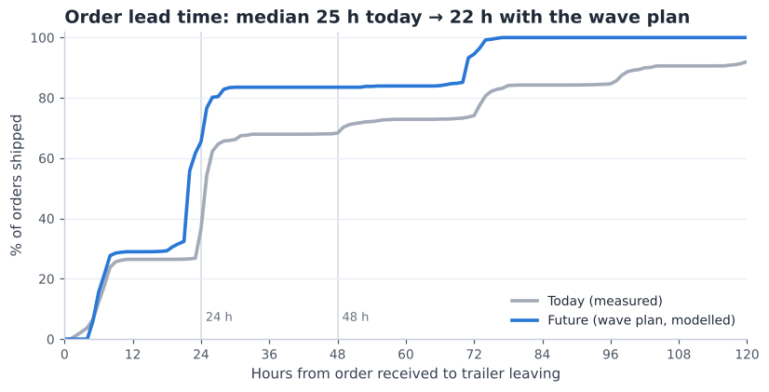
Fig 2. Share of orders shipped within X hours — today (measured) vs future (wave plan, modelled).
- Today (measured, 8,774 orders): median 25 h, average 45 h, slowest 10% 102 h or more. Only 37% of orders leave within 24 hours.
- Future (modelled on the same orders): an order received before 12:00 is picked in wave 3 and leaves on the same afternoon's trailer of its carrier; a later order is picked in the first wave next morning and leaves on that day's first slot of its carrier. Weekends are skipped.
- Result: 65% within 24 hours and the slowest 10% at 70 h. The median moves less (25 → 22 h) because 55% of orders arrive between 15:00 and 17:00 and still leave the next day — the gain is that no order waits for a second or third day.

2.2 Picking effort — where the saving comes from Arnau (Picking)
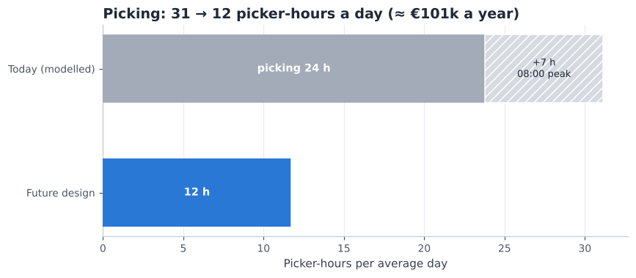
Fig 3. Picker-hours per average day: today's way of working (modelled) vs the design.
Lever | Today h/day | Future h/day | Saved h/day | Saved per year
Batch picking + demand-based slotting (fast-pick area) | 23.8 | 11.7 | 12.1 | €62,846
Wave release instead of one evening release (no 08:00 peak staffing) | 7.4 | 0.0 | 7.4 | €38,362

Today is modelled with the same pick-time model and rates as the design (D2 §6.2), but the way the data says the site works now: one order per tour, stock not placed by demand (the WMS class agrees with demand for only 48.6% of SKUs), and all orders released in the evening so the morning starts at 1.31× the average workload. It is a model, not a measurement — DHL's real pick hours would confirm it (A006).

2.3 Storage space Gleb (Storage)
- Positions: 8,960 (incl. 320 long-goods). Moving small parts to shelving frees 1,005 locations, so the peak need is ~7,507 (84% full).
- Growth: occupied locations rose from 7,715 (April) to 8,512 (June), +16% per quarter. At that speed the racks are full in ~4 months (~6 with a 12th rack module, +864 positions, which fits in the core). Three months of data cannot tell whether this is a season or a trend, so DHL should track the KPI monthly.
- What we do about it: (1) clear dead stock — 21% of loads are older than one year (D1 Fig 2b); (2) keep the 12th module as the first expansion; (3) the remaining ~270 m² of the 7,000 m² envelope stays free.

2.4 Stress test — 150%, 200% and 250% volume
Promised in D2 §3.1: what happens when volume grows? Workload scales with volume; trucks and doors are checked against the same rules as in D2.
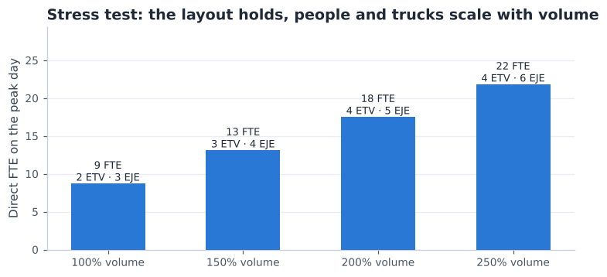
Fig 4. Direct FTE and trucks needed on the peak day at higher volumes.
Volume | Direct FTE (peak day) | ETV 216i | EJE 120i | ERE 225 | Outbound doors | Pickers in busiest wave
100% | 8.7 | 2 | 3 | 1 | 4 | 3
150% | 13.1 | 3 | 4 | 2 | 5 | 4
200% | 17.5 | 4 | 5 | 2 | 7 | 5
250% | 21.8 | 4 | 6 | 2 | 8 | 6

- Up to 150% the design runs as planned: 3 reach trucks, 4 pallet trucks and 5 shipping doors in the busiest hour.
- At 200% and more the 5 shipping doors are not enough in the busiest hour; the departure plan would need more spread (more slots before 12:00) or a 6th door — and storage would need the 12th module and a dead-stock clean-up first.
- Pickers per wave stay low (≤ 6 in the busiest wave at 250%), so aisle congestion is not the limit.

3. The zones — what happens where
The building has nine zones. Goods come in on the west side, are stored in the middle and leave on the east side (flow-through, D2 §5.1). Fig 5 numbers the zones in the order the goods pass through them; the table says what happens in each zone, who works there and when it is busy.
Fig 5. The nine zones, numbered in the order the goods pass through them (north up; receiving doors R1–R3 on the west wall, shipping doors S1–S5 on the east wall).
Zone | m² | What happens | Who / with what | When busy
1 Receiving | 262 | Trailers from the European plants are unloaded at R2 / R3. Every pallet is counted, checked and scanned against the delivery note, then left at a pick-up point for the reach truck. | receiving operator, ERE 225, scanner | the 2 daily deliveries (8-hour window)
2 Container zone | 190 | A loose container at R1 is unpacked: cartons roll out on a conveyor, are scanned and stacked on the build spot of their item (12 at once), then wrapped and labelled. | 2-person crew (DHL or contractor), conveyor, stretch wrapper | when a container arrives (~1 a day, ~3 h each)
3 Pallet racks | 4,233 | Full pallets of every item in reserve; the two lowest levels are the pick places of slow items (Section 4). | reach-truck drivers (ETV 216i); pickers on the lowest levels | putaway after each delivery, refills all day
4 Fast-pick area | 500 | A pick face for each of the 1,409 best-selling items: carton-flow lanes and, across the aisle, a wall row of shelves and floor pallets (Section 4). | zone-1 pickers with trolleys; EJE 120i for large orders | the 3 waves, 06:00–15:15
5 Packing | 450 | Small orders are sorted into customer orders at the put-to-light wall and packed; small parts are picked from the bin shelving next to it (Section 5). | putter, 2–4 packers, 4 pack stations | during and after each wave
6 Outbound staging | 216 | One lane per shipping door: parcels in roll cages per carrier and wrapped pallets wait for their trailer, which is loaded at its booked time. | loader with an ERE 225 | 10:30–16:45, 14 trailer slots
7 Returns | 180 | Returns are received, inspected and put in one of three places: restock, rework or scrap. Restocked goods go back through the normal putaway. | receiving operator, scanner | when a return arrives
8 Offices & amenities | 250 | Team leader, inventory control and admin; canteen, toilets and lockers for everyone. | team leader, admin | all day
9 Aisles | 450 | Two perimeter aisles and three cross-aisles, all 3.2 m wide (the storage aisles between the racks are counted in zone 3). Reach trucks use the main aisles; pickers stay in their pick zones. | everyone | all day

3.1 Receiving, container zone and returns — enlarged Vidhi (Receiving)
The west side handles everything that comes in. Fig 6 shows it enlarged, with the trailer flow (blue) and the container flow (orange):
Fig 6. Receiving, the container zone and returns enlarged (west side), with the key.
- Trailers (blue): pallets come off the trailer with the ERE 225 into the unload lane of their door (B), are checked at the bench (C) and left at the pick-up point (D). Two reach trucks take them away while the trailer is still being unloaded, so at the peak only ~17 pallets wait at once — two lanes of 9 places are enough.
- Containers (orange): the conveyor (F) brings the cartons out of the container. The crew scans each carton and puts it on the build spot of its item (G). A container holds 7 items (median; 11 for a large one), so 12 build spots cover most containers in one pass. A full pallet is wrapped and labelled (I) and waits in H for the reach truck.
- Big-container days (E): door R2 is closed and its half of receiving (131 m²) joins the container zone: 321 m², enough for 97% of containers. That is why R2 and R3 sit in different halves: trailers keep using R3 while R2's half is lent (§6.3).
- Returns: intake (J) → inspection at the bench (K) → restock, rework or scrap (L).
- Outbound staging (zone 6, east side): each shipping door S1–S5 has its own lane. Packed parcels wait in roll cages per carrier with the wrapped pallets next to them, so a trailer is loaded straight from its lane at its booked time. On the busiest day of Q2 the goods needed 100 of the 216 m² (§6.4).

4. Storage — where and how goods are stored Gleb (Storage)
Every item gets a place that suits how often it is picked and how big it is: fast movers close to the pickers, full pallets high up in the racks, small slow parts in bins. The table says what is stored where; Fig 7 shows each place (A–F) on the layout and enlarged. In total there are 8,960 pallet places; at the peak the racks are 84% full (§2.3).
Place (Fig 7) | What is stored | How it is stored | Size
A Carton-flow lanes | the 888 most-picked fast movers (90% of fast-pick lines); the busiest 42 have two lanes | cases on sloping lanes, 5 levels × 6 lanes per 2 m bay; filled from the back, picked from the front | 31 bays, 930 lanes
B Wall row | the other fast movers: 462 small items on shelves, 42 long items (up to ~2 m) lying on long shelves, 17 heavy or bulky items on floor pallets | across the pick aisle from the lanes; shelves 0.6 m deep; heavy items nearest packing | 31 shelving bays, 20 pallet places
C Pallet racks | full pallets of every item (reserve) and the pick places of slow items | single-deep, back-to-back: one pallet each side, 3 EUR pallets per 2.7 m bay, 8 levels | 9 modules, 7,776 places
D Odd-items module | loads that are not a standard pallet | the same racks, in their own module next to the long goods | 864 places
E Long-goods module | pallets 1.3–2.05 m long (255 loads) | 2 per 4.5 m bay, forks under the long side; 3.2 m aisle (§6.2) | 320 places
F Small-parts shelving | 2,657 slow small items (≤ 50 L of stock each) | one item per half-bin, 7 levels, in the packing area (§5.2) | 188 bays

Fig 7. Where goods are stored: (a) the whole warehouse, (b) the fast-pick area and the racks enlarged, with the key.
How the goods move between these places — put away, store, refill, pick — is shown from the side in Fig 8:
Fig 8. How storing works: a rack cut across (left), the fast-pick area cut north–south (right) and the four steps.

4.1 Putting away — where does a pallet go? Gleb (Storage)
- The scanner decides, not the driver. When a pallet is scanned at receiving, the WMS gives it a place by fixed rules: long pallets → long-goods module; odd loads → odd-items module; reserve pallets of fast movers → racks near the front cross-aisle (short refill trips); slow movers → further back. Small slow parts do not go to the racks at all: their cartons are put into bins.
- Height rules: pallets over 1 t (10 loads) on the lowest level; tall loads of 1.16–1.68 m (940 loads) on the top level, which has ~1.7 m of free height (1,120 places). The few loads that fit no level are handled as in §6.2.
- Route: the reach truck takes the pallet from the pick-up point in receiving, drives north on the left perimeter aisle, along a cross-aisle and into the storage aisle (blue in Fig 7). Every storage aisle is open at both ends, so the truck never backs out. ~99 pallets come in on an average day; one truck puts away ~25 an hour.
- Single-deep, back-to-back: each rack holds one pallet on each side, so every pallet can be taken out directly — no pallet ever has to be moved to reach another.

4.2 Refilling the fast-pick area Gleb (Storage)
- Trigger: every lane has a minimum. When a pick takes it below, the WMS creates a refill task for the reach truck (min/max, D2 §3).
- Refill from the back: the truck takes a reserve pallet of that item from the racks, drives down the storage aisle to the front cross-aisle and puts the pallet down in the refill strip behind the lanes. The driver slides the cases into the lane from the back; they roll forward to the pick face, so the oldest cases are always picked first.
- How often: ~24 pallets a day (~1.3 truck-hours), spread over the day and mostly between the waves.
- Wall row: shelves are refilled by hand from the pick aisle and floor pallets are swapped with the EJE 120i — both between the waves.
- Safety: reach trucks work only behind the lanes and in the racks; pickers only in the pick aisle and at the lowest rack levels. People and reach trucks never share a pick face.

4.3 Does every fast mover have a pick face? Gleb (Storage) · Arnau (Picking)
A check of our own design (A046): 1,409 fast movers (A and B items) were picked in Q2, but 31 carton-flow bays give 930 lanes. Lanes go to the items that are picked most and fit a lane (each item ≤ 28 × 33 × 60 cm and ≤ 15 kg). The rest stand on the wall row across the same aisle, so the picker's walk does not change:
Pick face | Items | Share of fast-pick lines | Size
Carton-flow lanes | 888 (+42 second lanes) | 89.5% | 930 lanes in 31 bays
Shelves (wall row) | 462 | 5.6% | 26 bays of 21 slots (+15% spare)
Long-item shelves | 42 | 2.0% | 5 bays of 2.2 m
Floor pallets (heavy or bulky) | 17 | 2.9% | 20 places, nearest packing
Total | 1,409 | 100% | wall row: 55 of 64 m used

The shelving costs ~€7,200 (Section 7). The 9 m left on the wall row is room for new items.

5. Sorting and small parts — what, how and when
Sorting means putting goods into the right group for the next step. In our design it happens in four places. Each one is simple, uses a scan to check the item, and happens at a fixed moment in the day.
Where | What is sorted | How | When | Equipment
1. Container zone (door R1) | Cartons from a container → one pallet per SKU | Cartons roll out on the conveyor; the worker scans each carton and puts it on the build spot of its SKU (a container has 7 SKUs on average, so 12 build spots are enough). Full pallet → wrap, label, putaway. | Morning, when the container arrives (~3 h) | Roller conveyor, RF scanner, stretch wrapper
2. Put-to-light wall (packing) | Picked items → customer orders | Pickers collect the items of many small orders in one trolley tour (~31 lines); small parts come straight from the shelving next to the wall. The packer scans an item, a light shows the order's slot, the item goes in and the button is pressed. A full slot lights up → pack. | During each wave (3 a day, ~40 small orders per wave) | Wall with 120 slots
3. Carrier lanes (outbound) | Packed parcels and pallets → trailer | The label says the carrier and departure slot. Parcels go into roll cages per carrier, pallets into the staging lane of their trailer (14 trailer slots a day). | All afternoon, until each trailer's departure | 41 roll cages, floor lanes
4. Returns | Returned goods → restock / rework / scrap | Inspect and grade, then each group goes to its own cage. | When a return arrives | Returns area, RF scanner

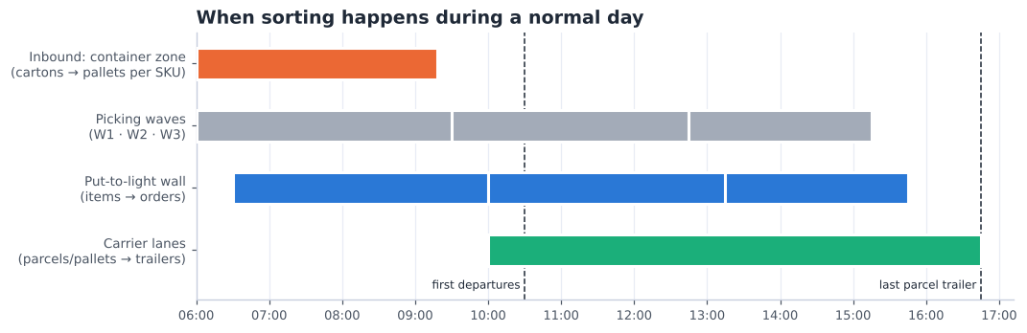
Fig 9. When the sorting points are busy during a normal day.
- Why a put-to-light wall and not sorting by hand: 84% of orders are small (median 7 litres). Picking them one by one would mean ~120 walks a day; picking them together and sorting at the wall is about twice as fast (D2 §6.2).
- Why not an automatic sorter: ~120 small orders a day is far too little for a sorter machine to pay off; the wall costs about €30k (Section 7).
- Large orders are not sorted: each one is picked straight onto its own pallet, so it goes directly to packing.

5.1 The put-to-light wall — where it is and how it works Arnau (Picking) · Rachel (Shipping)
The put-to-light wall is where the small orders are sorted. Pickers do not pick order by order: they pick many small orders at once into a few totes (a batch), and the wall splits that batch into customer orders. It does not store anything — an item stays in the wall for at most one wave (~3 hours).
Where it is. In the packing area on the east side of the building, at its south end: right next to the right perimeter aisle (where the pickers arrive from the fast-pick area and the racks) and just north of the outbound staging and the shipping doors. Fig 10 shows it on the whole layout and enlarged; it is also drawn on the floor plan (Fig 1).
Fig 10. Where the put-to-light wall is: (a) the whole warehouse, (b) the packing area enlarged, with the key.
How it works. The wall is a shelf you can reach from both sides. The pick side faces the aisle, the pack side faces the pack stations. Fig 11 shows it from the side:
Fig 11. How the wall works, seen from the side: pick side (left), the wall, pack side (right).
- Size: 24 columns × 5 levels = 120 slots, 10.8 m long, 0.6 m deep, slots between 0.2 and 2.0 m high. Each slot holds one open tote (600 × 400 mm, ~40 L) for one order and has a light with a button on both sides.
- Why 120 slots: the peak wave has ~73 small orders; 78% need one tote, 13% two and 9% three or four (average 1.35). 73 × 1.35 × 1.2 spare → 120 slots. A bigger order gets 2–4 slots next to each other.
- Orders from two zones wait in their slot until the last item arrives — only then does the pack-side light go on, so nobody packs half an order. A wrong item gives no light, so picking mistakes are caught here.
Where each item is stored before it reaches the wall:
Item type | Stored in | How it is stored | Who picks it
Fast movers (A/B) | Fast-pick area (south band, §4) | cases in carton-flow lanes, refilled from the back by the reach truck and picked from the front; less-picked, long or heavy ones on the wall row across the pick aisle | zone 1 picker with a trolley
Slow movers (C) | Low levels of the reserve racks | on the pallet, levels 1–2 within reach | zone 2–3 picker with a trolley
Small slow parts | Bin shelving behind the wall (E) | one SKU per half-bin (300 × 400 mm), 7 levels, 188 bays | the putter, between puts
Big orders (pallet-sized) | — | do not use the wall: picked straight onto a pallet (F) | EJE 120i picker

Who works at the wall, and how they move:
Role | Where (Fig 10) | How they move | People
Picker | zones → aisle H → pick side B | pushes a trolley along the zone route, leaves the full trolley at B and takes an empty one back (2 trolleys per picker) | 1–2 per zone per wave
Putter | pick side B + shelving E | walks along the 10.8 m wall putting items in; picks small parts in E (~8 s per item) | 1 per wave
Packer | pack side C → cages D | takes a finished order out of the wall, turns to the bench 1–2 m away, puts the carton in the carrier's cage | ~1.9 FTE (average), ~3.4 (peak, 4 stations)

5.2 How are small items stored efficiently? Gleb (Storage)
Today every SKU sits on a pallet location, even when its whole stock is a few litres. 2,657 slow SKUs (C class or no demand in Q2) have ≤ 50 litres of stock, units ≤ 20 L, ≤ 15 kg and ≤ 60 cm — together only 32 m³, yet they fill 1,005 pallet locations of about 1 m³ on their own (and share others). They need 3,424 half-bins (300 × 400 mm, ~20 L). We compared three ways to store them (A042):
Option | Floor m² | Pallet locations used | One-off cost | Pick rate | Cost per year*
Keep in pallet racks (today) | 393 | 1,005 | €130,650 | 49 lines/h | €28,576
Bin shelving next to the put-wall (chosen) | 207 | 0 | €69,184 | 50 lines/h | €19,597
Kardex Shuttle XP 500 lifts | 66 | 0 | €224,560 | 75 lines/h | €38,555

* depreciation over 7 years + picking labour for the ~93 small-part lines a day.
- Chosen: bin shelving next to the put-wall. 188 bays, 2.5 m high, in the packing area's spare floor. It is the cheapest option, frees 1,005 pallet locations, and the picked item goes straight into the wall — no walk to the reserve aisles.
- Kardex Shuttle XP 500 (Relevator Group, n.d.): 3 lifts ~10 m high would need only 66 m² and picks faster with a light pointer, but costs ~€19k a year more. With ~93 lines a day the lifts would stand still most of the day. They become the better choice when floor space runs out or small-part volume grows strongly — the shelving bins fit the lift trays, so the step is easy.
- A/B small items stay in the fast-pick area (390 SKUs): they are picked too often for a lift or a far-away shelf.

6. Design checks — machinery, long goods, space and hazardous goods

6.1 Machinery — is everything fit and justified?
Each machine was checked on three questions: does it have a job every day, does it fit the loads and the aisles, and is the number right?
Machine | Job | Units | Use (avg day) | Fits? | Verdict
ETV 216i reach truck | Putaway, refill fast-pick area, full pallets | 3 → 2 | 33% | Yes: 10.7 m lift for the 10.0 m top beam; single-deep → standard forks | Keep. 2 cover the peak day; a breakdown still leaves enough for an average day.
EJE 120i pallet truck | Large orders picked onto a pallet | 4 → 3 | 31% | Yes: 0.72 m wide, no U-turns needed | Keep 3 (peak need).
ERE 225 rider pallet truck | Unload / load trailers, container-zone pallets | 2 → 2 | 14% | Yes: 2.5 t, carries the few heavy loads | Keep 1 per dock side: docks are 96 m apart and both are busy 10:30–14:00. Low use — could drop to 1 if DHL accepts the walk.
Pick trolley + totes | Small orders, batch picking | 6 | — | Yes: 250 kg, 6 totes | Keep (cheap, flexible).
Put-to-light wall | Sort batch picks into orders | 120 slots | — | Peak wave ~73 small orders × 1.35 totes + 20% | Keep.
Small-parts bin shelving | Store and pick small slow parts | 188 bays | — | 2.5 m high, 7 levels; within reach without a ladder | Add (feedback 2).
Roller conveyor + 2 stretch wrappers | Unpack containers; wrap new and outgoing pallets | new | — | Yes: no heavy carrying out of the container | Add.
RF terminals | Scan every move | 14 | — | One per person at the peak + 20% | Keep.
Telescopic forks | (double-deep) | dropped | — | Not needed with single-deep racks | Removed.
Cantilever racking | (items > 2.4 m) | dropped | — | No real item is longer than ~2 m | Removed.
Kardex lifts | (small parts) | compared | — | Fit, but little work at our volume | Upgrade path (§5.2).
ECE 225 order picker / EZS 130 tugger | (rejected in D2) | — | — | Too long for 3.0 m aisles / driver idle | Not used.

6.2 Long goods — lengths, turning, capacity and access Gleb (Storage)
- Real lengths: nothing longer than a door (~2 m) can come in. The WMS shows 115 loads longer than 2.05 m — up to an '11 m' item that weighs 0.5 kg and is 1 cm high — so these are data errors and are capped at 2.05 m, the length of an XLONG pallet. That gives 255 long loads (1.3–2.05 m).
- Where they go: the long-goods module has 4.5 m bays with two long pallets each: 320 positions for 255 loads today (80% full).
- Turning clearance: a reach truck stacking a 2.05 m pallet crosswise needs an aisle of 2,976 mm (VDI right-angle stacking formula with the ETV 216i data: Wa 1,665 mm, 200 mm safety; Jungheinrich, 2019). A 3.0 m aisle leaves only 24 mm, so the long-goods aisle is 3.2 m (224 mm spare). The 3.2 m cross-aisles let the truck turn into it with the load.
- Truck capacity: the forks go under the long side, so the load centre is ~400 mm — inside the 600 mm rating, full 1.6 t. Forked on the short side the load centre would be ~1 m and the truck could carry only ~937 kg; the heaviest long load is 2,035 kg (95% below 346 kg), so loads over 1.6 t go to a floor position.
- Access: the module is open from both ends (front, middle and rear cross-aisles) and its outer row faces the 3.2 m perimeter aisle, so long goods never pass through the standard 3.0 m aisles.
Loads checked against the racks and trucks (all 11,015 loads in stock, 01-06-2025):
Check | Data | Result
Weight | 10 loads > 1 t, 3 > 1.6 t (actual qty × unit weight) | ETV 216i lifts 1.6 t → the few heavier loads go to floor positions, moved with the ERE 225 (2.5 t)
Height | 940 loads 1.16–1.68 m tall, 42 taller; 493 have no height in the WMS | tall loads use the top level (1,120 positions with ~1.7 m free); the tallest stand on the floor
Aisles | 3.0 m storage, 3.2 m long-goods / cross / perimeter | ETV needs 2.63–2.79 m (2.98 m with a long load), EJE 1.79–1.94 m → OK

6.3 Space for unpacking loose containers Vidhi (Receiving)
- What a container needs: cartons are sorted on the floor into one build spot per SKU. Measured on 568 Asian receipts: the median container needs ~134 m², the p90 ~186 m², the largest (82 SKUs) ~458 m².
- The zone (190 m²) fits 91% of containers.
- Borrowing door R2 (feedback idea, A044): receiving needs at most ~80 m² of its 262 m², because two reach trucks put pallets away while a trailer is unloaded (peak ~17 pallets waiting). On a big-container day R2 is blocked and 131 m² of receiving joins the zone → 321 m², enough for 97% of containers. R1 + R3 still give the 2 doors the base and peak days need; R2 is only blocked when no second trailer is booked.
- The last few % (more SKUs than build spots) are sorted in two passes.

6.4 Outbound staging (216 m²) and packing (450 m²) Rachel (Shipping)
- Outbound staging: all afternoon trailers' goods wait at the same time after wave 3. Measured per day: median 34 m², p90 60 m², busiest day 100 m² → every Q2 day fits, with room for twice the volume.
- Packing: pack stations, put-wall, small-parts shelving, waiting pallets, wrapper and packaging stock need 423 m² → fits in 450 m² with 27 m² spare (D2 §5.4).

6.5 Hazardous goods — recount and classes Gleb (Storage)
Counted per load (LODNUM) with the hazmat flag: 138 SKUs and 2,197 loads (20% of loads), ~385 t gross on 01-06-2025 (same method in April and May: 1727, 1895 loads — the count grows with the stock). The customs code tells what the products are:
Customs code | What it is | Likely hazard | Dutch rule | Loads | Tonnes
8303 | Safes and strong-boxes (electronic locks) | lithium cells in equipment (UN3481 / UN3091, class 9) | PGS 37-2 | 1,603 | 315
8471 | Readers / data units | lithium cells in equipment (UN3481, class 9) | PGS 37-2 | 171 | 10
8301 | Locks and padlocks (electronic) | lithium cells in equipment (UN3481 / UN3091, class 9) | PGS 37-2 | 148 | 27
8531 | Alarm and signalling devices | lithium cells in equipment (UN3481 / UN3091, class 9) | PGS 37-2 | 141 | 17
8525 | Cameras | lithium cells in equipment (UN3481, class 9) | PGS 37-2 | 88 | 8
4819 | Cardboard boxes | unclear - packaging should not be hazardous; check the flag | check flag | 33 | 6
8302 | other | unknown | check | 10 | 0
none | other | unknown | check | 7 | 1
3403 | Lubricants | possibly aerosols or flammable liquids (class 2 / 3) | PGS 15 | 6 | 0
8507 | Batteries (loose) | lithium batteries (UN3480 / UN3090, class 9) | PGS 37-2 | 5 | 0
8479 | other | unknown | check | 2 | 0

- 97% of hazardous loads are electronic security products (safes, locks, alarms, cameras, readers) — most likely with lithium cells inside (UN3481/UN3091, class 9). Storage then follows PGS 37-2 (from 333 kg; 1,000 kg for small cells; Evofenedex, n.d.; Special Cargo, n.d.; BOVAG, n.d.), not PGS 15.
- Only a few loads are chemicals (lubricants → PGS 15 if aerosols or flammable), and 33 loads of cardboard boxes look like a wrong flag.
- To confirm with Assa Abloy: the UN numbers on the safety data sheets. The hazmat section and its fire separation are sized after that and are not in this budget.

7. Costs — CAPEX and OPEX
The capacity plan (D2 §6) is turned into money in three steps: (1) count what the design needs (positions, bays, trucks, people), (2) multiply by a price from a public source or a labelled assumption (Section 9), (3) add it up per year. Labour is costed at €20 per hour for an operator (feedback; €28 tested as the high case). Trucks are leased with full service (repairs included), so they are OPEX. The building, dock levellers, sprinklers and the hazmat compartment are outside the project scope and not included.

7.1 One-off investment (CAPEX)
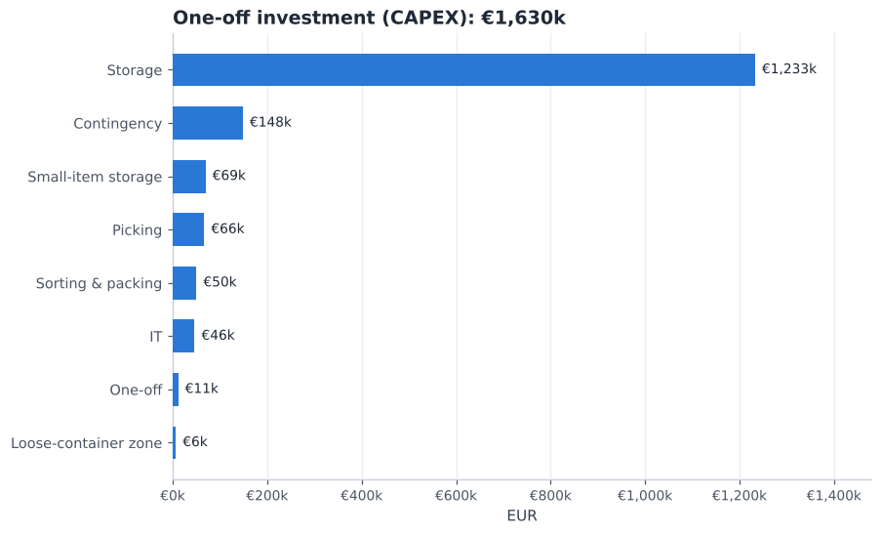
Fig 12. CAPEX by group — total €1,630k.
Item | Quantity | Unit price | Total | Source
Single-deep pallet racking (incl. installation) | 8,640 positions | €130 | €1,123,200 | A033 / IndexBox, n.d.; T-Racking, n.d.
Long-goods racking, 4.5 m bays (2.05 m pallets) | 320 positions | €160 | €51,200 | A033
Rack protection, end guards, load signs | 1 lot | €58,240 | €58,240 | A033 / SSI Schäfer, n.d.; STOW, n.d.
Bin shelving for small parts (next to the put-wall) | 188 bays | €200 | €37,600 | A042 / Manutan, n.d.
Half-bins and dividers | 3,948 slots | €8.00 | €31,584 | A042 / Logistiekdirect, n.d.
Carton-flow bays, fast-pick area | 31 bays | €1,800 | €55,800 | A034 / Shelving.com, n.d.
Fast-pick shelving + long-item shelves (wall row) | 36 bays | €200 | €7,200 | A046 / Manutan, n.d.
Pick trolleys (3-tier, 6 totes) | 6 trolleys | €433 | €2,598 | TBSG, n.d. / boxic24, n.d.
Totes 600 x 400 | 54 totes | €16 | €864 | Logistiekdirect, n.d.
Put-to-light wall (slots) | 120 slots | €150 | €18,000 | A035 / LatestCost, n.d.
Put-to-light installation + WMS link | 1 lot | €12,000 | €12,000 | A035 / LatestCost, n.d.
Pack stations (bench, scale, label printer) | 4 stations | €2,500 | €10,000 | A036
Stretch wrapper (packing) | 1 units | €3,849 | €3,849 | Machineseeker, n.d.
Roll cages for parcels | 41 cages | €150 | €6,150 | A036
Extendable roller conveyor (into the container) | 2 units | €1,250 | €2,500 | Cromwell, n.d.
Stretch wrapper (newly built pallets) | 1 units | €3,849 | €3,849 | Machineseeker, n.d.
RF terminals with cradles | 14 units | €1,500 | €21,000 | A036 / Bechtle, n.d.
WMS set-up: waves, put-wall, slotting, putaway rules | 1 lot | €25,000 | €25,000 | A037
Move-in / re-slotting (each load moved once) | 11,015 loads | €1.03 | €11,317 | ETV cycle model + A030
Contingency 10% | 1 lot | €148,195 | €148,195 | A037
Total CAPEX |  |  | €1,630,146

- Racking is 76% of the investment. If the racking already standing in Bemmel can be rebuilt in the new layout (about €25 per position), the investment drops to €521k. DHL must confirm the type and condition of today's racks.
- Depreciation: €141,591 a year (racking 15 years, equipment 7, IT 5).

7.2 Running cost (OPEX)
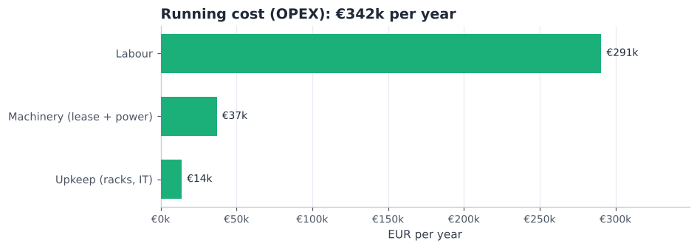
Fig 13. OPEX by group — total €342k per year.
Item | Quantity / year | Unit cost | Per year | Source
Direct DHL labour (receiving, putaway, replenishment, picking, packing, loading) | 9,161 paid h | €20 | €183,228 | capacity plan (D2 §6) x A030
Loose-container zone crew (2 people x 3 h per container) | 1,562 paid h | €20 | €31,232 | A019 x A030 (or contractor fee, see break-even)
Team leader + inventory control / admin | 2,928 paid h | €26 | €76,128 | A032 x A030
ETV 216i reach truck lease (2) | 24 truck-months | €900 | €21,600 | A038 / Liftlease, n.d.; Beekmans Heftrucks, n.d.; Itolang, n.d.; Solid Lift, n.d.
EJE 120i pallet truck lease (3) | 36 truck-months | €150 | €5,400 | A038
ERE 225 rider pallet truck lease (2) | 24 truck-months | €350 | €8,400 | A038
Electricity for trucks | 8,113 kWh | €0.20 | €1,660 | A039 / Statista, n.d.
Rack inspection (EN 15635) and repairs | 1 per year | €2,500 | €2,500 | A040 / SSI Schäfer, n.d.; STOW, n.d.
IT support, licences, device spares | 1 per year | €11,400 | €11,400 | A040
Total OPEX per year |  |  | €341,548
+ depreciation of CAPEX |  |  | €141,591 | A041
Total yearly cost |  |  | €483,139

Labour hours come from the capacity plan: 4.7 FTE on an average day × 8 paid hours × 244 working days. Peak days are covered by flexible staff at the same hourly cost.

7.3 Cost per unit
Per … | Volume per year | Cost
Order line | 156,160 | €3.09
Order | 35,136 | €13.75
Inbound pallet | 24,132 | €20.02
Pallet position per month | 8,960 | €4.49

These are full costs (OPEX + depreciation) split over the volume — useful for DHL to compare with the price agreed with Assa Abloy.

7.4 Today vs future — saving and payback
 | Process changes only | Whole design, re-used racking | Whole design, all new
One-off investment | €156,708 | €520,642 | €1,630,146
Labour saved per year (Section 2.2) | €101,208 | €101,208 | €101,208
Simple payback | 1.6 years | 5.1 years | 16.1 years

- Process changes = carton-flow lanes and shelving of the fast-pick area, trolleys and totes, put-to-light wall, RF terminals and the WMS set-up of waves and slotting. They create the whole labour saving and pay for themselves quickly — they can start before the racks are rebuilt.
- Racks, shelving and the container zone are capacity: they are needed to store and receive the goods at all, so they are judged on cost per position and space, not on labour saved.
- Only labour savings are counted. Shorter lead times, fewer parked trailers, fewer picking errors and a safer layout have value too, but no reliable price.

7.5 What if our cost assumptions are wrong?
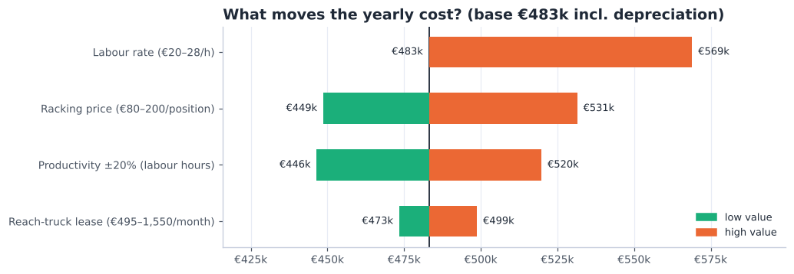
Fig 14. Yearly cost (OPEX + depreciation) when each assumption moves to the low or high end of its range.
- Labour rate and productivity matter most — labour is ~60% of the yearly cost. DHL's real hourly cost and time studies (A006, A025) are the most valuable inputs to get.
- Racking price is the biggest one-off uncertainty, but spread over 15 years its effect on the yearly cost is smaller.
- The truck lease price hardly matters: only 7 trucks are leased.
- Loose containers: a DHL crew costs ~€128 per container (244 containers a year). If a contractor quotes less, use the contractor in the same zone.

8. Supporting documents
Document | What it contains
Deliverable 1 — Analysis (updated) | Data analysis, concept choice and decision matrix; now single-deep racks and per-order lead time
Deliverable 2 — Future state (v3) | Processes, flowcharts, layout and 3D, docks, picking, machinery, capacity plan; now with the container zone and R2 overflow, long-goods module, small-parts shelving, area checks and the hazmat classes
Deliverable_3_Calculations.xlsx | Every price, quantity and formula of this report; change an input and all totals update
data/assumptions.json | All assumptions A001–A047, each with reason, source and impact
documentation/sources.md | All sources with links and what they support (cited in APA; reference list at the end)
analysis/*.py | Scripts that turn the raw data into every table and figure (run order in README.md)

9. Cost assumptions and open points
Assumptions added for Deliverable 3 (full register in data/assumptions.json):
ID | Assumption | Value | Source
A030 | Labour cost per paid hour | operative EUR 20 (high case EUR 28); team leader EUR 27; admin EUR 24 | Rogier, course teacher, personal communication, October 2026; Centraal Bureau voor de Statistiek, 2025b, 2025a; Cao Beroepsgoederenvervoer, n.d.; Connecting People, n.d.
A031 | Working days per year | 244 | Measured (Assa Abloy & DHL Supply Chain, 2025)
A032 | Indirect staff | 1.5 FTE (1 team leader + 0.5 inventory control / WMS admin) | Planning assumption
A033 | Racking prices | EUR 130 per installed single-deep position (80-200); long-goods position EUR 160; protection 5% of racking; re-use of existing racking EUR 25/position | IndexBox, n.d.; T-Racking, n.d. + assumption
A034 | Carton-flow bay price | EUR 1,800 per 2 m bay (1,100-2,300) | Shelving.com, n.d.; Machineseeker, n.d.
A035 | Put-to-light wall | EUR 150 per slot + EUR 12,000 installation and WMS link | LatestCost, n.d.
A036 | Small equipment prices | RF terminal EUR 1,500; trolley EUR 433; tote EUR 16; wrapper EUR 3,849; roller conveyor EUR 1,250; pack station EUR 2,500; roll cage EUR 150 | boxic24, n.d.; Logistiekdirect, n.d.; Machineseeker, n.d.; Cromwell, n.d.; Bechtle, n.d. + assumption
A037 | WMS set-up and contingency | WMS set-up EUR 25,000; contingency 10% of CAPEX | Assumption
A038 | Truck full-service lease per month | ETV 216i EUR 900 (495-1,550); EJE 120i EUR 150; ERE 225 EUR 350 | Liftlease, n.d.; Beekmans Heftrucks, n.d.; Itolang, n.d.; Solid Lift, n.d. + assumption
A039 | Truck energy | ETV 4 kWh per operating hour, pallet trucks 1.5 kWh/h; EUR 0.2046 per kWh | Statista, n.d. + assumption
A040 | Upkeep | rack inspection + repairs EUR 2,500/yr; IT support 15% of IT CAPEX/yr | SSI Schäfer, n.d.; STOW, n.d. + assumption
A041 | Depreciation | racking 15 yrs, equipment 7 yrs, IT 5 yrs, straight-line | Assumption
A042 | Small parts move from pallet racks to bin shelving | 2,657 slow SKUs (C or no demand) with stock <= 50 L, unit <= 20 L, <= 15 kg, <= 60 cm -> 3,424 half-bins on 188 shelving bays (207 m2) next to the put-wall; frees 1,005 rack locations; 50 lines/h | Relevator Group, n.d.; Cisco-Eagle, n.d.; Commander, n.d.; Modern Materials Handling, n.d.; Manutan, n.d. + measured
A043 | Maximum real item / pallet length | 2.05 m (XLONG pallet); 115 loads recorded longer are data errors (e.g. a 10.95 m item of 0.5 kg) | Rogier, course teacher, personal communication, October 2026 + Jungheinrich, 2019
A044 | Big containers borrow door R2 | on container days with > ~12 SKUs the north half of receiving (131 m2) beside R2 is used for unpacking; 91% of containers fit the zone alone, 97% with R2 | Rogier, course teacher, personal communication, October 2026 + dock model
A045 | Area check outbound staging and packing | outbound staging need: p90 60 m2, max 100 m2 of 216; packing need 423 m2 of 450 incl. shelving and the put-wall | Measured + planning assumption
A046 | Every fast mover (A/B item) gets a pick face in the fast-pick area | 31 carton-flow bays (2 m, 5 levels x 6 lanes = 930 lanes) hold the 888 most-picked A/B items that fit a lane (each <= 28 x 33 x 60 cm, <= 15 kg) + 42 second lanes for the top 1%; across the 2.6 m pick aisle a wall row holds the rest: 26 shelving bays (462 items), 5 long-item bays of 2.2 m (42 items up to ~2 m, lying lengthwise) and 20 floor pallet faces (17 heavy/bulky items) = 55 of 63.6 m | Measured (Q2 order lines, SKU dimensions) + planning assumption + Manutan, n.d.
A047 | Fixed places inside the working zones | Receiving: R2 in the north half (lent to container unpacking on big-container days), R3 in the south half; container zone: 10.5 m roller conveyor from R1, 12 build spots (6 each side), 35-pallet buffer, 4 x 4 m wrap/label station; fast-pick band: wall row 1.2 m, pick aisle 2.6 m, carton flow 1.8 m deep, refill strip ~1.6 m | Layout design (geometry.py)

- To get from DHL: real hourly labour cost and pick/pack times (A006, A025, A030); type and condition of today's racking (re-use); container numbers per week (A019).
- To get from suppliers: Jungheinrich lease quote for the trucks (A038); racking quote incl. the long-goods module (A033); contractor price per loose container (A026).
- To get from Assa Abloy: UN numbers / safety data sheets of the hazardous SKUs (A028), and a clean-up of the item lengths in the master data (A043).

References
APA 7th edition. Conversations with the course teacher and DHL are personal communications and are cited in the text only.
Assa Abloy, & DHL Supply Chain. (2025). Assa Abloy storage details (1 April, 1 May and 1 June 2025) and outbound details (April–June 2025) [Unpublished raw data]. DHL Supply Chain, Bemmel.
Bechtle. (n.d.). Zebra MC3300 charging cradle base [Product listing]. Retrieved October 18, 2026, from https://www.bechtle.com/de-en/shop/zebra-mc3300-charging-cradle-base--4258458--p
Beekmans Heftrucks. (n.d.). Reachtrucks. Retrieved October 18, 2026, from https://www.beekmansheftrucks.nl/product-categorie/reachtrucks/
BOVAG. (n.d.). Veelgestelde vragen over PGS 37-2. Retrieved October 18, 2026, from https://mijn.bovag.nl/dossiers/veelgestelde-vragen-over-pgs-37-2
boxic24. (n.d.). Fetra 28301 [Product listing]. Retrieved October 18, 2026, from https://boxic24.com/english/fetra-28301.html
Cao Beroepsgoederenvervoer. (n.d.). TLN functieloonschalen per 1 januari 2025. Retrieved October 18, 2026, from https://www.caoberoepsgoederenvervoer.nl/tln-functieloonschalen-per-1-januari-2025/
Centraal Bureau voor de Statistiek. (2025a). De arbeidsmarkt in cijfers 2025: Lonen en loonkosten. Retrieved October 18, 2026, from https://longreads.cbs.nl/dearbeidsmarktincijfers-2025/lonen-en-loonkosten/
Centraal Bureau voor de Statistiek. (2025b). Loonkosten per gewerkt uur 6 procent hoger in 2024. Retrieved October 18, 2026, from https://www.cbs.nl/nl-nl/nieuws/2025/42/loonkosten-per-gewerkt-uur-6-procent-hoger-in-2024
Cisco-Eagle. (n.d.). Vertical lift modules vs. horizontal carousels. Retrieved October 18, 2026, from https://www.cisco-eagle.com/blog/?p=2003
Commander. (n.d.). LogiMat vertical lift module [Product page]. Retrieved October 18, 2026, from https://www.commander.ca/product-logimat-vertical-lift-module/
Connecting People. (n.d.). Salaris orderpicker. Retrieved October 18, 2026, from https://www.connectingpeople.nl/salaris/orderpicker/
Cromwell. (n.d.). [Extendable roller conveyor, product listing]. Retrieved October 18, 2026, from https://cromwell.co.uk/
Evofenedex. (n.d.). PGS 37: Opslag lithiumbatterijen. Retrieved October 18, 2026, from https://www.evofenedex.nl/kennis/gevaarlijke-stoffen/pgs-37-opslag-lithiumbatterijen
Extensiv. (n.d.). 3PL fulfillment KPIs: Formulas & benchmarks. Retrieved October 18, 2026, from https://www.extensiv.com/blog/3pl-fulfillment-kpis-formulas-benchmarks
HAN University of Applied Sciences. (2026a). [Lecture slides on warehouse design, layouts, storage and order-picking systems, week 3]. OPERMB04 Operations Management. Unpublished course material.
IndexBox. (n.d.). European Union: Metal racks market analysis, forecast, size, trends and insights. Retrieved October 18, 2026, from https://www.indexbox.io/store/european-union-metal-racks-market-analysis-forecast-size-trends-and-insights/
Itolang. (n.d.). Lease. Retrieved October 18, 2026, from https://itolang.nl/lease
Jungheinrich. (2019). ETV 216i: Technical data [Data sheet]. Retrieved October 7, 2026, from https://www.fallsway.com/hubfs/Fallsway_January2022/Pdf/jungheinrich-ii-etv-216i-spec-sheet-english.pdf
LatestCost. (n.d.). Put-to-light system cost. Retrieved October 18, 2026, from https://latestcost.com/put-light-system-cost/
Liftlease. (n.d.). Reachtruck leasen. Retrieved October 18, 2026, from https://liftlease.nl/lease/reachtruck-leasen
Logistiekdirect. (n.d.). Magazijnbak Eco Euronorm 64 liter, 600x400x320 mm [Product listing]. Retrieved October 18, 2026, from https://www.logistiekdirect.be/magazijnbak-eco-euronorm-64-liter-donkergrijs-600x400x320mm
Machineseeker. (n.d.). Vogel Verpackungen Starter [Product listing]. Retrieved October 18, 2026, from https://www.machineseeker.com/vogel+verpackungen-starter/i-22833460
Manutan. (n.d.). Open stelling van plaatstaal Quick-Fix Plus, hoogte 2000 mm, breedte 1000 mm [Product listing]. Retrieved October 18, 2026, from https://www.manutan.be/nl/mab/open-stelling-van-plaatstaal-quick-fix-plus-hoogte-2000-mm-breedte-1000-mm
Modern Materials Handling. (n.d.). Van Meter optimizes with vertical lift modules. Retrieved October 18, 2026, from https://www.mmh.com/article/van_meter_optimizes_with_vertical_lift_modules_vlms
Relevator Group. (n.d.). Vertical lift modules [Product category]. Retrieved October 18, 2026, from https://www.relevatorgroup.com/product-category/vertical-storage-systems/vertical-lift-modules/
Shelving.com. (n.d.). Gravity flow rack prices [Price list]. Retrieved October 18, 2026, from https://www.shelving.com/v/gravityflowrackprices.pdf
Slack, N., Brandon-Jones, A., & Burgess, N. (2022). Operations management (10th ed.). Pearson.
Solid Lift. (n.d.). Reachtrucks. Retrieved October 18, 2026, from https://www.solidlift.nl/reachtrucks
Special Cargo. (n.d.). PGS 37-2 onder de loep. Retrieved October 18, 2026, from https://services.specialcargo.com/nl-nl/blog/kennisbank/pgs-372/
SSI Schäfer. (n.d.). What does the rack inspection check? Retrieved October 14, 2026, from https://ssi-schaefer.com/en-de/what-does-the-rack-inspection-check--1580504
Statista. (n.d.). [Electricity prices for non-household consumers in the Netherlands, Eurostat nrg_pc_205]. Retrieved October 18, 2026, from https://www.statista.com/statistics/596254/electricity-non-household-price-netherlands
STOW. (n.d.). DIN EN 15635 and other safety standards for racking. Retrieved October 14, 2026, from https://www.stow-group.com/en/racking/blog/warehouse-safety-standards/
T-Racking. (n.d.). How much does pallet racking cost? Retrieved October 18, 2026, from https://t-racking.com/how-much-does-pallet-racking-cost
TBSG. (n.d.). Order picking and display trolley with adjustable shelves [Product listing]. Retrieved October 14, 2026, from https://www.tbsg.co.uk/order-picking-and-display-trolley-with-adjustable-shelves--2

