PROJECT OTM
Warehouse Design — Analysis & Policy Pre-selection
Assa Abloy operation · DHL Supply Chain, Bemmel (NL_0032)
Field | Detail
Deliverable | 1 — Analysis of data, pre-selection & justification of policies
Due date | 16-09-2026
Data period analysed | Q2 2025 (01 Apr – 30 Jun)
Site constraints | ≤ 7,000 m² footprint · ≤ 12.2 m height
Scope | Receiving · Storage · Picking · Shipping (end-to-end)
Author | ________________________
Version | v2 — analysis, design options, policies & recommendation (updated with teacher feedback)

This draft covers Deliverable 1 end-to-end: data analysis, storage-capacity feasibility, three design options, policy pre-selection, equipment, and a recommended concept with a decision matrix. All figures are measured from the provided Assa Abloy data or computed by the analysis scripts; nothing is fabricated, and open assumptions are listed in Section 13.

Contents
(In Word: right-click → Update Field to build the table of contents.)

1. Introduction & scope
DHL Supply Chain previously ran warehouse operations for four clients in Tiel and recently relocated to a new site in Bemmel under significant time pressure. The Operations Manager considers the current (post-move) design sub-optimal. The objective of this project is to develop an alternative, more efficient and effective warehouse design for the Assa Abloy operation, based on a thorough analysis of the operational data.
The design covers four processes end-to-end — receiving, storage, picking and shipping — with all choices aligned across them. Facility architecture is out of scope; legal aspects (fire safety, compliance) are considered. The site envelope is a maximum footprint of 7,000 m² and a maximum height of 12.2 m.

2. Data sources & method
Two datasets from the Assa Abloy operation (warehouse NL_0032) form the primary source of truth:
Dataset | Files | Grain | Volume
Storage / inventory | 3 snapshots (01-04/05/06-2025) | Inventory detail (DTLNUM) | 16,575–17,290 records
Outbound shipping & picking | 3 months (Apr–Jun 2025) | Order line | 39,069 lines · 8,781 orders

Analysis is performed in Python (pandas). Every headline number is reproducible from the scripts in /analysis and cached in outputs/reports/phase1_metrics.json. Data-quality issues are flagged (Section 8), not silently corrected.

3. SKU profile
- 5,291 SKUs in stock across 11 product families.
- 3,115 SKUs have a case pack; 2,176 are each-only (≈41%) — confirming real each-pick demand.
- Each size is small: median cube 0.0005 m³ (~500 cm³) — typical for locks, cylinders and fittings.
- Units per pallet: median 1000 (mean skewed by high-count small parts).
- Pallet weight: median 431 kg — realistic for a EURO pallet (see data-quality flag on sentinel maxima).
- Pallet-type mix (SKU level): EURO 2,864, K3 2,040, XLONGPALLET 168 (long goods), plus K1/K2/K5/CONS.
- Hazardous SKUs: 138 — require segregation/compliance consideration.
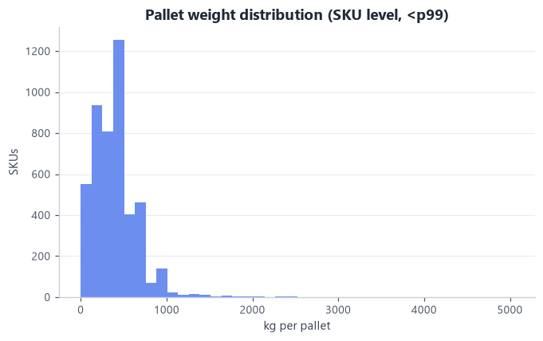
Fig 1. Pallet-weight distribution at SKU level (<p99).

4. Inventory & storage-position requirement
Snapshot | Detail recs | Loads (positions) | Occupied locations | Active SKUs | Cube (m³)
2025-04-01 | 16,575 | 10,176 | 7,715 | 5,164 | 3,209
2025-05-01 | 16,793 | 10,534 | 8,149 | 5,273 | 3,434
2025-06-01 | 17,290 | 11,015 | 8,512 | 5,291 | 3,679

- Occupied locations (pallet positions) grew 7,715 → 8,512 over the quarter; loads grew +8.2% (10,176 → 11,015); cube +15%.
- Peak pallet positions ≈ 8,512 occupied locations → the storage baseline. The 11,015 loads sit in those locations (some locations hold more than one load), so loads overstate the positions needed (A004).
- Loads per SKU: mean 2.07, median 1, max 337; 72.7% of SKUs occupy a single load — a long slow-moving tail one pallet deep.
- Eaches held roughly flat (~2.9M) while loads rose → stock is fragmenting into more, less-full locations: a current-design inefficiency to target.
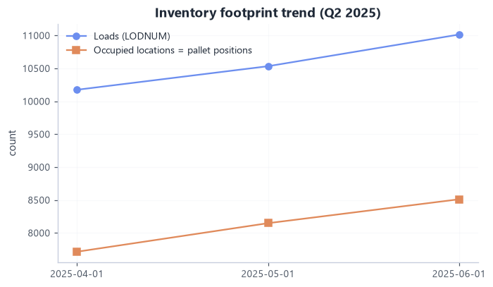
Fig 2. Inventory footprint trend, Q2 2025 (loads and occupied locations).
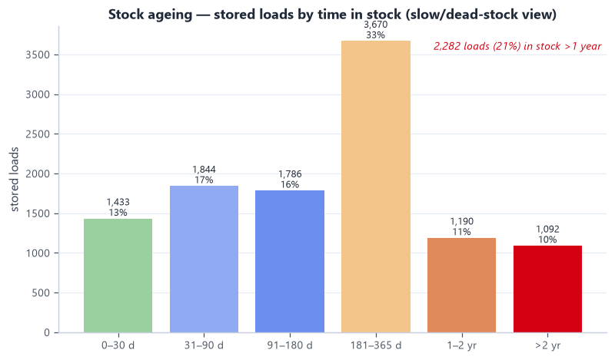
Fig 2b. Stock ageing — 21% of loads have been in stock >1 year (dead-stock signal).

5. Order & picking profile and lead time
Metric | Mean | Median | p95 | Max
Lines per order | 4.45 | 1 | 19 | 191
Units per line | 34.77 | 5 | 150 | 12020
Units per order | 154.7 | 8 | 575 | 20480

- 8,781 orders / 39,069 lines; 50.5% single-line orders and 23.6% single-unit lines — a small-order-heavy profile.
- Pick type is derived from what the client ordered (A022) — each line's quantity is compared with the SKU's case and pallet quantity: 75% each-pick lines, 24% case lines, 1% full-pallet lines (by units: 61% case, 26% each, 13% pallet).
- Picking is each-dominant by line count (the labour driver) and case-dominant by volume. DHL's historical pick flags (case/list 60.8%, each 16.0%, 20.6% unflagged) reflect past practice and are not used for design.
- Delivery lead time (order received → dispatched): average 78.3 h (~3.3 days), median 52.4 h (~2.2 days), p90 166.9 h. Right-skewed (mean > median), so the typical order is nearer the median; measured as TRAILER DISPATCED DATE − ORDER ARRIVE DATE.
- Channel mix (order type): NLD 20,944, EDC 4,703, BEL 4,596, DIRECT 4,003, AMADE 2,216.
- Geography: NLD 22,510, BEL 6,386, DEU 3,534, FRA 1,041, POL 911 — an NL hub serving Western Europe.
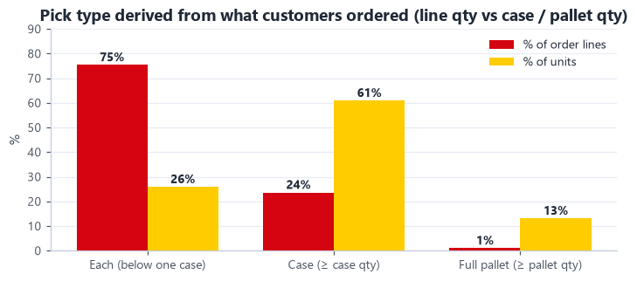
Fig 3. Pick type derived from the orders (line quantity vs case / pallet quantity).

6. Demand-based ABC classification
ABC is recomputed from actual outbound demand (picked quantity), not assumed. The distribution is steeper than the classic 80/20 rule:
Top X% of SKUs | % of picked volume
5% of SKUs | 58.9%
10% of SKUs | 74.5%
20% of SKUs | 88.1%
30% of SKUs | 94.0%
50% of SKUs | 98.5%

A/B/C by demand volume (A ≤ 80% cumulative, B ≤ 95%, C remainder):
Class | SKUs | % SKUs | % volume | % pick-lines
A | 565 | 13.0% | 80.0% | 41.8%
B | 858 | 19.7% | 15.0% | 30.0%
C | 2,931 | 67.3% | 5.0% | 28.3%

- ~13% of SKUs drive 80% of volume, yet C-class is 67% of SKUs and still 28% of picks → forward-pick / fast-lane slotting is high-value.
- Demand-ABC agrees with the WMS classification on only 48.6% of SKUs → strong evidence the current slotting is misaligned with real demand (re-slot).
- 4,354 SKUs shipped in Q2; 855 shipped were not in the latest stock snapshot (transient/cross-dock — to confirm).
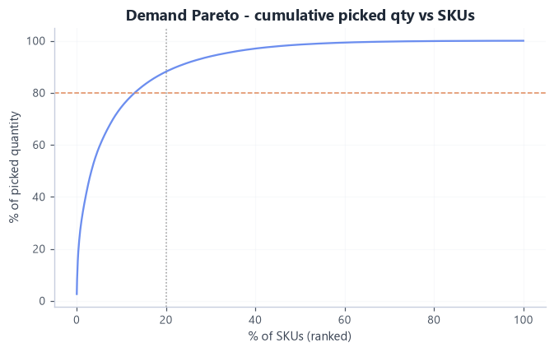
Fig 4. Demand Pareto — cumulative picked quantity vs ranked SKUs.
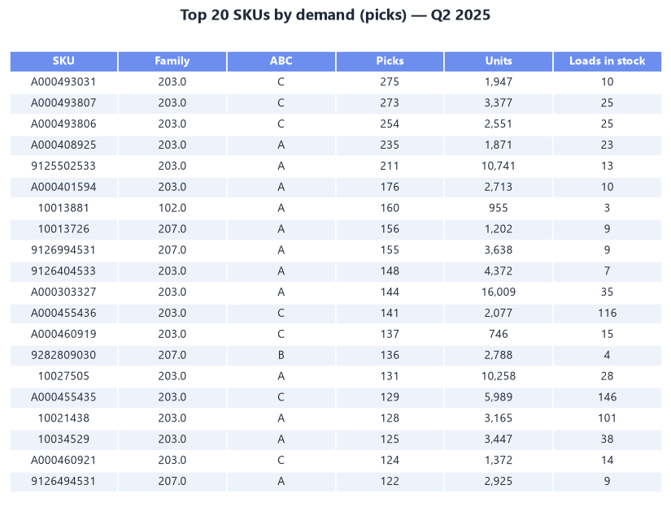
Fig 4b. Top-20 SKUs by demand — note several high-demand items still WMS-classed C.

7. Peak activity analysis
Metric | Average / day | PEAK / day | Peak ÷ Avg | Peak date
Order lines | 640 | 1171 | 1.83× | 2025-05-27
Units | 22269 | 63469 | 2.85× | 2025-05-27
Orders | 144 | 250 | 1.74× | 2025-04-29
Shipments | 134 | 229 | 1.71× | 2025-04-29

- Design to peak, not average. Units peak (2.85×) is far spikier than lines (1.83×), so sizing on lines alone understates pick/pack surges.
- Weekly peak 3563 lines (week of 2025-06-01) vs ~2791 average.
- The 08:00 intraday peak is caused by the order-release routine, not by customers (A023): 55% of orders arrive 15:00–17:00, are released 16:00–18:00 and are picked the next morning, so the backlog hits the floor at shift start (1.31× the average hour). Monday–Friday only, weekdays fairly even.
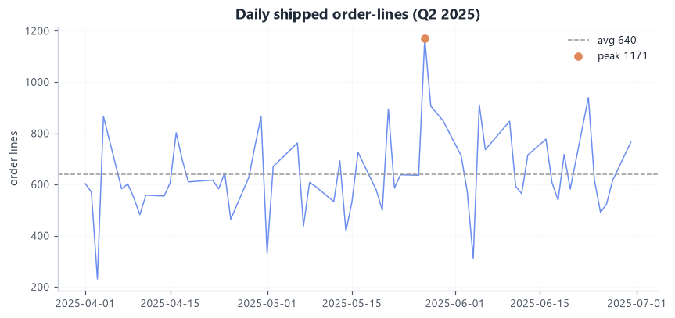
Fig 5. Daily shipped order-lines with average and peak.
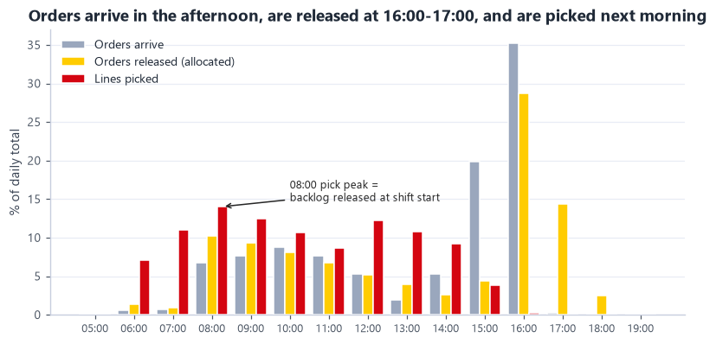
Fig 6. Order arrival vs release vs picking by hour — the 08:00 peak is the release backlog.

8. Data-quality flags
Raised, not silently corrected:
- PA WGT sentinel/impossible values — median 431 kg is fine, but p95 = 9999 kg and max = 60423 kg are impossible for one pallet (9,999 looks like a placeholder). To be cleaned before rack load-rating.
- units_per_pallet extreme mean (15171 vs median 1000) — use robust statistics.
- "Other" pick class = 20.6% of lines — no PALL/LIST/TROLLEY flag set. Resolved for the design: the pick type is derived from order quantities instead of these flags (A022).
- Stock vs demand mismatch — 855 shipped-not-stocked; a further set of stocked-not-shipped SKUs are dead-stock candidates. To confirm handling (cross-dock vs obsolete).

9. Headline design requirements (input to design options)
- Storage: ~8,512 pallet positions at peak → target ~9,500 (÷ 0.90 working utilisation); growth (+8%/quarter in loads) is absorbed by extra rack levels, not by an inflated count. Must fit the 12.2 m / 7,000 m² envelope (A008).
- Long slow tail: 67.3% C-SKUs and 72.7% single-load SKUs → high-density/deep storage for the tail, fast forward-pick for A/B.
- Picking is each-dominant by lines (75% each, 24% case, 1% full pallet — derived from the orders) and half of all orders are single-line → batch picking from an easy-reach fast-pick area is the key labour lever.
- Re-slot to demand — only 48.6% ABC agreement today.
- Capacity to peak — 1171 lines / 63469 units on the peak day; the 08:00 peak is a release effect that waves can level.

10. Storage capacity feasibility
Design target: peak 8,512 occupied locations ÷ 0.90 working utilisation ≈ 9,500 pallet positions (A010). This replaces the earlier 14,074 (loads × 1.15 buffer), which overstated the need by counting loads instead of positions. Measured pallet+load height is low (p90 116 cm), giving a 1.41 m level pitch and up to 8 levels under 12.2 m.
Bottom-up floor area needed to hold that target, by storage concept:
Concept | MHE | Levels | Total area m² * | % of 7,000 m² | Fits?
Selective - wide aisle | Counterbalance FLT | 6 | 6,810 | 97% | TIGHT
Selective - narrow aisle | Reach truck | 7 | 5,040 | 72% | YES
Double-deep | Reach truck (deep) | 7 | 4,280 | 61% | YES
VNA | VNA turret truck | 8 | 3,390 | 48% | YES
Drive-in | Counterbalance FLT | 5 | 6,330 | 90% | TIGHT

* includes a 35% allowance for receiving, staging, pick, pack, ship, offices and circulation.
- At the corrected target several concepts fit: double-deep 61%, narrow-aisle selective 72%, VNA 48%. Wide-aisle (97%) and drive-in (90%) are tight.
- → Space alone no longer decides the concept. The choice is driven by travel and labour, slotting flexibility, growth headroom and cost — compared in the options and decision matrix below.
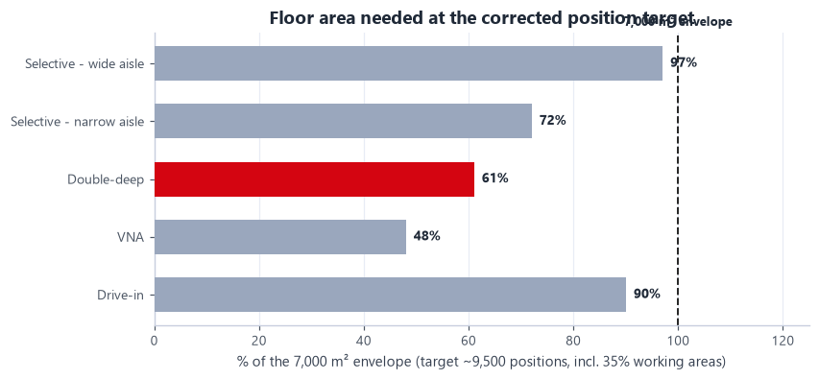
Fig 7. Floor area to hold the corrected position target, by concept, vs the 7,000 m² envelope.

11. Design options
Three end-to-end options (storage × picking × MHE × policies), each aligned across the four processes.

Option A — Conventional+ (improve the current concept)
- Storage: selective single-deep, narrow-aisle (reach), 7 levels; two-zone ABC. ≈72% of the envelope.
- Picking: RF-directed discrete + simple batch; case pick from pick-face; pallet from reserve.
- MHE: reach trucks, low-level order pickers, pallet trucks, RF scanners.
- Verdict: cheapest and simplest, but the most aisles, travel and labour.

Option B — Hybrid density + velocity slotting + zone/batch picking (recommended)
- Storage: double-deep reach racking for A/B reserve + selective single-deep for irregular SKUs + a forward-pick module (carton-flow / shelving) for fast case/each; cantilever for XLONG goods. ≈61% of the envelope for storage + working areas — room to grow.
- Picking: zone + batch/wave picking (batches the 50% single-line orders); A-movers in a golden-zone forward pick; voice/RF; put-to-light consolidation at pack.
- MHE: reach trucks with telescopic forks (Jungheinrich ETV 216i), horizontal order pickers (ECE 225), rider pallet trucks (ERE 225), voice/RF, print-and-apply — sized in Deliverable 2.
- Policies: velocity (demand-ABC) slotting, hybrid random-within-zone storage, min/max replenishment, FIFO via FIF DATE where relevant.
- Verdict: fits with buffer, materially lower travel/labour than A, moderate CAPEX — strongest business case.

Option C — High-density / semi-automated
- Storage: VNA (man-up turret) for reserve + automated small-parts store (shuttle/AutoStore-style) for the large C each-pick tail. ≈48% of the envelope (densest).
- Picking: goods-to-person / pick-to-light for smalls; VNA combined storage+pick; automated sortation.
- MHE: VNA turret trucks + guidance, automation modules, minimal manual MHE.
- Verdict: densest and lowest labour, but highest CAPEX and complexity; ROI depends on labour cost.

12. Decision matrix & recommendation
Option | Weighted score (max 5) | Result
B - Hybrid density | 3.75 | RECOMMENDED
C - Semi-automated | 3.70 | Strong alternative
A - Conventional+ | 3.05 | Baseline

Weight-sensitivity (robustness):
Option | Base | Cost-driven | Space-driven
B - Hybrid density | 3.75 | 3.65 | 4.75
C - Semi-automated | 3.70 | 3.35 | 4.85
A - Conventional+ | 3.05 | 3.35 | 3.55

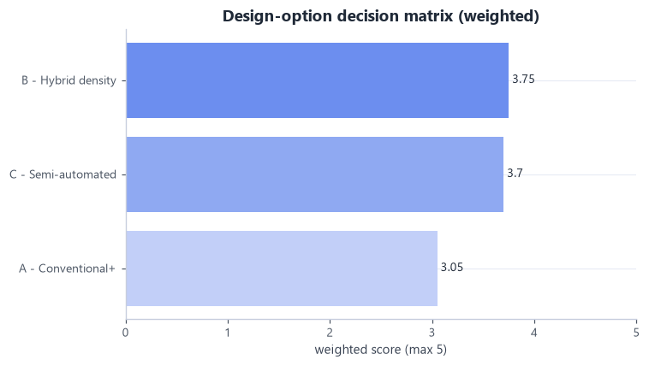
Fig 8. Weighted decision-matrix scores.
- Recommended: B - Hybrid density. It wins on base and cost-driven weightings; C overtakes only when space is the dominant criterion — likely if A008 resolves to a small Assa-only envelope.
- Why (data): double-deep holds the corrected target in ≈61% of the envelope, leaving growth room with fewer aisles than selective racking; 75% of order lines are each-picks and 50% of orders single-line → batch/zone picking from a fast-pick area is the biggest labour lever; 48.6% ABC mismatch → velocity slotting is a cheap, high-value win; 73% single-load tail → dense reserve.
- Conditions before locking: confirm the 7,000 m² scope (A008); obtain labour/equipment costs (A006) to confirm B vs C in the financial model; validate double-deep against the EURO/K3/XLONG pallet mix.
Recommended concept preview (detailed layout and 3D in Deliverable 2):
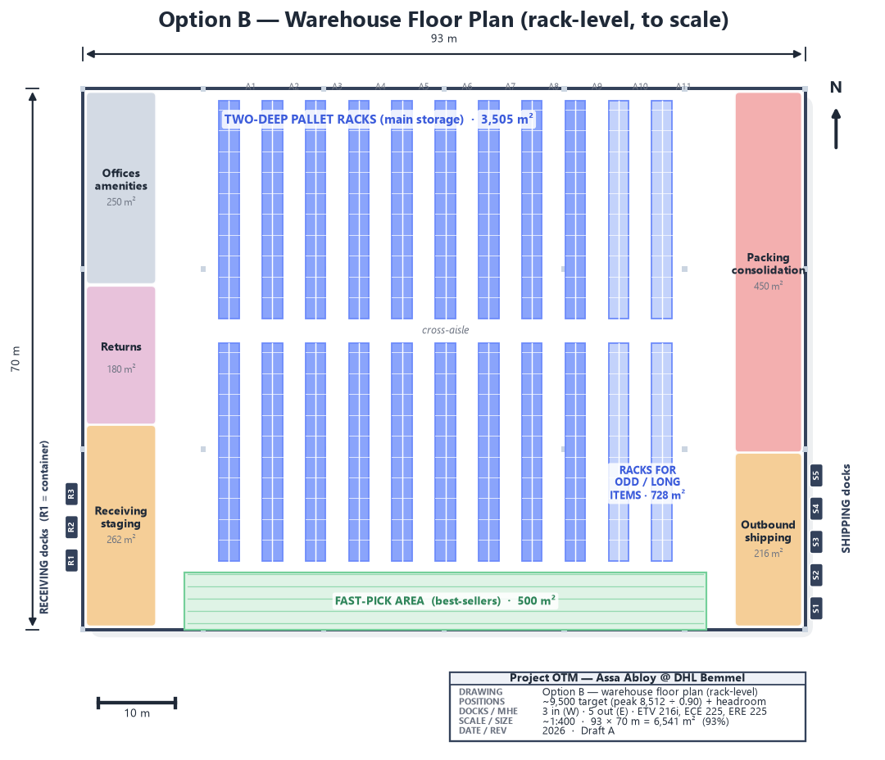
Fig 9. Recommended Option B — warehouse floor plan (rack-level, to scale).

13. Assumptions & open questions
Logged in data/assumptions.json. Items that materially affect the design:
ID | Assumption / open question | Impact
A001 | Max facility footprint | HIGH
A002 | Max clear/building height | HIGH
A003 | Analysis period is representative of normal operation | HIGH
A004 | Storage requirement is based on OCCUPIED LOCATIONS (pallet positions), not loads | HIGH
A005 | STAGED STATUS 'LATE' reflects staging vs the LATE SHIP window, i.e. a genuine on-time-staging miss | HIGH
A006 | No labour-productivity, MHE-fleet or cost data was provided | HIGH
A008 | The 7,000 m2 / 12.2 m envelope is the space available to DESIGN THE ASSA ABLOY operation within | HIGH
A010 | Design pallet-position target | HIGH
A013 | Functional (non-storage) areas sized from actual order volume | HIGH
A014 | Labour productivity benchmarks (units/person-hour) | HIGH
A017 | Peak-aware slotting: spread fast movers, duplicate extreme SKUs, balance picks/aisle on peak forecast | HIGH
A018 | Inbound arrives as 2 shipments per day, direct from Assa Abloy factories | HIGH
A019 | Part of inbound arrives LOOSE (floor-loaded sea containers) and is de-stuffed and palletised by hand | HIGH
A020 | Dock-door planning parameters | HIGH
A022 | Pick type is derived from what the client ordered, not from DHL's historical pick flags | HIGH

Sources: project brief, the Assa Abloy data files, teacher/DHL feedback and external references (Gadeyne on peak slotting; Jungheinrich equipment data) — full list in documentation/sources.md.

