PROJECT OTM
Future-State Operational Design
Assa Abloy operation · DHL Supply Chain, Bemmel (NL_0032)
Field | Detail
Deliverable | 2 — Proposed future state for the in-scope processes
Due date | 07-10-2026
Concept | Option B — Hybrid density + velocity slotting + zone/batch picking
Envelope | ≤ 7,000 m² · ≤ 12.2 m
Team | Group 3 — Gleb, Rachel Selvarathnam, Arnau, Vidhi
Version | v2 — adds inbound (loose containers), dock-door calculation, Jungheinrich MHE, order release

Future-state design for the recommended Option B (Deliverable 1). Workload drivers are measured from the Assa Abloy Q2-2025 data; equipment data come from Jungheinrich; productivities and handling allowances are documented assumptions (Section 7) to be validated with DHL. Reproducible from analysis/*.py.

Contents
(In Word: right-click → Update Field to build the table of contents.)

1. Recommended concept and what changed
Option B was selected in Deliverable 1. It combines two-deep (double-deep) reserve racking, selective + cantilever racking for irregular and long goods, and a fast-pick area (carton-flow / shelving) for the best-sellers, run with demand-based slotting and zone + batch picking. This version builds in the points agreed with the teacher and DHL:
Topic | Before | Now (this version)
Storage basis | 14,074 positions (11,015 loads + buffer) | ~9,500 positions: peak 8,512 occupied locations ÷ 0.90
Pick method | DHL's historical pick flags (61% case) | Derived from the orders: 75% each / 24% case / 1% full-pallet lines
Inbound | Estimated from flow balance | Measured ~99 loads/day; 2 shipments/day from Assa Abloy factories, pallets + loose containers
Dock doors | 3 + 3 assumed | Calculated: 3 receiving (west, 1 container dock) + 5 shipping (east)
Equipment | Generic truck types | Jungheinrich ETV 216i ×3, ECE 225 ×4, ERE 225 ×2 — sized from their technical data
08:00 peak | Treated as customer demand | Caused by the order-release routine → release in waves

2. Future-state processes
Each process below states the steps, the system transaction, the physical movement, the equipment, and where the Deliverable-1 design choices are applied. The swimlane (Fig 1) gives the end-to-end overview; per-process flowcharts follow.
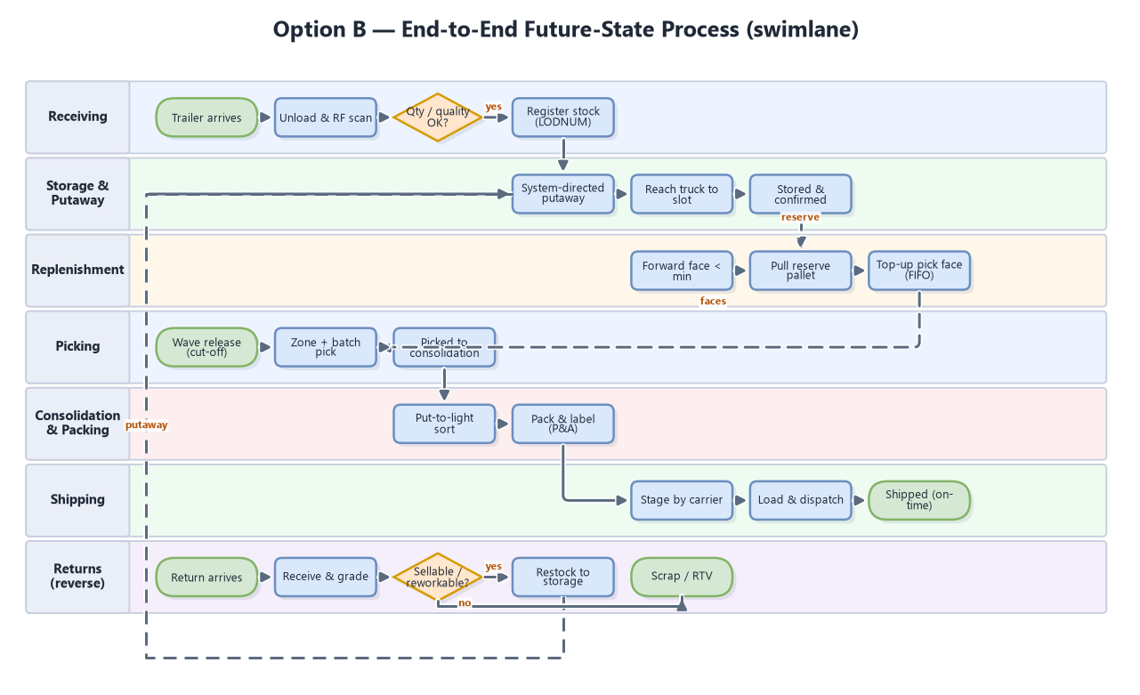
Fig 1. End-to-end future-state process — cross-functional swimlane.

2.1 Receiving & putaway
- What arrives: 2 shipments a day straight from Assa Abloy factories (S004). Trailers from the European plants arrive palletised; sea containers from Asia (~41% of loads) arrive loose — cartons stacked on the container floor.
- Palletised trailer (doors R2–R3): dock → unload with ERE 225 pallet truck → RF-scan against the ASN → quantity/quality check → register the load (LPN) → system-directed putaway with an ETV 216i reach truck → confirm.
- Loose container (door R1, container dock): dock → 2-person crew de-stuffs the cartons → sort by SKU on the dock → build and wrap pallets, print LPN labels → scan against the ASN → putaway. About 3 h per 40 ft container (A019, S005).
- Policy applied: demand-based directed putaway (A/B close to their fast-pick faces, C further away); pallets over 1 t on low levels; cantilever for extra-long goods.
- Truck route: reach trucks use the left perimeter aisle and the cross-aisle, never the fast-pick area — Jungheinrich's 'clear traffic guidance' principle (S009).
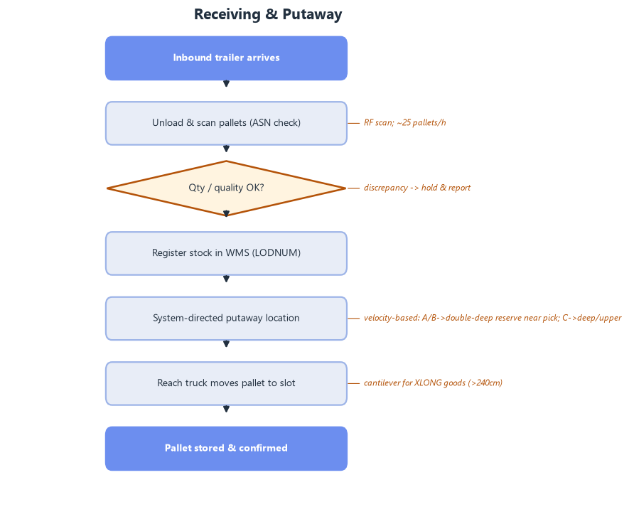
Fig 2. Receiving & putaway flow.

2.2 Replenishment
- Steps: fast-pick face below minimum → WMS replenishment task → ETV 216i takes the reserve pallet down the storage aisle → feeds the carton-flow lane from the rear → confirm (~24 pallets/day on average).
- Policy applied: min/max replenishment; FIFO via FIF DATE where relevant. Pickers work the front of the lanes and trucks the rear, so people and reach trucks never share a face.
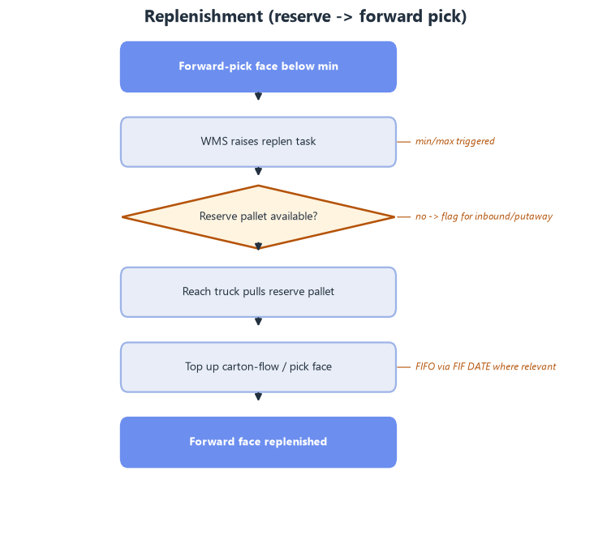
Fig 3. Replenishment flow.

2.3 Picking (zone + batch / wave)
- Pick method follows the orders (A022): comparing each line's quantity with the SKU's case and pallet quantity gives 75% each-pick lines, 24% case lines and 1% full-pallet lines (by units: 61% case, 26% each, 13% pallet). Picking is each-dominant by line count.
- Steps: orders released in waves (not one 08:00 backlog, Section 4.2) → batch single-line orders → picker on an ECE 225 collects 2 orders' roll cages/pallets per trip → full pallets by ETV 216i → to consolidation.
- Where: A/B fast movers in the fast-pick area; C items at the low levels of the reserve aisles (zones 2–3).
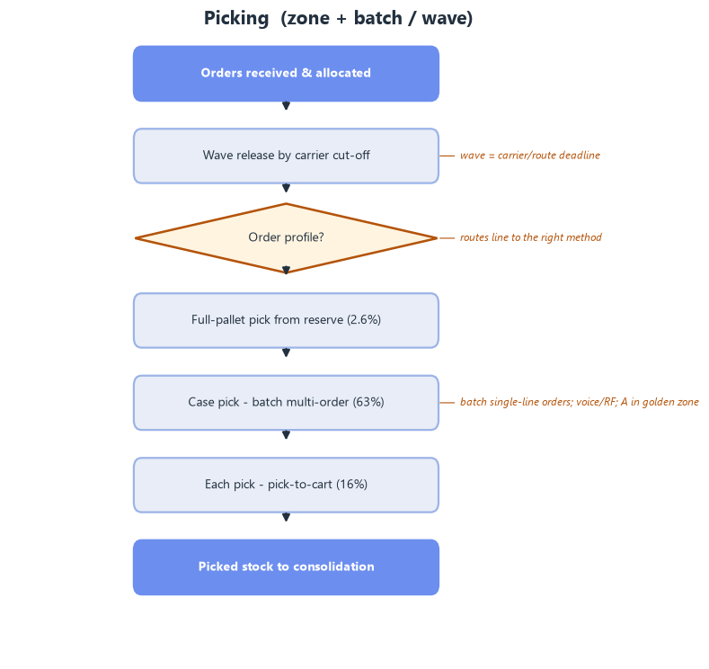
Fig 4. Picking flow (zone + batch/wave).

2.4 Consolidation, packing & shipping
- Steps: picked roll cages → put-to-light sort by order → pack, print-and-apply → parcel cartons onto roll cages by carrier / pallets wrapped → stage by carrier → live-load at the booked time → dispatch.
- Measured outbound: 15 trailers/day (p90 19), carrying on average only 1.2 pallets + 15 cartons; 73% of trailers carry no pallets at all (DHL Parcel routes).
- Policy applied: carriers book collection time slots; goods wait in the outbound staging lanes, not in parked trailers; 5 shipping doors on the east wall (Section 4.4).
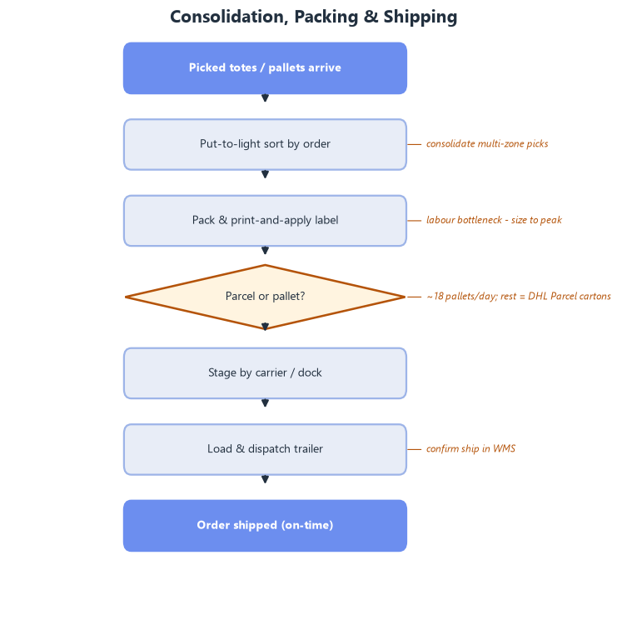
Fig 5. Consolidation, packing & shipping flow.

2.5 Returns (reverse logistics)
- Steps: customer return arrives through the receiving doors → receive & scan (RMA) → inspect and grade in the Returns area → sellable: restock · reworkable: rework, then restock · otherwise scrap / return to vendor → update inventory and credit.
- Policy applied: returns re-enter through the same demand-based putaway, so graded stock rejoins the reserve.
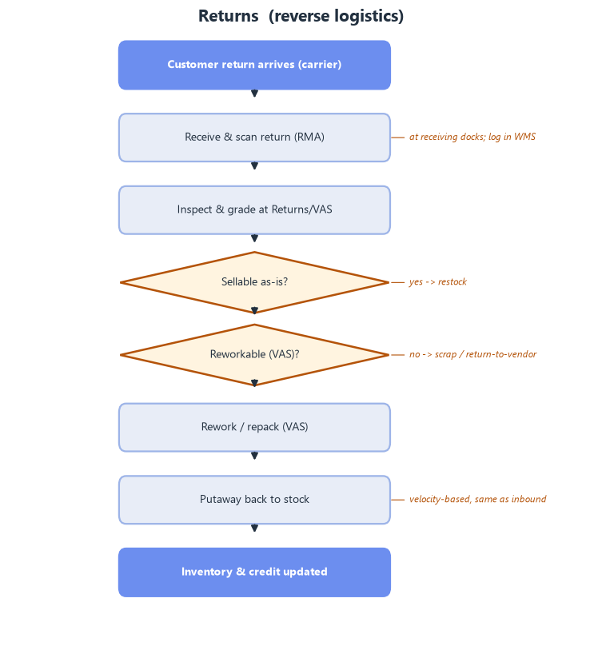
Fig 6. Returns / reverse-logistics flow.

3. Warehouse policies
Policy | Decision | Why (data)
Storage | Random within velocity zones; fixed fast-pick faces + random reserve | 73% single-load tail; 48.6% ABC mismatch
Slotting | Demand-ABC; fast movers spread across zones, extreme SKUs duplicated; heavy low | 13% SKUs = 80% volume; A = 60% of picks (S003)
Zoning | Fast-pick (A/B) vs reserve; truck routes kept out of the pick zone | 75% of order lines are each-picks; safety (S009)
Batching | Batch single-line / single-unit orders | 50% single-line, 24% single-unit
Order release | Waves through the shift instead of one 08:00 release | 08:00 = 1.31× the mean hour (A023)
Routing | S-shape / return within aisles | reduce travel in reserve
Putaway | System-directed, velocity-based to zone | align stock to demand
Replenishment | Min/max top-up from the rear of the lanes | keep faces filled at peak
Dock scheduling | Carrier time slots; stage, then live-load; 1 container dock | 15 trailers/day, 73% parcel-only; ~41% loose inbound
FIFO / FEFO | FIFO via FIF DATE where relevant | parts mostly not date-critical

3.1 Peak-season slotting (congestion control)
At peak, congestion — not walk distance — becomes the dominant cost (Gadeyne, S003). Because the peak is spiky (1.83× lines / 2.85× units) and picks are concentrated, clustering all fast movers in one golden zone would jam a single area. We therefore adopt peak-aware slotting:
- Picks are concentrated: the top 1% of SKUs (~43) do ~15.0% of all picks, and A-class SKUs ~60.0% of picks.
- Spread fast movers across all pick zones (balanced on peak-day pick frequency): one zone would carry ~60.0% of picks; spread over 3 zones each carries ~20.0%.
- Duplicate the extreme SKUs (~43 items) in different zones to allow parallel picking.
- Levers in priority order (S003): slotting → order batching → wave-release timing → pick-path sequencing.
- Validate by simulation at 150% / 200% / 250% of normal volume (Deliverable 3).

4. Inbound, order release & dock doors

4.1 What comes in
No separate receiving file was provided, so receipts are measured from the storage snapshots: loads with an ADD DATE in the 14 days before each snapshot (A007). Loads already shipped before the snapshot are not visible, so these are lower bounds.
Snapshot | Receiving days | Loads booked in | Loads / day | Busiest day | From Asia %
2025-04-01 | 10 | 709 | 71 | 111 | 22%
2025-05-01 | 9 | 974 | 108 | 167 | 54%
2025-06-01 | 9 | 1,058 | 118 | 160 | 48%

- ~99 loads are received per working day; the busiest day reached 167 (×1.7).
- 2 shipments a day, direct from Assa Abloy factories (teacher/DHL, S004) — in China, Germany, Romania, the Netherlands, Spain, Finland and others.
- ~41% of loads come from Asia and arrive loose in sea containers. The largest receipts (70–100 loads, all from China) take 1–3 days to book in — consistent with de-stuffing and palletising by hand.

4.2 Why picking peaks at 08:00
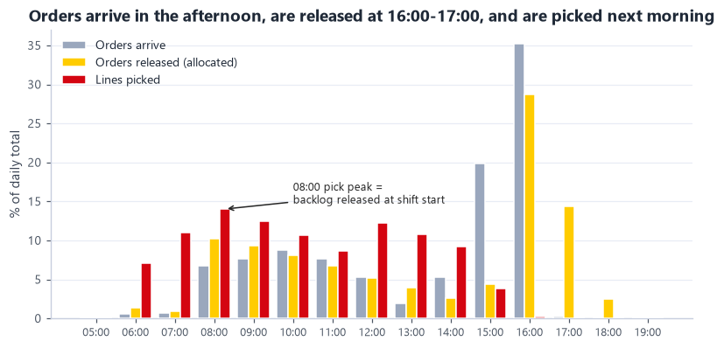
Fig 7. Orders arrive in the afternoon, are released at 16:00–17:00 and are picked the next morning — the 08:00 peak is the release backlog.
- 55% of orders arrive between 15:00 and 17:00, and ~43% are released (allocated) between 16:00 and 18:00.
- Picking starts at 06:00 and peaks at 08:00 at 1.31× the average working hour: the whole afternoon backlog lands on the floor at the start of the shift (A023).
- Future state: release work in waves (e.g. 06:00, 09:30, 12:00 plus a same-day wave for early orders). Levelling the load frees ~24% of peak-hour picker capacity without any change in customer service.

4.3 Inbound dock doors
Doors needed = the larger of (a) door-hours ÷ (receiving window 8 h × 85% utilisation) and (b) the number of arrivals that can be at the dock at the same time. A palletised trailer occupies a door ~1.3 h (unload with ERE 225 at ~1 min per pallet + 20 min dock-on and paperwork); a loose container ~3.3 h.
Scenario | Door-hours / day | Doors by capacity | Arrivals at once | Doors needed
Average day: 1 palletised trailer + 1 loose container | 4.6 | 1 | 2 | 2
Peak day: palletised volume x1.7 + 1 loose container | 5.3 | 1 | 2 | 2
Worst case: 2 loose containers (4 h de-stuff each) | 8.7 | 2 | 2 | 2
Sensitivity: ~8 smaller trucks/day (WMS truck IDs) | 4.3 | 1 | 3 | 3

Result: 3 receiving doors on the west wall — R1 a container dock (leveller with the range for container chassis), R2–R3 for trailers. The two daily shipments need 2 doors so a 3-hour container never blocks a trailer; the third door covers the 'many smaller trucks' case, customer returns and breakdowns.

4.4 Outbound dock doors
Sized trailer by trailer from the 912 outbound trailers in Q2. Dock time per trailer = 15 min dock-on and paperwork + loading of its actual pallets and roll cages with an ERE 225 (mean 18 min, p90 22 min). Doors are sized on the busiest hour: p90 9 trailers × 18 min ÷ (60 min × 85%) = 3.1 → 4 doors, plus 1 spare.
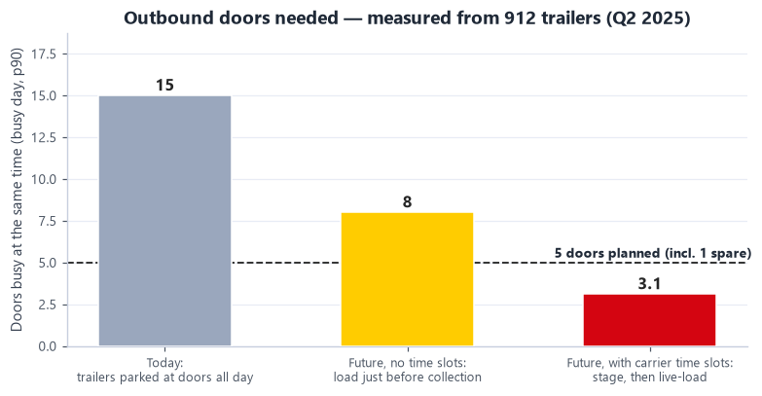
Fig 8. Outbound doors needed today vs in the future state (busy day, p90).
Measure | Value
Trailers per day (mean / p90 / max) | 15 / 19 / 22
Load per trailer (mean) | 1.2 pallets + 15 cartons
Trailers with no pallets (parcel only) | 73%
Trailers dispatched in the busiest hour (p90 / max) | 9 / 12
Today: trailers parked at the doors at once (p90) | 15
Future without time slots (p90) | 8
Future with carrier time slots | 3.1 → 5 doors incl. 1 spare

- Result: 5 shipping doors on the east wall, next to outbound staging and packing.
- Carrier time slots are a condition of this design. WMS dispatch times are closed in batches (60% of afternoon dispatches are under 2 minutes apart); without booked slots up to 8 doors would be needed, and today's all-day parked trailers would need ~15.
- Main carriers (trailers/day): Ex-works (customer pickup) 3.0, DHL DSV 2.4, DHL Parcel Netherlands 2.1, DHL Parcel NL DACH 1.4, DHL Parcel BE & LU 1.1, DHL4YOU 1.0.

5. Layout & zoning (3-dimensional)
Zones are sized from the measured volumes and laid out as a straight-through flow: goods come in on the west side and leave on the east side. Building ≈ 93 m × 70 m.
Zone | Area m² | % of building
Receiving & inbound staging | 262 | 4%
Offices & amenities | 250 | 4%
Returns / VAS | 180 | 3%
Double-deep reserve (A/B) | 3,505 | 54%
Selective + cantilever (irregular/XLONG/C) | 728 | 11%
Forward-pick module (carton-flow/shelving) | 500 | 8%
Packing & consolidation | 450 | 7%
Outbound staging & shipping | 216 | 3%
Circulation / aisles | 450 | 7%

Total floor area 6,541 m² = 93% of the 7,000 m² envelope.
- Storage: target ~9,500 positions (peak 8,512 occupied locations ÷ 0.90). Rack frames take up to 8 beam levels under 12.2 m (top beam 10.0 m, within the ETV 216i's 10.7 m lift); beams are installed for the target and extra levels absorb growth without more floor space.
- Working areas sized from measured volumes: inbound ~99 loads/day (peak 167); outbound 18 pallets + 225 cartons/day.
- Docks: 3 receiving (west, R1 = container dock) and 5 shipping (east). A trailer door needs ~4.3 m of wall — the 9.9 m receiving and 9.5 m outbound columns are too narrow on the south wall, so the doors sit on the side walls. This also separates inbound and outbound truck traffic.
- Aisles: 3.0 m reach aisles ≥ the ETV 216i working aisle of 2.63–2.79 m (S006); reach trucks travel the perimeter aisles and the cross-aisle.
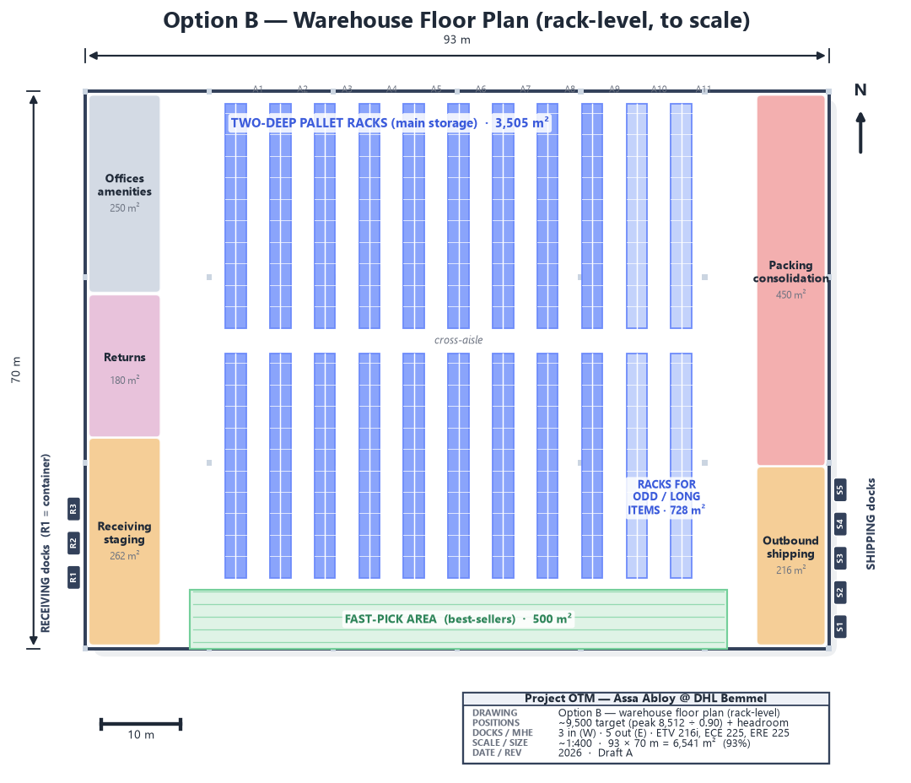
Fig 9. Detailed warehouse floor plan (rack-level, to scale) — racks, aisles, docks, dimensions.
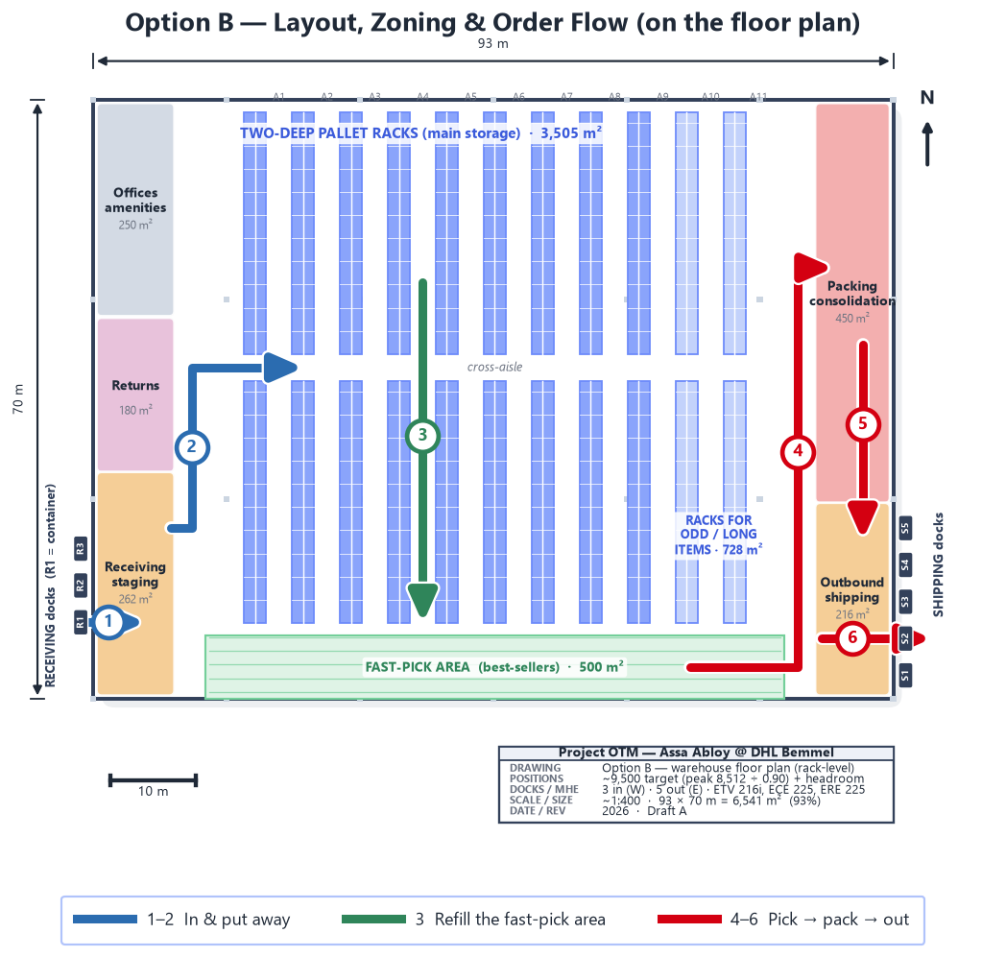
Fig 10. Main flow on the floor plan: in (R1) → put away → refill → pick → pack → out (S2). Arrows follow the real truck and picker routes.
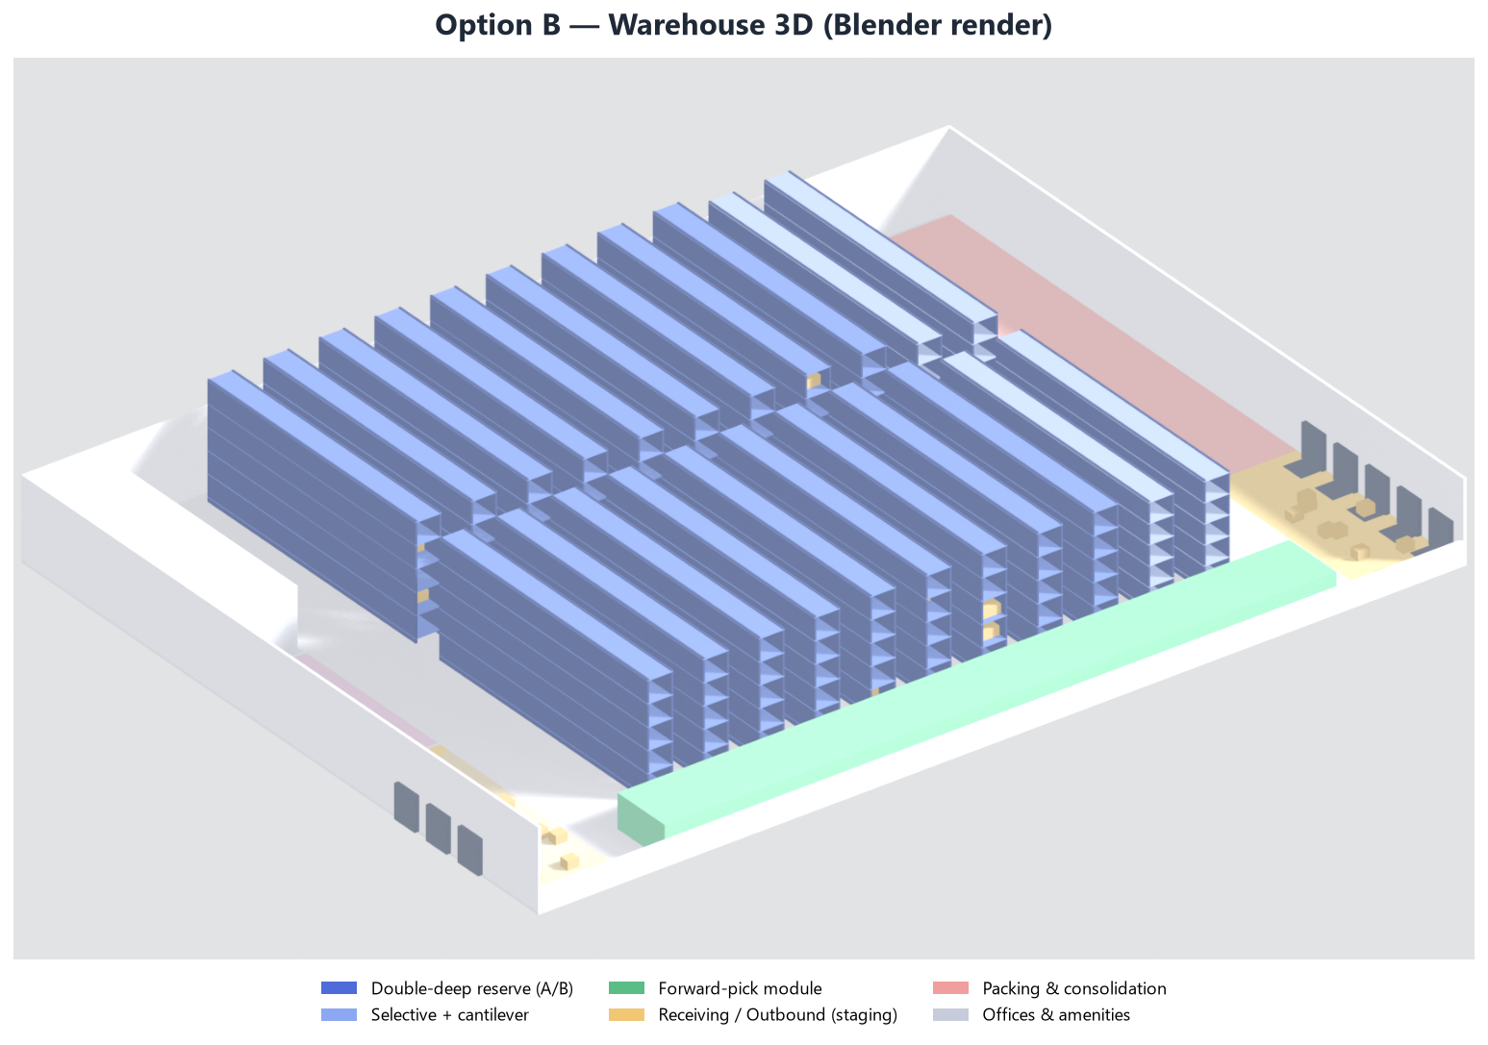
Fig 11. Option B in 3D (Blender): rack rows, fast-pick area, zones, 3 receiving doors (west) and 5 shipping doors (east).
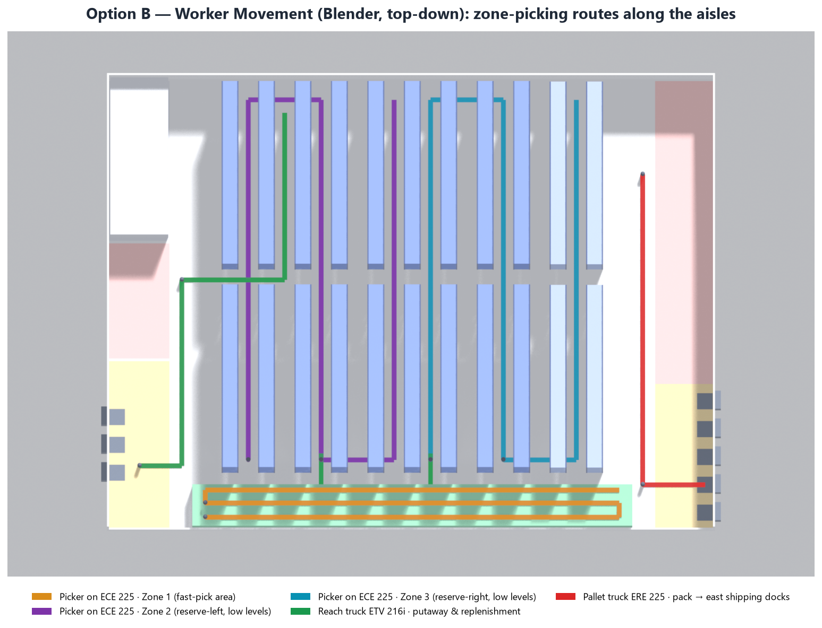
Fig 12. Worker and truck movement (Blender, top-down): pickers on ECE 225, reach trucks ETV 216i via perimeter and cross-aisle, ERE 225 to the shipping doors.

6. Capacity plan — labour & equipment

6.1 Labour
Workload drivers are measured: inbound ~99 loads/day, outbound 18 pallets + 225 cartons/day, 483 each lines and 151 case lines/day, replenishment ~24 pallets/day. Productivity rates are benchmarks (A014); loose containers are planned as crew-hours (A019).
Process | Rate / h | Peak × | FTE avg | FTE peak
Receiving - palletised (unload+check) | 25 | 1.69 | 0.31 | 0.52
Receiving - loose container de-stuff | - | 2.0 | 0.80 | 1.60
Putaway (reach truck) | 20 | 1.69 | 0.66 | 1.11
Replenishment (reach truck) | 18 | 2.85 | 0.18 | 0.51
Each picking | 55 | 1.83 | 1.17 | 2.14
Case picking | 80 | 1.83 | 0.25 | 0.46
Full-pallet picking | 22 | 1.83 | 0.04 | 0.07
Packing / consolidation | 45 | 1.83 | 1.88 | 3.44
Shipping / loading | 30 | 2.85 | 0.08 | 0.22

Direct labour ≈ 5.4 FTE on an average day and 10.1 FTE on the peak day (single shift, 7.5 productive hours). Cross-training covers the peak; supervision and admin come on top.
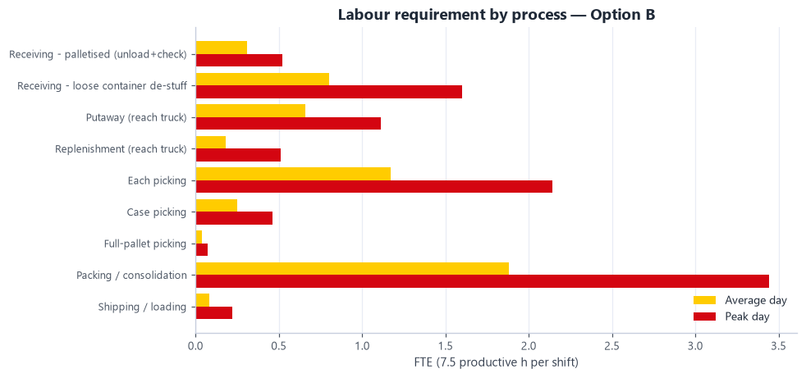
Fig 13. Labour requirement by process (average vs peak day).

6.2 Machinery — Jungheinrich fleet
Truck models were chosen from Jungheinrich (as advised) to match the layout and loads, and sized with a cycle-time model built from their published speeds on the Option B routes (A021).
Model | Task | Equip-h/day avg | Equip-h/day peak | Needed | Planned
ETV 216i | Putaway + replenishment + full-pallet picks | 5.1 | 9.6 | 2 | 3
ECE 225 | Case & each batch picking (2 pallets/roll cages per trip) | 10.7 | 19.6 | 4 | 4
ERE 225 | Unload trailers/containers, load outbound, dock moves | 2.2 | 4.6 | 1 | 2

- ETV 216i reach truck (S006): 1,600 kg, lift 10.7 m, working aisle 2.63–2.79 m, Li-ion. 2 cover the peak; a 3rd keeps putaway and replenishment running during service. Double-deep storage uses a telescopic-fork attachment (the truck has auxiliary hydraulics, 150 bar / 20 l/min); residual capacity at height to be confirmed with Jungheinrich.
- ECE 225 horizontal order picker (S007): 2,500 kg, 2.4 m forks — carries 2 pallets or roll cages, so one trip serves 2 orders (batch picking).
- ERE 225 rider pallet truck (S008): 2,500 kg, built for loading and unloading trailers and containers; one per dock side (west and east).
- Charging: Li-ion opportunity charging — no battery room is needed; chargers sit at the P&D points.
- Plus: RF / voice terminals per picker, print-and-apply at packing, roll cages for parcel staging.
Move | Truck | Avg one-way (m) | Cycle (min) | Moves / h
Putaway (receiving -> reserve) | ETV 216i | 77 | 2.46 | 24
Replenishment (reserve -> fast-pick rear) | ETV 216i | 30 | 1.95 | 31
Full-pallet pick (reserve -> outbound) | ETV 216i | 78 | 2.48 | 24
Unload pallet (trailer -> receiving lane) | ERE 225 | 19 | 0.99 | 61
Load pallet (staging -> trailer) | ERE 225 | 19 | 1.24 | 48

Fit checks — layout and loads against the truck data:
Check | Requirement | Result
Working aisle (reach aisle 3.0 m) | ETV 216i Ast 2,631-2,785 mm | OK - 0.2-0.4 m margin
Top beam 10.02 m (8 levels x 1.41 m) | Max lift 10.7 m | OK - 0.68 m spare
Clear height 12.2 m | Extended mast 11.7 m at max lift | OK - 0.5 m clearance
Pallet weight p95 875 kg / p99 1344 kg | 1,600 kg @ 600 mm | OK for 99.4% of SKUs; >1 t pallets slotted on low levels
Batch picking 2 orders per trip | ECE 225: 2,400 mm forks, 2,500 kg | OK - 2 EUR pallets / roll cages
Charging | Li-ion opportunity charging | No battery room; chargers at P&D points

7. Assumptions & open questions
Full register in data/assumptions.json; sources in documentation/sources.md. High-impact items:
ID | Assumption / open question | Impact
A001 | Max facility footprint | HIGH
A002 | Max clear/building height | HIGH
A003 | Analysis period is representative of normal operation | HIGH
A004 | Storage requirement is based on OCCUPIED LOCATIONS (pallet positions), not loads | HIGH
A005 | STAGED STATUS 'LATE' reflects staging vs the LATE SHIP window, i.e. a genuine on-time-staging miss | HIGH
A006 | No labour-productivity, MHE-fleet or cost data was provided | HIGH
A008 | The 7,000 m2 / 12.2 m envelope is the space available to DESIGN THE ASSA ABLOY operation within | HIGH
A010 | Design pallet-position target | HIGH
A013 | Functional (non-storage) areas sized from actual order volume | HIGH
A014 | Labour productivity benchmarks (units/person-hour) | HIGH
A017 | Peak-aware slotting: spread fast movers, duplicate extreme SKUs, balance picks/aisle on peak forecast | HIGH
A018 | Inbound arrives as 2 shipments per day, direct from Assa Abloy factories | HIGH
A019 | Part of inbound arrives LOOSE (floor-loaded sea containers) and is de-stuffed and palletised by hand | HIGH
A020 | Dock-door planning parameters | HIGH
A022 | Pick type is derived from what the client ordered, not from DHL's historical pick flags | HIGH

- To confirm with DHL: labour productivity and costs (A006/A014); the 7,000 m² scope (A008); container share and de-stuff time (A019); whether carriers accept collection time slots (A020).
- To confirm with Jungheinrich: telescopic-fork residual capacity at 10 m and ECE 225 turning space at aisle ends (A021).

