PROJECT OTM
Future-State Operational Design
Assa Abloy operation · DHL Supply Chain, Bemmel (NL_0032)
Field | Detail
Deliverable | 2 — Proposed future state for the in-scope processes
Due date | 07-10-2026
Concept | Option B — Hybrid density + velocity slotting + zone/batch picking
Envelope | ≤ 7,000 m² · ≤ 12.2 m
Author | ________________________
Version | DRAFT — processes, flowcharts, layout (3D), capacity plan

Future-state design for the recommended Option B (Deliverable 1). Workload drivers are measured from the Assa Abloy Q2-2025 data; productivities are benchmarked assumptions (Section 6) to be validated with DHL. Reproducible from analysis/*.py.

1. Recommended concept (recap)
Option B was selected via the Deliverable-1 decision matrix (robust across base and cost-driven weightings). It combines double-deep reserve racking for A/B stock, selective + cantilever racking for irregular and long goods, and a forward-pick module (carton-flow / shelving) for the case- and each-heavy demand, operated with velocity-based slotting and zone + batch/wave picking.

2. Future-state processes
Each in-scope process below states the steps, the system transaction, the physical movement, the equipment, and where the Deliverable-1 design choices are applied. Flowcharts follow.

2.1 Receiving & putaway
- Steps: trailer arrival → unload & RF-scan (ASN check) → quality/qty check → register stock (LODNUM) → system-directed putaway → reach-truck move → confirm.
- Policy applied: velocity-based directed putaway (A/B to double-deep reserve near pick faces; C to deep/upper); cantilever for XLONG goods (43 SKUs >240 cm).
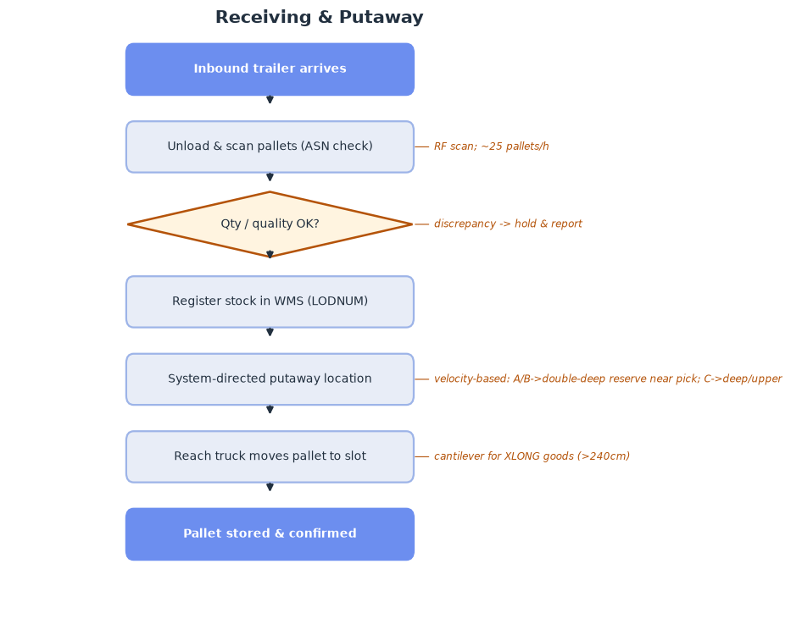
Fig 1. Receiving & putaway flow.

2.2 Replenishment
- Steps: forward face below min → WMS replen task → pull reserve pallet → top-up carton-flow/pick face → confirm.
- Policy applied: min/max replenishment; FIFO via FIF DATE where relevant.
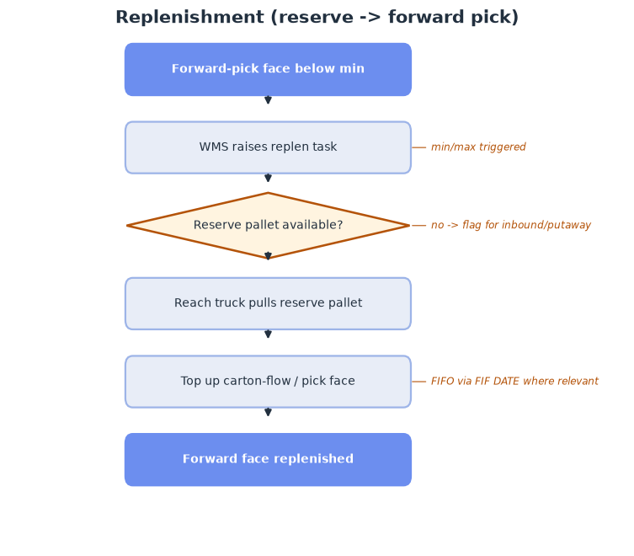
Fig 2. Replenishment flow.

2.3 Picking (zone + batch / wave)
- Steps: orders allocated → wave release by carrier cut-off → route by profile → full-pallet / case (batched) / each pick → to consolidation.
- Policy applied: batch the 50% single-line orders; A-movers in a golden-zone forward pick; voice/RF direction; zone picking across areas.
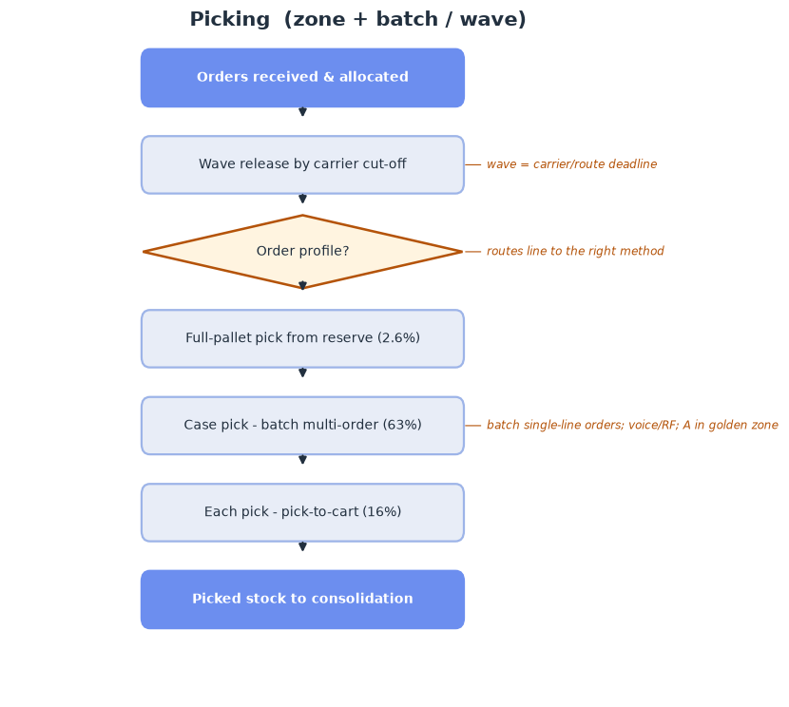
Fig 3. Picking flow (zone + batch/wave).

2.4 Consolidation, packing & shipping
- Steps: picked totes/pallets → put-to-light sort by order → pack & print-and-apply → parcel vs pallet → stage by carrier → load & dispatch.
- Policy applied: put-to-light consolidation of multi-zone picks; pack sized to peak (labour bottleneck); parcel-heavy outbound (~18 palletised shipments/day).
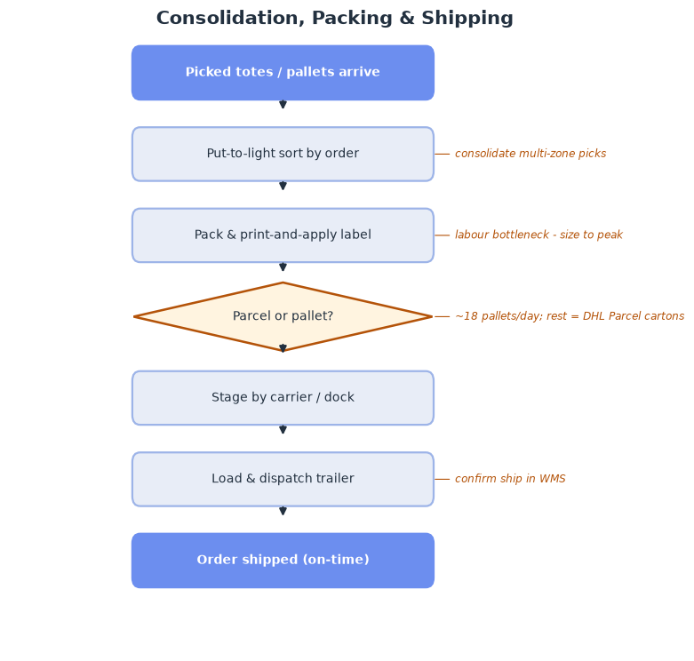
Fig 4. Consolidation, packing & shipping flow.

3. Warehouse policies
Policy | Decision | Why (data)
Storage | Hybrid: random within velocity zones; fixed forward-pick faces + random reserve | 73% single-load tail; 48.6% ABC mismatch
Slotting | Velocity/demand-ABC (hot/med/cold); A in golden zone; heavy low | 13% of SKUs = 80% of volume
Zoning | Forward-pick vs reserve; pick zones by area | case-dominant picking (83% of lifts)
Batching | Batch single-line/single-unit orders; wave by carrier cut-off | 50% single-line, 24% single-unit
Routing | S-shape / return within aisles | reduce travel in reserve
Putaway | System-directed, velocity-based to zone | align stock to demand
Replenishment | Min/max forward-pick top-up | keep pick faces filled at peak
FIFO/FEFO | FIFO via FIF DATE where relevant | stock age present; most parts not date-critical (confirm)

4. Layout & zoning (3-dimensional)
The zones are sized from the capacity analysis and laid out flow-through (receiving one side, shipping the other). Building ≈ 108 m × 70 m, providing ~14,074 pallet positions against the ~14,074 target.
Zone | Area m² | % of building
Receiving & inbound staging | 700 | 9%
Offices & amenities | 300 | 4%
Returns / VAS | 300 | 4%
Double-deep reserve (A/B) | 3,505 | 47%
Selective + cantilever (irregular/XLONG/C) | 728 | 10%
Forward-pick module (carton-flow/shelving) | 400 | 5%
Packing & consolidation | 700 | 9%
Outbound staging & shipping | 300 | 4%
Circulation / aisles | 560 | 7%

**Total floor area 7,493 m² = 107% of a 7,000 m² envelope.**
- At the detailed zoning level Option B lands slightly over 7,000 m² (107%) once full functional areas are included — tighter than the concept-level estimate.
- Mitigations if 7,000 m² is the binding Assa-only envelope (A008): (a) raise the double-deep share or add an 8th rack level (12.2 m height allows it, subject to truck reach); (b) trim office/returns/staging; (c) switch reserve to VNA (Option C), which frees ~2,000 m² and gives real headroom.
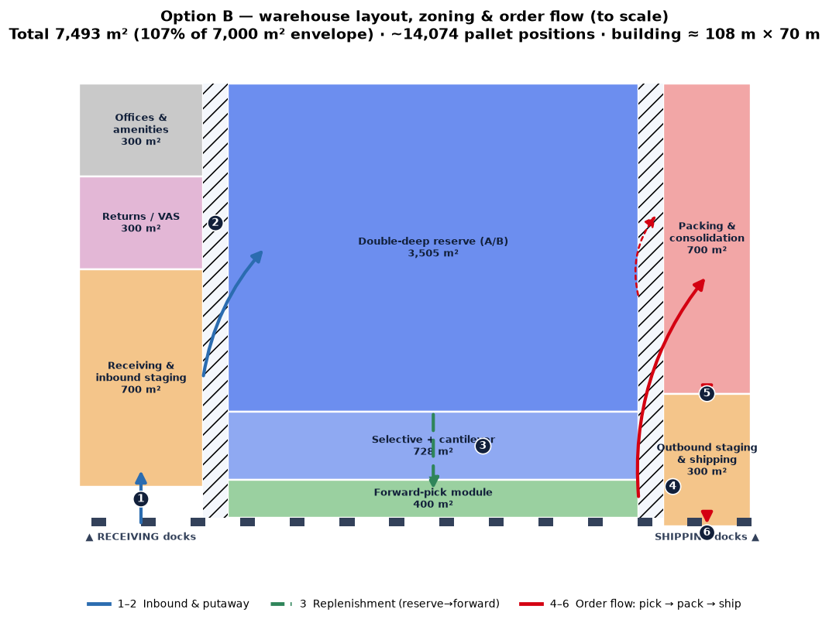
Fig 5. Option B layout & zoning, to scale, with order flow (①inbound→⑥ship).
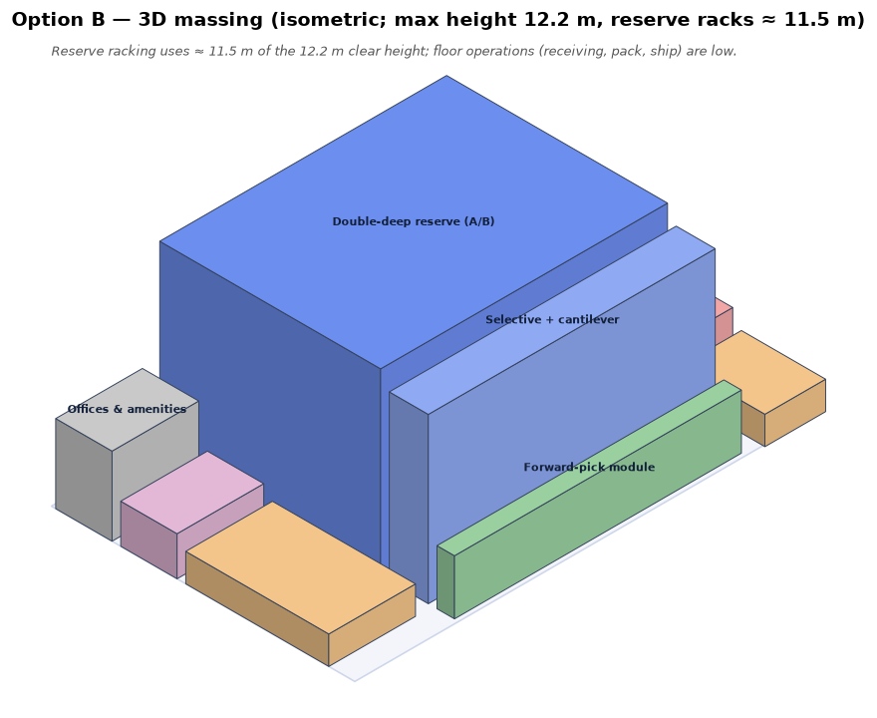
Fig 6. Option B 3D massing (isometric) — reserve racking ≈ 11.5 m within the 12.2 m limit.
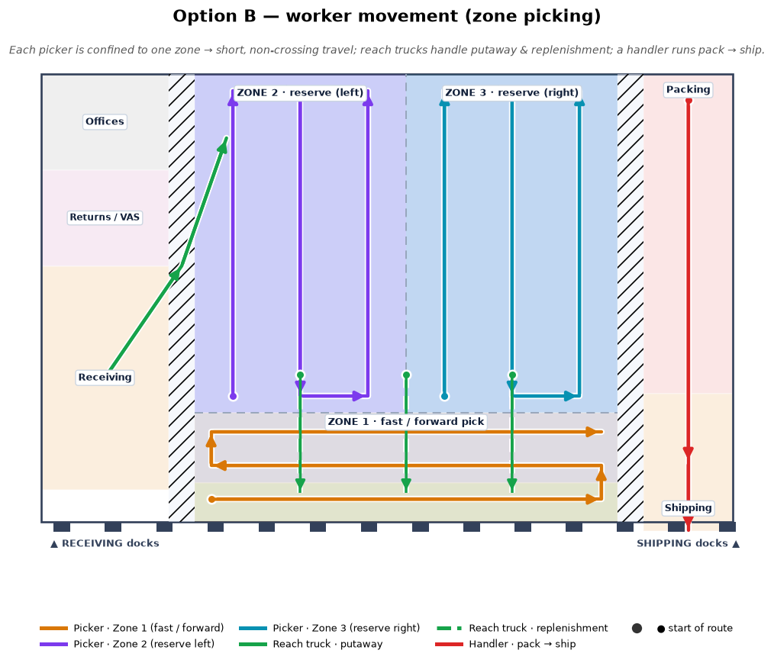
Fig 7. Worker movement — zone picking keeps picker paths short and separated.

5. Capacity plan — labour & equipment
Workload drivers (measured): outbound ≈ 18 palletised shipments/day (rest parcel), inbound ≈ 32 pallets/day, forward-pick replen ≈ 22 pallets/day. Productivities are benchmark assumptions (A014).
Process | Rate/h | FTE avg | FTE peak
Receiving (unload+check) | 25 | 0.17 | 0.48
Putaway (reach) | 20 | 0.21 | 0.60
Replenishment | 18 | 0.16 | 0.47
Case picking | 80 | 0.87 | 1.59
Each picking | 55 | 0.25 | 0.45
Full-pallet picking | 22 | 0.10 | 0.18
Packing/consolidation | 45 | 1.85 | 3.38
Shipping/loading | 30 | 0.08 | 0.22

**Total direct labour ≈ 3.7 FTE average, 7.4 FTE at peak** (≈ 12 if each process is staffed separately; cross-training reduces this). Add supervision/admin and value-add separately.
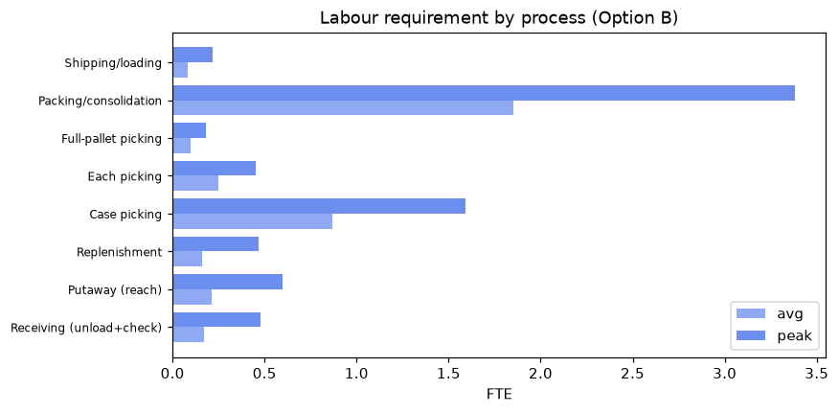
Fig 8. Labour requirement by process (average vs peak).
Material-handling equipment (peak):
Equipment | Peak equip-hours/day | Units
Reach truck (putaway/replen/pallet pick) | 9.4 | 2
Low-level order picker (case/each) | 15.3 | 3
Pallet truck (receiving/shipping) | 5.3 | 1

Plus RF/voice terminals per picker, print-and-apply at pack, and a small spares allowance. Peak may need overtime or a partial second shift rather than extra permanent FTE.

6. Assumptions & open questions
Full register in data/assumptions.json. High-impact items for the future state:
ID | Assumption / open question | Impact
A001 | Max facility footprint | HIGH
A002 | Max clear/building height | HIGH
A003 | Analysis period is representative of normal operation | HIGH
A004 | One LODNUM (load) occupies one pallet position | HIGH
A005 | STAGED STATUS 'LATE' reflects staging vs the LATE SHIP window, i.e. a genuine on-time-staging miss | HIGH
A006 | No labour-productivity, MHE-fleet or cost data was provided | HIGH
A008 | The 7,000 m2 / 12.2 m envelope is the space available to DESIGN THE ASSA ABLOY operation within | HIGH
A010 | Design pallet-position target | HIGH
A014 | Labour productivity benchmarks (units/person-hour) | HIGH

