Geometric Algorithms by Gleb R.
Module: IN1002 — Introduction to Algorithms

(All testing code can be found within the Java class file of the algorithm it tests)

Algorithm 1: Orientation Test (CCW Predicate)
Precondition:
Three points must lie on a 2D plane.

Postcondition:
The output will be -1, 0, or 1.

Explanation:
This algorithm finds the determinant of the vector p2 → p3, which can be expressed as the matrix:
(p2.x -p1.x) (p3.x-p1.x)
(p2.y-p1.y) (p3.y-p1.y)
Specifically the sign of this determinant is used to find whether point 3 is to the left of, to the right of, or in line with the vector p1 → p2.

Worked example:
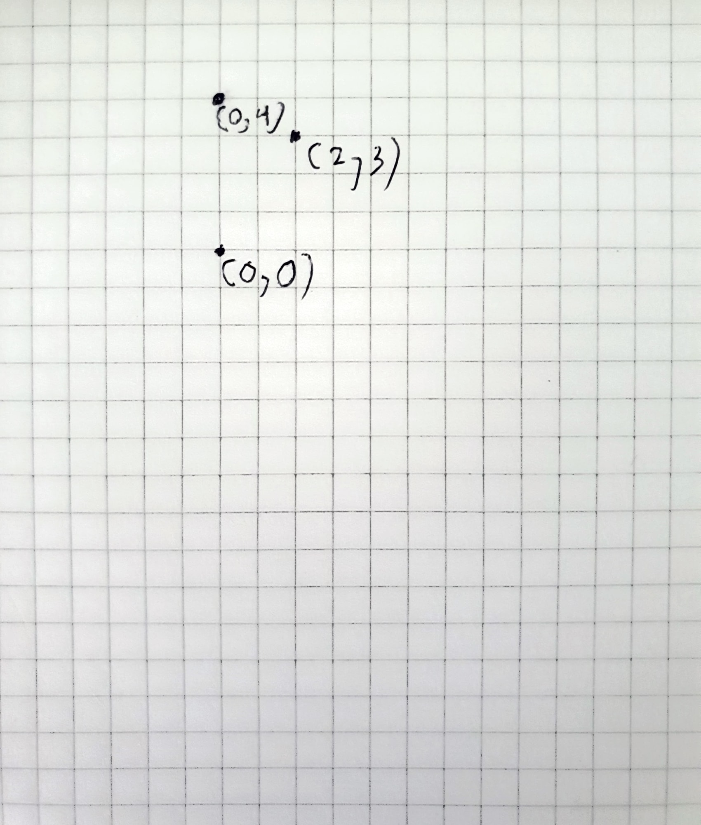

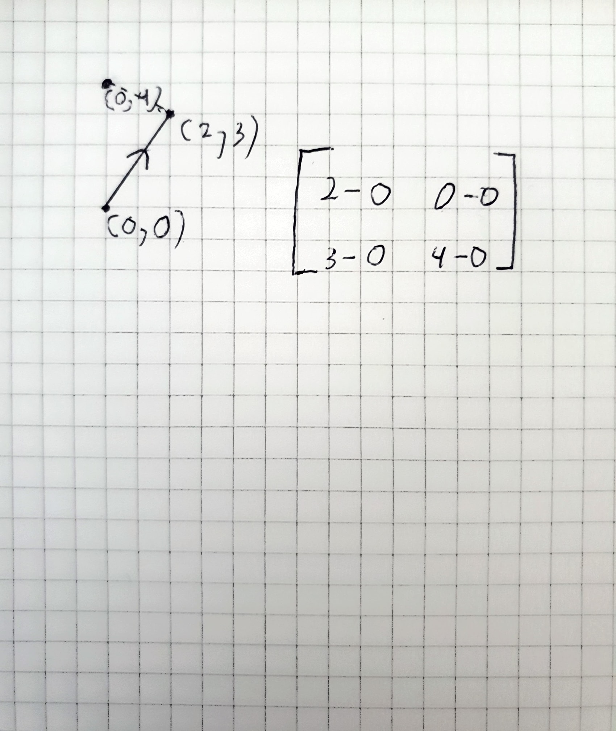
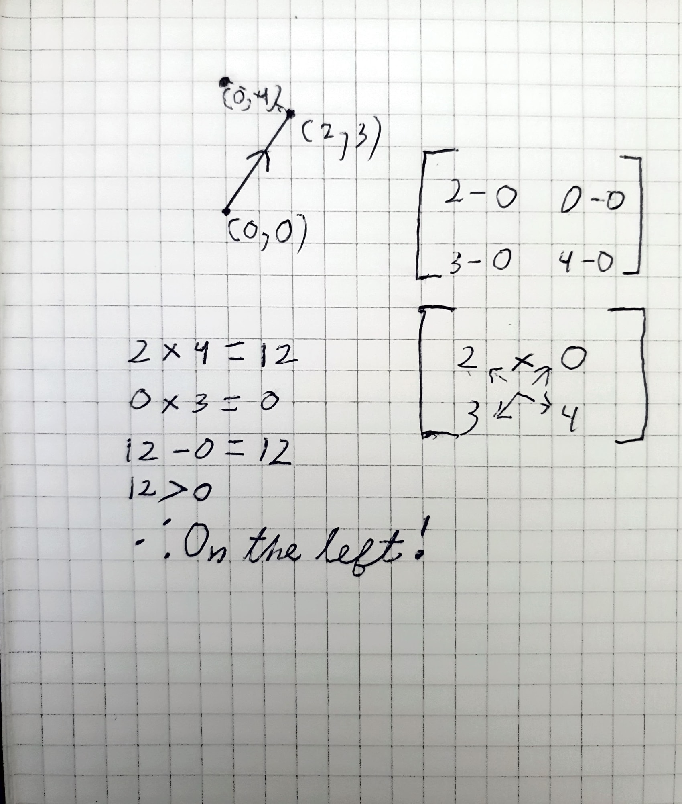

Java code:
public static int orientation(Point p1, Point p2, Point p3) {
return (int)Math.signum((p2.x - p1.x) * (p3.y - p1.y) - (p2.y-p1.y) * (p3.x - p1.x));
}

Test:

Input | Expected Result | Actual Output | Match?
(0, 0), (0, 1), (1, 2) | -1 | -1 | Y
(0, 0), (0, 1), (0, 2) | 0 | 0 | Y
(0, 0), (0, 1), (-1, 2) | 1 | 1 | Y

Complexity:
The algorithm can only ever take in three points, and it will always perform the same operation on them. It features no loops whatsoever — the complexity is O(1).

Algorithm 2: Area of a Polygon (Shoelace Formula)
Precondition:
The input comprises an ordered set of points that lie on a plane and construct a polygon with no intersections.
Postcondition:
The output is a positive number.
Worked Example:
First, we plot some points: (0, 0), (2, 3), (3, 4), (-3, 5), (-2, 0)
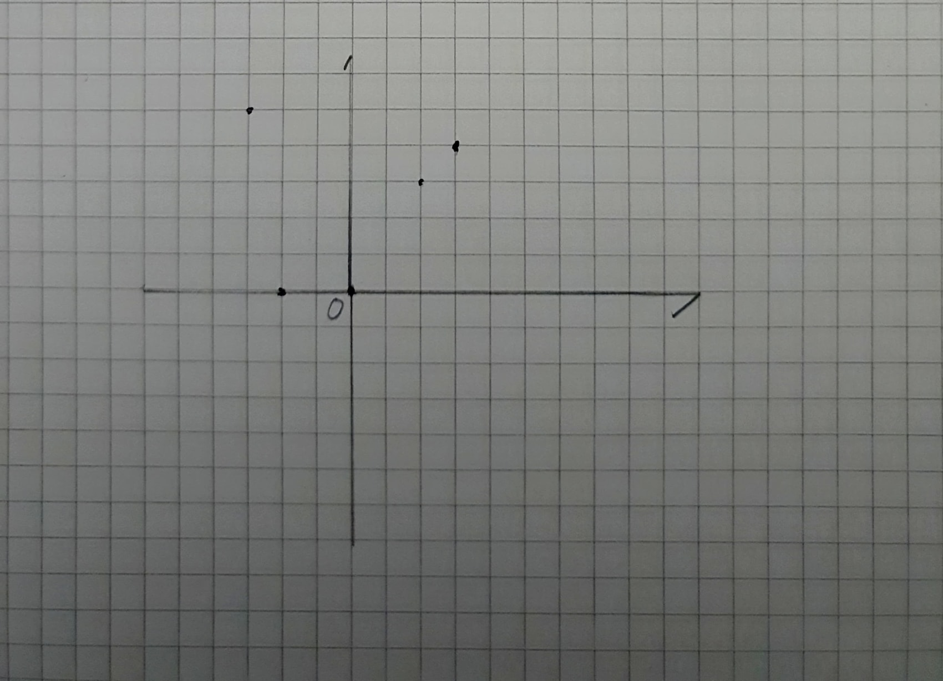
Then, form a 2x2 matrix with each ordered pair of vertices, P1 and P2, and find its determinant:
P1.x P2.x
P1.y P2.y
P1.x * P2.y – P2.x * P1.y
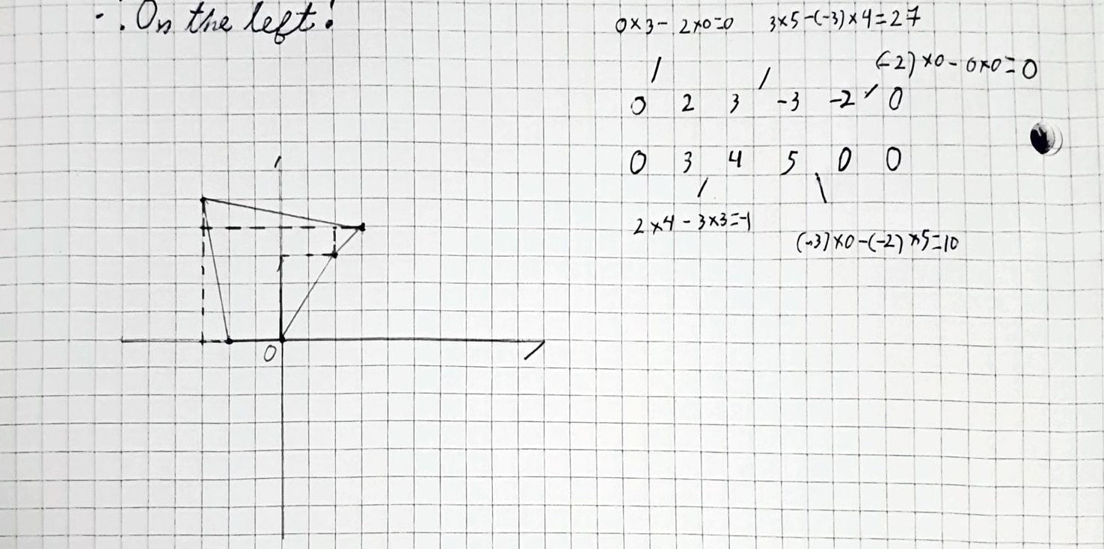
Here, I put them side by side to avoid repeatedly writing down the same points. We add the first point to the end, as it is a part of two pairs, just like every other!
Finally, we add up the values, make the sum absolute (as area is not signed), and divide it by two.
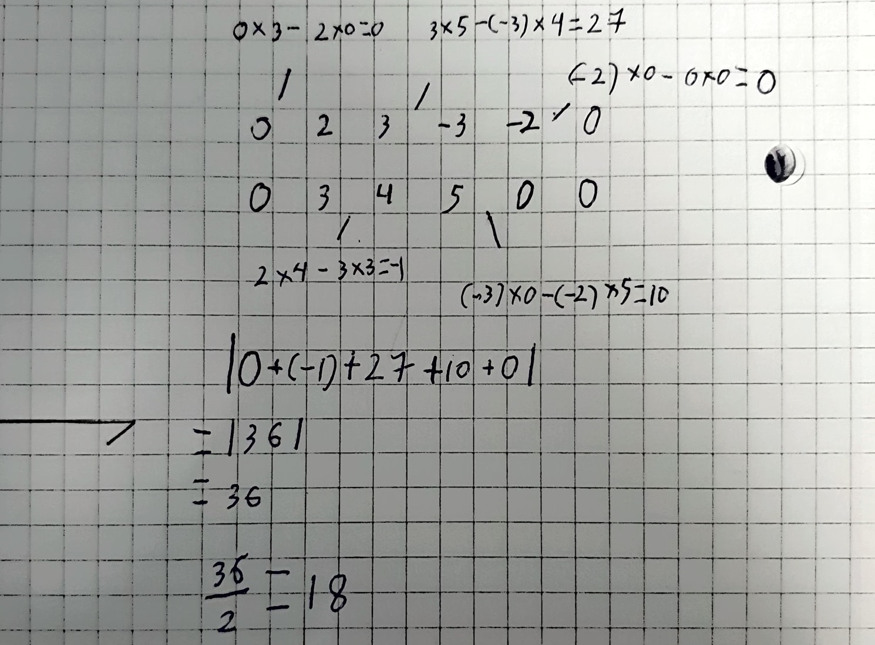

Java code:
/// Find the area of a polygon using an ordered array of points on a plane, where each is connected to the last and the next.
public static double polygonArea(Point[] vertices) {
//Create a double to add to for each vertex.
double output = 0.0;
//We want to perform the calculation for every pair of connected vertices, including the last and the first
//of the array. Thus, we make a new array and duplicate the first vertex at the end.
Point[] verticesButComplete = new Point[vertices.length + 1];
System.arraycopy(vertices, 0, verticesButComplete, 0, vertices.length);
verticesButComplete[vertices.length] = vertices[0];
for (int i = 0; i < vertices.length; i++) {
output += (verticesButComplete[i].x * verticesButComplete[i+1].y) - (verticesButComplete[i+1].x * verticesButComplete[i].y);
}
//Area is not signed. It would be positive or negative depending on the position of the vertices, but we do not
//have a use for that, so we make it absolute.
output = Math.abs(output);
return output / 2;
}

Test:
Input | Expected Result | Actual Output | Match?
Right-Angled Triangle  (0, 0), (0, 2), (2, 2) | 2.0 | 2.0 | Y
A Unit Square  (0, 0), (0, 1), (1, 1), (1, 0) | 1.0 | 1.0 | Y
An Irregular Polygon with Five Vertices  (0, 0), (2, 3), (3, 4), (-3, 5), (-2, 0) | 18.0 | 18.0 | Y

Complexity:
The algorithm performs two multiplications and an addition for each vertex in a polygon. Given a polygon with n points, the complexity will be O(n).

Algorithm 3: Convex Hull (Jarvis March / Gift Wrapping)
Precondition:
An array of length > 1 is given that contains points that lie on a plane.
Postcondition:
An ordered list of points is returned and contains the minimum number of points required to construct a polygon that contains every given point.

English explanation:
Imagine wrapping a two-dimensional gift of an irregular shape: it may be possible to wrap the paper exactly around every contour, though as it is so often taut, or will most likely bend to move in exactly straight lines between the angles — for example, an L shape would see a 45-degree slope of paper on its inside… even if there are other shapes within the resulting triangle!

Of course, in real life, this is achieved through the simple mechanics of pulling paper. How does one accomplish this *algorithmically?* Well, a simple way is to start at a point on the edge, and decide on a direction — which way are we wrapping? For this algorithm, we choose counter-clockwise. To find the next point on the edge, we check to see what would happen if we pulled the paper over to it — would there be any point left to our right? That would be outside! Naturally, that outside point is what we check next, and so on. By the time we’ve checked every point, we are guaranteed to find another on the edge — the convex hull, as it goes. At that point, we have no particular preference for the next point, and so we return to the start of the list, and skip every known hull point. Thus, every time we check every remaining point, we find another on the hull! This gives us a complexity of O(nh) for n points with h on the hull.

Java code:
static int DEBUG_checkCount = 0;
public static List<Point> convexHull(Point[] points) {
DEBUG_checkCount = 0;
if (points.length < 2) {
IO.println("Please provide a list of more than one point to avoid an infinite loop " +
"(should really be more than three, but we are required to test this on a triangle)");
return Arrays.asList(points);
}
ArrayList<Point> startingList = new ArrayList<>(Arrays.asList(points));
ArrayList<Point> output = new ArrayList<Point>();
double lowestX = startingList.getFirst().x;
Point startingPoint = startingList.getFirst();
//Find the leftmost point, guaranteed to be on the hull.
for (int i = 1; i < startingList.size(); i++) {
if (startingList.get(i).x < lowestX) {
lowestX = startingList.get(i).x;
startingPoint = startingList.get(i);
}
}
output.addLast(startingPoint);
//Remove it from the list until we have found a second hull point to make sure that we don't end early.
startingList.remove(startingPoint);
Point currentPoint = startingList.getFirst();
int DEBUG_loopCount = 0;
while (true) {
DEBUG_loopCount++;
//We make use of our knowledge that the starting point is at the END of the list/
if (currentPoint == startingPoint) {
IO.println("[DEBUG] Loop count: " + DEBUG_loopCount + ", Check count: " + DEBUG_checkCount);
return output;
}
Point potentialNextPoint = checkPoint(output.getLast(), currentPoint, startingList, startingPoint);
if (potentialNextPoint == currentPoint) {
if (output.size() == 1)
//We need to make sure we close the polygon, so the starting point is added once again.
startingList.addLast(startingPoint);
output.add(currentPoint);
startingList.remove(currentPoint);
currentPoint = startingList.getFirst();
} else {
currentPoint = potentialNextPoint;
}
}
}
private static Point checkPoint(Point knownHullPoint, Point pointToCheck, List<Point> otherPoints, Point startingPoint) {
DEBUG_checkCount++;
List<Point> tempList = new ArrayList<>(otherPoints);
tempList.remove(pointToCheck);
for (Point o : tempList) {
DEBUG_checkCount++;
if (orientation(knownHullPoint, pointToCheck, o) < 0) {
return o;
}
}
return pointToCheck;
}

Test:
Input | Expected Result | Actual Output | Match?
Triangle  (0.0, 0.0), (1.0, 1.0), (0.0, 1.0) | (0.0, 0.0), (1.0, 1.0), (0.0, 1.0) | (0.0, 0.0), (1.0, 1.0), (0.0, 1.0) | Y
Miscellaneous Set of Points  (1.0, 3.0), (0.0, 4.0), (2.0, -1.0), (1.0, 2.0), (-5.0, -5.0), (5.0, -5.0), (0.0, 0.0), (-1.0, -3.0) | (-5.0, -5.0), (5.0, -5.0), (1.0, 3.0), (0.0, 4.0) | (-5.0, -5.0), (5.0, -5.0), (1.0, 3.0), (0.0, 4.0) | Y
Random Set of Points  (9.0, 5.0), (5.0, 8.0), (8.0, 2.0), (2.0, 8.0), (8.0, 8.0), (4.0, 2.0), (0.0, 3.0), (7.0, 4.0), (4.0, 6.0) | (0.0, 3.0), (4.0, 2.0), (8.0, 2.0), (9.0, 5.0), (8.0, 8.0), (5.0, 8.0), (2.0, 8.0) | (0.0, 3.0), (4.0, 2.0), (8.0, 2.0), (9.0, 5.0), (8.0, 8.0), (5.0, 8.0), (2.0, 8.0) | Y

Complexity:
For a list of n points and h vertices on the convex hull:
n operations find the leftmost point.
In the worst case scenario, it takes n operations to find the next hull vertex. This is thus performed h number of times — the complexity is O(nh).

Algorithm 4: Point in Polygon (Ray Casting)
Precondition:
We are given a point to test, and an ordered set of points comprising a polygon to test it against. To be a valid polygon, it must have at least three points. All of these must lie on a plane. To work correctly, every point must be connected by a straight line.
Postcondition:
The algorithm returns either “true,” or “false.”
English explanation:
How does one find if a point lies inside a polygon? Well, a good way is to cast a straight ray from that point and out, into infinity. Of course, in practical terms, it only needs to be long enough to reach the farthest point that it is being compared against.

It is possible to model it as a line and compare it against the functions of the curves that make up a given shape, but what we’re concerned with here is an easier implementation, one that works only for polygons comprising vertices connected by straight line segments. This means that we needn’t model any lines at all, and can for the most part just compare coordinates.

So, our ray is going to be parallel to the X axis, and extend infinitely to the right. We will call its starting point Q. We will test it against every line segment in the polygon. We will call a given pair of vertices that make up such a line segment, P1 and P2. To intersect, the following conditions must be true:

1. P1 and P2 must have Y-values such that the Y-value of Q is between them.
2. The point along the line segment that has the same Y-value as Q must be to its right.

Now, the above conditions do appear redundant, so, a clarification:
- “The point along the line segment” would be more accurately described as “the point that follows the line equation of the straight line that passes through both P1 and P2,” but the fact that we check the Y-values of P1 and P2 prior guarantees that this point is, in fact, on the segment, not just the line.

Finally, the basis of all topology: the concept of the binary partition between “inside,” and “outside.” Every time one crosses a line segment, one’s state — in, out? — flips. Thus, any ray that crosses an even number of times ends up with the same state that it started with. However! To have a non-zero thickness, a polygon must intersect any given a number of times that’s a multiple of two! This is the property we use, as our ray extends infinitely in one direction, but not the other — if the entire polygon lies to one side, then we intersect and even number of times, and the point is outside of its bounds!

Java code:
/// Find if the given point is inside the given polygon by counting its intersections along the X axis.
public static boolean isInsidePolygon(Point q, Point[] polygon) {
if (polygon.length < 3) {
IO.println("A polygon must have at least 3 points!");
return false;
}
ArrayList<Point> polygonList = new ArrayList<>(List.of(polygon));
polygonList.addLast(polygon[0]);
int intersections = 0;
for (int i = 0; i < polygonList.size() - 1; i++) {
Point p1 = polygonList.get(i);
Point p2 = polygonList.get(i + 1);
//Using >= to try and count the intersection, but only once (and not when this same point, p1, is labeled p2).
if (p1.y >= q.y) {
if (p2.y < q.y) {
if (sufficientGradient(q, p1, p2))
intersections++;
}
} else if (p2.y > q.y) {
if (p1.y < q.y) {
if (sufficientGradient(q, p2, p1))
intersections++;
}
}
}
return Math.floorMod(intersections, 2) == 1;
}
/// Find whether the line is to the right of q at its height.
private static boolean sufficientGradient (Point q, Point higher, Point lower) {
Point potentialIntersection = new Point(higher.x - (higher.x - lower.x) / (higher.y - lower.y) * (higher.y - q.y), q.y);
//Once again, being on the edge counts as "inside."
return (potentialIntersection.x > q.x);
}
return Math.floorMod(intersections, 2) == 1;
}
/// Find whether the line is to the right of q at its height.
private static boolean sufficientGradient (Point q, Point higher, Point lower) {
Point potentialIntersection = new Point(higher.y - (higher.x - lower.x) / (higher.y - lower.y) * (higher.y - q.y), q.y);
return (potentialIntersection.x > q.x);
}

Test:
Input | Expected Result | Actual Output | Match?
Square, Point Inside  Point: (1, 1)  Polygon: (0, 0), (0, 2), (2, 2), (2, 0) | true | true | Y
Square, Point Outside  Point: (-1, 1)  Polygon: (0, 0), (0, 2), (2, 2), (2, 0) | false | false | Y
Square, Point on the Edge  Point: (0, 1)  Polygon: (0, 0), (0, 2), (2, 2), (2, 0) | Ambiguous; with my algorithm, true | true | Y
Mirrored L, Point Outside  Point: (0, 0)  Polygon: (-2, -1), (1, -1), (1, 2), (2, 2), (2, -2), (-2, -2) | false | false | Y

Complexity:
A series of calculations using coordinate values is performed once for every point on the polygon. Thus, the complexity is O(n).

