Early Research report
Student's first name: Gleb
Student's last name: Kirillov
Date of report submission: 30 May 2026
Project supervisor's full name: Pavel Osinenko
Project supervisor's work place and position: Associate Professor
Project name in English (mandatory): Lyapunov-based stabilizing controller for an underactuated wheeled inverted pendulum
Project name in Russian: Стабилизирующий регулятор на основе функции Ляпунова для недоприводного колёсного инвертированного маятника

Project description
The long-term motivation of this project is to design control laws for a wheeled, underactuated robot that exists in our laboratory. The full robot is significantly more complex than a segway, but a wheel + inverted-pendulum ("wheeled-pendulum") model captures its core stabilization difficulty: a single torque between the wheel and the body must keep the body upright while also controlling the wheel position. Mastering this benchmark is a deliberate first step before attacking the full robot.
The Early Research project spans two semesters. The first semester was spent (i) deriving the wheeled-pendulum dynamics from the Lagrangian and (ii) attempting a data-driven controller (vectorized REINFORCE) implemented in the repository. The second semester (this report) is dedicated to model-based control: I followed my supervisor's Advanced Control Methods course (Lyapunov-based control, adaptive control, backstepping, model predictive control) and used the material to design a closed-form, provably stable controller for the same plant. The control-theory experiments are collected in this repository; the Early Research deliverable proper is the adaptation of the Lyapunov-based controller of Aguilar-Ibáñez et al. (2005) — originally derived for the classical cart-pole — to the wheeled-pendulum plant.
Project goals and personal goals in the project. My role.
Project goals:
- Produce a model-based stabilizing controller for the wheeled-pendulum with explicit, mathematically verified stability guarantees (no black-box neural policy).
- Build a clean, reusable simulation + visualization framework that can later be reused for the more complex laboratory robot.
- Bridge the term-1 (modeling + RL) and term-2 (model-based control) work on the same plant, so that future work can compare and combine the two paradigms.
Personal goals:
- Translate the Advanced Control Methods course material into a piece of concrete, working code — from Lagrangian derivation through proof to simulation.
- Become fluent with the standard nonlinear-control toolbox: partial feedback linearization, Lyapunov function construction, LaSalle's invariance principle, attraction-region characterization.
- Improve software-engineering hygiene for control experiments: modular Python codebase, symbolic verification of the math, interactive visualization.
Role: I am the sole student on the project. My supervisor advised the direction (suggesting the cart-pole Lyapunov paper as a reference, feedback on the derivation) but the modelling, the controller derivation, the simulation, the codebase, and the report are mine.
Accomplished work and progress towards the objective
This semester I have completed the following deliverables.
1. Verification of the wheeled-pendulum dynamics.
Starting from the Lagrangian L = T − V with body mass m_b, wheel mass m_w, wheel radius r, body-CG offset l, body inertia I_b and wheel inertia I_w, I re-derived the Euler-Lagrange equations independently of the term-1 sympy notebook and confirmed the matrix form M(θ) q̈ + C(θ, θ̇) q̇ + G(θ) = τ with τ = (u, −u)ᵀ on the body and wheel coordinates.
2. Adaptation of the Aguilar-Ibáñez Lyapunov controller.
The reference paper derives the controller for a cart-pole, in which the input force acts only on the cart coordinate. In the wheeled pendulum the motor torque acts equal-and-opposite on the body and the wheel, so the recipe of the paper does not apply directly. The adaptation steps were:
- Introduce the relative angle ψ = φ − θ. In coordinates (θ, ψ) the input acts only on ψ, exposing the same structure as cart-pole.
- Apply collocated partial feedback linearization on ψ, producing θ̈ = (sinθ (D + β θ̇²) − b(θ) v) / a(θ), ψ̈ = v.
- Define the auxiliary variable ξ = ψ + kₚ (γθ + β sinθ). Note the primitive contains an unbounded γθ term (because in our system the off-diagonal of the mass matrix is γ + β cosθ, not cosθ as in cart-pole) — but the controller is operated in a bounded θ region so this is harmless.
- Build the drift-conserved energy Φ = kₚ D (1 − cosθ) − ½ kₚ a(θ) θ̇² + ½ ψ̇². Note the θ-dependent coefficient a(θ) in front of ½ θ̇² — this is the extra ingredient required to compensate the additional Coriolis term β sinθ θ̇² that the wheeled pendulum has but the cart-pole does not.
- Form the Lyapunov candidate V = ½ kᵢ ξ² + ½ ξ̇² + k_L Φ and verify dot(V) = ξ̇ [η(x) + δ(θ) v] where δ(θ) = k_L + 1 − kₚ b(θ)² / a(θ).
- Choose v = −(ξ̇ + η) / δ; then V̇ = −ξ̇² ≤ 0.
3. Stability proof (LaSalle).
I worked out the gain condition kₚ (γ + β)² > (1 + k_L) (α + 2β + γ) for V to be locally positive definite at the upright equilibrium, the critical angle θ_S defined by δ(θ_S) = 0 and the attraction-region threshold K_S = k_L kₚ D (1 − cos θ_S). LaSalle's invariance principle gives that the largest invariant subset of {ξ̇ = 0} ∩ Ω is the origin: on this set v is forced constant (= −kᵢ ξ̄ / k_L) and the boundedness of ψ̇ on Ω forces v ≡ 0; the remaining drift equation then admits only θ = 0 as a non-trivial trajectory.
4. Written technical report.
A self-contained Word document, Segway_Lyapunov_Controller.docx, presents the full derivation and proof in seven sections (model verification, coordinate change, partial feedback linearization, Lyapunov function, stability and domain of attraction, complete control law). It is the primary deliverable for my supervisor.

5. Modular Python codebase.
The simulator and controller are organized into separate modules so they can be reused with the more complex laboratory plant later:
- src/system.py — SegwayParams + SegwayDynamics (RHS of the ODE)
- src/controller.py — LyapunovController + ControllerGains, including critical_angle() and K_S() for the attraction region
- src/simulation.py — fixed-step RK4 simulate(...) returning the full trajectory and V(t), V̇(t)
- src/animation.py — pygame-native interactive window with sliders, Start / Replay / Pause / Save-GIF buttons, segway visualization and live state + Lyapunov plots
- main.py — entry point: python main.py for static figures (written to figures/) or python main.py --animate for the interactive window (GIFs saved to animations/)
6. Closed-loop simulation results.
Using the parameters of the term-1 sympy notebook (m_b = 10 kg, m_w = 1 kg, l = 0.30 m, r = 0.05 m) and gains kₚ = 100, kᵢ = 1, k_L = 0.5, the gain condition gives 3.21 > 2.29 and θ_S ≈ 37.4°. Starting from θ₀ = 0.30 rad (≈ 17°), the controller drives the body to |θ| < 0.03° within 8 s; V decays from 79.8 to 4·10⁻² (≈ 0.05% of its initial value), well below the threshold K_S ≈ 302.7. The numerically differentiated V̇ matches the analytic −ξ̇² to plotting accuracy. Three static figures (fig_states.png, fig_phase.png, fig_lyapunov.png) are produced automatically by main.py.
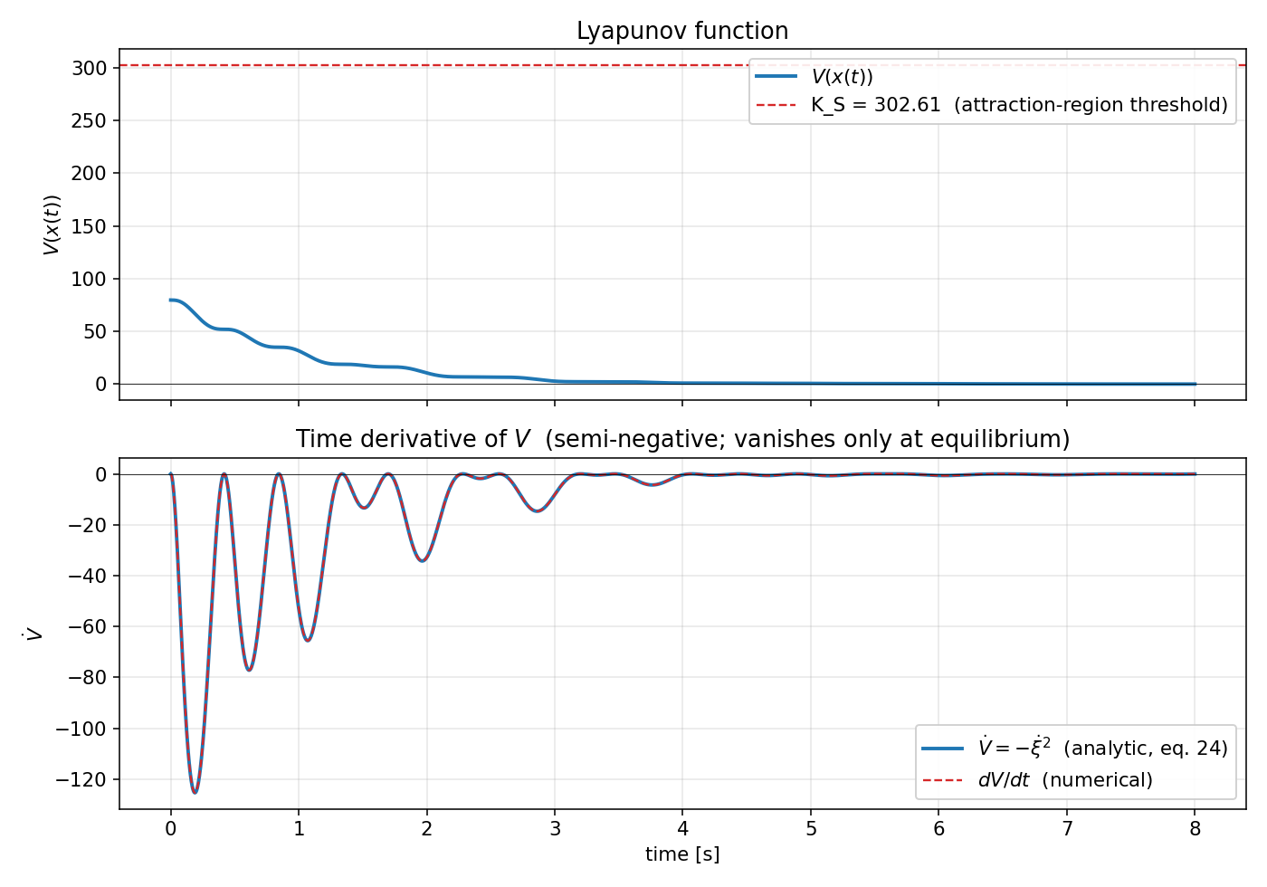
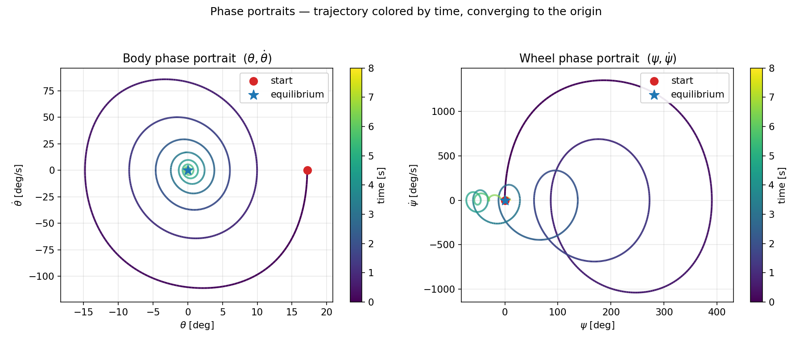
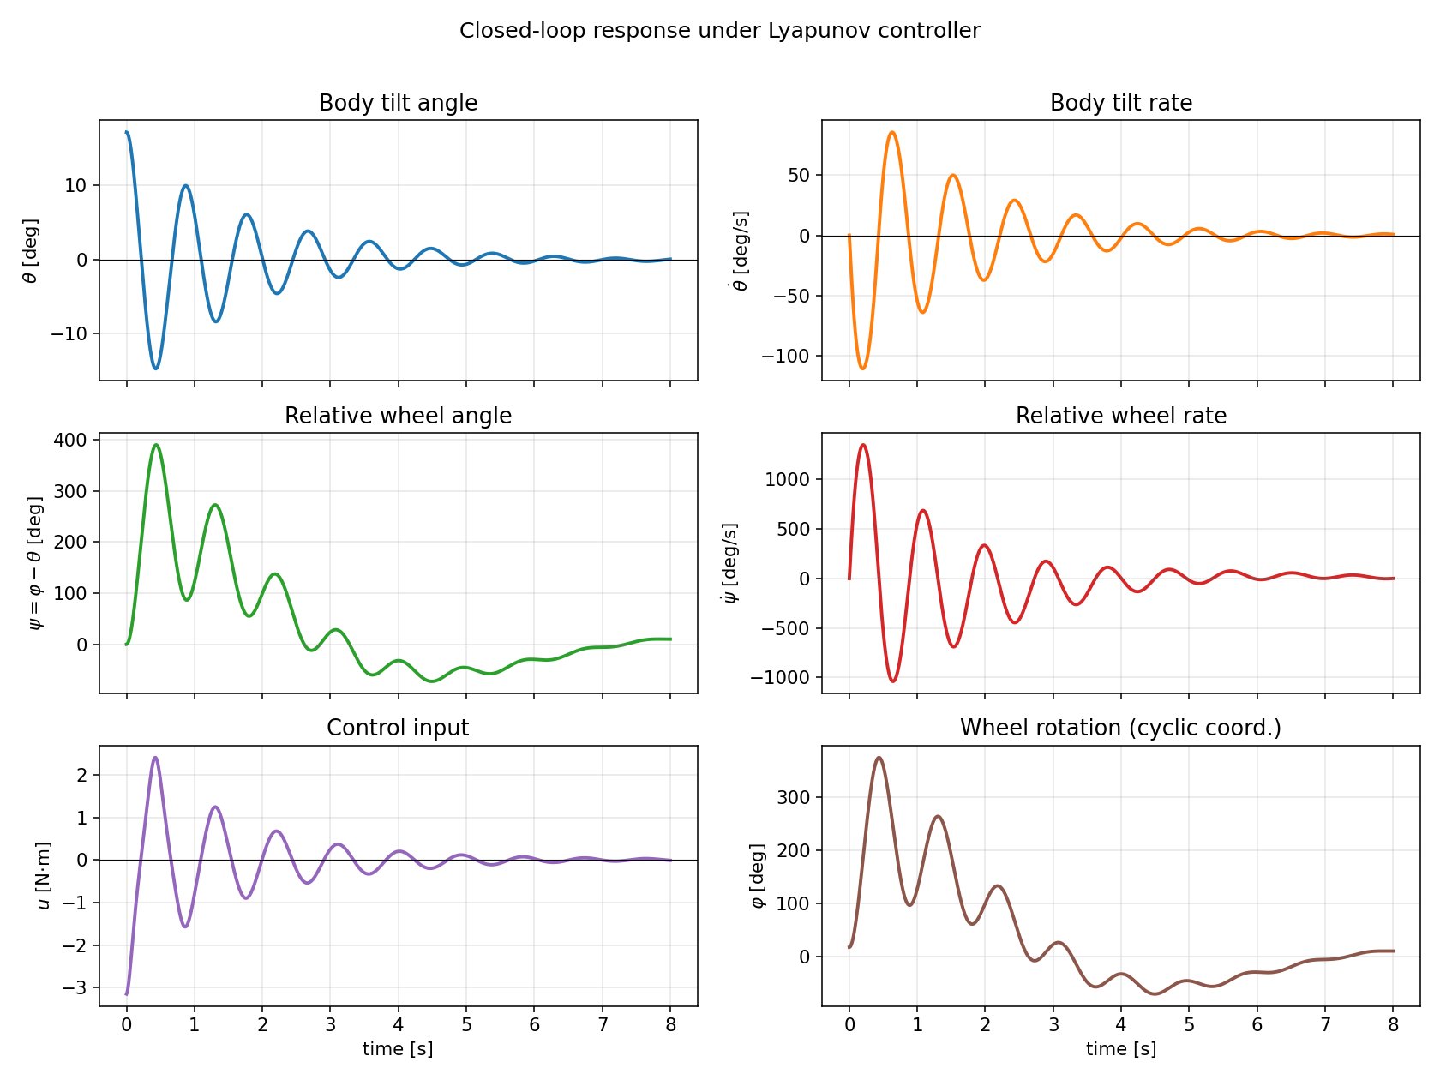
Problems faced and solutions; deviations from the original plan
1. Input direction.
The Aguilar-Ibáñez paper assumes the input acts on a single coordinate. For the wheeled pendulum the motor torque acts as τ = (u, −u)ᵀ, which blocks the direct application of their derivation. Solution: a constant-matrix change of coordinates ψ = φ − θ exposes the same structure (τ̃ = (0, −u)ᵀ), after which their recipe carries through.
2. Extra Coriolis term in the unactuated equation.
Because the off-diagonal of the new mass matrix depends on θ, the unactuated equation gains a β sinθ θ̇² term that the cart-pole does not have. As a consequence, the cart-pole's choice Φ_cp = kₚ (1 − cosθ) − (kₚ/2) θ̇² + ½ q̇² no longer produces dot(Φ) = v ξ̇. Solution: replace the constant 1 in front of θ̇² by the θ-dependent a(θ), and replace the integrand cosθ inside ξ by b(θ) = γ + β cosθ. Once these two substitutions are made, the identity dot(Φ) = v ξ̇ holds again.
3. More restrictive gain condition.
The cart-pole condition kₚ > 1 + k_L generalizes to kₚ (γ + β)² > (1 + k_L)(α + 2β + γ). For the lab parameters this requires kₚ > 47.6, much larger than for the cart-pole, because the wheel inertia γ is small relative to the body inertia α. Solution: tune kₚ accordingly; gains kₚ = 100, kᵢ = 1, k_L = 0.5 work well in practice.
4. Deviation from the original plan.
The term-1 sympy notebook started an LQR design that was never finished. I deliberately abandoned LQR in favour of the Lyapunov-based approach because (a) LQR only stabilizes the linearization and therefore provides a much smaller (and unquantified) attraction region; (b) the Lyapunov design gives an explicit, computable attraction-region estimate; (c) the design pattern (PFL + Lyapunov function + LaSalle) generalizes to the more complex laboratory robot, whereas LQR would have to be redesigned from scratch.
Outcomes: skills and competences developed
- Lyapunov stability theory in practice: I now know how to propose a Lyapunov candidate from a target conservation law, verify positive definiteness on a region, and apply LaSalle's invariance theorem rigorously rather than just citing it.
- Partial feedback linearization for under-actuated mechanical systems (collocated and noncollocated variants), and the trick of changing configuration coordinates to expose the (q_a, q_u) split.
- Symbolic computation for verification: I learned to use sympy not just for derivation but as a regression test — each non-trivial identity in the report has a one-line script that reduces it to 0.
- Modular software design for control experiments: clean separation of plant / controller / integrator / visualization, with a dedicated main.py entry point. The same skeleton is being reused for the other Advanced Control Methods projects (adaptive, backstepping, MPC) in Control-sandbox.
- Interactive visualization from scratch: I built the pygame application (custom sliders / buttons / threaded background simulation / GIF export) without relying on a higher-level UI library. This gave me experience with event loops, threading, and offscreen rendering.
- Bridging two paradigms on the same plant: comparing what last term's REINFORCE policy did empirically with what this term's controller does provably has been the most educational outcome — the same wheeled pendulum, seen from two complementary angles.
Team learning: the project is individual, but the Advanced Control Methods course was taken with a small cohort ("Team Lazy controller" in Control-sandbox) where the four projects (Lyapunov, adaptive, backstepping, MPC) are shared. Discussing each other's designs has been a non-trivial source of feedback, especially on the choice of gain-tuning conditions.
Format of the report to the project supervisor
The deliverables submitted to my supervisor are:
- Detailed technical report: Segway_Lyapunov_Controller.docx — full derivation, stability proof, attraction-region characterization, list of issues found in the original sympy notebook.
- Source code: main.py + the src/ package (system.py, controller.py, simulation.py, animation.py) plus verify_segway.py and verify_controller.py. Static plots are dropped into figures/ by main.py; interactive GIFs into animations/ by the pygame application.

Student's confirmation:
✓
Hereby I confirm that the report is approved by the project supervisor and academic or research (thesis) advisor (if known).

