Appendix S1
Gledis Guri, Ryan P. Kelly, Andrew O. Shelton, Owen R. Liu, and Krista M. Nichols
Smart environmental DNA sampling strategies: a spatial autocorrelation method and interactive planner for survey design
Ecological Applications
Table S1. Parameter values used to generate the 200 simulated Gaussian process (GP) spatial fields. Each row defines one simulation scenario characterised by a single spatial autocorrelation length-scale (ρ), given in kilometres and ranging from 25 to 1000 km. Across all scenarios the non-spatial variance (σ²) is fixed at 3 and the amplitude (α²) at 4, and 20 replicate spatial fields are drawn per scenario (10 ρ levels × 20 replicates = 200 datasets). Columns give the scenario number, ρ (km), σ², α², and the number of replicate iterations.
Simulation | rho | sigma | alpha | No of iterations
1 | 25 | 3 | 4 | 20
2 | 50 | 3 | 4 | 20
3 | 75 | 3 | 4 | 20
4 | 100 | 3 | 4 | 20
5 | 200 | 3 | 4 | 20
6 | 300 | 3 | 4 | 20
7 | 400 | 3 | 4 | 20
8 | 500 | 3 | 4 | 20
9 | 800 | 3 | 4 | 20
10 | 1000 | 3 | 4 | 20

Figure S1. Comparison of regression coefficients estimated from simulated (in-silico in x-axis) datasets and the empirical (in-situ in y-axis) dataset for the model relating prediction error (ε) to sampling density (e) and spatial autocorrelation (ρ). Points represent the estimated coefficients for the intercept (ω), sampling density effect (β), spatial autocorrelation effect (θ), and their interaction (γ). Horizontal and vertical error bars indicate ±2 standard errors of the coefficient estimate from the linear models. The dashed line represents the 1:1 relationship, indicating perfect agreement between simulated and empirical estimates.

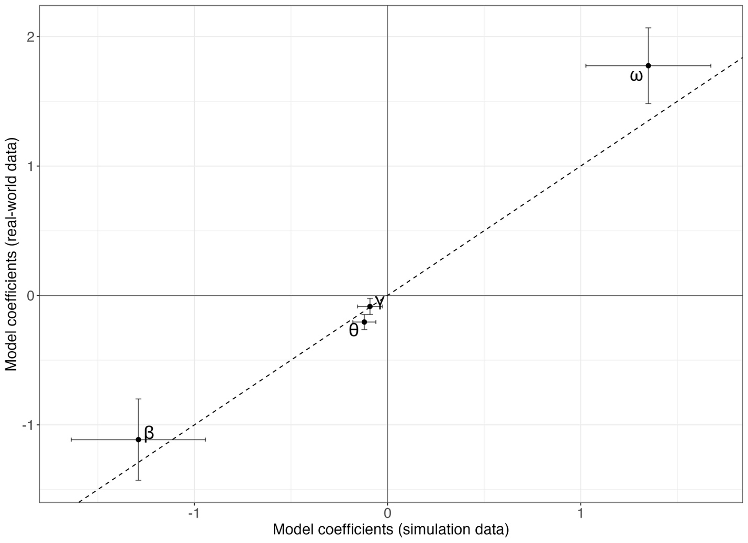

Figure S2. Prediction error as a function of sampling density for the simulated (left panel) and empirical (right panel) datasets, both referenced to a common baseline field (Z) derived from N = 358 samples. The x-axis is sampling density (number of samples per 10,000 km²) and the y-axis is prediction error (ε). Each point is an individual thinning replicate and each solid line is the fitted trend for a given spatial autocorrelation length-scale (ρ), coloured from dark blue (ρ = 25 km) through green and yellow to red (ρ = 1000 km).
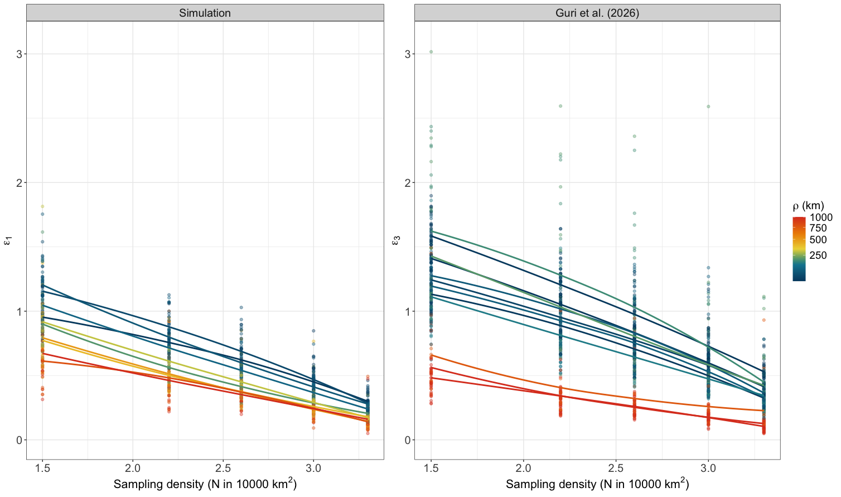
Figure S3. Predicted eDNA concentration and its uncertainty as a function of sampling density, shown in separate panels for each spatial autocorrelation length-scale (ρ = 25–1000 km; colour from dark blue for small ρ to red for large ρ). In every panel the x-axis is sampling density (number of samples per 10,000 km²) and the y-axis is the estimated concentration (copies/L) for a true value of 100 copies/L. Points mark the central estimate and vertical bars show the lower and upper prediction bounds implied by the prediction error (ε) at each sampling density.
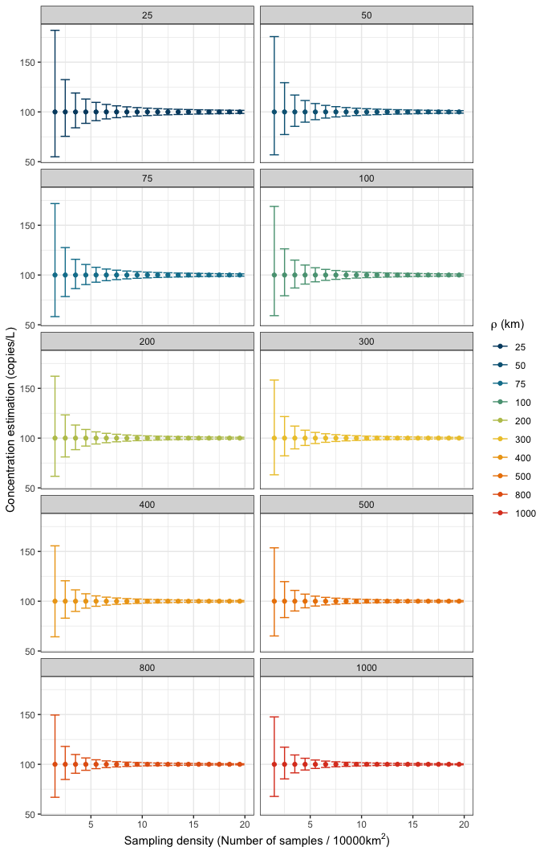
Figure S4. Per-grid-cell differences between the reference field (Z) and the effort-specific predicted field (Sₑ), shown in separate panels for each sampling effort (N = 150–2000 samples). Within each panel the x-axis is the spatial autocorrelation length-scale (ρ, in km, on a log scale) and the y-axis is the difference Z − Sₑ. Each point is one grid-cell residual across simulation replicates, plotted relative to the zero reference line.
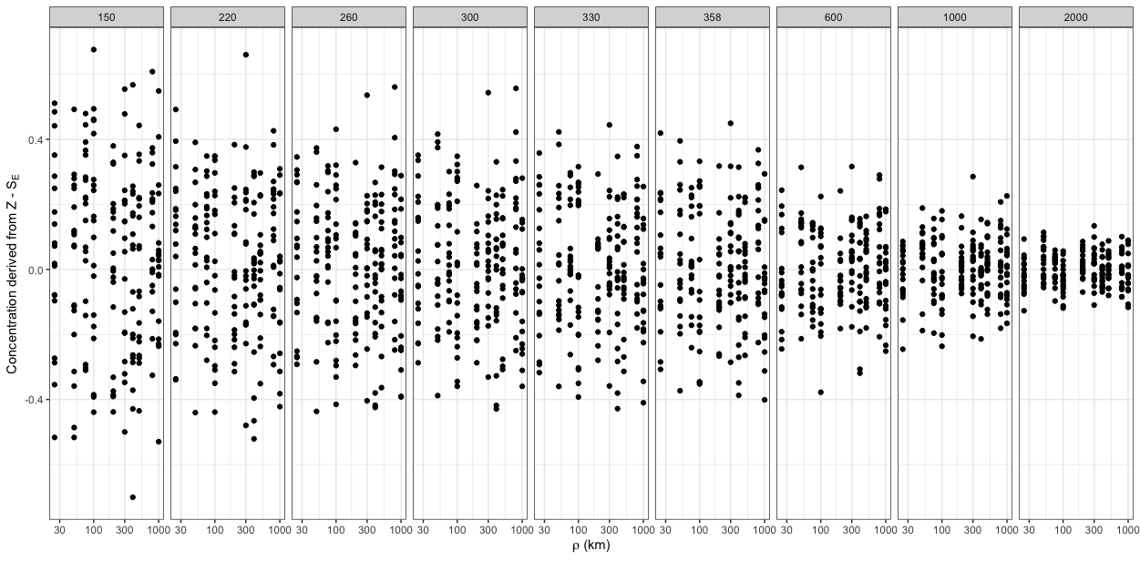

Figure S5. Observed prediction error and the corresponding fitted model values across sampling density. Points show the individual simulated prediction errors (ε₂) and dashed lines show the fitted values from the log–log model (Eq. 6). The x-axis is sampling density (number of samples per 10,000 km², on a log scale) and the y-axis is prediction error (ε₂). Points and lines are coloured by spatial autocorrelation length-scale, from ρ = 25 km (dark blue) to ρ = 1000 km (red).
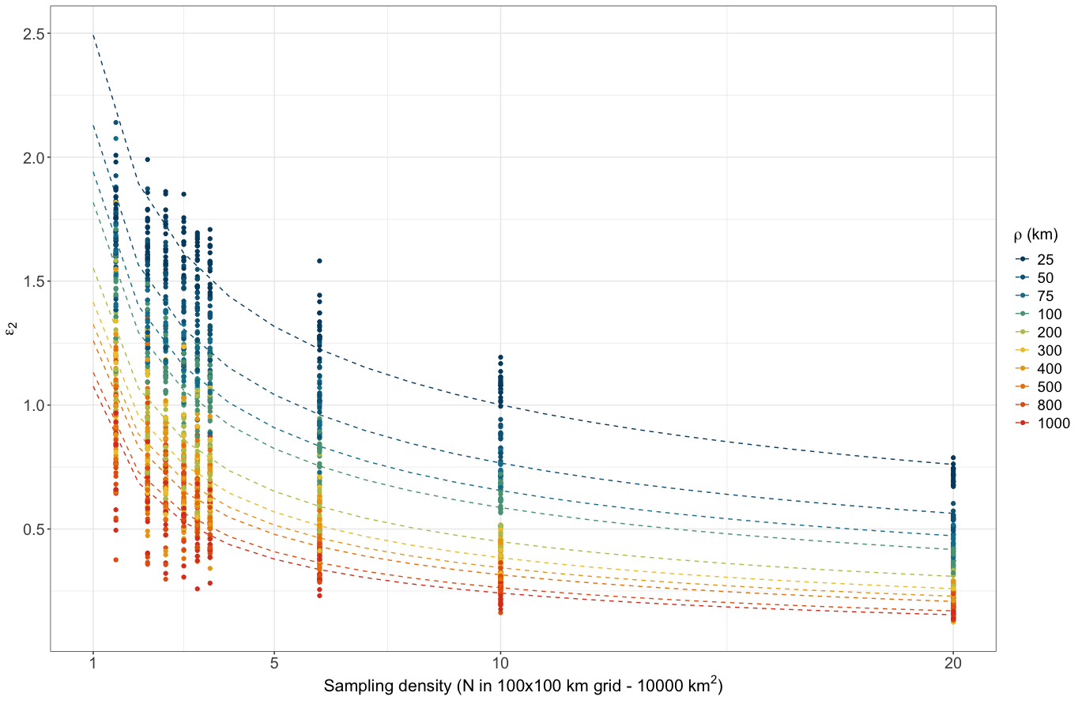

Section S1. Case-study sampling, laboratory processing and additional parameter estimates
Environmental DNA samples were collected during the Joint U.S.-Canada Integrated Ecosystem and Pacific Hake Acoustic-Trawl Survey aboard the NOAA ship Bell M. Shimada in summer 2019 (de Blois, 2020). Sampling spanned a broad latitudinal and longitudinal gradient along the U.S. West Coast, extending from 123.53° to 125.93° W (243–461 km UTM eastings; span = 218 km) and from 38.36° - 48.46° N (4249 - 5367 km UTM northings; range 1118 km), corresponding to a region from central California to northern Washington. At each site, seawater (10 L) was collected using Niskin bottles mounted on a CTD rosette system, targeting five depths (0, 50, 150, 300, and 500 m). From each bottle, 2.5 L of seawater was immediately filtered onboard through sterile 47 mm mixed cellulose ester filters (1 μm pore size) to capture suspended eDNA. Filters were preserved and DNA was extracted using a phase-lock phenol-chloroform protocol, following established methods (Ramón-Laca et al., 2021; Shelton et al., 2022).
Samples underwent PCR amplification using the MiFish U universal primer set (Miya et al., 2015), targeting a 170 bp fragment of the mitochondrial 12S rRNA gene and thereafter sequenced on an Illumina MiSeq platform (2x150 bp paired-end) at a university genomics core facility. Raw sequence reads were processed using the DADA2 pipeline (Callahan et al., 2016) to generate amplicon sequence variants (ASVs), which were taxonomically assigned using a custom reference database from NCBI GenBank and BOLD Systems. The same set of samples were used to estimate hake eDNA concentration using qPCR (Guri et al., 2025). Species-specific eDNA concentrations were estimated by jointly modeling ASV read counts, a mock community to correct for amplification bias, and qPCR measurements of Pacific hake to estimate absolute eDNA abundance for 12 fish species (Guri et al., 2024, 2025). The focal assemblage comprised a mixture of pelagic, mesopelagic, and demersal taxa characteristic of the California Current ecosystem, including Clupea pallasii, Engraulis mordax, Leuroglossus stilbius, Microstomus pacificus, Sardinops sagax, Scomber japonicus, Sebastes entomelas, Stenobrachius leucopsarus, Tactostoma macropus, Tarletonbeania crenularis, Thaleichthys pacificus and Trachurus symmetricus. The final empirical dataset included eDNA measurements (in log copies/L) from 358 spatially distributed sampling among the reported depth layers.
Across species, estimated α² ranged from 2.3 to 4.2, whereas the GP non-spatial variance σ² spanned from 1.5 to 4.5. Surface-associated taxa generally exhibited slightly higher σ² than bottom-associated taxa, indicating greater process variance of the inferred eDNA fields. This pattern may partly reflect a mean–variance relationship, as surface taxa showed higher mean eDNA concentrations or alternatively, differences in σ² are linked to the spatial autocorrelation parameter ρ. Together, these patterns suggest that surface-associated species may be more spatially heterogeneous, whereas deeper-dwelling species may display increasingly homogeneous distributions (main text Figure 3).
Surface-associated species were consistently patchier than deep-associated ones and showed larger surface–deep differences in mean concentration (main text Figure 3), which is consistent with greater spatial heterogeneity in surface waters driven by stronger horizontal gradients, mixing, productivity hotspots, and advective transport, while deeper layers may be more spatially structured and comparatively homogeneous at the regional scale (Guri et al., 2023). From a sampling-efficiency perspective, this implies that surface-focused monitoring may require denser spatial sampling to reconstruct patchy distributions, whereas deep-layer monitoring may allow coarser sampling grids while retaining predictive fidelity-provided that the eDNA field at depth remains spatially coherent and that vertical transport does not dominate the observed signal. Because the length-scale parameter reflects the integrated effects of organism distribution together with eDNA transport and decay, these depth patterns may also reflect depth-dependent physical processes (Brandão‐Dias et al., 2023).
Section S2. Benchmarking simulated against observed fields on a common scale
Due to the gap in sampling effort between field data and simulation datasets, prediction accuracy was benchmarked differently between the two datasets. The empirical benchmark (ε₁) was determined by the sampling effort of N = 358, while the simulation accuracy (ε₂) was benchmarked against a much larger set of sampling effort N = 4,000 samples (main text Figure 2).
To enable a like-for-like comparison between simulated and empirical results, we performed a secondary thinning analysis and prediction accuracy estimation (ε₃) in which the benchmark was redefined to match empirical sampling effort (N = 358; main text Figure 2A). Taking the N=358 subsample as the reference observation set and its prediction on Q as the baseline (Z), we compared the predictions (S_{E}) of the sampling-effort datasets (Y_{E}; E = 330, 300, 260, 220, and 150) to both the simulated and empirical datasets, refit the GP model at each effort, and computed effort-specific (ε₃) prediction errors by comparing each S_{E} to the matched reference field Z (derived from S_{E=358}; main text Figure 2A). Furthermore, we fitted the prediction accuracy (ε₃) as a function of sampling effort (E) and spatial autocorrelation (ρ) using Eq. 6 (similarly to empirical data). We then compared the estimated model coefficients of prediction accuracy between the simulated and empirical to assess whether similar patterns were observed.
Section S3. Model fitting
All the GP models (equation 1 and 2) were fitted in a Bayesian framework using Stan probabilistic programming language (Stan Development Team, 2023). We used weakly informative priors (Table S2) to allow the data to primarily inform the posterior distributions of the parameters. For each GP model in Stan, we ran four parallel chains with 2,000 iterations each, discarding the first 1,000 iterations as warm-up. Stan's warm-up phase both discards these initial draws and adapts the sampler's step size and mass matrix, and so is not strictly equivalent to a conventional burn-in. Convergence was assessed using R̂ values, where values below 1.01 indicated satisfactory convergence and effective sample size (ESS) above 200. The model in Eq. 6 was fitted using linear models using lm() function in R (R Core Team, 2024; Figure S5 for model fit diagnostics).
Table S2. Gaussian process model parameters and the prior distributions used in Bayesian inference.
Parameter | Prior | Lower bound | Upper bound
α² | N(4, 1) | 0 | +∞
μ | N(0, 5) | −5 | +∞
log(ρ) | N(0, 1) | −5 | +∞
σ² | N(0, 1) | 0 | +∞
Notes: N(m, s) denotes a normal prior with mean m and standard deviation s, truncated at the bounds shown. The same priors were used for the empirical and simulated datasets.
Section S4. Additional discussion of Gaussian process parameter recovery
Estimation of μ_{d} improved with increasing effort when scenarios had small spatial autocorrelations, but for highly autocorrelated scenarios (especially above 400 km) error (τ) in estimating μ increased rather than declined. One likely explanation is that, when the spatial autocorrelation parameter approaches or exceeds the spatial extent of the study area (200 km longitudinal here), the data provide only weak information about the parameter, leaving the posterior estimates heavily dependent on the Bayesian prior.
By contrast, estimation of the spatial autocorrelation parameter ρ was substantially more sensitive to reduced sampling effort, particularly in scenarios with low spatial autocorrelation. Estimating the mean mainly requires observations that broadly represent the range of values across the study area, whereas estimating spatial autocorrelation requires information on how similarity between samples changes with distance (Paciorek, 2010; Rocha et al., 2021). In practical terms, μ_{d} can remain relatively robust under reduced sampling effort, provided that the spatial structure is still contained within the extent of the survey. By contrast, estimating ρ depends much more strongly on the distances among sampling points, because resolving spatial autocorrelation requires enough closely and broadly spaced pairs to detect how similarity declines with distance (Paciorek, 2010).
Overall, this behavior is expected when the underlying process varies at a finer spatial scale than the sampling design can resolve. Once the true ρ is smaller than the spatial resolution of the sampling grid (e.g., a grid spaced at 5 km cannot resolve patchiness occurring at a 1 km scale) the model has no way to detect the pattern, and predictions default to the priors with large residual uncertainty (Kaufman & Shaby, 2013). Under these conditions, the model is operating close to the limit of what can be learned from the sampling design, and additional changes in true ρ may not translate into detectable changes in map-level accuracy. Practically, this implies that sample-removal diagnostics (or any assessment that treats an undersampled reference as truth) can become uninformative for very patchy species, because the benchmark surface itself is not resolved well enough to support fine-scale comparisons (Kaufman & Shaby, 2013). This, in turn, motivates our reliance on simulations with much higher spatial resolution to characterize how sampling effort should scale with spatial autocorrelation.
Overall, the parameter estimates indicate that most gains in estimation of the GP parameters occurred at low sampling effort, with little additional improvement once effort exceeded roughly 6 samples per 10,000 km² per depth layer. This consistent leveling-off across GP parameters estimation (main text Figure 5) suggests a clear point of diminishing returns, beyond which further increases in sampling effort are unlikely to substantially improve inference under the spatial scales considered here.
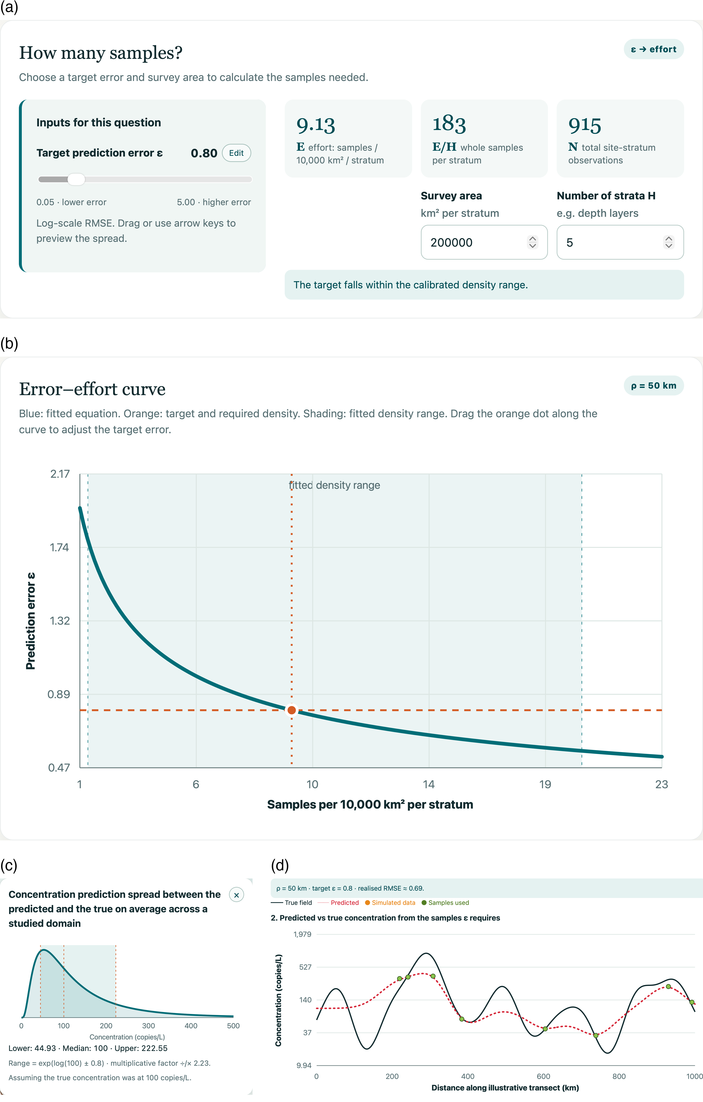
Figure S6. The eDNA Survey Planner applied to the case-study domain for a patchy taxon (ρ = 50 km), a target prediction error ε = 0.8 and 200,000 km² per depth layer in five layers (see main text, Applying the planner). (a) “How many samples?” returns the required sampling density (9.13 samples per 10,000 km² per stratum), samples per stratum (183) and total site–stratum observations (915), and confirms that the result lies within the calibrated range. (b) Error–effort curve (Eq. 6) for the chosen ρ: the target error (dashed line) and required density (dotted line and point, which can be dragged) within the fitted density range (shaded). (c) Translation of ε into a concentration range around a true concentration of 100 copies/L. (d) One-dimensional illustration of a simulated true field (black line), the samples required to reach ε (green points) and the resulting reconstruction (red dotted line). The planner is available at https://gledguri.github.io/Smart-eDNA-sampling/.
References
Brandão‐Dias, P. F. P., Hallack, D. M. C., Snyder, E. D., Tank, J. L., Bolster, D., Volponi, S., Shogren, A. J., Lamberti, G. A., Bibby, K., & Egan, S. P. (2023). Particle size influences decay rates of environmental DNA in aquatic systems. Molecular Ecology Resources, 23(4), 756–770. https://doi.org/10.1111/1755-0998.13751
Callahan, B. J., McMurdie, P. J., Rosen, M. J., Han, A. W., Johnson, A. J. A., & Holmes, S. P. (2016). DADA2: High-resolution sample inference from Illumina amplicon data. Nature Methods, 13(7), 581–583. https://doi.org/10.1038/nmeth.3869
de Blois, S. (2020). The 2019 Joint U.S.–Canada Integrated Ecosystem and Pacific Hake Acoustic-Trawl Survey: Cruise report SH-19-06 (NWFSC Processed Report 2020-03). Northwest Fisheries Science Center, National Oceanic and Atmospheric Administration. https://doi.org/10.25923/p55a-1a22
Guri, G., Liu, O. R., Kelly, R. P., Shaffer, M. R., Parsons, K. M., Ramón-Laca, A., Nichols, K. M., Brandão-Dias, P. F. P., Wells, A., & Shelton, A. O. (2025). Quantitative, multispecies monitoring at a continental scale. Ecology. https://doi.org/10.1101/2025.10.30.685180
Guri, G., Shelton, A. O., Kelly, R. P., Yoccoz, N., Johansen, T., Præbel, K., Hanebrekke, T., Ray, J. L., Fall, J., & Westgaard, J.-I. (2024). Predicting trawl catches using environmental DNA. ICES Journal of Marine Science, fsae097. https://doi.org/10.1093/icesjms/fsae097
Guri, G., Westgaard, J., Yoccoz, N., Wangensteen, O. S., Præbel, K., Ray, J. L., Kelly, R. P., Shelton, A. O., Hanebrekke, T., & Johansen, T. (2023). Maximizing sampling efficiency to detect differences in fish community composition using environmental DNA metabarcoding in subarctic fjords. Environmental DNA, edn3.409. https://doi.org/10.1002/edn3.409
Kaufman, C. G., & Shaby, B. A. (2013). The role of the range parameter for estimation and prediction in geostatistics. Biometrika, 100(2), 473–484. https://doi.org/10.1093/biomet/ass079
Miya, M., Sato, Y., Fukunaga, T., Sado, T., Poulsen, J. Y., Sato, K., Minamoto, T., Yamamoto, S., Yamanaka, H., Araki, H., Kondoh, M., & Iwasaki, W. (2015). MiFish, a set of universal PCR primers for metabarcoding environmental DNA from fishes: Detection of more than 230 subtropical marine species. Royal Society Open Science. https://doi.org/10.1098/rsos.150088
Paciorek, C. J. (2010). The importance of scale for spatial-confounding bias and precision of spatial regression estimators. Statistical Science, 25(1). https://doi.org/10.1214/10-STS326
R Core Team. (2024). R: A language and environment for statistical computing. R Foundation for Statistical Computing, Vienna, Austria. https://www.R-project.org/
Ramón-Laca, A., Wells, A., & Park, L. (2021). A workflow for the relative quantification of multiple fish species from oceanic water samples using environmental DNA (eDNA) to support large-scale fishery surveys. PLOS ONE, 16(9), e0257773. https://doi.org/10.1371/journal.pone.0257773
Rocha, A. D., Groen, T. A., Skidmore, A. K., & Willemen, L. (2021). Role of sampling design when predicting spatially dependent ecological data with remote sensing. IEEE Transactions on Geoscience and Remote Sensing, 59(1), 663–674. https://doi.org/10.1109/TGRS.2020.2989216
Shelton, A. O., Ramón-Laca, A., Wells, A., Clemons, J., Chu, D., Feist, B. E., Kelly, R. P., Parker-Stetter, S. L., Thomas, R., Nichols, K. M., & Park, L. (2022). Environmental DNA provides quantitative estimates of Pacific hake abundance and distribution in the open ocean. Proceedings of the Royal Society B: Biological Sciences, 289(1971), 20212613. https://doi.org/10.1098/rspb.2021.2613
Stan Development Team. (2023). Stan modeling language users guide and reference manual (Version 2.26.1). https://mc-stan.org/

