Supplementary Information for Smart eDNA sampling strategies: Spatial autocorrelation can guide efficient survey design
Gledis Guri$​^{1}$*, Ryan P. Kelly$​^{1}$, Andrew O. Shelton$​^{2}*$, Owen R. Liu³, Krista M. Nichols$​^{2}$

1 | School of Marine and Environmental Affairs, University of Washington, Seattle, Washington, USA
2 | Conservation Biology Division, Northwest Fisheries Science Center, NOAA Fisheries, Montlake Blvd E. Seattle, Washington, USA
3 | School of Aquatic and Fishery Sciences, University of Washington, Seattle, Washington, USA
 | corresponding author gguri@uw.edu
Journal: Ecological Applications

Table S1. Simulation scenarios and their parameters
Simulation | rho | sigma | alpha | No of iterations
1 | 25 | 3 | 4 | 20
2 | 50 | 3 | 4 | 20
3 | 75 | 3 | 4 | 20
4 | 100 | 3 | 4 | 20
5 | 200 | 3 | 4 | 20
6 | 300 | 3 | 4 | 20
7 | 400 | 3 | 4 | 20
8 | 500 | 3 | 4 | 20
9 | 800 | 3 | 4 | 20
10 | 1000 | 3 | 4 | 20

Figure S1. Comparison of regression coefficients estimated from simulated (in-silico in x-axis) datasets and the empirical (in-situ in y-axis) dataset for the model relating prediction error (ε) to sampling density (e) and spatial autocorrelation (ρ). Points represent the estimated coefficients for the intercept (ω), sampling density effect (β), spatial autocorrelation effect (θ), and their interaction (γ). Horizontal and vertical error bars indicate ±2 standard errors of the coefficient estimate from the linear models. The dashed line represents the 1:1 relationship, indicating perfect agreement between simulated and empirical estimates.

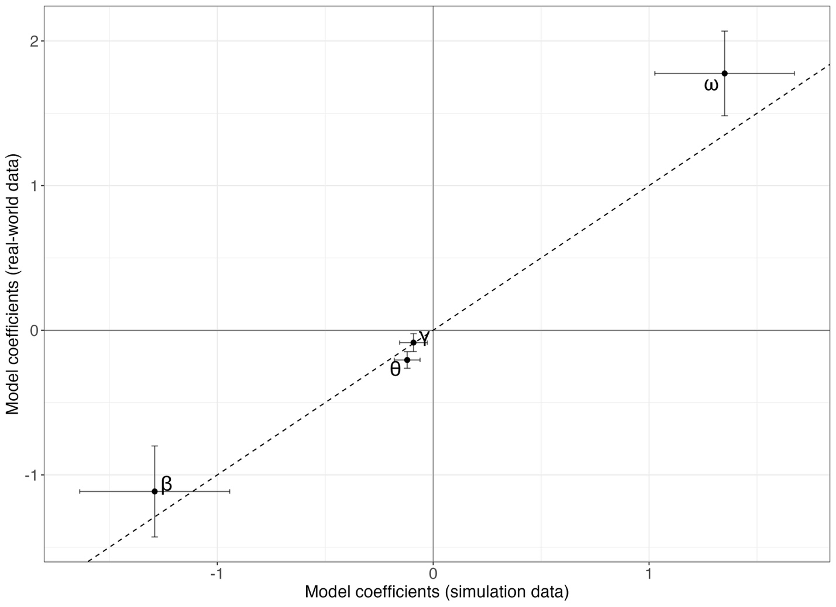

Figure S2. Comparison of prediction error between the simulated (left) and empirical (right) data where the baseline Z comes from a dataset of N = 358 samples.
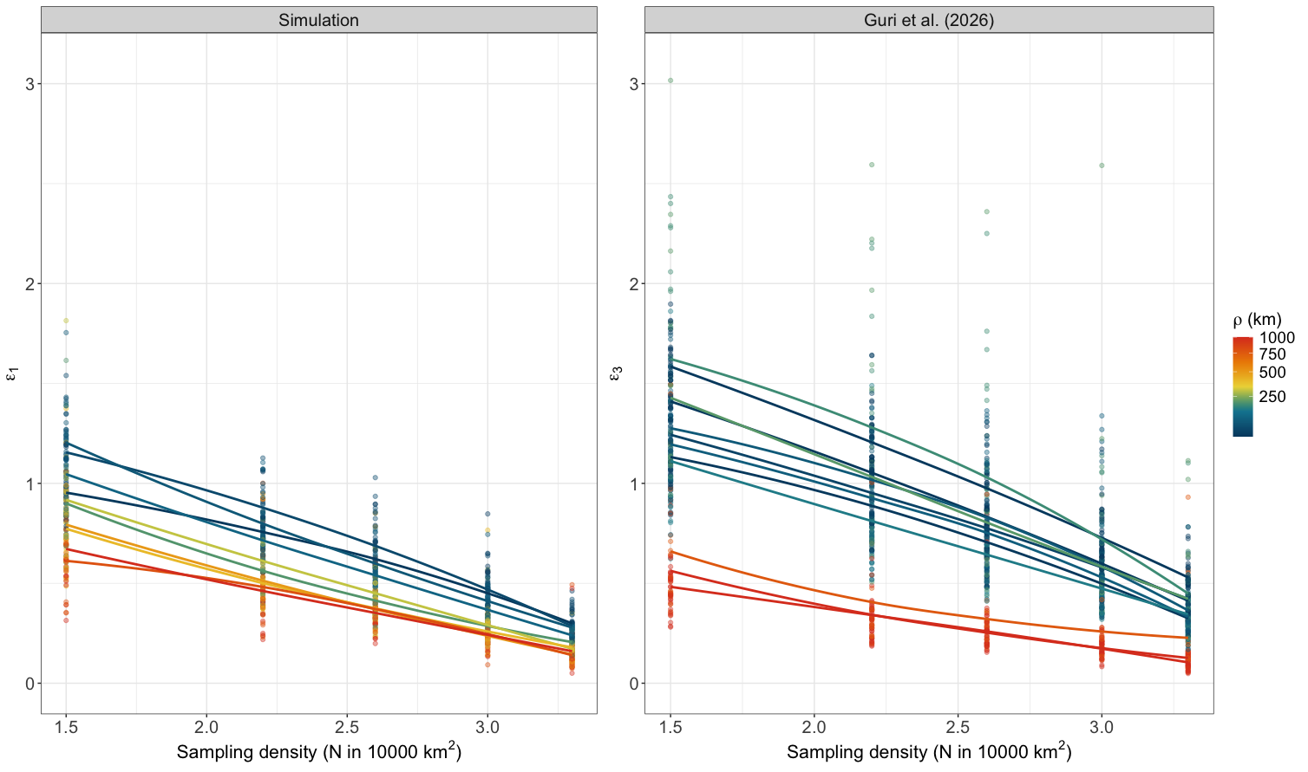
Figure S3. Visualization of the lower and upper bars of prediction given the prediction error (ε) per sampling effort (E) when the true eDNA concentration is 100 copies/L.
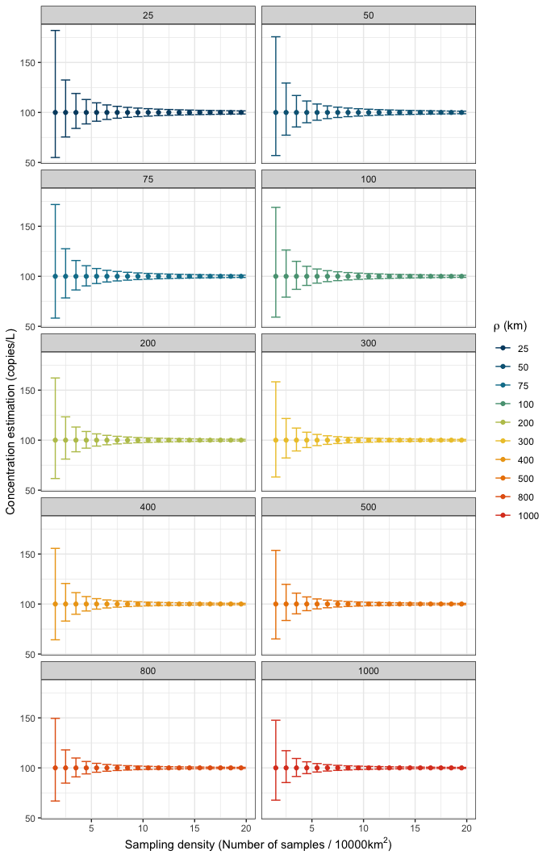

Figure S4. Bias vs precision, to prove that RMSE used here is mainly accounting for precision and not bias.
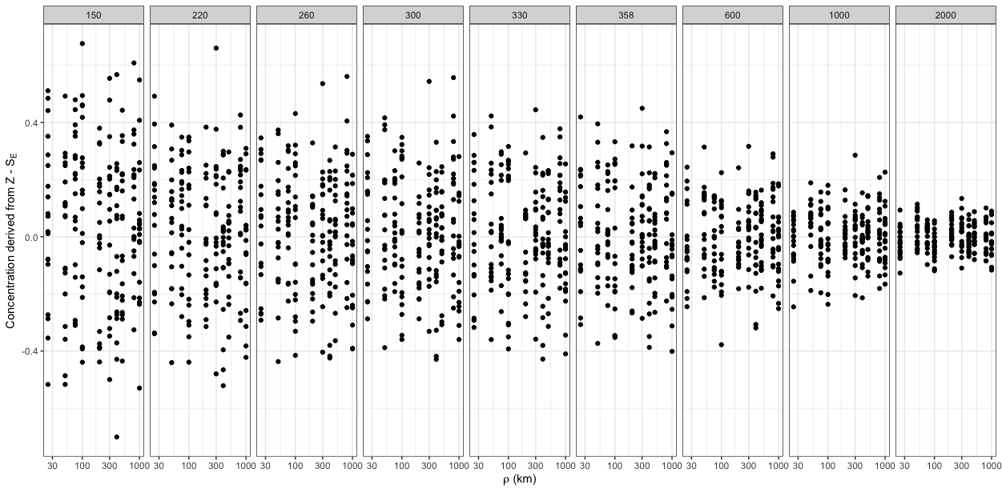

Figure S5. Showing the observations of the prediction error (dots) and the modeled estimates (line) from the fitted model using Eq. 6.
