Smart eDNA sampling strategies: Species spatial autocorrelation can guide efficient survey design
Gledis Guri$​^{1}$*, Ryan P. Kelly$​^{1}$, Ole Shelton2$​^{2}*$, Krista M. Nichols$​^{2}$, others
2025-11-20

1 | School of Marine and Environmental Affairs, University of Washington, Seattle, Washington, USA
2 | Conservation Biology Division, Northwest Fisheries Science Center, NOAA Fisheries,
 | Montlake Blvd E. Seattle, Washington, USA
 | corresponding author gguri@uw.edu

Abstract
Keywords:

Introduction
Appropriate sampling design plays a critical role in collecting sufficient and representative samples to accurately assess species distributions, forming the foundation for sound fisheries management and stock assessment protocols. Traditionally, abundance indices used in stock assessments are derived from capture-based surveys, acoustic methods, or visual observations, for all of which determining the appropriate sample size is vital for reliable estimation of population parameters including abundance, demographic structure, and spatial distribution patterns. This process must balance the need for sufficient data for detecting trends and changes in population while also ensuring that incurring unnecessary costs or effort are minimized (sampling efficiency). Excessive sampling can lead to redundant data – multiple samples that gives the exact same information, thus wasting time and money - whereas insufficient sampling risks overlooking critical patterns and producing unreliable estimates. Identifying optimal sampling efficiency – marginal uncertainty decrease over sampling effort – is therefore crucial for inferring the spatial variability and ecological traits of marine communities at reasonable cost. Under this definition, sampling becomes inefficient when extra samples contribute little new information and uncertainty declines only slowly due to redundancy (e.g., strong spatial autocorrelation).
The emergence of environmental DNA (eDNA) sampling has revolutionized marine monitoring capabilities, offering a non-invasive method to detect species presence and estimate relative abundance. In contrast to traditional survey techniques that are typically species-specific or require separate sampling efforts for different taxa, eDNA enables simultaneous, multi-species detection from a single water sample. This holistic approach allows for a more comprehensive assessment of community composition while substantially reducing field effort and disturbance. Recent synthesis work shows that eDNA methods have matured sufficiently for key uncertainties to be quantified and incorporated into existing fisheries stock-assessment frameworks, enabling the development of cost-effective abundance indices that complement conventional surveys \cite{baetscher2025}. Additionally, while conventional methods detect organisms directly at the point of capture or observation, eDNA signals integrate information from surrounding areas through processes of DNA transport and decay (\cite{dias2025} \cite{li2026}). This spatial integration effect means that adjacent eDNA samples may contain overlapping information, making the question of optimal spatial sampling resolution even more critical. Due to the spatiotemporal integration in eDNA signals – DNA signal from organisms located at varying distances from the sampling site and at different time points prior to collection - an additional layer of spatial autocorrelation is introduced beyond what would be expected from species distribution patterns alone. [xxx move this after the GP] Consequently, when applying Gaussian Process models to eDNA data, the spatial autocorrelation parameter inherently captures both the natural clustering patterns of species distributions and the physical processes that govern DNA dispersal and decay in the marine environment. Without concurrent independent sampling methods such as trawl surveys or acoustic monitoring to provide direct measures of local abundance, these two fundamental processes - biological smoothness and spatiotemporal eDNA integration - cannot be empirically separated and are therefore represented as a single integrated parameter within the modeling framework. While increased sampling intensity generally reduces variance in population estimates and improves the precision of spatial pattern detection, this relationship exhibits diminishing returns where beyond a certain threshold, additional sampling effort produces marginal gains in statistical precision that may not justify the associated costs and logistical demands. The optimal sampling intensity occurs at the point where incremental improvements in precision or information content become disproportionately small relative to the required investment of resources and effort. This principle guides the development of cost-effective sampling strategies that maximize analytical power while minimizing operational expenditure.
In ecological and fisheries research, Gaussian Process (GP) models have been widely adopted to capture spatial and environmental variation in species distributions \cite{lewy2009} \cite{nielsen2016}. This approach is grounded in the assumption that species distributions and abundances change in a smooth and continuous manner across space (or other covariates), reflecting correlated responses to spatial, environmental, and biological covariates \cite{lewy2009}. At the core, observations made at similar locations or under similar covariates should yield similar outcomes. This relationship is quantified through a covariance function, or kernel, which governs how the correlation between two points $x$ and $x'$ decays with increasing distance. The kernel defines the smoothness of the model across the covariates. One of the most influential parameters in this context is the length-scale, which represents the characteristic distance over which correlation between points remains strong. Large length-scales indicate that the modeled process changes gradually across space (or other covariates), with nearby points remaining highly correlated even over broad spatial extents or environmental conditions, whereas small length-scales imply rapid variation and weak correlation beyond short distances and environmental conditions. Spatially, this mathematical framework captures an essential ecological principle: species tend to form one or more areas of high concentration - "hotspots" - where individuals aggregate densely. As distance increases from these central areas, population density gradually declines in a smooth, continuous manner. The distribution of a species at various locations can be expressed as:
$$\begin{aligned}Y∼MVN\left(μ,k\left(x,x^{'}\right)\right)\#1\end{aligned}$$
$$\begin{aligned}k\left(x,x^{'}\right)=α^{2}exp\left(-\frac{(x-x')^{2}}{2ρ^{2}}\right)+σ^{2}\#2\end{aligned}$$
where Y is the vector of observed abundance or density of the species (spatial field) across all sampled locations with a global mean abundance $μ$ and covariance matrix k of covariate $x$ (here spatial coordinates). The covariance matrix is the most important part of the GP as it determines the (spatial or environmental) autocorrelation of the species distribution where $α$ is the amplitude of the $x$-$x'$ (difference of the covariate for all pairs of samples) correlation, $ρ$ is the length-scale parameter meaning the correlation (in $x$-$x'$ units) where the signal decays, and $σ$ is the process variance resolved by the kernel (noise in nature). Species with small autocorrelation ($ρ$) values exhibit rapidly changing abundance patterns that vary sharply across space and environmental gradients, indicating highly localized distributions with distinct boundaries between favorable and unfavorable conditions. Conversely, species with large $ρ$ values display smoothly varying abundances that remain correlated over broader spatial and environmental scales, suggesting gradual transitions in response to environmental heterogeneity and broader ecological niches.
In simple terms, knowing the within-species spatial autocorrelation of distributions can provide a quantitative basis for optimizing sampling effort - species exhibiting high spatial autocorrelation should require fewer samples to capture their distribution patterns due to their extended spatial coherence (Figure xxx). In this study, we aim to evaluate how spatial autocorrelation in species’ distributions, as well as sampling effort (represented by the number of samples deployed), influence the efficiency of eDNA metabarcoding marine sampling strategies. We investigate this question using both simulated and real-world eDNA data for 12 species that differ in their patterns of spatial autocorrelation. Specifically, we quantify the effect of sampling effort on (i) estimating the spatial autocorrelation (typically used for understanding ecological niches \cite{sanchez2025}), (ii) estimating the global mean (typically used for conservation and stock assessment), and (iii) the predictive precision of species abundance and distributions (typically used for species distribution inferences). In this formulation, we focus exclusively on spatial coordinates (latitude and longitude) as covariates to isolate the effects of spatial structure from environmental or biological drivers. However, the same GP framework can be extended to include additional covariates such as temperature, salinity, bathymetry, or even biotic interactions like species competition and trophic relationships. By explicitly quantifying the trade-off between spatial autocorrelation, sample size, and prediction accuracy, this study seeks to identify thresholds of sampling effort that maximize information gain and minimize redundancy - offering a principled, quantitative foundation for designing efficient marine spatial surveys.
Add that these analysis are good for designing protected area
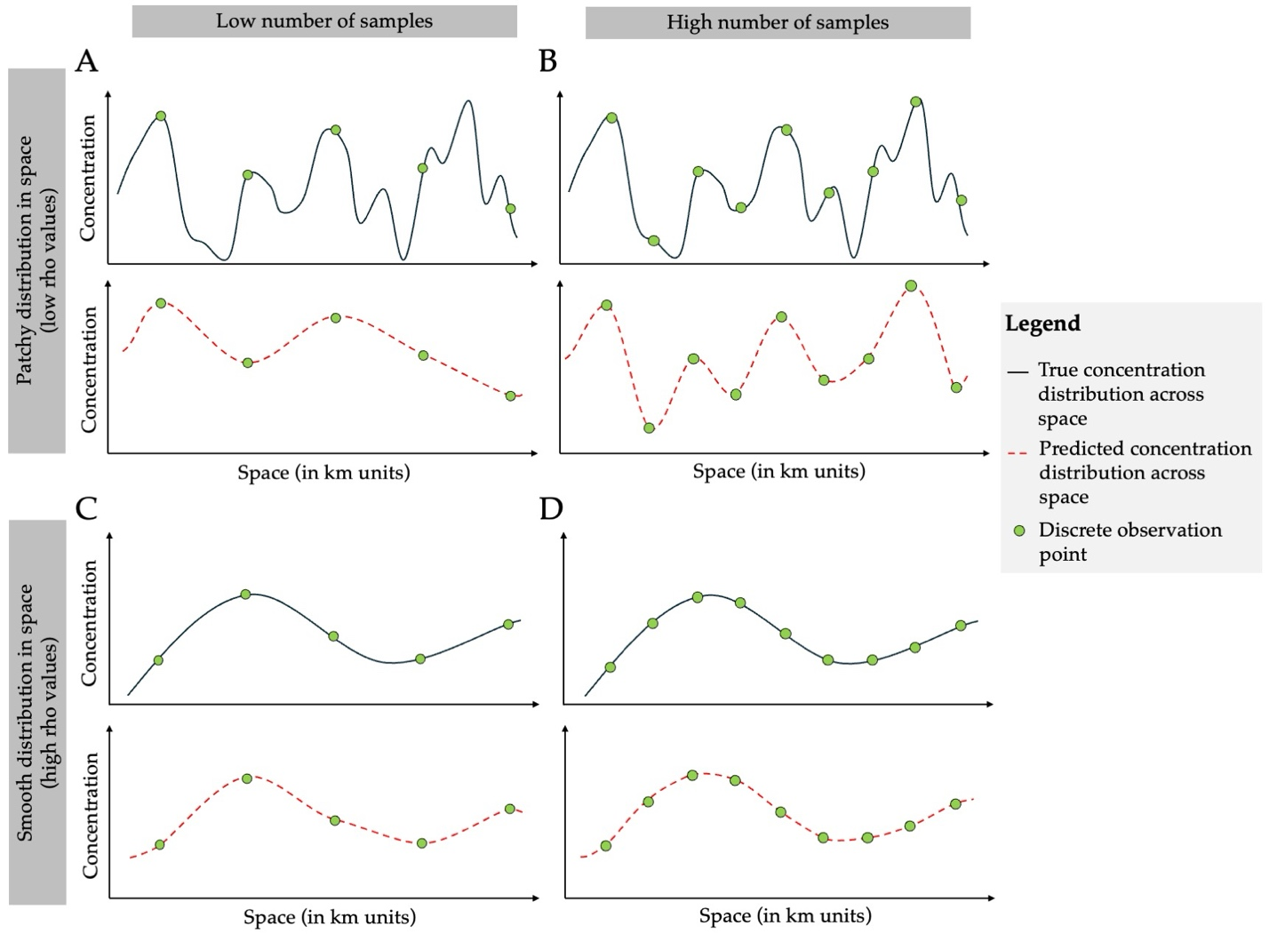
Figure 1. Conceptual figure demonstrating how sampling density influences the reconstruction of spatial concentration patterns. Panels compare a low number of samples (A, C) versus a high number of samples (B, D) across a patchy (A, B) and a smooth (C, D) species distribution along a one-dimensional spatial transect (x-axis; space in km units). In each panel, the solid black line represents the true underlying concentration distribution, green circles indicate discrete observation points (number of samples), and the red dashed line shows the concentration distribution predicted from the sampled observations (e.g., via Gaussian Processes). Increasing sampling density improves the ability to recover fine-scale spatial structure, with the greatest gains occurring under patchy spatial heterogeneity whereas on spatially smooth distributed species additional samples contribute relatively little new information.

Materials and methods
A common approach to evaluating sampling efficiency has been retrospective “sample-removal” analyses—e.g., rarefaction, random thinning, or jackknife deletion from an existing survey [xxx add ref]. Importantly, these retrospective diagnostics rest on a strong assumption of sufficient initial sampling effort to recover the spatial structure. If the original survey was undersampled, such analyses cannot reveal information that was never captured. In other words, sample-removal approaches only quantify the loss of information when data are removed, not the information that could have been gained with a more intensive initial sampling design.
To overcome this limitation, we employ simulation-based approaches that systematically vary sampling effort and spatial autocorrelation to directly assess its influence on the recovery of spatial structure and prediction accuracy. Specifically, to evaluate how sampling effort affects the accuracy of spatial field predictions using GP models, we utilize both simulated datasets (known GP parameters) and real-world eDNA concentration data (unknown GP parameters) collected from marine environments (Guri et al. 2025, in review).

Simulated eDNA data
To systematically evaluate the influence of spatial autocorrelation and sampling effort, we generated in-silico eDNA concentration (in log copies/L) across five depth strata (0, 50, 150, 300, and 500 m) on a fixed 200 x 1000 km spatial domain along the U.S. West Coast, following the domain used in Guri et al. (2025, in review). Simulations were generated using GP models (see equations 1 and 2) with predetermined parameters. The full simulated and prediction spatial grid (with x and y coordinates hereafter X) comprised of 18916 points (hereafter Q) distributed across five depth layers (4000, 4000, 4000, 3622, and 3294 points per depth layer), with each point (in space) assigned a simulated eDNA concentration.
We varied the GP length-scale parameter ($ρ$) across 10 levels - 25, 50, 75, 100, 200, 300, 400, 500, 800, and 1000 km - to represent a range of spatial autocorrelation degrees (basing these values form values of in-situ data). For each $ρ$, we generated 20 independent replicate spatial fields (iterations), yielding 200 simulated spatial fields in total (10 $ρ$ levels × 20 replicates). Within each simulation, $ρ$ was held constant across depths, while each depth had a separate mean ($μ$) drawn randomly from a normal distribution with mean of 0 and a standard deviation of 3. The amplitude ($α$) and the observation noise ($σ$) in Equation XXX were fixed at 4 and 3 respectively based on parameters estimates in Guri et al. (2025, in review)).
This parameterization was chosen to approximate real-world eDNA patterns, where species are assumed to exhibit a single underlying spatial autocorrelation structure ($ρ$) across depths, while allowing depth-specific mean differences in eDNA concentration. Fixing ($α$) and ($σ$) reflects the assumption that amplitude and residual variability are primarily driven by method-specific measurement uncertainty and therefore remain constant when the same sampling and analytical methods are applied.

Real-world eDNA data
We analyzed eDNA concentration data (in-situ) collected from marine environments, as detailed in Guri et al. (2025, in review). This dataset includes eDNA measurements (in log copies/L) from 358 spatially distributed sampling sites across multiple depth layers spanning a broad latitudinal and longitudinal gradient along the U.S. West Coast, covering an approximate spatial extent of 123.53° - 125.93° W (243 - 461 km UTM eastings; range of 218 km) and 38.36° - 48.46° N (4249 - 5367 km UTM northings; range 1118 km), corresponding to a region from central California to northern Washington. Samples were processed using metabarcoding with the MiFish U universal primer, enabling identification of fish species and quantification of eDNA abundance through calibration with a mock community and qPCR of a reference species (Guri et al. 2025, in review).
Environmental DNA samples were collected during the Joint U.S.-Canada Integrated Ecosystem and Pacific Hake Acoustic-Trawl Survey aboard the NOAA ship Bell M. Shimada in summer 2019 (de Blois 2020). At each site, seawater (10 L) was collected using Niskin bottles mounted on a CTD rosette system, targeting five depths (0, 50, 150, 300, and 500 m). From each bottle, 2.5 L of seawater was immediately filtered onboard through sterile 47 mm mixed cellulose ester filters (1 $μ$m pore size) to capture suspended eDNA. Filters were preserved and DNA was extracted using a phase-lock phenol-chloroform protocol, following established methods (Ramón-Laca et al. 2021, Shelton et al. 2022).
Samples were metabarcoded, libraries were prepared with the MiFish U universal primer set (Miya et al. 2015), targeting a 170 bp fragment of the mitochondrial 12S rRNA gene. Sequencing was performed on an Illumina MiSeq platform (2x150 bp paired-end) at the University of Washington Genomics Core. Raw sequence reads were processed using the DADA2 pipeline (Callahan et al. 2016) to generate amplicon sequence variants (ASVs), which were taxonomically assigned using a custom reference database from NCBI GenBank and BOLD Systems. Species-specific eDNA concentrations were estimated by normalizing ASV read counts to total reads per sample and calibrating against qPCR-derived abundances for target species (i.e. hake, eulachon, sea lamprey). After subsequent filtering a total of 358 samples were used in a joint model where together with a mock community correcting for amplification bias and qPCR of pacific hake to estimate absolute eDNA abundance for 12 fish species (Guri et al. 2025, in review).

Estimating sampling efficiency on prediction accuracy
After the simulation of in-silico fields and acquisition of the in-situ observations, we obtained eDNA concentration values (Y; or Q for in-silico data) paired with spatial coordinates (X) for each sampling location. Given the large number of in-silico eDNA points (Q) on the spatial grid (X), fitting a GP model to all locations (≈ 20,000 input values) was computationally prohibitive. To address this, we selected a representative subset of 4,000 sampling points from each simulated dataset to serve as the “complete” observation dataset (Y) for the following downstream analysis.
We then used the GP model (Eq. 1–2) to infer the underlying spatial structure and learn key parameters governing the spatial field, including the depth-specific mean (μ_{d}), length-scale (ρ), amplitude (α), and process noise (σ). Once fitted, the model was additionally used to predict eDNA concentrations Z across the full spatial grid (Q), simultaneously for both the simulated and real-world datasets.
Specifically, for a given depth d, the model computes the covariance matrix among observed locations, $K(X,X)$, using the squared exponential kernel and additionally adds the observation nugget term ($σ^{2}I$). Using the Cholesky decomposition ($K+σ^{2}I=LL^{⊤}$) to solve for $(K+σ^{2}I)^{-1}(Y-μ_{d})$ we combine it with the cross-covariance between observed and prediction points, $K(X,Q)$, to yield the predictive posterior mean at each prediction site:
$$\begin{aligned}Z=μ_{d}+K(X,Q)^{⊤}(K+σ^{2}I)^{-1}(Y-μ_{d})\#3\end{aligned}$$
To evaluate how sampling effort (e) influences spatial reconstruction and prediction accuracy, we generated a series of reduced-effort observation datasets by randomly thinning the observation set Y to fixed sample sizes (N = 2000, 1000, 600, 358, 330, 300, 260, 220, and 150). Sampling effort (e) was quantified as sampling density:
$$\begin{aligned}e=\frac{N}{A×H}×10000\#4\end{aligned}$$
where A is the spatial area of the study domain (200,000 km²), and H is the number of depth layers (d) included in this study (H=5), yielding e in units of samples per 10,000 km² per depth layer. Each D_{e} observation dataset was refit with the same GP model (Eq 1-2) and produced effort-specific spatial predictions (S_{e}) on the full grid Q, by substituting S_{e} with Z and D_{e} with Y in Eq. 3. This framework enables direct, like-for-like comparisons of reconstructed fields across sampling intensities.
We quantified the prediction accuracy we by calculating the prediction error (ε_{e}), defined as the root mean squared error (RMSE) between spatial fields predicted from the complete dataset (Z) and those predicted from each reduced sampling scenario (S_{e}) as follows:
$$\begin{aligned}\begin{aligned}ε_{e}&=\frac{1}{n}\sum_{i=1}^{n}{\sqrt{{\left(Z_{i}-S_{ie}\right)}^{2}}}\end{aligned}\#5\end{aligned}$$
with $n$ being the total number of Q grid points (n = 18,916) where the predictions (Z and S_{e}) are projected. This process was computed for all 200 simulated data (each of 20 iterations of different spatial autocorrelation values) to explore the relation between sampling effort, spatial autocorrelation and prediction accuracy. The primary metric of interest was prediction accuracy across all iterations, which allowed us to assess how sampling effort and spatial autocorrelation jointly influence the fidelity of GP-based spatial predictions. We modeled prediction error (ε) as a function of sampling density (e) and spatial autocorrelation (ρ), including their interaction as follows:
$$\begin{aligned}log\left(ε\right)=ω+β log\left(e\right)+θ log\left(ρ\right)+γ log\left(e\right)log\left(ρ\right)\#6\end{aligned}$$
where ω is the intercept, β slope of sampling density (e), θ is the slope of spatial autocorrelation (ρ) and γ is the coefficient on the interaction between the two latter factors.
Additionally, to evaluate the influence of sampling effort on GP parameter estimation, we compared the length-scale (ρ) and depth-specific mean (μ_{d}) estimates obtained from effort-specific datasets (D_{e}) to the true values used to generate the simulated fields. This allowed us to quantify how reliably different sample sizes recover the underlying spatial autocorrelation and mean eDNA concentration across depths. Differences between estimated and true parameter values were quantified using the root mean squared error (RMSE). This allowed us to assess how reliably different sampling efforts and spatial autocorrelation values recover the underlying spatial structure and mean eDNA concentration across depths.
Comparison of prediction accuracy between in-situ and in-silico data
Because the in-situ dataset contained only N=358 samples (e=3.6), the empirical analysis could not be evaluated at higher sampling densities (e.g., e=6 - 20) and therefore cannot be compared directly to the primary simulation baseline where the “complete” dataset was N=4000 (e=40). To enable a like-for-like comparison between simulated and real-world datasets, we conducted a secondary thinning analysis in which the baseline observation dataset was redefined to match the real-world sampling effort (N = 358; e = 3.6), rather than the simulated baseline used in the primary thinning analysis (N = 4000; e = 40). Specifically, for each simulated scenario and iteration we used the subsample of size N=358 (D_{e=3.6}) and treated this dataset as the reference observation set (i.e., Y ← D_{e=3.6}). We then generated the corresponding prediction S_{e=3.6} (i.e., Z ← S_{e=3.6}) on Q, denoted, using Eq. 3. From this generated baseline, we compared the predictions (S_{e}) of the sampling-effort datasets (D_{e}; e = 3.3, 3, 2.6, 2.2, and 1.5) to both the simulated and empirical datasets, refit the GP model at each effort, and computed effort-specific (ε_{e}) prediction errors by comparing each S_{e} to the matched reference field S_{e=3.6}. Furthermore, we applied the same model used in the primary thinning analysis (Eq. 6) to both the in-silico and in-situ datasets to evaluate whether prediction error exhibited similar relationships with sampling effort and spatial autocorrelation. We then compared the estimated model coefficients between the in-silico and in-situ datasets to assess whether similar patterns were observed.
All the GP models (equation 1 and 2) were fitted in a Bayesian framework using Stan probabilistic programming language (Carpenter et al. 2017). We used weakly informative priors (Table 1) to allow the data to primarily inform the posterior distributions of the parameters. For each GP model in Stan, we ran four parallel chains with 2,000 iterations each, discarding the first 1,000 iterations as burn-in. Convergence was assessed using $\hat{R}$ values, where values below 1.1 indicated satisfactory convergence and effective sample size (ESS) above 200. The model in Eq. 6 was fitted using linear models using lm() function in R (R Core Team, 2024), with log prediction error as the response variable and log-transformed sampling density and spatial autocorrelation as predictors.
Gaussian Process model parameters and their prior distributions used in Bayesian inference.
Parameter | Prior | Range
 |  | Min | Max
$$α$$ | $$N(4,1)$$ | 0 | +$∞$
$$μ$$ | $$N(0,5)$$ | -5 | +$∞$
$$ρ$$ | $$N(0,1)$$ | -5 | +$∞$
$$σ$$ | $$N(0,1)$$ | 0 | +$∞$
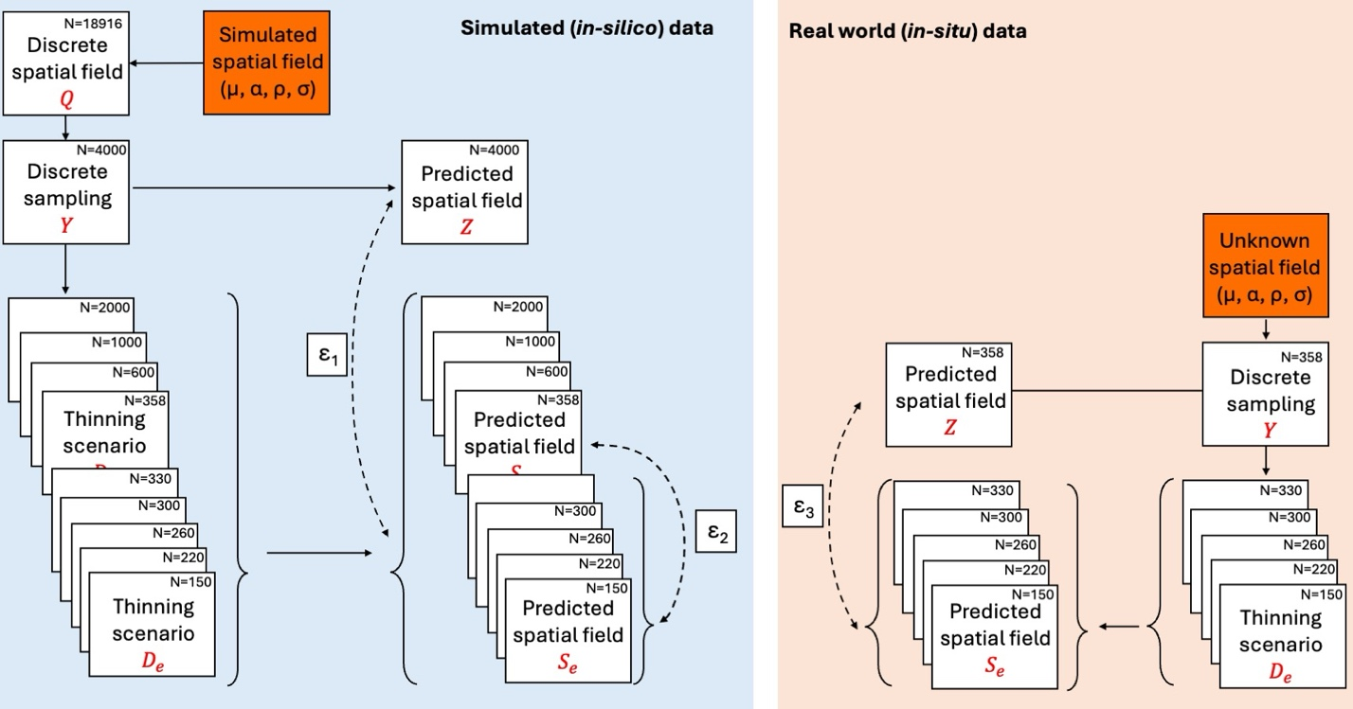
Figure 2. Workflow for evaluating sampling‐density effects on spatial field reconstruction in simulated (in-silico) and real-world (in-situ) data. A spatial field is generated (blue, in-silico data) from known parameters (μ, ρ, σ) and represented on a discrete grid (Q, n=18,916). A reference sampling set (Y, n=4000) is used to fit a GP model and generate a predicted field (Z), which serves as the reference reconstruction. The prediction error (ε₁) is defined as the difference between Z field and the progressively reduced using thinning designs (Dₑ) reconstructed field. To enable a like-for-like comparison with the in-situ data, a secondary baseline using n=358 samples is defined to produce a reference prediction S_{e=358}, and prediction error (ε₂) is calculated as the difference between S_{e=358} and reconstructions obtained from further thinned datasets (D_{e}). On the right (pink, real-world data), the underlying spatial field is unknown but assumed to arise from unknown parameters (μ, ρ, and σ). Using the full observed dataset (Y, N=358), a baseline predicted field (Z) is obtained. The observed samples are then thinned using the same D_{e} designs, re-fit, and used to generate predicted fields S_{e}. Deviations of thinned predictions from the baseline prediction quantify ε₃, representing the expected information loss when sampling density is reduced in empirical settings.

Results
Simulations
Prediction accuracy
Prediction error (ε; expressed as RMSE), decreased non-linearly with increasing sampling effort and with higher spatial autocorrelation (Figure 3A). These patterns were supported by a log–log linear model where the prediction error (ε) decreased exponentially for every exponential increase in sampling density (β = -0.176) and spatial autocorrelation (θ = -0.228), with an additional negative interaction (γ = -0.0684) and with an intercept of α = 1.65 (i.e., ε = 5.2 when e and rho = 1). For instance, at a sampling intensity of 6 samples per 10,000 km², species with spatial autocorrelation values of 50 km had mean prediction errors of 1 (Figure 3A) indicating that on average every point predicted the eDNA concentration will be off by a factor of 2.72 (for perspective a concentration of 100 copies/L will be predicted between 37-270 copies/L). In contrast, for the same sampling effort (i.e., 6 samples per 10,000 km²) but species with spatial autocorrelation above 500 km had errors below 0.4 indicating an average of over- and underestimation by a factor of 1.5 (for perspective a concentration of 100 copies/L will be predicted between 67-150 copies/L). When quantifying the marginal reduction in prediction error (ΔRMSE) across successive increases in sampling density (Δe), improvements were greatest at low sampling effort and declined rapidly with additional sampling, with ΔRMSE approaching zero at higher sampling densities (Figure 3B). Marginal gains effectively plateaued when sampling density increased from ~6 to 8 samples per 10,000 km², depending on the ρ (Figure 3B). For interpretation, a ΔRMSE of 0.4 indicates that adding one sample per 10,000 km² improves expected predictive accuracy from 37–270 copies/L to 55–182 copies/L when the true concentration is 100 copies/L respectively.
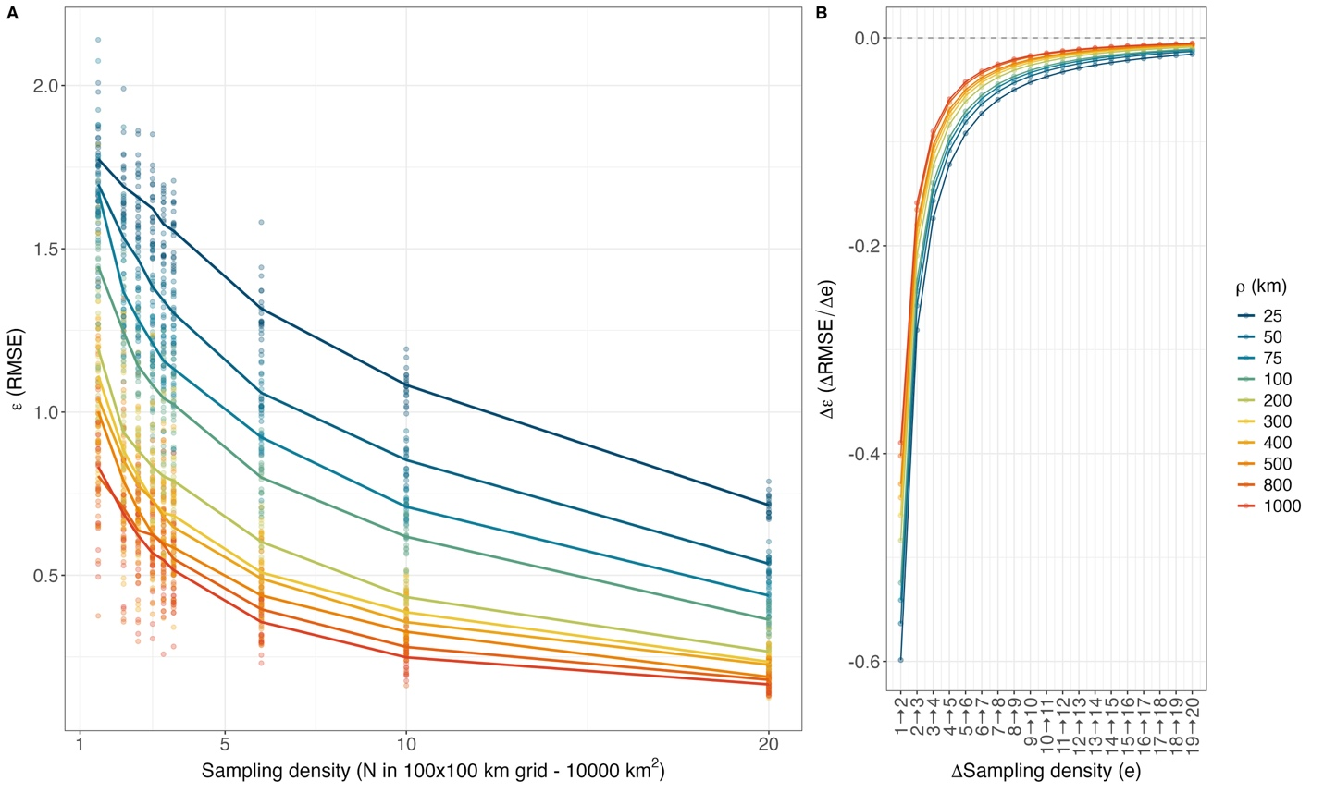
Figure 3: Mean prediction error (ε; RMSE) across five sampling-effort scenarios (indicated by color) for simulated datasets (A). Prediction error was higher with lower sampling effort and was also lower where spatial autocorrelation ($ρ$) was the greatest. Marginal improvement (B) in prediction performance (Δε) across successive increases in sampling densities (Δe = 1).
GP parameter recovery
Sampling effort and spatial autocorrelation strongly influenced the ability of the GP model to recover the parameters used to generate the simulated spatial fields (Figure 6). Estimation error for the depth-specific mean (μ) decreased with increasing sampling density for simulated fields with small spatial autocorrelation but showed the opposite pattern for fields with large spatial ranges (Figure 6A). Specifically, RMSE for μ increased with sampling effort when spatial autocorrelation exceeded 400 km, indicating that mean estimates became increasingly biased in highly spatially structured fields. Additionally, the recovery of the spatial autocorrelation length-scale (ρ) was highly sensitive to sampling density (Figure 6B). At low sampling effort (e < 4), estimates of ρ showed substantial error, particularly for simulations with large spatial ranges. However, estimation accuracy improved rapidly as sampling effort increased, with RMSE declining sharply and stabilizing once sampling densities were higher than 6 samples per 10,000 km², beyond which additional sampling produced only marginal improvements in ρ estimation.
Estimation error for the amplitude parameter (α) declined with increasing sampling density for simulations with small spatial autocorrelation, while remaining relatively stable across sampling densities for simulations with larger spatial ranges (Figure 6C). Overall improvements in α estimation were therefore limited once sampling effort increased above 6 samples per 10,000 km². The process noise parameter (σ) was consistently well recovered across sampling densities (Figure 6D). RMSE declined sharply with increasing sampling density and approached near-zero values once sampling densities exceeded 6 samples per 10,000 km².
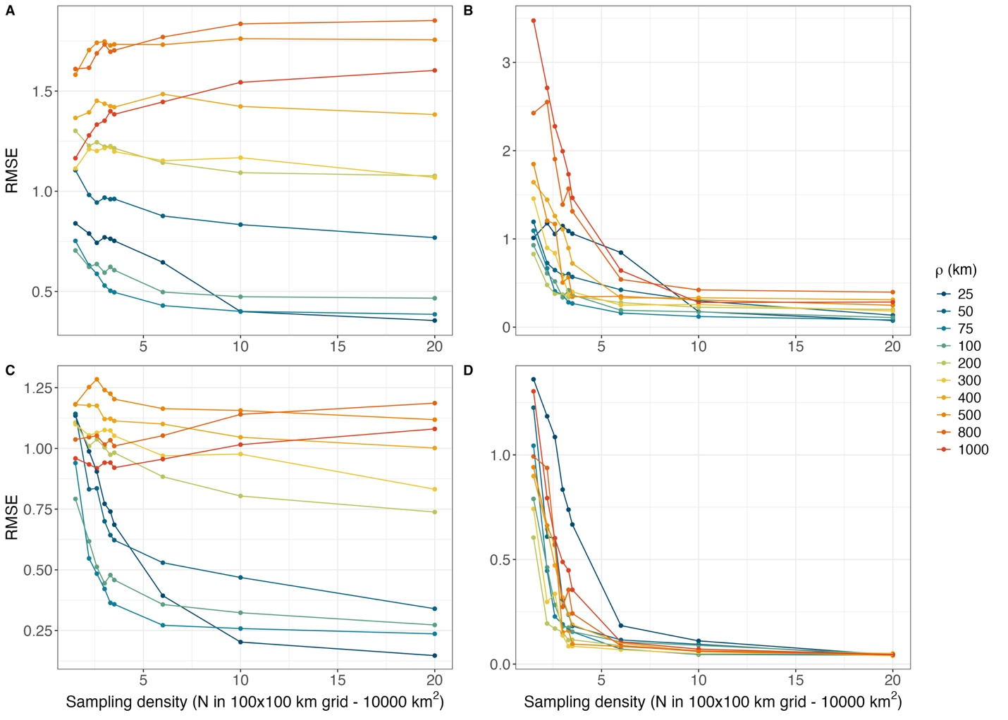
Figure 4. Accuracy of Gaussian Process (GP) parameter estimation across sampling densities and spatial autocorrelation values from in-silico data. Each dot represents the mean of Root Mean Squared Error (RMSE) across 20 simulation iterations between estimated and true parameter values for (A) depth-specific mean (μ), (B) spatial autocorrelation length-scale (ρ), (C) amplitude (α), and (D) process noise (σ). Lines represent the regression of mean RMSE across sampling effort for each spatial autocorrelation level. Sampling density is expressed as the number of samples per 10,000 km² (100 × 100 km grid).

Real-world data
GP parameters
Across species, depth-specific global mean eDNA concentrations generally declined with increasing sampling depth (Figure 5). Species-specific length-scale estimates revealed distinct depth-associated spatial structure. Surface-dwelling species were characterized by shorter length scales, indicating lower spatial autocorrelation, and showed pronounced differences between surface and deep mean eDNA concentrations (μ). In contrast, deep-dwelling species exhibited longer length scales, consistent with higher spatial autocorrelation, and relatively stable mean eDNA concentrations (μ) across depth strata. Together, these patterns suggest that eDNA from surface-associated species is more spatially heterogeneous, whereas deeper-distributed species display increasingly homogeneous and spatially structured eDNA distributions with depth.
Across species, α ranged from 2.3 to 4.2, whereas the GP process variance σ spanned from 1.5 to 4.5. Surface-associated taxa generally exhibited higher σ than bottom-associated taxa, indicating greater process variance of the inferred eDNA fields. This pattern may partly reflect a mean–variance relationship, as surface taxa showed higher mean eDNA concentrations or alternatively, differences in σ are linked to the length-scale parameter ρ (Fig. Sxxx).
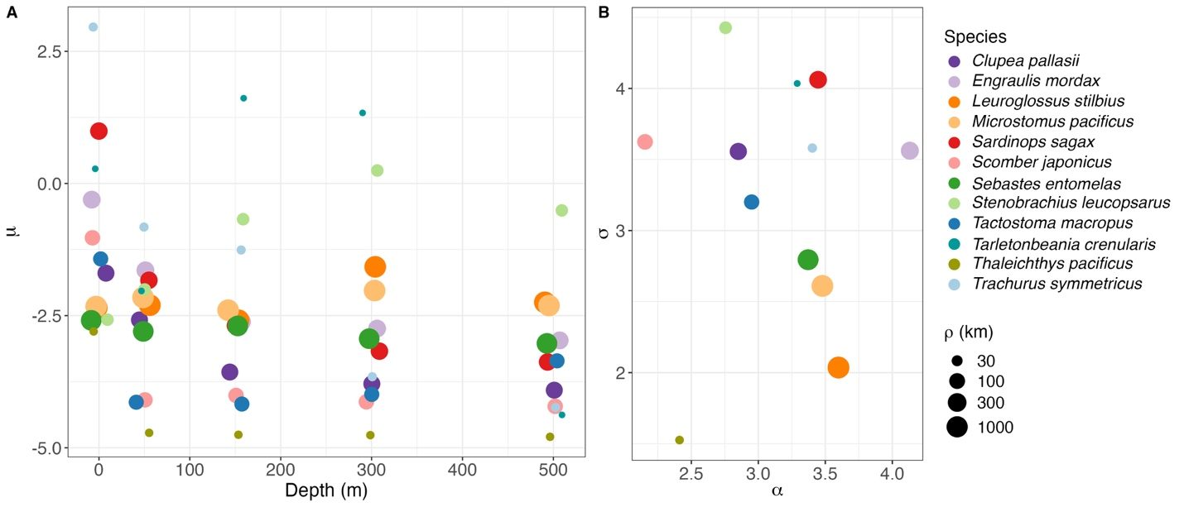
Figure 5: Depth-specific (0, 50, 100, 300, and 500 m) relationship between species spatial autocorrelation (ρ in km shown as the size of the points) and mean eDNA concentrations (in log concentration/L) across species (colors) in panel A. Panel B indicating the signal amplitude (α) relation between process noise (σ) and species spatial autocorrelation (ρ in km shown as the size of the points).
Comparison of prediction accuracy between in-situ and in-silico data
Prediction error (ε) increased as sampling effort and spatial autocorrelation decreased, indicating that prediction accuracy improved with both higher sampling density and stronger spatial structure (Fig. Sxxx). These prediction-effort relationships derived from the in-situ dataset were broadly consistent with those obtained from in-silico simulations (Figure 6). Specifically, the estimated intercept (ω), the influence of sampling effort (β), the effect of spatial autocorrelation (θ), and their interaction term (γ) all showed consistent directional effects and aligned closely with the 1:1 line, demonstrating a high degree of structural agreement between the empirical and simulated error models. Overall, the close correspondence between coefficients derived from the in-silico and in-situ datasets indicates that the simulation framework successfully reproduced the primary relationships between prediction error, sampling effort, and spatial autocorrelation observed in the real-world data.
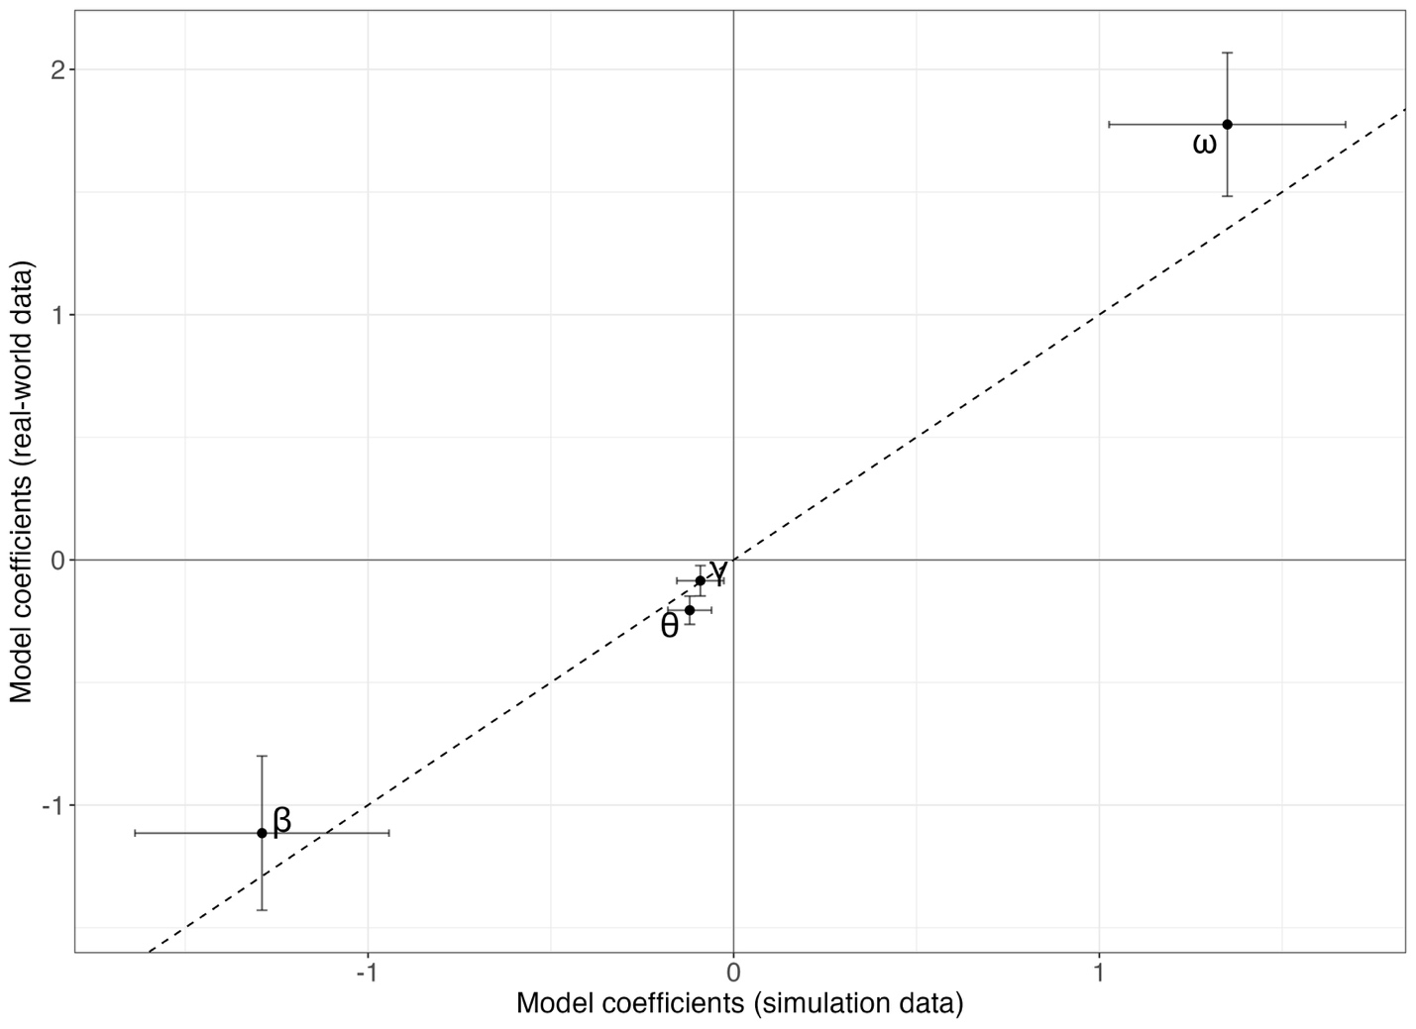
Figure 6. Comparison of regression coefficients estimated from simulated (in-silico in x-axis) datasets and the empirical (in-situ in y-axis) dataset for the model relating prediction error (ε) to sampling density (e) and spatial autocorrelation (ρ). Points represent the estimated coefficients for the intercept (ω), sampling density effect (β), spatial autocorrelation effect (θ), and their interaction (γ). Horizontal and vertical error bars indicate ±2 standard errors of the coefficient estimate from the linear models. The dashed line represents the 1:1 relationship, indicating perfect agreement between simulated and empirical estimates.

Discussion
Our results provide quantitative evidence that the efficiency of spatial eDNA surveys is strongly governed by the species-specific spatial autocorrelation (or length-scale parameter in general terms). Across both simulations and the real-world data, variation in the Gaussian Process (GP) length-scale parameter (ρ) structured how rapidly prediction performance improved with additional samples, and how quickly diminishing returns emerged.
Understanding parameters in ecology
A central outcome of this study is that the value of additional sampling effort is not fixed but depends strongly on the spatial structure of the target species. Across simulations, prediction error decreased non-linearly as sampling density increased, and it also declined as spatial autocorrelation length scale increased, showing that species with broader and more spatially coherent distributions are inherently easier to reconstruct than patchier species at the same effort level. The interaction between effort and spatial autocorrelation is especially important because it demonstrates that the value of additional samples is not universal in ecology, where the same increase in effort can produce substantial gains for one species and only marginal gains for another. Here, our results move beyond a general statement of sampling efficiency and provide a quantitative framework for understanding when extra effort is informative and when it yields diminishing returns.
For spatial reconstruction the prediction error decreased rapidly at low effort as the sampling effort increased, but the marginal gains weakened markedly once sampling density approached roughly 6 samples per 10,000 km² per depth layer. This implies that, for many ecological applications, the first increases in effort are the most valuable, whereas dense sampling beyond that threshold is less efficient for improving broad spatial reconstruction. This type of saturating return is ecologically intuitive as once the dominant spatial gradients have been captured, additional samples mostly refine local details rather than substantially improving the overall reconstruction.
The parameter estimation analyses provide further ecological insights into how sampling effort and spatial autocorrelation affect inference. The estimation of depth-specific mean, (μ_{d}) and the length scale (ρ), behaved very differently. Estimation of μ_{d} improved with increasing effort when scenarios had small spatial autocorrelations, but for highly autocorrelated scenarios (especially above 400 km) error (RMSE between simulated and estimated) in μ increased rather than declined. One likely explanation is that, when the autocorrelation length approaches or exceeds the spatial extent of the study area, the dominant scale of variation is only weakly identified by the data. Under these conditions, the field can appear nearly uniform across the sampled domain, making it difficult to separate the overall mean from the large-scale spatial process. In a Bayesian framework, this weak identifiability means that estimation becomes more influenced by the priors, which can reduce precision or introduce apparent bias in μ_{d} even as sampling effort increases.
By contrast, estimation of the length-scale parameter ρ was substantially more sensitive to sampling effort thinning, particularly in low spatially autocorrelated scenarios. Such difference follows from the type of information required to estimate each parameter. Estimating the mean mainly requires observations that broadly represent the range of values across the study area, whereas estimating spatial autocorrelation requires information on how similarity between samples changes with distance. In practical terms, μ_{d} can remain relatively robust under sampling effort thinning scenarios when sample removal is random (and uniformly distributed), provided that the spatial structure is still contained within the extent of the survey. By contrast, estimating ρ depends much more strongly on the distances among sampling points, because resolving spatial autocorrelation requires enough closely and broadly spaced pairs to detect how similarity declines with distance.
From a GP perspective, this behavior is expected when the underlying process varies at a finer spatial scale than the sampling design can resolve. Once ρ is sufficiently small, the field can resemble spatially uncorrelated variation at the scale of available station spacing, and predictions at unsampled locations revert toward the prior mean with large residual uncertainty. Under these conditions, the model is operating close to the limit of what can be learned from the sampling design, and additional changes in true ρ may not translate into detectable changes in map-level accuracy. Practically, this implies that sample-removal diagnostics (or any assessment that treats an undersampled reference as truth) can become uninformative for very patchy species, because the benchmark surface itself is not resolved well enough to support fine-scale comparisons. This, in turn, motivates our reliance on simulations with much higher spatial resolution to characterize how sampling effort should scale with spatial autocorrelation.
Overall, the parameter estimates indicate that most gains in estimation accuracy occurred at low sampling effort, with little additional improvement once effort exceeded roughly 6 samples per 10,000 km² per depth layer. This consistent leveling-off across parameters suggests a clear point of diminishing returns, beyond which further increases in sampling effort are unlikely to substantially improve inference under the spatial scales considered here.

Depth-dependent patterns
Across species, depth-specific mean eDNA concentrations generally declined with depth, while species-specific spatial length scales revealed a contrast between surface- and deep-associated taxa. Surface-associated species tended to have shorter length scales (lower spatial autocorrelation) and larger surface-deep differences in mean concentration, whereas deep-associated species showed longer length scales and more stable means across depth strata. Ecologically, this pattern is consistent with greater spatial heterogeneity in surface waters driven by stronger horizontal gradients, mixing, productivity hotspots, and advective transport, while deeper layers may be more spatially structured and comparatively homogeneous at the regional scale. From a sampling-efficiency perspective, this implies that surface-focused monitoring may require denser spatial sampling to reconstruct patchy distributions, whereas deep-layer monitoring may allow coarser sampling grids while retaining predictive fidelity-provided that the eDNA field at depth remains spatially coherent and that vertical transport does not dominate the observed signal.

Limitations on extrapolating simulations on real-world scenarios
The simulated and empirical thinning results showed strong agreement. In the real-world analysis, prediction error increased as sampling effort decreased, and species with shorter length scales generally had higher prediction error at comparable effort. This concordance suggests that the simulation framework captured important features of eDNA spatial structure at the scale of ten-degree latitude.
At the same time, extrapolating directly from simulations to natural systems requires care because real eDNA fields may violate the simplifying assumptions of the stationary, isotropic squared exponential kernel. Spatial structure may vary across the domain (non-stationarity), differ by direction (anisotropy), or include sharp transitions (fronts, plume boundaries, shelf-break structure) that are not well represented by a globally smooth covariance function. In addition, eDNA observation error is unlikely to be purely Gaussian: variability can arise from PCR bias, compositional constraints in metabarcoding, incomplete calibration to absolute concentration, and heterogeneity in filtration or extraction efficiency. Although the latter limitation might have been circumvented by Guri et al. (2026), minor errors or uncertainties can be further amplified in the GP inferences. Finally, ecological processes such as migration, schooling, habitat discontinuities, or patchy prey fields can generate multi-scale patterns that depart from a single characteristic length-scale. These features may help explain elevated prediction error at intermediate autocorrelation levels in the empirical data relative to simulations, where additional sources of spatial complexity are not represented. Despite these real-world complexities, the strong concordance between empirical and simulated results indicates that our framework captures a robust and ecologically meaningful relationship between spatial autocorrelation and the sampling effort required to estimate it reliably.
Several methodological limitations follow from these constraints. The simulation framework used here assumes a stationary GP with fixed amplitude and noise and a single length-scale across depths, whereas real eDNA fields may vary in variance structure, include multiple characteristic scales, and exhibit multiple environmental covariance (i.e., temperature, salinity, chlorophyll, bathymetry). In addition, our prediction error (ε) compares reduced-effort predictions to a “complete” prediction derived from a 4,000-point subset (Z) rather than the full underlying grid, which is necessary for computational tractability but implies that Z is itself an estimate with uncertainty and hence not the “truth”. This is more visible on the secondary thinning comparison as the field to which the reduced effort predictions are compared to is limited (N=358 samples) hence the prediction error is higher and more stochastic.
Intrinsically, eDNA integrates ecological information through space and across time via transport and decay. This means that even if organisms are locally patchy, the observed eDNA field may be smoother than the organism field, depending on hydrodynamic conditions and degradation rates. In our framework, such integration is embedded within the inferred length-scale (spatial autocorrelation; ρ), reinforcing that ρ should be interpreted as an effective length scale of the observed eDNA field rather than a purely ecological niche parameter. Importantly, because the length-scale parameter here reflects the integrated effects of organism distribution together with eDNA transport and decay, the depth patterns observed in this study may also reflect depth-dependent physical processes. DNA persistence times, particle dynamics, and water-mass stability can all vary with depth, potentially altering the effective smoothing of the eDNA field. Integrating eDNA observations with independent abundance data (trawl, acoustics) would allow some degree of separation of the spatial autocorrelation parameter, enabling clearer ecological interpretation of ρ and improving the transferability of sampling-effort recommendations.
Spatial scale also sets an important boundary on the applicability of these results. The relationships identified here are expected to hold most strongly when interpreted relative to the extent and resolution of the study domain, rather than as fixed thresholds transferable across all systems. For highly spatially autocorrelated species, estimation of the depth-specific mean, μ_{d} is likely to improve compared to results here when the study domain is sufficiently broad to contain the dominant scale of spatial variation, as might be the case in surveys spanning an entire ocean basin such as the Pacific Ocean. By contrast, in a very small study domain, the autocorrelation scale of the observed eDNA field may exceed the survey extent, causing the field to appear nearly uniform and making μ_{d} difficult to estimate independently of the spatial process. Estimation of spatial autocorrelation is similarly constrained, due to lack of samples outside of the distance-decay spatial autocorrelation.
Implications for survey design and management applications
The greater stability of global mean (μ) relative to (ρ) with reduced sampling effort has direct implications for how eDNA-derived indices may be used. If the goal is to derive depth-specific or region-specific abundance indices that function analogously to stock assessment indices, then global mean parameter under GP may be less effort demanding than full map reconstruction or habitat boundary inference. Conversely, if the goal is to quantify spatial niche breadth, hotspot identification, point-by-point quantification for species distribution models, or spatial overlap among species, then reliably estimating the length-scale parameter and increasing predictive accuracy becomes essential which subsequently requires more intensive sampling or designs explicitly optimized for spatial inference.
This distinction also clarifies how sampling design influences inference. Mean estimation benefits primarily from coverage (sampling across the full domain) and secondarily from balance (avoiding over-sampling a limited region). Length-scale estimation benefits from coverage but also requires a range of pairwise distances, including short-distance pairs that resolve rapid decorrelation and longer-distance pairs that constrain the tail behavior of the covariance function. Uniformly thinning a spatially regular design reduces both the number of pairs and the diversity of distances, which explains the widening uncertainty in ρ at low effort observed in the simulations. In practical marine contexts where sampling is constrained by ship time and station spacing, targeted design elements (e.g., nested station clusters within broader transects) may improve ρ recovery without proportionally increasing total effort.
The results shown here offer a practical conclusion: a single “optimal sample size” is unlikely to exist for multispecies eDNA surveys. Instead, optimal effort is species- and context-dependent and should be linked to the spatial scale of heterogeneity that is management-relevant.
For taxa with high spatial autocorrelation, moderate effort may be sufficient for stable spatial predictions and reliable mean-based indices, enabling broader monitoring at reduced cost. Fortaxa exhibiting low autocorrelation, comparable effort may yield high uncertainty and prediction error, implying that map-based products should be uncertainty-aware and may require targeted intensification in regions of high variability. Where mapping is essential, designs that explicitly allocate effort to both coverage and local replication offer a pragmatic route to improving spatial inference without incurring the costs of uniformly dense sampling everywhere.
Add somewhere here that increasing the sampling effort for estimating the mean of eDNA concentration (typically used for stock assessment) can be detrimental due to high number of samples can inflate the mean

Conclusions
This study demonstrates that spatial autocorrelation provides a unifying quantitative axis for understanding and optimizing eDNA sampling efficiency. In both simulations and real-world data, prediction accuracy and length-scale estimation degrade rapidly as sampling effort decreases, with the strongest sensitivity occurring for patchy (low-ρ) species. By contrast, mean abundance estimates are comparatively robust, supporting the feasibility of eDNA-derived indices even under moderate sampling effort. These findings emphasize that efficient multispecies eDNA monitoring requires explicitly acknowledging heterogeneity in spatial structure across taxa and depth, and designing surveys around the spatial scale of the process being inferred.

Appendix

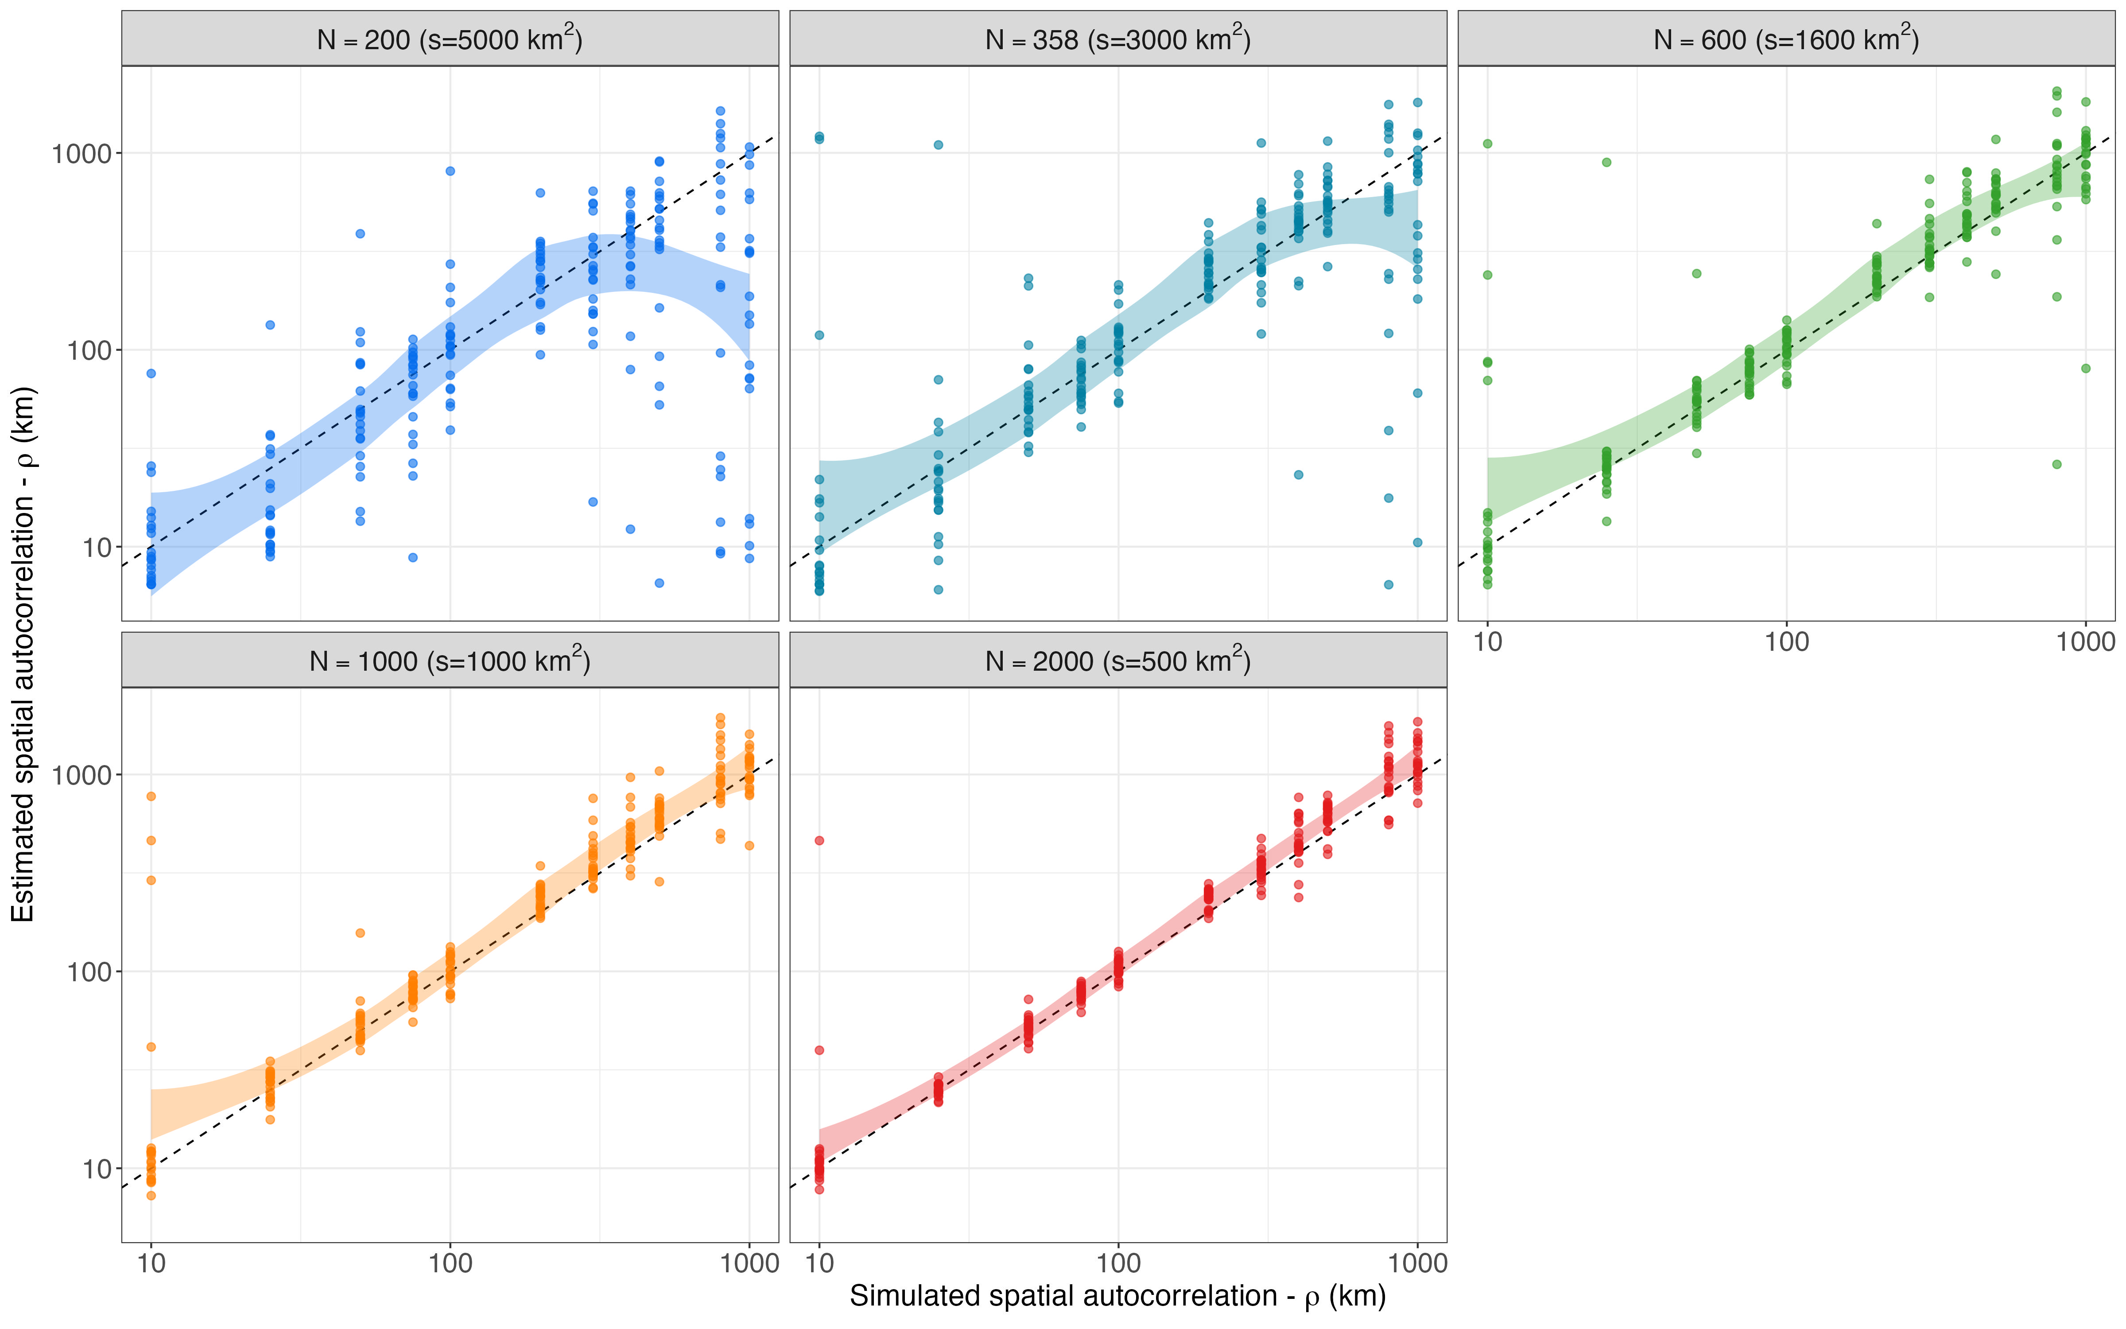
Figure S1: Estimated vs simulated length-scale parameter ($ρ$) across five sampling-effort scenarios. Each panel and color represents a different sampling effort (number of samples) campaign. The dashed line indicates the 1:1 relationship where estimated values equal simulated values and the grey ribbon represents the 95% credible interval around the estimates. The accuracy of spatial autocorrelation estimation decreases with the decreasing sampling effort.

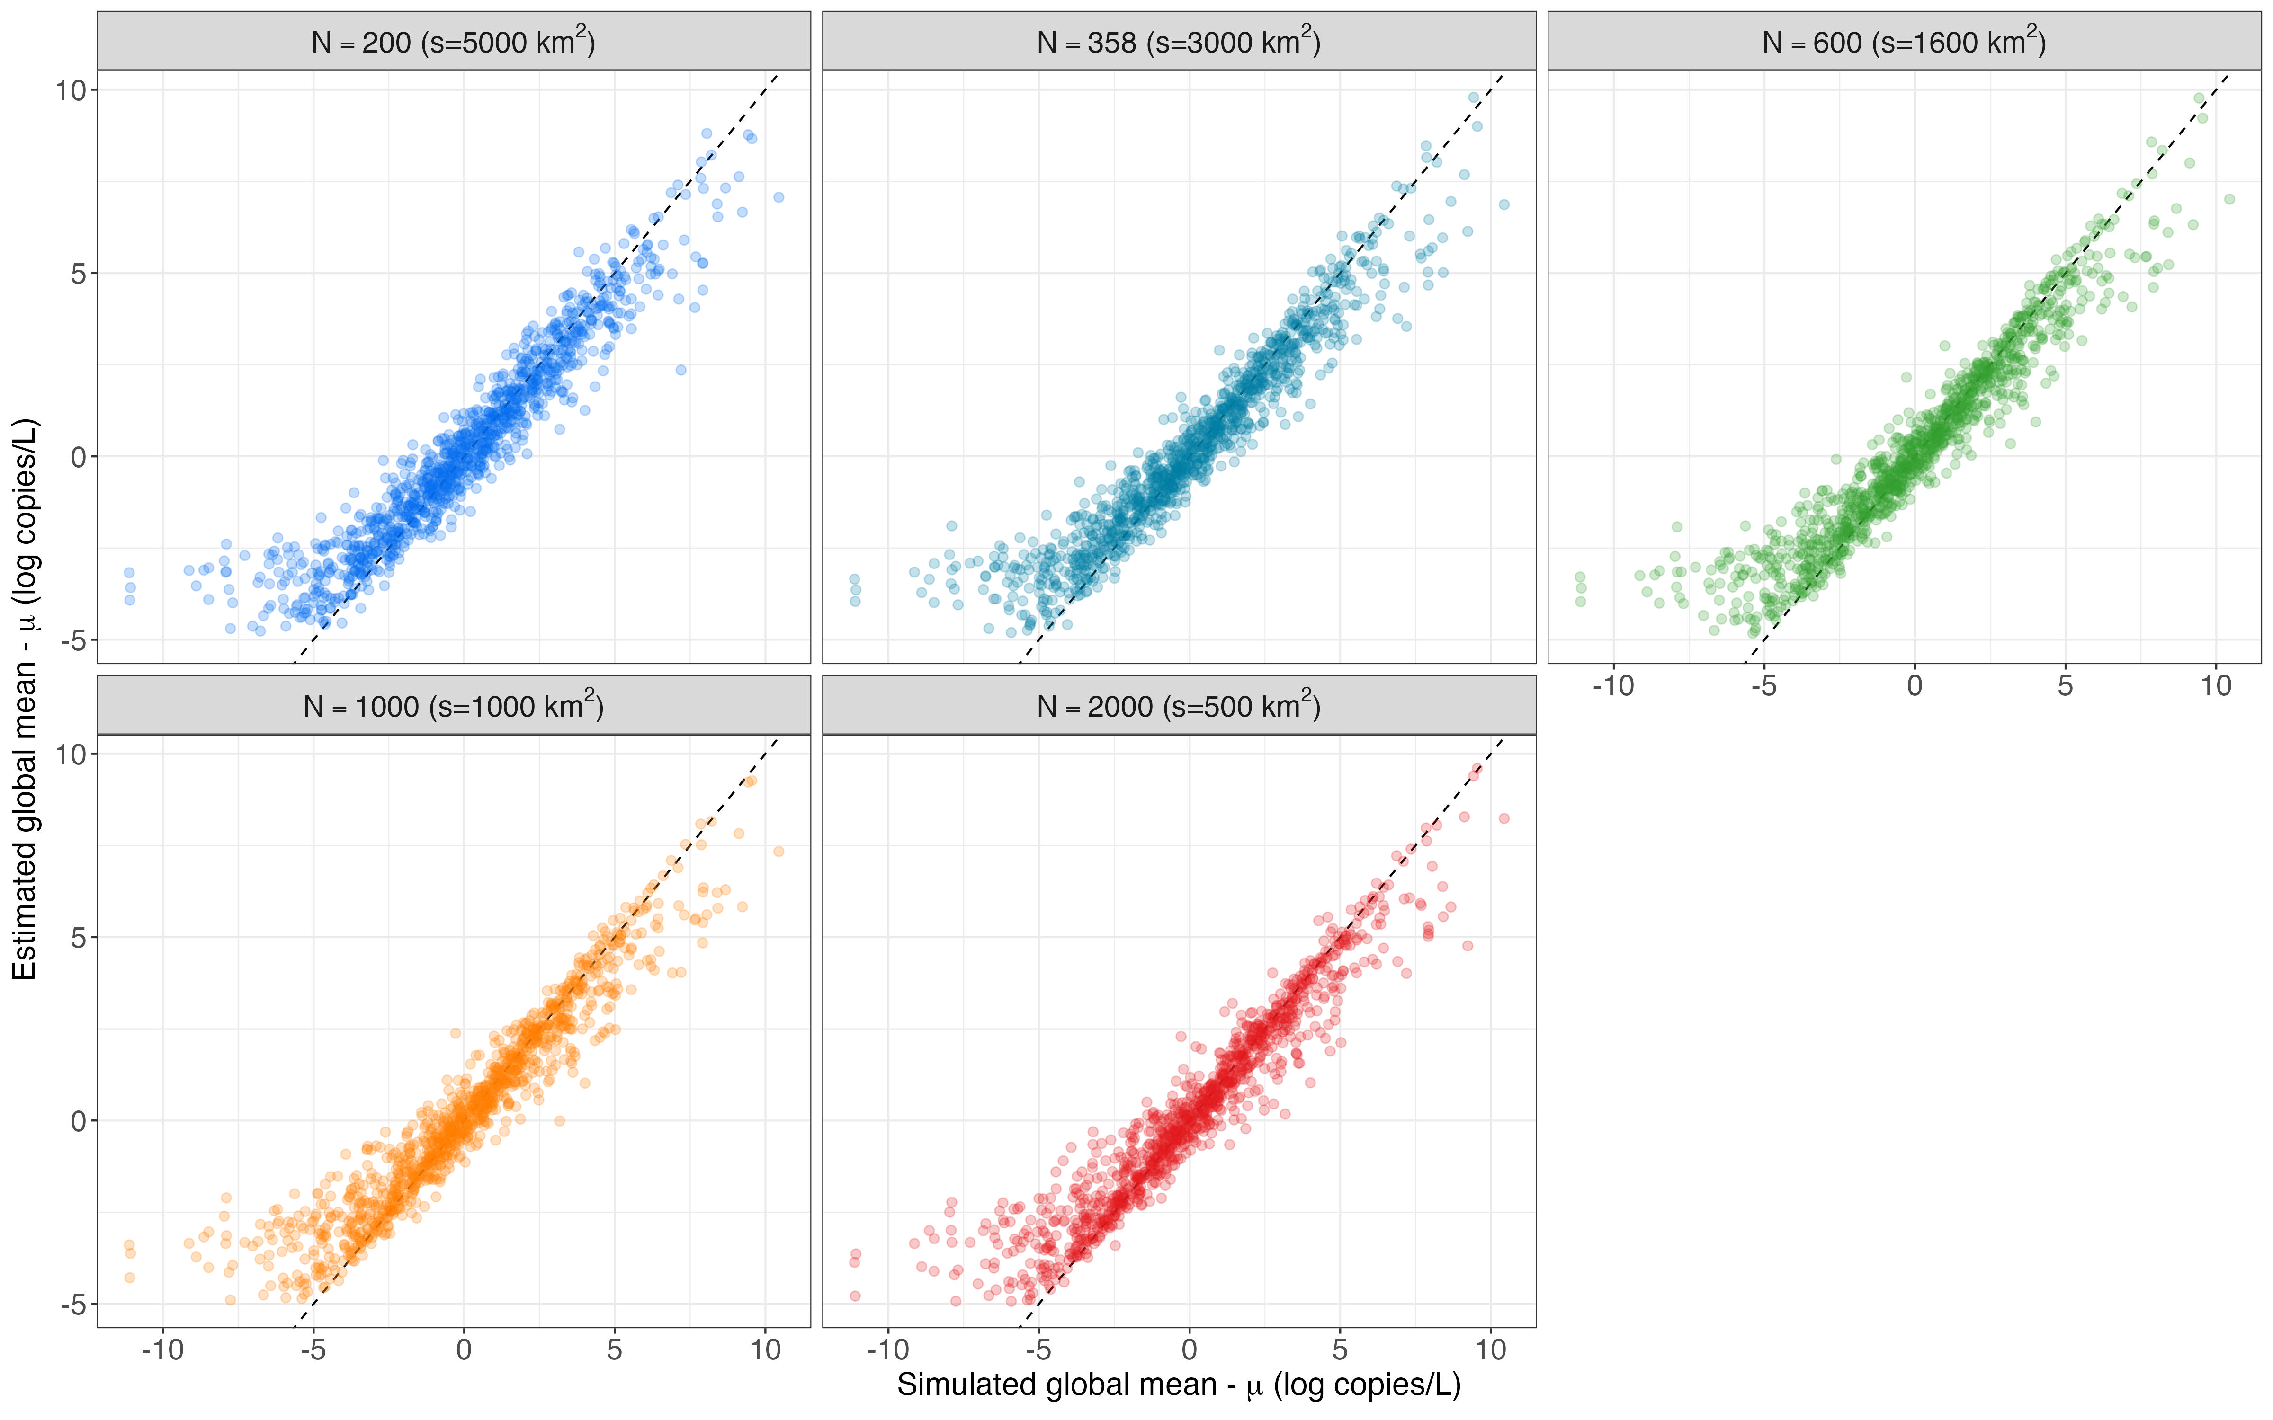
Figure 3: Estimates of global mean parameter ($μ$) across five sampling-effort scenarios. Each panel and color represents a different sampling effort (number of samples) campaign. The dashed line indicates the 1:1 relationship where estimated values equal simulated values. The accuracy of global mean estimation increased slightly with the increasing sampling effort.

Figure 6: Estimation of global mean (μ) across multiple sampling effort and species autocorrelation values (ρ)
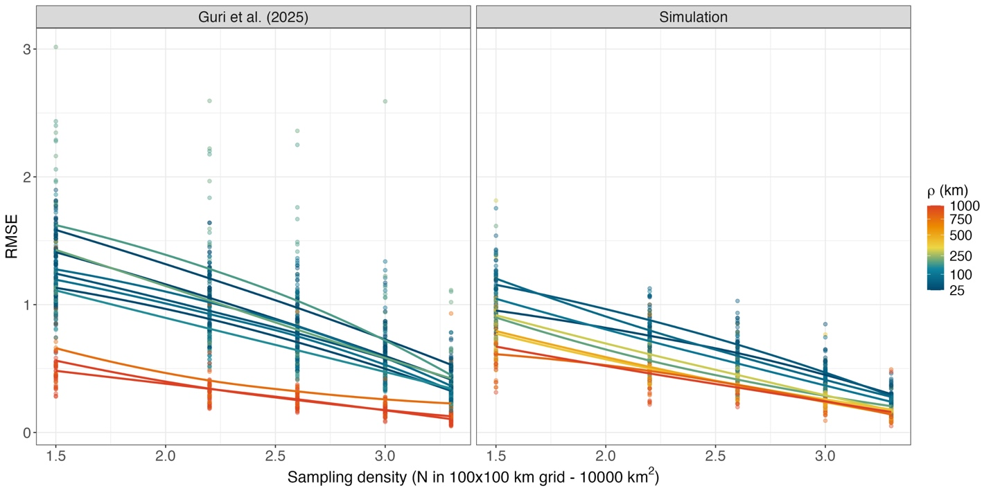
Figure 5: Mean prediction error (ε) across six sampling-effort scenarios (indicated by color) for real-world eDNA data (left panel) and simulated datasets (right panel). In both cases, prediction error increased with decreasing sampling effort and decreasing spatial autocorrelation ($ρ$) up to approximately 100 km. Beyond this threshold—where spatial structure became weak—prediction error plateaued and exhibited increasingly stochastic variation, with minimal sensitivity to further reductions in $ρ$.

References
Blois, S. de. 2020. The 2019 joint u.s.–canada integrated ecosystem and pacific hake acoustic-trawl survey: Cruise report SH-19-06. NMFS-NWFSC-PR-2020-03, U.S. Department of Commerce, NOAA Processed Report.
Callahan, B. J., P. J. McMurdie, M. J. Rosen, A. W. Han, A. J. A. Johnson, and S. P. Holmes. 2016. DADA2: High-resolution sample inference from Illumina amplicon data. Nature Methods 13:581–583.
Carpenter, B., A. Gelman, M. Hoffman, D. Lee, B. Goodrich, M. Betancourt, M. Brubaker, J. Guo, P. Li, and A. Riddell. 2017. Stan: A probabilistic programming language. Journal of Statistical Software 76.
Guri, G., O. R. Liu, R. P. Kelly, M. R. Shaffer, K. M. Parsons, A. Ramón-Laca, K. M. Nichols, P. F. P. Brandão-Dias, A. Wells, and A. O. Shelton. 2025. Quantitative, multispecies monitoring at a continental scale. bioRxiv.
Miya, M., Y. Sato, T. Fukunaga, T. Sado, J. Y. Poulsen, K. Sato, T. Minamoto, S. Yamamoto, H. Yamanaka, H. Araki, M. Kondoh, and W. Iwasaki. 2015. MiFish, a set of universal PCR primers for metabarcoding environmental DNA from fishes: Detection of more than 230 subtropical marine species. Royal Society Open Science 2:150088.
Ramón-Laca, A., A. Wells, and L. Park. 2021. A workflow for the relative quantification of multiple fish species from oceanic water samples using environmental DNA (eDNA) to support large-scale fishery surveys. PLOS ONE 16:e0257773.
Shelton, A. O., A. Ramón-Laca, A. Wells, J. Clemons, D. Chu, B. E. Feist, R. P. Kelly, S. L. Parker-Stetter, R. Thomas, K. M. Nichols, and L. Park. 2022. Environmental DNA provides quantitative estimates of Pacific hake abundance and distribution in the open ocean. Proceedings of the Royal Society B: Biological Sciences 289:20212613.

