Smart eDNA sampling strategies: spatial autocorrelation can guide efficient survey design
Gledis Guri$​^{1}$*, Ryan P. Kelly$​^{1}$, Andrew O. Shelton2$​^{2}*$, Owen R. Liu³, Krista M. Nichols$​^{2}$

1 | School of Marine and Environmental Affairs, University of Washington, Seattle, Washington, USA
2 | Conservation Biology Division, Northwest Fisheries Science Center, NOAA Fisheries, Montlake Blvd E. Seattle, Washington, USA
3 | School of Aquatic and Fishery Sciences, University of Washington, Seattle, Washington, USA
 | corresponding author gguri@uw.edu

Abstract
There is a growing need to define sampling strategies that accurately capture spatial patterns of environmental DNA (eDNA), which has become a powerful tool for biodiversity monitoring. Here, we combine empirical fish eDNA data from the U.S. Pacific coast with a series of simulated sampling scenarios to evaluate how sampling effort in marine eDNA surveys influences the estimation of eDNA concentration and spatial distribution. First, we fitted a Gaussian Process (GP) model for each species to estimate spatial parameters and then used the range of those parameter values to simulate spatial fields representing different degrees of spatial autocorrelation. Second, we simulated sampling from those fields at different densities and used the resulting samples to evaluate prediction error and GP parameter recovery under reduced sampling effort. We then compared these results with empirical eDNA observations from 358 sampling sites. Across both simulated and empirical datasets, prediction accuracy improved with higher spatial autocorrelation and increasing sampling density with the largest marginal gains in accuracy occurring at around 4-9 samples per 10000 km². GP parameter recovery under reduced sampling effort showed very little marginal gains past 6 samples per 10000 km². Our findings show that optimal eDNA sampling effort depends on the spatial structure of the target taxon and the inferential objective of the survey. Rather than supporting a universal sampling threshold, our results provide a quantitative framework for designing cost-effective marine eDNA surveys tailored to prediction, abundance indexing, and spatial ecological inference.

Keywords: eDNA, metabarcoding, fish, spatial, gaussian process, Bayesian

Introduction
Appropriate sampling design plays a critical role in collecting sufficient and representative samples to accurately assess species distributions, forming the foundation for sound fisheries management and stock assessment protocols [ref]. Traditionally, abundance indices used in stock assessments are derived from capture-based surveys, acoustic methods, or visual observations; all of these require a sample size appropriate for reliably estimating population parameters including abundance, demographic structure, and spatial distribution patterns [ref]. This process must balance the need for sufficient data for detecting trends and changes in population while also minimizing cost (i.e., maximizing sampling efficiency) \cite{xu2015} \cite{stein2003}.

The emergence of environmental DNA (eDNA) sampling has revolutionized monitoring capabilities, offering a non-invasive method to detect species presence and estimate relative abundance [ref]. In contrast to traditional survey techniques that are typically species-specific or require separate sampling efforts for different taxa, eDNA enables simultaneous, multi-species detection from a single sample. This holistic approach promises a more comprehensive assessment of community composition while substantially reducing field effort and impacts on sampled organisms \cite{guri2023}. Recent synthesis work shows that eDNA methods have matured sufficiently for key uncertainties to be quantified and incorporated into existing fisheries stock-assessment frameworks, enabling the development of cost-effective abundance indices that complement conventional surveys \cite{baetscher2025} \cite{guri2024a}. Additionally, while conventional methods detect organisms directly at the point of capture or observation, eDNA signals integrate information from surrounding areas through processes of DNA transport and decay (\cite{dias2025} \cite{li2026}). This spatial integration effect means that adjacent eDNA samples may contain overlapping information beyond what would be expected from species distribution patterns alone \cite{guri2024a}. This fact motivates increased consideration of how to design and interpret surveys that collect eDNA.

While increased sampling intensity generally reduces variance in population estimates and improves the precision of spatial pattern detection in species distribution models \cite{schweiger2016}, this relationship exhibits diminishing returns where beyond a certain threshold, additional sampling effort produces marginal gains in statistical precision that may not justify the associated costs and logistical demands \cite{perret2022} \cite{zhao2022}. The optimal sampling effort occurs at the point where incremental improvements in precision or information content become disproportionately small relative to the required investment of resources and effort \cite{thiele2023} \cite{tarugara2019} \cite{zhao2022}. This principle guides the development of cost-effective sampling strategies that maximize analytical power while minimizing operational expenditure \cite{muradian2019}.

Species distribution inferences can be performed with a variety of mathematical frameworks, including spline‑based generalized additive models, hierarchical Bayesian SPDE models fitted via INLA, conventional linear or additive regressions, spatial autoregressive structures, and kernel‑based methods such as Gaussian processes (GP) [ref ref ref ref]. In ecological and fisheries research, Gaussian Process (GP) models have been widely adopted due to their covariance parameters which has clear ecological interpretations and provide a flexible, non‑parametric way to capture spatial and environmental smooths \cite{lewy2009} \cite{nielsen2016}.

This approach is grounded in the assumption that species distributions and abundances change in a smooth and continuous manner across space (or other covariates), reflecting correlated responses to spatial, environmental, and biological covariates \cite{lewy2009}. At the core, in simple terms, GPs posit that observations made at similar locations or under similar covariates should be similar. Generally, the similarity among observations is quantified through a covariance function (or kernel), which governs the covariance change between two points x and x' with increasing distance. Although this distance can be defined in terms of spatial location, environmental covariates, or both, in this study we focus only the spatial covariance. For exponential and squared-exponential covariance functions, a single parameter known as the length-scale controls how correlation changes with distance. Large length-scales correspond with nearby points remaining highly correlated, whereas small length-scales imply a rapid decline in correlation with distance. We assert that many species can be well described using relatively simple covariance models [ref]. Specifically, we use an isotropic, squared exponential covariance model for the distribution of a species. Let X {x₁,x₂,…x_{N}} be the set of N observed spatial locations. The species abundance or density Y across all sampled locations (X) is then modeled as:
$$\begin{aligned}Y∼MVN\left(μ,K+σ^{2}I\right)\#1\end{aligned}$$
where μ is the global mean abundance, σ² is the non-spatial variance, I is an n x n identity matrix and K(X,X) is the covariate matrix whose (i,j)^{th} entry is given by the squared exponential kernel function:
$$\begin{aligned}K(X,X) = k\left(x_{i},x_{j}\right)=α^{2}exp\left(-\frac{(x_{i}-x_{j})^{2}}{2ρ^{2}}\right)\#2\end{aligned}$$
where α² is the amplitude, ρ is the length-scale parameter (in x_{i}-x_{j} units; hereafter spatial autocorrelation). Species with small spatial autocorrelation (ρ) values exhibit abundance patterns that vary sharply across space (Figure 1). Conversely, species with large $ρ$ values display smoothly varying abundances that remain correlated over broader spatial and environmental scales (Figure 1).

Therefore, we posit that knowledge of species-specific spatial autocorrelation can provide a quantitative basis for informing sampling effort. Specifically, species with high spatial autocorrelation should require fewer samples to capture their distribution patterns due to their extended spatial coherence (Figure 1) and vice-versa. Hence, in this study, we aim to assess how species spatial autocorrelation influences the efficiency of eDNA metabarcoding marine sampling strategies. We use both simulated and empirical eDNA data for species that differ in their patterns of spatial distributions to quantify the effect of species spatial autocorrelation and sampling effort on estimating (i) the predictive accuracy of species distribution models and (ii) the accuracy of GP parameter estimation. Although the Gaussian Process (GP) framework can incorporate a wide array of covariates, i.e., temperature, salinity, bathymetry, and biotic interactions, this study focuses exclusively on spatial coordinates. By explicitly quantifying the trade-off between spatial autocorrelation, sampling effort, and prediction accuracy, we can identify thresholds of sampling effort that maximize information gain and minimize redundancy - offering a principled, quantitative foundation for designing efficient eDNA surveys.

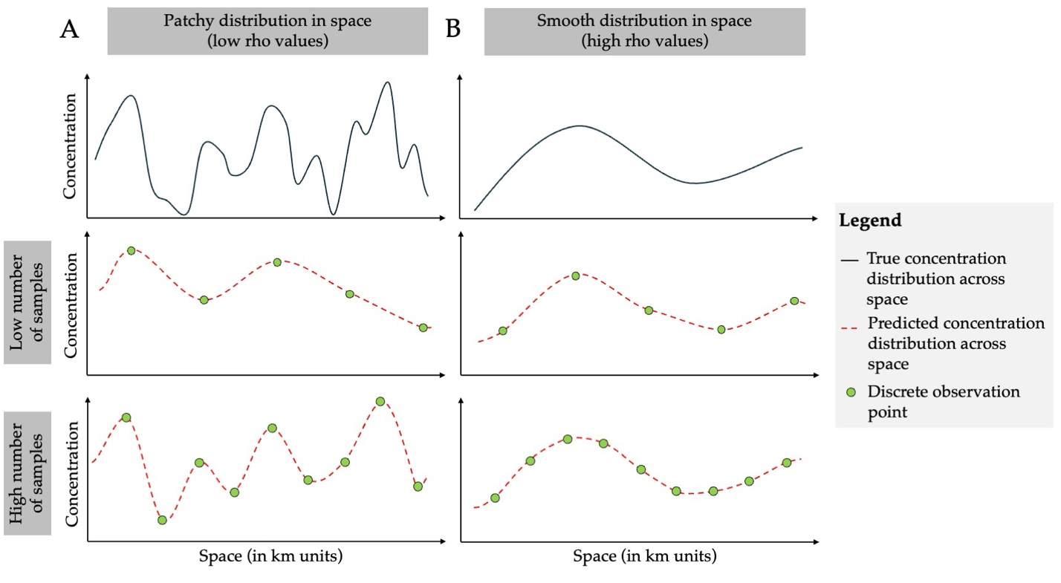
Figure 1. Conceptual figure illustrating how sampling density affects reconstruction of spatial concentration patterns across different spatial structures. Panel A shows a patchy species distribution in space, whereas panel B shows a smooth distribution in space, along a one-dimensional spatial transect (x-axis; space in km units). In the top row of each panel, the solid black line represents the true underlying concentration distribution whereas the middle and bottom rows show reconstructions of concentration distribution (red dashed line) based on a low number of samples and a high number of samples, respectively. Green circles indicate discrete observation points. The figure highlights conceptually that excessive sampling can lead to redundant data (multiple samples that give the exact same information, thus wasting time and money) whereas insufficient sampling risks overlooking critical patterns and producing unreliable estimates.

Materials and methods
In short, we evaluated how sampling effort influences the recovery of marine eDNA spatial patterns by integrating empirical observations with simulation-based analyses within a common Gaussian Process (GP) framework. We first analyzed a real-world eDNA metabarcoding dataset collected across 358 stations and five depth strata along the U.S. West Coast to characterize species-specific spatial structure and depth-specific mean eDNA concentration patterns. We then used the range of parameter values informed by these empirical estimates to simulate new spatial eDNA fields across the same study domain, but at a much higher sampling resolution than was available in the field dataset. For both empirical and simulated data, we evaluated how reduced sampling effort affected spatial prediction accuracy and the recovery of GP parameters through systematic thinning analyses. By combining empirical and simulation-based evaluation, this framework allowed us to assess sampling efficiency beyond the limits of the empirical dataset alone (restricted to 358 observations) and thus to evaluate the sampling effort required for reliable inference across a broader range of effort.

Empirical eDNA data
Environmental DNA samples were collected during the Joint U.S.-Canada Integrated Ecosystem and Pacific Hake Acoustic-Trawl Survey aboard the NOAA ship Bell M. Shimada in summer 2019 (de Blois 2020). Sampling spanned a broad latitudinal and longitudinal gradient along the U.S. West Coast, extending from 123.53° to 125.93° W (243–461 km UTM eastings; span = 218 km) and from 38.36° - 48.46° N (4249 - 5367 km UTM northings; range 1118 km), corresponding to a region from central California to northern Washington. At each site, seawater (10 L) was collected using Niskin bottles mounted on a CTD rosette system, targeting five depths (0, 50, 150, 300, and 500 m). From each bottle, 2.5 L of seawater was immediately filtered onboard through sterile 47 mm mixed cellulose ester filters (1 $μ$m pore size) to capture suspended eDNA. Filters were preserved and DNA was extracted using a phase-lock phenol-chloroform protocol, following established methods (Ramón-Laca et al. 2021, Shelton et al. 2022).

Samples underwent PCR amplification using the MiFish U universal primer set (Miya et al. 2015), targeting a 170 bp fragment of the mitochondrial 12S rRNA gene and thereafter sequenced on an Illumina MiSeq platform (2x150 bp paired-end) at the University of Washington Genomics Core. Raw sequence reads were processed using the DADA2 pipeline (Callahan et al. 2016) to generate amplicon sequence variants (ASVs), which were taxonomically assigned using a custom reference database from NCBI GenBank and BOLD Systems. The same set of samples were used to estimate hake eDNA concentration using qPCR (see more Guri et al 2026). Species-specific eDNA concentrations were estimated by jointly modeling ASV read counts, a mock community to correct for amplification bias, and qPCR measurements of Pacific hake to estimate absolute eDNA abundance for 12 fish species (Guri et al. 2026, Guri et al 2024). The final empirical dataset included eDNA measurements (in log copies/L) from 358 spatially distributed sampling among the reported depth layers.

Estimation of species-specific spatial structure
After the acquisition of the empirical data, we obtained eDNA concentration values (Y) paired with spatial coordinates (X) for each sampling location (x; N = 358). We then used the GP model (Eq. 1–2) to infer the underlying spatial structure and learn key parameters governing the spatial field, including the depth-specific mean (μ_{d}), spatial autocorrelation (ρ), amplitude (α²), and non-spatial variance (σ²). Additionally, we used to the model predict eDNA concentrations (Z) across the full spatial grid (Q) using Eq 3. We defined this grid (Q), as 18,916 discrete points estimates, representing the centroids of approximately 8 × 8 km spatial cells distributed across five depth layers. The number of points differed among depth layers (4,000, 4,000, 4,000, 3,622, and 3,294 points, respectively) because deeper layers covered a smaller spatial extent than shallower layers due to bathymetry.

Specifically, for a given depth d, the model computes the covariance matrix among observed locations, K(X,X), using the squared exponential kernel and additionally adds the non-spatial variance term (σ²I). Using the Cholesky decomposition we solved for (K(X,X) + σ²I)⁻¹(Y - μ_{d}) and we combined it with the cross-covariance between observed and prediction points, K(X,Q), to yield the predictions at each given spatial point (Q):
$$\begin{aligned}Z=μ_{d}+K(X,Q)^{⊤}(K(X,X)+σ^{2}I)^{-1}(Y-μ_{d})\#3\end{aligned}$$

Estimating sampling efficiency on prediction accuracy
To evaluate how sampling effort (E) influences spatial reconstruction and prediction accuracy, we generated a series of reduced-effort observation datasets (Y_{E} coupled with X_{E}) by randomly thinning the observation set (Y) and its spatial covariate (X_{E}) to fixed sample sizes (N = 330, 300, 260, 220, and 150). Each reduced-effort observation dataset (Y_{E}) together with its covariate (X_{E}) was refit with the same GP model (Eq 1-2) and produced effort-specific spatial predictions (S_{E}) on the full grid Q, by substituting S_{E} with Z, Y_{E} with Y and X_{E} with X in Eq. 3. This framework enables direct, like-for-like comparisons of reconstructed fields across sampling intensities since the predicted filed is the same (Q). Sampling effort (E) was quantified as sampling density:
$$\begin{aligned}E=\frac{N}{A×H}×10000\#4\end{aligned}$$
where A is the spatial area of the study domain (200,000 km²), and H is the number of depth layers (d) included in this study (H=5), yielding E in units of samples per 10,000 km² per depth layer.

For each model prediction, we calculated the prediction error (ε_{1E}), defined as the root mean squared error between spatial fields predicted from the full dataset (Z) and those predicted from each reduced sampling scenario (S_{E}) as follows:
$$\begin{aligned}\begin{aligned}ε_{1E}&=\sqrt{\frac{1}{n}\sum_{i=1}^{n}{{\left(Z_{i}-S_{iE}\right)}^{2}}}\end{aligned}\#5\end{aligned}$$
with $n$ being the total number of Q grid points (n = 18,916) where the predictions (Z and S_{E}) are projected. This process was computed 20 times for each thinning intensity mitigate the effects of sampling stochasticity on our prediction accuracy estimates.

Simulated eDNA data
To extend inference beyond the sampling effort limitations (N = 358) of the empirical dataset, we conducted a series of simulations. We generated in-silico eDNA concentration data using the GP model (Eq. 1-2) across the same spatial domain and prediction grid (Q) used in the empirical analysis.

The simulations were designed to explore a wide range of spatial structures by varying the GP length-scale parameter (ρ) across ten levels: 25, 50, 75, 100, 200, 300, 400, 500, 800, and 1000 km. These values were selected to represent differing degrees of spatial autocorrelation observed in empirical data. For each value of ρ we generated 20 independent replicate spatial fields, resulting in a total of 200 simulated datasets (10 $ρ$ levels × 20 replicates). Similar to empirical data, within each simulation, ρ was held constant across depth layers, while each depth had a separate mean (μ_{d}) drawn randomly from a normal distribution with mean of 0 and a standard deviation of 3. This assumption was made because we focused only on horizontal spatial autocorrelation, thus allowing the eDNA concentration at each depth to be independent. Although incorporating dependence among depths may better reflect ecological structure, doing so would substantially increase model complexity and make the results more difficult to interpret. The amplitude (α²) and the non-spatial variance (σ²) in Eq. 1 and 2 were fixed at 4 and 3 respectively based on parameters estimates in the empirical data.

Such parameterization was chosen to approximate empirical eDNA patterns, where species are assumed to exhibit a single underlying spatial autocorrelation structure (ρ) across depths, while allowing depth-specific mean differences in eDNA concentration. Fixing (α²) and (σ²) reflects the assumption that amplitude and residual variability are primarily driven by method-specific measurement uncertainty and therefore remain constant among species when the same sampling and analytical methods are applied.

Given the large number of in-silico eDNA points (Q), fitting a GP model using all locations (≈ 20,000 input values) was computationally prohibitive. To overcome this, we established a baseline for our analysis by randomly selecting a representative subset of 4,000 sampling points from each of the 200 simulated datasets. This subset served as the “complete” observation dataset (Y) and its covariate (X) for each simulation run. Following a procedure identical to that used for the empirical data, we first fit the GP model (Eq. 1–2) to each complete simulated dataset (Y) and covariate (X) to infer its governing parameters (μ_{d}, ρ, α², and σ²) and thereafter predict eDNA concentrations (Z) across the full spatial grid (Q) using Eq. 3. This prediction (Z) served as the “true” spatial field against which all subsequent reduced-effort predictions were compared.

To evaluate how sampling effort influences prediction accuracy on the simulated data, we generated a series of reduced-effort observation datasets (Y_{E}) and covariates (X_{E}) by randomly thinning each complete set (Y) and its covariate (X) to progressively smaller sample sizes (N = 2000, 1000, 600, 358, 330, 300, 260, 220, and 150). Following the same procedure used for the empirical data, we fit the GP model (Eq. 1-3) to estimate the governing parameters and generate an effort-specific spatial prediction (S_{E}) on the full spatial grid (Q). We then quantified the prediction error (ε_{2E}) for each scenario by calculating the root mean squared error between the “true” field (Z) and the reduced-effort field (S_{E}), as defined in Eq. 5. This approach allowed us to directly assess the interplay between sampling density, spatial autocorrelation, and the ability to accurately reconstruct the underlying eDNA field.

Additionally, to evaluate the influence of sampling effort on GP parameter estimation, we compared the estimated parameters (ρ, μ_{d}, σ², α²) from effort-specific datasets (Y_{E}) and covariate (X_{E}) to the true values used to generate the simulated fields. Differences between estimated and simulated parameter values were quantified using the root mean squared error (hereafter τ). This allowed us to quantify how reliably different sampling effort (E) recovered the underlying governing parameters of GP models.

Regression analysis of prediction error
After quantifying prediction error for the empirical and simulated datasets, we next asked how the two key drivers (i.e., sampling effort and spatial autocorrelation) jointly shape that error. By fitting a simple log‑linear model to each dataset separately (ε₁ and ε₂ respectively for empirical and simulation), we were able to isolate the individual contributions of each factor and compare between the two data. This analysis provides a quantitative estimate between effort, autocorrelation parameter and prediction accuracy.

We modeled prediction error (ε) as a function of sampling density (E) and spatial autocorrelation (ρ), including their interaction as follows:
$$\begin{aligned}log\left(ε\right)=ω+β log\left(E\right)+θ log\left(ρ\right)+γ log\left(E\right)log\left(ρ\right)\#6\end{aligned}$$
where ω is the intercept, β slope of sampling density (E), θ is the slope of spatial autocorrelation (ρ) and γ is the coefficient on the interaction between the two latter factors.

Comparison of prediction accuracy between empirical and simulations
Due to the gap in sampling effort between field data and simulation datasets, prediction accuracy was benchmarked at different sampling effort. The empirical benchmark (ε₁) was determined by the sampling effort of N = 358, while the simulation accuracy (ε₂) was benchmarked against a much larger set of sampling effort N = 4,000 samples. Consequently, prediction accuracy ε₁ in the empirical and ε₂ in the simulation datasets was evaluated against different reference benchmarks and is therefore not directly comparable. Moreover, the empirical dataset could not be used to evaluate prediction accuracy at sampling efforts greater than.

As a result, to enable a like-for-like comparison between simulated and empirical results, we performed a secondary thinning analysis and prediction accuracy estimation (ε₃) in which the benchmark was redefined to match empirical sampling effort (N = 358). Specifically, for each simulated scenario and iteration we used the subsample of size N=358 (Y ←Y_{E=358} and covariance X ←X_{E=358}) and treated this dataset as the reference observation set (benchmark). We then generated the corresponding prediction Z ← S_{E=358} on Q, using Eq. 3. From this generated baseline (Z), we compared the predictions (S_{E}) of the sampling-effort datasets (Y_{E}; E = 330, 300, 260, 220, and 150) to both the simulated and empirical datasets, refit the GP model at each effort, and computed effort-specific (ε₃) prediction errors by comparing each S_{E} to the matched reference field Z (derived from S_{E=358}). Furthermore, we fitted the prediction accuracy (ε₃) as a function of sampling effort (E) and spatial autocorrelation (ρ) using Eq. 6 (similarly to empirical data). We then compared the estimated model coefficients of prediction accuracy between the simulated and empirical to assess whether similar patterns were observed.

All the GP models (equation 1 and 2) were fitted in a Bayesian framework using Stan probabilistic programming language (Carpenter et al. 2017). We used weakly informative priors (Table 1) to allow the data to primarily inform the posterior distributions of the parameters. For each GP model in Stan, we ran four parallel chains with 2,000 iterations each, discarding the first 1,000 iterations as burn-in. Convergence was assessed using $\hat{R}$ values, where values below 1.01 indicated satisfactory convergence and effective sample size (ESS) above 200. The model in Eq. 6 was fitted using linear models using lm() function in R (R Core Team, 2024), with log prediction error as the response variable and log-transformed sampling density and spatial autocorrelation as predictors.

Gaussian Process model parameters and their prior distributions used in Bayesian inference.
Parameter | Prior | Range
 |  | Min | Max
α² | $$N(4,1)$$ | 0 | +$∞$
μ | $$N(0,5)$$ | -5 | +$∞$
log(ρ) | $$N(0,1)$$ | -5 | +$∞$
σ² | $$N(0,1)$$ | 0 | +$∞$
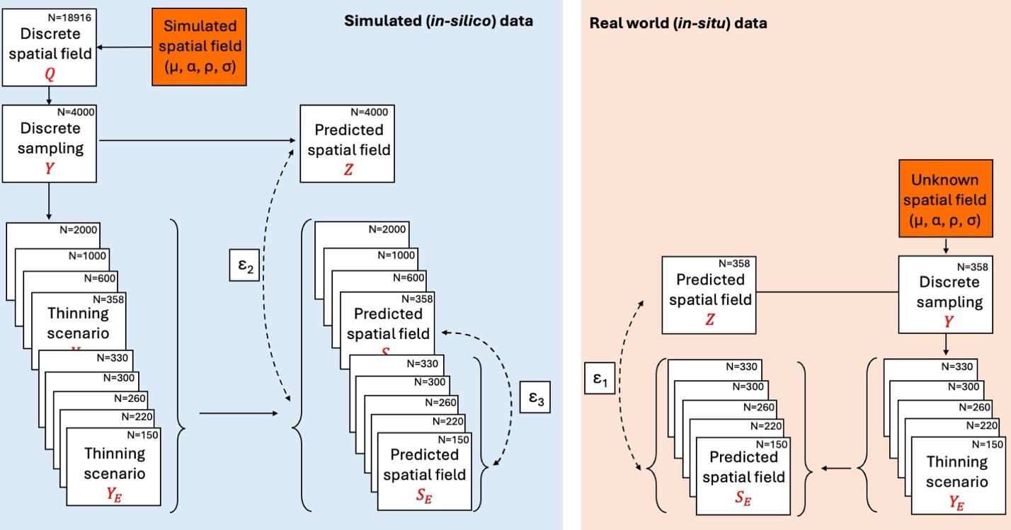
Figure 2. Workflow for evaluating sampling‐density effects on spatial field reconstruction in simulated (in-silico) and empirical (in-situ) data. A spatial field is generated (blue, in-silico data) from known parameters (μ, ρ, σ) and represented on a discrete grid (Q, N=18,916). A reference sampling set (Y, N=4000) is used to fit a GP model and generate a predicted field (Z), which serves as the reference reconstruction. The prediction error (ε₂) is defined as the difference between Z field and the progressively reduced using thinning designs (Y_{E}) reconstructed field. To enable a like-for-like comparison with the in-situ data, a secondary baseline using N=358 samples is defined to produce a reference prediction S_{E=358}, and prediction error (ε₃) is calculated as the difference between S_{E=358} and reconstructions obtained from further thinned datasets (Y_{E}). On the right (pink, real-world data), the underlying spatial field is unknown but assumed to arise from unknown parameters (μ, ρ, and σ). Using the full observed dataset (Y, N=358), a baseline predicted field (Z) is obtained. The observed samples are then thinned using the same Y_{E} designs, re-fit, and used to generate predicted fields S_{E}. Deviations of thinned predictions from the baseline prediction quantify ε₁, representing the expected information loss when sampling density is reduced in empirical settings.

Results

Empirical data
Across species, depth-specific global mean eDNA concentrations generally declined with increasing sampling depth (Figure 1). Species-specific length-scale estimates revealed some depth-associated spatial structure. Surface-dwelling species were characterized by shorter spatial autocorrelation (Figure 1A) and showed pronounced differences between surface and deep mean eDNA concentrations (μ; Figure 1B). In contrast, deep-dwelling species exhibited longer spatial autocorrelations (Figure 1A), and relatively stable mean eDNA concentrations (μ) across depth strata. Together, these patterns suggest that surface-associated species are more spatially heterogeneous, whereas deeper-distributed species display increasingly homogeneous.

Across species, α² ranged from 2.3 to 4.2, whereas the GP non-spatial variance σ² spanned from 1.5 to 4.5. Surface-associated taxa generally exhibited slightly higher σ² than bottom-associated taxa, indicating greater process variance of the inferred eDNA fields. This pattern may partly reflect a mean–variance relationship, as surface taxa showed higher mean eDNA concentrations or alternatively, differences in σ² are linked to the spatial autocorrelation parameter ρ.
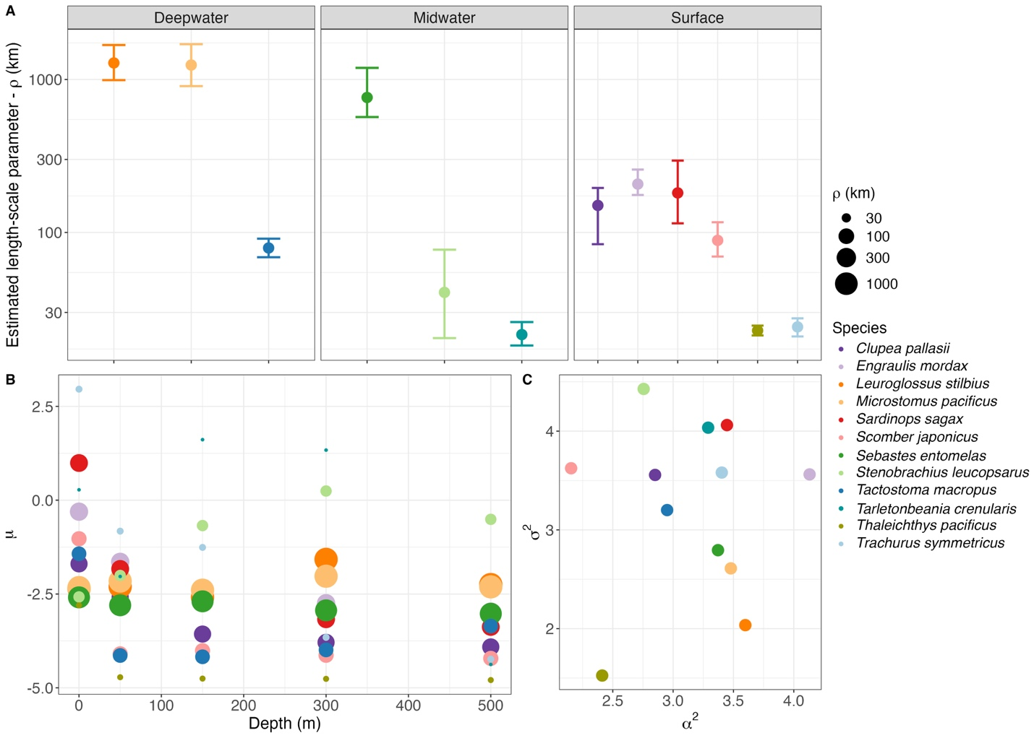
Figure 3: Species-specific Gaussian Process parameter estimates of empirical data. (A) Estimated spatial autocorrelation parameter (ρ in km) for each species (indicated in colors) across the three major depth strata defined from the literature (surface, midwater, and deepwater). Points indicate posterior mean estimates and bars denote 95% confidence intervals. Depth-specific (0, 50, 100, 300, and 500 m) relationship between species spatial autocorrelation (ρ in km shown as the size of the points) and mean eDNA concentrations (in log concentration/L) across species (colors) in panel B. Panel C indicating the signal amplitude (α²) relation between non-spatial variance (σ²) and species spatial autocorrelation (ρ in km shown as the size of the points).

Prediction accuracy on empirical data
Prediction error in empirical data decreased with increasing sampling density across all species (Supplementary Figure S1 and S2). However, this reduction was strongly modulated by the degree of spatial autocorrelation (Supplementary Figure S2). Species characterized by short spatial autocorrelation (small ρ values) consistently exhibited higher prediction error (ε₁) across all sampling densities, whereas species with wider spatial autocorrelation structures (e.g., ρ > 500 km) showed substantially lower prediction errors (ε₁) even under comparatively sparse sampling regimes. Although increased sampling effort reduced error for all species (with varying degrees of spatial autocorrelation), patchily distributed taxa retained a persistently higher prediction error (ε₁).

Simulations
Prediction error in simulation data (ε₂) decreased non-linearly with increasing sampling effort and with higher spatial autocorrelation (Figure 3A). These patterns were supported by a log–log linear model where the prediction error (ε) decreased exponentially for every exponential increase in sampling density (β = -0.176) and spatial autocorrelation (θ = -0.228), with an additional negative interaction (γ = -0.0684) and with an intercept of ω = 1.65 (i.e., ε = 5.2 when E and ρ = 1). For instance, at a sampling intensity of 6 samples per 10,000 km², species with spatial autocorrelation values of 50 = km had mean prediction errors of 1 (Figure 3A) indicating that on average every point predicted the eDNA concentration will differ from the predicted true concentration (Z) by a factor of 2.72 (for perspective a concentration of 100 copies/L will be predicted between 37-270 copies/L; Supplementary Figure S3). In contrast, for the same sampling effort (i.e., 6 samples per 10,000 km²) but species with spatial autocorrelation ρ > 500 km had errors below 0.4 indicating an average of over- and underestimation by a factor of 1.5 (for perspective a concentration of 100 copies/L will be predicted between 67-150 copies/L; Supplementary Figure S3). When quantifying the marginal reduction in prediction error (Δε₂) across successive increases in sampling density (ΔE), improvements were greatest at low sampling effort and declined rapidly with additional sampling, with Δε₂ approaching zero at higher sampling densities (Figure 3B). Marginal gains effectively plateaued when sampling effort increased above 10 samples per 10,000 km², depending on the ρ (Figure 3B). For interpretation, a Δε₂ of -0.4 indicates that adding one sample per 10,000 km² improves expected predictive accuracy from 37–270 copies/L to 55–182 copies/L when the predicted true concentration (Z) is 100 copies/L respectively. Importantly, diagnostic checks revealed no systematic bias in the predictions, so the observed variation reflects pure precision, (Supplementary Figure S4). For interpretative purposes, we adopt an arbitrary threshold of Δε₂/ΔE = -0.05 to denote negligible marginal gains. However, this value is arbitrary and may be redefined according to study-specific accuracy requirements.
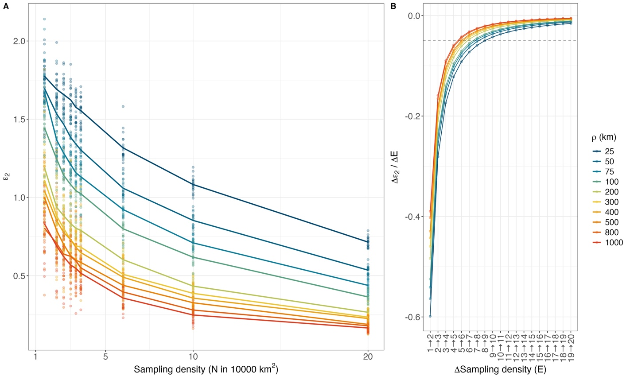
Figure 4: Estimated prediction error (ε₂) across sampling-effort scenarios (E; indicated by sampling density in 100x100 km grid) for simulated datasets (A) across various spatial autocorrelation values (indicated in colors). Points represent individual simulation outcomes, while solid lines denote the corresponding mean trends across replicates. Marginal improvement (B) in prediction performance (quantified as the change in error - Δε₂) across successive increases in sampling densities (ΔE = 1). Due to the discrete intervals of sampling effort in simulations, the lines in panel B are predicted form the fitted model in Eq. 6 (see Supplementary Figure for model fit diagnostics). The dashed line indicates the arbitrary threshold (Δε₂ /ΔE = -0.05) at which additional sampling effort yields negligible improvements in prediction accuracy.

GP parameter recovery
Sampling effort and spatial autocorrelation strongly influenced the ability of the GP model to recover the parameters used to generate the simulated spatial fields (Figure 6). Estimation error for the depth-specific mean (μ_{d}) decreased with increasing sampling density for simulated fields with small spatial autocorrelation but showed the opposite pattern for fields with large spatial ranges (Figure 5A). Specifically, τ (root mean squared error between estimated and simulated) for μ_{d} increased with sampling effort when spatial autocorrelation exceeded 400 km, indicating that mean estimates became increasingly biased in highly spatially structured fields. Additionally, the recovery of the spatial autocorrelation length-scale (ρ) was highly sensitive to sampling density (Figure 5B). At low sampling effort (E < 4), estimates of ρ showed substantial error, particularly for simulations with large spatial ranges. However, estimation accuracy improved rapidly as sampling effort increased, with τ declining sharply and stabilizing once sampling densities were higher than 6 samples per 10,000 km², beyond which additional sampling produced only marginal improvements in ρ estimation.

Estimation error for the amplitude parameter (α²) declined with increasing sampling density for simulations with small spatial autocorrelation, while remaining relatively stable across sampling densities for simulations with larger spatial ranges (Figure 5C). Overall improvements in α² estimation were therefore limited once sampling effort increased above 6 samples per 10,000 km². The process noise parameter (σ²) was consistently well recovered across sampling densities (Figure 5D). τ declined sharply with increasing sampling density and approached near-zero values once sampling densities exceeded 6 samples per 10,000 km².
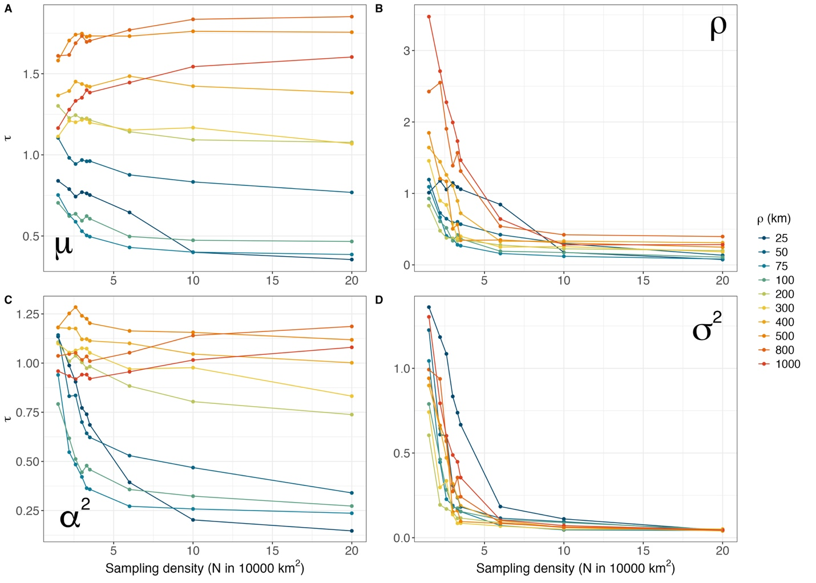
Figure 5. Accuracy of Gaussian Process (GP) parameter estimation across sampling effort (E; expressed in sampling density) and spatial autocorrelation values (ρ) from simulation data. Each dot represents the mean of root mean squared error (τ) across 20 simulation iterations of the difference between estimated and true parameter values for (A) depth-specific mean (μ_{d}), (B) spatial autocorrelation (ρ), (C) amplitude (α²), and (D) non-spatial variance (σ²). Lines represent the regression of mean τ across sampling effort for each spatial autocorrelation level. Sampling density is expressed as the number of samples per 10,000 km² (100 × 100 km grid).

Comparison of prediction accuracy between empirical and simulation data
Prediction error (ε) followed similar patterns using both empirical and simulation datasets. Specifically, the estimated intercept (ω), the influence of sampling effort (β), the effect of spatial autocorrelation (θ), and their interaction term (γ) all showed consistent directional effects and aligned closely with the 1:1 line, demonstrating a high degree of structural agreement between the empirical and simulated error models (Supplementary Figure S1). Overall, the close correspondence between coefficients derived from the in-silico and in-situ datasets indicates that the simulation framework successfully reproduced the primary relationships between prediction error, sampling effort, and spatial autocorrelation observed in the real-world data (Supplementary Figure S1).

Discussion
This study provides quantitative evidence how species-specific spatial autocorrelation governs the efficiency of marine eDNA spatial surveys for spatial distribution predictions. Through the integration of empirical observations from 358 sampling stations along the U.S. West Coast and simulation-based analyses spanning a wide range of spatial autocorrelation scenarios, we demonstrate that optimal sampling effort is not universal but depends critically on both the spatial autocorrelation of target species and the specific inferential objectives of the survey.

Diminishing returns of sampling effort on prediction accuracy
A central finding of this study, in par with other studies, is that the value of additional sampling effort is not fixed but depends strongly on the spatial structure of the target species (\cite{zhao2022}\cite{xu2015}). Across simulations and empirical data, prediction error decreased non-linearly with increasing sampling effort, while simultaneously declining as spatial autocorrelation increased, indicating that species with more homogenous distributions are inherently easier to reconstruct than patchier species at the same effort level. The interaction between sampling effort and spatial autocorrelation is particularly critical because it demonstrates that the value of additional samples is not universal in ecology, where the same increase in effort can produce substantial gains for one species and only marginal gains for another. Here, our results move beyond a general statement of sampling efficiency and provide a quantitative framework for understanding when additional effort is informative and when it yields diminishing returns.

Crucially, the decision of the sampling effort based on prediction accuracy (ε₂) cannot be reduced to a single universal number, as it depends heavily on both the acceptable margin of error and the spatial autocorrelation of the target organism. Our adopted threshold for negligible marginal gains (Δε₂ = -0.05) serves as a practical heuristic, but acceptable error is inherently context dependent. For instance, studies requiring high-resolution quantitative estimates might justify high sampling effort to achieve stricter precision, while, broad-scale biodiversity screenings might tolerate looser precision, allowing for even sparser sampling. Moreover, the species spatial autocorrelation parameter plays an additional role on defining the decision on sampling effort. Highly autocorrelated species (e.g., ρ > 500 km) reach the precision threshold of negligible improvement at much lower sampling densities (roughly 4 to 5 samples per 10,000 km²), conversely, patchily distributed species (ρ < 50 km) require a denser sampling network (roughly 8 to 11 samples per 10,000 km²) before the marginal gains drop below the threshold. Ultimately, the framework presented here reduces the sampling design problem to two key inputs: the level of predictive certainty required for the study objective (expressed as ε₂), and the spatial autocorrelation of the target species (ρ). Once these parameters are quantified - through prior literature, pilot sampling, or expert knowledge, the log-log model ε = e^{ω}E^{β}ρ^{θ}(Eρ)^{γ} (from Eq. 6) can be inverted to solve for the minimum sampling density E required to keep Δε below the chosen threshold.

Applying our simulation-derived thresholds to our empirical data further illustrates this context dependency. Extrapolating the findings from the simulations, species such as Leuroglossus stilbius and Microstomus pacificus (high spatial autocorrelations) would require only 4 samples per 10,000 km² to achieve a negligible marginal gain in precision (defined here arbitrary as Δε = -0.05). In contrast such as Trachurus symmetricus, Thaleichthys pacificus, Stenobrachius leucopsarus, and Tarletonbeania crenularis (low spatial autocorrelation) would require approximately 9 samples per 10,000 km² to reach the same relative threshold. Notably, the sampling effort required to adequately capture these patchily distributed taxa is more than double the effort needed for smoother distributed species. The remaining species fall within the range of 4-9 samples per 10,000 km², consistent with their intermediate spatial autocorrelation values. These results highlight that no single sampling strategy is universally appropriate, as optimal effort is inherently species- and context-specific.

Depth-dependent patterns
Across species, depth-specific mean eDNA concentrations generally declined with depth, while species-specific spatial length scales revealed a contrast between surface- and deep-associated taxa. Surface-associated species tended to have shorter length scales (lower spatial autocorrelation) and larger surface-deep differences in mean concentration, whereas deep-associated species showed longer length scales and more stable means across depth strata. Ecologically, this pattern is consistent with greater spatial heterogeneity in surface waters driven by stronger horizontal gradients, mixing, productivity hotspots, and advective transport, while deeper layers may be more spatially structured and comparatively homogeneous at the regional scale. From a sampling-efficiency perspective, this implies that surface-focused monitoring may require denser spatial sampling to reconstruct patchy distributions, whereas deep-layer monitoring may allow coarser sampling grids while retaining predictive fidelity-provided that the eDNA field at depth remains spatially coherent and that vertical transport does not dominate the observed signal.

Estimating GP parameters from reduced-effort simulations
The parameter estimation analyses provide further ecological insights into how sampling effort and spatial autocorrelation affect inference. The estimation of depth-specific mean, (μ_{d}) and the length scale (ρ), behaved very differently. Estimation of μ_{d} improved with increasing effort when scenarios had small spatial autocorrelations, but for highly autocorrelated scenarios (especially above 400 km) error (τ) in estimating μ increased rather than declined. One likely explanation is that, when the spatial autocorrelation parameter approaches or exceeds the spatial extent of the study area (200 km longitudinal here), the data provide only weak information about the parameter, leaving the posterior estimates heavily dependent on the Bayesian prior. This weak identifiability means that, even with greater sampling effort, the estimate of the depth‑specific mean (μ_{d}) becomes more driven by the prior distribution, which can diminish precision and produce an apparent bias. Under these conditions, the field can appear nearly uniform across the sampled domain, making it difficult to separate the overall mean from the large-scale spatial process.

By contrast, estimation of the spatial autocorrelation parameter ρ was substantially more sensitive to reduced sampling effort, particularly in scenarios with low spatial autocorrelation. Such difference follows from the type of information required to estimate each parameter. Estimating the mean mainly requires observations that broadly represent the range of values across the study area, whereas estimating spatial autocorrelation requires information on how similarity between samples changes with distance. In practical terms, μ_{d} can remain relatively robust under reduced sampling effort, provided that the spatial structure is still contained within the extent of the survey. By contrast, estimating ρ depends much more strongly on the distances among sampling points, because resolving spatial autocorrelation requires enough closely and broadly spaced pairs to detect how similarity declines with distance.

Overall, this behavior is expected when the underlying process varies at a finer spatial scale than the sampling design can resolve. Once ρ is sufficiently small, the field can resemble spatially uncorrelated variation at the scale of available station spacing, and predictions at unsampled locations revert toward the prior mean with large residual uncertainty. Under these conditions, the model is operating close to the limit of what can be learned from the sampling design, and additional changes in true ρ may not translate into detectable changes in map-level accuracy. Indeed, in situations with very low spatial autocorrelation, the value of constructing and implementing a spatial model disappears entirely. Practically, this implies that sample-removal diagnostics (or any assessment that treats an undersampled reference as truth) can become uninformative for very patchy species, because the benchmark surface itself is not resolved well enough to support fine-scale comparisons. This, in turn, motivates our reliance on simulations with much higher spatial resolution to characterize how sampling effort should scale with spatial autocorrelation.

Overall, the parameter estimates indicate that most gains in estimation accuracy occurred at low sampling effort, with little additional improvement once effort exceeded roughly 6 samples per 10,000 km² per depth layer. This consistent leveling-off across parameters suggests a clear point of diminishing returns, beyond which further increases in sampling effort are unlikely to substantially improve inference under the spatial scales considered here.

Limitations on extrapolating simulations on real-world scenarios
The simulated and empirical reduced effort analysis showed strong agreement. This concordance suggests that the simulation framework captured important features of eDNA spatial structure at the scale of ten-degree latitude. At the same time, extrapolating directly from simulations to natural systems requires care because real eDNA fields may violate the simplifying assumptions of the stationary, isotropic squared exponential kernel. Spatial structure may vary across the domain (non-stationarity), differ by direction (anisotropy), or include sharp transitions (fronts, plume boundaries, shelf-break structure) that are not well represented by a globally smooth covariance function. In addition, eDNA observation error is unlikely to be purely Gaussian: variability can arise from PCR bias, compositional constraints in metabarcoding, incomplete calibration to absolute concentration, and heterogeneity in filtration or extraction efficiency. Although the latter limitation might have been circumvented by Guri et al. (2026), minor errors or uncertainties can be further amplified in the GP inferences. Finally, ecological processes such as migration, schooling, habitat discontinuities, or patchy prey fields can generate multi-scale patterns that depart from a single characteristic length-scale. These features may help explain elevated prediction error at intermediate autocorrelation levels in the empirical data relative to simulations, where additional sources of spatial complexity are not represented. Despite these real-world complexities, the strong concordance between empirical and simulated results indicates that our framework captures a robust and ecologically meaningful relationship between spatial autocorrelation and the sampling effort required to estimate it reliably.

Several methodological limitations follow from these constraints. The simulation framework used here assumes a stationary GP with fixed amplitude and noise and a single length-scale across depths, whereas real eDNA fields may vary in variance structure, include multiple characteristic scales, and exhibit multiple environmental covariance (i.e., temperature, salinity, chlorophyll, bathymetry). In addition, our prediction error (ε₂) compares reduced effort predictions to a “complete” prediction derived from a 4,000-point subset (Z) rather than the full underlying grid. This is more visible on the secondary thinning comparison as the field to which the reduced effort predictions are compared to is limited (N=358 samples) hence the prediction error is higher and more stochastic.

Intrinsically, eDNA integrates ecological information through space and across time via transport and decay. This means that even if organisms are locally patchy, the observed eDNA field may be smoother than the organism field, depending on hydrodynamic conditions and degradation rates. In our framework, such integration is embedded within the inferred length-scale (spatial autocorrelation; ρ), reinforcing that ρ should be interpreted as an effective length scale of the observed eDNA field rather than a purely ecological niche parameter. Importantly, because the length-scale parameter here reflects the integrated effects of organism distribution together with eDNA transport and decay, the depth patterns observed in this study may also reflect depth-dependent physical processes. DNA persistence times, particle dynamics, and water-mass stability can all vary with depth, potentially altering the effective smoothing of the eDNA field. Integrating eDNA observations with independent abundance data (trawl, acoustics) would allow some degree of separation of the spatial autocorrelation parameter, enabling clearer ecological interpretation of ρ and improving the transferability of sampling-effort recommendations.

Spatial scale also sets an important boundary on the applicability of these results. The relationships identified here are expected to hold most strongly when interpreted relative to the extent and resolution of the study domain, rather than as fixed thresholds transferable across all systems. For highly spatially autocorrelated species, estimation of the depth-specific mean, μ_{d} is likely to improve compared to results here when the study domain is sufficiently broad to contain the dominant scale of spatial variation, as might be the case in surveys spanning an entire ocean basin such as the Pacific Ocean. By contrast, in a very small study domain, the autocorrelation scale of the observed eDNA field may exceed the survey extent, causing the field to appear nearly uniform and making μ_{d} difficult to estimate independently of the spatial process. Estimation of spatial autocorrelation is similarly constrained, due to lack of samples outside of the distance-decay spatial autocorrelation.

Implications for survey design and management applications
Sampling effort required for eDNA surveys should be matched to the intended inferential goal. When the objective is to derive depth-specific or region-specific abundance indices through estimation of the mean parameter (μ_{d}), analogous to those used in stock assessment, random sampling designs that adequately cover the full spatial domain of the species spatial autocorrelation are likely to be sufficient, as sampling effort appears to have relatively limited influence on mean estimation. In contrast, objectives aimed at quantifying spatial niche breadth, identifying hotspots, or inferring species distributions are much more sensitive to both sampling effort and the underlying spatial autocorrelation of the species.

This distinction also clarifies how sampling design shapes inference. Estimation of the mean benefits primarily from coverage (sampling across the full domain) and secondarily from balance (avoiding over-sampling a limited region). By contrast, estimation of the length-scale parameter requires not only broad coverage but also a wide distribution of pairwise distances, including closely spaced stations that resolve rapid decorrelation and widely spaced stations that constrain the long-distance tail of the covariance function. Uniformly thinning an otherwise regular spatial design reduces both the number of pairs and the diversity of distances, which helps explains the large uncertainty in estimating ρ under low effort scenarios as observed through the simulations. In practical marine surveys, where ship time and station spacing are limiting, incorporating targeted design features such as broad transects that cover the whole study area, together with small clusters of nearby stations placed within parts of those transects, may improve recovery of ρ without requiring a proportional increase in total effort, although this was not directly evaluated in the present study.

More broadly, our findings indicate that a single universally optimal sample size is unlikely to exist for multispecies eDNA surveys. Instead, optimal effort is species- and context-dependent and should be aligned with the spatial scale of heterogeneity that is most relevant for management. Nevertheless, across the scenarios considered here and the spatial domain used in this study, sampling effort of 4 - 9 samples per 10,000 km² per depth layer marked the point at which diminishing returns became apparent given species-specific spatial autocorrelation. Beyond this level of effort, general pattern of estimating all the parameters of interest here (μ, ρ, α, σ, and ε) showed minimal change with increasing sampling effort suggesting that further increases in effort may yield limited gains in inference relative to cost.

Conclusions
This study shows that the effectiveness of marine eDNA sampling depends strongly on spatial autocorrelation and on the specific goals of the survey. In both simulated and empirical datasets, increasing sampling effort improved spatial prediction, but these gains diminished once sampling effort reached 4 - 9 samples or more per 10,000 km² per depth layer. The results also indicate that estimating the mean signals (analogous to a stock assessment index), is more robust to reduced sampling than estimating spatial autocorrelation parameters, which require denser and more spatially representative designs. These findings emphasize that there is no single optimal sampling threshold for all multispecies eDNA surveys, since appropriate effort depends on the taxa and the ecological question being addressed. Overall, the study provides a practical framework for designing more efficient and purpose-specific eDNA surveys.

References
Blois, S. de. 2020. The 2019 joint u.s.–canada integrated ecosystem and pacific hake acoustic-trawl survey: Cruise report SH-19-06. NMFS-NWFSC-PR-2020-03, U.S. Department of Commerce, NOAA Processed Report.
Callahan, B. J., P. J. McMurdie, M. J. Rosen, A. W. Han, A. J. A. Johnson, and S. P. Holmes. 2016. DADA2: High-resolution sample inference from Illumina amplicon data. Nature Methods 13:581–583.
Carpenter, B., A. Gelman, M. Hoffman, D. Lee, B. Goodrich, M. Betancourt, M. Brubaker, J. Guo, P. Li, and A. Riddell. 2017. Stan: A probabilistic programming language. Journal of Statistical Software 76.
Guri, G., O. R. Liu, R. P. Kelly, M. R. Shaffer, K. M. Parsons, A. Ramón-Laca, K. M. Nichols, P. F. P. Brandão-Dias, A. Wells, and A. O. Shelton. 2025. Quantitative, multispecies monitoring at a continental scale. bioRxiv.
Miya, M., Y. Sato, T. Fukunaga, T. Sado, J. Y. Poulsen, K. Sato, T. Minamoto, S. Yamamoto, H. Yamanaka, H. Araki, M. Kondoh, and W. Iwasaki. 2015. MiFish, a set of universal PCR primers for metabarcoding environmental DNA from fishes: Detection of more than 230 subtropical marine species. Royal Society Open Science 2:150088.
Ramón-Laca, A., A. Wells, and L. Park. 2021. A workflow for the relative quantification of multiple fish species from oceanic water samples using environmental DNA (eDNA) to support large-scale fishery surveys. PLOS ONE 16:e0257773.
Shelton, A. O., A. Ramón-Laca, A. Wells, J. Clemons, D. Chu, B. E. Feist, R. P. Kelly, S. L. Parker-Stetter, R. Thomas, K. M. Nichols, and L. Park. 2022. Environmental DNA provides quantitative estimates of Pacific hake abundance and distribution in the open ocean. Proceedings of the Royal Society B: Biological Sciences 289:20212613.

Appendix
Table Sxxx. Simulation scenarios and their parmaeters
Simulation | rho | sigma | alpha | No of iterations
1 | 25 | 3 | 4 | 20
2 | 50 | 3 | 4 | 20
3 | 75 | 3 | 4 | 20
4 | 100 | 3 | 4 | 20
5 | 200 | 3 | 4 | 20
6 | 300 | 3 | 4 | 20
7 | 400 | 3 | 4 | 20
8 | 500 | 3 | 4 | 20
9 | 800 | 3 | 4 | 20
10 | 1000 | 3 | 4 | 20

Supplementary Figure S1. Comparison of regression coefficients estimated from simulated (in-silico in x-axis) datasets and the empirical (in-situ in y-axis) dataset for the model relating prediction error (ε) to sampling density (e) and spatial autocorrelation (ρ). Points represent the estimated coefficients for the intercept (ω), sampling density effect (β), spatial autocorrelation effect (θ), and their interaction (γ). Horizontal and vertical error bars indicate ±2 standard errors of the coefficient estimate from the linear models. The dashed line represents the 1:1 relationship, indicating perfect agreement between simulated and empirical estimates.

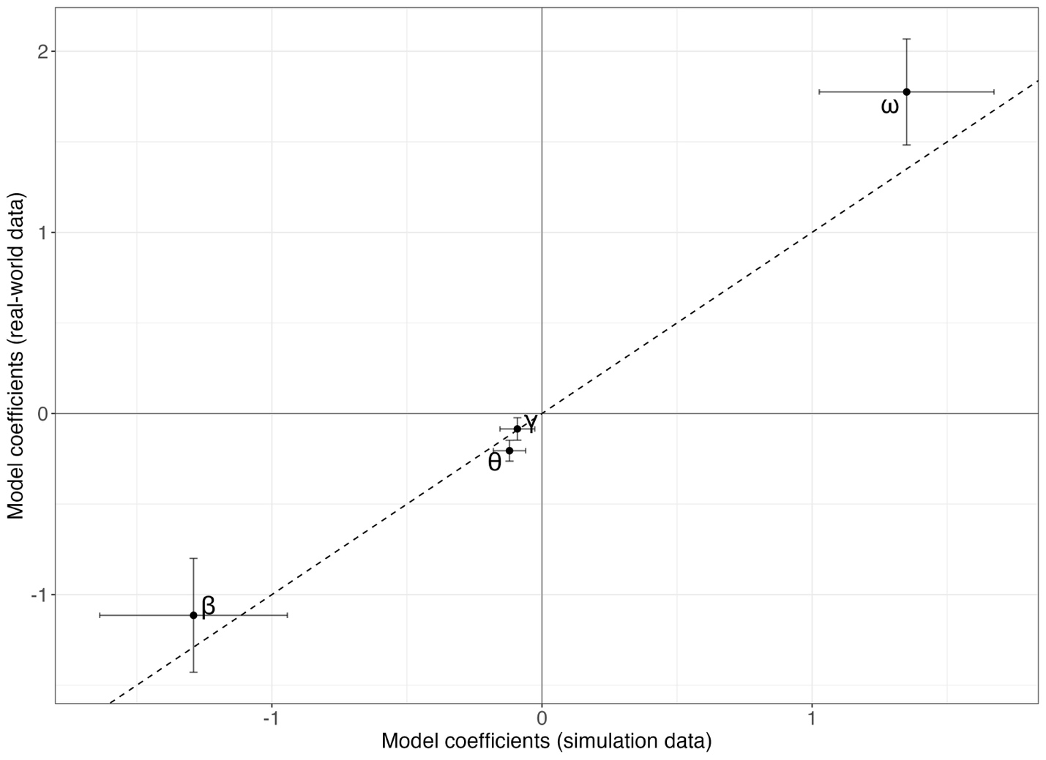

Supplementary Figure S2. Comparison of prediction error between the simulated (left) and empirical (right) data where the baseline Z comes from a dataset of N = 358 samples.
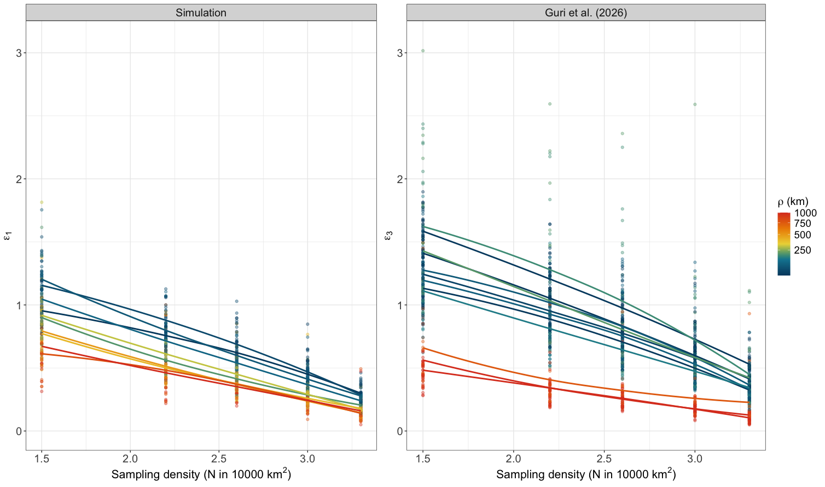
Supplementary Figure S3. Visualization of the lower and upper bars of prediction given the prediction error (ε) per sampling effort (E) when the true eDNA concentration is 100 copies/L.
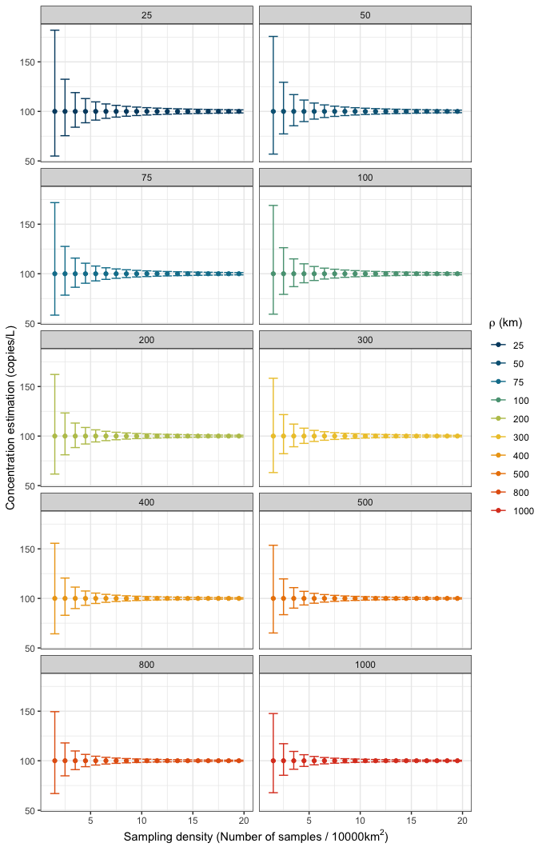

Supplementary Figure S4. Bias vs precision, to prove that RMSE used here is mainly accounting for precision and not bias.
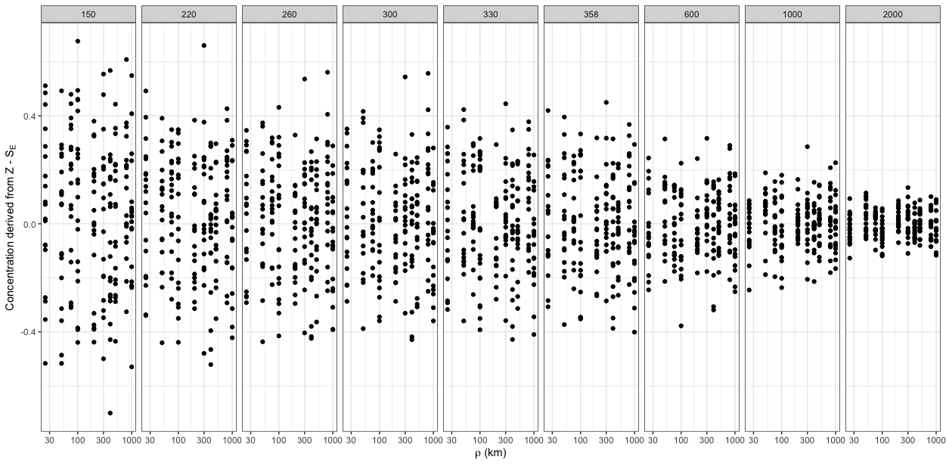

Figure Sxxx. Showing the observations of the prediction error (dots) and the modeled estimates (line) from the fitted model using Eq. 6.
