Smart eDNA sampling strategies: spatial autocorrelation can guide efficient survey design
Gledis Guri$​^{1}$*, Ryan P. Kelly$​^{1}$, Andrew O. Shelton$​^{2}*$, Owen R. Liu³, Krista M. Nichols$​^{2}$

1 | School of Marine and Environmental Affairs, University of Washington, Seattle, Washington, USA
2 | Conservation Biology Division, Northwest Fisheries Science Center, NOAA Fisheries, Montlake Blvd E. Seattle, Washington, USA
3 | School of Aquatic and Fishery Sciences, University of Washington, Seattle, Washington, USA
 | corresponding author gguri@uw.edu

Abstract
Designing sampling strategies that accurately capture spatial patterns of environmental DNA (eDNA) is increasingly critical for biodiversity monitoring. Because species abundance and eDNA signals are often spatially structured, accounting for spatial autocorrelation is important for robust distributional inference and sampling design evaluation. We combined empirical fish eDNA data from the U.S. Pacific coast with simulated sampling scenarios to evaluate how sampling effort influences eDNA concentration and spatial distribution estimation in marine surveys. Gaussian Process (GP) models were fitted to eDNA concentration as a function of spatial location and depth for 12 species, yielding species-specific spatial parameters. These empirically derived parameters were then used to generate synthetic spatial fields with varying degrees of spatial autocorrelation. Using both simulated and empirical data, we evaluated how progressive reductions in sampling effort affect predictive performance and GP parameter recovery, identifying effort thresholds that maximize inference accuracy and efficiency. Prediction accuracy improved with higher spatial autocorrelation and increasing sampling density with the largest marginal gains in accuracy occurring in our particular use-case at around 4-9 samples per 10000 km² per depth layer across the five sampled depth strata. Additionally, GP parameter recovery under reduced sampling effort showed very with little marginal gain past 6 samples per 10000 km². Optimal eDNA sampling effort depends on the spatial structure of the target taxon and the inferential objective of the survey, but here we suggest a quantitative framework for designing cost-effective eDNA surveys tailored to prediction, abundance indexing, and spatial ecological inference.

Keywords: eDNA, metabarcoding, fish, spatial, gaussian process, Bayesian

Introduction
Appropriate sampling design plays a critical role in accurately assessing species distributions, forming the foundation for evidence-based ecological inference and resource management (Yoccoz et al., 2001). Across ecological systems, indices of abundance and distribution are commonly derived from a range of survey approaches, including capture-based methods (Fraser et al., 2007), acoustic techniques (Lees et al., 2021), and direct visual observations (Ip et al., 2025). All of these approaches require a sample size appropriate for reliably estimating population parameters including abundance, demographic structure, and spatial distribution patterns (Guillera‐Arroita & Lahoz‐Monfort, 2012; Yoccoz et al., 2001) This process must balance the need for sufficient data for detecting trends and changes in population while also minimizing cost (i.e., maximizing sampling efficiency) (Stein & Ettema, 2003; Xu et al., 2015; Zhao et al., 2022).

The emergence of environmental DNA (eDNA) sampling has revolutionized monitoring capabilities, offering a non-invasive method to detect species presence and estimate relative abundance (Gold et al., 2021; Shelton et al., 2022; Taberlet et al., 2012). In contrast to traditional survey techniques that are typically species-specific or require separate sampling efforts for different taxa, eDNA enables simultaneous, multi-species detection from a single sample (Guri et al., 2024). This holistic approach promises a more comprehensive assessment of community composition while substantially reducing field effort and impacts on sampled organisms (Guri et al., 2023). Recent synthesis work shows that eDNA methods have matured sufficiently for key uncertainties to be quantified and incorporated into existing fisheries stock-assessment frameworks, enabling the development of cost-effective abundance indices that complement conventional surveys (Baetscher et al., 2025; Guri et al., 2024; Kirtane et al., 2021; Salter et al., 2026). Additionally, while conventional methods detect organisms directly at the point of capture or observation, eDNA signals integrate information from surrounding areas through processes of DNA transport and decay (Brandão-Dias et al., 2025; Z. Li et al., 2026). This spatial integration effect means that adjacent eDNA samples may contain overlapping information beyond what would be expected from species distribution patterns alone (Guri et al., 2024). This fact motivates increased consideration of how to design and interpret surveys that collect eDNA.

While increased sampling intensity generally reduces variance in population estimates and improves the precision of spatial pattern detection in species distribution models (Schweiger et al., 2016), this relationship exhibits diminishing returns where beyond a certain threshold, additional sampling effort produces marginal gains in statistical precision that may not justify the associated costs and logistical demands (Perret et al., 2022; Zhao et al., 2022). The optimal sampling effort occurs at the point where incremental improvements in precision or information content become disproportionately small relative to the required investment of resources and effort (Tarugara et al., 2019; Thiele et al., 2023; Zhao et al., 2022). This principle guides the development of cost-effective sampling strategies that maximize analytical power while minimizing operational expenditure (Muradian et al., 2019).

Species distribution inferences can be performed with a variety of mathematical frameworks, including spline‑based generalized additive models (GAMs), hierarchical stochastic partial differential equation (SPDE) models fitted using integrated nested Laplace approximation (INLA), conventional linear or additive regressions, spatial autoregressive structures, kernel‑based methods such as Gaussian processes (GP) and an expanding class of machine learning methods such as boosted regression trees (BRTs), random forests (RFs), and artificial neural networks (ANNs) (Dormann et al., 2007; Elith et al., 2008; Guisan & Zimmermann, 2000; Lek & Guégan, 1999; Lezama-Ochoa et al., 2020; X. Li & Wang, 2013). In ecological and fisheries research, Gaussian Process (GP) models have been widely adopted due to their covariance parameters which has clear ecological interpretations and provide a flexible, non‑parametric way to capture spatial and environmental smooths (Lewy & Kristensen, 2009; Nielsen et al., 2016)

This approach is grounded in the assumption that species distributions and abundances change in a smooth and continuous manner across space (or other covariates), reflecting correlated responses to spatial, environmental, and biological covariates (Lewy & Kristensen, 2009). GP models are appropriate only to the extent that their underlying smoothness assumptions are met and may therefore perform poorly in systems characterized by sharp boundaries or abrupt, non-smooth variation in space or covariate relationships. At the core, in simple terms, GPs posit that observations made at proximate locations or covariate values should be similar (Dormann et al., 2007). Generally, the similarity among observations is quantified through a covariance function (or kernel), which governs the covariance change between two points x and x' with increasing distance. Although this distance can be defined in terms of spatial location, environmental covariates, or both, in this study we focus only on spatial covariance. For exponential and squared-exponential covariance functions, a single parameter known as the length-scale controls how correlation changes with distance. Large length-scales mean that nearby points are highly correlated, whereas small length-scales imply a rapid decline in correlation with distance. We assert that many species can be well described using relatively simple covariance models (Thorson et al., 2015). Specifically, we use an isotropic, squared exponential covariance model for the distribution of a species. Let X {x₁,x₂,…x_{N}} be the set of N observed spatial locations. Then species (eDNA) abundance or density Y across all sampled locations (X) is modeled as,
$Y∼MVN\left(μ,K+σ^{2}I\right),\#1$
where μ is the global mean abundance, σ² is the non-spatial variance, I is an n x n identity matrix and K(X,X) is the covariance matrix whose (i,j)^{th} entry is given by the squared exponential kernel function,
$K(X,X) = k\left(x_{i},x_{j}\right)=α^{2}exp\left(-\frac{(x_{i}-x_{j})^{2}}{2ρ^{2}}\right)\#2$
where α² is the amplitude (i.e., the marginal variance of the spatial process, controlling the overall magnitude of variation in abundance), ρ is the length-scale parameter (in x_{i}-x_{j} units; hereafter spatial autocorrelation). Species with small spatial autocorrelation (ρ) values exhibit abundance patterns that vary sharply across space (Figure 1).

Knowledge of species-specific spatial autocorrelation can provide a quantitative basis for informing sampling effort (Fortin et al., 1989). Specifically, species with high spatial autocorrelation should require fewer samples to capture their distribution patterns due to their extended spatial coherence (Figure 1) and vice-versa (Wagner & Fortin, 2005). Hence, in this study, we assess how species spatial autocorrelation influences the efficiency of eDNA metabarcoding marine sampling strategies. We use both simulated and empirical eDNA data for species that differ in their patterns of spatial distributions to quantify the effect of species spatial autocorrelation and sampling effort on estimating (i) the predictive accuracy of species distribution models and (ii) the accuracy of GP parameter estimation. Although the GP framework can incorporate a wide array of covariates, i.e., temperature, salinity, bathymetry, and biotic interactions, this study focuses exclusively on spatial coordinates. By explicitly quantifying the trade-off between spatial autocorrelation, sampling effort, and prediction accuracy, we can identify thresholds of sampling effort that maximize information gain and minimize redundancy, offering a principled, quantitative foundation for designing efficient eDNA surveys.

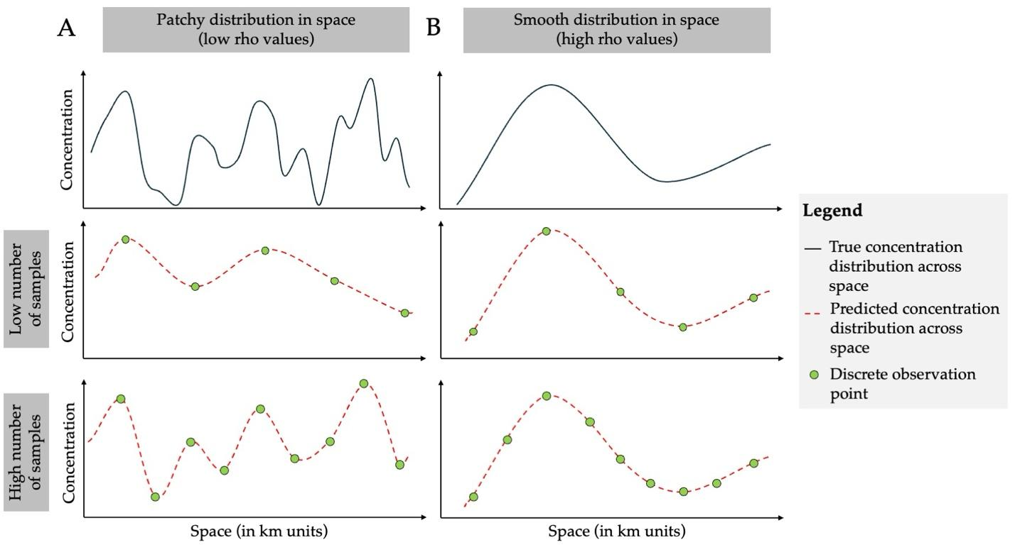
Figure 1. Conceptual figure illustrating how sampling density affects reconstruction of spatial concentration patterns across different spatial structures. Panel A shows a patchy species distribution in space, whereas panel B shows a smooth distribution in space, along a one-dimensional spatial transect (x-axis; space in km units). In the top row of each panel, the solid black line represents the true underlying concentration distribution whereas the middle and bottom rows show reconstructions of concentration distribution (red dashed line) based on a low number of samples and a high number of samples, respectively. Green circles indicate discrete observation points. For species A, high sample density is necessary to approximate the true distribution because of its low spatial autocorrelation, while the pattern for species B is well captured with fewer samples, with excessive sampling leading to redundant data (multiple samples that give the exact same information, thus wasting time and money).

Materials and methods
We evaluated how sampling effort influences the recovery of marine eDNA spatial patterns by integrating empirical observations with simulation-based analyses within a common GP framework. We first analyzed a real-world eDNA metabarcoding dataset collected across 358 stations and five depth strata along the U.S. West Coast to characterize species-specific spatial structure and depth-specific mean eDNA concentration patterns. We then used the range of parameter values informed by these empirical estimates to simulate new spatial eDNA fields across the same study domain, but at a much higher sampling resolution than was available in the field dataset. For both empirical and simulated data, we evaluated how reduced sampling effort affected spatial prediction accuracy and the recovery of GP parameters through systematic thinning analyses. By combining empirical and simulation-based evaluation, this framework allowed us to assess sampling efficiency beyond the limits of the empirical dataset alone (restricted to 358 observations) and thus to evaluate the sampling effort required for reliable inference across a broader range of effort.

Empirical eDNA data
Environmental DNA samples were collected during the Joint U.S.-Canada Integrated Ecosystem and Pacific Hake Acoustic-Trawl Survey aboard the NOAA ship Bell M. Shimada in summer 2019 (de Blois 2020). Sampling spanned a broad latitudinal and longitudinal gradient along the U.S. West Coast, extending from 123.53° to 125.93° W (243–461 km UTM eastings; span = 218 km) and from 38.36° - 48.46° N (4249 - 5367 km UTM northings; range 1118 km), corresponding to a region from central California to northern Washington. At each site, seawater (10 L) was collected using Niskin bottles mounted on a CTD rosette system, targeting five depths (0, 50, 150, 300, and 500 m). From each bottle, 2.5 L of seawater was immediately filtered onboard through sterile 47 mm mixed cellulose ester filters (1 $μ$m pore size) to capture suspended eDNA. Filters were preserved and DNA was extracted using a phase-lock phenol-chloroform protocol, following established methods (Ramón-Laca et al., 2021; Shelton et al., 2022).

Samples underwent PCR amplification using the MiFish U universal primer set (Miya et al. 2015), targeting a 170 bp fragment of the mitochondrial 12S rRNA gene and thereafter sequenced on an Illumina MiSeq platform (2x150 bp paired-end) at the University of Washington Genomics Core. Raw sequence reads were processed using the DADA2 pipeline (Callahan et al. 2016) to generate amplicon sequence variants (ASVs), which were taxonomically assigned using a custom reference database from NCBI GenBank and BOLD Systems. The same set of samples were used to estimate hake eDNA concentration using qPCR (see more Guri et al., 2025). Species-specific eDNA concentrations were estimated by jointly modeling ASV read counts, a mock community to correct for amplification bias, and qPCR measurements of Pacific hake to estimate absolute eDNA abundance for 12 fish species (Guri et al., 2024, 2025). The focal assemblage comprised a mixture of pelagic, mesopelagic, and demersal taxa characteristic of the California Current ecosystem, including Pacific herring (Clupea pallasii), northern anchovy (Engraulis mordax), northern smoothtongue (Leuroglossus stilbius), Dover sole (Microstomus pacificus), Pacific sardine (Sardinops sagax), Pacific chub mackerel (Scomber japonicus), widow rockfish (Sebastes entomelas), northern lampfish (Stenobrachius leucopsarus), longfin dragonfish (Tactostoma macropus), plainfin midshipman (Tarletonbeania crenularis), eulachon (Thaleichthys pacificus), and Pacific jack mackerel (Trachurus symmetricus). The final empirical dataset included eDNA measurements (in log copies/L) from 358 spatially distributed sampling among the reported depth layers.

Estimation of species-specific spatial structure
After the acquisition of the empirical data, we obtained log eDNA concentration values (Y) paired with spatial coordinates (X) for each sampling location (x; N = 358). We then used the GP model (Eq. 1–2) to infer the underlying spatial structure and learn key parameters governing the spatial field, including the depth-specific mean (μ_{d}), spatial autocorrelation (ρ), amplitude (α²; a scaling parameter that reflects the magnitude of spatially structured variability in the signal over the length scale), and non-spatial variance (σ²). Additionally, we used the model to predict eDNA concentrations (Z) across the full spatial grid (Q) using Eq 3. We defined this grid (Q), as 18,916 discrete point estimates, representing the centroids of approximately 8 × 8 km spatial cells distributed across five depth layers. The number of points differed among depth layers (4,000, 4,000, 4,000, 3,622, and 3,294 points, respectively) because deeper layers covered a smaller spatial extent than shallower layers due to bathymetry.

For a given species, we compute the covariance matrix among observed locations, K(X,X’), using the squared exponential kernel and the non-spatial variance term (σ²I). Using the Cholesky decomposition we solved for (K(X,X’) + σ²I)⁻¹(Y - μ_{d}) and we combined it with the cross-covariance between observed and prediction points, K(X,Q), to yield the predictions at each given spatial point (Q):
$Z=μ_{d}+K(X,Q)^{⊤}(K(X,X')+σ^{2}I)^{-1}(Y-μ_{d})\#3$

Estimating sampling efficiency on prediction accuracy
To evaluate how sampling effort (E) influences spatial reconstruction and prediction accuracy, we generated a series of reduced-effort observation datasets (Y_{E} coupled with X_{E}) by randomly thinning the observation set (Y) and its spatial covariate (X_{E}) to fixed sample sizes (N = 330, 300, 260, 220, and 150; Figure 2B). Each reduced-effort observation dataset (Y_{E}) together with its covariate (X_{E}) was refit with the same GP model (Eq 1-2) and produced effort-specific spatial predictions (S_{E}) on the full grid Q, by substituting S_{E} with Z, Y_{E} with Y and X_{E} with X in Eq. 3. This framework enables direct, like-for-like comparisons of reconstructed fields across sampling intensities since the predicted field is the same (Q). Sampling effort (E) was quantified as sampling density:
$E=\frac{N}{A×H}×10000\#4$
where A is the spatial area of the study domain (200,000 km²), and H is the number of depth layers (d) included in this study (H=5), yielding E in units of samples per 10,000 km² per depth layer.

For each model prediction, we calculated the prediction error (ε_{1E}), defined as the root mean squared error between spatial fields predicted from the full dataset (Z) and those predicted from each reduced sampling scenario (S_{E}) as follows (Figure 2B):
$ε_{1E}=\sqrt{\frac{1}{n}\sum_{i=1}^{n}{}{\left(Z_{i}-S_{iE}\right)}^{2}} \#5$
with n being the total number of Q grid points (n = 18,916) where the predictions (Z and S_{E}) are projected. We repeated this thinning-fitting-prediction process across 20 random realizations for each thinning intensity to mitigate the effects of sampling stochasticity on our prediction accuracy estimates.

Simulated eDNA data
To extend inference beyond the sampling effort limitations (N = 358) of the empirical dataset, we conducted a series of simulations. We generated in-silico eDNA concentration data using the GP model (Eq. 1-2) across the same spatial domain and prediction grid (Q) used in the empirical analysis.

The simulations were designed to explore a wide range of spatial structures by varying the GP length-scale parameter (ρ) across ten levels: 25, 50, 75, 100, 200, 300, 400, 500, 800, and 1000 km (Supplementary Table S1). These values were selected to represent differing degrees of spatial autocorrelation observed in empirical data. For each value of ρ we generated (arbitrarily) 20 independent replicate spatial fields, resulting in a total of 200 simulated datasets (10 $ρ$ levels × 20 replicates; Supplementary Table S1). Similar to GP inference of the empirical data, within each simulation, ρ was held constant across depth layers, but each layer had a separate mean (μ_{d}) drawn randomly from a normal distribution with mean of 0 and a standard deviation of 3. We focused only on spatial autocorrelation across latitude and longitude, allowing the eDNA concentration at each depth to be independent. Although incorporating dependence among depths may better reflect ecological structure, doing so would substantially increase model complexity and make the results more difficult to interpret. The amplitude (α²) and the non-spatial variance (σ²) in Eq. 1 and 2 were fixed at 4 and 3, respectively, to mirror parameter estimates in the empirical data. Fixing α² reduced the number of parameter combinations of simulations and maintained computational tractability. This choice is further supported by the empirical data, where estimated α² values ranged between 2 and 4 across species, indicating that fixing α² at 4 remains within a realistic range (Supplementary Table S1). In contrast σ² represents the method-specific measurement uncertainty and therefore reflecting a shared observation process across species.

Given the large number of projected eDNA points (Q), fitting a GP model using all locations (≈ 20,000 input values) was computationally prohibitive. To overcome this, we established a baseline for our analysis by randomly selecting a subset of 4,000 sampling points from each of the 200 simulated datasets. This subset served as the “complete” observation dataset (Y) and its covariate (X) for each simulation run. Following a procedure identical to that used for the empirical data, we first fit the GP model (Eq. 1–2) to each complete simulated dataset (Y) and covariate (X) to infer its governing parameters (μ_{d}, ρ, α², and σ²) and thereafter predict eDNA concentrations (Z) across the full spatial grid (Q) using Eq. 3. This prediction (Z) served as the “true” spatial field against which all subsequent reduced-effort predictions were compared (Figure 2A).

To evaluate how sampling effort influences prediction accuracy on the simulated data, we generated a series of reduced-effort observation datasets (Y_{E}) and covariates (X_{E}) by randomly thinning each complete set (Y) and its covariate (X) to progressively smaller sample sizes (N = 2000, 1000, 600, 358, 330, 300, 260, 220, and 150; Figure 2A). Following the same procedure used for the empirical data, we fit the GP model (Eq. 1-3) to estimate the governing parameters and generate an effort-specific spatial prediction (S_{E}) on the full spatial grid (Q). We then quantified the prediction error (ε_{2E}) for each scenario by calculating the root mean squared error between the “true” field (Z) and the reduced-effort field (S_{E}), as defined in Eq. 5 (Figure 2A). This approach allowed us to directly assess the interplay between sampling density, spatial autocorrelation, and the ability to accurately reconstruct the underlying eDNA field.

Additionally, to evaluate the influence of sampling effort on GP parameter estimation, we compared the estimated parameters (ρ, μ_{d}, σ², α²) from effort-specific datasets (Y_{E}) and covariates (X_{E}) to the true values used to generate the simulated fields. Differences between estimated and simulated parameter values were quantified using the root mean squared error (hereafter τ). This allowed us to quantify how reliably different sampling effort (E) recovered the underlying governing parameters of GP models.

Regression analysis of prediction error
After quantifying prediction error for the empirical and simulated datasets, we next asked how the two key drivers (i.e., sampling effort and spatial autocorrelation) jointly shape that error. By fitting a simple log‑linear model to each dataset separately (ε₁ and ε₂ respectively for empirical and simulation), we were able to isolate the individual contributions of each factor and compare between the two datasets.

We modeled prediction error (ε) as a function of sampling density (E) and spatial autocorrelation (ρ), including their interaction using a linear model (lm function) in R as follows:
$log\left(ε\right)=ω+β log\left(E\right)+θ log\left(ρ\right)+γ log\left(E\right)log\left(ρ\right)\#6$
where ω is the intercept, β slope of sampling density (E), θ is the slope of spatial autocorrelation (ρ) and γ is the coefficient on the interaction between the two latter factors.

Comparison of prediction accuracy between empirical and simulations
Due to the gap in sampling effort between field data and simulation datasets, prediction accuracy was benchmarked at different sampling effort levels. The empirical benchmark (ε₁) was determined by the sampling effort of N = 358, while the simulation accuracy (ε₂) was benchmarked against a much larger set of sampling effort N = 4,000 samples. Consequently, prediction accuracy ε₁ in the empirical and ε₂ in the simulation datasets was evaluated against different reference benchmarks and is therefore not directly comparable (Figure 2). Moreover, the empirical dataset could not be used to evaluate prediction accuracy at sampling effort levels greater than the existing sampling scheme.

To enable a like-for-like comparison between simulated and empirical results, we performed a secondary thinning analysis and prediction accuracy estimation (ε₃) in which the benchmark was redefined to match empirical sampling effort (N = 358; Figure 2A). Specifically, for each simulated scenario and iteration we used the subsample of size N=358 (Y ←Y_{E=358} and covariance X ←X_{E=358}) and treated this dataset as the reference observation set (benchmark). We then generated the corresponding prediction Z ← S_{E=358} on Q, using Eq. 3. From this generated baseline (Z), we compared the predictions (S_{E}) of the sampling-effort datasets (Y_{E}; E = 330, 300, 260, 220, and 150) to both the simulated and empirical datasets, refit the GP model at each effort, and computed effort-specific (ε₃) prediction errors by comparing each S_{E} to the matched reference field Z (derived from S_{E=358}; Figure 2A). Furthermore, we fitted the prediction accuracy (ε₃) as a function of sampling effort (E) and spatial autocorrelation (ρ) using Eq. 6 (similarly to empirical data). We then compared the estimated model coefficients of prediction accuracy between the simulated and empirical to assess whether similar patterns were observed.

All the GP models (equation 1 and 2) were fitted in a Bayesian framework using Stan probabilistic programming language (Carpenter et al. 2017). We used weakly informative priors (Table 1) to allow the data to primarily inform the posterior distributions of the parameters. For each GP model in Stan, we ran four parallel chains with 2,000 iterations each, discarding the first 1,000 iterations as burn-in. Convergence was assessed using $\hat{R}$ values, where values below 1.01 indicated satisfactory convergence and effective sample size (ESS) above 200. The model in Eq. 6 was fitted using linear models using lm() function in R (R Core Team, 2024), with log prediction error as the response variable and log-transformed sampling density and spatial autocorrelation as predictors (Supplementary Figure S5 for model fit diagnostics).

Table 1. Gaussian Process model parameters and their prior distributions used in Bayesian inference.
Parameter | Prior | Range
 |  | Min | Max
α² | $N(4,1)$ | 0 | +$∞$
μ | $N(0,5)$ | -5 | +$∞$
log(ρ) | $N(0,1)$ | -5 | +$∞$
σ² | $N(0,1)$ | 0 | +$∞$
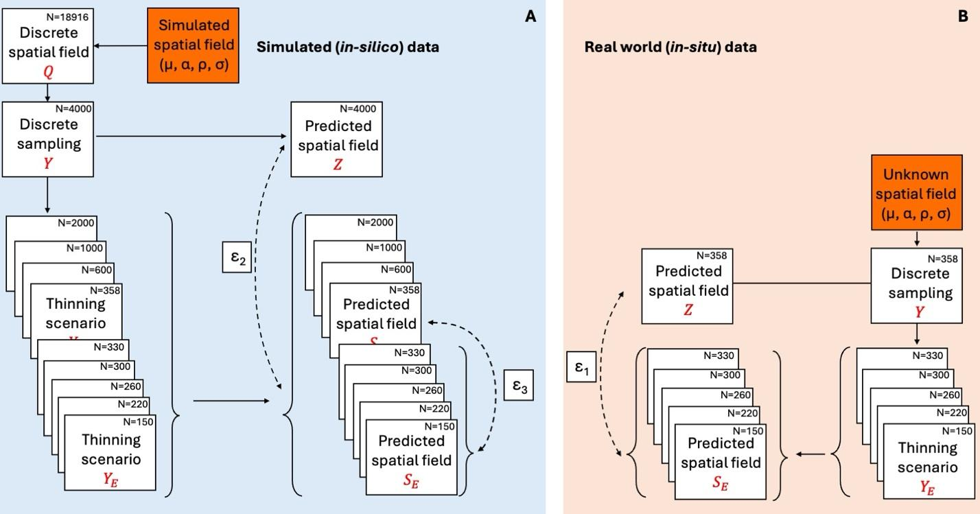
Figure 2. Workflow for evaluating sampling‐density effects on spatial field reconstruction in simulated (in-silico) and empirical (in-situ) data. A spatial field is generated (panel A; in-silico data) from known parameters (μ, ρ, σ) and represented on a discrete grid (Q, N=18,916). A reference sampling set (Y, N=4000) is used to fit a GP model and generate a predicted field (Z), which serves as the reference reconstruction. The prediction error (ε₂) is defined as the difference between Z field and the progressively reduced using thinning designs (Y_{E}) reconstructed field. To enable a like-for-like comparison with the in-situ data, a secondary baseline using N=358 samples is defined to produce a reference prediction S_{E=358}, and prediction error (ε₃) is calculated as the difference between S_{E=358} and reconstructions obtained from further thinned datasets (Y_{E}). On the right (panel B; real-world data), the underlying spatial field is unknown but assumed to arise from unknown parameters (μ, ρ, and σ). Using the full observed dataset (Y, N=358), a baseline predicted field (Z) is obtained. The observed samples are then thinned using the same Y_{E} designs, re-fit, and used to generate predicted fields S_{E}. Deviations of thinned predictions from the baseline prediction quantify ε₁, representing the expected information loss when sampling density is reduced in empirical settings.

Results

Empirical data
Across species, depth-specific global mean eDNA concentrations generally declined with increasing sampling depth (Figure 3). Species-specific length-scale estimates varied considerably across species (Figure 3A), likely reflecting differences in habitat use and movement behavior. Surface-dwelling species tended toward shorter spatial autocorrelation lengths and showed more pronounced differences between surface and deep mean eDNA concentrations (μ; Figure 3B), though exceptions were evident. Deep-dwelling species broadly exhibited longer spatial autocorrelations (Figure 3A) and relatively stable mean eDNA concentrations across depth strata, although this pattern was not universal, Tactostoma macropus, for instance, showed a comparatively short length-scale despite its deep-water affinity. Together, these patterns suggest that surface-associated species may be more spatially heterogeneous, whereas deeper-dwelling species may display increasingly homogeneous distributions.

Across species, estimated α² ranged from 2.3 to 4.2, whereas the GP non-spatial variance σ² spanned from 1.5 to 4.5. Surface-associated taxa generally exhibited slightly higher σ² than bottom-associated taxa, indicating greater process variance of the inferred eDNA fields. This pattern may partly reflect a mean–variance relationship, as surface taxa showed higher mean eDNA concentrations or alternatively, differences in σ² are linked to the spatial autocorrelation parameter ρ.
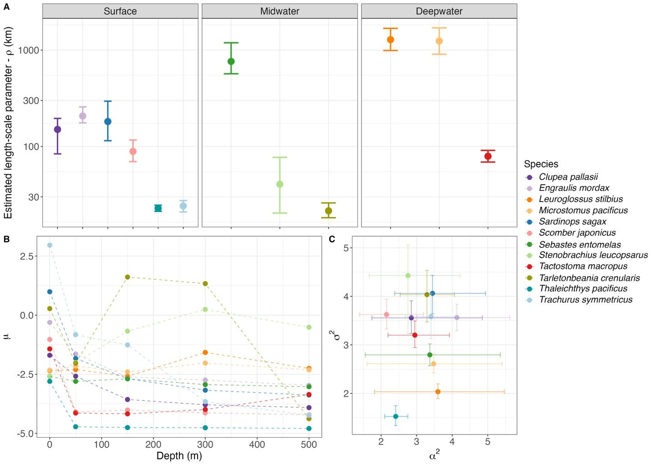
Figure 3: Species-specific Gaussian Process parameter estimates of empirical data. (A) Estimated spatial autocorrelation parameter (ρ in km) for each species (indicated in colors) across the three major depth strata defined from the literature (surface, midwater, and deepwater). Points indicate posterior mean estimates and bars denote 95% credible intervals. Depth-specific (0, 50, 100, 300, and 500 m) relationship between species spatial autocorrelation (ρ in km shown as the size of the points) and mean eDNA concentrations (in log copies/L) across species (colors) in panel B. Panel C indicating the signal amplitude (α²) relation between non-spatial variance (σ²) and species spatial autocorrelation (ρ in km shown as the size of the points).

Prediction accuracy on empirical data
Prediction error in empirical data decreased with increasing sampling density across all species (Supplementary Figure S1 and S2). However, this reduction was strongly modulated by the degree of spatial autocorrelation (Supplementary Figure S2). Species characterized by short spatial autocorrelation (small ρ values) consistently exhibited higher prediction error (ε₁) across all sampling densities, whereas species with wider spatial autocorrelation structures (e.g., ρ > 500 km) showed substantially lower prediction errors (ε₁) even under comparatively sparse sampling regimes. Although increased sampling effort reduced error for all species (with varying degrees of spatial autocorrelation), patchily distributed taxa retained a persistently higher prediction error (ε₁).

Simulations
Prediction error in simulation data (ε₂) decreased non-linearly with increasing sampling effort and with higher spatial autocorrelation (Figure 4A). These patterns were supported by a log–log linear model where the prediction error (ε) decreased exponentially for every exponential increase in sampling density (β = -0.176) and spatial autocorrelation (θ = -0.228), with an additional negative interaction (γ = -0.0684) and with an intercept of ω = 1.65 (i.e., ε = 5.2 when E and ρ = 1). For instance, at a sampling intensity of 6 samples per 10,000 km², species with spatial autocorrelation values of 50 = km had mean prediction errors of 1 (Figure 4A) indicating that on average every point predicted the eDNA concentration will differ from the predicted true concentration (Z) by a factor of 2.72 (for perspective a concentration of 100 copies/L will be predicted between 37-270 copies/L; Supplementary Figure S3). In contrast, for the same sampling effort (i.e., 6 samples per 10,000 km²) but species with spatial autocorrelation ρ > 500 km had errors below 0.4 indicating an average of over- and underestimation by a factor of 1.5 (for perspective a concentration of 100 copies/L will be predicted between 67-150 copies/L; Supplementary Figure S3). When quantifying the marginal reduction in prediction error (Δε₂) across successive increases in sampling density (ΔE), improvements were greatest at low sampling effort and declined rapidly with additional sampling, with Δε₂ approaching zero at higher sampling densities (Figure 4B). Marginal gains effectively plateaued when sampling effort increased above 10 samples per 10,000 km², depending on the ρ (Figure 4B). For interpretation, a Δε₂ of -0.4 indicates that adding one sample per 10,000 km² improves expected predictive accuracy from 37–270 copies/L to 55–182 copies/L when the predicted true concentration (Z) is 100 copies/L respectively. Importantly, diagnostic checks revealed no systematic bias in the predictions, so the observed variation reflects pure precision, (Supplementary Figure S4). For interpretative purposes, we adopt an arbitrary threshold of Δε₂/ΔE = -0.05 to denote negligible marginal gains. However, this value is arbitrary and may be redefined according to study-specific accuracy requirements.
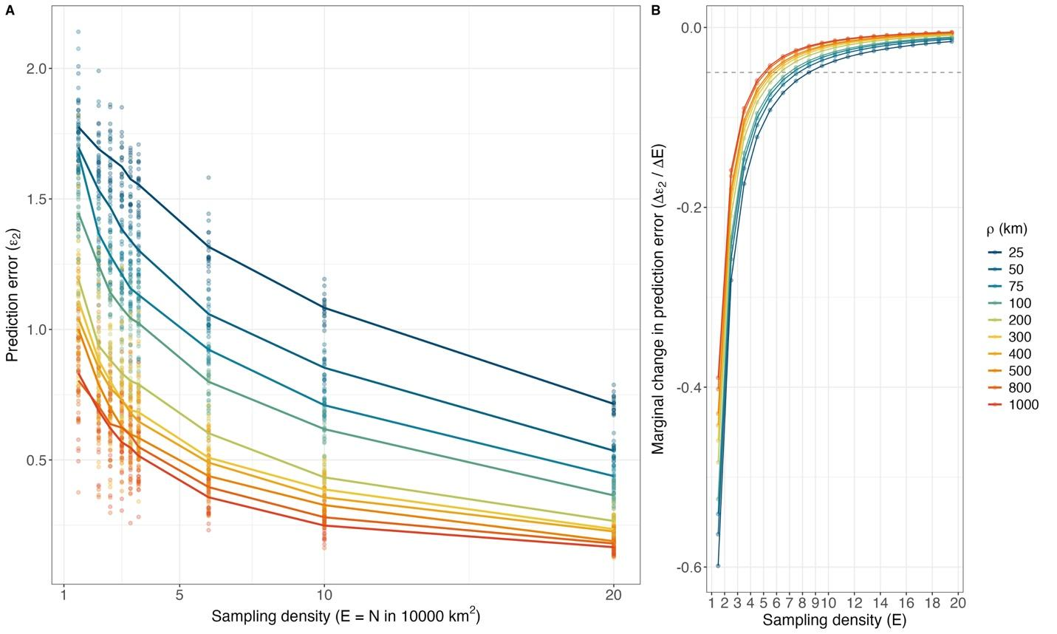
Figure 4: Estimated prediction error (ε₂) across sampling-effort scenarios (E; indicated by sampling density in 100x100 km grid) for simulated datasets (A) across various spatial autocorrelation values (indicated in colors). Points represent individual simulation outcomes, while solid lines denote the corresponding mean trends across replicates. Marginal improvement (B) in prediction performance (quantified as the change in error - Δε₂) across successive increases in sampling densities (ΔE = 1) where each point represents the marginal change at the midpoint of a unit interval (e.g., E = 1.5 reflects the change from E = 1 to E = 2), with lines connecting successive points. Due to the discrete intervals of sampling effort in simulations, the lines in panel B are predicted form the fitted model in Eq. 6 (see Supplementary Figure S5 for model fit diagnostics).The dashed grey horizontal line indicates the arbitrary threshold (Δε₂ /ΔE = -0.05) at which additional sampling effort yields negligible improvements in prediction accuracy.

GP parameter recovery
Sampling effort and spatial autocorrelation strongly influenced the ability of the GP model to recover the parameters used to generate the simulated spatial fields (Figure 6). Estimation error for the depth-specific mean (μ_{d}) decreased with increasing sampling density for simulated fields with small spatial autocorrelation but showed the opposite pattern for fields with large spatial ranges (Figure 5A). Specifically, τ (root mean squared error between estimated and simulated) for μ_{d} increased with sampling effort when spatial autocorrelation exceeded 400 km, indicating that mean estimates became increasingly biased in highly spatially structured fields. Additionally, the recovery of the spatial autocorrelation length-scale (ρ) was highly sensitive to sampling density (Figure 5B). At low sampling effort (E < 4), estimates of ρ showed substantial error, particularly for simulations with large spatial ranges. However, estimation accuracy improved rapidly as sampling effort increased, with τ declining sharply and stabilizing once sampling densities were higher than 6 samples per 10,000 km², beyond which additional sampling produced only marginal improvements in ρ estimation.

Estimation error for the amplitude parameter (α²) declined with increasing sampling density for simulations with small spatial autocorrelation, while remaining relatively stable across sampling densities for simulations with larger spatial ranges (Figure 5C). Overall improvements in α² estimation were therefore limited once sampling effort increased above 6 samples per 10,000 km². The non-spatial variance parameter (σ²) was consistently well recovered across sampling densities (Figure 5D). τ declined sharply with increasing sampling density and approached near-zero values once sampling densities exceeded 6 samples per 10,000 km².
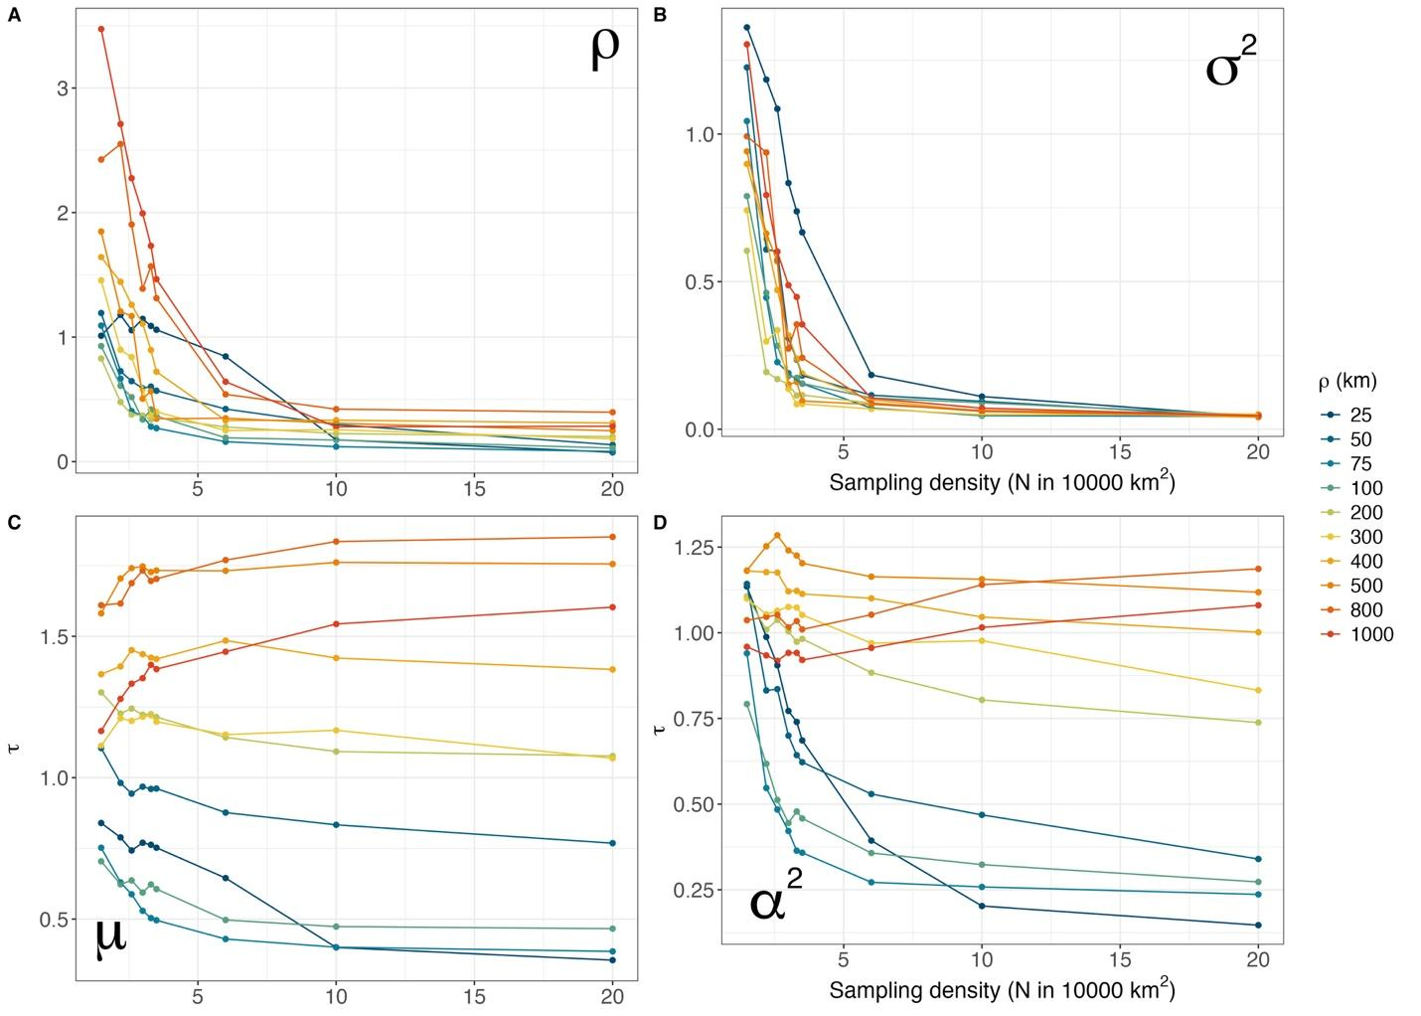
Figure 5. Accuracy of Gaussian Process (GP) parameter estimation across sampling effort (E; expressed in sampling density) and spatial autocorrelation values (ρ) from simulation data. Each dot represents the mean of root mean squared error (τ) across 20 simulation iterations of the difference between estimated and true parameter values for (A) spatial autocorrelation (ρ), (B) non-spatial variance (σ²), (C) depth-specific mean (μ_{d}), and (D) amplitude (α²). Lines represent the regression of mean τ across sampling effort for each spatial autocorrelation level. Sampling density is expressed as the number of samples per 10,000 km² (100 × 100 km grid).

Comparison of prediction accuracy between empirical and simulation data
Prediction error (ε) followed similar patterns using both empirical and simulation datasets. Specifically, the estimated intercept (ω), the influence of sampling effort (β), the effect of spatial autocorrelation (θ), and their interaction term (γ) all showed consistent directional effects and aligned closely with the 1:1 line, demonstrating a high degree of structural agreement between the empirical and simulated error models (Supplementary Figure S1). Overall, the close correspondence between coefficients derived from the in-silico and in-situ datasets indicates that the simulation framework successfully reproduced the primary relationships between prediction error, sampling effort, and spatial autocorrelation observed in the real-world data (Supplementary Figure S1).

Discussion
We provide quantitative evidence for how species-specific spatial autocorrelation governs the efficiency of eDNA spatial surveys for spatial distribution predictions. Through the integration of empirical observations from 358 sampling stations along the U.S. West Coast and simulation-based analyses spanning a wide range of spatial autocorrelation scenarios, we demonstrate that optimal sampling effort is not universal but depends critically on both the spatial autocorrelation of target species and the specific inferential objectives of the survey.

Diminishing returns of sampling effort on prediction accuracy
The value of additional sampling effort is not fixed but depends strongly on the spatial structure of the target species (Xu et al., 2015; Zhao et al., 2022) Across simulations and empirical data, prediction error decreased non-linearly with increasing sampling effort, while simultaneously declining as spatial autocorrelation increased, indicating that species with more homogenous distributions are inherently easier to reconstruct than patchier species at the same effort level (Wagner & Fortin, 2005). The interaction between sampling effort and spatial autocorrelation is particularly critical because it demonstrates that the value of additional samples is not universal in ecology, where the same increase in effort can produce substantial gains for one species and only marginal gains for another (García‐Machado et al., 2024). Here, our results move beyond a general statement of sampling efficiency and provide a quantitative framework for understanding when additional effort is informative and when it yields diminishing returns.

Crucially, the decision of the sampling effort based on prediction accuracy (ε₂) cannot be reduced to a single universal number, as it depends heavily on both the acceptable margin of error and the spatial autocorrelation of the target organism. Our adopted threshold for negligible marginal gains (Δε₂ = -0.05) serves as a practical heuristic, but acceptable error is inherently context dependent. For instance, studies requiring high-resolution quantitative estimates might justify high sampling effort to achieve stricter precision, while, broad-scale biodiversity screenings might tolerate looser precision, allowing for even sparser sampling (Perkins et al., 2021; Radinger et al., 2019) Moreover, the species spatial autocorrelation parameter plays an additional role in defining the decision on sampling effort. Highly autocorrelated species (e.g., ρ > 500 km) reach the precision threshold of negligible improvement at much lower sampling densities (roughly 4 to 5 samples per 10,000 km²), conversely, patchily distributed species (ρ < 50 km) require a denser sampling network (roughly 8 to 11 samples per 10,000 km²) before the marginal gains drop below the threshold. Ultimately, the framework presented here reduces the sampling design problem to two key inputs: the level of predictive certainty required for the study objective (expressed as ε₂), and the spatial autocorrelation of the target species (ρ). Once these parameters are quantified - through prior literature, pilot sampling, or expert knowledge, the log-log model ε = e^{ω}E^{β}ρ^{θ}(Eρ)^{γ} (from Eq. 6; Figure 4B, Supplementary Figure S1 and S6) can be inverted to solve for the minimum sampling density E required to keep Δε below the chosen threshold.

Applying our simulation-derived thresholds to our empirical data further illustrates this context dependency. Extrapolating the findings from the simulations, species such as Leuroglossus stilbius and Microstomus pacificus (species with high spatial autocorrelations) would require only 4 samples per 10,000 km² to achieve a negligible marginal gain in precision (defined here arbitrary as Δε = -0.05). In contrast such as Trachurus symmetricus, Thaleichthys pacificus, Stenobrachius leucopsarus, and Tarletonbeania crenularis (species with low spatial autocorrelation) would require approximately 9 samples per 10,000 km² to reach the same relative threshold (Liu et al., 2026). Notably, the sampling effort required to adequately capture these patchily distributed taxa is more than double the effort needed for smoother distributed species (Perkins et al., 2021). The remaining species fall within the range of 4-9 samples per 10,000 km², consistent with their intermediate spatial autocorrelation values. These results highlight that no single sampling strategy is universally appropriate, as optimal effort is inherently species- and context-specific. However, given that our analysis is based on 12 fish species, extending this conclusion to other taxa or ecosystems should be done with caution, and additional species may exhibit different scaling relationships.

Depth-dependent patterns
Across species, depth-specific mean eDNA concentrations generally declined with depth, while species-specific spatial length scales revealed a contrast between surface- and deep-associated taxa. Surface-associated species tended to have shorter length scales (lower spatial autocorrelation) and larger surface-deep differences in mean concentration, whereas deep-associated species showed longer length scales and more stable means across depth strata. Ecologically, this pattern is consistent with greater spatial heterogeneity in surface waters driven by stronger horizontal gradients, mixing, productivity hotspots, and advective transport, while deeper layers may be more spatially structured and comparatively homogeneous at the regional scale (Guri et al., 2023). From a sampling-efficiency perspective, this implies that surface-focused monitoring may require denser spatial sampling to reconstruct patchy distributions, whereas deep-layer monitoring may allow coarser sampling grids while retaining predictive fidelity-provided that the eDNA field at depth remains spatially coherent and that vertical transport does not dominate the observed signal.

Estimating GP parameters from reduced-effort simulations
The parameter estimation analyses provide further ecological insights into how sampling effort and spatial autocorrelation affect inference. The estimation of depth-specific mean, (μ_{d}) and the length scale (ρ), behaved very differently. Estimation of μ_{d} improved with increasing effort when scenarios had small spatial autocorrelations, but for highly autocorrelated scenarios (especially above 400 km) error (τ) in estimating μ increased rather than declined. One likely explanation is that, when the spatial autocorrelation parameter approaches or exceeds the spatial extent of the study area (200 km longitudinal here), the data provide only weak information about the parameter, leaving the posterior estimates heavily dependent on the Bayesian prior. This weak identifiability means that, even with greater sampling effort, the estimate of the depth‑specific mean (μ_{d}) becomes more driven by the prior distribution, which can diminish precision and produce an apparent bias. Under these conditions, the field can appear nearly uniform across the sampled domain, making it difficult to separate the overall mean from the large-scale spatial process.

By contrast, estimation of the spatial autocorrelation parameter ρ was substantially more sensitive to reduced sampling effort, particularly in scenarios with low spatial autocorrelation. Such difference follows from the type of information required to estimate each parameter. Estimating the mean mainly requires observations that broadly represent the range of values across the study area, whereas estimating spatial autocorrelation requires information on how similarity between samples changes with distance (Paciorek, 2010; Rocha et al., 2021). In practical terms, μ_{d} can remain relatively robust under reduced sampling effort, provided that the spatial structure is still contained within the extent of the survey. By contrast, estimating ρ depends much more strongly on the distances among sampling points, because resolving spatial autocorrelation requires enough closely and broadly spaced pairs to detect how similarity declines with distance (Paciorek, 2010).

Overall, this behavior is expected when the underlying process varies at a finer spatial scale than the sampling design can resolve. Once the true ρ is sufficiently small, the spatial pattern is too fine for the sampling grid to detect making the model to lose the signal defaulting the predictions to rely on the priors with large residual uncertainty (Kaufman & Shaby, 2013). Under these conditions, the model is operating close to the limit of what can be learned from the sampling design, and additional changes in true ρ may not translate into detectable changes in map-level accuracy. Indeed, in situations with very low spatial autocorrelation, the value of constructing and implementing a spatial model disappears entirely. Practically, this implies that sample-removal diagnostics (or any assessment that treats an undersampled reference as truth) can become uninformative for very patchy species, because the benchmark surface itself is not resolved well enough to support fine-scale comparisons (Kaufman & Shaby, 2013). This, in turn, motivates our reliance on simulations with much higher spatial resolution to characterize how sampling effort should scale with spatial autocorrelation.

Overall, the parameter estimates indicate that most gains in estimation of the GP parameters occurred at low sampling effort, with little additional improvement once effort exceeded roughly 6 samples per 10,000 km² per depth layer. This consistent leveling-off across GP parameters estimation (Figure 5) suggests a clear point of diminishing returns, beyond which further increases in sampling effort are unlikely to substantially improve inference under the spatial scales considered here.

Limitations on extrapolating simulations on real-world scenarios
The simulated and empirical reduced effort analysis showed strong agreement. This concordance suggests that our simulation framework captured important features of eDNA spatial structure at the scale of ten-degree latitude. At the same time, extrapolating directly from simulations to natural systems requires care because real eDNA fields may violate the simplifying assumptions of the stationary, isotropic squared exponential kernel. Spatial structure may vary across the domain (non-stationarity), differ by direction (anisotropy), or include sharp transitions (fronts, plume boundaries, shelf-break structure) that are not well represented by a globally smooth covariance function (Paciorek & Schervish, 2006). In addition, eDNA observation error is unlikely to be purely Gaussian: variability can arise from PCR bias (Kelly et al., 2019), compositional constraints in metabarcoding (Gloor et al., 2017), incomplete calibration to absolute concentration (Shaffer et al., 2025), and heterogeneity in filtration or extraction efficiency (Bessey et al., 2020). Although the PCR bias and compositional constraints might have been circumvented by (Guri et al., 2025), minor errors or uncertainties can be further amplified in the GP inferences. Finally, ecological processes such as migration, schooling, habitat discontinuities, or patchy prey fields can generate multi-scale patterns that depart from a single characteristic length-scale (Wagner & Fortin, 2005). These features may help explain elevated prediction error at intermediate autocorrelation levels in the empirical data relative to simulations, where additional sources of spatial complexity are not represented. Despite these real-world complexities, the strong concordance between empirical and simulated results indicates that our framework captures a robust and ecologically meaningful relationship between spatial autocorrelation and the sampling effort required to estimate it reliably.

Several methodological limitations follow from these constraints. The simulation framework used here assumes a stationary GP with fixed amplitude and noise and a single length-scale across depths, whereas real eDNA fields may vary in variance structure, include multiple characteristic scales, and exhibit multiple environmental covariance (i.e., temperature, salinity, chlorophyll, bathymetry) (Liu et al., 2026). In addition, our prediction error (ε₂) compares reduced effort predictions to a “complete” prediction derived from a 4,000-point subset (Z) rather than the full underlying grid. This is more visible on the secondary thinning comparison as the field to which the reduced effort predictions are compared to is limited (N = 358 samples) hence the prediction error is higher and more stochastic.

Intrinsically, eDNA integrates ecological information through space and across time via transport and decay (Brandão‐Dias et al., 2023; Fukaya et al., 2021) This means that even if organisms are locally patchy, the observed eDNA field may be smoother than the organism field, depending on hydrodynamic conditions and degradation rates. In our framework, such integration is embedded within the inferred length-scale (spatial autocorrelation; ρ), reinforcing that ρ should be interpreted as an effective length scale of the observed eDNA field rather than a purely ecological niche parameter (Jo et al., 2025). Importantly, because the length-scale parameter here reflects the integrated effects of organism distribution together with eDNA transport and decay, the depth patterns observed in this study may also reflect depth-dependent physical processes (Brandão‐Dias et al., 2023). DNA persistence times, particle dynamics, and water-mass stability can all vary with depth, potentially altering the effective smoothing of the eDNA field (Brandão-Dias et al., 2025). Integrating eDNA observations with independent abundance data (trawl, acoustics) would allow some degree of separation of the spatial autocorrelation parameter, enabling clearer ecological interpretation of ρ and improving the transferability of sampling-effort recommendations (Guri et al., 2024).

Spatial scale also sets an important boundary on the applicability of these results. The relationships identified here are expected to hold most strongly when interpreted relative to the extent and resolution of the study domain, rather than as fixed thresholds transferable across all systems. For highly spatially autocorrelated species, estimation of the depth-specific mean, μ_{d} is likely to improve compared to results here when the study domain is sufficiently broad to contain the dominant scale of spatial variation, as might be the case in surveys spanning an entire ocean basin such as the Pacific Ocean (Paciorek, 2010; Redfern et al., 2006) By contrast, in a very small study domain, the autocorrelation scale of the observed eDNA field may exceed the survey extent, causing the field to appear nearly uniform and making μ_{d} difficult to estimate independently of the spatial process (Paciorek, 2010; Redfern et al., 2006) Estimation of spatial autocorrelation is similarly constrained, due to lack of samples outside of the distance-decay spatial autocorrelation (Paciorek, 2010).

Implications for survey design and management applications
Sampling effort required for eDNA surveys should be matched to the intended inferential goal. When the objective is to estimate GP parameters such as the mean (μ_{d}) for deriving depth-specific or region-specific abundance indices typically used in stock assessment indices (Shelton et al., 2022), the autocorrelation (ρ) for applied ecological questions, like implementing protected area networks or monitoring programs (Laroche, 2024), or the variance parameter (α²), random sampling designs that adequately cover the full spatial domain of the species spatial autocorrelation are likely to be sufficient (Rocha et al., 2021), as sampling effort appears to have relatively limited influence on parameter estimation (Figure 5). In contrast, when the objective shifts toward predicting spatial distributions - such as identifying hotspots, mapping species occurrence, or quantifying spatial niche breadth - the accuracy of these predictions is much more sensitive to both sampling effort and the underlying spatial autocorrelation of the species (Figure 4A). Such contrast is due to the GP parameter estimation is primarily concerned with establishing the covariance structure (Eq. 1-2) while, prediction is subject to a two-fold requirement: first, it relies on the parameters derived from Eq. 1-2 being accurate, and second, on the density and proximity of the observed points (Eq. 3) from which the new data is extrapolated. Additionally, the GP parameters estimated here were species-specific and shared across depth layers, whereas spatial predictions were both species- and depth-specific. Consequently, sampling effort distributed across all depth strata contributed jointly to estimation of the GP parameters, while prediction accuracy was evaluated independently for each depth-specific spatial field, with no shared information among depths.

This distinction also clarifies how sampling design shapes inference. Estimation of the mean benefits primarily from coverage (sampling across the full domain) and secondarily from balance (avoiding over-sampling a limited region) (Rocha et al., 2021). By contrast, estimation of the length-scale parameter requires not only broad coverage but also a wide distribution of pairwise distances, including closely spaced stations that resolve rapid decorrelation and widely spaced stations that constrain the long-distance tail of the covariance function (Kaufman & Shaby, 2013). Uniformly thinning an otherwise regular spatial design reduces both the number of pairs and the diversity of distances, which helps explain the large uncertainty in estimating ρ under low effort scenarios as observed through the simulations. In practical marine surveys, where ship time and station spacing are limiting, incorporating targeted design features such as broad transects that cover the whole study area, together with small clusters of nearby stations placed within parts of those transects, may improve recovery of ρ without requiring a proportional increase in total effort, although this was not directly evaluated in the present study.

Broadly, our findings indicate that a single universally optimal sample size is unlikely to exist for multispecies eDNA surveys. Instead, optimal effort is species- and context-dependent and should be aligned with the spatial scale of heterogeneity that is most relevant for management. Nevertheless, across the scenarios considered here and the spatial domain used in this study, sampling effort of 4 - 9 samples per 10,000 km² per depth layer marked the point at which diminishing returns became apparent given species-specific spatial autocorrelation. Beyond this level of effort, the general pattern of estimating all the parameters of interest here (μ, ρ, α, σ, and ε) showed minimal change with increasing sampling effort suggesting that further increases in effort may yield limited gains in inference relative to cost.

Conclusions
This study shows that the effectiveness of marine eDNA sampling depends strongly on spatial autocorrelation and on the specific goals of the survey. In both simulated and empirical datasets, increasing sampling effort improved spatial prediction, but these gains diminished once sampling effort reached 4 - 9 samples or more per 10,000 km² per depth layer. The results also indicate that estimating the mean signals (analogous to a stock assessment index), is more robust to reduced sampling than estimating spatial autocorrelation parameters, which require denser and more spatially representative designs. These findings emphasize that there is no single optimal sampling threshold for all multispecies eDNA surveys, since appropriate effort depends on the taxa and the ecological question being addressed. Overall, the study provides a practical framework for designing more efficient and purpose-specific eDNA surveys.

References
Baetscher, D. S., Omori, K. L., Goethel, D. R., Shelton, A. O., Berger, A. M., Ledger, K. J., Nichols, K. M., & Larson, W. A. (2025). The Pragmatic Sceptic: A Practical Approach for Integrating Environmental DNA Into Marine Stock Assessment and Fisheries Management. Fish and Fisheries, faf.70001. https://doi.org/10.1111/faf.70001
Bessey, C., Jarman, S. N., Berry, O., Olsen, Y. S., Bunce, M., Simpson, T., Power, M., McLaughlin, J., Edgar, G. J., & Keesing, J. (2020). Maximizing fish detection with eDNA metabarcoding. Environmental DNA, 2(4), 493–504. https://doi.org/10.1002/edn3.74
Brandão‐Dias, P. F. P., Hallack, D. M. C., Snyder, E. D., Tank, J. L., Bolster, D., Volponi, S., Shogren, A. J., Lamberti, G. A., Bibby, K., & Egan, S. P. (2023). Particle size influences decay rates of environmental DNA in aquatic systems. Molecular Ecology Resources, 23(4), 756–770. https://doi.org/10.1111/1755-0998.13751
Brandão-Dias, P. F., Shaffer, M., Guri, G., Parsons, K. M., Kelly, R. P., & Allan, E. A. (2025). Differential decay of multiple environmental nucleic acid components. Scientific Reports, 15(1), 26791. https://doi.org/10.1038/s41598-025-12916-5
Dormann, C. F., McPherson, J. M., Araújo, M. B., Bivand, R., Bolliger, J., Carl, G., Davies, R. G., Hirzel, A., Jetz, W., Daniel Kissling, W., Kühn, I., Ohlemüller, R., Peres‐Neto, P. R., Reineking, B., Schröder, B., Schurr, F. M., & Wilson, R. (2007). Methods to account for spatial autocorrelation in the analysis of species distributional data: A review. Ecography, 30(5), 609–628. https://doi.org/10.1111/j.2007.0906-7590.05171.x
Elith, J., Leathwick, J. R., & Hastie, T. (2008). A working guide to boosted regression trees. Journal of Animal Ecology, 77(4), 802–813. https://doi.org/10.1111/j.1365-2656.2008.01390.x
Fortin, M.-J., Drapeau, P., & Legendre, P. (1989). Spatial autocorrelation and sampling design in plant ecology. Vegetatio, 83(1–2), 209–222. https://doi.org/10.1007/BF00031693
Fraser, H. M., Greenstreet, S. P. R., & Piet, G. J. (2007). Taking account of catchability in groundfish survey trawls: Implications for estimating demersal fish biomass. ICES Journal of Marine Science, 64(9), 1800–1819. https://doi.org/10.1093/icesjms/fsm145
Fukaya, K., Murakami, H., Yoon, S., Minami, K., Osada, Y., Yamamoto, S., Masuda, R., Kasai, A., Miyashita, K., Minamoto, T., & Kondoh, M. (2021). Estimating fish population abundance by integrating quantitative data on environmental DNA and hydrodynamic modelling. Molecular Ecology, 30(13), 3057–3067. https://doi.org/10.1111/mec.15530
García‐Machado, E., Normandeau, E., Côté, G., Caza‐Allard, I., Babin, C., & Bernatchez, L. (2024). Evaluating Sampling Designs to Survey Fish Diversity in Lakes From Northern Temperate Zones. Environmental DNA, 6(6), e70015. https://doi.org/10.1002/edn3.70015
Gloor, G. B., Macklaim, J. M., Pawlowsky-Glahn, V., & Egozcue, J. J. (2017). Microbiome Datasets Are Compositional: And This Is Not Optional. Frontiers in Microbiology, 8, 2224. https://doi.org/10.3389/fmicb.2017.02224
Gold, Z., Sprague, J., Kushner, D. J., Marin, E. Z., & Barber, P. H. (2021). eDNA metabarcoding as a biomonitoring tool for marine protected areas. PLoS ONE, 16(2 February 2021), 1–19. https://doi.org/10.1371/journal.pone.0238557
Guillera‐Arroita, G., & Lahoz‐Monfort, J. J. (2012). Designing studies to detect differences in species occupancy: Power analysis under imperfect detection. Methods in Ecology and Evolution, 3(5), 860–869. https://doi.org/10.1111/j.2041-210X.2012.00225.x
Guisan, A., & Zimmermann, N. E. (2000). Predictive habitat distribution models in ecology. Ecological Modelling, 135(2–3), 147–186. https://doi.org/10.1016/S0304-3800(00)00354-9
Guri, G., Liu, O. R., Kelly, R. P., Shaffer, M. R., Parsons, K. M., Ramón-Laca, A., Nichols, K. M., Brandão-Dias, P. F. P., Wells, A., & Shelton, A. O. (2025). Quantitative, Multispecies Monitoring at a Continental Scale. Ecology. https://doi.org/10.1101/2025.10.30.685180
Guri, G., Shelton, A. O., Kelly, R. P., Yoccoz, N., Johansen, T., Præbel, K., Hanebrekke, T., Ray, J. L., Fall, J., & Westgaard, J.-I. (2024). Predicting trawl catches using environmental DNA. ICES Journal of Marine Science, fsae097. https://doi.org/10.1093/icesjms/fsae097
Guri, G., Westgaard, J., Yoccoz, N., Wangensteen, O. S., Præbel, K., Ray, J. L., Kelly, R. P., Shelton, A. O., Hanebrekke, T., & Johansen, T. (2023). Maximizing sampling efficiency to detect differences in fish community composition using environmental DNA metabarcoding in subarctic fjords. Environmental DNA, edn3.409. https://doi.org/10.1002/edn3.409
Ip, Y. C. A., Guri, G., Allan, E. A., & Kelly, R. P. (2025). Passive air sampling detects environmental DNA transfer from water into air. Scientific Reports, 15(1), 42245. https://doi.org/10.1038/s41598-025-26293-6
Jo, T. S., Murakami, H., & Nakadai, R. (2025). Spatial dispersal of environmental DNA particles in lentic and marine ecosystems: An overview and synthesis. Ecological Indicators, 174, 113469. https://doi.org/10.1016/j.ecolind.2025.113469
Kaufman, C. G., & Shaby, B. A. (2013). The role of the range parameter for estimation and prediction in geostatistics. Biometrika, 100(2), 473–484. https://doi.org/10.1093/biomet/ass079
Kelly, R. P., Shelton, A. O., & Gallego, R. (2019). Understanding PCR Processes to Draw Meaningful Conclusions from Environmental DNA Studies. Scientific Reports, 9(1), 1–14. https://doi.org/10.1038/s41598-019-48546-x
Kirtane, A., Wieczorek, D., Noji, T., Baskin, L., Ober, C., Plosica, R., Chenoweth, A., Lynch, K., & Sassoubre, L. (2021). Quantification of Environmental DNA (eDNA) shedding and decay rates for three commercially harvested fish species and comparison between eDNA detection and trawl catches. Environmental DNA, 3(6), 1142–1155. https://doi.org/10.1002/edn3.236
Laroche, F. (2024). Efficient sampling designs to assess biodiversity spatial autocorrelation: Should we go fractal? Peer Community Journal, 4, e76. https://doi.org/10.24072/pcjournal.454
Lees, K. J., MacNeil, M. A., Hedges, K. J., & Hussey, N. E. (2021). Estimating demographic parameters for fisheries management using acoustic telemetry. Reviews in Fish Biology and Fisheries, 31(1), 25–51. https://doi.org/10.1007/s11160-020-09626-8
Lek, S., & Guégan, J. F. (1999). Artificial neural networks as a tool in ecological modelling, an introduction. Ecological Modelling, 120(2–3), 65–73. https://doi.org/10.1016/S0304-3800(99)00092-7
Lewy, P., & Kristensen, K. (2009). Modelling the distribution of fish accounting for spatial correlation and overdispersion. Canadian Journal of Fisheries and Aquatic Sciences, 66(10), 1809–1820. https://doi.org/10.1139/F09-114
Lezama-Ochoa, N., Pennino, M. G., Hall, M. A., Lopez, J., & Murua, H. (2020). Using a Bayesian modelling approach (INLA-SPDE) to predict the occurrence of the Spinetail Devil Ray (Mobular mobular). Scientific Reports, 10(1), 18822. https://doi.org/10.1038/s41598-020-73879-3
Li, X., & Wang, Y. (2013). Applying various algorithms for species distribution modelling. Integrative Zoology, 8(2), 124–135. https://doi.org/10.1111/1749-4877.12000
Li, Z., Ramón, C. L., Bogdanowicz, S., Koeberle, A. L., Wang, D., Rueda, F. J., Cowen, E. A., Walter, M. T., Sethi, S. A., Lodge, D. M., Luo, D., & Andrés, J. A. (2026). Tracing Environmental DNA Transport in a Large Lake with Synthetic DNA Microparticles and Hydrodynamic Modeling. Environmental Science & Technology, 60(4), 3519–3531. https://doi.org/10.1021/acs.est.5c11071
Liu, O. R., Shelton, A. O., Ramón-Laca, A., Nichols, K. M., Ward, E. J., Phillips, E. M., Zamon, J. E., Wells, A., & Kelly, R. P. (2026). Mapping the marine distribution of eulachon (Thaleichthys pacificus) in the Northeast Pacific using environmental DNA. Communications Biology, 9(1), 465. https://doi.org/10.1038/s42003-026-09733-5
Muradian, M. L., Branch, T. A., & Punt, A. E. (2019). A framework for assessing which sampling programmes provide the best trade-off between accuracy and cost of data in stock assessments. ICES Journal of Marine Science, 76(7), 2102–2113. https://doi.org/10.1093/icesjms/fsz163
Nielsen, J. R., Kristensen, K., Lewy, P., & Bastardie, F. (2016). A Statistical Model for Estimation of Fish Density Including Correlation in Size, Space, Time and between Species from Research Survey Data. PLOS ONE, 11(2), e0148722. https://doi.org/10.1371/journal.pone.0148722
Paciorek, C. J. (2010). The Importance of Scale for Spatial-Confounding Bias and Precision of Spatial Regression Estimators. Statistical Science, 25(1). https://doi.org/10.1214/10-STS326
Paciorek, C. J., & Schervish, M. J. (2006). Spatial modelling using a new class of nonstationary covariance functions. Environmetrics, 17(5), 483–506. https://doi.org/10.1002/env.785
Perkins, N. R., Prall, M., Chakraborty, A., White, J. W., Baskett, M. L., & Morgan, S. G. (2021). Quantifying the statistical power of monitoring programs for marine protected areas. Ecological Applications, 31(1), e2215. https://doi.org/10.1002/eap.2215
Perret, J., Charpentier, A., Pradel, R., Papuga, G., & Besnard, A. (2022). Spatially balanced sampling methods are always more precise than random ones for estimating the size of aggregated populations. Methods in Ecology and Evolution, 13(12), 2743–2756. https://doi.org/10.1111/2041-210X.14015
Radinger, J., Britton, J. R., Carlson, S. M., Magurran, A. E., Alcaraz‐Hernández, J. D., Almodóvar, A., Benejam, L., Fernández‐Delgado, C., Nicola, G. G., Oliva‐Paterna, F. J., Torralva, M., & García‐Berthou, E. (2019). Effective monitoring of freshwater fish. Fish and Fisheries, 20(4), 729–747. https://doi.org/10.1111/faf.12373
Ramón-Laca, A., Wells, A., & Park, L. (2021). A workflow for the relative quantification of multiple fish species from oceanic water samples using environmental DNA (eDNA) to support large-scale fishery surveys. PLOS ONE, 16(9), e0257773. https://doi.org/10.1371/journal.pone.0257773
Redfern, J., Ferguson, M., Becker, E., Hyrenbach, K., Good, C., Barlow, J., Kaschner, K., Baumgartner, M., Forney, K., Ballance, L., Fauchald, P., Halpin, P., Hamazaki, T., Pershing, A., Qian, S., Read, A., Reilly, S., Torres, L., & Werne, F. (2006). Techniques for cetaceanhabitat modeling. Marine Ecology Progress Series, 310, 271–295. https://doi.org/10.3354/meps310271
Rocha, A. D., Groen, T. A., Skidmore, A. K., & Willemen, L. (2021). Role of Sampling Design When Predicting Spatially Dependent Ecological Data With Remote Sensing. IEEE Transactions on Geoscience and Remote Sensing, 59(1), 663–674. https://doi.org/10.1109/TGRS.2020.2989216
Salter, I., Brandner, M., Djurhuus, A., Præbel, K., & Wangensteen, O. (2026). Comparison of Environmental DNA Metabarcoding and Trawl Data Highlights Gear Selectivity of Marine Demersal Fish Surveys on the Faroese Plateau. Environmental DNA, 8(2), e70253. https://doi.org/10.1002/edn3.70253
Schweiger, A. H., Irl, S. D. H., Steinbauer, M. J., Dengler, J., & Beierkuhnlein, C. (2016). Optimizing sampling approaches along ecological gradients. Methods in Ecology and Evolution, 7(4), 463–471. https://doi.org/10.1111/2041-210X.12495
Shaffer, M. R., Andruszkiewicz Allan, E., Van Cise, A. M., Parsons, K. M., Shelton, A. O., & Kelly, R. P. (2025). Observation Bias in Metabarcoding. Molecular Ecology Resources, 25(7), e14119. https://doi.org/10.1111/1755-0998.14119
Shelton, A. O., Ramón-Laca, A., Wells, A., Clemons, J., Chu, D., Feist, B. E., Kelly, R. P., Parker-Stetter, S. L., Thomas, R., Nichols, K. M., & Park, L. (2022). Environmental DNA provides quantitative estimates of Pacific hake abundance and distribution in the open ocean. Proceedings of the Royal Society B: Biological Sciences, 289(1971), 20212613. https://doi.org/https://doi.org/10.1098/rspb.2021.2613
Stein, A., & Ettema, C. (2003). An overview of spatial sampling procedures and experimental design of spatial studies for ecosystem comparisons. Agriculture, Ecosystems & Environment, 94(1), 31–47. https://doi.org/10.1016/S0167-8809(02)00013-0
Taberlet, P., Coissac, E., Hajibabaei, M., & Rieseberg, L. H. (2012). Environmental DNA. Molecular Ecology, 21(8), 1789–1793. https://doi.org/10.1111/j.1365-294X.2012.05542.x
Tarugara, A., Clegg, B. W., Gandiwa, E., & Muposhi, V. K. (2019). Cost-benefit analysis of increasing sampling effort in a baited-camera trap survey of an African leopard (Panthera pardus) population. Global Ecology and Conservation, 18, e00627. https://doi.org/10.1016/j.gecco.2019.e00627
Thiele, J., Schulte Auf’M Erley, G., Glemnitz, M., & Gabriel, D. (2023). Efficiency of spatial sampling designs in estimating abundance and species richness of carabids at the landscape level. Landscape Ecology, 38(4), 919–932. https://doi.org/10.1007/s10980-023-01605-1
Thorson, J. T., Shelton, A. O., Ward, E. J., & Skaug, H. J. (2015). Geostatistical delta-generalized linear mixed models improve precision for estimated abundance indices for West Coast groundfishes. ICES Journal of Marine Science, 72(5), 1297–1310. https://doi.org/10.1093/icesjms/fsu243
Wagner, H. H., & Fortin, M.-J. (2005). Spatial analysis of landscapes: Concepts and statistics. Ecology, 86(8), 1975–1987. https://doi.org/10.1890/04-0914
Xu, B., Zhang, C., Xue, Y., Ren, Y., & Chen, Y. (2015). Optimization of sampling effort for a fishery-independent survey with multiple goals. Environmental Monitoring and Assessment, 187(5). https://doi.org/10.1007/s10661-015-4483-9
Yoccoz, N. G., Nichols, J. D., & Boulinier, T. (2001). Monitoring of biological diversity in space and time. Trends in Ecology & Evolution, 16(8), 446–453. https://doi.org/10.1016/S0169-5347(01)02205-4
Zhao, J., Yang, K., & Ma, J. (2022). Optimization of Sampling Effort for Different Fishery Groups in the Yangtze River Estuary, China. Marine and Coastal Fisheries, 14(4). https://doi.org/10.1002/mcf2.10214

Appendix
Supplementary Table S1. Simulation scenarios and their parameters
Simulation | rho | sigma | alpha | No of iterations
1 | 25 | 3 | 4 | 20
2 | 50 | 3 | 4 | 20
3 | 75 | 3 | 4 | 20
4 | 100 | 3 | 4 | 20
5 | 200 | 3 | 4 | 20
6 | 300 | 3 | 4 | 20
7 | 400 | 3 | 4 | 20
8 | 500 | 3 | 4 | 20
9 | 800 | 3 | 4 | 20
10 | 1000 | 3 | 4 | 20

Supplementary Figure S1. Comparison of regression coefficients estimated from simulated (in-silico in x-axis) datasets and the empirical (in-situ in y-axis) dataset for the model relating prediction error (ε) to sampling density (e) and spatial autocorrelation (ρ). Points represent the estimated coefficients for the intercept (ω), sampling density effect (β), spatial autocorrelation effect (θ), and their interaction (γ). Horizontal and vertical error bars indicate ±2 standard errors of the coefficient estimate from the linear models. The dashed line represents the 1:1 relationship, indicating perfect agreement between simulated and empirical estimates.

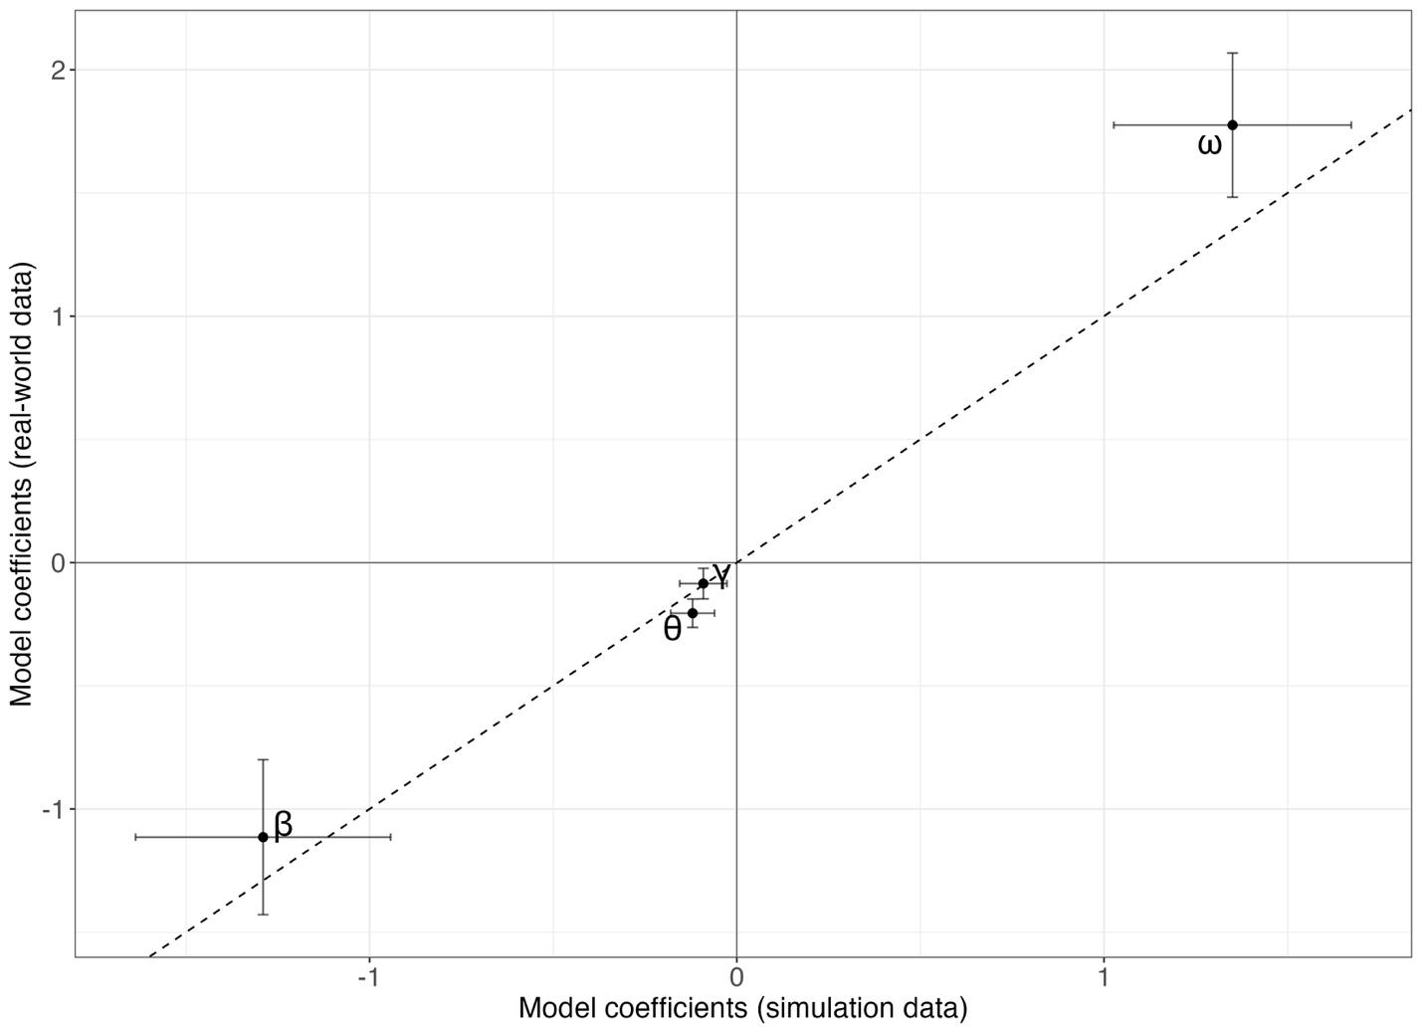

Supplementary Figure S2. Comparison of prediction error between the simulated (left) and empirical (right) data where the baseline Z comes from a dataset of N = 358 samples.
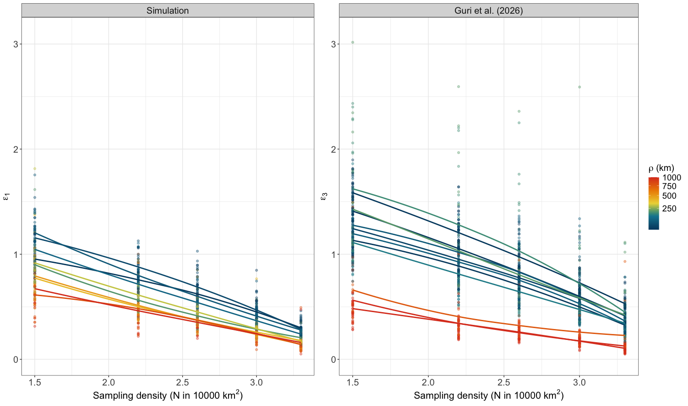
Supplementary Figure S3. Visualization of the lower and upper bars of prediction given the prediction error (ε) per sampling effort (E) when the true eDNA concentration is 100 copies/L.
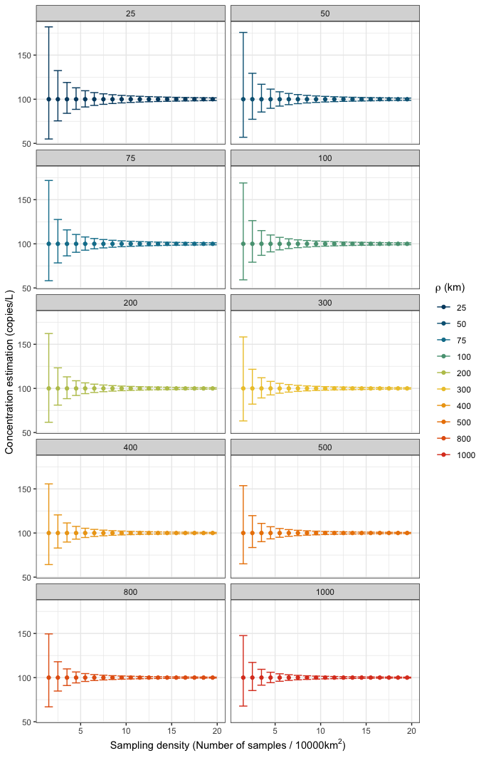

Supplementary Figure S4. Bias vs precision, to prove that RMSE used here is mainly accounting for precision and not bias.
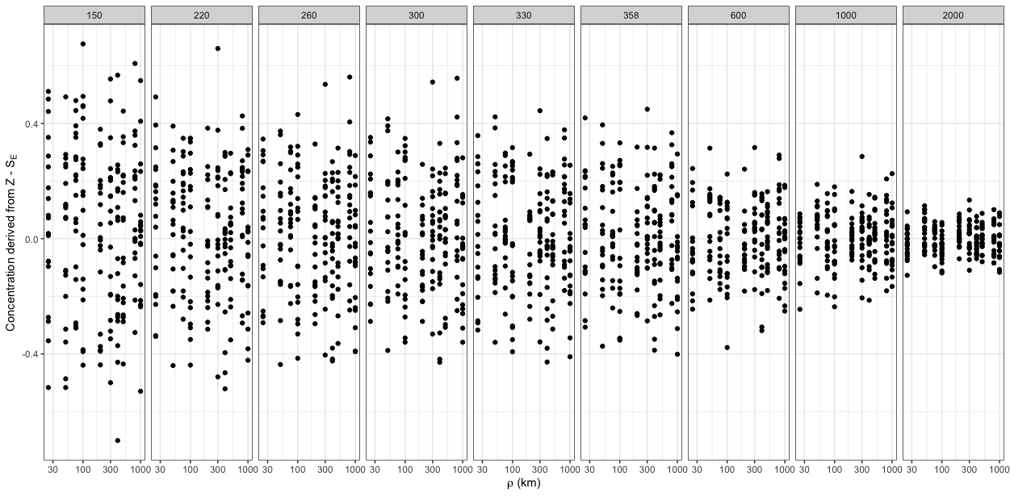

Supplementary Figure S5. Showing the observations of the prediction error (dots) and the modeled estimates (line) from the fitted model using Eq. 6.
