Supplementary Information for Smart eDNA sampling strategies: Spatial autocorrelation can guide efficient survey design
Table S1. Parameter values used to generate the 200 simulated Gaussian process (GP) spatial fields. Each row defines one simulation scenario characterised by a single spatial autocorrelation length-scale (ρ), given in kilometres and ranging from 25 to 1000 km. Across all scenarios the non-spatial variance (σ²) is fixed at 3 and the amplitude (α²) at 4, and 20 replicate spatial fields are drawn per scenario (10 ρ levels × 20 replicates = 200 datasets). Columns give the scenario number, ρ (km), σ², α², and the number of replicate iterations.
Simulation | rho | sigma | alpha | No of iterations
1 | 25 | 3 | 4 | 20
2 | 50 | 3 | 4 | 20
3 | 75 | 3 | 4 | 20
4 | 100 | 3 | 4 | 20
5 | 200 | 3 | 4 | 20
6 | 300 | 3 | 4 | 20
7 | 400 | 3 | 4 | 20
8 | 500 | 3 | 4 | 20
9 | 800 | 3 | 4 | 20
10 | 1000 | 3 | 4 | 20

Figure S1. Comparison of regression coefficients estimated from simulated (in-silico in x-axis) datasets and the empirical (in-situ in y-axis) dataset for the model relating prediction error (ε) to sampling density (e) and spatial autocorrelation (ρ). Points represent the estimated coefficients for the intercept (ω), sampling density effect (β), spatial autocorrelation effect (θ), and their interaction (γ). Horizontal and vertical error bars indicate ±2 standard errors of the coefficient estimate from the linear models. The dashed line represents the 1:1 relationship, indicating perfect agreement between simulated and empirical estimates.

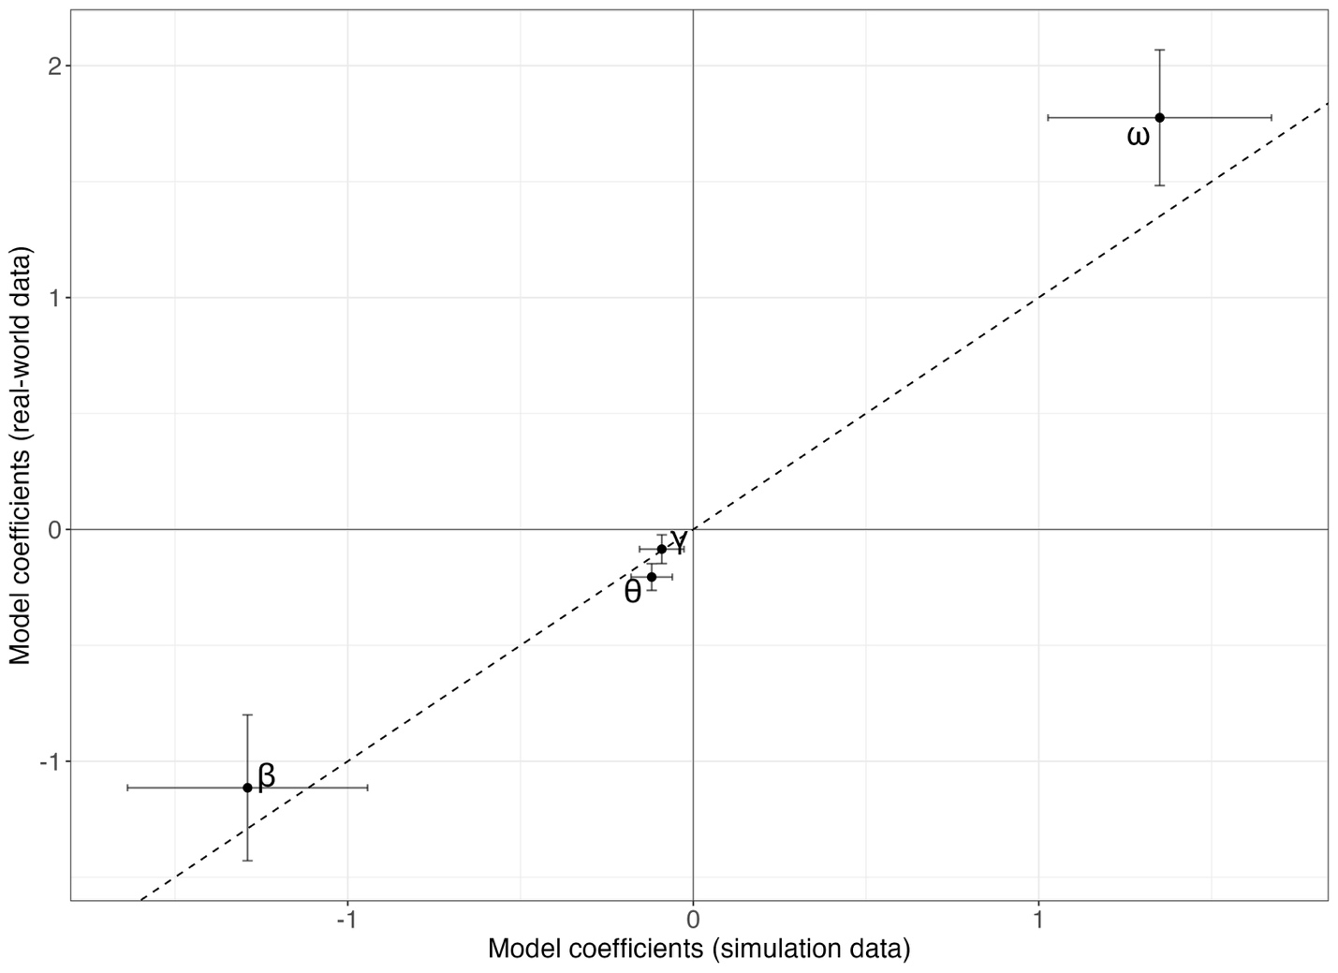

Figure S2. Prediction error as a function of sampling density for the simulated (left panel) and empirical (right panel) datasets, both referenced to a common baseline field (Z) derived from N = 358 samples. The x-axis is sampling density (number of samples per 10,000 km²) and the y-axis is prediction error (ε). Each point is an individual thinning replicate and each solid line is the fitted trend for a given spatial autocorrelation length-scale (ρ), coloured from dark blue (ρ = 25 km) through green and yellow to red (ρ = 1000 km).
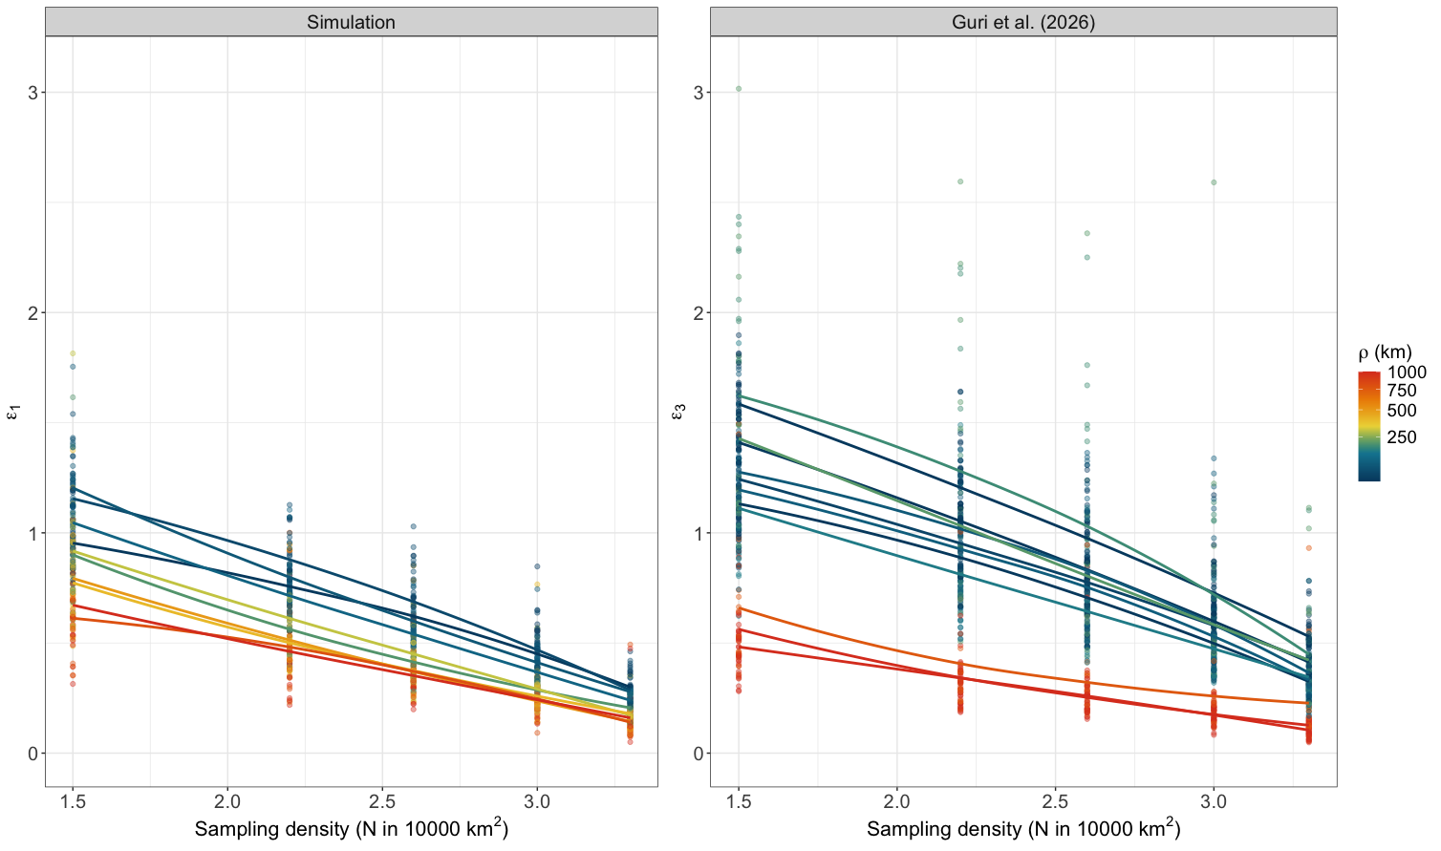
Figure S3. Predicted eDNA concentration and its uncertainty as a function of sampling density, shown in separate panels for each spatial autocorrelation length-scale (ρ = 25–1000 km; colour from dark blue for small ρ to red for large ρ). In every panel the x-axis is sampling density (number of samples per 10,000 km²) and the y-axis is the estimated concentration (copies/L) for a true value of 100 copies/L. Points mark the central estimate and vertical bars show the lower and upper prediction bounds implied by the prediction error (ε) at each sampling density.
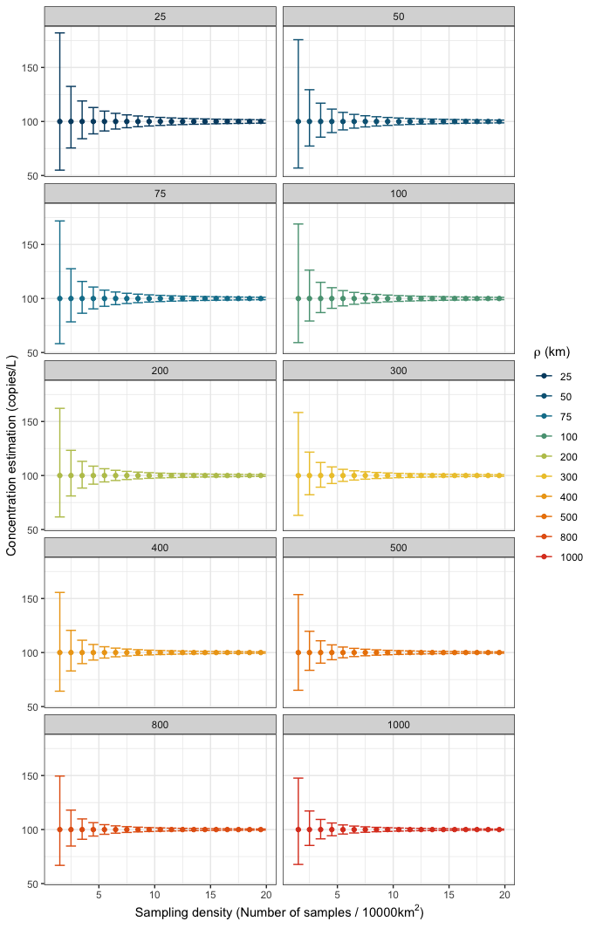
Figure S4. Per-grid-cell differences between the reference field (Z) and the effort-specific predicted field (Sₑ), shown in separate panels for each sampling effort (N = 150–2000 samples). Within each panel the x-axis is the spatial autocorrelation length-scale (ρ, in km, on a log scale) and the y-axis is the difference Z − Sₑ. Each point is one grid-cell residual across simulation replicates, plotted relative to the zero reference line.
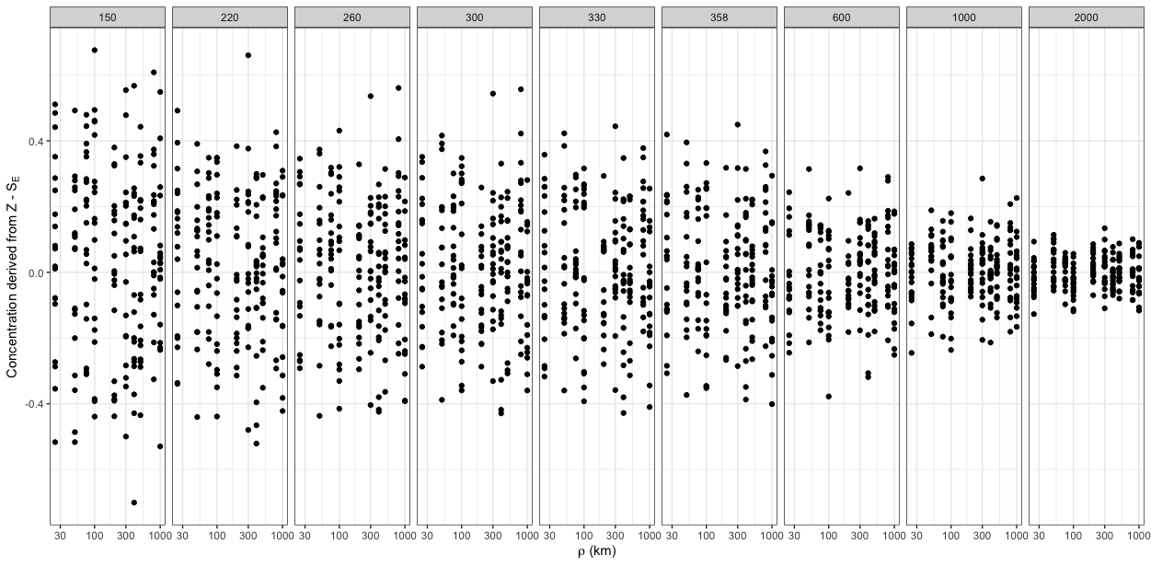

Figure S5. Observed prediction error and the corresponding fitted model values across sampling density. Points show the individual simulated prediction errors (ε₂) and dashed lines show the fitted values from the log–log model (Eq. 6). The x-axis is sampling density (number of samples per 10,000 km², on a log scale) and the y-axis is prediction error (ε₂). Points and lines are coloured by spatial autocorrelation length-scale, from ρ = 25 km (dark blue) to ρ = 1000 km (red).
