Smart eDNA sampling strategies: Species spatial autocorrelation can guide efficient marine survey design

Gledis Guri¹, Ryan Kelly¹, Ole Shelton², Krista M. Nichols²

Introduction
Marine sampling efficiency plays a critical role in collecting sufficient and representative samples to accurately assess species distributions, forming the foundation for sound fisheries management and stock assessment protocols. In stock assessment contexts, determining the appropriate sample size is vital for reliable estimation of population parameters including abundance, demographic structure, and spatial distribution patterns. This process must balance the need for sufficient data for detecting population trends and changes while also ensuring that incurring unnecessary costs or effort are minimized. Therefore, efficient sampling strategies are designed to capture the spatial variability of marine communities, allowing researchers to infer important ecological traits such as habitat preferences and ecological niches.

While increased sampling intensity generally reduces variance in population estimates and improves the precision of spatial pattern detection, this relationship exhibits diminishing returns where beyond a certain threshold, additional sampling effort produces marginal gains in statistical precision that may not justify the associated costs and logistical demands. The optimal sampling intensity occurs at the point where incremental improvements in precision or information content become disproportionately small relative to the required investment of resources and effort. This principle guides the development of cost-effective sampling strategies that maximize analytical power while minimizing operational expenditure.

The emergence of environmental DNA (eDNA) sampling has revolutionized marine monitoring capabilities, offering a non-invasive method to detect species presence and estimate relative abundance. However, eDNA introduces unique considerations for sampling design. Unlike traditional methods where detection occurs at the point of sampling, eDNA signals integrate information from surrounding areas through processes of DNA transport and decay. This spatial integration effect means that adjacent eDNA samples may contain overlapping information, making the question of optimal spatial sampling resolution even more critical.

In many inferences of species distribution, habitat preferences and population estimates, statistical models such as Gaussian Processes (GP) are typically used to explain and understand the predictive patters of fish aggregations, population estimates, and dispersal across space. [give some examples]. The foundation of this approach rests on the assumption that species distributions in nature follow patterns that can be effectively modeled using Gaussian Processes (GPs). This mathematical framework captures an essential ecological principle: species tend to form one or more areas of high concentration - "hotspots" - where individuals aggregate densely. As distance increases from these central areas, population density gradually declines in a smooth, continuous manner. The distribution of a species at various locations can be expressed as:
$$Y_{i} \sim MVN(μ_{i},k(x,x'))$$
$$k(x,x')=α^{2}*exp⁡\left(-\frac{1}{2ρ^{2}}*{\left\|x-x'\right\|}^{2}\right)+σ^{2}$$
where Y is the observed abundance or density of the species at location i with a mean abundance μ and covariate matrix k of coordinate x and x’. The covariate matrix is the most important part of the Gaussian Process (GP) as it determines the spatial autocorrelation of the species distribution where α is the amplitude of the x-x’ correlation, ρ is the length-scale parameter meaning the correlation (in x-x’ units) where the signal fades out, and σ is the noise in nature. Species with small spatial autocorrelation (ρ) values exhibit rapidly changing abundance patterns over space, indicating highly localized distributions with sharp boundaries between high and low-density areas. Conversely, species with large ρ values display smoothly varying abundances that remain spatially autocorrelated over greater distances, suggesting more gradual transitions and broader distribution patterns.

In simple terms, knowing the spatial autocorrelation of species distributions provides a quantitative basis for optimizing sampling effort—species exhibiting high spatial autocorrelation should require fewer samples to capture their distribution patterns due to their extended spatial coherence.

Here we investigate the relationship between species-specific precision of abundance estimate inferred from GP models under varying sampling efforts and the spatial autocorrelation parameter. Due to the spatiotemporal integration in eDNA signals – DNA signal from organisms located at varying distances from the sampling site and at different time points prior to collection - an additional layer of spatial autocorrelation is introduced beyond what would be expected from species distribution patterns alone. Consequently, when applying Gaussian Process models to eDNA data, the spatial autocorrelation parameter inherently captures both the natural clustering patterns of species distributions and the physical processes that govern DNA dispersal and decay in the marine environment. Without concurrent independent sampling methods such as trawl surveys or acoustic monitoring to provide direct measures of local abundance, these two fundamental processes - biological smoothness and spatiotemporal eDNA integration - cannot be empirically separated and are therefore represented as a single integrated parameter within the modeling framework.

Methods
Here we used both simulated (Gaussian Process parameters) and real-world eDNA concentration data (unknown Gaussian Process parameters) to evaluate the impact of sampling effort on spatial field prediction accuracy. For each dataset, we first fitted Gaussian Process models to estimate the GP parameters and predict eDNA concentration across the spatial field. We then systematically reduced sample sizes by randomly removing 10%, 20%, 30%, 40%, and 50% of the original sampling points and re-fitted the Gaussian Process models to these reduced datasets. To quantify the effect of reduced prediction accuracy for each sampling effort, we calculated the prediction error (ε) as the difference between the spatial fields predicted from the complete dataset and those predicted from each reduced sampling scenario. We iterated this process 100 times to get better estimates.

This paper presents a unified framework for spatial sample thinning that addresses these challenges by: (1) leveraging GP models to explicitly characterize spatial autocorrelation in species distributions, (2) developing methods to identify optimal sampling resolutions based on estimated length-scales, (3) incorporating the unique characteristics of eDNA sampling into spatial design considerations, and (4) providing practical guidelines for implementing spatial thinning strategies in real-world fisheries assessments. By aligning sampling effort with the inherent spatial structure of marine populations, this approach promises to enhance both the efficiency and effectiveness of marine monitoring programs, ultimately supporting more informed fisheries management decisions.

Ecological Interpretation of the Covariance Structure
The abundance correlation between any two given points decays with increasing distance according to the link function of the covariate matrix. The covariance kernel k(x,x′) defines how species density diminishes with distance from a hotspot. Correlation between sampling points decays exponentially, governed by ρ: at distances greater than ρ, abundances become largely independent. The parameter α² sets the baseline abundance level on the y-axis, while σ² is the uncertainty around the relationship line. This relationship can be visualized as a curve where the correlation coefficient gradually diminishes as sampling points become more distant from each other (Fig. 1B)
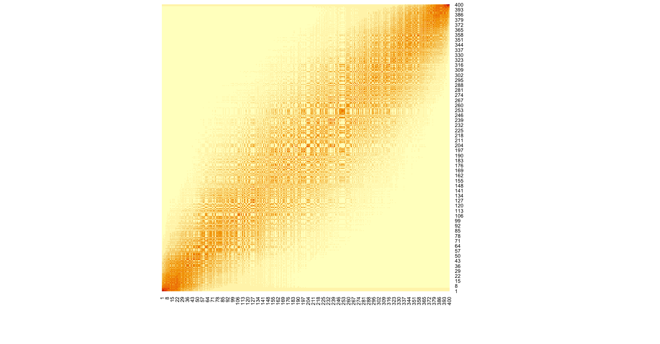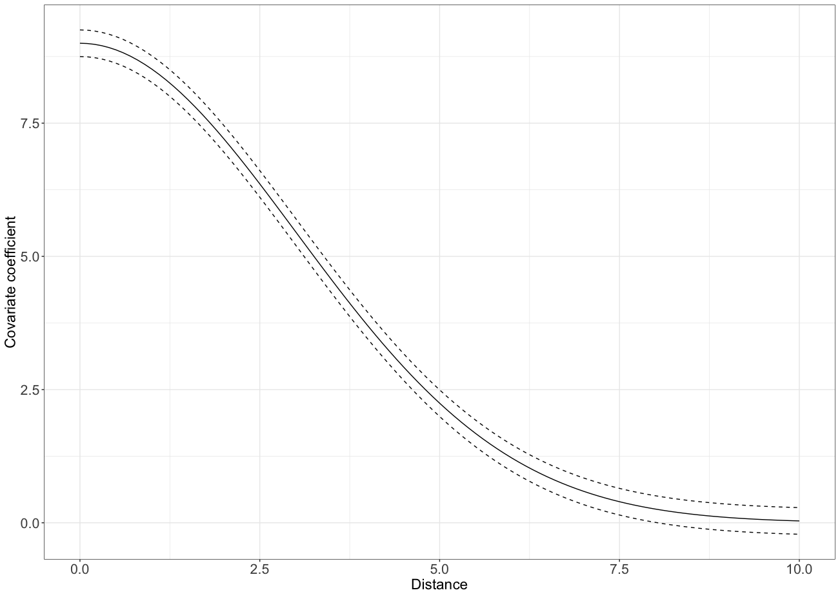

Species with small ρ values exhibit rapidly changing abundance patterns over space, indicating highly localized distributions with sharp boundaries between high and low-density areas. Conversely, species with large ρ values display smoothly varying abundances that remain spatially autocorrelated over greater distances, suggesting more gradual transitions and broader distribution patterns.

The amplitude parameter α characterizes the magnitude of abundance variation across the entire spatial domain. Higher α values indicate greater contrast between abundance extremes—more pronounced differences between hotspots and low-density areas. Meanwhile, σ² represents the inherent variability or noise in the relationship, accounting for unexplained variation in abundance patterns.

In general, knowing the ρ values of the species distribution can help determine the sampling resolution as it is the indicator at which distance the values would not be spatially autocorrelated.
Because we are using eDNA methods, the observation is inheriting the added stochasticity of the abundance being present at point x and the signal being detected at another point x+d, where d is the distance at which the source signal can still be detected, hence it is a function of DNA transport and decay. Given this argument, when using GP on eDNA samples the ρ parameter encapsulates both processes, the abundance correlation and DNA transport in space between any two given points. Without additional independent data (such as trawl catches or acoustic survey) these two processes cannot be disentangled hence are going to be represented by one parameter (ρ).

Simulation
I set up a couple of simulations to explore and understand the nature of GP and how we can extract information with respect to giving inference of sampling design. The typical way to conduct this type of analysis is by leave-one-out analysis. However, this type of analysis usually yields information how many samples one can remove from the current sampling design and often does not yield the information if you are already under-sampling.
So, I wanted to explore two questions:
How can we know that we are not under-sampling initially, hence everything we derive is already a sampling thinned scenario; and is there a quantitative absolute threshold of error (with ecological interpretation) that should not be surpassed.

Does the initial sampling density influence the outcome of leave-one-out analysis and how can we know if the initial sampling was over-sampling or under-sampling.

Theoretically if we were to imagine that 1 is undersampling, 4 is just the right amount of sampling, and 9 is oversampling, then we can use this function to understand if we are already undersampling or oversampling, by doing the spatial thinning of the samples and knowing in which area we are (left, middle, right).
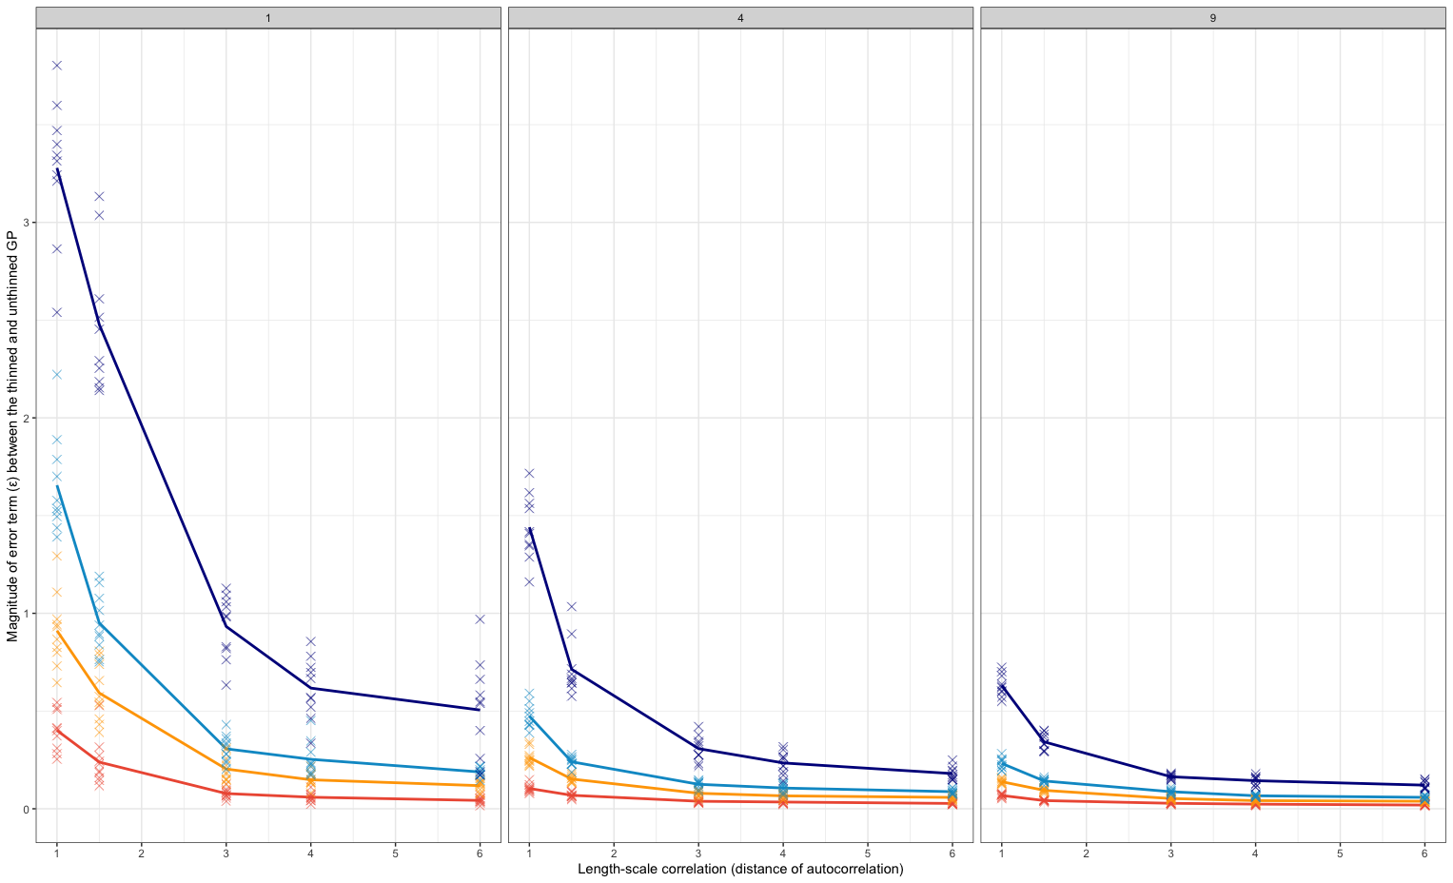
Can I build an estimator of this? Meaning, I put the d, the Δε and spit me the n?

Using simulated and empirical data for 40 lake and stream fish species, we demonstrate that t
