On Line Scheduler for Snow Creek Ski Patrol R1

Hi team, the following is how to get online to complete your personal data and to schedule your shifts.

Our website is **SnowCreekSkiPatrol.org** (the capitals are not necessary but I added them so you could easily see that it simply says Snow Creek Ski Patrol). Entering this into Google does not work so if you are using Google, enter [gledhills.com/SnowCreek/](http://gledhills.com/SnowCreek/) The result will be a screen that looks like this:

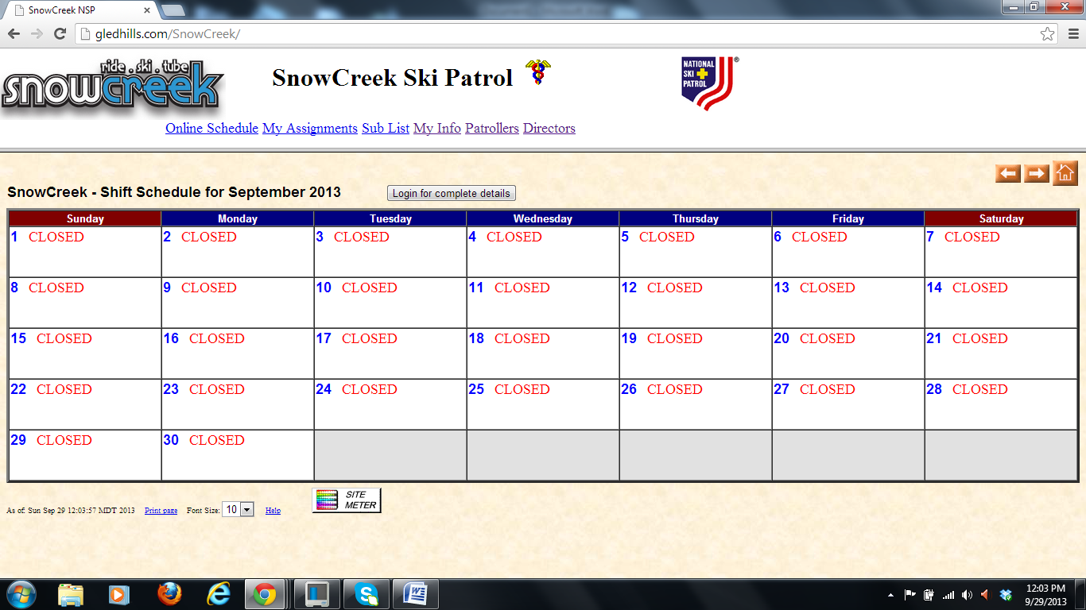

Now click on "Login for complete details" Your next screen would look like this:

*(Balance of page left blank for formatting purposes.)*

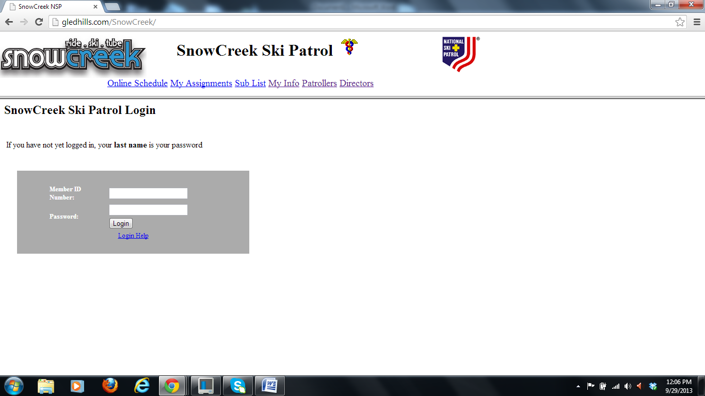

Insert your Member ID Number and Password. Your member ID number is found on your NSP card or, if you lost your card, your member ID is on the Roster kept by Ed Reitz. Note: Your number is this one.

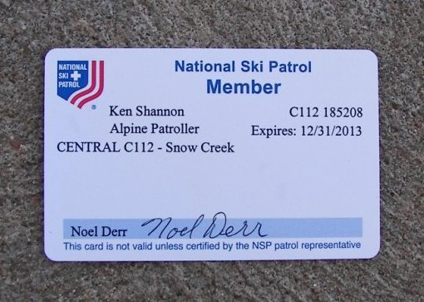

Currently, your password is your last name. It does not matter if you capitalize it or not.

If you goof on entry, you get many more chances. If on about the 3rd attempt you still fail, the problem may be my error. I could have entered your number or name incorrectly. Thus, send me an email explaining you are having difficulty AND provide me with your correct number AND spelling for your last name. Send that to [Kimber_CK@yahoo.com](mailto:Kimber_CK@yahoo.com) or [KenRexShannon@yahoo.com](mailto:KenRexShannon@yahoo.com) .

Assuming you are able to sign in, the web site will return you to the schedule.

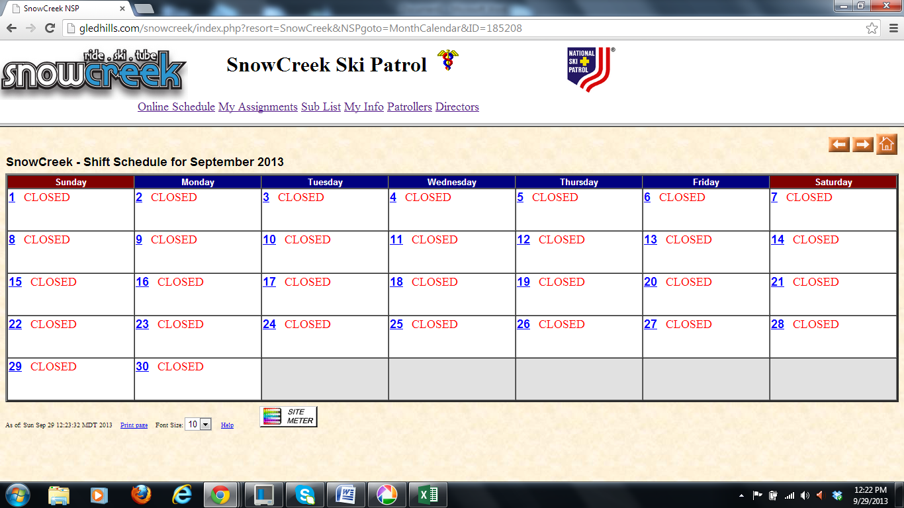

Now, click on "My Info" to fill out the table.

NOTE: We are using your last name to indicate if you are a toboggan handler (passed the hill test). If your name is all capitals “KIMBER” then you are a toboggan handler. If not in capital letters (Kimber) then you are not a toboggan handler. This is important later when we schedule as we MUST have at least two toboggan handlers on each shift. If your name is misspelled, please fix it. Contact me if I incorrectly indicated your toboggan handler status.

VERY important is your correct email address. You will receive notices of the schedule and reminders to that email so enter it.

If you are unfortunate, you will get a screen like this:

*(Balance of page left blank for formatting purposes.)*

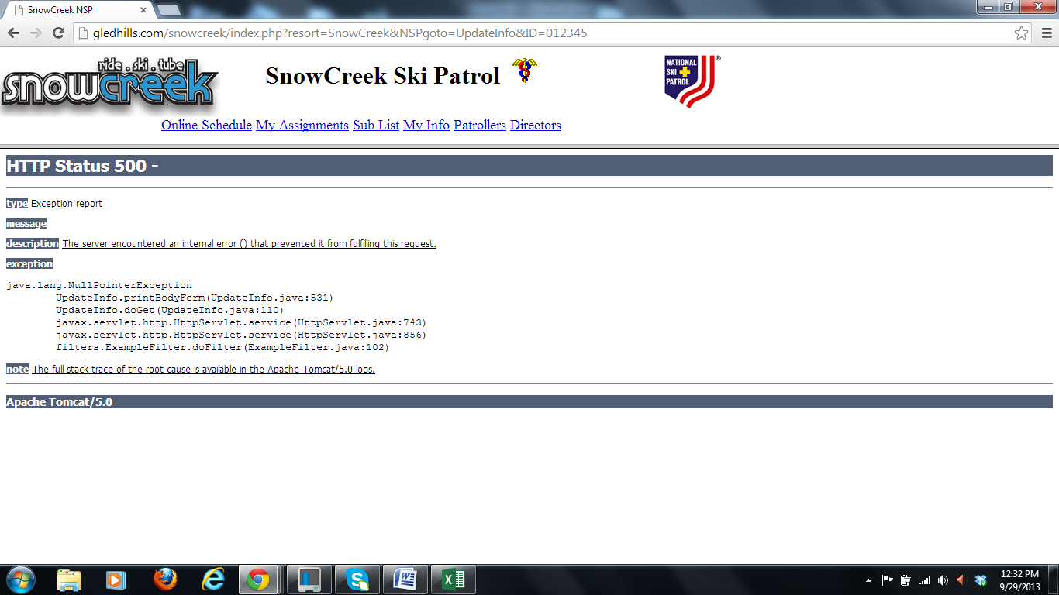

If so, try refreshing. If it sticks around, contact me and I will look into it. If you get a screen like the following:

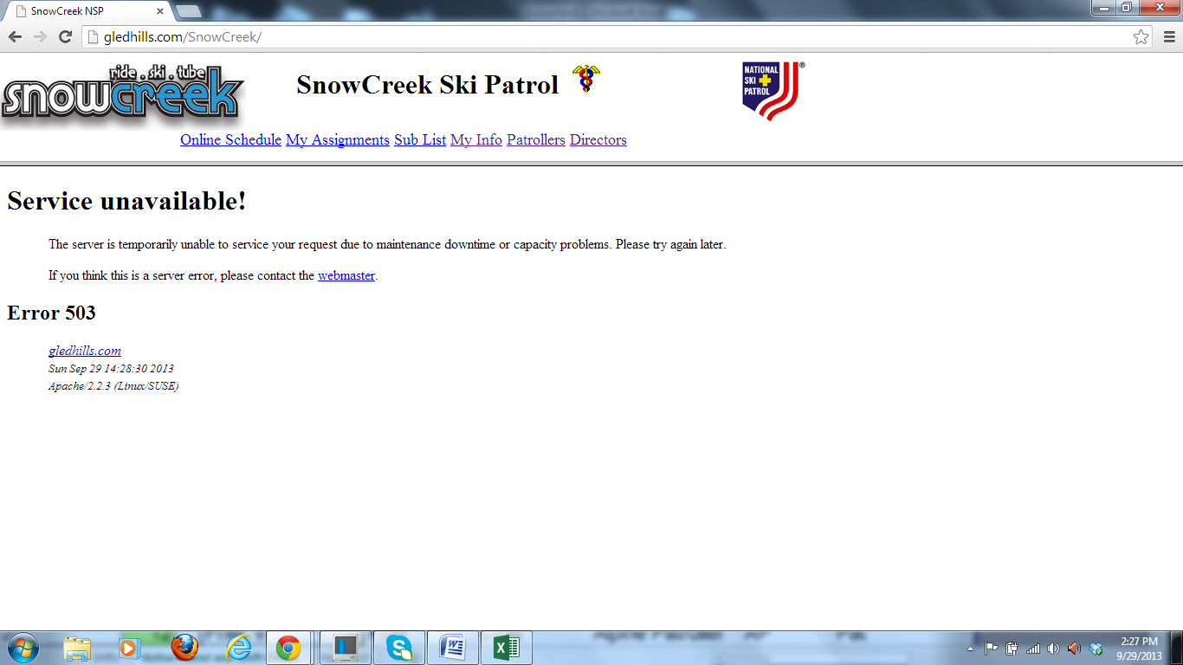

It is not your fault. Try refreshing. If this doesn't work, there is probably a server problem. Wait for a while and try again later. DON'T contact me. It is not my fault.

If you are Justin and you successfully signed in, your page would look like this:

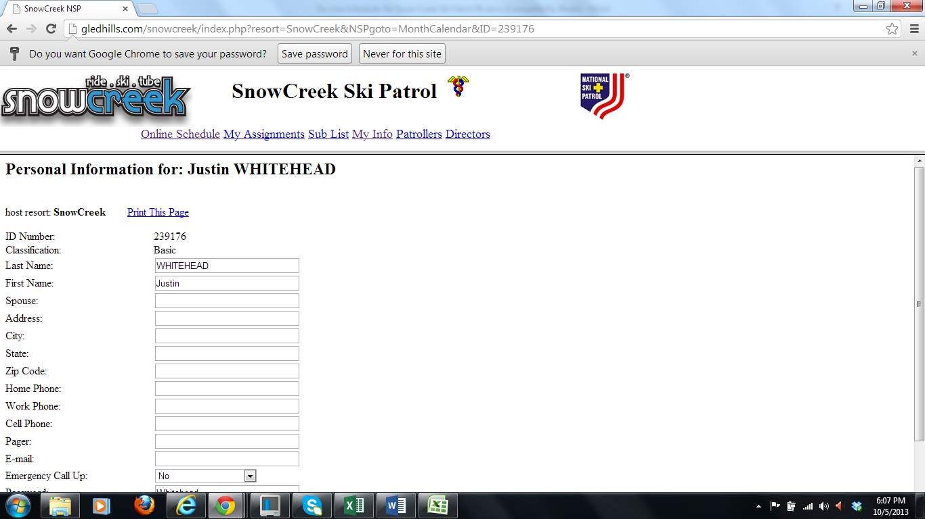

(The following is repeated for those that don’t read everything)

Look at your "Last Name". If your last name is all capitals, “WHITEHEAD”, that means you are a toboggan handler. THIS IS IMPORTANT so don't modify it (other than to correct spelling). Every shift MUST have at least two (2) people who are toboggan handlers. If you are approved to handle a toboggan and I didn’t enter you info in capital letters, let me know. I probably just goofed on entry.

If you live close to the hill and you can be drop whatever you are doing on the weekend for an emergency, definitely put "yes" for the "Emergency Call Up". When you scroll down, the balance of the page will look like this:

*(Balance of page left blank for formatting purposes.)*

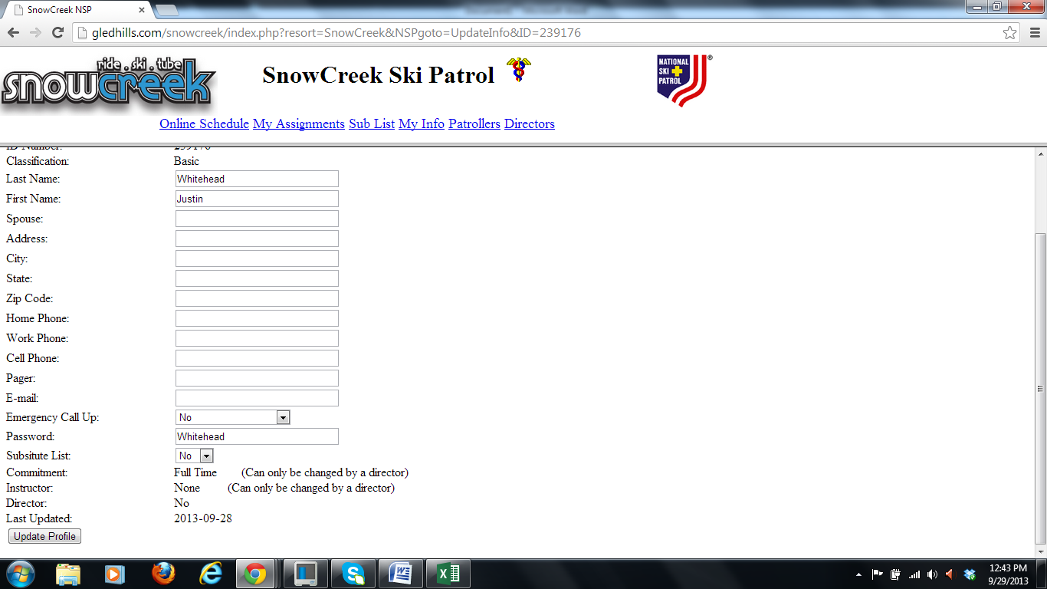

Here is where you can change your password if you decide to do so. Please record the password you select as there are no prompts should you forget what you selected.

Note: If you wish to have your name on a "Substitute List", click "yes". People on that list will be notified if someone removes their name from the schedule. If you are on that list, you will receive an email stating the slot is available.

When finished, click "Update Profile".

*(Balance of page left blank for formatting purposes.)*

The next screen looks like this: Now you can click on "Online Schedule". If you click on "Done", it will take you back to the "My Info" page. This puts you in a never ending "do loop".

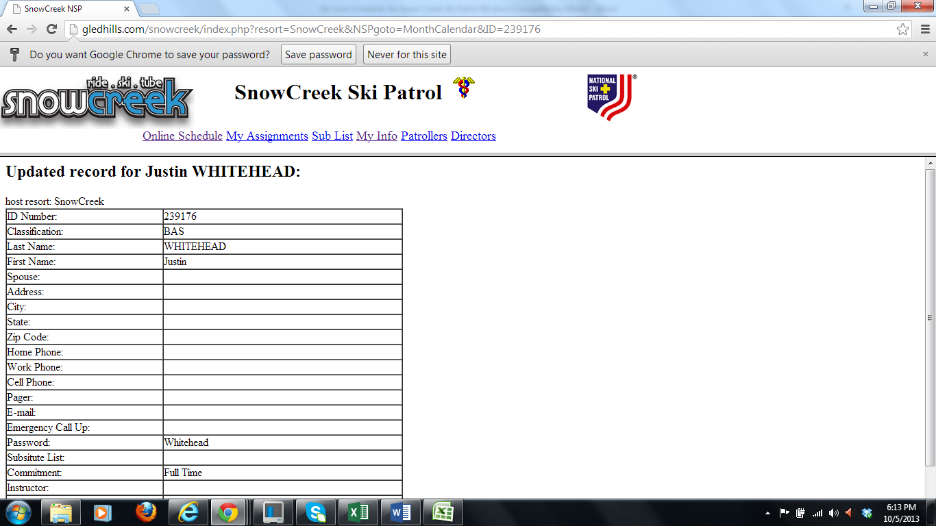

Clicking on "Online Schedule" takes you to this screen:

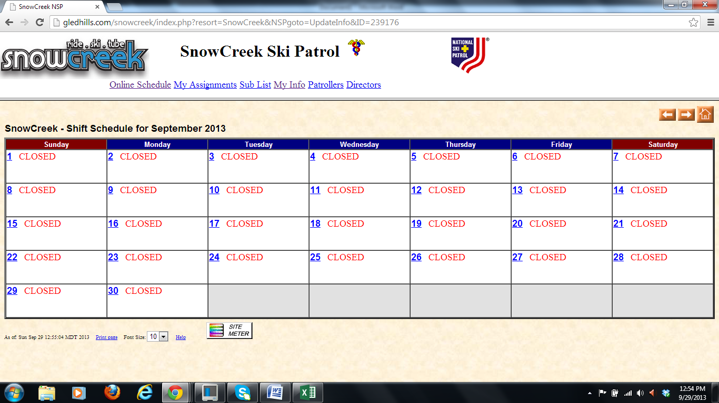

Arrow over to the month you wish to view. This page displays "September 2013".

NOTE: DO NOT FILL OUT THE SCHEDULE YET unless you are an instructor!

Instructors get the first shot at selecting four (4) schedule spots. The instructors are allowed one week to make their choices. After that week, the balance of the patrol, (with the exception of candidates) then gets to select four (4) schedule spots. After two weeks of allowing the balance of the patrol to select their four spots, the instructors will be allowed to select the balance of their spots (six). They are allowed one week to do this. The schedule will be again released to the patrol to select the balance of their choices. Two weeks after this third offering is when the candidates may choose their schedules.

Note: All shifts must be selected by January 15, 2014. There are only two exceptions to this standard; if you have a job that requires sudden, unanticipated travel and if you are an out-of-town student, we will allow you to make late scheduling choices.

Note: Scheduling is a first come, first serve basis. As mentioned earlier, if you are not a certified toboggan handler, you need to be careful in selecting your slots. We MUST have at least two (2) toboggan handlers per shift.

After there is coverage on each shift, we will open more slots. Typically there are about 6 patrollers per shift.

So, to enter your name in a slot, first scroll to the month. Again, you do that with the aforementioned arrow. Then, click on the day you wish to patrol (making sure you are on the correct month). Lets assume you choose January. Your screen will look like this:

*(Balance of page left blank for formatting purposes.)*

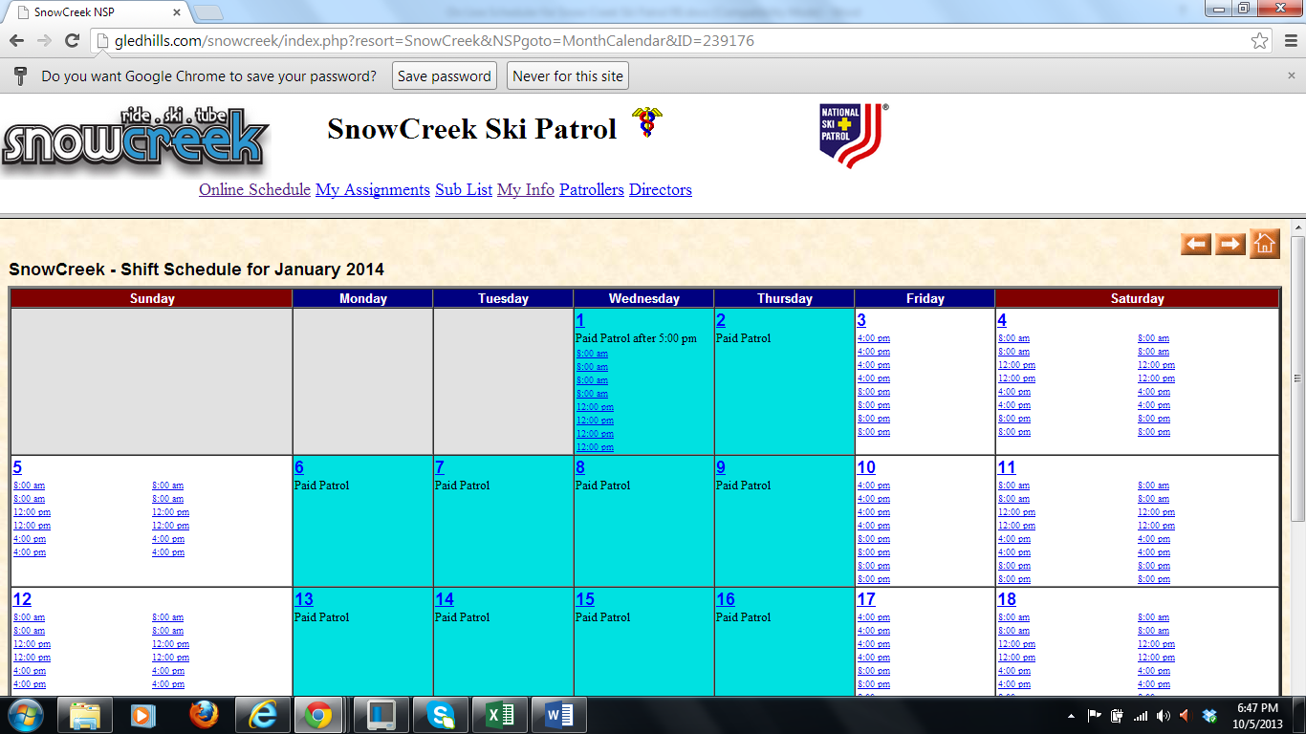

Now, (for this example, you are Justin) so if you want to work the 8:00 am shift, you would click on an 8:00 am slot. This next screen is zoomed into that area.

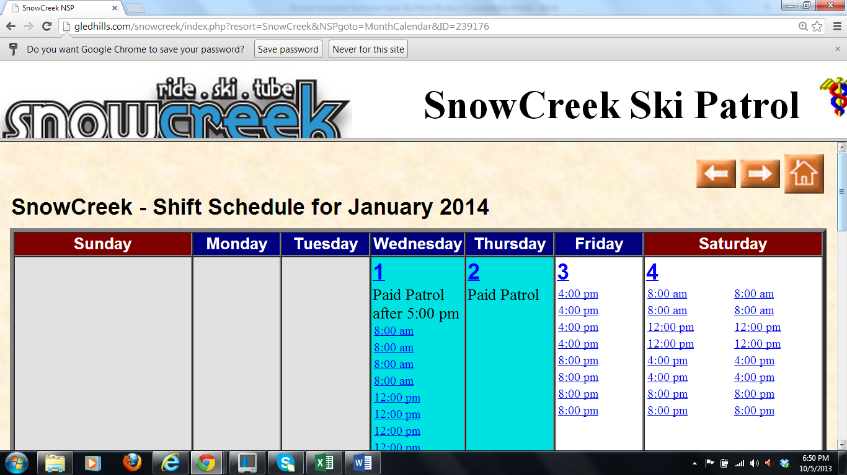

When you click on the “8:00 am” your screen will change to:

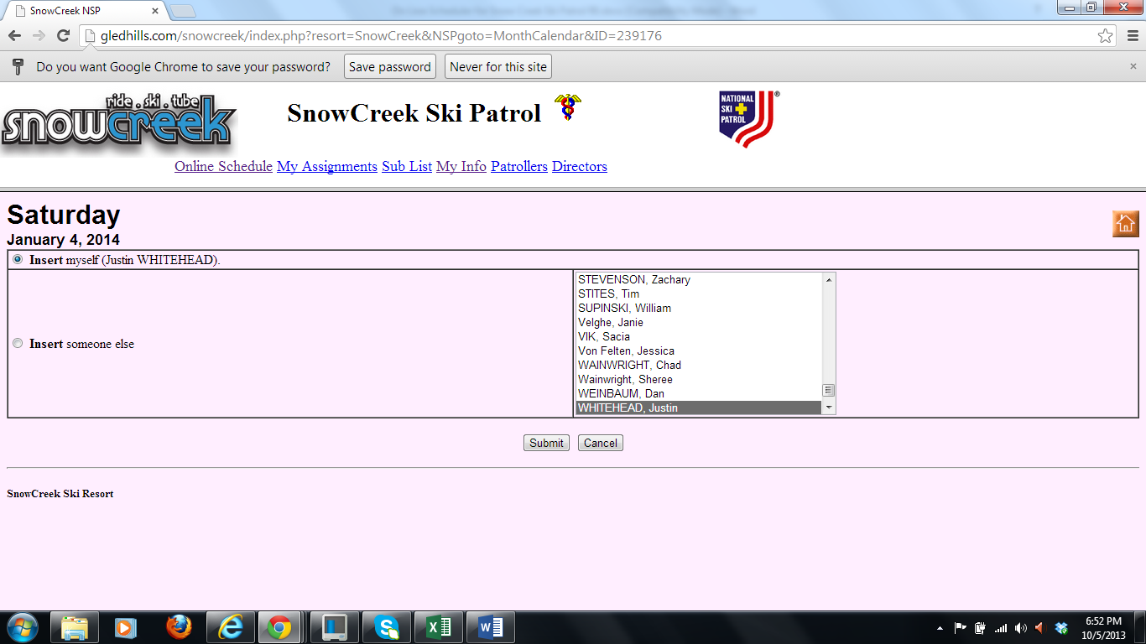

(I zoomed in so you can better see the results.) You have choices. If you wish to insert yourself, just click “Submit”. Note: The little circle has a green dot in the middle beside “Insert myself (Justin WHITEHEAD) If you are filling out the name for someone else (helping them if they don’t have a computer or you are scheduling an arch enemy for all midnight shifts) you can click on that name then click “Submit”. The green dot will automatically move to the “Insert someone else”.

The screen will then flash back to the schedule page and you will see your name in the 8:00 am slot. Way to go Justin! I zoomed in for your viewing pleasure.

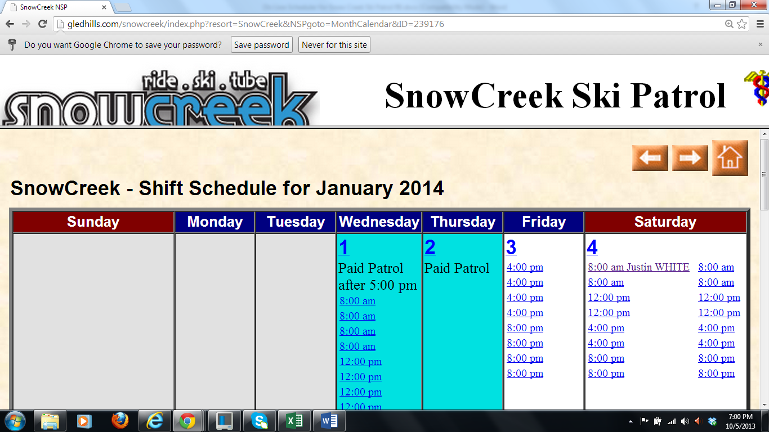

You can then select three more slots (the first round). At any time, you can click on “My Assignments” to see your list of scheduled shifts.

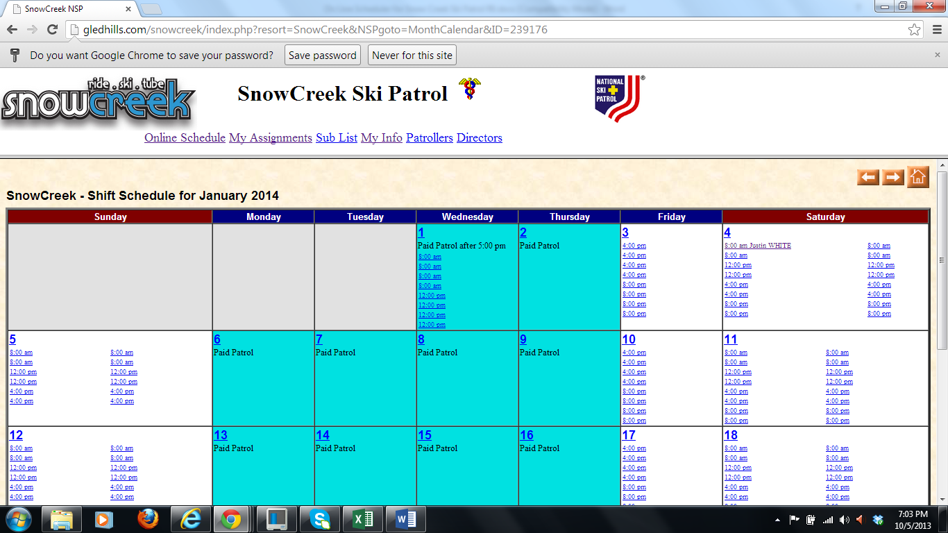

If you do that, the screen will jump to this:

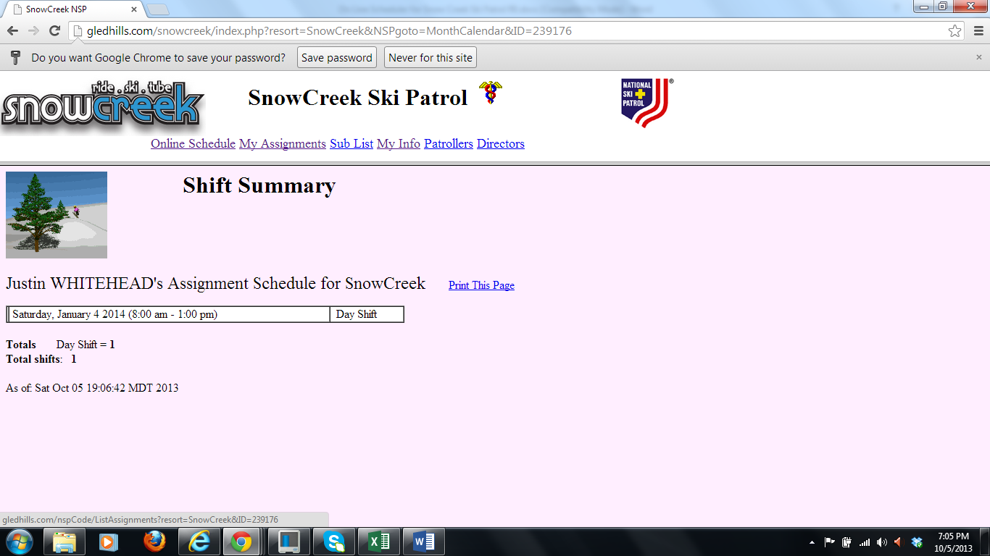

(The picture with the tree is Justin)

Two days before your assigned shift, you will get an email notice reminding you of your shift.

If you need to change your shift, go into the schedule and click on your name. Let’s use Justin again (as so many women before have done). Justin has a conflict and has to remove his name from the list. To do this, he clicks on his name:

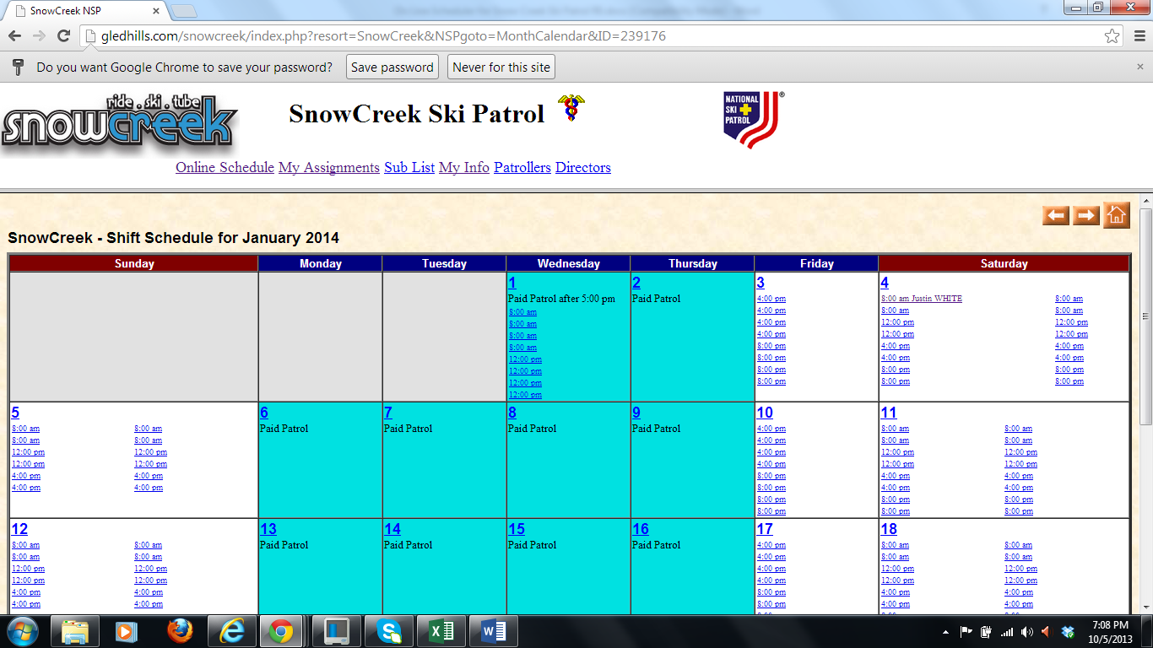

This screen now appears. Justin can then click “Submit”, replace with someone else or “Highlight as Needs a Replacement”. I recommend the Submit unless you are giving up your slot for someone else.

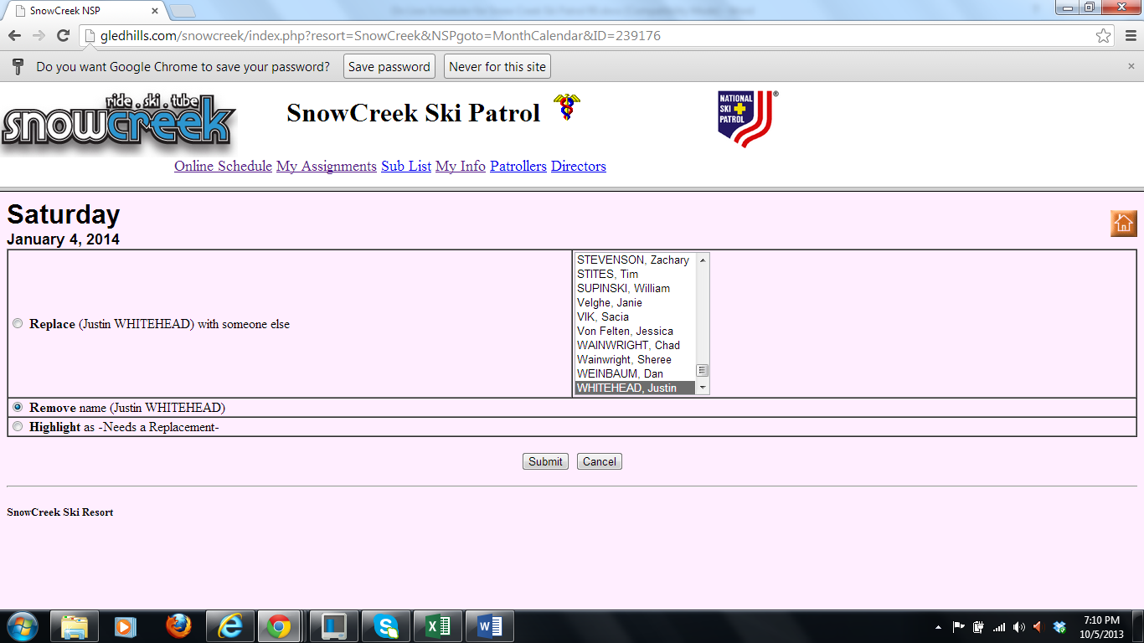

That is pretty much it. Contact Cindy Kimber [Kimber_CK@yahoo.com](mailto:Kimber_CK@yahoo.com) or Ken Shannon [KenRexShannon@yahoo.com](mailto:KenRexShannon@yahoo.com) if you are needing assistance.