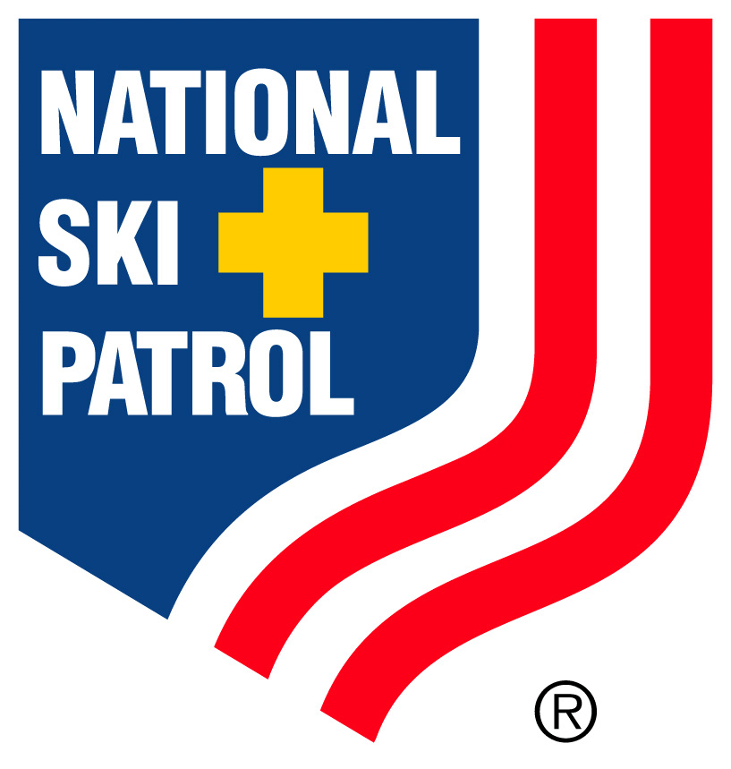 | Make a Difference, Become a Volunteer  Ski Patrol Open House and Ski Test  January 23rd or January 24th 2010  9 a.m. in the "A" frame building, (next to Crest lift)  Meet on the main floor. Yes, there is a cost $ – A Day Pass | 
You spend a day skiing with the patrol. The training staff will inform you if your skiing or boarding skills are at a level to continue on with the process of becoming a patroller, or if you need more practice.

If your skiing or boarding level meets the expectation you will be asked to join the on hill training class.
- January 30th through April 4th
- You must pass the skiing and toboggan handling test, which is an all day skill test
You must complete the OEC (Outdoor Emergency Care) first aid course, which includes professional CPR, written first aid test, and a practical first aid test. Classroom time covers 12 weeks: which breaks down to 2 nights per week, 3 ½ hours each class. The OEC class starts in September and runs through the middle of November. The class concludes with 3 on the hill working classes
You must be at least 17 years old.
Perks for Full-time Volunteer Patrollers
Requirements per season
- 16-18 weekend days
- 3-5 nights

Your Skiing privileges
- 1st year (Training year): Skiing privileges up to 3 times a week. Must be current on training!
- 2nd year and beyond: Season Pass
  - Ski credits or
  - Family program
  - Canyon UTA bus pass
  - Discounts on ski lesson
  - Discounts on food

Patroller’s are people who have a desire to help people
and
People who love to Ski and Board

Please print the form out below and mail back

Brighton Ski Patrol
Request for application
Please print information

Name:

First_________________________ Last __________________________

Address:
_____________________________________________________________

City ____________________________ State_____ Zip Code ___________

Home telephone number (_____) _____________________________

Cell number (_____) ___________________________________

Email Address _________________________________________________________

How many years have you skied or boarded? _____________

Tell us about you and your boarding or skiing experience:

____________________________________________________________________

____________________________________________________________________

____________________________________________________________________

____________________________________________________________________

____________________________________________________________________

__________________________________________________________________________

Mail this form to:
Brighton Ski Patrol
9489 Crosswood Lane
Sandy, Utah 84092

