**PROJECT SYNOPSIS**

**Project Title:-** FilmFrenzy (Movie Recommendation System)

**Group Number:-** 5

**Team Members:-**

1) Raghav Gupta (102117200)

2) Sahaj Garg (102117205)

3) Tarndeep Singh (102117210)

**Project Description:-**

The FilmFrenzy Web Application (Movie Recommendation Web Application) uses machine learning algorithms to suggest movies to users based on their preferences, previous viewing history, and other relevant data. The goal of this project is to create an AI model that can predict which movies a user is likely to enjoy and recommend those movies to them.

To build a movie recommendation AI system, the first step would be to collect a large dataset of movie information, including user ratings, movie genres, actors, directors, and other relevant data. This dataset would need to be preprocessed and cleaned to remove any errors or inconsistencies.

Next, the AI model would need to be designed and trained using machine learning algorithms, such as CountVectorizer , Cosine_Similarity. These algorithms would allow the AI to identify patterns and similarities in the data and use this information to make personalized movie recommendations for each user.

Once the AI model has been trained and tested, it can be integrated into a web application that allows users to input their preferences and receive movie recommendations. This application could be used by streaming platforms or movie rental services to help users find new movies to watch and increase engagement on their platforms.

**ALGORITHM:-**

Metrics:- CountVectorizer , Cosine_Similarity

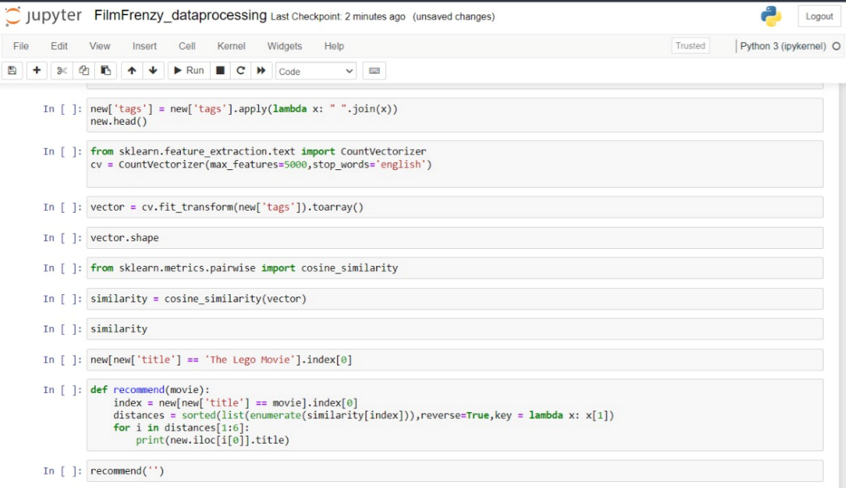

**Dataset:-**

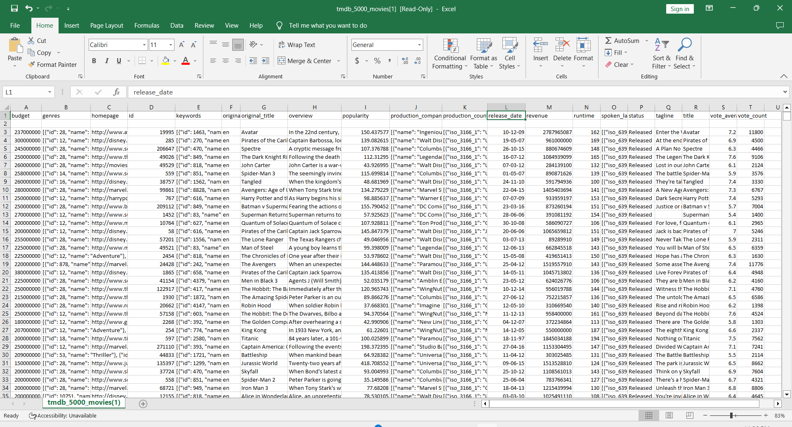

**Expected Output:-**

1) 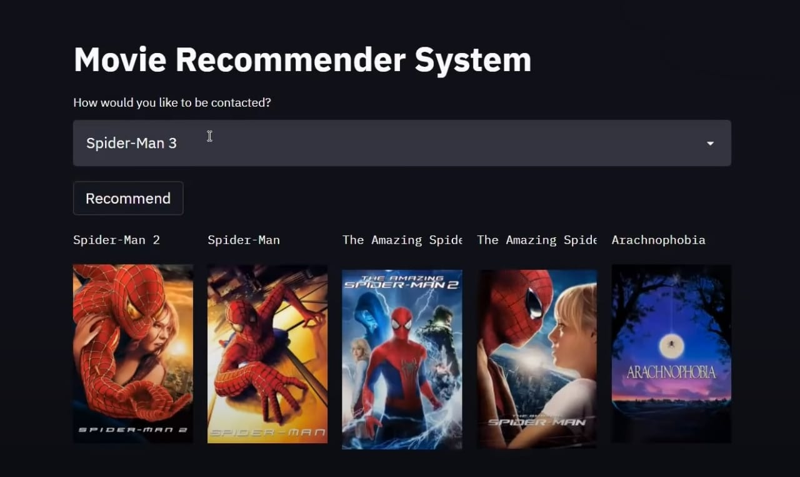

2)