HW4 – Understanding volatile saturation and degassing (22 pts)
The aim of this practical was first use VESical (Iacovino et al. 2021) to get students to investigate how solubility models differ. We use IaconoMarziano and Dixon as neither of these requires students to use a local thermoengine installation.
Then students use PetThermoTools to investigate what happens to volatiles from the mantle to the surface. They start by ascending a magma to see when volatile saturation initiates. Then, they let the same magma undergo fractional crystallization, noting the differential behavoir of H2O and CO2.
Finally, they ascend it towards the surface to see the large change in volatile volume (i.e. the driving force of volcanic eruptions!).

Q1 – We are looking at a typical, Kilauea magma composition.
1a – How much CO2 can be dissolved at 1000 bars, 1200C, in a pure CO2 system (so X_fluid = mol fraction of water in the fluid = 0)?
{'H2O_liq': 0.0, 'CO2_liq': 0.05314192542591163}
1b – Now change X_fluid =0.05 (e.g. 5% H2O in the fluid phase), and rerun the calc. What is the fractional change in CO2 content (e.g. CO2 dry/CO2 0.05). Is this what you would expect from Henry’s law?
{'H2O_liq': 0.7540099313023552, 'CO2_liq': 0.056696649828960936}
CO2 dry/CO2 0.05 = 0.9373027433936048
No, opposite of Henry’s law, which would predict that the system with some of another volatile phase would have lower CO2 solubility.
1c – How much CO2 can be dissolved at 3000 bars, 1200C, in a pure CO2 system (so X_fluid = mol fraction of water in the fluid = 0)?
{'H2O_liq': 0.0, 'CO2_liq': 0.1876342635470089}
1d – Now do again for X_fluid=0.05 at 3000 bars. How does the change in CO2 compare with the 1000 bar
{'H2O_liq': 1.347983283365527, 'CO2_liq': 0.21967629396451244}
CO2 dry/CO2 0.05 = 0.854, much bigger change.
1e – for 1000 and 3000 bars, do calculations at 10 different values of X_fluid. Save the values and plot an isobar diagram (H2O on x axis, CO2 on y axis), with your 10 datapoints. Your life is going to be easier if you write a forloop for this:
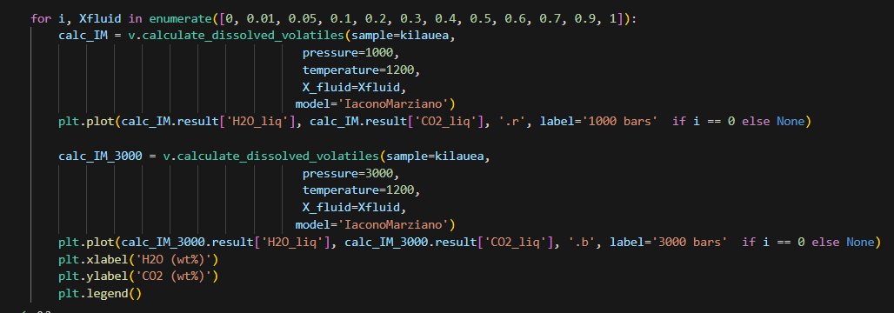
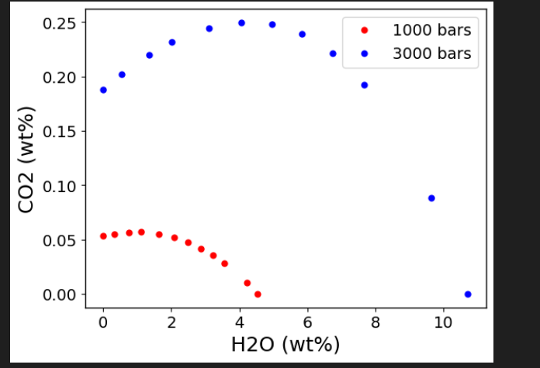
1f) How do you explain the larger change in CO2 for 3000 bars by changing XH2O=0.05 vs. 1000 bars?
Fluids are more unideal at higher pressures – adding small amounts of water increases the solubility of CO2 vs. decreasing it as Henry’s law would predict.
1g) Now do the same calculation using model=’Dixon’, and overlay them on this plot. What are the differences?
Dixon shows only ideal behavior. Massively difference H2O solubility behavoir, CO2 is actually pretty similar between models. IM puts a lot of H2O in the fluid.
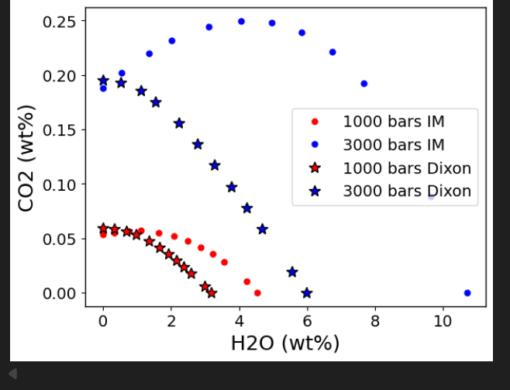

2 – We are going to consider what happens when a primary Hawaiian melt ascends from 30 km depth (10,000 bars) up to 3 km (1000 bars). Remember, Kil_decompress is a dictionary. To get the keys do Kil_decompress.keys(). The ‘All’ key has most things you need in it
2a- Plot ‘P_bar’ vs. ‘CO2_Liq’, and ‘P_bar’ vs. ‘H2O_Liq’, and screenshot below. Remember to label your axes.

2b) How much CO2 degasses vs. H2O? What would you speculate XH2O (proportion of H2O in the fluid phase would be)?
~80% of the initial CO2 degasses, while only ~3% of the H2O degasses (don’t be too fussy grading this, some offset is that MELTS is renormalizing).
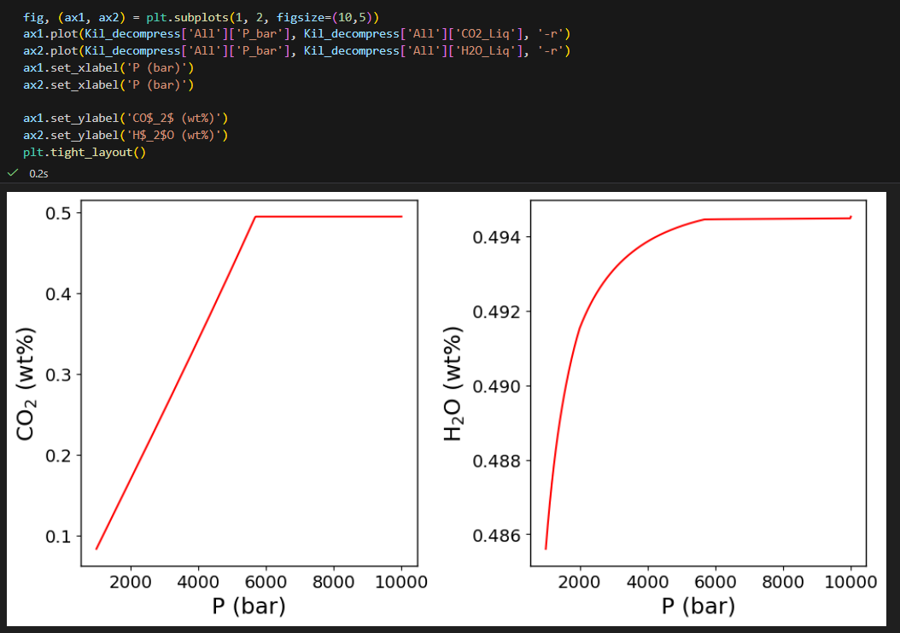
2c) Describe what happens to the system at ~6000 bars in terms of the physical phases present.
Before 6000 bars, CO2 is constant, and so is water. There is no vapour in the system. you can confirm this by doing kil_decompress[‘PhaseList’]. There is no vapour phase at the start of the model, so the magma hasn’t reached volatile saturation yet. It vapour saturates at 6000 bars.
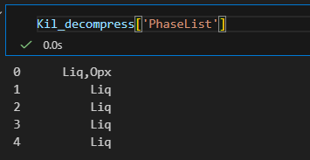
2d) What type of boiling is this?
First boiling – occurring during magma ascent.
2e) Plot 'X_H2O_mol_Fl' against pressure. If this gas makes its way to the surface diffusively, what volatile species do we expect to be dominant?
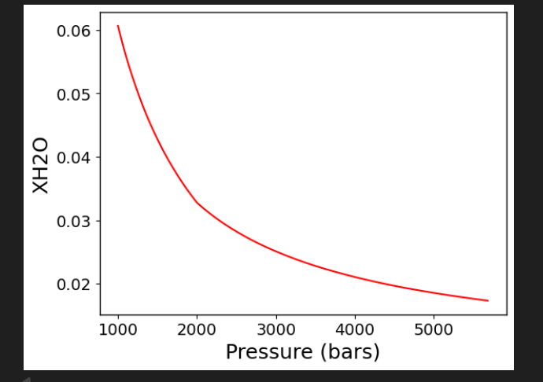
Volatile phase is dominated by CO2. Only a max of 6 mol% H2O. So would expect to measure CO2 diffusively degassing.
3 – Now we are going to consider what happens once this magma has stagnated at 1000 bars, and begins to cool and undergo fractional crystallization.
3a – What is the order of phase appearance during crystallization?
Liq + Fl => Liq+Fl+Ol => Liq+Fl+Ol+Cpx => Liq,Fl,Ol,Cpx,Plag => Liq,Fl,Ol,Cpx,Plag,Sp => Liq,Fl,Cpx,Plag,Sp,Cpx2 => Liq,Fl,Cpx,Plag,Sp,Opx
3b – At what point does the magma saturate in volatiles?
This is a trick question – The magma stays volatile saturated throughout! Its very hard to be come volatile undersaturated again!
3c –We are currently running this as an open system for H2O and CO2, so the moment the bubbles form, they escape. Plot what happens to H2O and CO2 in the melt against the MgO content of the melt.
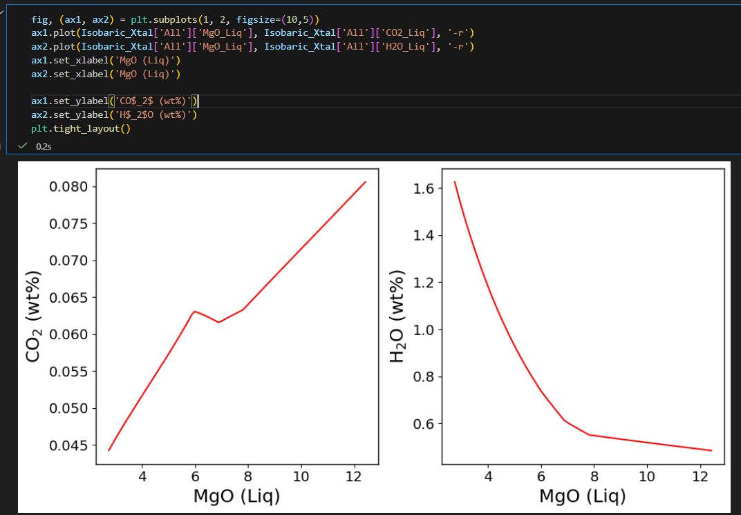

3d – Why do they do different things? Hint: plot the fluid composition against MgO and the cumulative amount of fluid exsolved against MgO (you can find this under the ‘mass_g’ key in the dictionary, the _cumsum columns show the cumulative sum, the other columns in show the amount of phase formed at each step). What happens to the amount of fluid during FC?
The fluid is dominated by CO2, so most the mass lost is CO2, not H2O. H2O behaves almost incompatibly. Amount of fluid exsolving correlates pretty well with MgO.
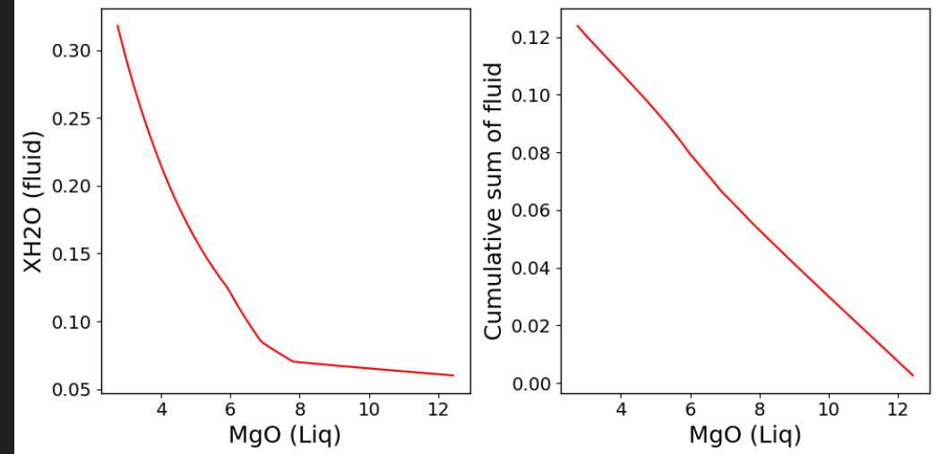
3e – Now run the calculation with Frac_fluid=False. This will keep the fluid in the system. Look at the ‘volume_cm3’ dataframe. Calculate the % of fluid, where % fluid = 100*fluid volume/(liquid volume+fluid vol). Plot this against MgO. The % fluid in the system is the amount of vesicularity – e.g. the vol% of the bubbles in the melt.
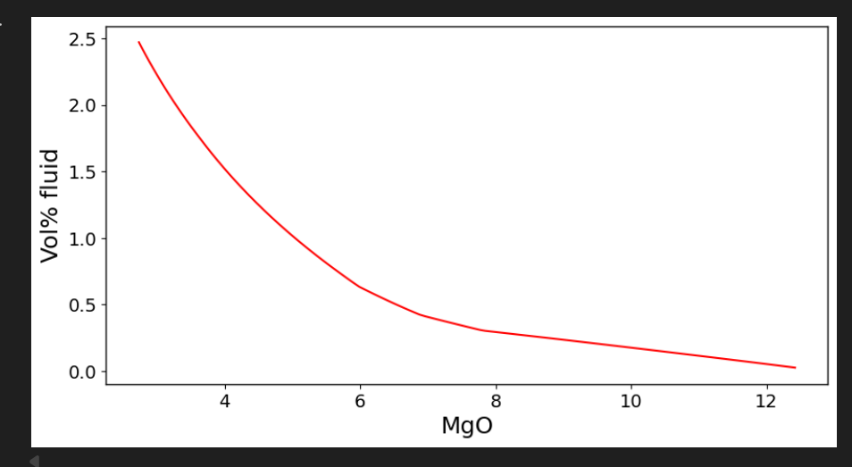
4 – Now lets let the fractionated magma (e.g. last step in the frac_fluid=True model) ascend up towards the surface during an eruption. This completes its journey from the mantle into the crust!
4a- What rock type is this now?
An andesite on a TAS diagram
4b – Plot H2O (x axis) vs CO2 (y axis) in the liquid. Also plot CO2 vs pressure and H2O vs pressure. Describe what happens to each volatile phase during degassing.
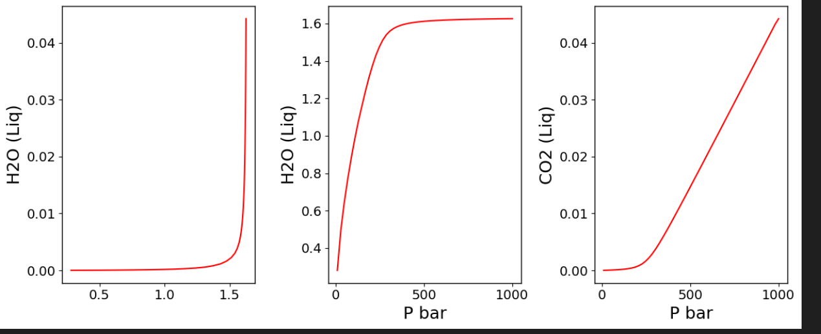
CO2 drops very quickly in the melt, and H2O only really begins to degass very close to the surface.
4c – Plot Pressure (x axis) vs. SiO2 in the liquid. What happens to SiO2 during ascent?
SiO2 goes up – quite dramatically!
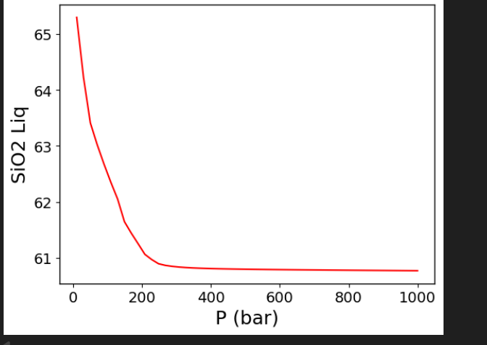
4d – Why is SiO2 going up?
All the phases fractionating have less SiO2 than the bulk magma (around 50-55 wt% for silicates, vs 61 wt% for magma). As you ascend, you degass water, and cause crystallization of solid phases as the effective liquid temperature goes up, so you are further from the liquid so get more crystallization.
4e – Plot volume % volatiles vs. pressure. You can either reference volatiles to the liquid as above, or include the solid phases. Just state what you did. Describe what happens to vesicularity as you ascent
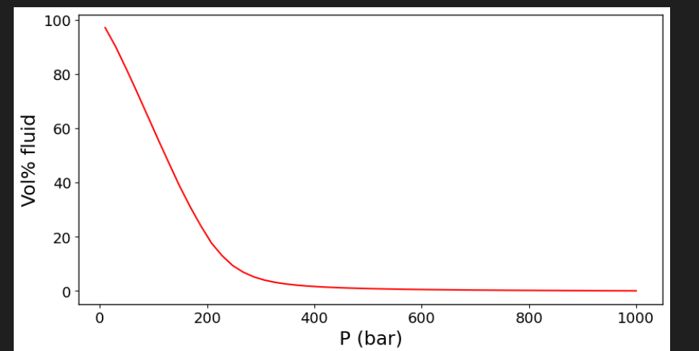
Degassing really starts around 200-300 bars, by the time you get to the surface, the magma is almost 100% volatiles – e.g. very thin melt films.

