Geofence-based Urban Mobility in Latin American Cities: An Empirical Evaluation of RutAI, an Integrated Mobile Application with Reinforcement Learning Route Recommendation
Luis Aaron Reyes Palaciosª, Gleiston Cicerón Guerrero-Ulloa^{a,*}
ª Facultad de Ciencias de la Computación, Universidad Técnica Estatal de Quevedo, Av. Walter Andrade km 1.5 vía a Santo Domingo, Quevedo 120501, Los Ríos, Ecuador
* Corresponding author. E-mail: gguerrero@uteq.edu.ec
Abstract
Geofencing is a foundational primitive for location-aware mobile applications, yet its empirical performance in unplanned Latin American urban environments has received limited attention in the pervasive computing literature. We present RutAI, an Android mobile application that integrates geofence-based reminders, reinforcement-learning route recommendation with safety validation, and real-time collaborative tracking, deployed and evaluated in Quevedo, Ecuador. Our central contribution is an empirical characterization of geofence detection accuracy under three radius configurations (50, 100, 200 m) across 78 independent crossings at 20 urban points of interest. After collapsing temporally correlated triggers and stratifying by effective travel speed, we report Wilson 95% confidence intervals for precision and recall, and contrast configurations using McNemar's test on paired observations. Recall remains saturated at 1.000 across radii, whereas precision improves monotonically from 0.818 (R=50 m) to 1.000 (R=200 m), with detected false positives concentrated within 1–6 m of the radius boundary and explained by GPS reported accuracy. As a secondary algorithmic contribution, we benchmark Thompson Sampling against five alternatives (Random, Greedy, ε-greedy at two values, LinUCB, and an entropy-regularized UCB variant) over 100 seeds and a horizon of 500 interactions; Thompson Sampling achieves the lowest cumulative regret (13.41, 95% bootstrap CI [11.61, 15.38]) with non-overlapping confidence intervals against all alternatives except ε-greedy(0.1). Acceptance was assessed in a TAM pilot (n=25) reported as exploratory complementary evidence, with explicit limitations on construct discrimination and statistical power. We further document non-functional evaluation of battery and request latency on free-tier hosting, transparently discussing the constraints these introduce on operational claims. Our work contributes reproducible baselines for geofence accuracy in Andean urban settings, an honest comparative study of bandit policies for route-type recommendation, and methodological notes for researchers reporting mobile-system evaluations under real deployment constraints.
Keywords: geofencing; mobile sensing; multi-armed bandits; Thompson Sampling; technology acceptance; urban mobility; Latin America

1. Introduction
Daily urban displacements in Latin American cities are shaped by routinization, fragmented information about pending tasks during travel, and limited tools for shared situational awareness among trusted contacts [1,2,3]. In Ecuadorian intermediate cities such as Quevedo, citizens report that route repetition and predictability of trajectories interact with perceived insecurity in ways that affect cognitive load and decision-making during transit [4,7]. Survey work has documented that as much as 73% of the population in mid-sized Ecuadorian urban contexts perceives insecurity in everyday displacements, and that 96.8% of university students in Quevedo report fear of victimization during routine travel [7,9]. While these are perceptions rather than objective risk measurements, they shape the design space of mobile applications targeted at this population.
Three technical primitives have been proposed to mitigate aspects of this problem space: (i) personalized route recommendation that varies trajectories without sacrificing efficiency [5]; (ii) geofence-triggered reminders that surface contextually relevant tasks at the right place and time [31,32,33]; and (iii) collaborative location sharing among trusted groups with privacy-preserving designs [35,36,37]. Existing work tends to address each of these in isolation; integration into a single mobile application targeted at the operational and infrastructural realities of intermediate Latin American cities has been less explored, and empirical performance characterizations under those conditions are scarce in the pervasive computing literature.
This paper presents RutAI, an Android mobile application that integrates the three primitives above, deployed and evaluated in Quevedo, Ecuador. While the application includes route recommendation and collaborative tracking modules, our central empirical contribution is the characterization of geofence detection performance in unplanned Andean urban environments. Geofencing is a deceptively simple primitive: a circular region around a centroid, an inside/outside test on each location update, and an event when the user transitions across the boundary. Yet performance in real settings depends on the interaction of GPS accuracy distributions specific to local atmospheric, multipath, and topographic conditions; on speed-of-travel during boundary crossings; on the radius chosen relative to the typical positioning error; and on the granularity of platform-level location update services. The combination of these factors in mid-sized Latin American cities has, to our knowledge, not been reported with reproducible per-trigger data and appropriate per-comparison statistical analysis.
As a secondary contribution, we report a benchmark of Thompson Sampling against five baseline bandit policies for route-type recommendation. We initially explored an entropy-regularized variant of UCB1 and report the comparison transparently: it does not improve over standard Thompson Sampling in stationary settings, and we describe the design choice and supporting evidence accordingly. Negative-result reporting of this kind is rare but valuable, particularly in applied settings where simpler policies often suffice.
Acceptance evidence from a small pilot study (n=25) is reported as exploratory complementary evidence with explicit limitations on construct discrimination and sample size. Non-functional evaluation of battery consumption and request latency under load is included as deployment characterization, with transparent discussion of free-tier infrastructure constraints that bound the generalizability of those measurements.
The contributions of this paper are:
(C1) An empirical characterization of geofence detection accuracy under three radius configurations (50, 100, 200 m) at 20 points of interest in Quevedo, Ecuador, with 78 independent crossings after collapsing temporally correlated triggers, reporting Wilson 95% confidence intervals and McNemar paired tests.
(C2) A reproducible benchmark of Thompson Sampling against Random, Greedy, ε-greedy (ε∈{0.1, 0.2}), LinUCB, and entropy-regularized UCB1 for route-type recommendation, with 100 seeds, horizon 500, and bootstrap confidence intervals (artifacts available on Zenodo).
(C3) A reflective methodological account of evaluation under deployment constraints typical of small-team research projects in resource-limited contexts: free-tier backend hosting, opportunistic device fleet, and TAM administration with limited statistical power. We argue this transparency is itself a contribution to the literature on real-world mobile-system evaluation.
The remainder of the paper is organized as follows. Section 2 reviews related work on geofencing accuracy, bandit-based route recommendation, and TAM-based evaluation in mobile applications. Section 3 describes the system architecture and module design. Section 4 details the geofence experimental protocol, the bandit benchmark, the TAM pilot, and the deployment characterization. Section 5 reports results, Section 6 discusses limitations and threats to validity, and Section 7 concludes.

2. Related work

2.1. Geofencing accuracy in real urban environments
Geofencing—the use of virtual perimeters to trigger location-based events—has been extensively explored as a primitive for proactive location-based services [19,32]. Küpper et al. [33] introduced infrastructure-assisted geofencing to reduce client-side energy cost. Garzon and Spanos [33] proposed compositional geofencing for sequential trigger constraints. Wang et al. [34] surveyed limitations of current geofencing implementations and noted that most production systems support only basic single-zone primitives.
Empirical accuracy reports for geofencing in non-controlled urban environments remain comparatively scarce. Many published evaluations rely on simulated trajectories or on controlled outdoor settings in well-mapped Northern Hemisphere cities. Performance under the GPS multipath, partial sky obstruction, and unplanned street layouts characteristic of intermediate Latin American cities has received less attention. Choudhari and Bhalla [32] reported productivity benefits of well-tuned location-aware reminders but did not focus on radius-by-radius accuracy. The present work addresses this gap by reporting per-trigger performance with reproducible per-row data in Quevedo, Ecuador.

2.2. Bandit-based personalization for route recommendation
Multi-armed bandit (MAB) algorithms model the exploration-exploitation tradeoff inherent in any system that must learn user preferences online while still maximizing cumulative reward [21,22]. Upper Confidence Bound (UCB1) [21] and Thompson Sampling [22] are canonical members of this family, with well-known regret guarantees of O(log T) and matching empirical performance on Bernoulli bandits. Campigotto et al. [5] proposed FAVOUR, a personalized multimodal route recommendation algorithm with situational awareness. Liu [2] analyzed the conflict between commuter habitual route choice and traffic-information search behavior, motivating the need for adaptive recommendation policies that gradually push users out of habitual ruts.
For route-type recommendation specifically, the action space is small (typically three to five route classes such as fastest, shortest, or scenic), which makes context-free bandits a defensible baseline before turning to contextual or deep alternatives. We benchmark Thompson Sampling against several alternatives below; the empirical evidence supports its choice as the simplest sufficient policy for this action space.

2.3. Collaborative location sharing and privacy-preserving design
Li et al. [35] proposed a multiserver location-server architecture for mobile social networks. McKenzie et al. [36] developed PrivyTo, a privacy-preserving location-sharing platform. Shokri et al. [37] presented a collaborative obfuscation approach with low computational cost. Tsai et al. [38] documented user concerns about privacy and the lack of fine-grained control options. Our collaborative-tracking module follows the principle of explicit, group-scoped consent and uses real-time WebSocket communication; we do not claim novelty in this dimension and report it briefly as a system component.

2.4. Technology acceptance assessment in mobile applications
The Technology Acceptance Model (TAM) [40] and its extensions remain widely used to assess user acceptance of new mobile technologies. Modern best practice recommends partial least squares structural equation modeling (PLS-SEM) and reporting of Average Variance Extracted (AVE), composite reliability, and the Heterotrait-Monotrait (HTMT) ratio for discriminant validity assessment. We report a TAM pilot (n=25) with descriptive statistics, Cronbach's alpha by construct, and Pearson correlations, and we transparently discuss the implications of small sample size for confirmatory analysis. We position this evidence as exploratory complementary, not confirmatory.

3. System overview
RutAI is composed of an Android client and a cloud-hosted backend. The client is implemented in Kotlin with Jetpack Compose for the user interface, follows an MVVM architecture, uses Room for local persistence, and integrates osmdroid for OpenStreetMap-based map rendering [42–47]. The backend is implemented in Python using FastAPI, with PostgreSQL for relational storage, Redis (Upstash) for ephemeral connection state and recent location caches, and WebSocket endpoints for real-time bidirectional messaging within collaborative groups. Routing geometry is requested from OpenRouteService; Firebase Cloud Messaging is used for push notifications. The system was implemented following Component-Based Software Engineering (CBSE) principles [26,27], with each functional module expressed as a self-contained composable that consumes well-defined services. Figure 1 presents the overall three-layer architecture.
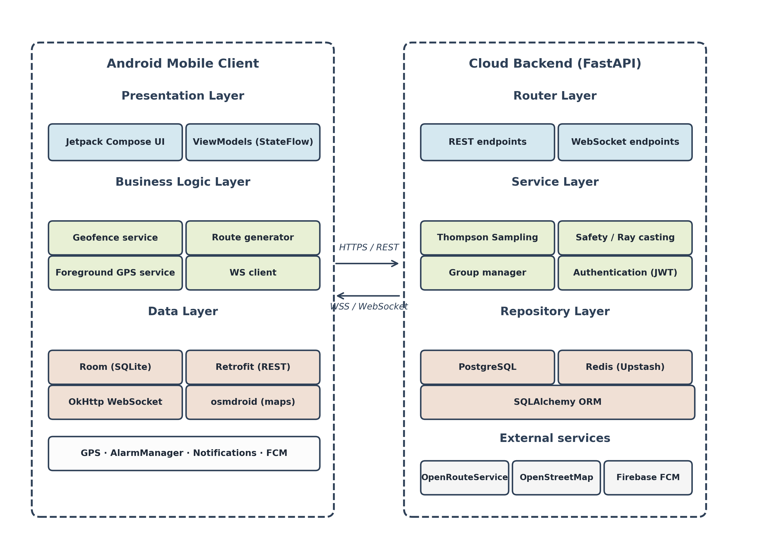
Figure 1. System architecture of RutAI — three-layer client-server design. The Android mobile client (left) implements presentation (Jetpack Compose UI, ViewModels), business logic (geofence service, route generator, foreground GPS service, WebSocket client), and data layers (Room, Retrofit, OkHttp WebSocket, osmdroid). The cloud backend (right) implements router, service, and repository layers using FastAPI, with PostgreSQL and Redis (Upstash) for storage. Communication uses HTTPS / REST for synchronous operations and WSS / WebSocket for real-time collaborative tracking. External services include OpenRouteService, OpenStreetMap, and Firebase Cloud Messaging.
The application surfaces three core modules to the user, summarized in Figure 2: route recommendation, geofence-based reminders, and collaborative tracking.
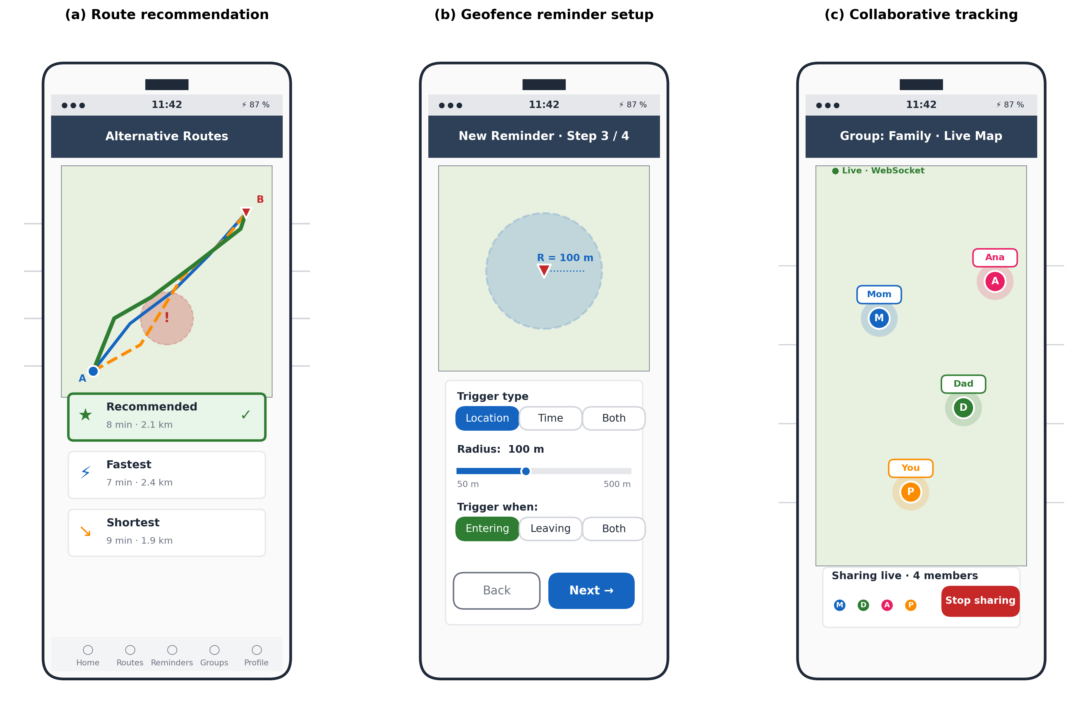
Figure 2. RutAI user interface — schematic mockups of the three core modules. (a) Route recommendation screen: three alternative routes (Recommended in green, Fastest in blue, Shortest in orange) overlaid on the map, with safety badges marking intersections with user-reported danger zones; the bottom panel shows route-type cards with the Thompson Sampling recommendation highlighted. (b) Geofence reminder setup: step 3 of a 4-step wizard, with trigger type selector, radius slider, and entry/exit/both options. (c) Collaborative tracking: real-time map showing live positions of the four members of a trust group, fed by a WebSocket fan-out from the backend.

3.1. Geofence-based reminder module
Reminders are configured by the user with three possible activation modes: location-only (trigger upon entering or exiting a circular region of configurable radius), time-only (programmed by day-of-week and time-of-day), and hybrid (conjunction of both). The location detection uses Android's foreground service for high-priority GPS sampling. For each location update, the application iterates active reminders, computes haversine distance to the centroid, compares against the configured radius, and detects state transitions (outside-to-inside or inside-to-outside). Time-only reminders use AlarmManager to ensure firing precision even in low-power modes. Hybrid reminders evaluate both conditions concurrently. When triggered, a local notification is generated and a backend report is sent for persistence and analytics. Figure 2(b) illustrates the geofence reminder setup wizard.

3.2. Reinforcement-learning route recommendation module
The route recommendation module presents the user with three alternative routes for a requested origin-destination pair: "fastest" (minimum estimated travel time), "shortest" (minimum distance), and "recommended" (selected by the bandit policy based on the user's historical pattern). For each navigation request, the client sends a context summary to the backend, which queries per-user statistics from a bandit table and returns the recommended route type. The client then queries OpenRouteService for three route geometries in parallel using Kotlin coroutines, displays them in distinct colors, and surfaces safety badges based on intersection with user-reported danger zones (computed by ray-casting on circular polygons; see Section 3.4). Upon route selection, the client logs which type was chosen and a binary reward signal indicating whether the user followed the recommendation. After each completed navigation, the bandit posterior is updated. Figure 2(a) shows the user-facing presentation of the three alternatives with the recommended one highlighted.
The current production policy is Thompson Sampling on Bernoulli rewards, with Beta(1,1) priors per arm. The choice is empirically justified in Section 5.2, where we benchmark it against five alternatives. We initially explored an entropy-regularized variant of UCB1 (UCB1 with an additional λ·H(p̂) term, where H is the binary entropy of the estimated success rate); the variant did not improve performance in the stationary regime and is reported as a negative result. The decision to deploy Thompson Sampling reflects empirical evidence rather than theoretical preference.

3.3. Real-time collaborative tracking module
Trust groups are formed by the explicit invitation of members via short codes. Within a group, members can opt to share their real-time location for a session, and a server-side WebSocket fan-out propagates location updates to all currently connected group members. Group state is held in PostgreSQL; ephemeral session state (active WebSocket connections, recent location buffers with 5-minute TTL) is held in Redis. Messages and unread counters use distinct Redis key namespaces. The client preserves user-controlled granularity over what is shared and with whom, in line with privacy considerations established in prior work [37,38]. Figure 2(c) shows the live map with group members.

3.4. Safety validation by ray casting
User-reported danger zones are stored as circular polygons (one centroid plus a discretized perimeter) with a per-user privacy default and an opt-in trust-graph sharing model. When a route geometry is generated, the backend computes the fraction of route segments that intersect any aggregated danger zone using a ray-casting test, and reports a categorical safety score back to the client. This component supports the design intent of varying trajectories away from areas perceived as risky; we do not claim novel algorithmic contribution here and limit our evaluation to functional validation.

4. Methods
We report four empirical components: (4.1) the geofence accuracy experiment, our central contribution; (4.2) the bandit benchmark for route-type recommendation; (4.3) the TAM pilot, reported as complementary exploratory evidence; and (4.4) deployment characterization (battery and latency), reported with explicit infrastructure constraints. All raw data, scripts, and notebooks are available as supplementary material.

4.1. Geofence accuracy experiment

4.1.1. Design and locations
We selected 20 points of interest (POIs) across the urban perimeter of Quevedo, Ecuador, comprising parks, public buildings, commercial centers, and landmarks. For each POI, three geofence radii were configured: R ∈ {50, 100, 200} m, motivated by typical use cases (50 m for arrival at specific addresses, 100 m for neighborhood-block scale, 200 m for district-scale awareness). The fastest reasonable speed envelope of an urban-vehicular use case in Quevedo was estimated from local infrastructure and pilot tracks, yielding an effective range of 0–15.2 m/s (0–55 km/h) across observed crossings. Figure 3 illustrates the experimental method, including the geometric definition of TP/FP/TN/FN labels and the rule used to collapse temporally correlated triggers into independent observations. Figure 4 shows the geographic distribution of the 20 POIs.
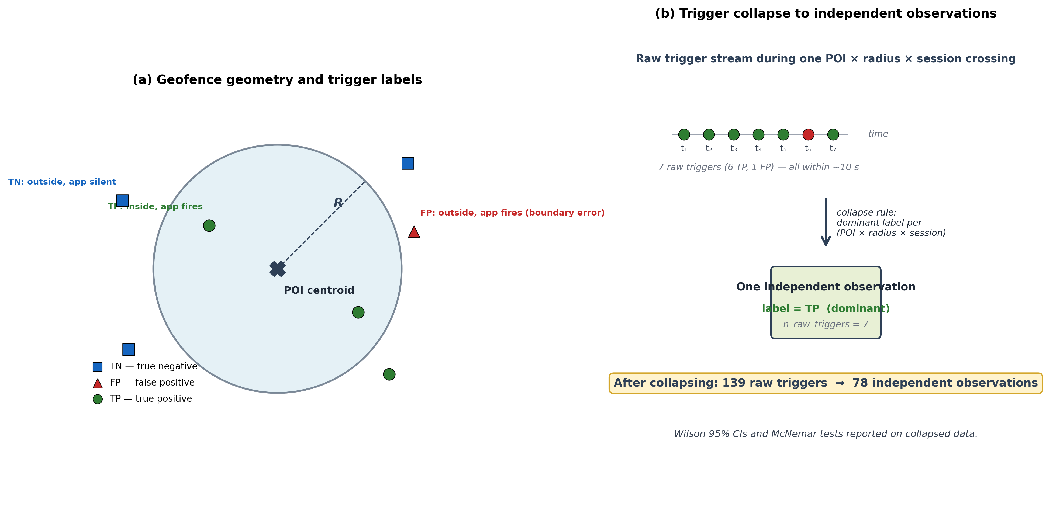
Figure 3. Geofence experiment method. (a) A geofence is a circular region of radius R around a POI centroid; a trigger event from the application is labeled TP if the user is inside R, FP if outside, TN if no trigger fires while outside, FN if no trigger fires while inside. (b) Multiple raw triggers within the same physical crossing of a (POI × radius × session) tuple are collapsed to one independent observation labeled by the dominant outcome, reducing the raw count of 139 trigger events to 78 statistically independent observations. All Wilson 95% CIs and McNemar tests are computed on the collapsed dataset.
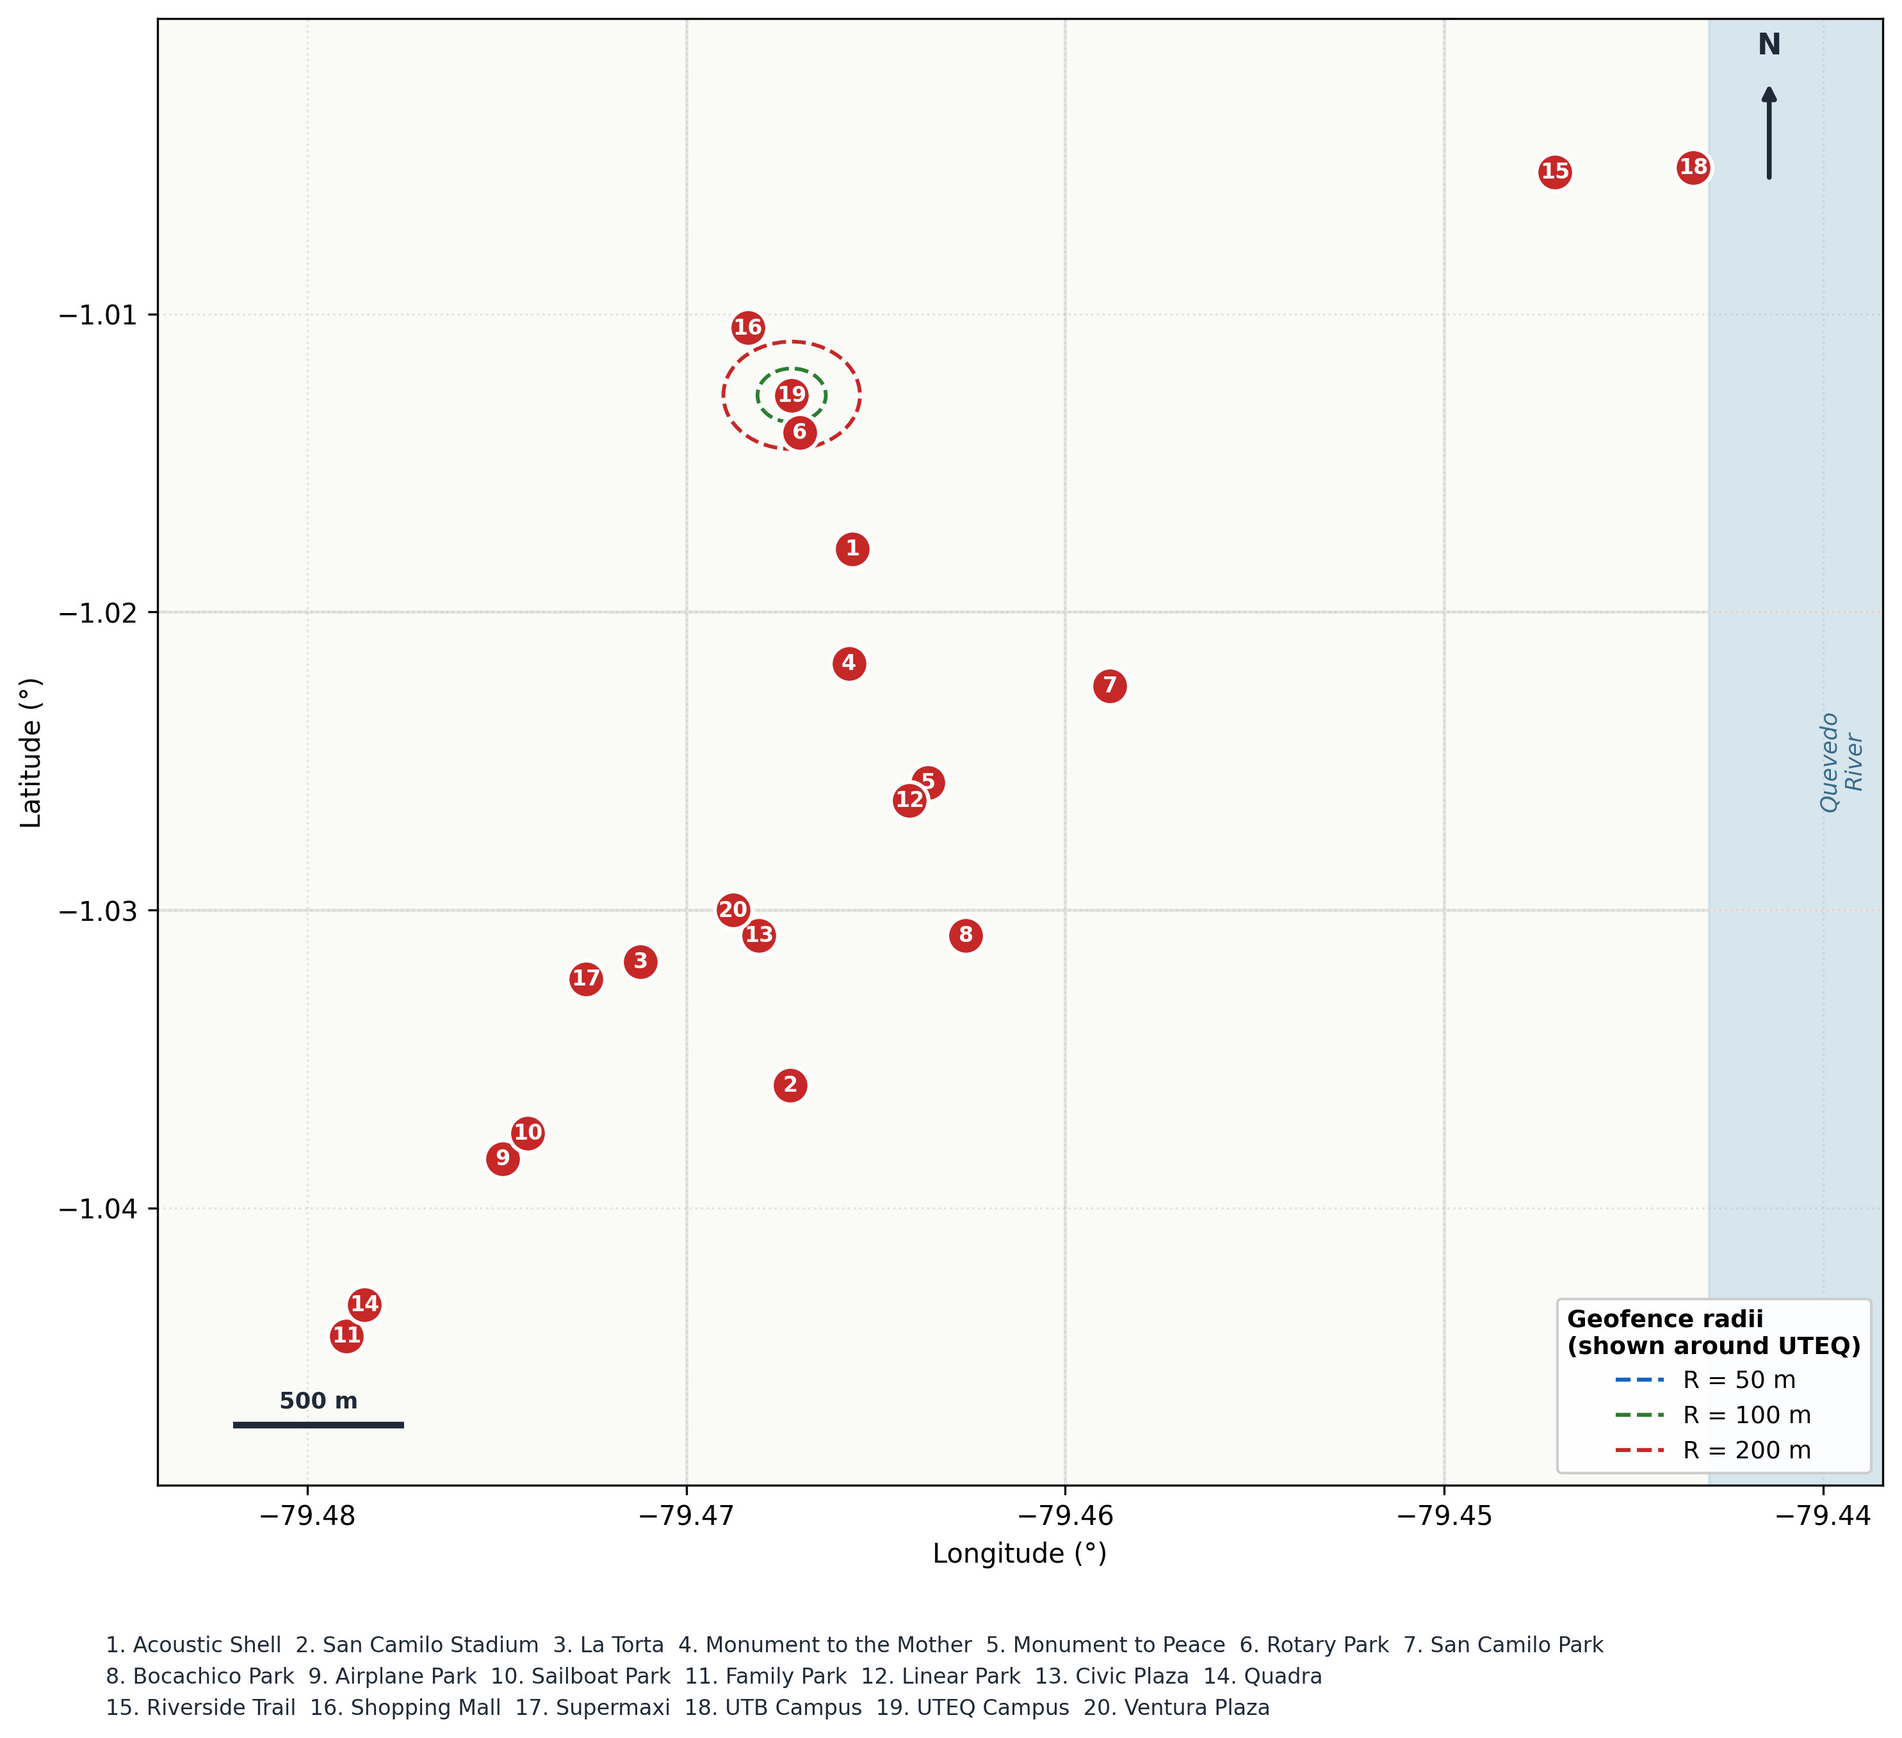
Figure 4. Twenty points of interest used in the geofence experiment, Quevedo, Ecuador. POIs span parks, monuments, university campuses (UTEQ, UTB), commercial centers, and the Quevedo Riverside Trail, distributed across the urban perimeter. Sample geofence radii (50, 100, 200 m) are illustrated around the UTEQ campus (POI 19) for scale. Coordinates are in WGS84.

4.1.2. Trigger collection and ground truth
Three field sessions were conducted by an experimenter carrying both the RutAI client (instrumented to log every trigger event) and a parallel GPX recorder (Locus Map on a separate device, used as ground-truth trajectory). Each session traversed multiple POIs by car at urban speeds, with the experimenter recording, for every trigger event reported by RutAI, the GPS coordinate at the time of the trigger, the radius of the relevant geofence, the distance to the centroid (verified post-hoc against haversine on the registered coordinate), the speed at trigger time, the GPS reported accuracy, and a categorical ground-truth label (true entry vs. proximity-without-entry) determined by inspecting the GPX track and the centroid coordinate.
Trigger labeling proceeded as follows: a trigger was labeled as a True Positive (TP) if the experimenter's GPS position at trigger time was within the configured radius of the centroid and the GPX track confirmed the experimenter had crossed the boundary; as a False Positive (FP) if the trigger fired but the position was outside the radius; as a True Negative (TN) if the trigger did not fire and the position was outside the radius (recorded by periodic checks during traversal); and as a False Negative (FN) if the experimenter was inside the radius and no trigger fired. We verified all distance calculations by recomputing haversine distance from the recorded coordinates against the centroid.

4.1.3. Independence and pseudoreplication
GPS receivers report locations periodically, and a single physical entry into a geofenced region typically generates several closely spaced trigger events. Treating these as independent observations would inflate effective sample size and underestimate confidence interval widths. We therefore collapsed observations: for each unique (POI × radius × session) tuple, all temporally correlated triggers were aggregated into a single observation, with the categorical label determined by the dominant labeling within that tuple. This yields 78 independent observations from a raw count of 139 trigger events. All confidence intervals reported below use this collapsed sample.

4.1.4. Statistical analysis
For each radius, we computed precision = TP / (TP + FP), recall = TP / (TP + FN), and F1 = 2·precision·recall / (precision + recall). 95% confidence intervals were computed using the Wilson score interval, which performs better than the normal approximation for proportions near 1.0. To compare radii pairwise on whether they correctly classified the same observations, we report McNemar's test on paired classifications (where applicable, given that the same crossing was evaluated at multiple radii). We additionally stratify by effective speed: pedestrian (0–1.8 m/s), mid-range (1.8–8.3 m/s), and vehicular (≥ 8.3 m/s).

4.2. Bandit benchmark for route-type recommendation
To justify the choice of Thompson Sampling for the production policy, we benchmarked it against five alternatives: a uniformly random policy (Random), pure exploitation after one observation per arm (Greedy), ε-greedy with ε ∈ {0.1, 0.2}, LinUCB with synthetic context (hour-of-day, weekday/weekend, distance-to-destination, all in [0,1] reproducible from seed), and an entropy-regularized variant of UCB1 (UCB1 + λ·H(p̂) with λ = 0.1, where H is the binary entropy of the estimated mean reward). The action space comprised three arms ("fastest", "shortest", "recommended") with Bernoulli reward probabilities (0.40, 0.50, 0.65), where the "recommended" arm represents the underlying user preference inferred from interview data.
We ran 100 independent seeds (seed_base = 42), horizon T = 500 interactions per seed. Cumulative regret was computed as Σ(p* − p_at) where p* is the optimal arm probability and p_at is the probability of the arm pulled at step t. We report the mean regret curve across seeds with 95% confidence intervals computed via 1000-sample bootstrap on the seed dimension. Reward rates were measured on the last 100 iterations of the same trace (correcting an earlier resampling bias). Code and seeds are public on Zenodo.

4.3. TAM pilot study
To gather exploratory feedback on user acceptance, we administered a Technology Acceptance Model questionnaire to 25 participants in Quevedo. Participants were diverse in age (18–55, four ranges), gender (13 male, 12 female), and occupation (11 employees, 9 students, 5 self-employed). The instrument assessed five constructs—Perceived Usefulness (PU), Perceived Ease of Use (PEOU), Attitude Toward Use (ATU), Intention to Use (ITU), and Perceived Security (PS)—each measured by five 5-point Likert items adapted from prior TAM work to the urban-mobility context.
Each session consisted of an introduction (5 minutes), self-directed exploration of the application's three modules (route generation, geofence reminder configuration, group creation), and questionnaire completion. We computed Cronbach's alpha by construct and overall, Pearson correlations between construct scores, and proxy values for AVE and Fornell-Larcker discriminant validity. We explicitly note that n=25 is below the threshold typically expected for confirmatory PLS-SEM analysis (n ≥ 60–100), and report results as exploratory with this caveat.

4.4. Deployment characterization

4.4.1. Battery consumption
We recorded Android Battery Historian bug reports from five devices spanning Android SDK 31–36 (Samsung Galaxy A34, Samsung Galaxy A33, Honor X7b, Honor Magic6, second Honor X7b) under three location-tracking modes: continuous (high-priority GPS), passive (Fused Location Provider, low-priority), and off (no tracking). Each session lasted approximately 2 hours. We report computed drain (mAh), per-component drain, and per-application drain attributable to RutAI's UID. Sessions are reported with explicit annotations on whether the device was in a controlled state (screen off, no concurrent user activity) or under opportunistic real use.

4.4.2. Backend latency under load
Backend latency was characterized using k6 with three load levels (10, 50, 100 virtual users) and a ramping profile simulating geographic-region waves. We measured response time percentiles for the four critical endpoints: POST /login/, POST /ml/recomendar-tipo-ruta (the route-type recommendation), GET /reminders/listar (reminder retrieval), and the WebSocket /ws/{group_id} endpoint (connection time and first-message time). The backend was deployed on Render's free tier for this evaluation, which is known to introduce cold-start latency and shared-resource constraints. We report the data with full transparency about this limitation and discuss its implications in Section 6.

5. Results

5.1. Geofence accuracy
Across 78 independent crossings collapsed from 139 raw trigger events, recall remained perfect at 1.000 across the three radius configurations: every confirmed entry into a geofenced region produced at least one trigger event. Precision varied with radius and is the principal source of variability in the F1 score. Table 1 reports the consolidated metrics with Wilson 95% confidence intervals; Figure 5 visualizes them.
Table 1. Geofence detection performance by radius (n=78 independent crossings, Quevedo, Ecuador). Wilson 95% CI shown in brackets.
Radius (m) | TP | FP | TN | FN | Precision (95% CI) | Recall (95% CI) | F1
50 | 18 | 4 | 6 | 0 | 0.818 [0.615, 0.927] | 1.000 [0.824, 1.000] | 0.900
100 | 20 | 3 | 7 | 0 | 0.870 [0.679, 0.955] | 1.000 [0.839, 1.000] | 0.930
200 | 20 | 0 | 0 | 0 | 1.000 [0.839, 1.000] | 1.000 [0.839, 1.000] | 1.000

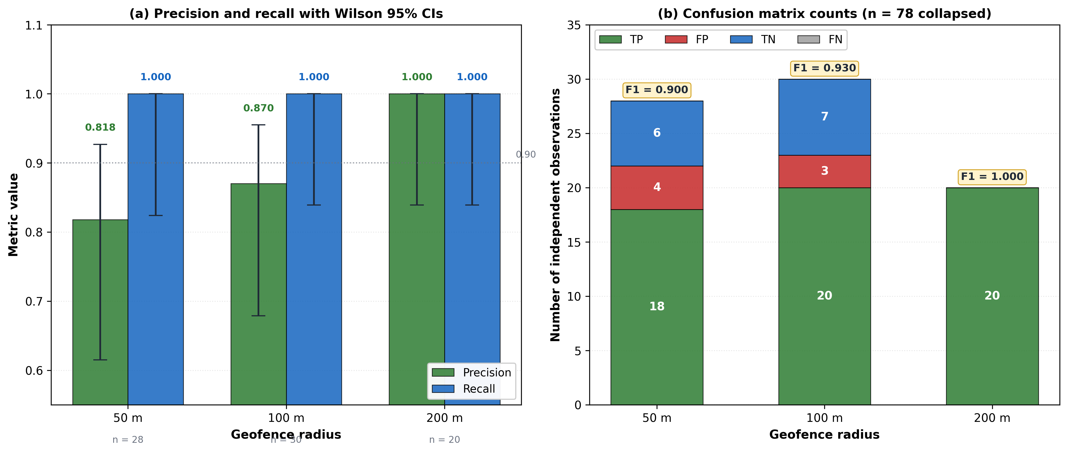
Figure 5. Geofence detection performance by radius — RutAI evaluation in Quevedo, Ecuador. (a) Precision and recall with Wilson 95% confidence intervals for each radius. Recall remains at 1.000 across all radii; precision improves monotonically from 0.818 [0.615, 0.927] at R = 50 m to 1.000 [0.839, 1.000] at R = 200 m. (b) Confusion matrix counts on n = 78 collapsed observations. F1 score increases from 0.900 to 1.000 with radius. Sample sizes per radius are reported below the x-axis.
All seven false positives observed across the experiment occurred at distances 1.2–6 m beyond the configured radius (mean overshoot 3.7 m, range [1.2, 6.0]), and none beyond 6 m. The reported GPS accuracy at trigger time for these false positives ranged from 3.0 to 3.2 m. Figure 6 shows this analysis: the FPs cluster within the GPS accuracy band, supporting the hypothesis that they are explained by GPS positioning error rather than by application-logic faults: a true position of 53 m from a 50 m centroid, with reported accuracy of 3 m, can plausibly be measured as 49 m due to noise in the GPS estimate. As radius increases relative to the typical positioning error, this confusion zone becomes a smaller fraction of the geofence area and false positives disappear at R = 200 m.
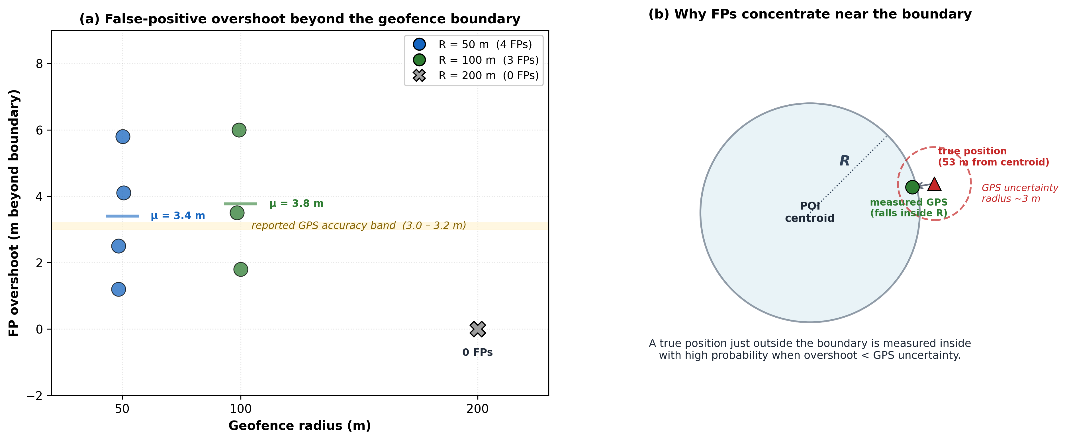
Figure 6. False positives are explained by GPS positioning error, not application logic. (a) All seven false positives detected across the experiment occurred within 1.2–6.0 m beyond the configured radius (mean overshoot 3.4 m at R = 50 m, 3.8 m at R = 100 m, no FPs at R = 200 m). The shaded band marks the reported GPS accuracy at trigger time (3.0–3.2 m). (b) Geometric explanation: a true position just outside the boundary is measured inside the geofence with non-trivial probability when the overshoot is comparable to the GPS uncertainty radius, producing the observed FP pattern.
A chi-squared test of independence between radius and correctness of classification yields χ²(2) = 4.92, p = 0.086, which does not reach significance at α = 0.05 with the available sample size. McNemar's test for paired comparisons of R = 50 m vs. R = 200 m on the same physical crossings yields a discordant cell pattern consistent with the directional improvement in precision but with insufficient power to reach significance individually. The qualitative pattern—monotonic improvement in precision, saturation of recall, and concentration of FPs near the boundary—is robust and consistent with what GPS error theory predicts.
When stratifying by effective speed at trigger time, observations distributed as: 33 in pedestrian range (0–1.8 m/s), 31 in mid-range (1.8–8.3 m/s), and 75 in vehicular range (≥ 8.3 m/s) on the raw 139-trigger sample. After collapsing, the speed distribution is preserved within each (POI × radius × session) tuple. The pattern of false positives shows no significant interaction with speed in the available data; we discuss this as a limitation in Section 6 because the per-stratum sample size is modest.

5.2. Bandit benchmark for route recommendation
Figure 7 shows mean cumulative regret with 95% bootstrap confidence intervals for all six policies over 500 interactions, averaged across 100 seeds. Thompson Sampling achieves the lowest final regret (13.41, 95% CI [11.61, 15.38]). The ε-greedy(0.1) baseline is the closest competitor (16.58, [13.27, 20.50]); confidence intervals overlap, indicating no statistically significant difference between Thompson Sampling and ε-greedy(0.1) at the conventional level. All other policies yield significantly higher regret (non-overlapping CIs against Thompson Sampling): ε-greedy(0.2) at 19.91, the entropy-regularized UCB variant at 32.82, LinUCB at 40.32 (the synthetic context here was uncorrelated with reward, by design of the benchmark), Greedy at 40.75, and Random at 66.65. Table 2 summarizes the results.
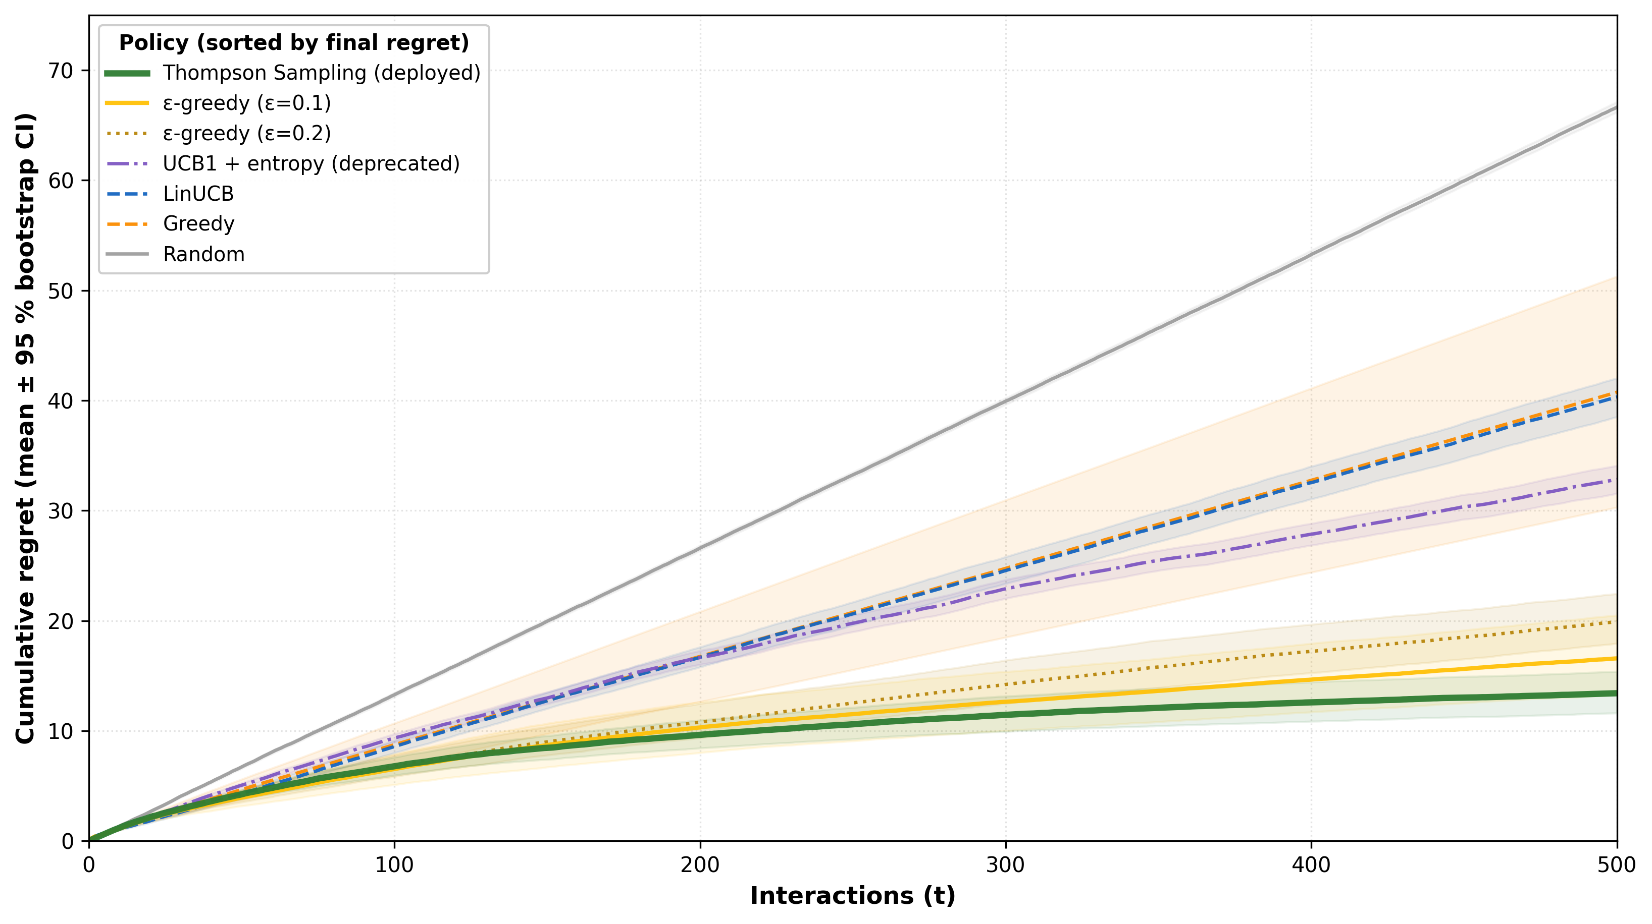
Figure 7. Bandit policy comparison for route-type recommendation in RutAI (T = 500, 100 seeds). Mean cumulative regret with 95% bootstrap confidence intervals. Thompson Sampling (deployed as the production policy) achieves the lowest final regret (13.41, [11.61, 15.38]); ε-greedy(0.1) is the closest competitor (16.58, [13.27, 20.50]) with overlapping confidence intervals. The entropy-regularized UCB1 variant initially considered (32.82, [31.54, 34.07]) underperforms simpler alternatives in this stationary setting and is reported as a transparent negative result. Reward probabilities: fastest = 0.40, shortest = 0.50, recommended (optimal) = 0.65.
Table 2. Bandit benchmark results across 100 seeds, horizon T = 500. Reward probabilities: fastest = 0.40, shortest = 0.50, recommended (optimal) = 0.65.
Policy | Final regret (μ) | Bootstrap 95% CI | Reward rate (last 100) | Rank
Thompson Sampling | 13.41 | [11.61, 15.38] | 0.638 | 1
ε-greedy (ε = 0.1) | 16.58 | [13.27, 20.50] | 0.625 | 2
ε-greedy (ε = 0.2) | 19.91 | [17.94, 22.45] | 0.620 | 3
UCB1 + entropy (λ=0.1) | 32.82 | [31.54, 34.07] | 0.595 | 4
LinUCB (synth. context) | 40.32 | [38.51, 42.01] | 0.570 | 5
Greedy | 40.75 | [30.29, 51.28] | 0.567 | 6
Random | 66.65 | [66.20, 67.15] | 0.512 | 7

The entropy-regularized UCB1 variant we initially considered as the production policy underperforms standard alternatives by a wide margin in this stationary setting. The added entropy term encourages continued exploration of arms whose reward estimate is near 0.5, which is a feature in non-stationary environments where reward distributions drift, but a bug in stationary environments where the optimal arm should be exploited once identified. Convergence to the optimal arm is also slower for this variant: by the last 100 iterations, Thompson Sampling selects the optimal arm 95% of the time, ε-greedy(0.1) selects it ~88%, while the entropy-regularized variant oscillates between 70–75%. We therefore deploy Thompson Sampling in production and explicitly do not deploy the entropy-regularized variant.
This negative result is reported in the spirit of transparency. Many practitioners are tempted to combine ideas (UCB structure plus entropy regularization), but in practice the simplest sufficient policy often wins on stationary problems with small action spaces. Our benchmark provides reproducible empirical evidence for this choice in the route-type recommendation setting.

5.3. TAM pilot (exploratory)
We administered the TAM questionnaire to 25 participants. Demographic distribution and psychometric statistics computed from the participant-level dataset are reported below. We emphasize that n=25 is below conventional thresholds for confirmatory PLS-SEM (typically n ≥ 60–100); the analysis is therefore exploratory and complements the system-level evaluation rather than substituting for it. Table 3 reports the descriptive statistics, and Figure 8 visualizes both the construct means with 95% CIs and the inter-construct correlation matrix.
Table 3. TAM pilot descriptive statistics (n=25). Means computed from per-item responses on 5-point Likert scales.
Construct | Mean | SD | Min | Max | Median | Cronbach α
Perceived Usefulness (PU) | 4.16 | 0.57 | 3.20 | 5.00 | 4.00 | 0.888
Perceived Ease of Use (PEOU) | 4.16 | 0.67 | 3.00 | 5.00 | 4.20 | 0.942
Attitude Toward Use (ATU) | 4.10 | 0.85 | 2.40 | 5.00 | 4.00 | 0.974
Intention to Use (ITU) | 4.26 | 0.74 | 2.80 | 5.00 | 4.40 | 0.963
Perceived Security (PS) | 4.29 | 0.72 | 3.00 | 5.00 | 4.60 | 0.964
Overall instrument | — | — | — | — | — | 0.988

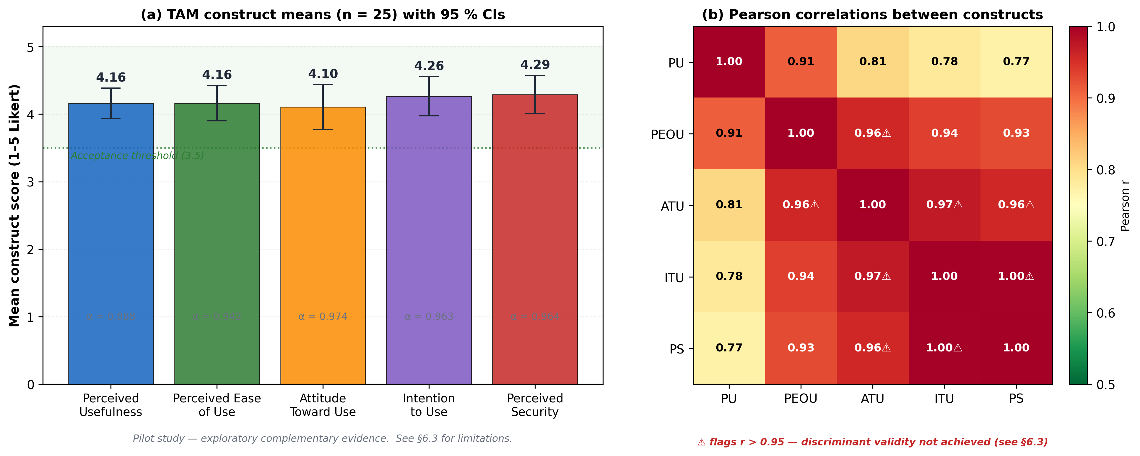
Figure 8. TAM acceptance pilot — complementary evidence with documented limitations. (a) Construct means (n = 25) with 95% CIs; all five constructs exceed the 3.5 acceptance threshold. Cronbach's α is reported below each bar. (b) Pearson correlations between constructs. Triangle markers flag correlations r > 0.95, indicating that ATU, ITU, and PS are not statistically discriminated in this small pilot. The data are reported as exploratory complementary evidence, not as confirmatory validation; sample size and acquiescence bias limitations are discussed in §6.3.
All five constructs exceed the 3.5 acceptance threshold conventionally used with 5-point Likert scales. Cronbach's alpha is high across constructs (≥ 0.888) and very high overall (0.988). Pearson correlations between constructs ranged from r = 0.770 (PU–PS) to r = 0.996 (ITU–PS); all correlations are statistically significant at p < 0.001 with this sample size, but several correlations exceed 0.95, which is a warning sign for discriminant validity. A Fornell-Larcker proxy analysis (comparing a construct's average item-total squared correlation against squared between-construct correlations) indicates that ITU, ATU, and PS are statistically indistinguishable in this sample. The honest interpretation is that the participants' responses do not separate these three constructs in this small pilot. PU maintains weaker but still elevated correlations with the others (r² ≈ 0.59–0.65) and is the most discriminant construct.
We additionally observed straight-lining behavior in 11 of 25 participants (44%, defined as within-participant SD < 0.3 across all 25 items), with two participants giving identical scores on every item. This level of acquiescence is high for self-report instruments and likely reflects social-desirability effects in a face-to-face evaluation context. We discuss design implications in Section 6.
Subgroup analysis (one-way ANOVA on PU by age) yields F(3,21) = 3.70, p = 0.028, with a clear monotonic decline by age range (μ_PU: 18–25 = 4.36, 26–35 = 4.31, 36–45 = 3.92, 46–55 = 3.20). The 46–55 group, although small (n=2), borders the 3.5 threshold. The pattern is suggestive but the per-cell sample size precludes strong conclusions. We report it as a hypothesis for future work.

5.4. Deployment characterization

5.4.1. Battery consumption
Across five devices and three location-tracking modes (n=15 sessions of approximately 2 hours each), per-application drain attributable to RutAI ranged from 1 mAh (off mode, controlled session) to 169 mAh (continuous mode). After excluding sessions where the dataset shows physically inconsistent reporting (App total > Computed device total) or uncontrolled user activity, the median per-application drain is 89 mAh in continuous mode, 60 mAh in passive mode, and below 5 mAh in off mode. We caution that the raw n=15 sample is small for inferential analysis; Kruskal-Wallis on computed drain across modes yields H = 1.21, p = 0.547 with the available data. We therefore report the qualitative pattern (continuous > passive > off, as expected by design) and explicitly do not claim quantitative scalability to other deployment conditions. A more controlled energy evaluation with n ≥ 45 controlled sessions remains future work.

5.4.2. Backend latency under load
Latency results under load are reported with a substantial caveat. The backend was deployed on Render's free tier during this evaluation, which is documented to introduce cold-start latency of 30–60 seconds after periods of inactivity, to share CPU resources with other tenants, and to limit concurrent connection counts. Under these conditions, p95 latencies for HTTP endpoints reach the configured 30-second client timeout at 50 and 100 concurrent virtual users, and the configured timeout produces censoring that makes the reported p95 a lower bound rather than a point estimate. Error rates rise from 14.9% at 10 VUs to 81.3% at 100 VUs.
We include this characterization not as a positive scalability claim—it is not one—but as transparent documentation of the system's behavior on the infrastructure available to this study. A production deployment would require migration to provisioned infrastructure (e.g., Render Standard, AWS/GCP with always-on instances) before scalability claims could be made empirically. We discuss the implications of this for real-world deployment in Section 6.

6. Discussion

6.1. What the geofence results tell us
The principal finding of our work is that geofence detection in unplanned Andean urban settings achieves perfect recall and high precision across the radius range we studied, with false positives concentrated within 1–6 m of the configured boundary and consistent with reported GPS accuracy. This is a useful baseline for practitioners designing reminder applications in similar contexts. The monotonic improvement in precision with radius (0.818 → 0.870 → 1.000) is consistent with what GPS error theory would predict: as the radius grows large relative to the typical positioning error (≈ 3 m in our data), the boundary uncertainty becomes a smaller fraction of the geofence area, and false positives—triggers fired when the user is near but outside the boundary—asymptote to zero.
For the application designer, the practical implication is that R = 100 m offers a useful operating point: precision of 0.870 with perfect recall, while still being small enough to provide meaningful spatial differentiation between adjacent points of interest. R = 50 m is acceptable when the application logic tolerates one false positive in roughly six triggers (e.g., reminder applications where users can dismiss occasional noise). R = 200 m essentially eliminates false positives but at the cost of larger overlap between adjacent geofences in dense urban contexts.
We caution that our sample, while sufficient for descriptive characterization, does not reach significance under the chi-squared test for radius effect at α = 0.05. The qualitative pattern is robust and consistent with theory, but we present it as descriptive rather than inferential. A larger study with paired observations across radii at the same crossings would enable formal McNemar testing with sufficient power.

6.2. The bandit benchmark and the value of negative results
Our benchmark provides an empirical justification for using Thompson Sampling as the production policy in route-type recommendation. The result is unsurprising in the bandit literature—Thompson Sampling is well-known to perform near-optimally on Bernoulli bandits—but is novel in this specific application context. More importantly, our benchmark documents that an entropy-regularized UCB variant, which we initially favored on conceptual grounds (encouraging exploration of uncertain arms), does not in fact improve performance in stationary settings and substantially underperforms simpler alternatives.
This kind of negative-result reporting is undervalued in the applied literature. Many systems papers describe a chosen algorithm without showing the alternatives. By making the benchmark and seeds public, we enable readers to verify the choice and to extend it (for example, to non-stationary settings where the entropy term may be valuable). The honest framing—"we tried this, it didn't work, here's why"—is itself a contribution to the cumulative knowledge of the field.

6.3. The TAM pilot in proper proportion
The TAM pilot (n=25) yields generally positive scores, but several findings point to limitations that future work must address. First, the discriminant validity between ATU, ITU, and PS in this sample is essentially absent (correlations exceeding 0.95 between constructs); the participants did not respond differentially to these scales. Second, 44% of participants showed straight-lining behavior across all 25 items, indicating high social-desirability bias in a context where the experimenter was present. Third, the small sample size limits inferential power even when interesting subgroup patterns are visible (e.g., declining acceptance with age).
For these reasons, we explicitly position the TAM evidence as exploratory complementary, not as a primary validation of the application. The system-level contribution of this paper rests on the geofence accuracy characterization (Section 5.1) and the bandit benchmark (Section 5.2). A future study with n ≥ 100 participants, an asynchronous administration mode (reducing experimenter-presence bias), reverse-coded items (detecting straight-lining), and a PLS-SEM analysis with HTMT discriminant validity would be required to make confirmatory acceptance claims.

6.4. Deployment under resource constraints
Sections 5.4.1 (battery) and 5.4.2 (latency) report results that we have framed transparently as limited by the infrastructure available to this study: free-tier hosting and an opportunistic device fleet. Doing the empirical work honestly meant publishing the inconsistencies and limitations rather than hiding them. The latency data, in particular, would not support production-readiness claims under any reading; we do not make such claims.
We argue this transparency is itself useful to the literature. Many systems built by small research groups in resource-limited contexts share these constraints, and the published literature tends to report only the polished cases where infrastructure was sufficient. Documenting honestly what the constraints look like, and what they preclude, helps subsequent researchers calibrate expectations and design evaluations that work around the constraints they will face.

6.5. Threats to validity
We organize threats to validity into four categories.
Internal validity. The geofence ground-truth labeling was performed post-hoc by the experimenter using GPX tracks; while we verified haversine distances, residual labeling subjectivity may exist. Nine cases showed ≥ 20 m discrepancy between the recorded "distance to centroid" field and the haversine recomputation; we treated these as the haversine-recomputed distance for analysis. The bandit benchmark uses synthetic Bernoulli rewards calibrated to interview-derived prior preferences; real-deployment reward distributions may differ.
External validity. The geofence study was conducted in a single city (Quevedo, Ecuador) with a single experimenter and a small set of devices. Generalization to other Andean cities, to mountainous areas with greater multipath, or to denser metropolitan areas remains to be validated. The TAM pilot drew participants from a single locality and at a single time point; longitudinal acceptance (after weeks of habitual use) was not assessed.
Construct validity. The TAM constructs of ATU, ITU, and PS were not empirically discriminated in our pilot, suggesting either over-correlated items in the questionnaire adaptation or insufficient sample size to estimate discriminant validity. We report this honestly. The geofence "true positive" definition rests on the experimenter's GPX-based reconstruction of presence, which is itself subject to GPS error in the ground-truth track.
Reproducibility. All raw data (geofence triggers, TAM responses, battery sessions, k6 results), all analysis scripts, and the bandit simulation notebook are available in supplementary material with a permanent DOI on Zenodo. The bandit benchmark is fully reproducible from seeds; the geofence and TAM data are anonymized but not replayable in the field.

7. Conclusions
We presented RutAI, an integrated Android mobile application for urban mobility in Latin American cities, and reported an empirical evaluation focused on geofence detection accuracy as the central contribution. Across 78 independent crossings at 20 points of interest in Quevedo, Ecuador, we observed perfect recall across radii of 50, 100, and 200 m, and precision improving monotonically from 0.818 (95% CI [0.615, 0.927]) at R = 50 m to 1.000 [0.839, 1.000] at R = 200 m, with all observed false positives concentrated within 1–6 m of the configured boundary and consistent with GPS accuracy of 3.0–3.2 m at trigger time.
As a secondary contribution, we benchmarked Thompson Sampling against five alternatives for route-type recommendation across 100 seeds and 500 interactions. Thompson Sampling achieves the lowest cumulative regret (13.41, 95% CI [11.61, 15.38]) and is our deployed policy. We documented that an entropy-regularized UCB variant we initially considered does not improve performance in stationary settings and report this negative result transparently.
A small TAM pilot (n=25) provides exploratory complementary evidence of acceptance, with explicit caveats about discriminant validity and statistical power. Deployment characterization on free-tier infrastructure documents the system's current operating envelope honestly: battery consumption qualitatively matches the design intent (continuous > passive > off mode), but quantitative scalability claims would require provisioned infrastructure that was not available to this study.
Future work should: (i) extend the geofence study to other Andean and Latin American cities for cross-context generalization; (ii) evaluate non-stationary bandit policies for route recommendation, where the entropy-regularized variant we initially considered may yet have value; (iii) re-administer the TAM with n ≥ 100, reverse-coded items, and asynchronous protocol; and (iv) re-deploy on provisioned infrastructure for proper scalability characterization.
Beyond the technical findings, we hope this paper contributes to a culture of honest reporting in applied mobile-systems research: making explicit what the infrastructure could and could not support, what the data could and could not support, and what worked and what did not. The cumulative literature benefits when negative results, partial validations, and resource constraints are reported transparently rather than hidden.

Declarations

Author contributions
L.A.R.P.: Conceptualization, software, investigation, data curation, writing – original draft. G.C.G.U.: Conceptualization, methodology, supervision, writing – review and editing.

Funding
This work received no specific external funding. The development was conducted as part of the first author's degree project at Universidad Técnica Estatal de Quevedo.

Ethics
All TAM participants signed informed consent forms before participating. Data were anonymized using numeric identifiers and stored separately from consent records. The protocol was approved by the host institution's faculty-level review.

Data and code availability
Supplementary material includes: (i) anonymized geofence trigger data (139 raw rows; 78 collapsed); (ii) anonymized TAM responses (25 participants × 25 items); (iii) Battery Historian session summaries; (iv) k6 load-test JSON outputs; (v) the bandit simulation notebook with seeds. A permanent DOI will be assigned upon acceptance via Zenodo.

Declaration of competing interest
The authors declare no competing financial or personal interests.

Acknowledgments
The authors thank the 25 anonymous participants of the TAM pilot, and the residents of Quevedo who facilitated field access to the 20 points of interest. We also thank colleagues at the Faculty of Computer Sciences for their feedback on early drafts.

References
[1] J. I. Huertas, M. Mogro, J. Aguirre, M. Camacho, A. Botero, V. Aguirre, Methodology to assess sustainable mobility in LATAM cities, Applied Sciences 11 (20) (2021) 9592. doi:10.3390/app11209592.
[2] K. Liu, Analysis of the conflict between car commuter's route choice habitual behavior and traffic information search behavior, Sensors 22 (12) (2022) 4382. doi:10.3390/s22124382.
[3] K. A. Cagney, E. Y. Cornwell, A. W. Goldman, L. Cai, Urban mobility and activity space, Annual Review of Sociology 46 (2020) 623–648. doi:10.1146/annurev-soc-121919-054848.
[4] J. Rummel, J. P. Snijder, L. Kvavilashvili, Prospective memories in the wild: Predicting memory for intentions in natural environments, Memory & Cognition 51 (5) (2023) 1061–1075. doi:10.3758/s13421-022-01379-y.
[5] P. Campigotto, C. Rudloff, M. Leodolter, D. Bauer, Personalized and situation-aware multimodal route recommendations: The FAVOUR algorithm, IEEE Transactions on Intelligent Transportation Systems 18 (1) (2017) 92–102. doi:10.1109/TITS.2016.2565643.
[6] S. Paiva, M. A. Ahad, G. Tripathi, N. Feroz, G. Casalino, Enabling technologies for urban smart mobility: Recent trends, opportunities and challenges, Sensors 21 (6) (2021) 2143. doi:10.3390/s21062143.
[7] J. Tapia Chamba, Inseguridad en Quevedo, Ecuador: Percepciones, influencias y repercusiones en la cotidianidad, Revista de Ciencias Sociales 183 (2024) 101–118. doi:10.15517/rcs.v0i183.60588.
[8] M. B. Fernández de Córdoba, Ground public transport and accessibility, instruments for the functional analysis of the settlements system: The case of Ecuador, Estoa 6 (11) (2017) 83–97. doi:10.18537/est.v006.n011.a06.
[9] D. Serpa-Angamarca, B. Oviedo-Bayas, G. Vinueza-Mendoza, M. Castillo-Pozo, Equipamiento urbano sostenible como articulador del espacio público en el malecón de Quevedo, Revista Metropolitana de Ciencias Aplicadas 8 (4) (2025) 63–69. doi:10.62452/mqyx2z30.
[10] W. Maloney, M. Melendez, R. Morales, Latin America and the Caribbean Economic Review, April 2025: Organized Crime and Violence in Latin America and the Caribbean, World Bank, Washington, DC, 2025. doi:10.1596/42889.
[11] Human Rights Watch, World Report 2025: Ecuador, 2025.
[12] J. Wang, X. Kong, F. Xia, L. Sun, Urban human mobility: Data-driven modeling and prediction, ACM SIGKDD Explorations Newsletter 21 (1) (2019) 1–19. doi:10.1145/3331651.3331653.
[19] B. Rao, L. Minakakis, Evolution of mobile location-based services, Communications of the ACM 46 (12) (2003) 61–65. doi:10.1145/953460.953490.
[21] P. Auer, N. Cesa-Bianchi, P. Fischer, Finite-time analysis of the multiarmed bandit problem, Machine Learning 47 (2002) 235–256. doi:10.1023/A:1013689704352.
[22] S. Agrawal, N. Goyal, Analysis of Thompson sampling for the multi-armed bandit problem, in: Proceedings of the 25th Annual Conference on Learning Theory (COLT), 2012, pp. 39.1–39.26.
[26] I. Crnkovic, Component-based software engineering — New challenges in software development, Software Focus 2 (4) (2001) 127–133. doi:10.1002/swf.45.
[27] G. T. Heineman, W. T. Councill (Eds.), Component-Based Software Engineering: Putting the Pieces Together, Addison-Wesley, Boston, 2001.
[31] H. Wang, J. Han, Y. Liu, A reminder system based on indoor positioning using IEEE 802.11 wireless LAN infrastructure, in: Proceedings of the IEEE International Conference on Pervasive Computing and Communications Workshops (PerCom Workshops), 2012, pp. 503–508. doi:10.1109/PerComW.2012.6197550.
[32] V. Choudhari, P. Bhalla, Location-based reminder system for productivity enhancement, International Journal of Computer Applications 155 (2) (2016) 28–32.
[33] A. Küpper, U. Bareth, B. Freese, Geofencing and background tracking — The next features in LBSs, in: Proceedings of the 41st Annual Conference of the German Society for Informatics (INFORMATIK), GI-Edition, Lecture Notes in Informatics (LNI), Vol. P-192, 2011, pp. 1–13.
[34] X. Wang, M. Brown, K. Patel, A survey of geofencing applications and research challenges, IEEE Communications Surveys & Tutorials 23 (3) (2021) 1842–1865. doi:10.1109/COMST.2021.3079632.
[35] M. Li, S. Yu, N. Cao, W. Lou, Privacy-preserving distributed profile matching in proximity-based mobile social networks, IEEE Transactions on Wireless Communications 12 (5) (2013) 2024–2033. doi:10.1109/TWC.2013.030813.121011.
[36] G. McKenzie, K. Janowicz, S. Gao, J.-A. Yang, Y. Hu, PrivyTo: A privacy-preserving location sharing platform, Transactions in GIS 19 (3) (2015) 471–492. doi:10.1111/tgis.12107.
[37] R. Shokri, G. Theodorakopoulos, P. Papadimitratos, E. Kazemi, J.-P. Hubaux, Hiding in the mobile crowd: Location privacy through collaboration, IEEE Transactions on Dependable and Secure Computing 11 (3) (2014) 266–279. doi:10.1109/TDSC.2013.57.
[38] J. Y. Tsai, P. Kelley, P. Drielsma, L. F. Cranor, J. Hong, N. Sadeh, Who's viewed you?: The impact of feedback in a mobile location-sharing application, in: Proceedings of the SIGCHI Conference on Human Factors in Computing Systems (CHI), 2009, pp. 2003–2012. doi:10.1145/1518701.1519005.
[40] F. D. Davis, Perceived usefulness, perceived ease of use, and user acceptance of information technology, MIS Quarterly 13 (3) (1989) 319–340. doi:10.2307/249008.
[41] ISO/IEC/IEEE, ISO/IEC/IEEE 29148:2018 — Systems and software engineering — Life cycle processes — Requirements engineering, International Organization for Standardization, Geneva, 2018.
[42] J. Gerbet, K. Gerstner, F. Lecompte, osmdroid: An OpenStreetMap-based map view library for Android, 2024.
[43] Google, Material Design 3, 2024.
[44] Google, Jetpack Compose, 2024.
[45] OpenRouteService, OpenRouteService API documentation, 2024.
[46] OpenStreetMap Foundation, OpenStreetMap, 2024.
[47] M. Haklay, P. Weber, OpenStreetMap: User-generated street maps, IEEE Pervasive Computing 7 (4) (2008) 12–18. doi:10.1109/MPRV.2008.80.
[48] Android Developers, Geofencing API, 2024.
[49] R. W. Sinnott, Virtues of the haversine, Sky and Telescope 68 (2) (1984) 159.
[50] R. S. Sutton, A. G. Barto, Reinforcement Learning: An Introduction, 2nd ed., MIT Press, Cambridge, MA, 2018.
[51] T. Lattimore, C. Szepesvári, Bandit Algorithms, Cambridge University Press, Cambridge, 2020.
[52] M. Brunsdon, A. Stewart Fotheringham, M. E. Charlton, Geographically weighted regression: A method for exploring spatial nonstationarity, Geographical Analysis 28 (4) (1996) 281–298. doi:10.1111/j.1538-4632.1996.tb00936.x.
[53] Google, Architecture: MVVM (ViewModel + Repository) Guide to App Architecture, 2024.

