**Novel Approach to Record the Attendance of Students Using Facial Recognition**

**Abstract:**

During ancient Indian times, the Gurukul system of education was the style of learning in the country. In this system the students were learning with their mentors (Gurus) and receiving education, knowledge, moral values and life skills under the guidance of their gurus. This system of education was practiced in ancient times, where all students who resided at the place of the guru in the Gurukula were considered equal. As the days passed the things took a drastic change and government schools were introduced. A few decades ago, the number of students in government schools decreased due to the privatization of the education system. Later, more schools were introduced by corporations, which led to a significant increase in the number of schools. To perform the tasks like monitoring and taking the attendance of each class was tedious job at the same time it was time consuming, where the total number of students in each class has increased and number of subjects for each class also increased and every teacher has to document the number of students attending the classes for each subject and they need to submit it to the higher authorities. To overcome these difficulties, In this paper a novel approach is schemed to record attendance of all the students of a class. In the proposed system to take the attendance of the students all at once, a live video is processed for each frame and to recognize the faces of all the students it uses a deep convolutional neural network face recognition algorithm which extract 128-dimensional face encodings from images and then compares these encodings with the faces stored in the dataset to determine the best match and further the attendance of the students present in the class is recorded in the form of excel sheet so that the teacher can carry out the further analysis. The findings of the experiment overcomes the difficulties faced in the existing systems and eyewitnesses the furturistic transition in marking attendance.

**SECTION I.**

Introduction

The regular attendance of students in educational institutions is a major concern these days, mainly because it can have a significant impact on their overall academic performance. There are two conventional methods of marking attendance which is calling out the roll numbers of the student or by letting students sign on the paper. Both the methods seemed to be time-consuming and cumbersome. Hence, there has always been a concern to develop an automated student attendance management system that can assist the faculty in recording the attendance of students automatically.

The smartest way to mark the attendance is to use face recognition. In comparison with other techniques, face recognition is more accurate and faster and optimize the chance of proxies. Face recognition known for providing passive identification i.e., a person need not to take any action in order to get identified.

Face Recognition is accomplished in three major steps firstly for detection of faces 68 landmarks of faces are considered and the algorithms used were Voila and Jones and Haar Classifiers, after face detection is considered as the next step in the feature extraction once faces have been aligned and detected, the next step is to extract features from them here in the proposed systemthe systemhave used Convolutional Neural Networks through which the system extracts high level features from an image. The last step is to match extracted features with faces in a database for face recognition a trained deep learning convolutional neural network model is used.

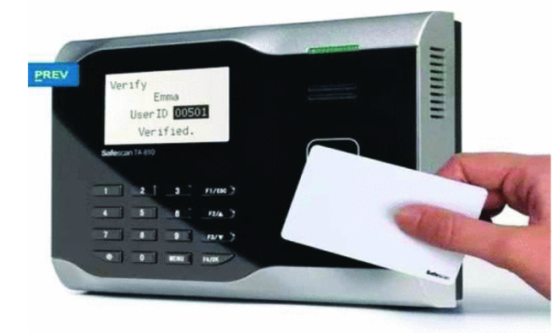

**Fig. 1.** Radio-Frequency Identification (RFID) Attendance system

**Fig. 2.** Attendance system with Fingerprint

**Fig. 3.** IRIS Attendance System

Fig. 1. An instance of attendance system with Radio-Frequency Identification The article In this system, each student has a separate individual id cards which is used to scan in order to mark the attendance and the system drawbacks includes a tag for individual student, proxy done by sharing the tags with other students and also a one-to-one human-machine interaction which is time consuming.

Fig. 2. An instance of attendance system with Fingerprint, In this system each student will have a unique fingerprint which is used to get scanned to mark attendance and this type of attendance system limitations include large-scale human and machine interaction to carry out the process and this system also fails to detect when the fingerprint is not clear.

Fig. 3. This system is known for scanning the iris of each students to spot the attendance. The above mentioned approaches suffer from the major limitations namely both the approaches are time-consuming, and also require additional Human-machine Interaction as only individual student can spot the attendance at a time. This system has overcome the problem of proxy attendances and it is not attainable to use in the classrooms. By considering the limitations of these above mentioned existing systems there is a concern for developing a novel approach to record the attendance of students using facial recognition.

The proposed system can take the attendance of students in a classroom all at once. The project contributes in the field of education by improving accuracy and efficiency in taking attendance and also increased security by identifying individuals who are not authorized on school or college premises. Overall, the project has the potential to improve the attendance tracking process and enhance the learning experience for students and teachers. Organization of the paper: Ballari Institute of Technology and Management.

**SECTION II.**

LITERATURE SURVEY

This paper narrates on how a "Smart Attendance System for Face Recognition" is proposed to address the issue of insufficient attendance in education institutions. The system uses a face-recognition-based approach to track students’ attendance and eliminate proxy attendance. The system requires students to sign up initially and employs the Local Binary Pattern Histogram algorithm. The implementation is done using Python and Visual Studio with the Tkinter interface. This system ensures reliable attendance tracking and authentication [1].

In this paper, the author discussed that Attendance is crucial in schools, colleges, and workplaces as it helps monitor student progress and employee workload. Attendance is usually logged manually by instructors, which can be tedious and prone to errors. This study proposes an autonomous attendance logging system to eliminate manual intervention and enable institutions and instructors to focus on academics. This proposed system is developed using RFID and Raspberry [2].

In this paper, the proposed system narrates on how Facial recognition-based attendance systems are crucial in today’s digital age for various institutions. A database of individuals’ faces is built using a camera, and a recognizer algorithm is utilized for attendance tracking. The system cross-checks the acquired face image with the database and records attendance in an excel sheet if a match is found. The system employs PCA and CNN for facial recognition [3].

This paper is about a smart attendance system using real-time face recognition to manage student attendance. It discusses the problems with traditional methods of taking attendance and the benefits of using facial recognition technology. This system uses high-definition cameras and computer algorithms to quickly and accurately recognize students’ faces. The goal is to create an automated attendance management system for educational institutions [4].

This paper narrates that the traditional way of taking student attendance in educational organizations is time-consuming and manual. To improve teaching efficiency, a proposed biometric attendance system based on IoT uses facial recognition technology to record attendance and store data on a remote server. This system uses a Raspberry Pi camera to capture and compare student face images with stored images in a database [5].

This paper mainly deals with facial recognition in order to manage the attendance. One of the widely used technology is recognized as face recognition. It is also known as important features of computer vision. Identification of a person is done with spontaneity from a real frame to still snap. It is also used to monitor the attendance of students and the staff in an educational institute [6].

In this paper the author has proposed an automatic system for attendance marking by considering the concept of face recognition. The suggested system not only spots the attendance but it also makes an excel sheet in order to keep the records protected [7].

In this paper, the author has proposed a Face Recognition methodology using the most Supervised Learning method to propose an attendance system using the relative study between various different techniques of face detection and face acknowledgement [8].

This article briefs about the technologies in the areas of Artificial Intelligence and ML first and foremost on Picturing and pattern-recognition and highlighting the real-time applications of used technologies. In this paper the authors have developed a system using facial recognition consolidated with python libraries to detect and recognize the human faces with masks at the times COVID-19 Pandemic [9].

In this paper the author has mentioned the uses of face recognition and its development of the software by consolidating the face recognition technology with already existing open sthece computer vision which is known as OpenCV for spotting the attendance of the students and also facilitates the faculty people to keep track of the student attendance [10].

The authors of this paper have proposed an approach using the algorithms like KNN, generative adversarial networks, CNN, SVM. The system proposed in here recognizes the face and generates attendance reports and stored in excel format [11].

The authors have discussed the analysis system of students attendance state in classroom based on human posture recognition here in this system process the video and extracts the information and makes some analysis [12].

In the paper, image set based face recognition was performed by applying face frontalization to all images in the sets. The faces in the IJBA database were frontalized using the Rotate and Render hybrid frontalization method, which is based on a Three-Dimensional and Generative Adversial Network. Then, a discriminative convex classifier was used for set based face recognition. In face recognition experiments, it was observed that the accuracy of face recognition increased with the frontalized face images when the frontalized IJBA database and its non-frontalized version were compared [13].

In this paper, the proposed system is presented as a solution for performing face recognition using serverless edge computing within the browser. A user-friendly web portal has been developed for students to access the system, which includes a plugin extension. The extension utilizes various models, such as Tiny Face Detector and Face Recognition Net, to detect and recognize students’ faces and update attendance dynamically in a Google Sheet [14].

In this paper, a stable level of masked face recognition accuracy is demonstrated by a face recognition system application that was developed using Python and related libraries. The system implements SSD and ResNet feature extraction and was evaluated at predetermined distances between the face and the camera, under room lighting conditions of 200 lux. The average accuracy achieved was 67%. Additionally, the application is equipped with a feature that sends notification emails to employees who are unable to attend work on their scheduled workdays [15].

In this paper, A new attendance system based on face recognition is proposed, which is capable of identifying present students from a group photo of a class. The system uses a one-shot learning method for face recognition, making it highly efficient and resilient to new users with only one image. The research includes a functional android application and backend system architecture that can be easily implemented by schools or universities without the need for expensive infrastructure setup. The model achieved an accuracy rate of approximately 97% on LFW dataset, while the attendance system demonstrated an 85% accuracy rate on a public student class photo dataset [16]. Figure 4 presents the Face Recognition and Attendance marking process.

**SECTION III.**

PROPOSED METHODOLOGY

**Fig. 4.** Face Recognition and Attendance marking process

In this proposed methodology there are two major phases i.e., face detection and face recognition the system employs Viola-Jones algorithm for face detection which can extract the facial features even in the lower level of illuminations and deep cnn algorithm for facial recognition. As these two algorithms gives the highest accuracy as compared to other face detection and recognition algorithms even in normal conditions as well as for the image with the faces in slight darker region, distorted image, and face at different angle relative to camera.

The pseudo code or the workflow of the proposed system, firstly it creates and initializes the csv file for storing the attendance of students further after detected and recognized multiple faces in a frame. Next the face dataset is created where the camera gets on and eventually face gets detected during enrollment of the students.

Here, In this project are using pretrained cascade classifier i.e "haarcascade_frontalface_default.xml" for detecting frontal faces in images or video streams and then captures the images until face is detected immediately the detected face gets stored in already created directory called face_dataset. Later in the Face Recognition phase, it loads the dataset of kown_faces and then initializes the camera and captures the frame and loops through each face in the frame and then compares the face encodings with the known faces in the dataset finally, it finds the best match from the known faces (already stored faces in the dataset) also this loop continued to process untill all the faces in the frame are detected where it provides a funtionality of quitting the camera live video input untill all the faces in the frame are marked as recognized and unrecognized.

The architecture of a CNN for face recogntion basically has these following layers:

Input Layer: This layer takes in the input image and applies pre-processing steps, such as resizing and normalization, to prepare the image for the subsequent layers.

Convolutional Layers: These layers apply convolution operations to the input image using a set of filters to extract features such as edges, textures, and shapes. The formula for the convolution operation is given below i.e [Equation (1)](https://ieeexplore.ieee.org/document/#deqn1).

 (1)

where x and w represent the input image and filter, respectively. k and l represent the spatial coordinates of the input image.

Activation Layers: These layers apply an activation function i.e [Equation (2)](https://ieeexplore.ieee.org/document/#deqn2), to the output of the convolutional layers to introduce non-linearity and help the network learn complex features.

f(x)=max(0,x) (2)

where x is the input to the ReLU function

Pooling Layers: These layers down sample the output of the convolutional layers by reducing the spatial dimensions of the feature maps. The formula for max pooling is,

P(i, j) = max { X ( I + ( u – 1 ) , j + ( v – 1 ) ) } (3 )

where P is the pooled feature map, X is the input feature map, and (u, v) is the pooling window size.

Fully Connected Layers: These layers take in the output of the previous layers and apply a set of weights to produce the final output. [Equation (4)](https://ieeexplore.ieee.org/document/#deqn4) is the formula for the fully connected layer is,

Y = f ( Wx + b ) (4)

View Sourcewhere x is the input to the fully connected layer, W is the set of weights, b is the bias term, and f is the activation function.

Output Layer: This layer produces the final output of the network, which can be used for classification or recognition tasks. In the case of face recognition, the output layer typically produces a set of probabilities for each class (i.e., each person in the dataset). [Equation (5)](https://ieeexplore.ieee.org/document/#deqn5) is the formula for the softmax function, which is commonly used in the output layer of CNNs for classification tasks,

 (5)

where y_i is the probability of class i, x_j is the input to the output layer, and K is the total number of classes.

**A. Database Creation**

Database will be created at the time of enrolment of students. For this reason,the system first describe the database which carries the student data and picture. The image of a student is captured from the input video and student faces are cropped and then saved in a different folder.

**B. Face Detection**

In this step, an operable video is processed using the existing software and the first available frame is taken into consideration for processing. In order to detect the faces of the student from the captured frame, the system uses Viola-Jones algorithm to detect the faces of the humans from an image, in fact the described algorithm is quite old, but still it is used by Apple company to detect the faces in the darker region as well. It was designed for specific objects detection but most of the times it is mainly used for detecting the faces.

**C. Feature Extraction**

Once faces have been aligned and detected, the next step is to extract features from them, here the system uses Convolutional Neural Networks which can extract high level features from an image.

**D. Face Recognition**

In this phase, a live video is processed for each frame and to recognize the faces of all the students it uses a deep convolutional neural network face recognition algorithm which extract 128-dimensional face encodings from images and then compares these encodings with the faces stored in the dataset to determine the best match and further the attendance of the students present in the class is recorded.

**E. Report Generation**

Final report is generated in the Excel format. The generated report is preserved for the further analysis in the future for each individual subject, session and the total number of students present. At the semester end the total percentage of the student’s attendance can be monitored and based on his/her percentage it is easy to predict whether the candidate is eligible to appear or the exams or not.

**SECTION IV.**

RESULTS AND DISCUSSIONS

The proposed Novel approach to record the attendance of students using facial recognition system has been tested for multiple datasets, firstly the proper dataset considered in normal conditions containing students facing towards the camera or to the front under the proper illumination and angles with no distorted image. For this type of dataset, the system got the results of highest accuracy of 99.54%.

And furthermore, the system is tested for dataset with various kind of images with the faces in the lower level of illuminations, pose, head movements with max of 60* angle, distorted image and faces at different angles. The results showed a slight difference in efficiency but still the proposed system can get the higher results ranging from 93-95%.

The proposed attendance system fails to detect the faces with the mask, faces in the complete darker region however the proposed system uses Viola-Jones algorithm for face detection which can extract the facial features even in the lower level of illuminations. Final report is generated in an Excel format as shown in Table I.

Here as shown in the below Figure 5, the proposed project takes the attendences by recognizing all the faces in the frame and records that into a separate csv file or an excel sheet with the date and time.

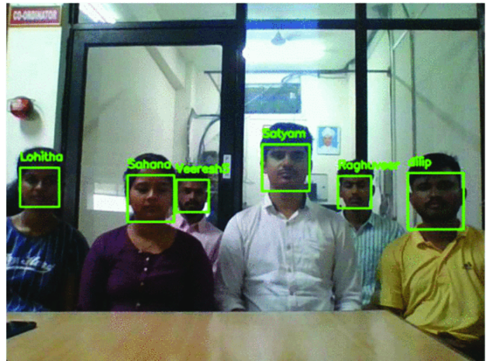

**Fig. 5.** A realtime tested attendance marking process through multiple face recognition

The below Figure 6 shows an example for the result conducted for the realtime dataset.

**Fig. 6.** An example of realtime dataset

**TABLE I.**Final Report of attendance in an Excel format

The attendance of each student is recorded and stored in an excel file where if the student is present then 1 is stored in the column data, if the student is absent then 0 is stored and the total number of presents and absentees is calculated as shown in the Table I. The Comparative study of Existing system and Proposed system is presented in Table II and The Comparison of Face recognition accuracy presented in Table III.

**TABLE II.**Comparative study of Existing system and Proposed system

**TABLE III.**Comparison of Face recognition accuracy

**SECTION V.**

CONCLUSION

Limitations and Future Scope:

1. As the system has been tested using a laptop’s webcam for face recognition, it can detect and recognize multiple students at a maximum distance of 15 feet.
2. The system can’t detect or recognize the students faces in the darker region or in lower illuminations
3. By using High definition cameras it can detect and recognize the students even at the larger distances (average area of classroom)
4. The system fails to detect the faces with the mask.

To conclude,

In this proposed system, a novel approach is developed to record student attendance based on face detection and recognition algorithms. This system overpowers the complications faced while using conventional systems. The proposed system takes the attendance of the students all at once in the classroom, where a live video is processed and all the recognized faces are marked as present and updates the result in an excel file.