Core business questions
QUESTION 1  QUESTION 2 | What is the total revenue shown on the dashboard, and how many invoices and customers does it cover?  Total revenue is 220.78K. The dashboard counts 1.422K distinct invoices and 298 customers. The total quantity sold is 2K units.  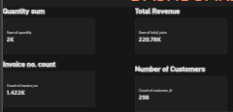  Which product category generates the highest sales?  In the “Sum of Total Price by Product” bar chart, Eggs (Tray) appears to be the tallest bar, well ahead of the rest. Cooking Oil and Bread (400g) follow, and the smaller bars on the right (Milk, Rice, Sanitary Towels and similar items) bring in far less. The product slicer lists Bread (400g), Cooking Oil (1L), Eggs (Tray), Maize Flour (2kg), Milk (500ml), Rice (1kg) and Sanitary Towels (Pack).  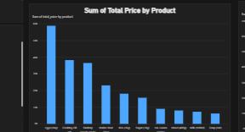
1
QUESTION 03  QUESTION 4  QUESTION 5 | How do sales trend over time, and what pattern stands out?  The “Sum of Total Price by Month” line chart shows a sharp decline early in the period, then a long flat stretch at a very low level. The area chart (Total Price by Customer Type and Invoice_no) shows the same drop, with a high start followed by a steep fall and then a low plateau. This suggests either a big drop in sales or incomplete data for the later months, so it deserves a closer look  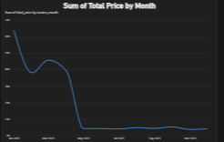  How is revenue split across customer types?  The donut chart “Sum of Total Price by Customer Type” shows the three segments, Budget, Premium and Regular, which together make up the 220.78K total. The customer type slicer on the left lets you filter the whole dashboard to any one of them and see how each behaves  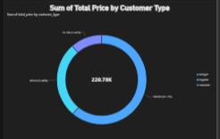  What does the RFM segment treemap tell us, and why is it useful?  The treemap “Sum of Total Price by rfm_segment” shows how much revenue each customer segment contributes, based on Recency, Frequency and Monetary value. The largest blocks, the blue and purple ones, are the segments that bring in the most money. The business can use this to focus retention on its best customers and win-back campaigns on its weaker segments  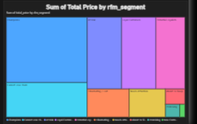

2

