Runtime Environment
for Simulation Database (SimDB)

Laurent Bourgès
LUTh, EuroVO-DCA Project

Version 0.1
creation date : November 2008

Status : Document in Progress
Contents

1. Abstract 3
2. User accounts & File System 4
2.1. Groups / Users 4
2.1.1. root 4
2.1.2. tomcat 4
2.1.3. postgres 4
3. Required Software 5
3.1. Server Software list : 5
3.2. Server Port Mapping : 6
4. Server Configuration 7
4.1. Apache HTTP Server 7
4.1.1. JK Module 7
4.1.2. Deflate Module 8
4.2. Apache Tomcat 9
4.2.1. server.xml : 9
4.2.2. Application Contexts 11
4.2.3. Common libraries 11
4.2.4. Log files 12
4.2.5. Start / Stop commands 12
4.2.6. Useful links 12
4.3. Postgresql 8.1 13
4.3.1. pg_hba.conf`: client authentication configuration : 13
4.3.2. postgresql.conf : PostgreSQL configuration file : 13
4.3.3. Start / Stop commands 15
5. Database Structure 16
5.1. SimDB Main classes 16
5.2. SimDB Specific classes 17
6. SimDB installation 19
7. SimDB configuration 21
7.1. Log configuration 21
7.2. SQL configuration 21
8. SimDB Pipeline 22

Abstract

This document presents the runtime environment for the Simulation database (SimDB).

This audience of this document corresponds to linux administrators, database & web developers.

This document will describe the user definition & rights, software configuration & tuning and present database structure & web applications.

User accounts & File System

Groups / Users
This chapter lists user groups & needed user accounts :

root
password : ?
groups : all

This user is the machine administrator and is the only user allowed to start / stop apache HTTP server on port 80.

tomcat
password : ?
groups : users
home : /usr/share/tomcat6/ (TOMCAT_HOME)

This account is dedicated to the tomcat web server (uses Java) and used to start / stop tomcat.

This implies that web applications use this account to interact with the linux file system.

postgres
password : ?
groups : postgres
home : /usr/local/pgsql (PG_HOME)

This account is dedicated to the postgresql database server : owns the data directory & starts / stops the postgres server.

Required Software
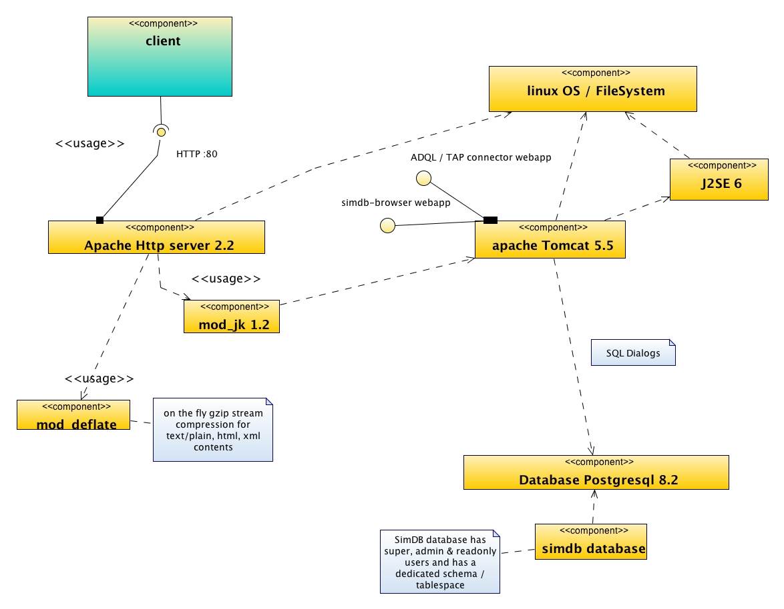

Server Software list :
This chapter lists all required software :
- Apache HTTP Server 1.3 or 2.x with deflate_module + jk_module
- Apache Tomcat 5.5 or 6.0
- Sun Java 5 or 6
- Postgresql 8.1+ database
- Subversion client & Apache Ant 1.6+ for installation

Apache Version (root) :
/usr/sbin> ./apache2ctl -v
Server version: Apache/2.2.0
Server built: Jul 27 2006 13:28:51

Apache Tomcat Version :
TOMCAT_HOME/bin> ./version.sh
Using CATALINA_BASE: /java/apache-tomcat-6.0.18
Using CATALINA_HOME: /java/apache-tomcat-6.0.18
Using CATALINA_TMPDIR: /java/apache-tomcat-6.0.18/temp
Using JRE_HOME: /Library/Java/Home
Server version: Apache Tomcat/6.0.18
Server built: Jul 22 2008 02:00:36
Server number: 6.0.18.0
OS Name: Mac OS X
OS Version: 10.4.11
Architecture: i386
JVM Version: 1.5.0_16-b06-275
JVM Vendor: "Apple Computer, Inc."

Java (Sun) Version :
> java -version
java version "1.6.0"
Java(TM) SE Runtime Environment (build 1.6.0-b105)
Java HotSpot(TM) Server VM (build 1.6.0-b105, mixed mode)

Postgresql Version (postgres) :
> psql -V
psql (PostgreSQL) 8.1.9

Server Port Mapping :
The following table presents port / server mappings :

Port pattern | Server
22 | ssh 2 (linux)
80 | Apache HTTP Server
443 | Apache HTTP Server – SSL
[5432] | Postgresql Database  disabled : only local unix socket connections are allowed
8080-8081 | Unused
8009 | Apache Tomcat (ajp 13 connector)  used by Apache HTTP Server
8089 | Apache Tomcat (http connector)  available on local network area or via ssh (internet)  used to access to /manager & other web applications

Note : RED means public port available on Internet.

Server Configuration
This chapter will present shortly the specific runtime configuration :

Apache HTTP Server

Binary or source releases can be found at the following url :
http://httpd.apache.org/

Two modules are necessary :
- mod_jk : Jakarta module : enables the connection between Apache & Tomcat web servers
- mod_deflate : enables the gzip compression for apache responses

Linux Configuration (root) is defined in /etc/ folder :
/etc/sysconfig> vi apache2
…
APACHE_MODULES="authz_host actions alias auth_basic authz_groupfile authn_file authz_user autoindex cgi dir include log_config mime negotiation setenvif status userdir asis dav dav_fs imagemap php5 perl python authz_default jk deflate"
…

Configuration Files are located in /etc/apache2/ :

/etc/apache2>
…
|-- conf.d
| |-- jk.conf tomcat connector (used)
| |-- mod_deflate.conf gzip responses (used)
…

JK Module
This module is a bridge between Apache HTTP Server & Tomcat using the AJP 1.3 protocol (local port 8009).

Binary or source releases can be found at the following url :
http://tomcat.apache.org/connectors-doc/

This module uses 2 configuration files :
- jk.conf (apache) :

# simple configuration for apache (for AJP connector, modul mod_jk.so)

<IfModule mod_jk.c>

JkWorkersFile <TOMCAT_HOME>/conf/workers.properties

# JkLogFile /var/log/tomcat5/base/mod_jk.log
JkLogFile <TOMCAT_HOME>/logs/mod_jk.log

# Log level to be used by mod_jk
# LBO : later => error
JkLogLevel info

# The following line makes apache aware of the location of
# the /simdb-browser context
Alias /simdb-browser "<TOMCAT_HOME>/webapps/simdb-browser"
<Directory "<TOMCAT_HOME>/webapps/simdb-browser">
# Options Indexes FollowSymLinks
Options FollowSymLinks
allow from all
</Directory>

# The following line mounts all JSP files and the /servlet/ uri to tomcat
JkMount /simdb-browser/* ajp13

…

# The following line prohibits users from directly accessing WEB-INF
<Location "/simdb-browser/WEB-INF/">
AllowOverride None
deny from all
</Location>

</IfModule>

This defines the public web applications (apache = Internet) : /simdb-browser.

- <TOMCAT_HOME>/conf/workers.properties (tomcat) :

# workers.properties -
#
# The workers that your plugins should create and work with
#
worker.list=ajp13

#
#------ DEFAULT ajp13 WORKER DEFINITION ------------------------------
#---------------------------------------------------------------------
#

#
# Defining a worker named ajp13 and of type ajp13
# Note that the name and the type do not have to match.
#
worker.ajp13.port=8009

worker.ajp13.host=localhost

worker.ajp13.type=ajp13

# LBO : added properties :
worker.ajp13.connection_pool_timeout=600

# worker.ajp13.socket_timeout=120

This file defines an AJP 1.3 Client to the local Apache Tomcat server on port 8009. Note : Socket & Connection timeouts are set to a high value.

Deflate Module
This module enables gzip compression on response output streams (only included in httpd version 2.x).
Its configuration file mod_deflate.conf is simple :

AddOutputFilterByType DEFLATE text/html text/plain test/xml

So every html, text or xml output will then be compressed if the client (navigator) supports gzip-compression (given in http headers).

Apache Tomcat
This software is installed with the tomcat user <TOMCAT_HOME> :
/usr/share/tomcat5/ or /usr/share/tomcat6/

This server software implements a J2EE Web container 1.4 in this version (5.5) :
- Servlet API 2.4
- Java Server Pages (JSP) API 2.0 with Expression Language (EL)

http://tomcat.apache.org/

Configuration Files are located in <TOMCAT_HOME>/conf :

server.xml :
This file defines the server components (modules, connectors, ports) :
…
<!-- A "Server" is a singleton element that represents the entire JVM,
which may contain one or more "Service" instances. The Server
listens for a shutdown command on the indicated port.

Note: A "Server" is not itself a "Container", so you may not
define subcomponents such as "Valves" or "Loggers" at this level.
-->

<Server port="8005" shutdown="SHUTDOWN" debug="0" >
…
<!-- Global JNDI resources -->
…
<!-- Define the Tomcat Stand-Alone Service -->

<Service name="Catalina" debug="0" >
…
<!-- Connector in use for manager web-apps & galIcs-dev -->
<!-- timeout = 2 minutes -->
<Connector port="8089" maxHttpHeaderSize="8192"
maxThreads="150" minSpareThreads="5" maxSpareThreads="75"
enableLookups="false" redirectPort="8443" acceptCount="100"
connectionTimeout="120000" disableUploadTimeout="true"
debug="0" />
…
<!-- Define an AJP 1.3 Connector on port 8009 -->
<Connector port="8009"
enableLookups="false" redirectPort="8443" protocol="AJP/1.3"
request.registerRequests="false" useIPVHosts="true"
debug="0" />
…
<!-- Define the top level container in our container hierarchy -->

<Engine name="Catalina" defaultHost="localhost" debug="0">
…
<!-- This Realm uses the UserDatabase configured in the global JNDI
resources under the key "UserDatabase". Any edits
that are performed against this UserDatabase are immediately
available for use by the Realm. -->

<Realm className="org.apache.catalina.realm.UserDatabaseRealm"
resourceName="UserDatabase" debug="0" />
…
<Host name="localhost" appBase="webapps"
unpackWARs="true" autoDeploy="true"
xmlValidation="false" xmlNamespaceAware="false" debug="0" >

<!-- Normally, users must authenticate themselves to each web app
individually. Uncomment the following entry if you would like
a user to be authenticated the first time they encounter a
resource protected by a security constraint, and then have that
user identity maintained across *all* web applications contained
in this virtual host. -->
…
</Host>
</Engine>
</Service>
</Server>

This file defines two http connectors : AJP 1.3 on port 8009 (Internet) and Http on port 8089 (local network area).

Notes :
- all developer loggers are disabled (production mode).
- tomcat users are defined in tomcat-user.xml

- tomcat-users.xml :
<tomcat-users>
<role rolename="manager" description="Server manager"/>
<role rolename="admin" description="Administration role"/>

<user username="admin" password="simdb" fullName="Tomcat admin" roles="admin,manager "/>
</tomcat-users>

This file defines first roles and then users with roles :
- roles :
role | Definition
manager | Required to use manager web application /manager
admin | Required to use manager web application /admin
- users :
role | Definition | Roles
admin | tomcat admin account | admin  manager

- web.xml : global servlet engine configuration (production mode) :

<web-app … version="2.4">
…
<!-- ======================== Introduction ============================== -->
<!-- This document defines default values for *all* web applications -->
<!-- loaded into this instance of Tomcat. As each application is -->
<!-- deployed, this file is processed, followed by the -->
<!-- "/WEB-INF/web.xml" deployment descriptor from your own -->
<!-- applications. -->
…
<!-- ================== Built In Servlet Definitions ==================== -->
…
<!-- The default servlet for all web applications, that serves static -->
<!-- resources. It processes all requests that are not mapped to other -->
<!-- servlets with servlet mappings (defined either here or in your own -->
<!-- web.xml file. … -->
…
<servlet>
<servlet-name>default</servlet-name>
<servlet-class>org.apache.catalina.servlets.DefaultServlet</servlet-class>
<init-param>
<param-name>debug</param-name>
<param-value>0</param-value>
</init-param>
<init-param>
<param-name>listings</param-name>
<param-value>false</param-value>
</init-param>
<load-on-startup>1</load-on-startup>
</servlet>
…
<!-- The JSP page compiler and execution servlet, which is the mechanism -->
<!-- used by Tomcat to support JSP pages. Traditionally, this servlet -->
<!-- is mapped to the URL pattern "*.jsp". … -->
…
<servlet>
<servlet-name>jsp</servlet-name>
<servlet-class>org.apache.jasper.servlet.JspServlet</servlet-class>
<init-param>
<param-name>fork</param-name>
<param-value>true</param-value>
</init-param>
<init-param>
<param-name>mappedfile</param-name>
<param-value>true</param-value>
</init-param>
<init-param>
<param-name>development</param-name>
<param-value>false</param-value>
</init-param>
<init-param>
<param-name>modificationTestInterval</param-name>
<param-value>0</param-value>
</init-param>
<init-param>
<param-name>trimSpaces</param-name>
<param-value>true</param-value>
</init-param>
<init-param>
<param-name>xpoweredBy</param-name>
<param-value>false</param-value>
</init-param>
<load-on-startup>3</load-on-startup>
</servlet>
…
<!-- ================ Built In Servlet Mappings ========================= -->
…
<!-- ================== Built In Filter Definitions ===================== -->
…
<!-- ==================== Default Session Configuration ================= -->
<!-- You can set the default session timeout (in minutes) for all newly -->
<!-- created sessions by modifying the value below. -->
…
<session-config>
<session-timeout>5</session-timeout>
</session-config>
…
<!-- ===================== Default MIME Type Mappings =================== -->
…
<!-- ==================== Default Welcome File List ===================== -->
…
</web-app>

Application Contexts
- conf/context.xml : disable session persistence :

<!-- The contents of this file will be loaded for each web application -->
<Context>

<!-- Default set of monitored resources -->
<WatchedResource>WEB-INF/web.xml</WatchedResource>

<!-- Uncomment this to disable session persistence across Tomcat restarts -->
<Manager pathname="" />

</Context>

Common libraries

The tomcat server incorporates several libraries but their location depends on the tomcat version (later referenced as TOMCAT_LIB) :
For Tomcat 5.5, common libraries are located in <TOMCAT_HOME>/common/lib.
For Tomcat 6.0, libraries are located in <TOMCAT_HOME>/lib

First, the postgres jdbc driver must be added in <TOMCAT_LIB> :
|-- postgresql-8.3-603.jdbc3.jar postgres 8.x JDBC Driver Type 3

If Java 5 is used, JAXB 2.x libraries must be added in <TOMCAT_LIB> :

- jaxb-api-2.1.jar : JAXB 2.1 API
- jaxb-impl-2.1.6.jar : JAXB 2.1.6 RI Implementation
- jaxb-xjc-2.1.6.jar : JAXB XJC

- activation.jar : JavaBeans(TM) Activation Framework Specification
- jsr173_1.0_api.jar (StaX) : Streaming API for XML

These libraries are provided in the SimDB subversion in the lib folder.

Log files
The folder /logs contains tomcat & web application log files :
|-- catalina.out tomcat std.out redirection
`-- simdb.log simdb-browser logs

Start / Stop commands
To start the tomcat server, type the following commands :
- substitute to tomcat user :

> su - tomcat

- use startup.sh :

./bin/startup.sh

Note : JVM options are set to (JAVA_OPTS) :
-server (hot spot server mode)
-Xms128m –Xmx384m (128 to 384 Mb for java heap)
-XX:NewSize=64m -XX:MaxNewSize=128m (128 Mb for young generation)

JAVA_OPTS=”-server -Xms128m -Xmx384m -XX:PermSize=64m -XX:MaxPermSize=128m”

To stop the tomcat server, type the following commands :
- substitute to tomcat user :

> su - tomcat

- use shutdown.sh :

./bin/shutdown.sh

Useful links
Local applications (port 8089) :
http://localhost:8089/manager/html tomcat Manager

Public applications (Internet) :
http://<host>/simdb-browser/ simDB-Browser

Postgresql 8.1
This software is installed with a system user account postgres :
/usr/local/pgsql/

Configuration Files are located in /usr/local/pgsql/data/ i.e. /home/postgres/pgsql/data :
  - pg_ident.conf : Ident Authentication Maps

pg_hba.conf`: client authentication configuration :

# PostgreSQL Client Authentication Configuration File
# ===================================================
…
# TYPE DATABASE USER CIDR-ADDRESS METHOD

# "local" is for Unix domain socket connections only
local all all trust
# IPv4 local connections:
host all all 127.0.0.1/32 md5
# IPv6 local connections:
host all all ::1/128 md5

This configuration restricts connection to be local for both Unix socket & TCP/IP interfaces (no remote access allowed) and password are required with md5 encryption.

postgresql.conf : PostgreSQL configuration file :
This big file contains many comments and default values, so only changed parameters (for big read only databases) are listed below :

# -----------------------------
# PostgreSQL configuration file
# -----------------------------
…
#---------------------------------------------------------------------------
# CONNECTIONS AND AUTHENTICATION
#---------------------------------------------------------------------------
…
max_connections = 20
#max_connections = 100
…
authentication_timeout = 3
#authentication_timeout = 60 # 1-600, in seconds
…
#---------------------------------------------------------------------------
# RESOURCE USAGE (except WAL)
#---------------------------------------------------------------------------

# - Memory -

# 64 x 8k = 512M (LBO)
shared_buffers = 64000
#shared_buffers = 1000 # min 16 or max_connections*2, 8KB each

# 8 x 8k = 64M (LBO)
temp_buffers = 8000
#temp_buffers = 1000 # min 100, 8KB each

# Disable prepared transaction (LBO)
max_prepared_transactions = 0
#max_prepared_transactions = 5 # can be 0 or more
…
# 32M = Sort / Hash memory (LBO)
work_mem = 32768 # min 64, size in KB
#work_mem = 1024 # min 64, size in KB

# 128 Mo (LBO)
maintenance_work_mem = 131072 # min 1024, size in KB

# 8Mb (LBO)
max_stack_depth = 8192
#max_stack_depth = 2048 # min 100, size in KB

# - Free Space Map -

# LBO : free pages
max_fsm_pages = 200000
#max_fsm_pages = 20000 # min max_fsm_relations*16, 6 bytes each
…
#---------------------------------------------------------------------------
# WRITE AHEAD LOG
#---------------------------------------------------------------------------
…
# disable sync writes (LBO)
fsync = off # turns forced synchronization on or off
#fsync = on # turns forced synchronization on or off
…
# Maximum distance between automatic WAL checkpoints, in log file segments (each segment is normally 16 megabytes).
# Big transactions (LBO)
checkpoint_segments = 16 # in logfile segments, min 1, 16MB each
#checkpoint_segments = 3 # in logfile segments, min 1, 16MB each

# Maximum time between automatic WAL checkpoints, in seconds.
# 20 minutes = 1200s (LBO)
checkpoint_timeout = 1200 # range 30-3600, in seconds
#checkpoint_warning = 30 # in seconds, 0 is off
…
#---------------------------------------------------------------------------
# QUERY TUNING
#---------------------------------------------------------------------------
…
# Sets the planner’s assumption about the effective size of the disk cache that is available to a single query.
# 128Mb => prefer index scan over table scans (LBO)
effective_cache_size = 16000
#effective_cache_size = 1000 # typically 8KB each
…
# - Other Planner Options -

# more stats (LBO)
default_statistics_target = 200
#default_statistics_target = 10 # range 1-1000
…
#---------------------------------------------------------------------------
# RUNTIME STATISTICS
#---------------------------------------------------------------------------
…
stats_start_collector = on
#stats_start_collector = on
…
stats_command_string = on
#stats_command_string = off
…
stats_block_level = on
#stats_block_level = off
…
stats_row_level = on
#stats_row_level = off
…
stats_reset_on_server_start = on
#stats_reset_on_server_start = off
…
#---------------------------------------------------------------------------
# AUTOVACUUM PARAMETERS
#---------------------------------------------------------------------------

autovacuum = on # enable autovacuum subprocess?

# autovacuum every 8h : 28800 s
autovacuum_naptime = 28800
#autovacuum_naptime = 60 # time between autovacuum runs, in secs
…
#---------------------------------------------------------------------------
# CLIENT CONNECTION DEFAULTS
#---------------------------------------------------------------------------
…
# max duration for a query (1 hour) (LBO)
statement_timeout = 3600000 # 0 is disabled, in milliseconds
#statement_timeout = 0 # 0 is disabled, in milliseconds
…
#---------------------------------------------------------------------------
# LOCK MANAGEMENT
#---------------------------------------------------------------------------

# 30s timeout (LBO)
deadlock_timeout = 10000 # in milliseconds
#deadlock_timeout = 1000 # in milliseconds

Start / Stop commands
To start the postgres server, type the following commands :
- substitute to postgres user :

> su - postgres

- use pg_ctl (postgres server controller) with start keyword :

> pg_ctl start
postmaster en cours de démarrage

> ps -ef | grep postmaster
postgres 7513 1 0 20:53 ? 00:00:00 /usr/bin/postmaster

To stop the postgres server, type the following commands :
- substitute to postgres user

> su - postgres

- use pg_ctl (postgres server controller) with stop keyword :

> pg_ctl stop
en attente de l'arrêt du postmaster.... fait
postmaster arrêté

To get status information for the postgres server, type the following command :
- substitute to postgres user

> su - postgres

- use pg_ctl (postgres server controller) with status keyword :

> pg_ctl status
pg_ctl : postmaster est en cours d'exécution (PID : 7539)
/usr/bin/postgres

Database Structure
The database structure is derived from the UML model shown in the sections below :

SimDB Main classes
This diagram presents the main classes :
- Resource (registry like VOResource)
- dal (Data Access Layer) : Web services definition
- experiment : description of the code run (snapshot, characterisation)
- protocol : description of the code (parameters, algorithms, representation objects)
- objects : description of the simulated objects (representation or target) with their properties

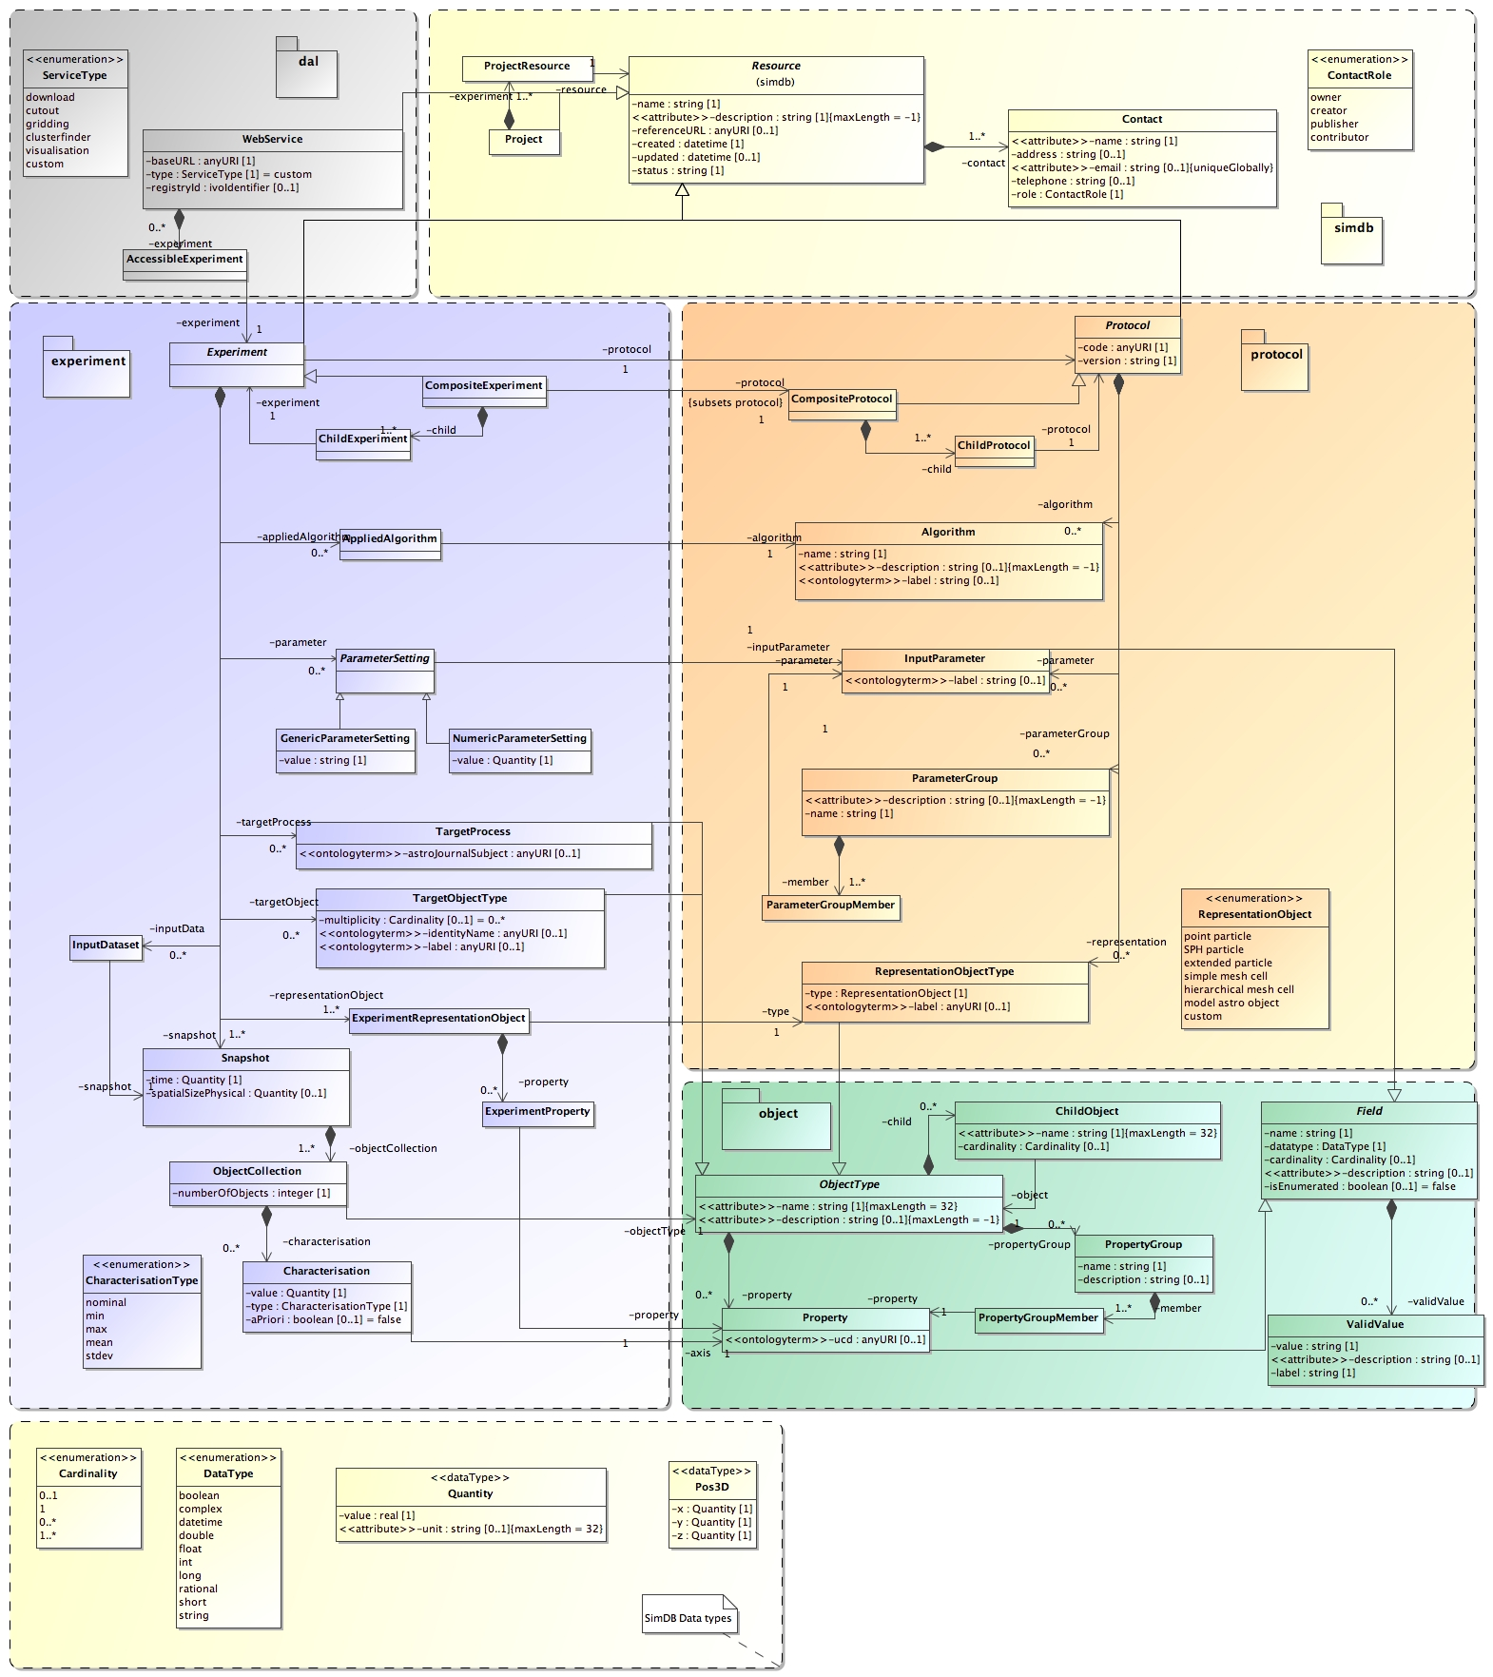

SimDB Specific classes

Simulation classes :

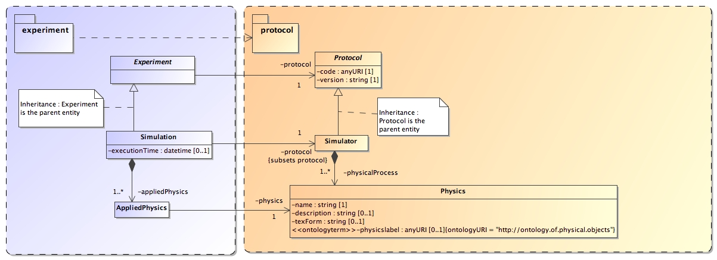

Post Processing classes :

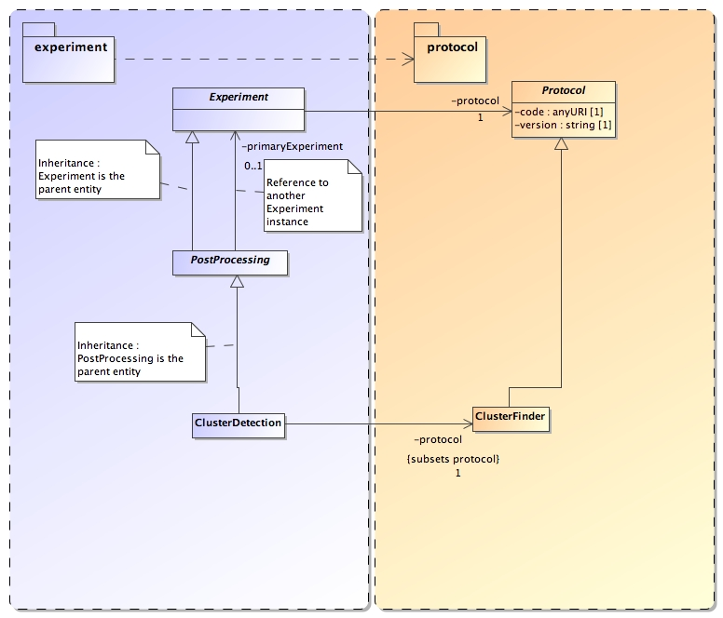

SimDB installation
This installation requires a subversion client (svn command) and Apache Ant 1.6 + :

Fast SimDB installation :

1/ Get the subversion SimDB repository :

svn checkout http://volute.googlecode.com/svn/trunk/projects/theory/snapdm simdb-svn

2/ Create SimDB database in postgres :

cd simdb-svn/ddl/postgres/

psql –U postgres < init_simdb.sql

3/ Edit tomcat home :

cd simdb-svn/webapp/simdb-browser

vi build.properties

# tomcat home (local) :
tomcat.home=/usr/share/tomcat5

Change the variable tomcat.home to your <TOMCAT_HOME>

4/ Edit pipeline options (optional) :

cd simdb-svn/

vi pipeline.properties

# Controls if unit tests should be run finally to check if generated codes are compatible :
target.run.active = true

Change the variable target.run.active to false to disable unit tests (load fake data into the database).

5/ Launch ant :

export PATH=$PATH:/opt/ant/apache-ant-1.7.0/bin (ANT_HOME)

cd simdb-svn/

To see possible tasks :
ant
Buildfile: build.xml

init:
[echo] -------------------------------------------------------------------------------
[echo] IVOA, Theory Interest Group
[echo] UML2 Generator tool - 0.5
[echo] -------------------------------------------------------------------------------
[echo] Build File
[echo] -------------------------------------------------------------------------------
[echo] Contacts : laurent.bourges@obspm.fr, gerard.lemson@mpe.mpg.de
[echo] Build date : 28/11/2008 19:07:43
[echo] -------------------------------------------------------------------------------
[echo] project name : SimDB_DM
[echo] source : SimDB_DM.xml
[echo] root package : org.ivoa
[echo] model package : org.ivoa.dm.model
[echo] schema location : http://volute.googlecode.com/svn/trunk/projects/theory/snapdm/xsd/
[echo] target namespace : http://www.ivoa.net/xml/SNAP/v0.1
[echo] -------------------------------------------------------------------------------
[echo] target.run.active : true
[echo] -------------------------------------------------------------------------------

about:
[echo] available ant targets :
[echo] -------------------------------------------------------------------------------
[echo] - makeAll : make all transformations (uml -> metaModel -> others)
[echo] - forceMakeAll : CLEANS outputs and then make all transformations (makeAll)
[echo] -------------------------------------------------------------------------------

BUILD SUCCESSFUL

To make the full build (with unit tests) :

ant forceMakeAll

6/ Start & Check tomcat :

cd <TOMCAT_HOME>/logs

tail –f simDB-Browser.log
vi simDB-Browser.log

7/ Open a browser :

http://roxxor.obspm.fr:8089/simDB-browser/

SimDB configuration

Log configuration

To Enable / Disable logs :
cd /properties
vi log4j.xml

To Enable / Disable logs for the simdb-browser application :
cd /webapp/simdb-browser/properties
vi log4j.xml

Change levels among :
- debug
- info
- warn
- error

SQL configuration
To Enable / Disable SQL logs :

cd /properties
vi jpa-config.properties

# -----------------------------------------------------------------------------
# Logging level :
# OFF – disables logging
# SEVERE – logs exceptions indicating EclipseLink cannot continue, as well as any exceptions generated during login. This includes a stack trace.
# WARNING – logs exceptions that do not force EclipseLink to stop, including all exceptions not logged with severe level. This does not include a stack trace.
# INFO – logs the login/logout per sever session, including the user name. After acquiring the session, detailed information is logged.
# CONFIG – logs only login, JDBC connection, and database information.
# FINE – logs SQL.
# FINER – similar to warning. Includes stack trace.
# FINEST – includes additional low level information.
#
# -----------------------------------------------------------------------------

eclipselink.logging.level = FINE

To change JDBC properties (connection with the database) :

# -----------------------------------------------------------------------------
# Postgres 8.x sample :

eclipselink.target-database = PostgreSQL

eclipselink.jdbc.driver = org.postgresql.Driver

eclipselink.jdbc.url = jdbc:postgresql://localhost/simdb

eclipselink.jdbc.user = simdb_super
eclipselink.jdbc.password = super

# -----------------------------------------------------------------------------

SimDB Pipeline
This diagram presents the SimDB Pipeline = UML / code generation tool :
