
COS700 Research Proposal
Prototype Demonstration Guide
Adaptive Forensic Framework for 5G Network Slicing
Student number: u21538795
Supervisor(s): Mr. SM (Sheunesu) Makura
Student: Lister Glen Mukota
Validation date: 4 September 2026

1 Completed Prototype and Demonstration Purpose
This guide shows how I run the completed proof of concept from a Windows computer and how I explain the result in a supervisor meeting. The prototype is a contained two-slice 5G laboratory. It does not use a live mobile network, physical radio equipment or real subscriber data.
The current validation completed the full chain without errors: the software build completed with zero warnings and errors, 13 laboratory containers were healthy, all five planned evaluation scenarios passed and all six defined measures passed.
1.1 The six steps in one view
Phase | Plain language work | Main evidence | Latest result
1 | Start a stable two-slice laboratory | Health and baseline files | 13 containers healthy
2 | Run virtual devices and labelled traffic | Scenario ledger and traffic outputs | 2 traffic cases completed
3 | Organise selected records | Evidence index | 27 queryable records
4 | Explain each slice decision | Attribution report and rule reason | 8 of 8 labelled cases correct
5 | Apply approved adaptation and protect records | Priority audit, hashes and custody | 27 of 27 hashes verified
6 | Evaluate the full chain | Scenario, metric and limitation reports | 5 of 5 scenarios; 6 of 6 measures

Table 1: Completed proof of concept and the evidence available for demonstration
How to explain the project: I first create a safe test network, then create known traffic, organise its records, attach a reason to each slice decision, protect the evidence, and finally compare the result with what I expected to see.

2 Before Starting the Prototype
Use this page when starting from a new computer or when preparing for a meeting. The full written installation guide is also in the repository README file.
2.1 What to check
Check | What to do | Why it matters
Docker Desktop | Click Start, open Docker Desktop, and wait for Engine running in the lower-left corner. | It runs the safe 5G laboratory.
Windows WSL 2 | Open PowerShell and run wsl.exe --status. | The containers need Linux support.
.NET SDK | In PowerShell run dotnet --version. | It runs the prototype program.
Git | In PowerShell run git --version. | It downloads the version-controlled project.

Table 2: First checks before a prototype demonstration
2.2 Get the project and open it
If the project is not already on the computer, open PowerShell in a research-project folder and run the following commands. They download the public repository and the pinned laboratory dependency used by the tested scripts.
git clone https://github.com/glen-mukota/adaptive-forensic-framework-5g-network-slicing.git
Set-Location .\adaptive-forensic-framework-5g-network-slicing
New-Item -ItemType Directory -Force .\third_party | Out-Null
git clone https://gitlab.eurecom.fr/oai/openairinterface5g.git .\third_party\openairinterface5g
git -C .\third_party\openairinterface5g checkout 42bf80e9b25dbf521cc692fa6338cbbbebfbcd1d
To inspect the program, click Start, open Visual Studio, select File, Open, Project or Solution, then choose AdaptiveForensics.sln. The runnable project is named ForensicFramework.LabBootstrap.

3 Start the Laboratory and Create Known Traffic
These are the first two phases. Their purpose is to make a controlled starting point: I know what traffic I create and I can later check whether the collected evidence agrees with it.
3.1 Build and check the program
dotnet build .\AdaptiveForensics.sln --configuration Release
dotnet run --project .\src\ForensicFramework.LabBootstrap -- preflight --output .\artifacts\preflight.json
Expected result: Build succeeded, zero warnings and errors, then a PASS result for the local prerequisites. If this fails, fix the named prerequisite before continuing.
3.2 Start Phase 1 and Phase 2
.\scripts\Prepare-OaiTwoSliceLab.ps1
docker compose --project-name oai-two-slice-forensic-lab -f .\third_party\openairinterface5g\doc\tutorial_resources\oai-cn5g\docker-compose.yaml up -d --wait --wait-timeout 300
.\scripts\Capture-OaiBaselineEvidence.ps1
.\scripts\Start-Phase2Rfsim.ps1 -WaitTimeoutSeconds 300
.\scripts\Run-Phase2ControlledTraffic.ps1
In Docker Desktop, click Containers in the left menu. Green healthy status beside each core and virtual-radio container is the visible confirmation that the laboratory is ready. This is what I will show first in a meeting.
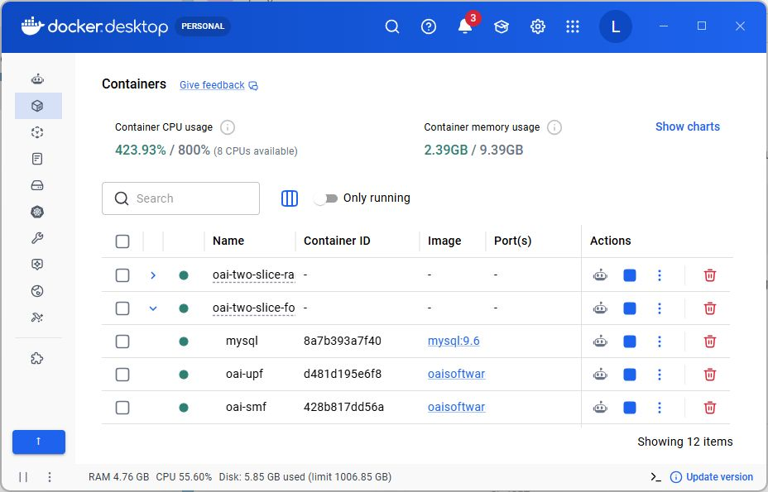
Figure 1: Docker Desktop shows the current controlled laboratory with the required containers running

4 Organise Explain and Protect the Evidence
Phases 3 to 5 turn the controlled traffic into evidence that can be reviewed. They keep the source files unchanged, state why a slice was or was not assigned, and create integrity and custody records.
4.1 Run phases 3 to 5 in this order
Command | Purpose | What to say when demonstrating
Run-Phase3EvidenceIngestion.ps1 | Creates the structured evidence index. | The program records what it found without changing the original file.
Run-Phase4SliceAttribution.ps1 | Applies clear slice rules. | A record is assigned only when the context supports it; shared evidence stays ambiguous.
Run-Phase5AdaptiveCollection.ps1 | Applies the approved priority rule and protects evidence. | The rule is recorded, SHA-256 hashes are checked and custody details are retained.

Table 3: Commands and simple explanations for Phases 3 to 5
.\scripts\Run-Phase3EvidenceIngestion.ps1
.\scripts\Run-Phase4SliceAttribution.ps1
.\scripts\Run-Phase5AdaptiveCollection.ps1
The image below shows the same C# solution open in Visual Studio. The solution explorer on the right identifies the runnable project; the error list at the bottom shows zero errors and zero warnings.
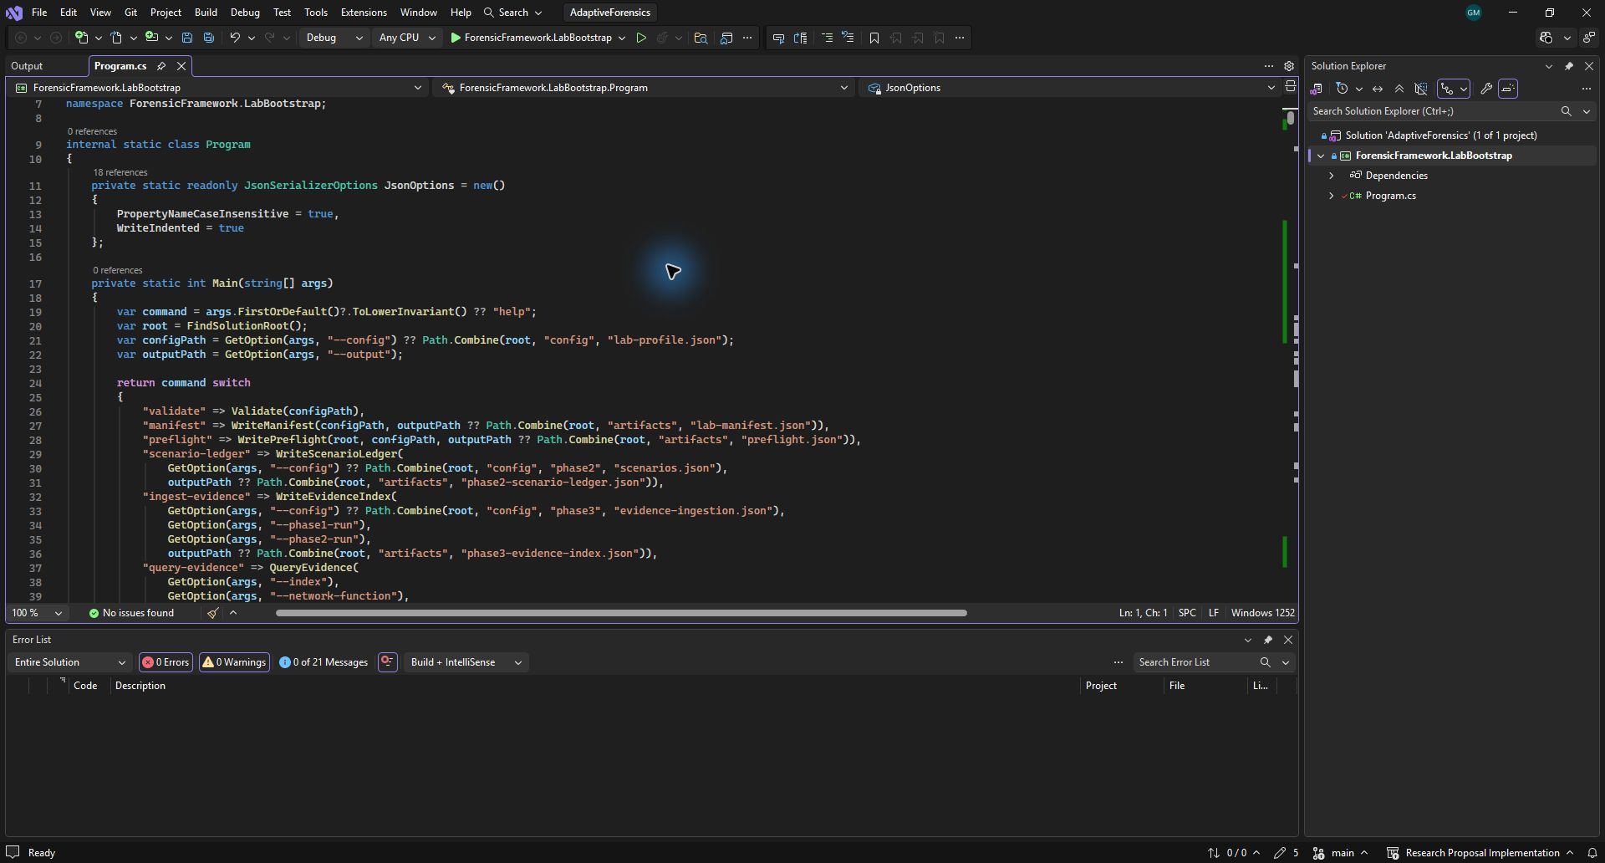
Figure 2: Visual Studio showing the forensic framework solution and a clean error list

5 Run Phase 6 and Read the Evaluation
Phase 6 checks the completed chain against known inputs. It is not a new traffic attack: the allocation-anomaly test is a data-only replay that confirms the logic refuses an unknown slice context.
.\scripts\Run-Phase6Evaluation.ps1
The command creates a new folder named artifacts\runs\phase6-<timestamp>. It checks that each preceding phase is complete before accepting the final result.
5.1 Current measured result
Measure | How it was checked | Current result
Attribution accuracy | Correct labelled records / labelled cases | 8/8 = 100%
Collection completeness | Required normal-operation evidence / expected evidence | 8/8 = 100%
Integrity verification | Matching recomputed hashes / custody entries | 27/27 = 100%
Adaptation latency | Maximum time from approved event to update | 9 milliseconds
Custody completeness | Complete custody entries / all custody entries | 27/27 = 100%
Observed laboratory overhead | Before/after total Docker activity | 83.36 CPU percentage points; 2.58 MiB memory change

Table 4: Phase 6 measures from the latest completed evaluation run
Important interpretation: the overhead row is an observation of total container activity during the controlled traffic run. It does not claim to measure the isolated cost of the forensic program in a production mobile network.
5.2 View the result
$phase6 = Get-ChildItem .\artifacts\runs -Directory -Filter 'phase6-*' | Sort-Object LastWriteTime -Descending | Select-Object -First 1
Get-Content (Join-Path $phase6.FullName 'phase6-summary.json')
Get-Content (Join-Path $phase6.FullName 'metrics.json')
Expected result: Result is completed, 5 of 5 scenarios passed and 6 of 6 measures passed. The same folder contains the scenario results, resource observation and limitations file.

6 External Examiner Test and Meeting Demonstration
An examiner can reproduce the proof of concept by following the README commands in order. The commands below are a short meeting sequence; each step uses the evidence created by the previous step.
6.1 Short live demonstration script
Time | Action | Simple explanation
1 minute | Open Docker Desktop and show Containers. | This is the safe laboratory. Green healthy statuses show that the required services are available.
1 minute | Run preflight and show the build result. | This checks the computer and confirms that the program can run.
1 minute | Run the Phase 2 traffic command or show its latest summary. | The two known traffic cases give me a reference for later checks.
1 minute | Run Phases 3 to 5 or open their latest summaries. | The records are organised, explained, protected and linked to their custody details.
2 minutes | Run Phase 6 and open phase6-summary.json and metrics.json. | The final result compares the retained evidence with the five planned scenarios and six measures.

Table 5: A six-minute supervisor demonstration sequence
6.2 Safe shutdown and simple recovery
After the meeting, stop only the containers created by this prototype. The commands do not delete the retained artifacts folder.
docker compose --project-name oai-two-slice-ran -f .\config\phase2\docker-compose.rfsim.yaml down
docker compose --project-name oai-two-slice-forensic-lab -f .\third_party\openairinterface5g\doc\tutorial_resources\oai-cn5g\docker-compose.yaml down
If Docker Engine fails in preflight, start Docker Desktop and wait for Engine running. If an evaluation input is rejected, run Phases 2 to 5 again in sequence; Phase 6 deliberately rejects incomplete or unlinked evidence chains.
Repository location: https://github.com/glen-mukota/adaptive-forensic-framework-5g-network-slicing. The README gives the complete clean-computer installation, deployment, run, output and troubleshooting instructions.

