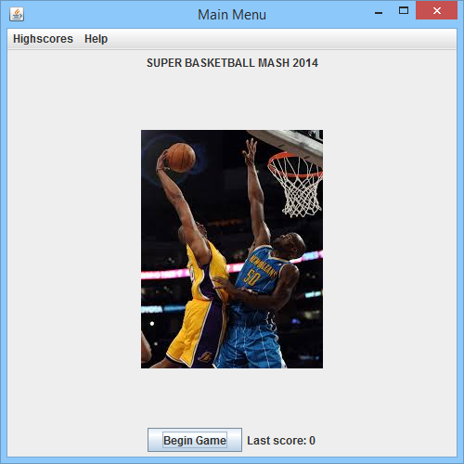

Beginning title screen. JMenuBar, begin game button, and other components.

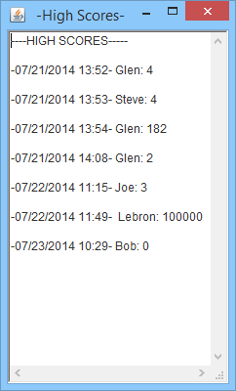JMenuItem selection seeHigh scores, textarea with frame, shows file contents of “highScores.txt”

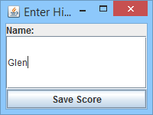

Window for entering highScore, that will last recieved score, name, and time.

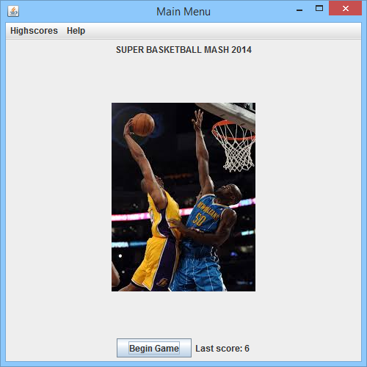

Same menu after last game played, displays last score on the bottom next to “Begin Game” button.

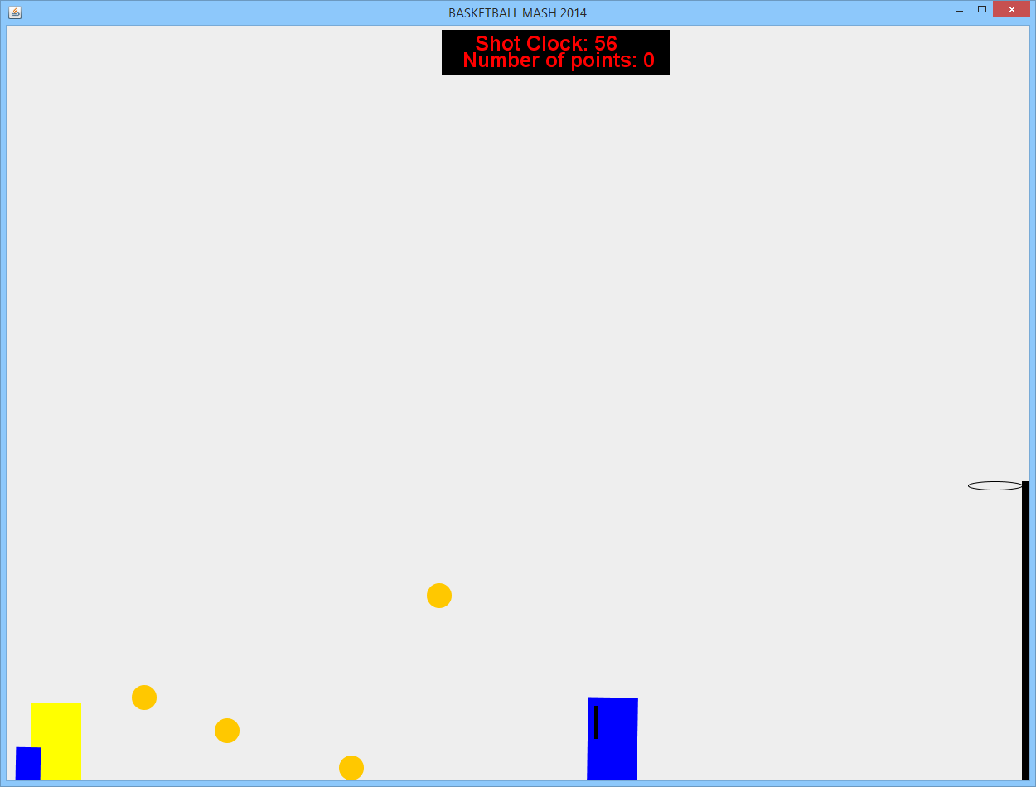

Image of Ball objects in the action of movement

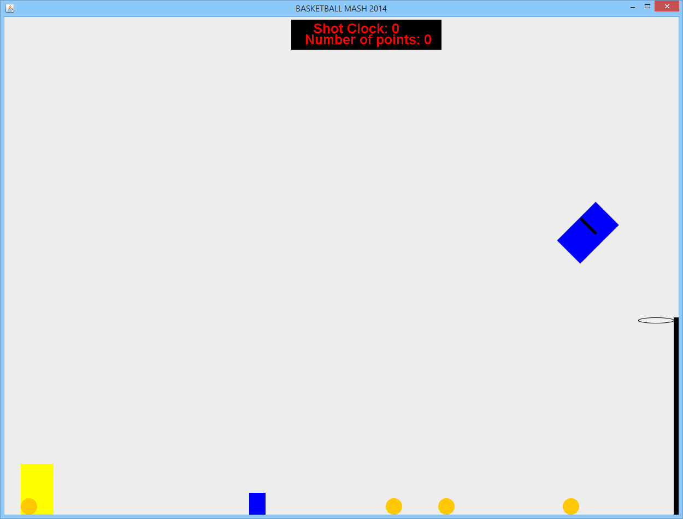

Image of defender playing jumping, also showing object rotation abilities.

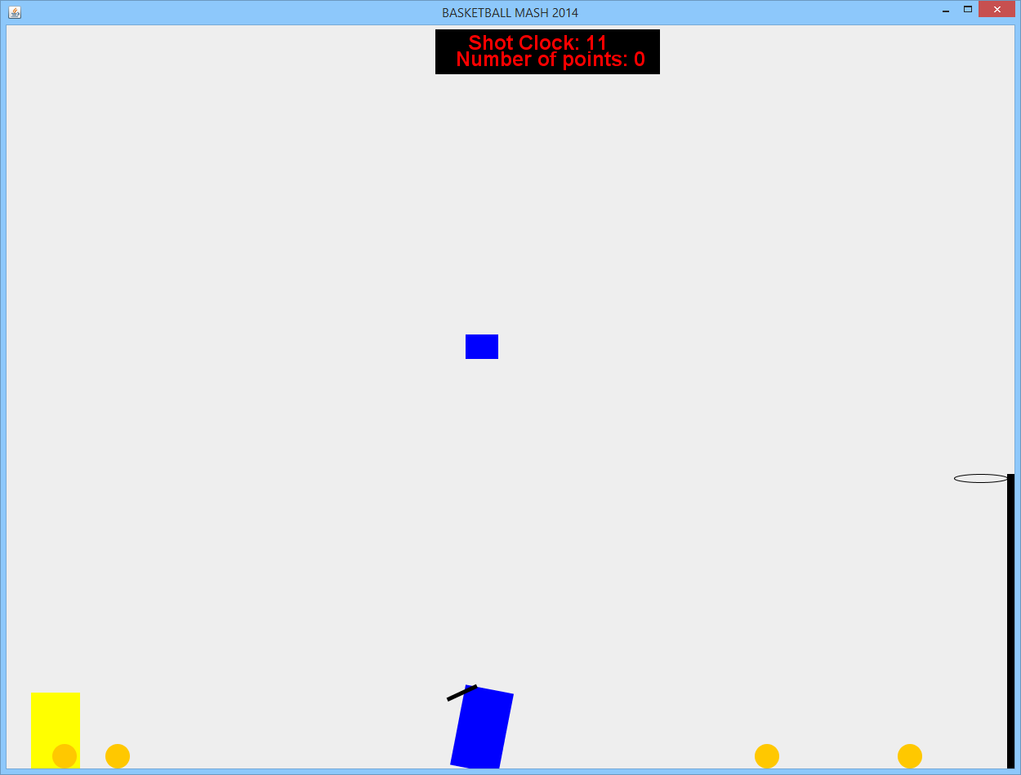

Shows the defender bouncing square object off of it’s head.

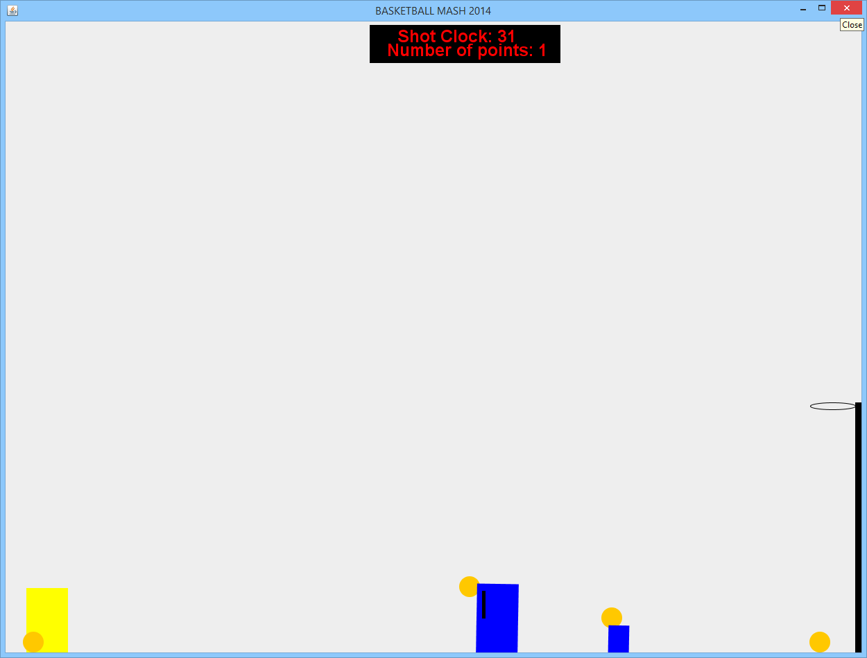

Shows shot clock where a point has previously been scored, as well as the defender interacting with a ball, and a square object interacting with a ball.