ChatGTP Workout

95 incline bench
60x2 dumbbell Incline bench
Shoulder press 37.5
Cable crunch 62.5
Lat crunch 70
Machine chest press 120x2
Tricep push down 75
Seated Cable row 172
Lat pulldown 130
Face pull 60
Db curl 55
Lying hamstring 98
Bulgarian 80
Calf raises 200
Leg press 370 (235x2)
Paloff 47.5
Goblet squat 100
Dumbbell row 55
Tricep machine 135x2p
Cable chest 32.5x2
Lying leg press 380
Back pull incline 115
Assisted pull-up 30
Mid row 170
Seated machine triceps 265

Exercises
Main Work (about 40–45 min total)

1️⃣ Incline DB or Barbell Press
4 sets x 6–10 reps
• increasing weight
• stop 1 rep before failure

2️⃣ Machine Chest Press
3 x 8–12
• slow control

3️⃣ Seated DB Shoulder Press (neutral grip)q
3 x 8–10

4️⃣ Cable Triceps Pushdown
3 x 10–12

5️⃣ Core Finisher — Cable Crunch
3 x 10–12 heavy
L:0::
✅ Much stronger stimulus than high-rep push-ups + crunches. PPP pp

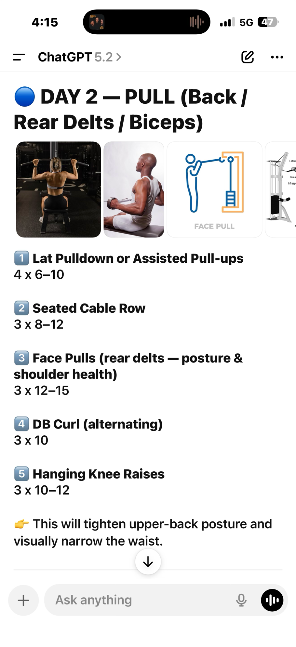
P

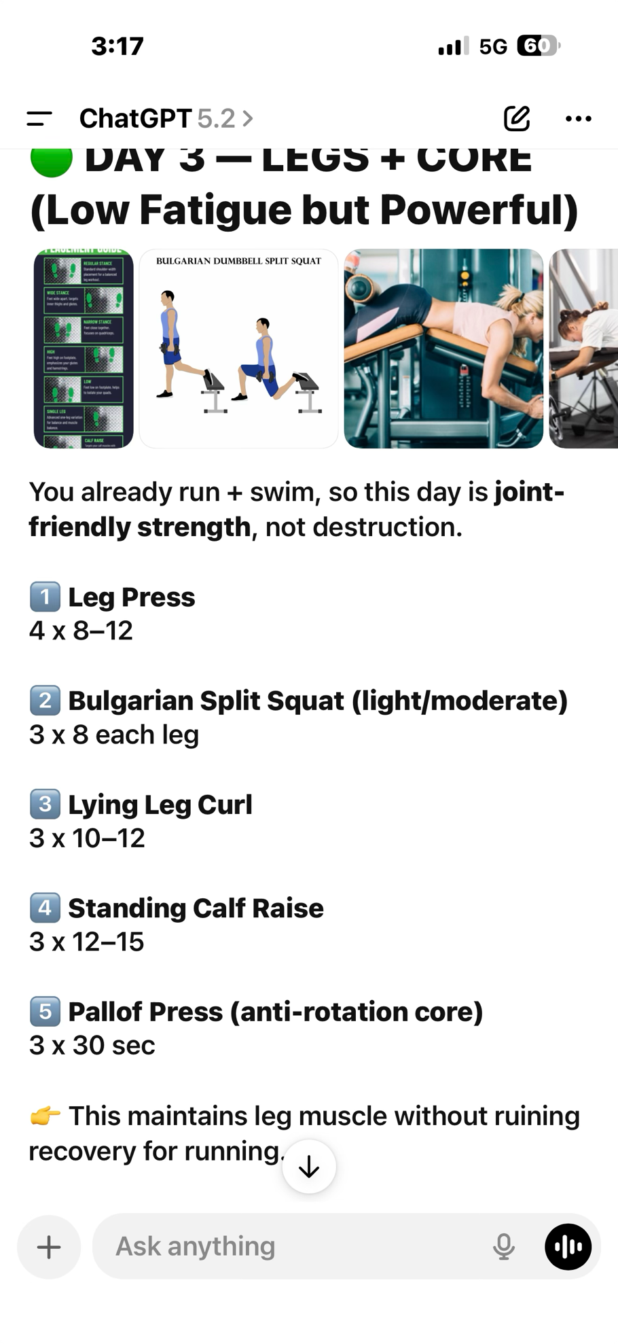
l

