Glenn Norris Jr

CMPE 3434 Microprocessor Lab

Dr. Lei

May 26, 2016

Temperature Sensing Write Up

Materials Needed

Beagle Bone Black, 2 Seven Segment Displays, 2 shift registers (74HC595), 10 kilo ohm resistor ,many connector wires , a bread board and a thermistor

Procedure

First procure a thermistor and attach it to a bread board. In order to use the thermistor properly you must calculate the changing value R. To do this create a voltage divider where you are inputting 1.8 V and Ra is your10 kilo ohm resistor. Rb is the thermistor.

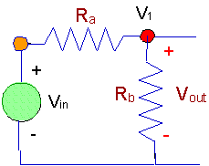

Taken from : <https://www.facstaff.bucknell.edu/mastascu/eLessonsHTML/Sensors/TempRNote1.htm>

Once you have the circuit set up on your bread board you can test it.

Turn on your beagle bone black, make sure you export

$SLOT=/sys/devices/bone_capemgr.9/slots

$PINS=/sys/kernel/debug/pinctrl/44e108000.pinmux/pins

Navigate to /lib/firmware

Once there load the BB-BONE-BACONE into $SLOTS

To do this use echo BB-BONE-BACONE > $SLOTS

Once this has been accomplished navigate to /sys/devices/ocp.3/bacon_adc_helper.15

To ensure the Analog inputs are on and reading you can cat AIN0-AIN7 where you will see random values

Once here you may choose any of the analog input values (AIN0-AIN7)

I chose AIN5 which is the P9_36 pin on the beagle bone

You can connect your ground to p9_34 and your initial voltage of 1.8V to P9_32

Once you have the pins connected properly you be able to see value in AIN5 using the cat command

This value is in MICROVolts (µV). With this voltage output you can calculate the unknown resistor value.

Once you have gone through your calculations and acquired your unknown resistor value you can plug it into the temperature equation



Or you can use



Where T is the Temperature in Kelvin, T0 is the initial temperature (or room temperature 273.15 + 25) , B or Beta is a constant you acquire from the thermistor’s datasheet , R is your calculated Resistor value of the thermistor and R0 is the other resistor value in your circuit which in your case is 10 kΩ.

Being that you are probably in a room that is around 25 degrees Celsius your final temperature should be within a few degrees of that. (Remember Final value is in kelvin so convert to Celsius and check room temperature)

Once this was accomplished I developed a c program to read in the Analog Input Values using a function that check the value of the changing file

Once you have the program up and running you must now set up your displays in my case I used two 7 segment displays and two shift registers (74HC595)

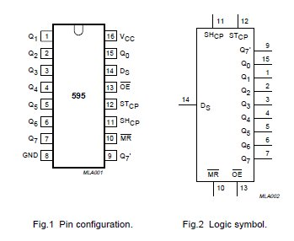

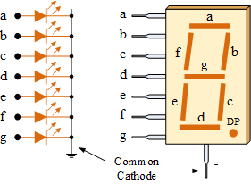

The ser pin is serial which is p9_18 , while the SRCLK pin acts as the Clock p9_22 and the RLCLK acts as the latch p9_22. Using the datasheet for the 7 segment display you can configure the shift register and 7 segment display together. Once you have them configured you can plug in your beagle bone black and if the displays turn on or light up you have wired them correctly.

Now you must navigate back to /lib/firmware and load the BB-BONE-BACONE into the $SLOTS folder

Use the command echo BB-BACONE > $SLOTS

Once this is done you can now write a script to change the value displayed on both 7 segment register. In my case I developed arrays that hold 8 bit binary values and then I passed it into a function that would display the numbers.

Once that was accomplished I assembled my program where I added in the algorithm to get values from the analog input, computing the temperature, extract the values and then using the function to set the 8 bit value corresponding to the temperature into the 7 segment display. I set this whole routine into a while statement so that the program is in a constant state of checking for the temperature.