**April 21, 2021**

**PROF. DEMELYN E. MOZON**

*Head, Office of the Student Affairs and Services*

*PUP Quezon City Branch*

This is to certify that **COMMONWEALTH INFORMATION TECHNOLOGY SOCIETY** or COMMITs is accredited under the supervision of *PUPQC Office of the Student Affairs and Services* and has already been cleared for financial liability in *Supreme Student Council* for the school year 2020 - 2021.

This certification is issued upon the request of **COMMONWEALTH INFORMATION TECHNOLOGY SOCIETY** for whatever purpose it may serve.

Thank you!

Respectfully yours,

**MS. SOPHIA VEINNE B. CERBO**

AUDIT DIVISION CHAIRPERSON, SSC

Noted by:

**MR. DANILO ROBERTO MERCADO JR.**

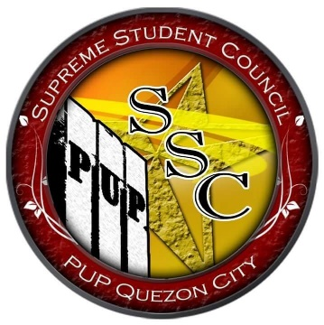*President, SSC 2020-2021*