**EVENT TITLE:**



**DATE, TIME, AND VENUE:**

* This event will be conducted on **March 15-24, 2021**
* **Vox Nova** and **MUSA** will conduct a webinar on **March 15, 2021** (Monday) at 9:00am to 11:00am via zoom.
* **Vox Nova** will post the announcement of contest on the official Facebook page of Vox Nova.
* The duration of entry will last until March 22, 2021 (Monday)
* March 24, 2021 will be the announcement of winners in the official Facebook page of Vox Nova

**EVENT ORGANIZER AND BRIEF INTRODUCTION:**

* The organizer of this event will be led by **Vox Nova** the official publication of Polytechnic University of the Philippines - Quezon City that serves as the instrument in which the voices of the PUPQC students shall be heard with the collaboration of Mag-aaral ng Unibersidad sa Sining at Adhika (**MUSA**) a non-academic organization that help the students to showcase their talents.

**EVENT OVERVIEW:**

* The theme of this event “The 21st Generation Artists and Writers: Challenges Amidst Pandemic” aims to showcase those inspiring students who are willing to share and inspire others from their work.
* This event will incorporate some of the TEN PILLARS of PUP to vision, mission, objectives, and philosophies in implementing plans and programs of each organization, especially the pillar number five (5) which is empowering faculty members and employees in all the organizations of PUPQC.
* Vox Nova and Musa will conduct a webinar on the first day of the event with the participation of all the members of Vox Nova and Musa. This webinar will help the members of the both organizations to strengthen the relationship of all the members. This will also help the members to be aware of the challenges in times of this pandemic and how will they cope up with it.
* The posting of announcement of contest will be on **March 15, 2021** (Monday), the entry of participants will start as soon as the digital layout of the contest has been posted. We will accept entries until **March 22, 2021** (Monday), and the announcement of winners will be on **March 24, 2021** (Wednesday).
* The participants will submit their entry in the email account of Vox Nova:

***[voxnovaqc@gmail.com](mailto:voxnovaqc@gmail.com)***

* This event will feature the following contest:

- Poster Making Contest

- Editorial Writing Contest

- Editorial Cartooning Contest

**LINK TO EVENT PAGE/SITE OR SOCIAL MEDIA PAGES**:

* **Vox Nova** Official Facebook Page link:

***<https://www.facebook.com/voxnovapupqc>***

* **MUSA** Official Facebook Page link:

***<http://facebook.com/musapupqc>***

**TARGET PARTICIPANTS:**

* This contest is open to all the students of Polytechnic University of the Philippines – Quezon City Branch

**PRIZES FOR WINNERS:**

* **POSTER MAKING CONTEST**

***FIRST PLACE* -** PHP 1,000.00

***SECOND PLACE* -** PHP 500.00

* **EDITORIAL WRITING CONTEST**

***FIRST PLACE* -** PHP 1,000.00

***SECOND PLACE* -** PHP 500.00

* **EDITORIAL CARTOONING CONTEST**

***FIRST PLACE* -** PHP 1,000.00

***SECOND PLACE* -** PHP 500.00

The winners will receive their prize via Gcash and/or preferred mode of transaction; all the participants will receive a certificate of participation.

**SOURCE OF FUNDS:**

* The source of funds for this event will be the remaining organization's funds from the admin as mentioned in our Budgetary Outlay.

**REGISTRATION LINK:**

**<https://docs.google.com/forms/d/1Hemb-33pFP3h4eRSijd9q6-0MAWmNMoBsRWPXhnAAls/edit?usp=sharing>**

**CRITERIA FOR JUDGING:**

* **POSTER MAKING RUBRIC**

|  |  |  |  |  |  |
| --- | --- | --- | --- | --- | --- |
| **CRITERIA** | **4** | **3** | **2** | **1** |  |
| **RELEVANCE TO THE THEME** | All graphics are  related to the theme  and easy to understand  understand | All graphics are  related to the theme  and most make it  easier to  understand | Some topics does not relate to the theme | Graphics do not  relate to the  theme | 40% |
| **CREATIVITY AND ORIGNALITY** | The text and graphics  used on the poster  reflect an exceptional  degree of  creativity in contestant’s  creation and/or  display. | One or two  elements of text and  graphics used on the  poster  reflect student  creativity in contestant’s  creation and/or  display. | The text and graphics  are made  by the contestant, but  are based on the  designs or ideas of  others. | No original text or  graphics made by the  contestant is included. | 30% |
| **PRESENTATION AND AUDIENCE IMPACT** | The poster is  exceptionally  enticing in terms of  design, layout, and  neatness. | The poster is  enticing in terms  of design, layout  and neatness. | The poster is  acceptably  enticing though it  may be a bit messy | The poster is  distractingly messy  or very poorly  designed. It is not  attractive. | 30% |
| **TOTAL** |  |  |  |  | **100%** |

* **WRITING CONTEST RUBRIC (EDITORIAL)**

**50% Relevance to the Theme**

**20% Coherence of Facts & Idea**

**15% Observance of Proper Technical Writing**

**15% Conviction of the Article**

**EDITORIAL CARTOON CRITERIA**

|  |  |  |  |  |  |
| --- | --- | --- | --- | --- | --- |
| **CRITERIA** | **EXCELLENT** | **ACCEPTABLE** | **MINIMAL** | **UNNACCEPTABLE** |  |
| **Creativity and originality** | Color  and creative  graphics  are used  exceptionally  well and shows originality  30 | Color and creative  graphics are  used.  20 | Some  color and  creative  graphics are  used.  10 | Color and graphics  are lacking; shows no originality.  0 | **30%** |
| **Content** | Cartoon clearly  conveys an  understanding  of the issue;  excellent use  of appropriate  symbolism;  key issue and  cartoonist’s  position  are clearly  identifiable; message is clear,  clever, and  relevant to  topic.  50 | Cartoon  conveys  understanding  of the  issue; uses  appropriate  symbolism;  Key issue and  cartoonist’s  position are  identifiable; message is somewhat clear and relevant to  topic.  30 | Cartoon  conveys  a limited  understanding  of the issue;  attempts to  use symbolism;  message is unclear  or irrelevant to  topic;  Key issue is  identifiable;  cartoonist’s  position may  be unclear  10 | Cartoon  conveys  little or no  understanding  of the issue;  does not use  symbolism;  message and relevance is missing.  Key issue and  cartoonist’s  position are  unclear.  0 | **50%** |
| **Visual presentation** | Cartoon  demonstrates  a high level of  neatness and  quality; captions  are readable.  20 | Cartoon  demonstrates  moderate level  of quality and  neatness; captions  are readable.  15 | Somewhat  lacking in  neatness; captions  are included.  10 | Cartoon is  lacking in  neatness and messy; captions are  omitted or  unreadable.  0 | **20%** |
| **TOTAL** |  |  |  |  | **100** |

**Prepared by: Checked by:**

***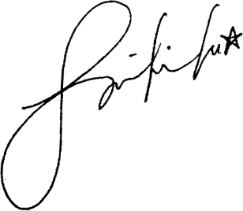*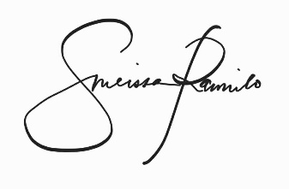**

**MELISSA JOY RAMILO Aiza Nicole Dela Rosa**

**EIC-Internal – Vox Nova President - MUSA**

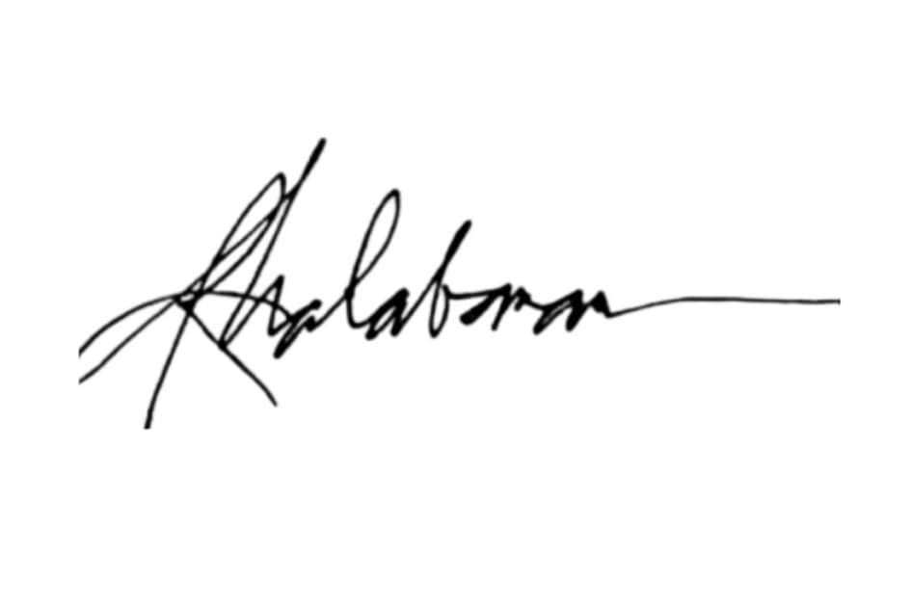

**Noted by: Approved by:**

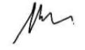

**JOHN CASPER MORADA PROF. ROSELLER MALABANAN**

**Editor-In-Chief – Vox Nova Adviser – Vox Nova**

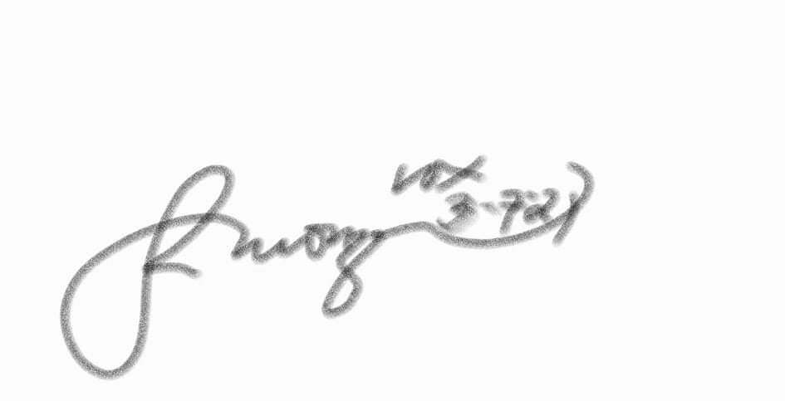

**Submitted to:**

**PROF. DEMELYN P. MONZON**

**Head, Student Affairs and Services**