**CERTIFICATION**

This is the certify that the new ***Commonwealth Information Technology Society (COMMITS)***- PUP Quezon City Executive Board AY 2020-2021 are officially enrolled as Bachelor of Science in Information of Technology for Academic Year 2020-2021.

|  |  |  |
| --- | --- | --- |
| **NAME** | **SECTION** | **STUDENT NUMBER** |
| **Mark Kennedy S. Asilan jr.** | BSIT 4-1 | 2017-00308-CM-0 |
| **Ariel Ordanza Jr.** | BSIT 3-1 | 2018-074484-CM-0 |
| **Elric C.j S. Robillos** | BSIT 3-1 | 2018-00091-CM-0 |
| **John Peter Narzoles** | BSIT 3-1 | 2018-00137-CM-0 |
| **Zsyrhill Anne C. Soria** | BSIT 2-1 | 2019-00280-CM-0 |
| **Riezel Mae R. Sanchez** | BSIT 3-2 | 2018-00138-CM-0 |
| **Arlou R. Luganob** | BSIT 3-2 | 2018-00129-CM-0 |
| **Angel Ann C. Retamar** | BSIT 2-1 | 2019-00040-CM-0 |
| **Kier a. Esteban** | BSIT 2-1 | 2019-00157-CM-0 |
| **Filwayne Kean M De Lara** | BSIT 2-1 | 2019-00094-CM-0 |
| **Jhay Mark T. Pineda** | BSIT 2-1 |  |

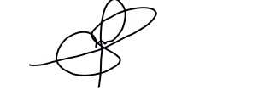PREPARED BY:

**MARK KENNEDY S. ASILAN JR.**

President, COMMITS PUPQC



**PROF. ALMA C. FERNANDEZ**

Adviser, COMMITS PUPQC

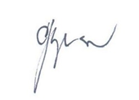NOTED BY:

**PROF. CLEOTILDE SERVIGON**

Branch Registrar

**PROF. DEMELYN E. MONZON**

Head Office of Student Affairs and Services