# March 1, 2021

**EXECUTIVE BOARD MEMBERS A.Y. 2020-2021**

**Kristine Joy Baldovizo**

*President*

**Mae Adrianne Dalmacio**

*Executive Vice-President*

**Kristine Casaños**

*Executive Board Secretary*

**Jaswyn Jade Dacalos**

*Internal Affairs Officer*

**Michelle Delos Reyes**

*External Affairs Officer*

**Jerald Vincent Agustin**

*Student Relations and Legality Officer*

**Lalaine Ann Lagrisola**

*Budget and Finance Officer*

**Mary Joy Arcega**

*Audit Officer*

**Jerome Chester Gay**

*Public Affairs Officer*

**Melissa Joy Ramilo**

*Research and Development Officer*

**Jummel Balantac**

*Fund Raising and Collection Activity Officer*

**Jo Abigail Maria Morales**

*Assistant Officer for Budget and Finance*

**Lianne De La Rosa**

*Assistant Officer for Auditing*

**Nico Suarez**

*3rd Yr. Staff Representative*

**Icey Caxandra Quiseo**

*2nd Yr. Staff Representative*

**Marcelino Emmanuel Pamisa**

*1st Yr. Staff Representative*

**“A Manager’s Excellence through his Dedication, Motivation and Commitment.”**

**PROF. EDGARDO S. DELMO**

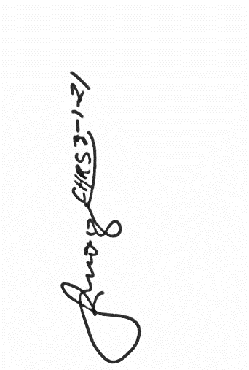Branch Director

**Polytechnic University of the Philippines

Quezon City Branch *3-1-21*

**Thru:**      **PROF. DORIS B. GATAN**

Academic Head

**PROF. DEMELYN MONZON**

                                        Head, Student Affairs and Services

Dear Sir/Madam:

A day filled with grace and blessings!

The **Community of Human Resource Students** (CHRS) of PUP Quezon City Branch is the student organization of Bachelor of Science in Business Administration major in Human Resource Development Management of the University that aims standard leadership, unity and equity for the betterment of its co-students.

The Community of Human Resource Students (CHRS) will be holding a **Webinar titled “FUTURE PROOF IN COPING UP WITH THE NEW TRENDS”** on **March 8, 2021; 2:00pm – 05:00pm** via Zoom Meeting

In line with this, we invited resource speaker to deliver the topics that would help us in attaining our goals and objectives in this event, hereunder are the name and schedule given to him:

March 8, 2021

2:50 PM – 4:20 PM Mr. Rolando Canda Jr

Program Manager in the office of Deputy

General for Partnership Linkages, TESDA

We are looking forward for your most favorable response regarding this request.



Thank you and God bless!

Respectfully yours,

**Kristine Joy Baldovizo**

President, CHRS

Noted by:

**Prof. Melanie F. Bactasa, RGC, RPm**

Adviser, CHRS