

**FBTO GOT TALENT**

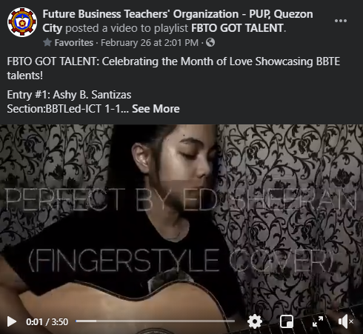  
**Entry #1:** Ashly B. Santizas from BBTLed-ICT 1-1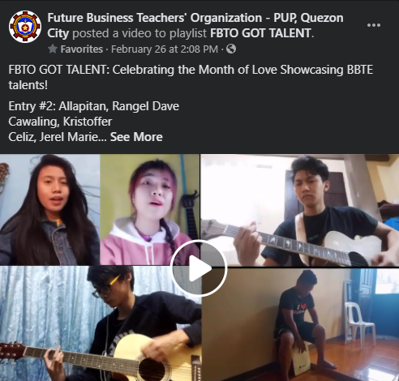 **Entry #2:** SPROUTS from BBTLed-ICT 2-1

  
**Entry #3:** Ma. Karmella Therese Santos from BBTLed-HE3-1  
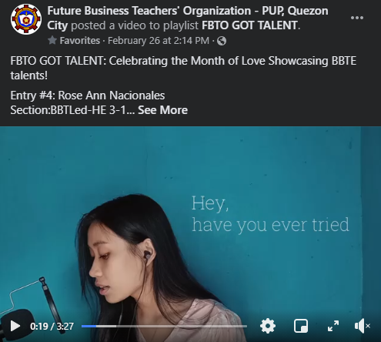  
**Entry #4:** Rose Ann Nacionales from BBTLed-HE3-1  
  
**Entry #5:** James B. Mantes from BBTLed-ICT 1-1  
  
**Entry #6:** Rose Ann Nacionales from BBTLed-HE3-1  
|  
  
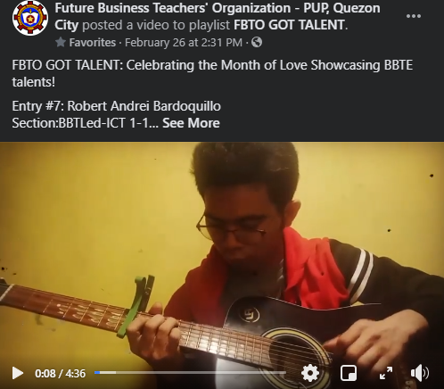  
**Entry #7:** Robert Andrei Bardoquillo from BBTLed

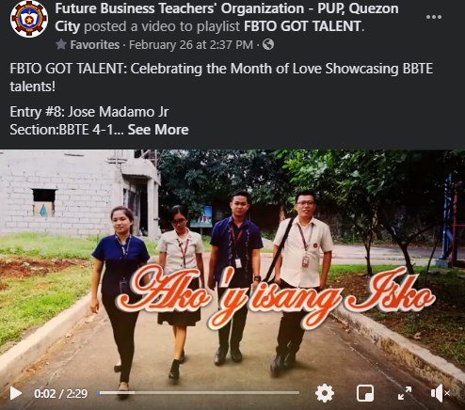  
**Entry #8:** Jose Madamo Jr. from BBTE 4-1



**Entry #4:** Joni Lopez from BBTE 4-1

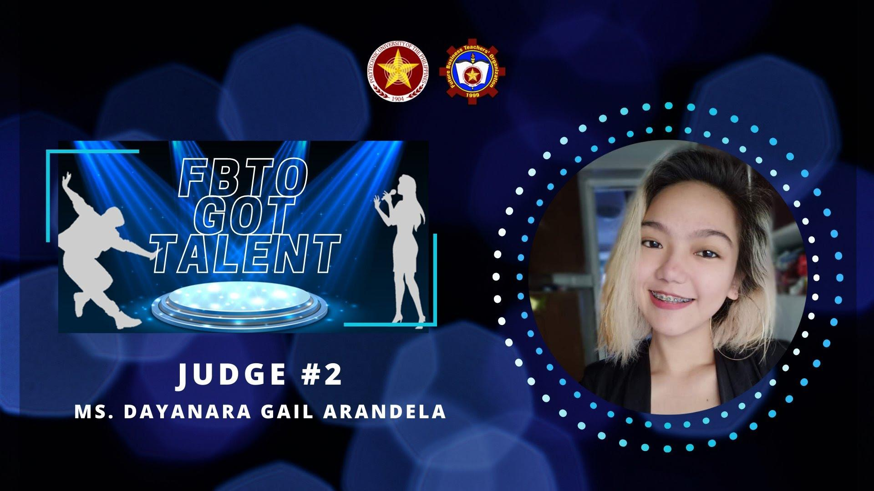

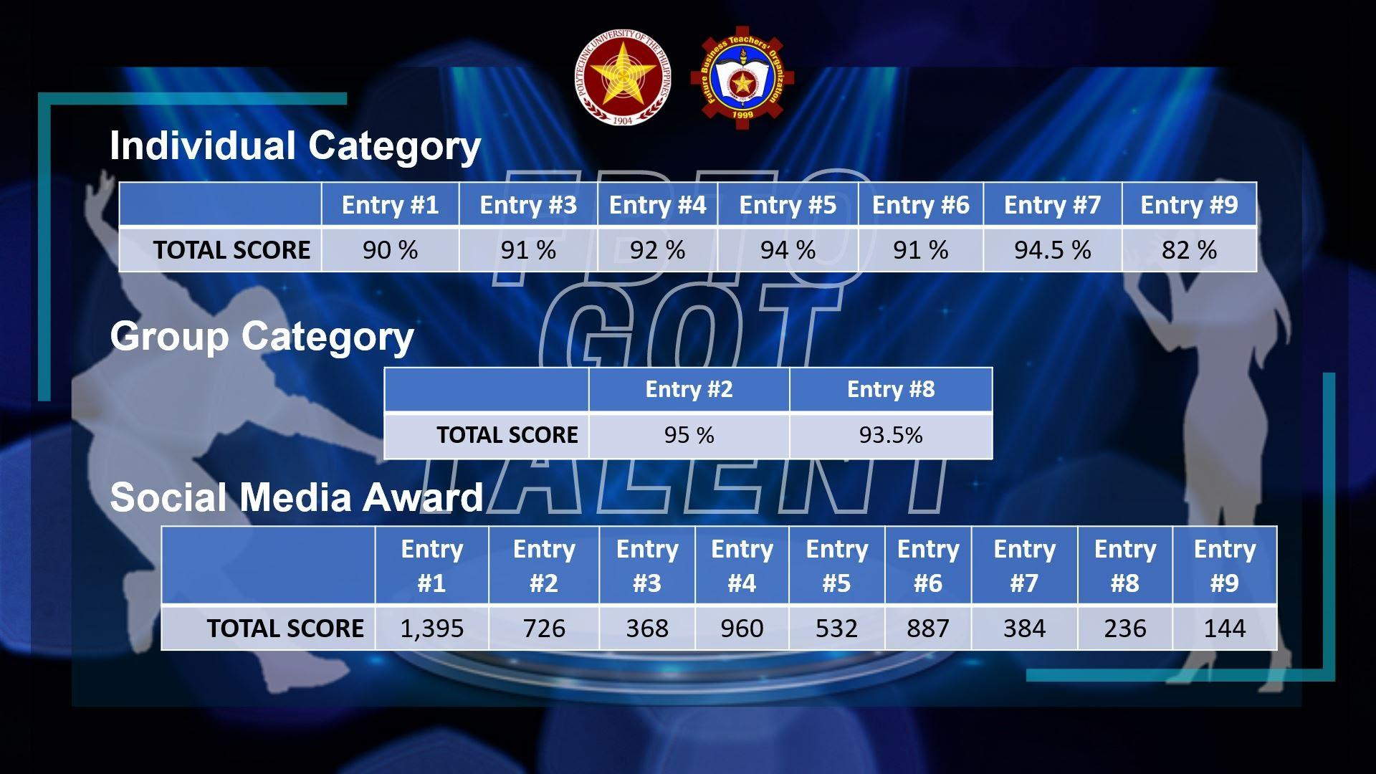  
  
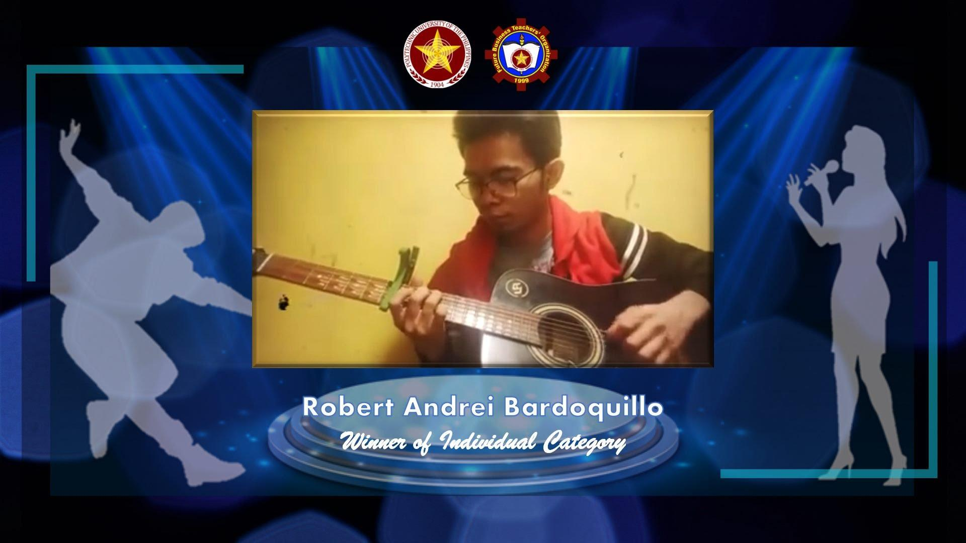

Winner of Individual Category : P300.00

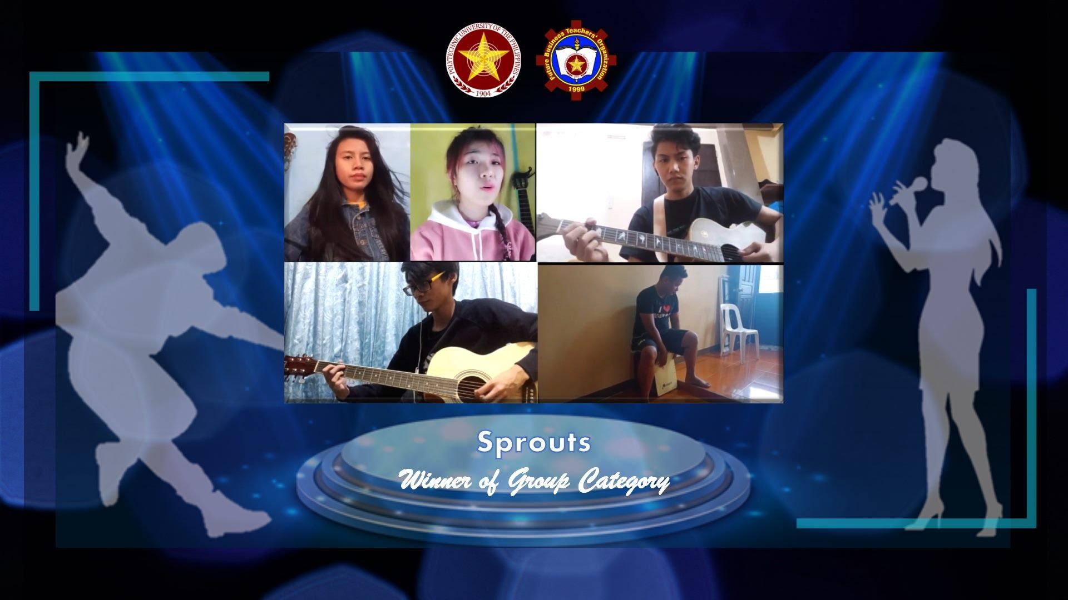  
  
Winner of Group Category: P400.00

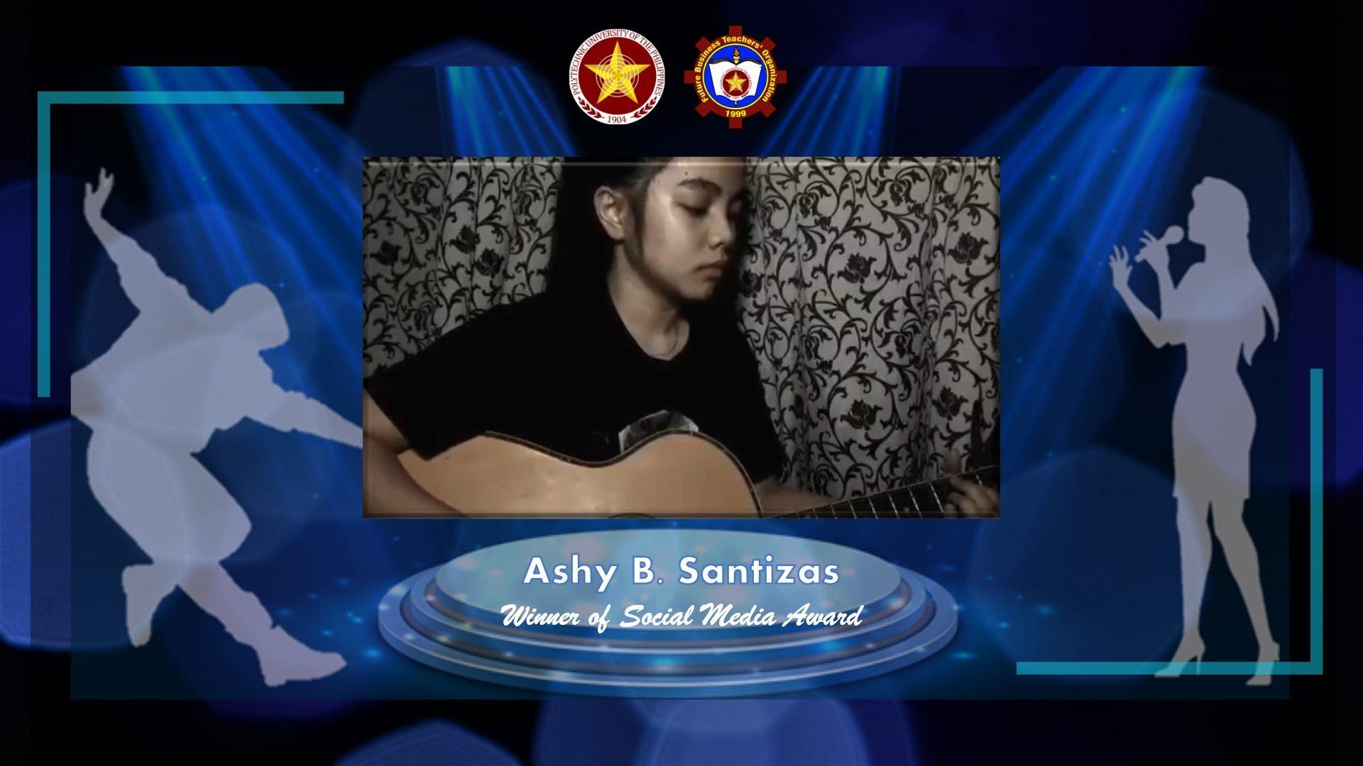

Winner of Social Media Award: P200.00

Appendix 1

CERTIFICATE OF ACCREDITATION

Appendix 2

LIST OF OFFICERS

**LIST OF OFFICERS  
Future Business Teachers’ Organization**

**List of Officers A.Y. 2020-2021**

| Name Position | | Year/Section Student Number | | Contact No. | |
| --- | --- | --- | --- | --- | --- |
| Jay Ann F. Rom | President | BBTE 4-1 | 2017-00320-CM-0 | 9087520849 | |
| Bonie A. Latagan | V.P Internal | BBTLED HE 3-1 | 2018-00087-CM-0 | 9105217081 | |
| Arlene H. Dumale | V.P External | BBTE 4-1 | 2017-00335-CM-0 | 9996896307 | |
| Carlo C. Arevalo | Secretary | BBTE 4-1 | 2014-00478-CM-0 | 9208238000 | |
| Mary Grace G. Aquino | Asst. Secretary | BBTLED HE 3-1 | 2018-00094-CM-0 | 9652839897 | |
| Iren S. Mariscal | Treasurer | BBTE 4-1 | 2017-00321-CM-0 | 9152890555 | |
| Zelynda Marie V. Loquias | Asst. Treasurer | BBTLED HE 3-1 | 2018-00466-CM-0 | 9615089557 | |
| Jennylyn M. Balaoro | Auditor | BBTLED HE 3-1 | 2018-00155-CM-0 | 9127772957 | |
| Lloyd S. Lagare | Asst. Auditor | BBTLED HE 2-1 | 2019-00362-CM-0 | 09168207952 | |
| Mark Erfe | PRO | BBTE 4-1 | 2017-00103-CM-0 | 9169342168 | |
| Jhan Darren S. Cabiles | RGT Chairman | BBTE 4-1 | 2017-00102-CM-0 | 9215312490 | |
| Vanessa Cabaco | RGT  Commissioner | BBTLED HE 3-1 | 2018-00151-CM-0 | 9501166323 | |
| Jerusalem V. Tabo | RGT  Commissioner | BBTE 4-1 | 2017-00231-CM-0 | 9077152406 | |
| Jay Aimee J. Lleno | 1st Year ICT  Representative | BBTLED ICT 1-1 | 2020-00079-CM-0 | 9993182729 |  |
| MissiGilen P. Borromeo | 1st Year HE  Representative | BBTLED HE 1-1 | 2020-00088-CM-0 | 9564467715 | |
| Jelly Gaufo | 2nd Year ICT  Representative | BBTLED ICT 2-1 | 2019-00308-CM-0 | 9560818065 | |
| Lynette N. Gonzaga | 2nd Year HE Representative | BBTE-HE 2-1 | 2019-00135-CM-0 | 9285607508 | |
| Ismari Charles C. Ebalo | 3rd Year ICT  Representative | BBTE-ICT 3-1 | 2018-00637-CM-0 | 9185962868 | |
| Allyka Joy L. Delos Santos | 3rd Year HE  Representative | BBTLED HE 3-1 | 2018-00246-CM-0 | 09651562768 | |
| Allapitan, Rose G. | 4th Year  Representative | BBTE 4-1 | 2017-00226-CM-0 | 9074411199 | |

**Appendix 3**

**CONSTITUTION AND BY-LAWS**

**Constitution and By-Laws**

**FUTURE BUSINESS TEACHERS’ ORGANIZATION**

**Preamble**

We, the students of Bachelor in Business Teacher Education, implementing the aid of the Divine Providence, in order to establish a common front, an organization that shall seek to advance and realize our professional, intellectual, social and spiritual pursuits in life, in keeping with the noble ideas and standards of the University and the nation, do hereby ordain and promulgate this constitution:

**Article I Organization’s Name and Stationed**

Sec.1 This organization shall be known as the Future Business Teachers’ Organization – Quezon City Branch, herein after to as FBTO – Quezon City.

Sec.2 This organization shall be stationed inside the Polytechnic University of the Philippines – Quezon City Branch, as may be provided by the University and/or the Student Council.

Sec.3 This organization shall practice autonomy from control and supervision of other university organizations, except subject to reasonable conditions from the Student Council.

**Article II Purpose**

Sec.1 Vision

Future Business Teachers’ Organization shall be the Polytechnic University of the Philippines –

Quezon City Branch’s powerhouse of highly competent students that will build dynamic and diverse teachers who will become tomorrow’s great educators.

Sec.2 Mission Future Business Teachers’ Organization is dedicated in developing prospective educational leaders who act as changing agents of today by engaging them in magnitude opportunities across the network of educational needs in signs of time. Thus, this fosters personal renewal and collaborative social transformation.

Sec.3 Objectives

The objectives of the organization shall be to:

* Assist in maintaining and upgrading the standard of education;
* Reinforce and improve researches and studies for the development of the services offered for the achievement of academic excellence; and
* Promote harmonious relationship among the members and with other legitimate student organizations in the University and Institution regarding activities that will benefit the students and the community.

Sec.4 Philosophy

Education must be integrated in all aspects. The organization is focused on promulgating the cognitive, affective and psychomotor skills of every individual. Enhancing every member to perceive the factors in life and creating people that are persuasive, informative, and subjective while being objective in mind, body and soul.

Sec.5 Core Values

**T**ruthfulness upholding integrity

**E**mpowerment in embracing change

**A**ccountability to social uprightness

**C**ommitment on profession

**H**umility on diversity of backgrounds

**E**thical standards on professionalism

**R**everence to the Almighty

**S**ense of nationalism and pride

**Article III Membership**

Sec.1 All student enrolled in the Bachelor in Business Teacher Education at the Polytechnic University of the Philippines shall be eligible for membership in the organization upon payment of the organizational fee.

Sec.2 The organizational fee and other dues required of members shall be collected during enrollment.

Sec.3 Membership of good standing shall be maintained through active participation in all activities of the organization and upon regular payment of organizational fee and other dues required of members in the organization.

Sec.4 Every member of good standing shall enjoy all rights to vote and to be voted upon, to participate actively in the deliberations, and to receive benefits obtained through the organization.

**Article IV Rights and Duties of Members**

Sec.1 Every member of the organization shall enjoy the following rights and privileges:

1. To participate actively in the activities of the organization;
2. To elect officers of the organization;
3. To be elected upon as the officer of the organization;
4. To receive benefits obtained through the organization; and
5. To impeach any officer of the organization found waiting in their duties and responsibilities through proper procedure.

Sec.2 Every member of the organization shall perform the following duties and responsibilities:

1. To be present and punctual in meeting called for;
2. To attend all official gathering and functions of the organization;
3. To enforce the Constitution and By-Laws of the organization;
4. To pay organizational fee and dues required; and
5. To perform such other functions and duties inherent in the position to which one is elected or appointed

**Article V Officers**

Sec.1 The Officers of the organization shall be:

1. A President (must be a 4th year student);
2. A Vice President for Internal affairs (must be a 4th year student);
3. A Vice President for External affairs (must be a 4th year student);
4. A Secretary (must be a 4th year student);
5. An Assistant Secretary (must be a 2nd year or 3rd year student)
6. A Treasurer (must be a 4th year student)
7. An Assistant Treasurer (must be a 2nd year or 3rd year student)
8. An Auditor (must be a 3rd year or 4th year student)
9. An Assistant Auditor (must be a 2nd year or 3rd year student)
10. a Public Relation Officer (must be a 2nd year or 3rd year student)
11. A Research Guide Team (consist of 5 Commissioners from 4th year students)
12. A Representative from each year level

* 1 from 1st year students,
* 1 from 2nd year students,
* 1 from 3rd year students and
* 1 from 4th year students

Sec.2 All student members of the organization in good academic status before the election shall be eligible to hold office.

Sec.3 The term of office for the officers of Future Business Teachers’ Organization shall be from first semester of the regular academic year up to the end of second semester of the following academic year.

Sec.4 The officers except a 1st Year Representative shall be elected by a majority of the members of the Future Business Teachers’ Organization (FBTO) at the annual elections held every last General Assembly of the Organization.

Sec.5 Vacancies of office shall be filled again by voting system.

Sec.6 A graduating student holding a position as officer shall resign ONE MONTH before the graduation rights and turn over all documents including financial accountabilities and responsibilities to the newly elected officers. A general clearance must be accomplished prior to turning-over of these documents. The said clearance must be certified by the incoming President, incoming Treasurer, Advisor and the Dean for Student Affairs.

**Article VI Adviser**

Sec.1 The Organization’s Adviser must be a member of the faculty, administration, or staff of Polytechnic University of the Philippines – Quezon City Branch and his/her profession must be parallel to the purpose of the Organization.

Sec.2 The Adviser shall officially represent the organization in every faculty meeting and other formal gatherings.

Sec.3 The Adviser shall coordinate with the Dean/Director of the College in the issues and concerns affecting the organization.

**Article VII Executive Board**

Sec.1 The Executive Board shall consists of the President, Vice President for Internal Affairs, and Vice President for External Affairs, Secretary, Treasurer and Advisor

**Article VIII Meetings**

Sec.1 The regular meetings of the organization shall be held at least ONCE A MONTH. It is recommended to hold a meeting every last week of the month in preparation for the next month’s activities.

Sec.2 Special or emergency meetings of the organization shall be called upon as the need arises or upon notice of the Advisor and upon fixed by the officers.

Sec.3 The quorum, unless otherwise defined by applicable law, shall consist of 1/3 of the elected officers needed in the conduct of a meeting.

Sec.4 All meetings shall be open to the public unless otherwise closed due to its confidentiality. The organization may hold a meeting closed to the public for one or more of the following reasons:

Any discussion of the job performance, character, and physical or mental condition of any of the officers;

Any investigative proceedings regarding allegations or misconduct;

A matter related to the query of funds where the premature disclosure would adversely affect the public interest; and

Any discussion regarding the matter of internal conflicts.

Sec.5 The minutes of the meeting shall be a public records and shall be available within 2 weeks or at the next regularly scheduled meeting or whichever is earlier except where such disclosure would be inconsistent with the provisions of a closed meeting or where the elected officers by majority vote extends the time period for the filing of the said minutes and specifically states the reason.

**Article IX Impeachment, Disciplinary Measures and Resignation**

Sec.1 The impeachment, before its actual deliberation, must be presented with a written resolution stating therein the ground/s and affixed thereto the name and signature of the proponent.

Sec.2 Any officers may be removed from office on impeachment for and conviction of culpable violations of the constitution, bribery, graft and corruption, or oral defamation.

Sec.3 No impeachment proceedings shall be initiated against the same officer more than once within a period of one academic year.

Sec.4 An officer convicted of violation/s under Article IX, Section 2 is subject to the following disciplinary measures:

1. Judgment in cases of impeachment shall not extend further than removal from office and disqualification to hold any office under organization.
2. The elected officer shall be promulgating the rules on impeachment to effectively carry out the purpose of this section.

Sec.5 Any officer who shall be resigning must consult and inform first the President and the Advisor.

Sec.6 Three (3) copies of resignation letter must be furnished to the President and the Advisor. The resignation shall be effective only if duly signed by the President and by the Advisor.

Sec.7 In case of non-conformation, the officer concerned shall continue to hold his/her office.

**Article X Finances**

Sec.1 Before the end of the day, all collections from the organization fees must be remitted to the Head of Student Affairs and Services.

Sec.2 Every plans, activities and programs that has money involvement, at the end of every activities and program must have a financial statement.

Sec.3 All expenses incurred must be liquidated for future references.

**Article XI Active Status**

Sec.1 In order to maintain active status, the organization agrees to abide by the rules and regulations including financial procedures of Polytechnic University of the Philippines – Quezon City Branch which pertain to all students’ organization.

Sec.2 All officers must provide reports and accomplishments every semester.

**Article XII Duties of Officers**

Sec.1 The duties of the President shall be:

1. To preside over the meetings of the organization;
2. To coordinate activities of the organization;
3. To sign all resolutions and communications of the organization;
4. To approve the disbursement of funds, upon consultation with the rest of the elected officers;
5. To see to it that the organizational policies and guidelines are properly implemented;
6. To create a special committee to take charge of the different activities of the organization; and
7. To delegate other functions as fitting to others in the organization.

Sec.2 The duties of the Vice President for Internal Affairs shall be:

To secure, process, and implement benefits as well as incentives;

1. To maintain, update and file all records pertaining to the organization;
2. To take care, operate, maintain office facilities, equipment, furniture and other office devices/paraphernalia and account for use, consumption, and maintenance of the same;
3. To coordinate with the President and Auditor in funds utilization and internal accounting and auditing rules, systems, guidelines and procedures;
4. To receive and deposit all money due to the organization; and
5. To perform such other functions and duties inherent in the position and as may be assigned by the President.

Sec.3 The duties of the Vice President for External Affairs shall be:

1. To formulate and recommend developmental plans, policies, priorities and programs for
2. FBTO Outreach Community Program;
3. To prepare, maintain, and secure financial and progress report pertaining to the operation of the FBTO Outreach Community Program; and
4. To perform such other functions and duties inherent in the position and as may be assigned by the President

Sec.4 The duties of the Secretary shall be:

1. To keep the minutes of the meetings of the organization;
2. To serve as custodian of all papers and documents of the organization as classified by the Vice President for Internal affairs for decision making purposes.
3. To notify officers and members of their appointments to special committees created for the discharge of specified functions and duties.
4. To prepare and file memoranda, communications and notes;
5. To check attendance of officers and members during meetings, conferences, seminars, symposia, and other related activities and record such attendance; and
6. To perform such other functions and duties inherent in the position and as may be assigned by the President

Sec.5 The duties of the Assistant Secretary shall be:

1. To serve notices to officers and members to attend meetings and functions of the organization;
2. To disseminate information to all officers and members of the organization;
3. To perform such other functions and duties inherent in the position and as may be assigned by the President

Sec.6 The duties of the Treasurer shall be:

1. To keep all the financial records of the organization;
2. To take charge in the collection of organizational fees and other funds issue;
3. To submit written financial report every monthly meeting; and
4. To perform such other functions and duties inherent in the position and as may be assigned by the President

Sec.7 The duties of the Assistant Treasurer shall be:

1. To assist the treasurer on keeping all the financial records of the organization; and
2. To perform such other functions and duties inherent in the position and as may be assigned by the President

Sec.8 The duties of Auditor shall be:

1. To check and countercheck the accounts and expenditures of the organization;
2. To verify the financial report of the Treasurer;
3. To coordinate with the President and Treasurer in securing funds through monthly assessment of the same; and
4. To perform such other functions and duties inherent in the position and as may be assigned by the President.

Sec.9 The duties of the Assistant Auditor shall be:

1. To assist the Auditor on checking and counterchecking the accounts and expenditures of the organization;
2. To assist the Auditor on verifying financial report of the Treasurer; and
3. To perform such other functions and duties inherent in the position and as may be assigned by the President.

Sec.10 The duties of the Public Relation Officer shall be:

1. To serves as the official spokesperson of the organization;
2. To serve as liaison officer with external organizations;
3. To render public relations work to the organization;
4. Responsible for the advertising, invitations and promotions in whatever endeavor the organization may venture in; and
5. To perform such other functions and duties inherent in the position and as may be assigned by the President.

Sec.11 The duties of the Research Guide Team shall be:

1. To initiate activities that would empower the research capability of the members;
2. To serve as the source of moral support for members taking up research courses; and
3. To perform such other functions and duties inherent in the position and as may be assigned by the President.

Sec.12 The duties of the Representatives shall be:

1. To serve as the official spokesperson of the class;
2. To serve as the representative of specific year level;
3. To deliver all the important matters that had been discussed by the organization; and
4. To perform such other functions and duties inherent in the position and as may be assigned by the President

**Article XIII Duties of the Advisor**

Sec.1 The duties of the Advisor shall be:

1. To counter-sign all administrative financial forms (mandatory);
2. To act as consultant for projects and special committees of Future Business Teachers’
3. Organization (FBTO); and
4. Attend social activities sponsored by the Organization (mandatory).

Sec.2 The Advisor shall not have voting privileges in the Organization.

**Article XIV Elections**

Sec. 1 The Future Business Teachers’ Organization (FBTO) elections shall be held before the end of 2nd Semester.

Sec.2 Candidates for officers shall be eligible provided that they have the requirements for that office as stated in Article III of this Constitution.

Sec.3 Candidates running for office must be a member of Future Business Teachers’ Organization at the time of their election and during their term of office.

Sec.4 Candidates running for office must be registered students in good standing at the time of their nomination and must maintain that status during their term of office.

Sec.5 Other specific guidelines for the election procedure are left to the discussion of the Organization.

**Article XV Amendments or Revision**

Sec.1 Any amendments to or revision of this Constitution and By-Laws may be proposed by:

1. The elected and appointed officers upon a vote of 2/3’s of them; or
2. A Constitutional Convention

Sec.2 Amendments to this Constitution and By-Laws may likewise be directed proposed by the general assembly through initiative upon a petition of it’s at least 60%.

Sec.3 In any of the ways indicated in this Article, the revision or amendments must be valid only when ratified by a majority of the votes cast in a plebiscite.

Sec.4 Amendments to this Constitution shall be recommended to the Dean of Academic and Student Services for approval following approval by the Dean/Director of the College.

**Article XVI Effectivity**

Sec.1 This Constitution and By-Laws shall take effect immediately upon its ratification by a majority of the votes cast in a plebiscite held for the purpose and shall supersede all previous Constitution and ByLaws.

**FUTURE BUSINESS TEACHERS’ ORGANIZATION LIST OF OFFICERS FOR A.Y. 2017-2018**

**LORENA M. ARANETA**

President

**EMIL STEVE G. JARDIN MARCO O. NOGALES**

Vice President for Internal Affairs Vice President for External Affairs

**MA. DHANNA LUISA C. CABAROC**

Secretary

**MA. VENUS S. GUMANIT**

Assistant Secretary

**NIKKI Z. UMILDA**

Treasurer

**JOCELYN L. DAPUNAN**

Assistant Treasurer

**KIMBERLY E. SISON**

Auditor

**PRINCE M. PANCIPANE**

Assistant Auditor

**MARIE SAM B. LUCERO**

Business Manager

**LILIBETH M. BAGOLOR**

P. R. O.

**EMILIANO S. TANCHIATCO**

4th Year Representative

**TRINA FELIZE NAEL**

3rd Year Representative

**JERSON C. SICAT**

2nd Year Representative

**ARLENE H. DUMALE**

1st Year Representative

**EVAMAE O. QUIOBE**

Chairperson, Research Guide Team

**PATRICIA C. DELA ROSA MA. JESSICA MAE A. MORTEL**

Commissioner, Research Guide Team Commissioner, Research Guide Team

**AMI MOSSELA S. ORCENA WENCY MAE E. UY**

Commissioner, Research Guide Team Commissioner, Research Guide Team

**DR. LILY G. MENDOZA**

Adviser

**Appendix 4**

**LIST OF ORGANIZERS**

| Working Committees | Committee Head | Committee Members |
| --- | --- | --- |
| Communication Letters | Jay Ann F. Rom | Bonie A. Latagan  Mary Grace Aquino |
| Technical Committee | Ismari Charles Ebalo | Mark Erfe |
| Documentation Committee | Darren Cabiles | Jerusalem Tabo |
| Registration Committee | Vanessa Cabaco | JennylynBalaoro |
| Finance Committee | Iren Mariscal | JennylynBalaoro |

**Appendix 5**

**COMMUNICATION LETTERS**

**February 15, 2021**

**PROF. EDGARDO S. DELMO**

*Branch Director*

*PUP Quezon City Branch*

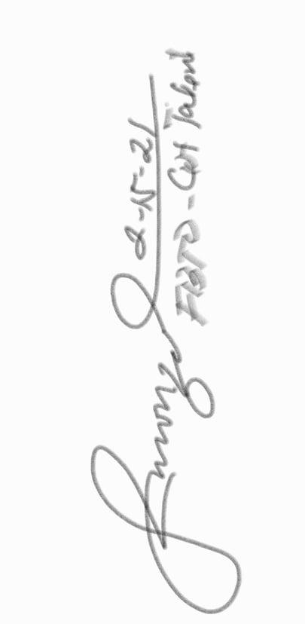

**THRU: PROF. DORIS B. GATAN**

*Head, Office of the Academic Affairs*

**PROF. DEMELYN E. MONZON**

*Head, Office of Student Affairs and Services*

Dear Prof. Delmo:

The Future Business Teachers’ Organization will be conducting a Talent Contest namely, **“FBTO Got Talent”** as a part of the lined-up activities for the School Year. This event aims to encourage students to engage themselves to the organization by generating quality content and creative outcome. In addition, this will be the organization’s avenue to uncover the skills and familiarize the students of the said organization.

In connection with this, may we ask permission of executing this event to accomplish our aims. The FBTO Got Talent will be held on February 26, 2021.

We are hoping for your utmost support and affirmative response regarding this matter.

Thank you in advance and May God bless you!



**MS. JAY ANN F. ROM**

*President, FBTO 2020 – 2021*

*Noted by:* **DR. CAROLYN SUMANDE** 

*Adviser, FBTO*

**FBTO GOT TALENT**

1. **RATIONALE**

The Polytechnic University of the Philippines endeavors to produce and provide knowledge across disciplines that are relevant and responsive to the fast-changing conditions of national and multinational environment. The prime concern is to help the students on how to cope up in this new system of education how to handle stress and be motivated in their study. In this affair, the **Future Business Teachers’ Organization (FBTO)** has prototyped this actual aim in its plans, functions, and other related matters as it serves as the powerhouse of highly competent students who will become tomorrow’s great educators.

It is in this sense that the **FBTO** plans to conduct a Talent Contest entitled **“FBTO Got Talent”** as a part of the lined-up activities for the School Year. This event aims to encourage students to engage themselves to the organization by generating quality content and creative outcome. Thus, pursuing this kind of activity would likely to have a profound effect on the development of students’ competencies and the realization of organization’s mission and vision.

1. **THEME:**

**FBTO GOT TALENT:**

**A SHOWCASE OF BBTE TALENTS**

1. **OBJECTIVES:**

* + - 1. To develop future teachers’ creativity, talent, communication and media literacy.
      2. To engage future teachers generate content, become resourceful and be able to express ideas, thoughts and opinions.
      3. To encourage students develop the sense of “learning by doing” attitude.
      4. To enable students to actively participate in activities that will hone their skills and showcase their talents as one of the stakeholders of the university.

1. **SPONSORING GROUP AND PARTICIPANTS**

**Event Host:** Future Business Teachers’ Organization (FBTO)

**Participants:** Open to ALL BBTE Students

1. **VENUE AND DATE/TIME**

**Venue:** Via FBTO Facebook Page

**Date/Time:** February 26, 2021

**MECHANICS OF IMPLEMENTATION:**

1. Coordinate with the persons involved:

* Director of PUP-QC Branch
* Academic Head of PUP-QC
* Administrative Officer and Property Custodian
* Office of Student Affairs and Services
* FBTO Adviser

1. Conduct an orientation to the student organizations of what they will do on the said event.
2. Send them a letter of invitation.
3. Creation of technical working committees:

| Working Committees | Committee Head | Committee Members |
| --- | --- | --- |
| Communication Letters | Jay Ann F. Rom | Bonie A. Latagan  Mary Grace Aquino |
| Technical Committee | Ismari Charles Ebalo | Mark Erfe |
| Documentation Committee | Darren Cabiles | Jerusalem Tabo |
| Registration Committee | Vanessa Cabaco | JennylynBalaoro |
| Finance Committee | Iren Mariscal | JennylynBalaoro |

1. Preparation and Actualization

**Guidelines**

1. The contest is open to all currently enrolled member of Future Business Teachers Organization.
2. Official entry individual or by group must be uploaded to Google drive and be shared to Future Business Teachers’ Organization official gmail account pupqcfbtoofficial@gmail.com on or before February 25, 2021 11:59 pm.
3. The final video must be in MP4 format.
4. The final output should not exceed 5 minutes.
5. Inappropriate choice of wordings is strictly prohibited.
6. Participants can choose their preference piece of entry.
7. Participants who choose the by group category must be 2-4 members only.
8. Criteria for Evaluating and Judging:

| **Criteria** |  |
| --- | --- |
| Technical Ability | 30 % |
| Creativity | 40 % |
| Audience Impact | 10 % |
| Overall Performance | 20 % |
| **Total Score** | **100%** |

**VI. PROJECT TIMETABLE**

1. Committee meeting, planning, and preparation of the action plan

2. Write letters to the persons involved for review and approval

3. Acquisition and preparation of materials

4. Preparation and finalization of the activity

5. Proposed activity date

**VII. BUDGETARY OUTLAY**

**Budgetary Outlay**

**FBTO GOT TALENT**

| **Description** | **Quantity** | **UNIT PRICE** |  | **Total** |
| --- | --- | --- | --- | --- |
| Prizes |  |  | ₱ | 900.00 |
|  |  |  |  |  |
| Technical Aspects |  |  |  |  |
| Projector and white Screen |  |  |  |  |
| Documentation |  |  |  |  |
| Printing and documentation |  |  |  |  |
| **TOTAL EXPENSE** | | | ₱ | 900.00 |
| **MISCELLANEOUS (10% of the total Amount of Expenses)** | | |  |  |
| **GRAND TOTAL** | | | ₱ | **900.00** |

**COMPILATION**

**OF RECEIPT**

Winner of Group Category

Received by: Jilbrix Kyle M.



Winner of Social Media Award

Received by: Ashly S.



Winner of Individual Category

Received by: Robert Andrei B.





**Prepared by: Checked by: Approved by:** 



**IREN S. MARISCALJ ENNYLYN M. BALAORO JAY ANN F. ROM**

*Treasurer, FBTO Auditor, FBTO President, FBTO*

**Submitted to: Verified by:**

**DANILO MERCADO JR. PROF. DEMELYN MONZON**

*President, SSC Head, student Affairs and Services*