**March 23, 2021**

**PROF. EDGARDO S. DELMO**

*Branch Director*

**PUP Quezon City**

**THRU: PROF. DORIS B. GATAN**

*Head, Academic Program*

**PROF. ROSELLER M. MALABANAN**

*Administrative Officer and Property Custodian*

**PROF. DEMELYN E. MONZON**

*Head, Student Affairs and Services*

Dear Sir:

Greetings from the Bachelor of Science in Entrepreneurship! The **Youth Entrepreneurs Society** will be having their Innovation exhibit with the theme **AgriXhibit: Building Our Entre-Pinoy Mindset** scheduled on; June 7, 2021 – Prelimenary Round, June 14, 2021 – Semi Final Round and June 28, 2021 – Final Round via ZOOM MEETING and FACEBOOK LIVE

The objectives of this activity are as follows:

* To promote a Sustainable Social Development Programs and Projects for the welfare of the entrepreneurship students of the polytechnic university of the Philippines
* To promote Global Academic Standards and Excellence
* To encourage every student to participate in this event to reinforce their skills Knowledge and abilities in the university for the upcoming years.

Attached is the concept paper which includes the details that we need for the said event. We look forward for a favorable response and cooperative assistance. Thank you very much!



Respectfully yours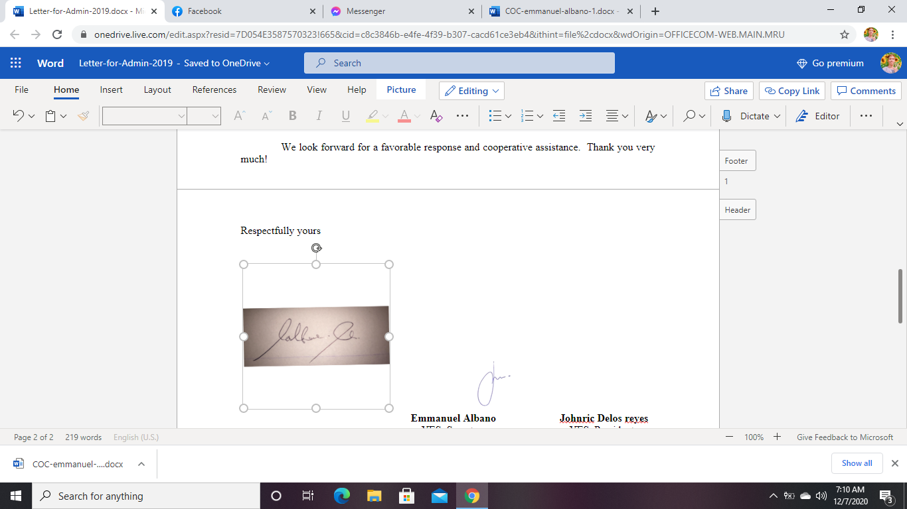

**Emmanuel Albano Johnric Delos reyes**

YES, Secretary YES, President

Noted by



**Prof. Rodrigo Dolorosa**

Adviser

**Mr. Danilo R. Mercado Jr.**

*President, Supreme Student Council*

*2020 - 2021*