April 5, 2021

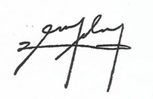

**PROF. EDGARDO S. DELMO**

**Branch Director**

**PUP Quezon City Branch**

**gatan.JPG**

THRU: **PROF. DORIS B. GATAN**

Head, Office of the Academic Program

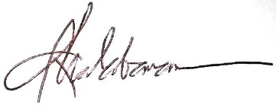

**PROF. ROSELLER M. MALABANAN**

Administrative Officer/Property Custodian

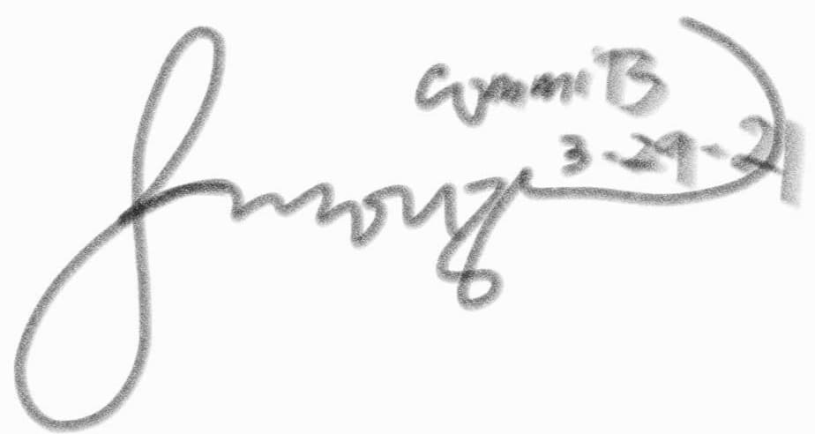

**PROF. DEMELYN E. MONZON**

Head, Office of the Student Affairs and Services

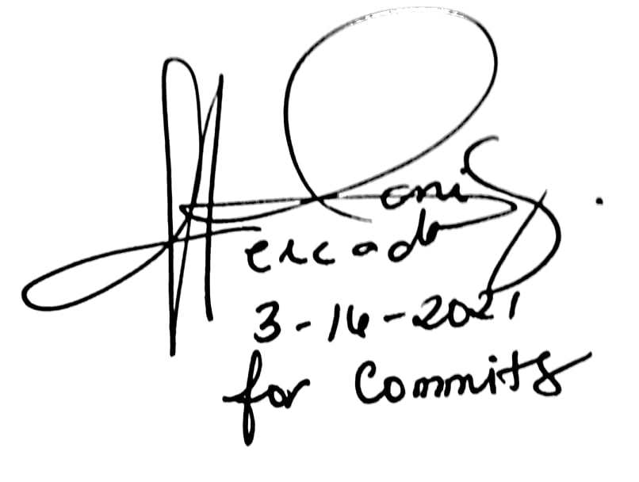

**DANILO R. MERCADO JR.**

President, Supreme Student Council

Dear Prof. Delmo,

A day filled with grace and blessings!

The **Commonwealth Information and Technology Society (COMMITS)** of Polytechnic University of the Philippines Quezon City Branch upholding the standard of information technology education by promoting academic excellence, leadership, unity and equity.

As part of its endeavors, the COMMITS will be holding its COMMITS WEBINAR with a theme **“Engaging Possibilities: Initiating the Future of I.T. Raising Leaders in a Technological Society.”** on **April 17, 2021 (Saturday)**, from **01:00pm to 03:00pm** via **Zoom-Cloud Meeting Room**.

The objectives of this event are as follows;

To entice students to be a leader

To show the dynamic, transformational, and responsible Leadership

To widen their knowledge about leadership

We are hoping for your utmost support. Thank you in advance and May God bless you!

For the students we remain,

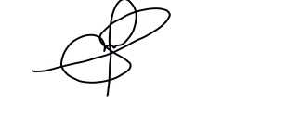

**MARK KENNEDY S. ASILAN JR.**

President, PUPQC COMMITS

Noted by:



**PROF. ALMA FERNANDEZ**

Adviser, PUPQC COMMITS

**COMMITS OFFICERS**

**A.Y. 2020-2021**

**MARK KENNEDY S. ASILAN JR**

COMMITS PRESIDENT

**ARIEL ORDANZA JR.**

VICE PRESIDENT FFOR INTERNAL

**ELRIC C.J. S. ROBILLOS**

VICE PRESIDENT FOR EXTERNAL

‘

**JOHN PETER NARZOLES**

VICE PRESIDENT FOR RDT

**ZSYRHILL ANNE C. SORIA**

SECRETARY

**RIEZEL MAE R. SANCHEZ**

AUDITOR

**ARLOU R. LUGANOB**

BUSINESS MANAGER

**ANGEL ANN C. RETAMAR**

P.I.O

**KIER A. ESTEBAN**

RESEARCH AND DEVELOPMET TEAM

**JHAY MARK T. PINEDA**

RESEARCH AND DEVELOPMENT TEAM

**FILWAYNE KEAN M. DE LARA**

RESEARCH AND DEVELOPMENT TEAM

**PROF. ALMA FERNANDEZ**

COMMITS ADVISER

**“REST IF YOU MUST, BUT DO NOT QUIT!”**