ZERO TRUST ARCHITECTURE
A Practical Reference
Model · Deep Dive · Implementation Checklist · Detailed Guidance · Sources
Aligned to NIST SP 800-207 · DoD Zero Trust Strategy · CISA ZTMM v2.0
with federal and State of Maryland references
Study & reference brief — May 2026

Contents

Part I — Hierarchy & the Core Model

1. The shift away from the perimeter
Traditional network security was built like a castle: a hard outer wall (the firewall) with a trusted interior. Once a user, workstation, or server was inside the perimeter — on the corporate LAN, behind the VPN — it was largely trusted to talk to other internal systems. This is implicit trust, and it is exactly what attackers exploit. A single phished credential, a compromised laptop, or a misconfigured server lets an adversary move laterally across the soft interior, because everything inside already trusts everything else inside.
Zero Trust (ZT) discards that model. Its governing assumption is that the network is already breached, and that no actor — human or machine, internal or external — should be trusted by default. The foundational standard is NIST Special Publication 800-207, Zero Trust Architecture (2020), which underpins both the DoD Zero Trust Strategy (2022) and CISA's Zero Trust Maturity Model (v2.0, 2023). The principle is usually compressed to four words: never trust, always verify.
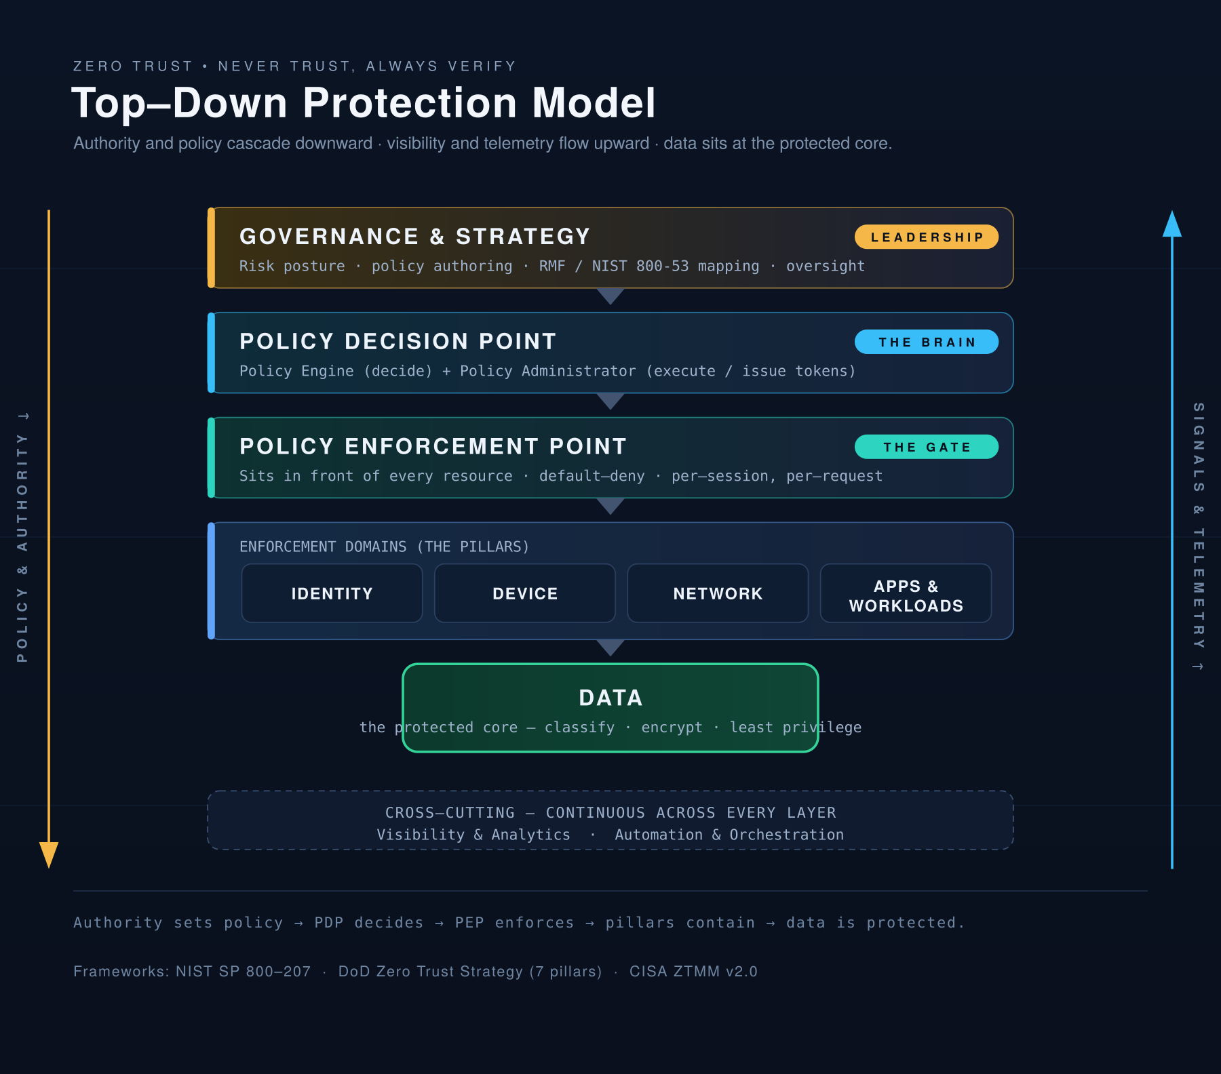
Figure 1. Top-down protection: authority and policy cascade down from governance through the decision and enforcement layers to the pillars and the protected data core; telemetry flows back up.

2. Reframing “hierarchy”: there is no trusted interior
It is natural to picture an organization as a hierarchy of trust — employees sit on workstations, workstations talk to servers, servers talk to other servers, and trust flows down the chain. Zero Trust deliberately flattens that hierarchy. In a ZT model there is no privileged “inside.” Every actor is treated as an untrusted subject that must prove itself on every request to every resource.
Every arrow in the old mental hierarchy — employee→workstation, workstation→server, and crucially server→server — becomes a connection that must pass through the same verify-then-grant pipeline. There are no exceptions for “internal” traffic.

3. The entities: subjects and resources
Zero Trust collapses everything in the enterprise into two roles. Anything can be a subject (the thing requesting) and anything can be a resource (the thing being requested). The same actor is often both.
Entity | As a SUBJECT, it must… | As a RESOURCE, it is protected by…
Employees / users | Authenticate with strong MFA, prove identity, and be continuously evaluated for risk | — (users initiate access)
Workstations / endpoints | Prove device identity and report health (patch level, encryption, EDR running) before access | Endpoint protection, posture checks
Servers | Authenticate to the systems they reach out to — not trusted merely for being on the network | A PEP / gateway authenticating every inbound connection
Services / APIs / workloads | Present a cryptographic workload identity (e.g., a certificate) on every call | Mutual authentication so callers are verified
Service accounts / NPEs | Be issued scoped, short-lived credentials and be monitored like users | Tight least-privilege scoping
Data | — | Classification, encryption, and access tied to policy at the object level

The critical case people miss is server-to-server (east–west) traffic. In the old model, two servers on the same subnet trusted each other implicitly. In Zero Trust, Server A must authenticate and be authorized to talk to Server B every time, typically using mutual TLS (mTLS) and a machine identity — exactly as if it were an outside party. This is what shuts down lateral movement.

4. How one access request actually flows
- A subject requests a resource — e.g., an engineer's laptop opens a program-data application, or a microservice calls another service's API.
- The PEP intercepts the request. Nothing connects directly; the enforcement point sits in front of the resource.
- The PEP asks the PDP for a decision. The Policy Engine evaluates a bundle of signals — verified identity, device health, location, time, resource sensitivity, and behavioral risk — not just a password.
- A decision is issued — allow, deny, or “step up” (require additional verification).
- If allowed, access is granted for that session only, scoped to the minimum needed (least privilege). It is not a standing, reusable trust relationship.
- The session is continuously monitored. If posture or behavior changes mid-session, access can be revoked in real time.
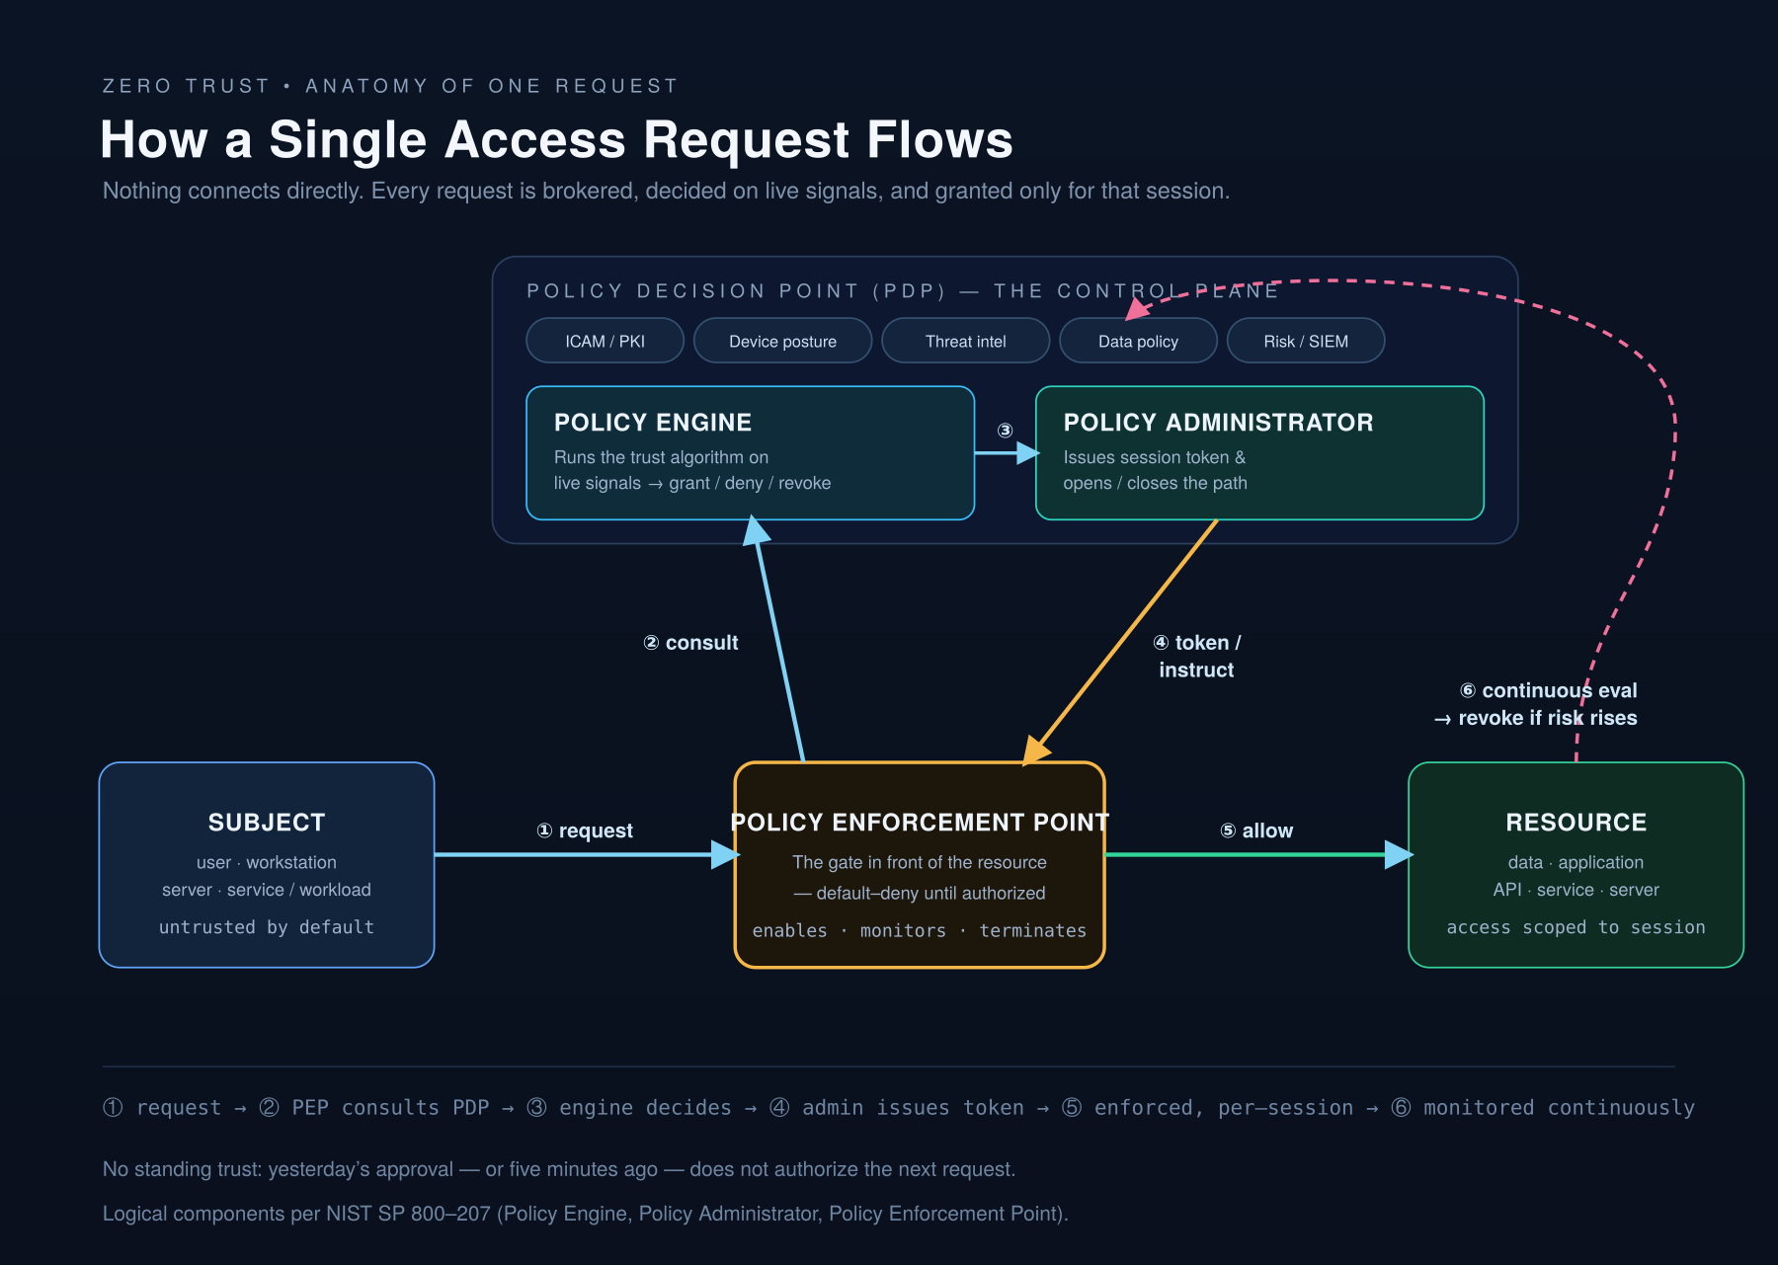
Figure 2. Anatomy of one access request: subject → PEP → PDP (Policy Engine + Policy Administrator) → resource, with continuous evaluation feeding back into the decision.
Control plane vs. data plane. The decision-making machinery (PEP/PDP, identity, policy) is the control plane; the actual subject-to-resource connection is the data plane. Compromising one resource does not hand the attacker the policy brain.
Per-session, per-request authorization. Trust is never permanent. Yesterday's approval — or the approval from five minutes ago — does not guarantee the next request succeeds.

5. The seven NIST tenets
NIST SP 800-207 defines seven tenets that any true Zero Trust implementation should satisfy:
- All data sources and computing services are considered resources.
- All communication is secured regardless of network location (no “trusted” subnet).
- Access to individual resources is granted per session.
- Access is determined by dynamic policy — identity, device state, and other behavioral/environmental attributes.
- The enterprise monitors and measures the integrity and security posture of all owned and associated assets.
- All resource authentication and authorization are dynamic and strictly enforced before access.
- The enterprise collects as much data as possible about asset, network, and communication state and uses it to improve its posture.

6. The pillars at a glance
DoD Zero Trust Strategy — 7 pillars: User · Device · Applications & Workloads · Data · Network & Environment · Automation & Orchestration · Visibility & Analytics. The DoD roadmap breaks these into 152 activities, with 91 “Target Level” activities required across the department by FY2027 and the remaining 61 (“Advanced”) by FY2032.
CISA Zero Trust Maturity Model — 5 pillars + 3 cross-cutting capabilities: Identity · Devices · Networks · Applications & Workloads · Data, with Visibility & Analytics, Automation & Orchestration, and Governance running through all of them. CISA grades each pillar across four maturity stages: Traditional → Initial → Advanced → Optimal.
Both descend from NIST SP 800-207. The DoD model is more prescriptive and mission-aligned; the CISA model is a flexible maturity roadmap.

7. Why this matters (especially in defense IT)
For systems supporting programs at an installation like Patuxent River, Zero Trust is not optional or aspirational — it is mandated policy with deadlines. Authorizing Officials increasingly evaluate a system's ZT posture holistically, because a weakness in any one pillar undermines the whole architecture. The consequences of not implementing it are concrete and cascading.
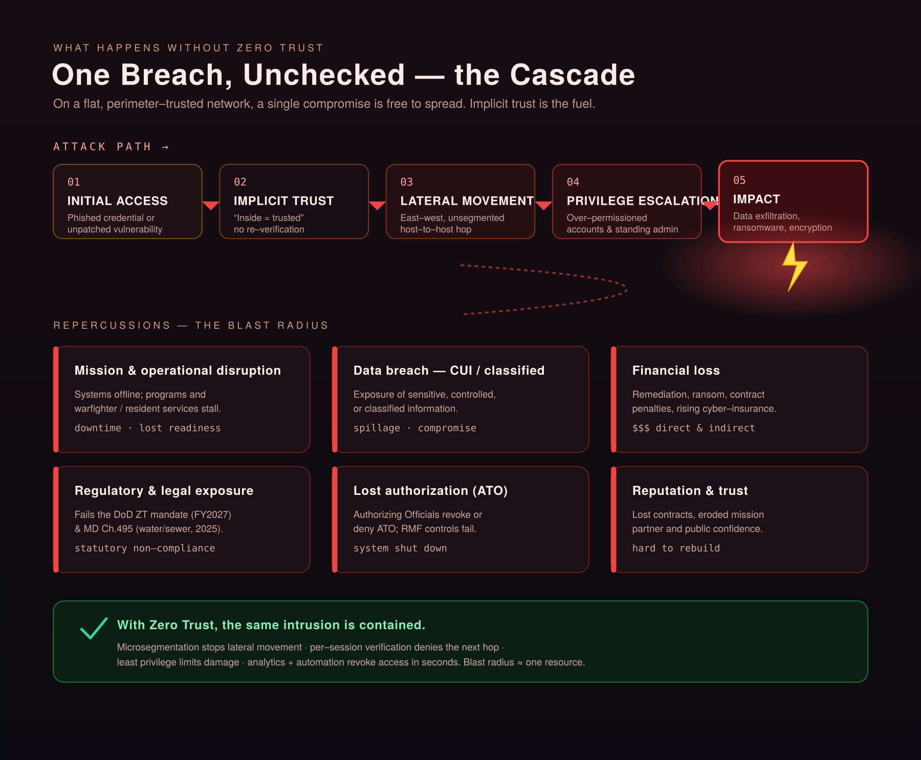
Figure 3. Without Zero Trust, one compromise cascades — initial access, implicit trust, lateral movement, privilege escalation, impact — and fans out into mission, data, financial, legal, and reputational damage.

Part II — Technical Deep Dive
This part expands the core model into the components, algorithms, and mechanisms that make Zero Trust work. Where Part I answered “what is the model,” this answers “how is it engineered.”

1. The NIST logical components
NIST SP 800-207 decomposes the decision brain into three logical components plus supporting data sources.
Policy Engine (PE). The actual decision-maker. It runs the trust algorithm against incoming signals and outputs grant, deny, or revoke for a specific request. The PE never touches traffic directly — it only produces decisions.
Policy Administrator (PA). The executor. When the PE says “grant,” the PA establishes the session — generating any authentication token the client needs and instructing the PEP to open the path. On “deny” or “revoke,” the PA tells the PEP to tear the connection down. (PE + PA together form the Policy Decision Point.)
Policy Enforcement Point (PEP). The gate in the data path in front of each resource. It enables, monitors, and ultimately terminates the connection, acting on the PA's instructions. Physically it can be a gateway, reverse proxy, sidecar, endpoint agent, or cloud access broker.
Data sources feeding the Policy Engine: ICAM / identity management (in DoD, CAC/PKI); enterprise PKI; Continuous Diagnostics and Mitigation (CDM) for device posture; threat-intelligence feeds; activity logs and telemetry; data-access policy; SIEM / security analytics; and industry/compliance inputs. The PE's decision is only as good as its inputs.

2. The trust algorithm
Criteria-based vs. score-based. Criteria-based requires a fixed set of qualifications (valid cert AND compliant device AND correct group) — predictable and auditable. Score-based weights signals into a confidence/risk score and grants access if it clears a threshold for the resource's sensitivity — adaptive, and supports step-up challenges.
Singular vs. contextual. Singular judges each request in isolation; contextual considers history and behavior (recent patterns, sequence, prior anomalies). Contextual evaluation enables true continuous, behavior-aware authorization. Mature implementations are typically score-based and contextual.

3. Deployment models
- Device agent / gateway-based. A trusted agent on the endpoint coordinates with a gateway in front of each resource. Strong for managed fleets.
- Enclave-based. A single gateway protects a group of resources — useful for legacy systems that cannot host their own agent.
- Resource portal-based. Subjects reach resources through a portal/broker; no agent required (good for BYOD/partner access, but less device-posture detail).
- Device application sandboxing. Vetted applications run in isolated compartments on the endpoint, segregated so a compromise elsewhere can't reach them.

4. Identity as the new perimeter (ICAM)
Because the network is no longer a trust boundary, identity becomes the primary control plane.
- Strong authentication. Phishing-resistant MFA is the baseline — PKI/CAC and derived credentials in DoD; FIDO2/WebAuthn hardware keys commercially. Passwords alone are disqualifying at any mature level.
- Non-person entities (NPEs). Service accounts, scripts, and machines need managed, scoped, rotated, monitored identities. Long-lived static secrets are a classic ZT failure.
- Least privilege and just-in-time (JIT) access. Minimum entitlement for minimum time; privileged access brokered through PAM with session recording and ephemeral elevation, not standing admin rights.
- Continuous authentication. Not a one-time login event; the session is continuously re-evaluated against posture and behavior.

5. Microsegmentation and east–west traffic
- Macrosegmentation divides the network into broad zones.
- Microsegmentation isolates individual workloads so each reaches only its legitimate peers; policy is expressed by identity and workload, not IP/subnet.
- Software-defined perimeter (SDP) hides resources until a subject is authenticated and authorized — “dark” to unauthorized scanners.
The payoff is the death of lateral movement: even if an attacker lands on one host, it can reach only its narrowly defined neighbors, and every connection still demands authentication. Some assets, though, are so sensitive that the strongest control is no network path at all — see the isolation model below.
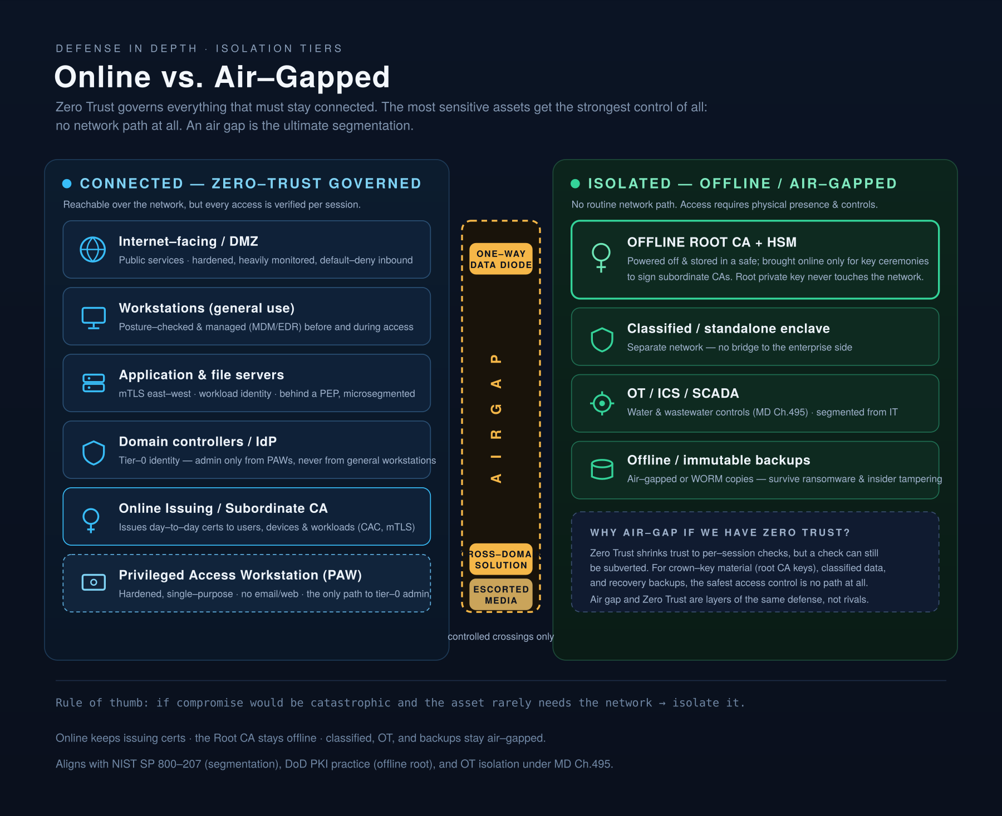
Figure 4. Online vs. air-gapped. Zero Trust governs everything connected; crown-key material (the offline Root CA), classified enclaves, OT/ICS, and offline backups are isolated behind an air gap with controlled crossings only.

6. Server-to-server and workload identity
This is the area engineers most often under-build. For two services to trust each other the Zero Trust way, each needs a cryptographic workload identity and they must mutually authenticate.
- Mutual TLS (mTLS). Both ends present and verify certificates; every east-west call is authenticated and encrypted.
- SPIFFE / SPIRE. Issues verifiable workload identities (SPIFFE IDs delivered as short-lived SVID certificates) so services authenticate by who they are, not where they run — across cloud, on-prem, and containers.
- Service mesh. Sidecar proxies enforce mTLS and policy transparently, so teams get east-west security without hand-rolling it per service.
- Short-lived credentials. Certificates and tokens issued for minutes/hours and auto-rotated, shrinking the value of any stolen secret.

7. Continuous monitoring, visibility, and automation
Visibility & Analytics. Comprehensive logging and telemetry across users, devices, network, apps, and data feed the analytics layer that computes risk and detects anomalies. You cannot enforce policy on what you cannot see.
Automation & Orchestration (SOAR). Automated playbooks revoke access, isolate hosts, and adjust policy in seconds — this is what moves an organization from “Advanced” to “Optimal.”
Governance. Policy must be authored, versioned, audited, and tied to compliance frameworks (in federal work, mapped to NIST RMF controls).

8. The maturity journey
CISA's model treats Zero Trust as incremental and assesses it per pillar. An organization is rarely at one uniform level — it may be Advanced in Identity but Initial in Data. That is expected; the model exposes gaps for prioritization.
Stage | Characteristics
Traditional | Static credentials, perimeter defense, manual configuration and response, implicit trust based on network location.
Initial | Starting automation, some cross-pillar integration, MFA introduced, the beginning of least-privilege.
Advanced | Centralized visibility and identity control, cross-pillar coordination, posture-based and predefined responses, expanded least-privilege.
Optimal | Fully automated, dynamic policy, continuous monitoring and just-in-time access across all pillars; self-adjusting on real-time analytics.

9. The pillars in depth
- User / Identity. Authenticate and continuously evaluate every human and NPE; MFA, PAM, behavioral analytics, least privilege.
- Device. Only known, healthy, compliant devices get access; CDM/MDM, TPM-backed identity, comply-to-connect, continuous posture.
- Network & Environment. Segment everything; encrypt all traffic; software-defined networking and microsegmentation; treat every network as hostile.
- Applications & Workloads. Secure the supply chain and runtime; DevSecOps, workload identity, authenticated APIs, least-privilege service calls.
- Data. Classify, label, encrypt at rest and in transit, apply rights management, tie access to dynamic policy at the object level.
- Visibility & Analytics (cross-cutting). Telemetry and analytics feeding the Policy Engine and detection.
- Automation & Orchestration (cross-cutting). Machine-speed enforcement and response.
- Governance (cross-cutting, CISA). Policy authoring, oversight, and compliance alignment.

Part III — Implementation Checklist
A working checklist for standing up (or assessing) a Zero Trust architecture. Treat Foundation as prerequisite work, then progress through the pillars. Items roughly ascend from Initial → Advanced → Optimal maturity within each section; Part IV explains the why and how behind each.

0. Foundation / Program
- Secure executive sponsorship and a named Zero Trust program owner.
- Inventory everything — users, non-person entities (NPEs), devices, applications, services, and data stores.
- Classify data and identify the high-value assets / “protect surfaces.”
- Map transaction flows: who/what talks to what, and over which paths.
- Pick a reference framework and map to it (NIST SP 800-207, CISA ZTMM v2.0, DoD ZT Strategy 7 pillars / 152 activities).
- Run a current-state maturity assessment per pillar (Traditional/Initial/Advanced/Optimal).
- Define target maturity and a phased roadmap with milestones (for DoD, Target Level by FY2027).
- Establish governance: policy authoring, change control, mapping to RMF/compliance controls.
- Define metrics and a feedback loop to measure progress.

1. Identity / User
- Consolidate to a centralized, authoritative identity provider (IdP).
- Enforce phishing-resistant MFA for all users (PKI/CAC or FIDO2/WebAuthn; not SMS).
- Eliminate or vault all shared/local accounts and default credentials.
- Implement role-/attribute-based access control (RBAC/ABAC) with least privilege.
- Bring NPEs (service accounts, machine identities) under management — scoped, rotated, monitored.
- Deploy Privileged Access Management (PAM): no standing admin rights; just-in-time elevation with session recording.
- Enable conditional access policies (user + device + context + risk).
- Add behavioral analytics / risk scoring (UEBA) to detect anomalous identity use.
- Implement continuous authentication and real-time, risk-based session revocation.
- Automate the full identity lifecycle (joiner/mover/leaver) with prompt deprovisioning.

2. Devices / Endpoints
- Maintain a real-time, authoritative device inventory (CDM).
- Establish hardware-rooted device identity (TPM-backed certificates).
- Deploy MDM/UEM to manage and enforce configuration on all endpoints.
- Require device health/posture checks before and during access (“comply-to-connect”).
- Deploy EDR/XDR on all endpoints with centralized telemetry.
- Enforce full-disk encryption and a secure baseline/hardening standard.
- Block or quarantine unmanaged/non-compliant devices automatically.
- Feed device posture into the Policy Engine as an access signal.

3. Networks / Environment
- Encrypt all traffic in transit, including internal east-west traffic.
- Implement macrosegmentation, then microsegmentation down to the workload.
- Adopt a software-defined perimeter / ZTNA so resources are hidden until authorized.
- Replace broad VPN access with per-application, identity-aware access.
- Define and enforce default-deny network policies (allow-list, not block-list).
- Place a PEP in front of every resource (gateway, proxy, sidecar, or enclave gateway for legacy).
- Continuously monitor and log all network flows.
- Isolate crown-key material, classified enclaves, OT/ICS, and backups by air gap where warranted.

4. Applications & Workloads
- Inventory all applications, APIs, and workloads (including shadow IT).
- Issue cryptographic workload identities (e.g., SPIFFE/SPIRE).
- Enforce mutual TLS (mTLS) for all service-to-service (east-west) traffic.
- Apply least-privilege authorization to every API call (default-deny).
- Integrate security into the pipeline (DevSecOps): SAST/DAST, dependency/SBOM scanning, signed artifacts.
- Secure the software supply chain and verify provenance of third-party components.
- Use short-lived, auto-rotated credentials/certificates (no long-lived secrets in code/config).
- Consider a service mesh to enforce mTLS and policy transparently.
- Continuously monitor application behavior at runtime.

5. Data
- Discover and inventory data across all repositories.
- Classify and label data by sensitivity.
- Encrypt data at rest and in transit; manage keys centrally.
- Apply rights management (DRM) and enforce access at the data-object level.
- Tie data access to dynamic policy (identity + device + context + sensitivity).
- Deploy Data Loss Prevention (DLP) and monitor data access patterns.
- Define and enforce data retention and disposal policies.

6. Visibility & Analytics (cross-cutting)
- Centralize logging from all pillars into a SIEM/analytics platform.
- Establish behavioral baselines and anomaly detection.
- Build risk scoring that feeds the Policy Engine in near real time.
- Maintain dashboards and alerting for security posture and ZT maturity metrics.
- Ensure log integrity, sufficient retention, and audit readiness.

7. Automation & Orchestration (cross-cutting)
- Deploy SOAR with automated response playbooks (isolate host, revoke session, rotate creds).
- Automate policy enforcement and dynamic, risk-based access decisions.
- Automate provisioning/deprovisioning across identity, device, and network.
- Integrate tools via APIs so signals and actions flow without manual handoffs.

8. Governance (cross-cutting)
- Codify Zero Trust policies and keep them version-controlled and auditable.
- Map every control to the relevant compliance framework (NIST RMF, applicable overlays).
- Run periodic maturity reassessments and update the roadmap.
- Conduct continuous control validation (breach-and-attack simulation, red teaming).
- Review and recertify access entitlements on a defined cadence.

How to sequence this. A pragmatic order: Foundation → Identity → Devices → Network/microsegmentation → Applications/Data → Visibility → Automation, with Governance throughout. Identity and device posture come first because nearly every other policy decision depends on those signals. Don't boil the ocean: take one high-value protect surface to target maturity end-to-end, prove the model, then expand.

Part IV — Detailed Implementation Guidance
This part expands the checklist. For each area it covers why it matters, how to do it, what “good” looks like across the maturity ladder, and the common pitfalls.

0. Foundation / Program
Why. Zero Trust fails most often as a program problem, not a technology problem. Without an authoritative inventory and a protect-surface focus, teams bolt tools onto an environment they don't fully understand.
How.
- Inventory first. You cannot apply least privilege, segment, or write policy for assets you don't know exist. This is the single highest-leverage early step.
- Find the protect surface. Identify the small set of high-value data, applications, assets, and services (“DAAS”) and design controls around them first.
- Map flows. Microsegmentation and PEP placement depend on knowing real traffic patterns; guessing breaks production.
- Assess and roadmap. Score maturity per pillar, set a target, phase the work. In defense, anchor to the DoD roadmap's Target-Level activities and FY2027 deadline.
What good looks like. Progress is measured by coverage of the protect surface, not tools purchased.
Pitfalls. Treating ZT as a product; skipping inventory; doing all pillars everywhere at once; no executive sponsor, so the program stalls at team boundaries.

1. Identity / User
Why. With the perimeter gone, identity is the primary control plane. Most breaches begin with a credential, so strong, continuously evaluated identity is the highest-impact pillar.
How.
- Centralize identity into one authoritative IdP so policy is consistent and deprovisioning is immediate everywhere.
- Phishing-resistant MFA. Move past passwords and SMS; PKI/CAC and derived credentials in DoD, FIDO2/WebAuthn commercially. This alone defeats most credential attacks.
- Least privilege + JIT. RBAC for coarse roles, ABAC for fine context-aware decisions; replace standing admin with PAM-brokered, time-boxed elevation.
- Manage NPEs. Scope tightly, rotate secrets automatically, monitor them like users.
- Continuous and conditional. Conditional access evaluates user + device + context + risk on every request and can step up or revoke mid-session.
What good looks like. Initial: MFA + central IdP. Advanced: least privilege, PAM, conditional access. Optimal: continuous, behavior-aware auth with automated revocation; NPEs fully managed with short-lived credentials.
Pitfalls. MFA exceptions that become the norm; orphaned accounts after offboarding; service accounts with domain-admin rights and a password set in 2019.

2. Devices / Endpoints
Why. A verified user on a compromised device is still a compromise. Device health is a first-class input to every access decision.
How.
- Authoritative inventory (CDM) in real time — unknown devices cannot be governed.
- Hardware-rooted identity. TPM-backed certificates prove a device is the enrolled, managed asset, not a clone.
- Comply-to-connect. Check posture before access and continuously during the session; if a device falls out of compliance, access drops.
- EDR/XDR everywhere, telemetry centralized for the analytics layer and Policy Engine.
- Automate quarantine of non-compliant or unmanaged devices.
What good looks like. Initial: MDM + EDR, basic inventory. Advanced: posture gates access, cryptographic device identity. Optimal: continuous posture feeds dynamic policy; non-compliant devices isolated in seconds.
Pitfalls. BYOD and contractor devices with no posture visibility; inventory that's a stale spreadsheet; posture checked only at login.

3. Networks / Environment
Why. Segmentation turns a single compromised host into a contained incident instead of a domain-wide breach. The goal is to make lateral movement impossible by default.
How.
- Encrypt all traffic, including east-west. Treat every segment as hostile.
- Segment progressively. Macrosegmentation first, then microsegmentation where each workload reaches only legitimate peers; express policy by identity/workload, not IP.
- SDP / ZTNA. Hide resources until authorized; replace broad VPN tunnels with per-application, identity-aware access.
- PEP in front of everything (or each enclave for legacy); default-deny, allow-list only.
- Air-gap the irreplaceable. Where compromise would be catastrophic and the network is rarely needed — Root CA keys, classified data, OT/ICS, backups — isolate with no routine network path.
What good looks like. Initial: macrosegmentation, encrypted external traffic. Advanced: microsegmentation around protect surfaces, ZTNA replacing VPN. Optimal: dynamic, identity-based segmentation everywhere.
Pitfalls. “Microsegmentation” that's just more VLANs; legacy apps left in a flat zone “temporarily” forever; IP-based rules that break on every move.

4. Applications & Workloads
Why. This is where server-to-server trust lives — the area engineers most often under-build. Authenticated, least-privilege service communication extends Zero Trust into the data center and cloud.
How.
- Workload identity. Cryptographic identities (SPIFFE SVIDs) so services authenticate by who they are, not where they run.
- mTLS for all east-west traffic, ideally enforced transparently by a service mesh.
- Least-privilege APIs. Default-deny; a service calls only the endpoints its function requires.
- DevSecOps and supply chain. SAST/DAST, dependency and SBOM scanning, signed and verified artifacts, provenance checks.
- Kill long-lived secrets. Short-lived, auto-rotated credentials so a leaked secret expires before it's useful.
What good looks like. Initial: app inventory, TLS, pipeline scanning. Advanced: mTLS for critical services, workload identities, signed artifacts. Optimal: universal mTLS via mesh, every API least-privilege, automated short-lived credentials.
Pitfalls. Internal APIs left unauthenticated because they're “behind the firewall”; hardcoded secrets; one over-privileged token reused everywhere; trusting third-party packages without provenance.

5. Data
Why. Data is the ultimate object of protection — every other pillar exists to keep the wrong subject away from the wrong data. ZT pushes protection down to the data object itself.
How.
- Discover and classify. You can't protect or write policy for data you haven't found and labeled.
- Encrypt at rest and in transit, with centralized key management.
- Object-level access tied to dynamic policy — identity + device posture + context + sensitivity, not network location.
- Rights management and DLP. Apply DRM where appropriate; monitor for exfiltration.
- Lifecycle. Define retention and secure disposal — old data you don't need is liability you're still defending.
What good looks like. Initial: encryption + basic classification. Advanced: labels drive access policy, DLP monitoring. Optimal: dynamic, attribute-based access at the object level with automated classification.
Pitfalls. Encrypting the disk but leaving data open to any authenticated user; classification no one maintains; DLP in alert-only mode forever.

6. Visibility & Analytics (cross-cutting)
Why. Every dynamic policy decision depends on signals. You cannot enforce, detect, or improve what you cannot see.
How.
- Centralize logs and telemetry from all pillars into a SIEM/analytics platform.
- Establish behavioral baselines so anomalies stand out.
- Compute risk scores that feed the Policy Engine in near real time.
- Protect log integrity; retain enough history for detection and audit; surface ZT maturity metrics to leadership.
What good looks like. Telemetry from every pillar actually loops back into access decisions, not just dashboards.
Pitfalls. Collecting logs no one analyzes; blind spots in workloads or data; analytics that never influence policy.

7. Automation & Orchestration (cross-cutting)
Why. At enterprise scale, humans cannot evaluate every request or respond to every alert fast enough. Automation is what moves an organization from Advanced to Optimal.
How.
- Deploy SOAR playbooks that act at machine speed — isolate a host, revoke a session, rotate a credential, tighten a policy.
- Automate provisioning/deprovisioning across identity, device, and network.
- Integrate tools via APIs so a signal in one system drives an action in another without manual handoffs.
What good looks like. Routine response is automatic and measured in seconds, with humans handling exceptions.
Pitfalls. Automation without good signals (you automate bad decisions faster); no guardrails, so a response causes an outage; playbooks written but never tested.

8. Governance (cross-cutting)
Why. Zero Trust is a continuous program, not a finished project. Governance keeps policy coherent, auditable, and aligned to compliance — and keeps the roadmap honest.
How.
- Codify policies; keep them version-controlled and auditable.
- Map every control to the relevant framework (NIST RMF and overlays; for DoD, ZT activities tied to AO evaluation).
- Reassess maturity periodically and update the roadmap.
- Validate controls continuously via breach-and-attack simulation and red teaming.
- Recertify access entitlements on a cadence so privilege doesn't accumulate.
What good looks like. Controls are demonstrably effective and tied to authorization, not assumed to work.
Pitfalls. Policies in a slide deck instead of enforced configuration; “set and forget” after the first assessment; access granted but never reviewed.

Closing: how the pieces lock together
Every actor is an untrusted subject; every resource sits behind an enforcement point; every request is decided dynamically by a Policy Engine fed by identity, device, network, application, and data signals; access is least-privilege and per-session; and the whole loop is continuously monitored and automated. A weakness in any single pillar undermines the entire architecture — which is why mature programs build across all of them in parallel. Start with one high-value protect surface, take it end-to-end to target maturity, prove the model, and expand.

Appendix — References & Authoritative Sources
Grouped by issuing authority. Federal and Maryland government publications are public-domain works. Where a precise identifier exists (SP number, chapter number, memo number) it is given so the citation can be verified directly.

A. Foundational federal standards (NIST)
- NIST SP 800-207, Zero Trust Architecture (NIST, August 2020). The foundational definition of Zero Trust; establishes the seven tenets and the PE/PA/PEP logical architecture used throughout this reference.
- NIST SP 800-53, Rev. 5, Security and Privacy Controls (September 2020). The control catalog Zero Trust capabilities map to under the federal Risk Management Framework (RMF).
- NIST Cybersecurity Framework (CSF) 2.0 (February 2024). The risk-management framework Maryland's modernized policy suite is aligned to.
- NIST SP 1800-35, Implementing a Zero Trust Architecture (NIST NCCoE). Practical, vendor-neutral build guides — a useful supplement to the checklist.

B. Department of Defense
- DoD Zero Trust Strategy (DoD CIO, October 2022). Seven pillars: User, Device, Applications & Workloads, Data, Network & Environment, Automation & Orchestration, Visibility & Analytics.
- DoD Zero Trust Reference Architecture, v2.0 (DISA / NSA, July 2022). The technical reference architecture underpinning the strategy; grounded in NIST SP 800-207.
- DoD Zero Trust Capability Execution Roadmap (COA 1) (DoD CIO, 2022). 152 activities: 91 “Target Level” required by the end of FY2027 (Sept 30, 2027) and 61 “Advanced Level” targeted by FY2032.
- Introduction to DoD Zero Trust — Student Guide (CS125) (CDSE, 2024). Maps the NIST seven tenets to the DoD pillars; a strong study aid.

C. CISA
- CISA Zero Trust Maturity Model, v2.0 (April 2023). Five pillars (Identity, Devices, Networks, Applications & Workloads, Data) plus three cross-cutting capabilities (Visibility & Analytics, Automation & Orchestration, Governance), assessed across four stages: Traditional → Initial → Advanced → Optimal.

D. Executive / policy mandates
- Executive Order 14028, Improving the Nation's Cybersecurity (May 12, 2021). Directed federal agencies toward Zero Trust architecture.
- OMB Memorandum M-22-09, Moving the U.S. Government Toward Zero Trust Cybersecurity Principles (January 26, 2022). Set specific federal Zero Trust objectives; CISA's ZTMM v2.0 is aligned to it.

E. State of Maryland
- Maryland SB 871 / HB 1062 (2025 Regular Session) — Community Water and Sewerage Systems, Cybersecurity Planning and Assessments. SB 871 was the enacted vehicle: approved by the Governor May 13, 2025 as Chapter 495, effective October 1, 2025; HB 1062 is its identical cross-filed House companion. Requires community water and sewerage systems to adopt a zero-trust approach for on-premises and cloud services, conduct maturity assessments, and report incidents — codifying “no implicit trust; continually evaluate access” into state law.
- Maryland Cybersecurity and Privacy Policy Suite (Maryland DoIT, Office of Security Management; announced February 24, 2026). A 31-module suite shifting the state executive branch from “trust but verify” to a zero-trust framework; 22 Cabinet agencies adopt within 18 months. Aligned to NIST CSF 2.0 and SP 800-53 Rev. 5.
- Maryland Cybersecurity Council — Biennial Activities Report (July 1, 2025; via UMGC). Documents the Council's involvement in shaping Maryland cybersecurity legislation, including zero-trust language.

A note on verifying citations. Bill status, chapter numbers, and effective dates were confirmed against the Maryland General Assembly's legislation tracker for the 2025 Regular Session. Federal document identifiers are stable. For any formal submission, open and cite the primary document rather than a secondary summary.

