CSCI 2100E Spring 2020 | Student Name: ______Cai Long Hua_______  Student Id: _______1155126875________

"Written" Exercise #10

Please give answers to this exercise via writing or drawing when needed.
This exercise is counted as a regular lab exercise in terms of weighting.
Aim of this exercise is to give you more experience in answering conceptual questions in data structures topics.

In these concept questions, your answers are merited by the proper use of terminology and demonstration of understanding of subject matter. In both exams and exercises, answer these questions as if you are attending an industry test/interview, as it is assessed as such.

Question 1 Binary Expression Tree

We have a arithmetic expression (4 + 5) * (9 - 7) / 2 + 6 - 1

a) Please construct a Binary Expression Tree (BET) based on the above expression. You can draw on paper and photo/scan it or use vector graphics features in your word processor.

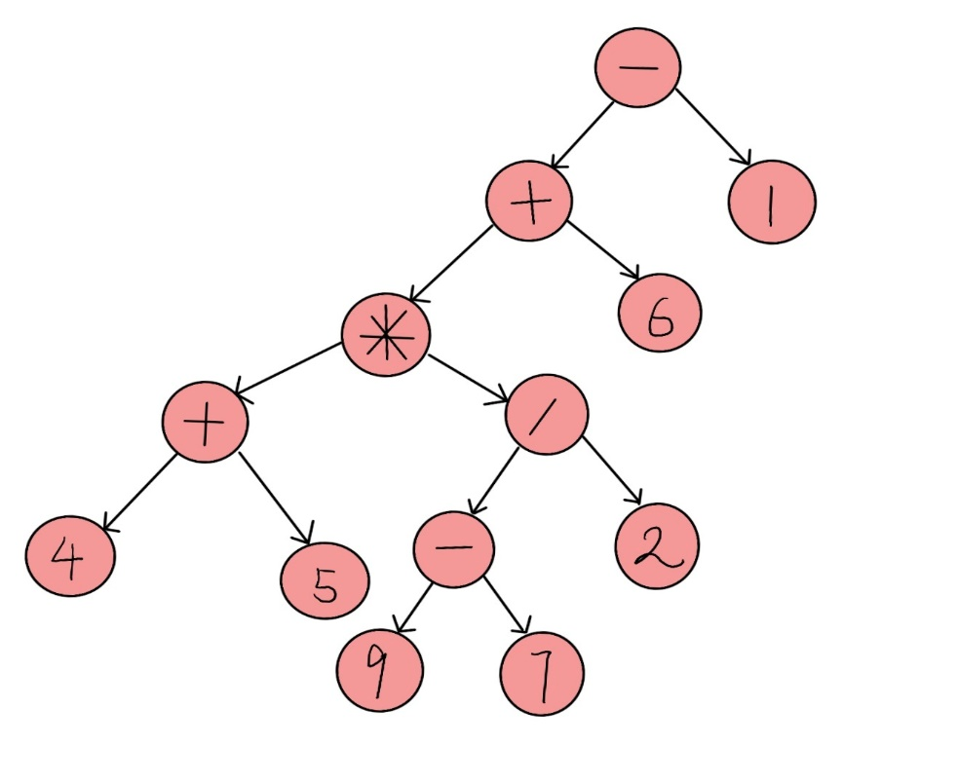

b) Using the answer in a), derive and write down the polish and reverse polish notation of the expression.

Give that the infix is : (4 + 5) * (9 - 7) / 2 + 6 – 1
I will use bracket method for polish and stack method for reverse polish respectively to derive it blow.

First, the polish notation (Prefix) of the expression (use bracket method):
(4 + 5) * (9 - 7) / 2 + 6 – 1

+45 * (9 - 7) / 2 + 6 – 1

+45 * -97 / 2 + 6 – 1

*+45-97 / 2 + 6 -1

/*+45-97 2 + 6 -1

+/*+45-972 6 – 1

-+/*+45-97261

Therefore, the polish notation is -+/*+45-97261

Second, the reverse polish notation (Postfix) of the expression (use stack method):
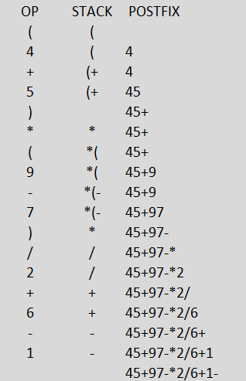
Therefore, the reverse polish notation is 45+97-*2/6+1-

c) We now want to model the unary operator negation, e.g. -1. Using your knowledge in Binary Expression Tree, deduce what the BET would be like for the expression (-(-(-3))) * (-(-2))

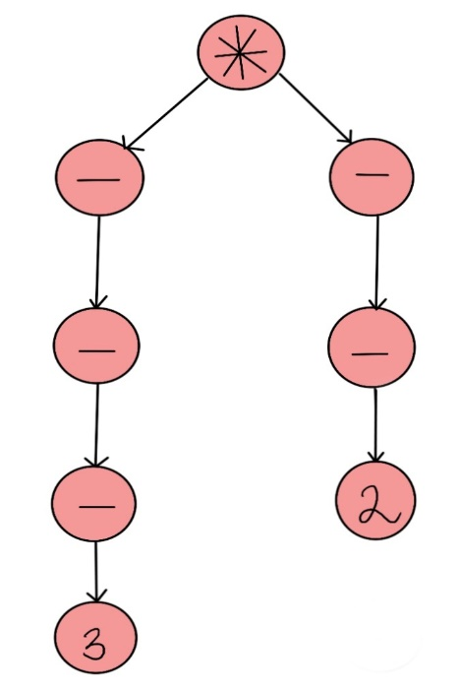

Question 2 Binary Search Tree

We now have a series of seven integers: 30, 66, 23, 1, 100, 15, 91

a) Assume we insert the above integers into a Binary Search Tree (BST) in the order shown above, what would the BST be like after each insertion? Please indicate the step clearly.

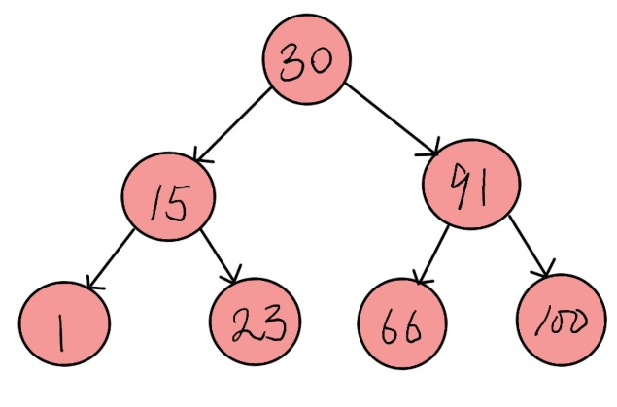

From above, we have seven integer, it means that n = 7. We sorted these seven integer (1,15,23,30,66,91,100), and then we use n/2 to find the middle number. 7/2 = 3.5 is about 4. So the middle number is 30. We know that in Binary Search Tree, all nodes of left-subtree should be lesser than the root which is in the top, and also all nodes of right-subtree should be larger than the root which is in the top. In this moment, we let the middle number ‘30’ be the root, there are 3 integer (1,15,23) are lesser than ‘30’, also, there are 3 integer (66,91,100) are larger than ‘30’. Let us see the left-subtree first, inserting ‘15’ be the children of ‘30’ in left side, ‘1’ is lesser than ‘15’, inserting ‘1’ be the left children of ‘15’. Then, ‘23’ is larger than ‘15’ and also lesser than ‘30’, so inserting ‘23’ be the right children of ‘15’. Besides, let us see the right-subtree, we insert ’91’ which is the right children of ‘30’, then insert ‘66’ be the left children of ‘91’, which is lesser than ‘91’ and larger than ‘30’. At last, inserting ‘100’ be the right children of ‘91’. So the BST is completed and it is balance.

b) Perform a pre-order and post-order traversal of the BST in a) and write down the print orders

Pre-order (Root, Left, Right) : 30 15 1 23 91 66 100
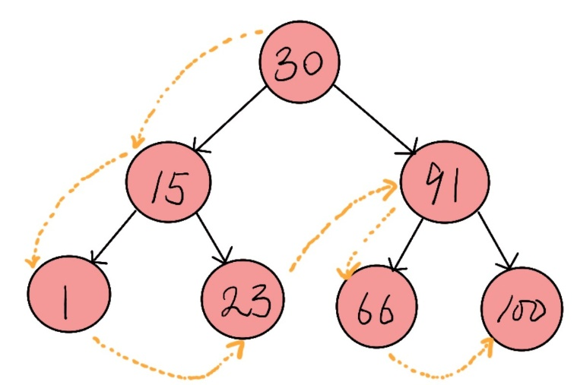

Post-order (Left, Right, Root) : 1 23 15 66 100 91 30
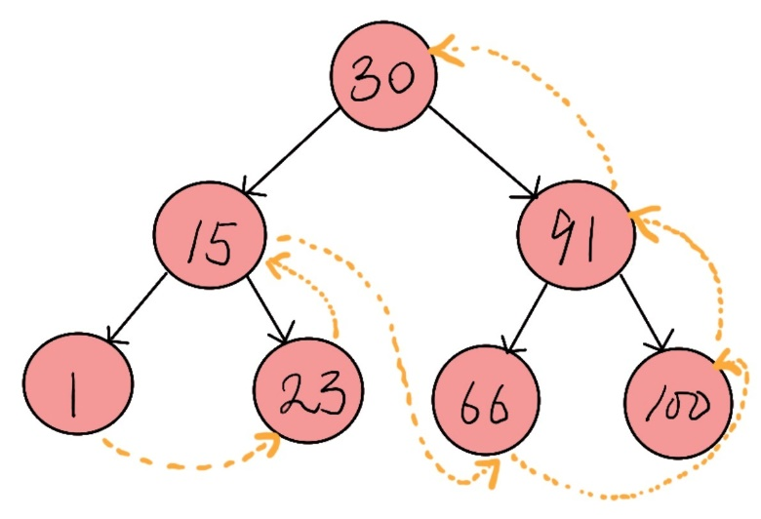

c) Draw a completely unbalanced but valid BST with the same seven integers. You do not need to show any steps.

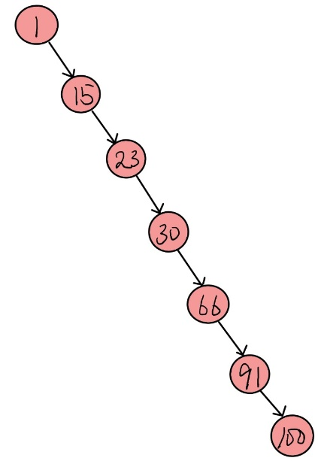
This is unbalanced but valid BST with the seven integers.
All nodes in the right side with the children which is larger than its parent.

Question 3 Heap
We have a binary heap as shown. It is a max-heap, i.e. the children of a node must be smaller than its parent.;
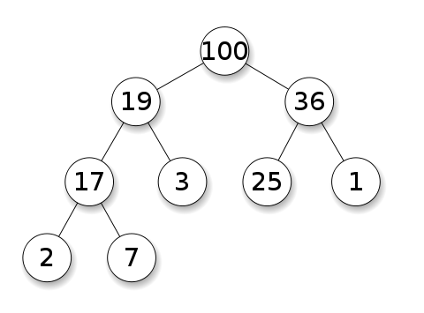
https://commons.wikimedia.org/wiki/File:Max-Heap.svg

a) Please show the array representation of the heap, if we adopt the implementation in the lecture notes.

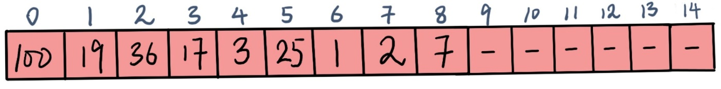

b) If I insert/enqueue key 18 into the heap in a), what would the heap be like? Please provide both the tree representation and array implementation.

Tree representation:
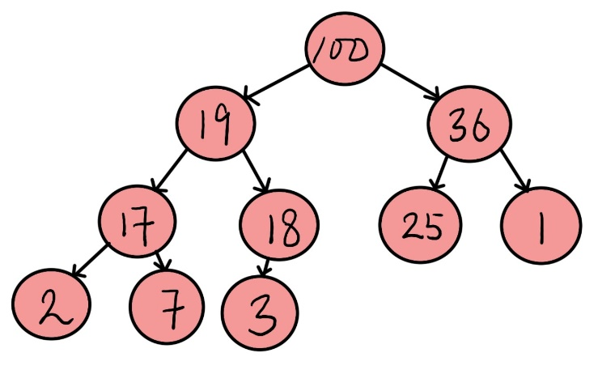

Array implementation:
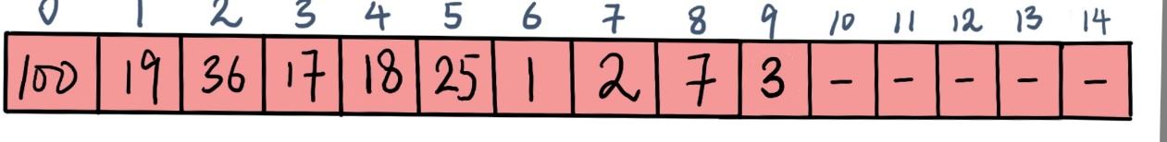

c) If I withdraw the root 100 from the heap in a), what would the heap be like? Please provide both the tree representation and array implementation.

Tree representation:
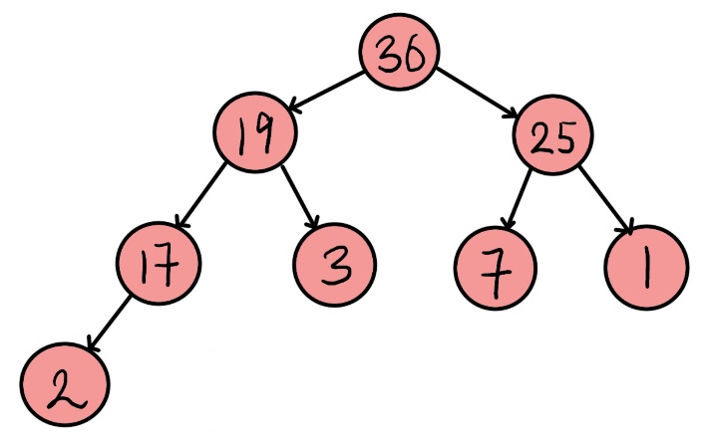

Array implementation:
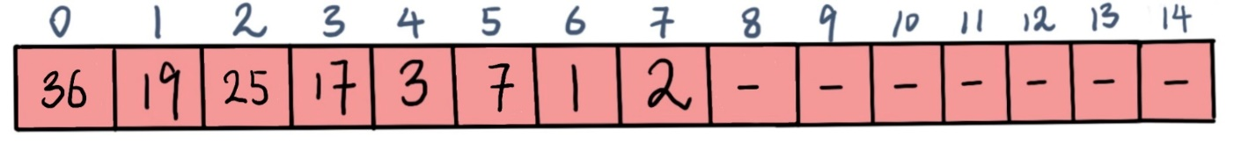

d) Draw a valid min-heap with the exactly the same set of integer keys in a)

Valid min-heap:
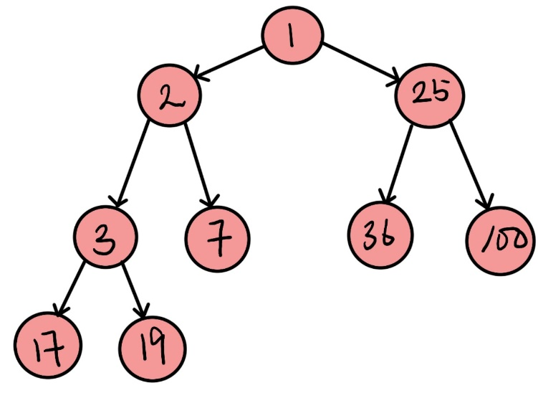

Corresponding array implementation:
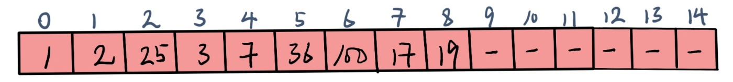

Question 4 Set ADT by Binary Search Tree
I have a set of integers 201, 901, 550, 300, 700, 101, 444. I want to create a Set ADT that keeps track of this set of integers. In reality, many engineers will choose to choose a Binary Search Tree to implement the Set ADT.

a) Assume now I am inserting the keys into the Set ADT in the listed order above, what would the Binary Search Tree be like?

Binary Search Tree:
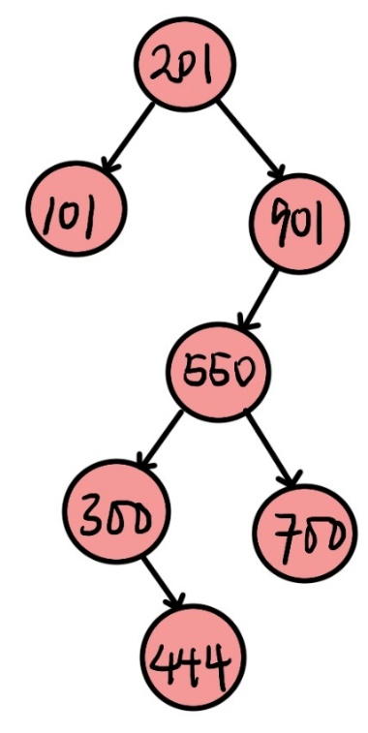

b) What would be the main rationale of the common practice of using a Binary Search Tree over a simple binary tree to implement the Set ADT?

Insert, delete and search function of BST time complexity is O(Log n), it is very faster. But simple binary tree is slow and execute above function will cost O(n) in worst time.

c) Name one main advantage and one main disadvantage of using a Binary Search Tree over hashtable to implement a Set ADT?

Advantage: Just perform an ordered traversal of BST, you can get all the keys in sorted order. This is not a natural operation in Hash Tables and requires extra efforts.

Disadvantage: In common, hash table has the average time is Θ(1) (i.e delete, insert, search), while BST is O(Log n) for all operation, it is not stable.

