CSCI 2100E Spring 2020 | Student Name:  Student Id:

Lab Exercise #4
Lab exercises are always due 2 weeks after day of the lab. Please notice lab exercises are very important under the new changes.

Please fill in the lab sheet and submit the completed Word doc file to blackboard. Places you need to fill in or work on are marked in red.

Demo
Your instructor will debug the below faulty QuickSort example.

#include <stdio.h>
int size = 8; // makes code simpler
void swap(int *xp, int *yp)
{
int temp = *xp;
*xp = *yp;
*yp = temp;
}
void displayArray(int intArray[]) {
for (int i=0;i<size;i++) {
printf("%d ",intArray[i]);
}
printf("\n");
}
int partition(int intArray[], int left, int right, int pivot) {
int leftPointer = left;
int rightPointer = right;
printf("Calling quick sort, index %d to %d with pivot %d...\n",left, right, pivot);
while(1) {
while(intArray[++leftPointer] < pivot) {
// keep increasing left pointer until run into something greater than pivot
}
while(rightPointer > 0 && intArray[--rightPointer] > pivot) {
// keep decreasing right pointer until run into something smaller than pivot
}
if(leftPointer >= rightPointer) {
break;
} else {
printf("item swapped: %d,%d\n",intArray[leftPointer],intArray[rightPointer]);
swap(&intArray[leftPointer],&intArray[rightPointer]);
}
}
printf("pivot swapped to final position: %d,%d\n",intArray[leftPointer],intArray[right]);
swap(&intArray[leftPointer],&intArray[right]);
displayArray(intArray);
return leftPointer;
}
void quickSort(int intArray[], int left, int right) {
if(right-left <= 0) {
return;
} else {
int pivot = intArray[right]; // use the rightmost as pivot (lazy!)
int partitionPoint = partition(intArray, left, right, pivot);
quickSort(intArray, left,partitionPoint-1);
quickSort(intArray, partitionPoint+1,right);
}
}
int main() {
int a[] = {1,4,5,2,3,6,7,8};
int b[] = {4,7,2,5,8,6,1,3};
printf("\nSorting a: ");
displayArray(a);
quickSort(a,0,size-1);
printf("\nSorting b: ");
displayArray(b);
quickSort(b,0,size-1);
}

Problem 1
Here we have a simple implementation of selection sort. It appears to work on array a but not on array b. Please debug the program so that it can now sort array b successfully. Please highlight your changes in bright red.

#include <stdio.h>

void swap(int *xp, int *yp)
{
int temp = *xp;
*xp = *yp;
*yp = temp;
}

void selectionSort(int a[], int n)
{
int i, j, minIndex;

printf("sorting array of length %d...\n",n);
for (i = 0; i < n; i++)
{
// in selection sort we find the smallest element
// from array and put it aside, then we
// find the next smallest in the remaining array
// again, and go on and go on

// print it out to easily visualize
for (int i=0;i<n;i++) {
printf("%d ",a[i]);
}
printf("\n");

// find the minimum in remaining array
minIndex = i;
for (j = i+1; j < n; j++) {
if (a[j] < a[minIndex])
minIndex = j;
}

// swap the found minimum element with the current i element
swap(&a[minIndex], &a[i]);

}

for (int i=0;i<n;i++) {
printf("%d ",a[i]);
}
printf("\n");

}

int main()
{
int a[] = {1,4,5,2,3,6,7,8};
int b[] = {6,12,15,16,18,
4,11,2,5,6,
7,10,12,5,6,
90,4,88,72,32,
66,54,12,0,1,
300,57,19,6,2};

selectionSort(a, 8);
selectionSort(b, 30);

return 0;
}

Problem 2
In our lecture notes, we have shown that the total number of comparisons needed for selection sort should be roughly ½ * n * (n-1). Using the debugged program from above, please confirm this by counting the number of comparisons needed for n = 5 to 40. Does it follow the formula? Show your tabulated results and conclusion below:

Yes, it does.
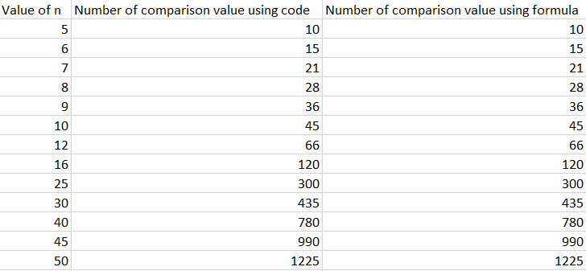

By executing our debugged program above by changing the value of n form 5 to 40, we can conclude that the number of comparison value using code is exactly matching the formula ½ * n * (n-1).

Problem 3
Below you will see a partial implementation of Merge Sort. Please complete the implementation. You are only allowed to insert code INSIDE the "INSERT CODE HERE" area.

- The MergeSort function is the main function of the sorting. The input parameters include the array to be sorted, the starting index and the ending index. We need to pass in the indices because we need to recursively sort part of the array ("sublists"), so the indices specify which part of the array will get sorted.
- The DoMerging is a helper function for MergeSort; what it do is simple: merge the sublist from startIndex to midIndex with the sublist from midIndex+1 to endIndex. This is the part you need to complete

Please read through the program and make sure you understand the function MergeSort before you start. Also please read through the lecture notes on MergeSort if you forgot how merging is done already.

#include <stdio.h>

int b[100]; // temporary array used for merging

void DoMerging(int a[], int startIndex, int midIndex, int endIndex) {
// Here we should merge the subllists a[startIndex] to a[midIndex] with
// a[midIndex+1] to a[endIndex] together into b[], in ascending order
// Please consult lecture notes for an example of how the merge is done!
// Please use b[] as temporary array for merging!
// INSERT CODE HERE

int first_1= startIndex;
int first_2 = midIndex+1;
int last_1= midIndex;
int last_2 = endIndex;
int index = first_1;

while(first_1<=last_1 && first_2<=last_2) {
if(a[first_1]<a[first_2]) {
b[index] = a[first_1];
first_1++;
}
else {
b[index] = a[first_2];
first_2++;

}
index++;

}
while(first_1<=last_1) {
b[index++] = a[first_1++];

}
while(first_2<=last_2) {
b[index++] = a[first_2++];

}

// copy the result from b[] back to a[]
int k;
printf("Merge Result: ");
for(k = startIndex; k <= endIndex; k++){
a[k] = b[k];
printf("%d ", b[k]);
}
printf("\n");

}

void MergeSort(int a[], int startIndex, int endIndex) {
// this is the recursive function for MergeSort
// we separate the list into two sublists and call mergesort again;
// the sublist is marked by startIndex and endIndex
int midIndex;

if(startIndex < endIndex) {
// more than one element, pls sort!
midIndex = (startIndex + endIndex) / 2;
MergeSort(a, startIndex, midIndex);
MergeSort(a, midIndex+1, endIndex);
DoMerging(a, startIndex, midIndex, endIndex);
} else {
// only one element, no need to sort!
return;
}
}

int main() {
int i;
int a[] = { 17, 22, 10, 22, 49, 30, 25, 2 };

printf("Original: ");
for(i = 0; i < 8; i++)
printf("%d ", a[i]);
printf("\n");

MergeSort(a, 0, 7); // in the beginning, we put in the whole list, which is from
// 0 to 7

printf("Final Result: ");
for(i = 0; i < 8; i++)
printf("%d ", a[i]);
printf("\n");

}

A successful output should look like this:

Original: 17 22 10 22 49 30 25 2
Merge Result: 17 22
Merge Result: 10 22
Merge Result: 10 17 22 22
Merge Result: 30 49
Merge Result: 2 25
Merge Result: 2 25 30 49
Merge Result: 2 10 17 22 22 25 30 49
Final Result: 2 10 17 22 22 25 30 49

Problem 4
Please find out the number of comparisons needed for sorting an array of size n from 5 to 40 using Merge Sort. Does it fit the formula seen in the lecture notes? Show your tabulated results and conclusion below:

In lecture notes, the given formula is T(n) = (n + nlog₂n) , the results will be shown blow.
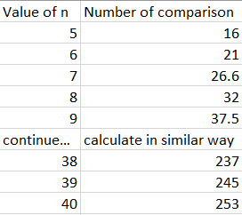
The log is with base 2 because the merge sort divides the array into two equal parts.
From the above results, we can see the formula which is given in lecture note, the number of comparison by executing the program is fit the formula seen in lecture notes.

Problem 5 (Hard, Optional)
Go online and search for a sort called Bogosort. Find an implementation in C or write one your own. Find out the empirical time cost as in Problem 2 and Problem 4. Since Bogosort does not really do meaningful comparison, let's count the total number of random shuffles used from n = 2 to 30. Compare to selection sort and merge sort and see who's slower? Show your tabulated results and conclusion below:

Bogo sort is more slower than selection and merge sort.

Please finish other Lab Exercises if you haven't already!
Please be reminded that lab exercises are compulsory now.

